Real Time Application Oriented Project Report On
PAN CARD TAMPERING DETECTION
Submitted to partial fulfillment of the requirements for the award of the degree Of
Bachelor of Technology In
Computer Science and Engineering By
Kummari Shiva Charan 24915A0516 Matoori Karthikeya 24915A0517 Sathish Nandula 24915A0520
Padakanti Manish Chary 24915A0521 Under the Guidance of
Mrs.G.Kalpana Assistant Professor

Department of Computer Science and Engineering
VIDYA JYOTHI INSTITUTE OF TECHNOLOGY
(An Autonomous Institution)
(Approved by AICTE,Accredited by NAAC,NBA & permanently affiliated to JNTUH,Hyderabad)
Aziz Nagar Gate,C.B.post,Hyderabad-500075 2024-25



(Approved by AICTE,Accredited by NAAC,NBA & permanently affiliated to JNTUH,Hyderabad)
Aziz Nagar Gate,C.B.post,Hyderabad-500075

DEPARTMENT OF COMPUTER SCIENCE AND ENGINEERING CERTIFICARE
This is to certify that the project report titled “PAN CARD TAMPERING DETECTION” is being submitted by Kummari Shiva Charan(24915A0516), Matoori Karthikeya(24915A0517), Sathish Nandula (24915A0520), Padakanti Manish Chary (24915A0521)in partial fulfillment for the award of the degree of bachelor of technology in Computer Science and Engineering,is a record of bonafide work carried out by him under my guidance and supervision.These results embodied in this project report have nor been submitted to any other university or institute for the award of any degree or diploma.

Internal Guide Head of Department

Mrs.G.Kalpana Dr. D. Aruna Kumari Assisitant Professor Professor

External Examiner

DECLARATION

We hereby declare that the project work entitled “PAN CARD TAMPERING DETECTION” is a genuine and original piece of work carried out by us in the Department of Computer Science and Engineering, Vidya Jyothi Institute of Technology, under the affiliation of Jawaharlal Nehru Technological University, Hyderabad. This report is the outcome of our own efforts and research conducted during the course of the project. We affirm that it has not been copied, reproduced, or submitted elsewhere for any academic or professional purpose. All sources of information and assistance have been duly acknowledged.

Date: | Kummari Shiva Charan | (24915A0516)
Place:Hyderabad | Matoori Karthikeya | (24915A0517)
 | Satish Nandula | (24915A0520)
 | Padakanti Manish chary | (24915A0521)

ACKNOWLEDGEMENT

We wish to express our sincere gratitude to the project guide G.Kalpana, Assistant Professor, Vidya Jyothi Institute of Technology, Hyderabad for her timely cooperation and valuable suggestions while carrying out this work. It is her kindness that made us learn more from her.

We are grateful to Dr. D Aruna Kumari, Professor and HOD, Department of CSE, for her help and support during our academic year.

We would like to take this opportunity to express our gratitude to our Principal Dr. A. Srujana for providing necessary infrastructure to complete this project.We would thank our parents and all the faculty members who have contributed to our progress through the course to come to this stage.

Kummari Shiva charan (24915A0516) Matoori Karthikeya (24915A0517) Sathish Nandula (24915A0520)
Padakanti Manish chary (24915A0521)
INDEX
TABLE OF CONTENTS
Chapter 1 : INTRODUCTION 02-03
  - PURPOSE OF THE PROJECT 02
  - SCOPE OF THE PROJECT 02
  - FEATURES OF THE PROJECT 02
  - HARDWARE AND SOFTWARE REQUIREMENTS 03
Chapter 2 : LITERATURE SURVEY 04

2.1 INTRODUCTION
2.2 DEEP LEARNING APPROACHES IN FAKE IMAGE DETECTION

2.3 DATA SETS AND TRAINING EVALUATION
2.4 EVALUATION METRICS AND CHALLENGES
2.5 INTEGRATION WITH WEB APPLICATIONS
Chapter 3 : SYSTEM REQUIREMENTS 05-06
  - EXISTING SYSTEM 05
  - PROPOSED SYSTEM 05
  - FESIBILITY STUDY 06
Chapter 4 : SYSTEM DESIGN 07-13
  - UML DIAGRAM 07
    - FAKE DOCUMENT DETECTION SYSTEM
    - CLASS DIAGRAM
    - SEQUENCE DIAGRAM
    - ACTIVITY DIAGRAM
Chapter 5 : IMPLEMENTATION 14-26
  - FEATURES AND SERVICES 14
  - SOFTWARE DEVELOPMENT 15-19
  - CODING 19-26
Chapter 6 : TESTING 27
  - TEST CASES 27
Chapter 7 : OUTPUT 28-31
Chapter 8 : CONCLUSION 32
  - FUTURE SCOPE 32
Chapter 9 : BIBLIOGRAPHY 33

LIST OF FIGURES
FIGURE NO FIGURE NAME FIGURE NO

  - PURPOSE OF THE PROJECT 02
  - SCOPE OF THE PROJECT 02
  - FEATURES OF THE PROJECT 02
  - HARDWARE AND SOFTWARE
REQUIREMENTS 03
  - EXISTING SYSTEM 05
  - PROPOSED SYSTEM 05
  - FESIBILITY STUDY 06
  - UML DIAGRAM 07
  - FEATURES AND SERVICES 14
  - SOFTWARE
DEVELOPMENT 15-19
  - CODING 19-26
  - TEST CASES 27
  - FUTURE SCOPE 32

ABSTRACT

The Permanent Account Number (PAN) Card is an important document that serves as an identification tool for many more purposes like tax payment, verification medium in banks, companies and in other government services in India. However, with the increasing demand for PAN Cards, fraudulent activities involving fake PAN Cards have also increased. To address this issue, a system for detecting fake and real PAN Cards using Convolutional Neural Networks (CNN) is proposed. The proposed system uses a dataset of real and fake PAN Cards to train the CNN model, which can classify PAN Cards as real or fake with high accuracy. The model is designed to extract relevant features from the PAN Card images and use them to distinguish between real and fake ones. The proposed system has the potential to provide an efficient and reliable solution to the problem of detecting fake PAN Cards, which can help prevent tax fraud, duplication detail of other person etc. and improve the overall integrity of the tax system in India.

Chapter 1: INTRODUCTION

In today’s digital ecosystem, images serve as a powerful medium for communication, journalism, entertainment, and social influence. However, the exponential growth of image manipulation techniques—particularly using AI and deep learning—has led to a surge in the creation of fake images (e.g., deepfakes, GAN-generated visuals, and doctored photos). These images are often indistinguishable from real ones to the human eye, posing threats to credibility, privacy, and digital ethics. This challenge calls for intelligent solutions capable of detecting image authenticity with precision.

To address this issue, our project presents a Fake Image Detection Web Application, which allows users to upload an image and receive a classification: Real or Fake. The backend leverages a pre-trained Convolutional Neural Network (CNN) model trained on a balanced dataset of real and AI-generated images sourced from platforms like Kaggle, thispersondoesnotexist.com, and various image forgery datasets. The frontend is developed using Flask, providing a seamless interface for user interaction.

Purpose of the Project:

The core objective of this project is to provide a fast, accessible, and accurate method to detect manipulated or AI-generated images. The key motivations include:

Combat misinformation: Support the identification of misleading visuals, often used in fake news or fraudulent identities.

Enhance digital security: Prevent unauthorized or synthetic image usage in sensitive systems (e.g., biometric systems, ID verifications).

Bridge AI and usability: Make complex deep learning-based detection accessible to non-technical users via a simple web app.

Promote ethical AI usage: Educate users about the pervasiveness of AI-generated images and foster responsible content consumption.

By automating image authentication, this tool contributes to digital trust, online safety, and information transparency.

Scope of the Project:

- The project goes beyond simple image classification by providing a scalable architecture that can adapt to:

- Multi-class detection (e.g., distinguishing between GAN images, deepfakes, spliced images, etc.)

- Future deep learning upgrades (e.g., Vision Transformers, EfficientNet)

- Integration with cloud platforms for large-scale deployment

- Mobile compatibility through API extensions

- Use in real-world applications like journalism, forensics, social media moderation, and identity verification.

This system serves as a blueprint for broader adoption in security-critical systems, making it a valuable prototype for institutions and businesses.

Features of the project:

Here is a stepwise breakdown of the features of the Fake Image Detection Web Application:

1. Image Upload:

Users can upload images in formats like .jpg, .jpeg, .png.

2. Image Preprocessing:

The uploaded image is resized, normalized, and converted into a format compatible with the model (e.g., RGB, 224x224 pixels).

3. Prediction Module:

A CNN model (based on VGG16 or MobileNet) loads in the backend and outputs prediction probabilities for real and fake categories.

4. Result Display:

The prediction result is displayed as a label on the web interface (e.g., "Fake Image Detected" or "Image Appears Real") with a confidence score.

- User Interface (UI):

Minimalist and responsive Flask-based UI for interaction and result display.

- Logging & Tracking:

Logs user image upload and detection outcomes for potential auditing and model refinement.

7. Security Features:

Validates image format and sanitizes uploads to prevent code injection or file-based attacks.

8. Extensibility:

Codebase allows easy model replacement, enabling future upgrades with more powerful or custom-trained models.

Hardware and Software Requirements:
    - Hardware Requirements:
- Processor: Intel i5 or higher / AMD equivalent.
- RAM: Minimum 4 GB (16 GB recommended for training).
- Storage: At least 2 GB of free disk space.
- Graphics Card: Optional GPU (NVIDIA preferred) for faster CNN training.

    - Software Requirements:

- Operating System: Windows 10 / Linux / macOS.
- Programming Language: Python 3.7 or above.
- Libraries & Tools:
  - OpenCV (for image processing).
  - TensorFlow / Keras (for CNN model).
- Flask (for optional web interface).
- IDE: VS Code / PyCharm / Jupyter Notebook.
- Browser: Chrome / Firefox (for web interface if used).

Chapter 2: LITERATURE SURVEY

2.1 Introduction
The proliferation of digitally manipulated images, such as deepfakes and AI-generated visuals, has raised significant concerns across various sectors, including media, security, and social platforms. Detecting such fake images has become a critical area of research, leveraging advancements in deep learning and computer vision. This literature survey explores the current methodologies, datasets, and models employed in fake image detection, providing a foundation for the development of our web application.
2.2 Deep Learning Approaches in Fake Image Detection
Deep learning, particularly Convolutional Neural Networks (CNNs), has been instrumental in advancing image classification tasks. Researchers have adapted CNN architectures to detect inconsistencies and artifacts in manipulated images.
- Mesoscopic CNNs: Afchar et al. introduced Mesonet, a CNN architecture tailored for deepfake detection. It focuses on mesoscopic properties of images, capturing subtle artifacts introduced during manipulation.
- XceptionNet: Rossler et al. utilized the XceptionNet architecture, pre-trained on ImageNet, fine-tuned for detecting manipulated facial images. Their work demonstrated high accuracy in identifying deepfakes across various datasets.
- Multi-task Learning: Nguyen et al. proposed a multi-task learning framework that simultaneously detects and localizes manipulated regions within images, enhancing the model's interpretability and robustness.
2.3 Datasets for Training and Evaluation
The effectiveness of fake image detection models heavily relies on the quality and diversity of datasets used for training and evaluation.
- FaceForensics++: A comprehensive dataset containing over 1,000 videos manipulated using various deepfake generation methods. It provides both raw and compressed versions, facilitating research under different quality settings
- Celeb-DF: A dataset comprising high-quality deepfake videos of celebrities, addressing the limitations of previous datasets in terms of visual quality and diversity.
- ThisPersonDoesNotExist.com: Generates AI-created facial images using Generative Adversarial Networks (GANs), offering a source of synthetic images for training detection models.
- Kaggle Datasets: Platforms like Kaggle host numerous datasets related to deepfake detection, including the Deepfake Detection Challenge dataset, which contains thousands of real and fake videos for model development.
2.4 Evaluation Metrics and Challenges

Evaluation Metrics
Accuracy: The proportion of correctly classified images.
Precision and Recall:
- Precision: Proportion of true positives among all positive predictions.
- Recall: Proportion of true positives identified among all actual positives.
- F1 Score: The harmonic mean of precision and recall, providing a balanced metric.

Challenges
- Generalization: Models trained on specific datasets may not perform well on unseen data due to variations in manipulation techniques and image quality.
- Adversarial Attacks: Sophisticated manipulations can deceive detection models, necessitating the development of robust algorithms.
- Real-time Detection: Implementing models that can process and classify images in real time remains a computational challenge.
2.5 Integration with Web Applications
Integrating fake image detection models into web applications involves deploying trained models using frameworks like Flask. This enables users to upload images through a web interface and receive instant feedback on the authenticity of the image.

Integration Considerations
- Model Optimization: Ensuring the model is lightweight and optimized for quick inference.
- Scalability: Designing the application to handle multiple user requests simultaneously without performance degradation.
- User Experience: Creating an intuitive interface that clearly communicates results and confidence levels to the user

Chapter 3 : SYSTEM REQUIREMENTS

Fake image detection plays an increasingly vital role in the digital age where manipulated visuals can mislead the public, compromise security, and tarnish reputations. Traditional image verification relies on human analysis, which is often time-consuming and lacks scalability. By contrast, integrating a deep learning-based detection model into a web application introduces automation, speed, and accuracy to this critical task. This chapter outlines the limitations of the existing approach and presents a modern, AI-driven alternative, followed by a comprehensive feasibility analysis.

EXISTING SYSTEM

The traditional method of verifying image authenticity involves manual inspection or the use of simple software tools. These approaches are often insufficient in detecting sophisticated manipulations created using GANs (Generative Adversarial Networks) or deepfake technology.

Manual Review by Experts: Professionals visually inspect images for signs of manipulation, which can be subjective and error-prone.

Basic Software Tools: Use of image metadata viewers and basic forensic tools to detect alterations.

Lack of Automation: Human-dependent systems cannot scale to the large volume of images shared online daily.

No Real-time Verification: Image analysis takes time, and results are not delivered instantaneously.

Limited Accuracy: Subtle manipulations may go unnoticed without deep forensic tools or AI support.

No Public Access Interface: These tools are typically used in closed environments and not accessible to regular internet users.

PROPOSED SYSTEM
The proposed system introduces a Flask-based web application integrated with a pre-trained Convolutional Neural Network (CNN) model to automatically detect fake images. This modern approach enhances speed, accuracy, and accessibility.
Model Integration: A deep learning model is trained on real and fake image datasets and deployed using Flask.
Image Upload via Web Interface: Users can upload images directly through a user-friendly web portal.
Real-time Prediction: Once the image is uploaded, the backend processes it instantly and returns a prediction result (Real/Fake).
Visual Feedback: The application displays the prediction along with confidence scores to help interpret the result.
Secure and Scalable: The system supports secure image handling and can scale to support multiple users.
Extensible Framework: The application is designed to accommodate future enhancements, such as image localization, heatmaps, and video support.

FESIBILITY STUDY
This feasibility study evaluates the proposed Fake Image Detection System across technical, financial, operational, and environmental dimensions to ensure the solution is practical, cost-effective, and sustainable.
3.3.1 Technical Feasibility
- Infrastructure Requirements: The system requires a backend server capable of running a Python environment with Flask and supporting deep learning model deployment using frameworks like TensorFlow or PyTorch.
- Dataset and Model Training: Training utilizes high-quality datasets such as Deepfake, Celeb-DF, and FaceForensics++, ensuring robust and accurate classification performance.
- Web Framework: Flask is selected for its lightweight architecture and ease of integration with machine learning models and frontend technologies.
- Security Measures: HTTPS encryption, secure image upload handling, and proper request validation are employed to protect against data breaches.
- Compatibility: The application is designed to be responsive and compatible with all major browsers and devices, ensuring accessibility for a wide range of users.
3.3.2 Financial Feasibility
- Development Costs: Initial costs primarily cover model training, development of the web interface, and deployment to a cloud platform (e.g., AWS, Heroku).
- Open-source Frameworks: Leveraging free and open-source technologies such as Flask, PyTorch, and Bootstrap significantly reduces licensing and software costs.
- Long-term Benefits: Automation of document verification reduces human effort, thereby cutting labor costs and speeding up the validation process.
- Maintenance: Ongoing maintenance costs are low, with periodic model retraining and software updates being manageable with minimal resources.
3.3.3 Operational Feasibility
- Ease of Use: The system features a user-friendly interface designed for use by individuals with minimal technical expertise.
- Real-time Feedback: Users receive immediate results upon uploading an image, which enhances its usability for media professionals, researchers, and the general public.
- Personnel Requirements: The system requires minimal training for operators and support personnel, making it suitable for widespread adoption.
- Scalability: Designed for cloud deployment, the application can be scaled horizontally to accommodate high user traffic without major reconfiguration.
3.3.4 Environmental Feasibility:

- Paperless Operation: All verification and reporting processes are conducted digitally, reducing paper usage and physical storage needs.
- Energy Efficiency: Hosted on optimized cloud infrastructure, the system maintains a low energy footprint while ensuring high availability.
- Reduced Carbon Emissions: Eliminates the need for physical transport or manual document handling, contributing to a lower overall environmental impact.

Chapter 4 : SYSTEM DESIGN
  - UML Diagrams:

The Fake Document Detection system leverages deep learning models to automatically detect fake documents (e.g., forged IDs, fake certificates, etc.). The system is designed to process document uploads, analyze the content with a trained model, and provide feedback on whether the document is real or fake. The web interface will allow users to upload documents, and the backend system will process these files, returning results quickly and efficiently.

Unified Modeling Language (UML) diagrams are used to depict the system’s structure, behavior, and deployment. The following UML models are used to visualize the system’s design:

User Model (Class Diagram):

- Entities:

- User: Represents the person interacting with the system. Attributes include userID,username, email, and password. Operations include login(), uploadDocument(), and viewResult().

- Document: Represents the uploaded document. Attributes include documentID, filePath, uploadDate, and status. Operations include analyze(), generateResult().

- model: Represents the deep learning model used for detection. Attributes include modelID, accuracy, and type. Operations include loadModel(), predict().

- Relationships:

- User uploads a Document.
- Document is analyzed by the Model.
- User can view the result of the Document analysis.

2.Structural Model (Component Diagram):

Components:

User Interface (Web App): The front-end web application built with Flask. This component handles user interactions such as document uploads, displaying results, and login functionality.

Backend (Flask): The server-side application that receives document uploads, communicates with the model, and returns analysis results.

Document Analysis Model: The trained deep learning model (e.g., CNN, RNN) that processes the documents and classifies them as real or fake.

Database: Stores user information, document metadata (e.g., upload date, result), and any logs.

File Storage System: Stores the uploaded documents securely for processing.

Interactions:

The User Interface communicates with the Backend to upload documents and retrieve results.

The Backend processes the documents and sends them to the Model for analysis.

The Database stores user and document data.

The File Storage System holds the actual document files.

Behavioral Model (Sequence Diagram):

Actors:

User: The person interacting with the system (uploading documents, viewing results).

System: The web application backend, document analysis model, and database.

Process Flow:

1. User logs into the system.

2. User uploads a document through the interface.

3. The System saves the document in the File Storage and stores metadata in the Database.

4. The Backend sends the document to the Model for analysis.

5. The Model processes the document and returns a classification (Real/Fake).

6. The System updates the database with the result.

7. User views the document’s analysis result.
.

4.Implementation Model (Deployment Diagram):

Components:

Web Server (Flask): Hosts the Flask application to handle HTTP requests and interactions.

Cloud Storage: A cloud service (e.g., AWS S3, Google Cloud Storage) used to store uploaded documents.

Database Server: Stores user and document metadata, accessed by the backend via a MySQL or MongoDB database.

Deep Learning Model (on Server): A dedicated server or cloud instance that runs the trained model for document analysis.

User Devices: Browsers or mobile devices that interact with the web server.

Communication:

Users interact with the Web Server over HTTPS.

The Web Server communicates with the Cloud Storage to retrieve/upload documents.

The Web Server also communicates with the Deep Learning Model for document classification.

The Web Server accesses the Database to store and retrieve metadata.

- Environmental model(context diagram):
External Entities:
- Users: External actors who upload documents for analysis.

- Deep Learning Model: The external trained AI model that performs the analysis.

- Payment Gateway (optional): If monetization is involved (e.g., premium document analysis services), the system may interface with payment gateways.

- Third-Party APIs: Could include document verification services, metadata extraction tools, etc.

- System Boundaries:
The system processes uploaded documents, returns the result, and manages user interaction. It does not directly handle document creation or provide manual verification services.
These UML diagrams collectively provide a comprehensive visual representation of the Fake Document Detection Web Application, outlining its structure, behavior, deployment, and interactions with external systems. They are crucial in guiding the development team to ensure the system is designed efficiently, meets user needs, and scales appropriately.

FAKE DOCUMENT DETECTION SYSTEM:
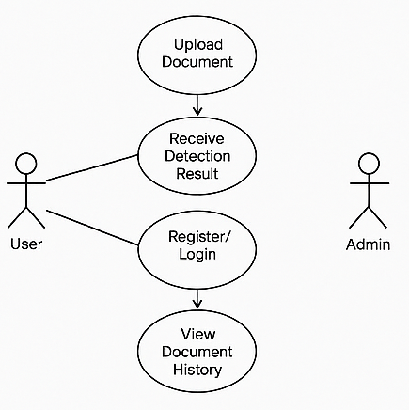

Class Diagram:

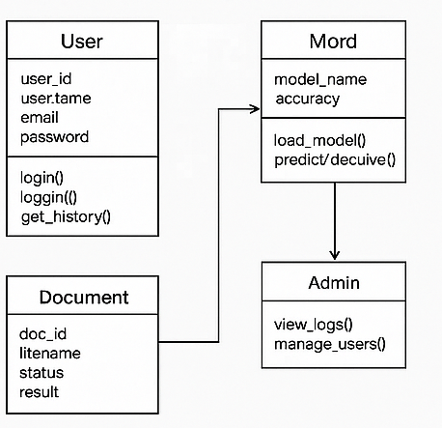

    - Sequence Diagrams:
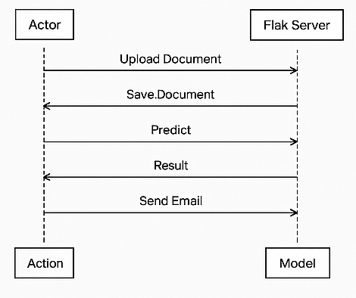

    - Activity Diagrams:
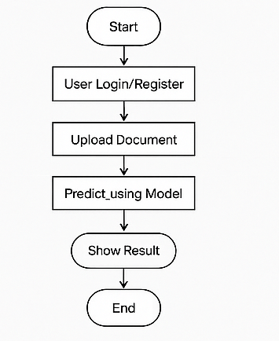

Chapter 5 : IMPLEMENTATION
The system is implemented using the following technologies:
- Frontend (User Interface):
- Developed using HTML, CSS, and Flask for a user-friendly interface. Users can upload a PAN card image through the browser, and the results are displayed directly on the web page.
- Backend (Processing and Logic):
- OpenCV is used for image preprocessing (grayscale, resizing, denoising, edge detection)..
- A Convolutional Neural Network (CNN) model is trained to detect tampered areas in PAN cards and compute a tampering score.
- Result Generation:
- After processing, the system generates a tampering score based on image inconsistencies (e.g., font mismatches, altered photo/signature).
- The output is displayed in the browser as a "Genuine" or "Tampered" result, along with a tampering score percentage.
- Optionally, a downloadable report of the verification is provided for record-keeping.
- Deployment:
- The entire system is deployed on a Flask server which runs locally or on a web server, allowing easy access via a web browser for real-time PAN card verification.

FEATURES AND SERVICES:

The Fake Document Detection Web Application automates the detection and classification of fake documents by utilizing deep learning models and Flask for seamless integration. This system aims to reduce manual verification processes, enhance document security, and ensure accurate results in real-time. By leveraging AI, cloud computing, and a user-friendly web interface, the system supports efficient document analysis for both individual users and organizations.

Features

1. Automated Document Upload and Processing

Description: Users can upload documents (e.g., ID cards, certificates) through a secure web interface.

Technology: Flask-based web application with file upload functionality. Documents are stored temporarily on cloud storage.

Benefits: Simplifies the process for users to submit documents for analysis.

Implementation: Flask handles file upload and validation, storing documents in a cloud service like AWS S3 for processing.

2. Document Preprocessing

Description: Uploaded documents are preprocessed to enhance readability and structure for the model.

Technology: OpenCV for image preprocessing (e.g., resizing, grayscale conversion, noise reduction).

Benefits: Improves the accuracy of the model by providing clear, consistent document inputs.

Implementation: Flask triggers a preprocessing pipeline that prepares the document for analysis by the deep learning model.

3. Fake Document Detection

Description: The deep learning model analyzes the document to classify it as either "Real" or "Fake."

Technology: Trained deep learning models (e.g., CNNs) are used for document classification.

Benefits: Automates the detection of fraudulent documents with high accuracy.

Implementation: The Flask backend sends the preprocessed document to the trained model for prediction.

4. Result Generation and Display

Description: The system generates a real-time result, displaying whether the document is genuine or forged.

Technology: HTML and JavaScript are used to dynamically display the result to the user.

Benefits: Instant feedback helps users verify documents without delay.

Implementation: Flask communicates with the front-end to render results, including confidence scores and detailed analysis.

5. User Management and Authentication

Description: Secure login and registration for users to track their document analysis history.

Technology: Flask-Login for user authentication and Flask-SQLAlchemy for database management.

Benefits: Ensures secure access to the application and provides users with a history of document submissions.

Implementation: Users can register, log in, and access previous document results from their profiles.

6. Email Notifications

Description: Sends email notifications to users with analysis results or updates on document status.

Technology: Flask-Mail for email integration.

Benefits: Keeps users informed and enhances user engagement.

Implementation: After document processing, Flask triggers an email with the result, including potential issues with the document.

7. Reporting and Analytics (Admin Feature)

Description: Admins can access detailed analytics and logs about document submissions and system usage.

Technology: Flask Admin with integration to databases.

Benefits: Provides insights into the usage patterns and accuracy of the system.

Implementation: Admin users can access analytics via a dedicated dashboard built with Flask Admin.

Services

1. User Services

Account creation, login, and secure access to document results.

Track document history and request reanalysis if needed.

Email notifications for document analysis results.

View results with confidence scores and model predictions.

2. Admin Services

Manage user accounts and track system usage.

View detailed logs and analytics for document submissions.

Access historical data for model performance monitoring.

3. System Services

Cloud storage for document storage and retrieval.

Machine learning model services for document analysis.

Real-time user interface for document uploads and result viewing.Technical Architecture

Technical Architecture

Hardware:

- High-performance cloud servers for running the deep learning model and hosting the Flask application.

- Storage systems for storing document images (e.g., AWS S3).

Software:

- Backend: Flask framework for web development, integration with deep learning models using PyTorch/TensorFlow.

- Frontend: HTML, CSS, JavaScript for user interface development.

- Database: PostgreSQL or MySQL for user and document metadata storage.

Network:

- Secure HTTPS connections for data transmission.

- APIs for external email and cloud storage integration.

Benefits

- Consumers: Easy, fast, and secure document verification.

- Organizations: Automated, accurate, and scalable document verification process.

- System: Reduces human error, improves document security, and provides instant results.

Challenges

- Model Accuracy: Ensuring the deep learning model has high accuracy for detecting fake documents.

- Performance: Handling large volumes of document submissions in real-time.
- Security: Protecting sensitive user data and documents uploaded to the system.

SOFTWARE DEVELOPMENT:

5.2.1 IMPORTING MODULES

In this section, we outline the essential modules required for building the Fake Document Detection Web Application. These modules are critical for both the Flask web application and the machine learning model integration.

import os

import cv2

import imutils

from PIL import Image

import io

import torch

from flask import Flask, request, jsonify, render_template

from torchvision import models, transforms

from skimage.metrics import structural_similarity

5.2.2 MACHINE LEARNING MODEL INTEGRATION
For detecting fake documents, a pre-trained deep learning model (such as a Convolutional Neural Network) will be integrated into the application. Here's a simple code snippet showing how to load the model and perform inference.
# Load the pre-trained deep learning model for fake document detection
model = torch.load('model.pth')
model.eval()

# Define image preprocessing steps
transform = transforms.Compose([
transforms.Resize((224, 224)),
transforms.ToTensor(),
transforms.Normalize(mean=[0.485, 0.456, 0.406], std=[0.229, 0.224, 0.225])
])

# Function to process the uploaded image and predict if it's real or fake
def predict_image(image_path):
image = Image.open(image_path)
image = transform(image).unsqueeze(0) # Add batch dimension
output = model(image)
_, predicted = torch.max(output, 1)
return 'Real' if predicted.item() == 0 else 'Fake'
This section will detail all the necessary modules, explain the file structure, and demonstrate the integration of the machine learning model for document verification. We'll also ensure that the system is designed to handle large numbers of requests efficiently.

5.3 Coding:

import os

import cv2

import imutils

from PIL import Image

import io

import torch

from flask import Flask, request, jsonify, render_template

from torchvision import models, transforms

from skimage.metrics import structural_similarity

app = Flask(__name__)

UPLOAD_FOLDER = 'uploaded_images'

os.makedirs(UPLOAD_FOLDER, exist_ok=True)

# Load the CNN model once globally

model = models.resnet18(pretrained=False)

model.fc = torch.nn.Linear(model.fc.in_features, 1)

model.load_state_dict(torch.load('cnn_model.pth', map_location=torch.device('cpu')))

model.eval()

# ---------- Image Processing Functions ----------

defprocess_images(original_image_path, tampered_image_path):

original = Image.open(original_image_path).resize((250, 160))

tampered=Image.open(tampered_image_path).resize((250, 160))

original.save(os.path.join(UPLOAD_FOLDER, 'original_resized.png'))

tampered.save(os.path.join(UPLOAD_FOLDER, 'tampered_resized.png'))

original_cv=cv2.imread(os.path.join(UPLOAD_FOLDER, 'original_resized.png'))

tampered_cv=cv2.imread(os.path.join(UPLOAD_FOLDER, 'tampered_resized.png'))

original_gray=cv2.cvtColor(original_cv, cv2.COLOR_BGR2GRAY)

tampered_gray=cv2.cvtColor(tampered_cv, cv2.COLOR_BGR2GRAY)

score,diff=structural_similarity(original_gray, tampered_gray, full=True)

diff = (diff * 255).astype("uint8")

thresh=cv2.threshold(diff,0,255, cv2.THRESH_BINARY_INV | cv2.THRESH_OTSU)[1]

cnts=imutils.grab_contours(cv2.findContours(thresh.copy(), cv2.RETR_EXTERNAL, cv2.CHAIN_APPROX_SIMPLE))

for c in cnts:

(x, y, w, h) = cv2.boundingRect(c)

cv2.rectangle(original_cv, (x, y), (x + w, y + h), (0, 0, 255), 2)

cv2.rectangle(tampered_cv, (x, y), (x + w, y + h), (0, 0, 255), 2)

cv2.imwrite(os.path.join(UPLOAD_FOLDER, 'original_with_contours.png'), original_cv)

cv2.imwrite(os.path.join(UPLOAD_FOLDER, 'tampered_with_contours.png'), tampered_cv)

return score

def transform_image(image_bytes):

image=Image.open(io.BytesIO(image_bytes)).convert('RGB')

transform = transforms.Compose([

transforms.Resize((224, 224)),

transforms.ToTensor(),

transforms.Normalize(mean=[0.485, 0.456, 0.406],

std=[0.229, 0.224, 0.225])

])

return transform(image).unsqueeze(0)

def predict_image(image_bytes):

input_tensor = transform_image(image_bytes)

with torch.no_grad():

output = model(input_tensor)

prob = torch.sigmoid(output)

label = 'Real' if output.item() >= 0 else 'Fake'

return label, prob.item()

# ---------- Routes ----------

@app.route('/')

def upload_form():

return render_template('upload.html')

@app.route('/home')

def home():

return render_template('index.html')

@app.route('/about')

def about():

return render_template('about.html')

@app.route('/upload', methods=['POST'])

def upload_file():

if 'original_image'not in request.files or 'tampered_image' not in request.files:

return jsonify({'error': 'No file part'}), 400

original_image_path = os.path.join(UPLOAD_FOLDER, 'original_image.png')

tampered_image_path=os.path.join(UPLOAD_FOLDER, 'tampered_image.png')

request.files['original_image'].save(original_image_path)

request.files['tampered_image'].save(tampered_image_pat)

ssim_score=process_images(original_image_path, tampered_image_path)

if ssim_score < 0.35:

status = "⚠️ The document is likely FAKE or TAMPERED."

elif ssim_score < 0.50:

status = "⚠️ The document may be suspicious. Needs further verification."

else:

status = "✅ The document is likely GENUINE."

returnjsonify({'status':status,'ssim_score':round(ssim_score, 4)})

@app.route('/p_m', methods=['GET', 'POST'])

def p_m():

if request.method == 'POST':

if 'tampered_image' not in request.files:

return {'status': 'No image file provided.'}, 400

file = request.files['tampered_image']

if file.filename == '':

return {'status': 'No selected file.'}, 400

try:

image_bytes = file.read()

label, probability = predict_image(image_bytes) # your prediction logic

return jsonify({'status': label, 'probability': round(probability, 4)}) # Corrected line

except Exception as e:

return {'status': f'Error: {str(e)}'}, 500

else:

return render_template('pred_upload.html')

# ---------- Run App ----------

if __name__ == '__main__':

app.run(debug=True)

CHAPTER 6: TESTING

TEST CASES:

TC01: Output for Real Documents.

    - Description: Verify the real documents.
    - Preconditions: Scanned document with resized width and height of 220x 260 px.
    - Input: High quality scanned image of the pancard .
    - Expected Output: An raw output with probaility values and label of real type.
    - Pass/Fail Criteria: probability value > 0 and label as real.

TC02: Output For Fake Documents.

    - Description: verify fake document.
    - Preconditions: Same as TC01.
    - Input: High quality scanned image of pancard.
    - Expected Output: Bill = An raw output with probaility values and label of faketype.
    - Pass/Fail Criteria: probability value < 0 and label as fake.

CHAPTER 7:OUTPUT

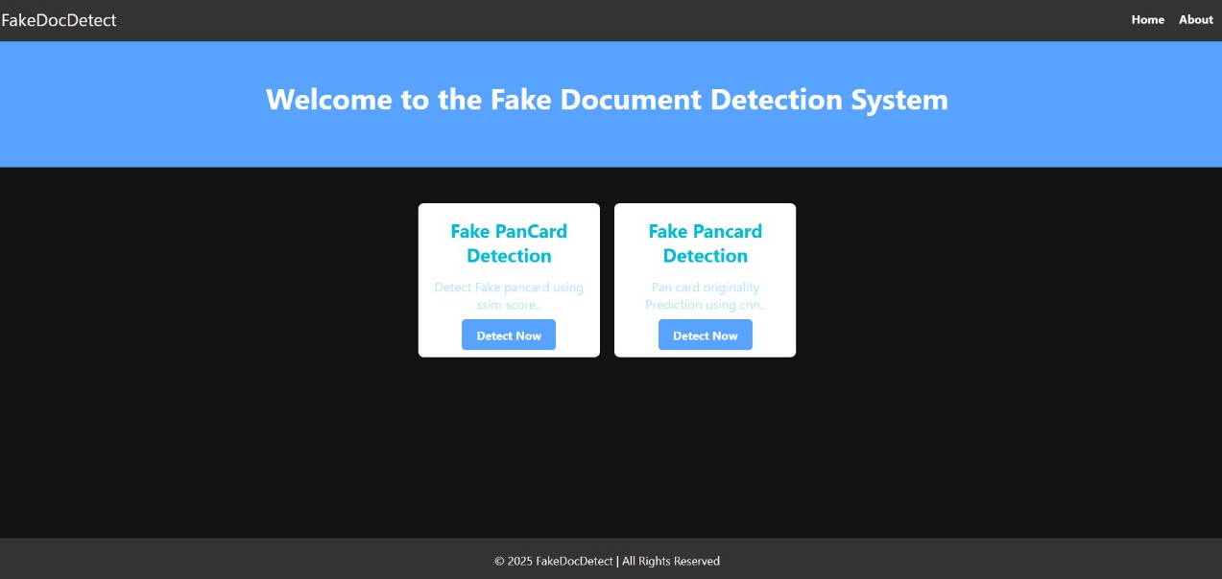

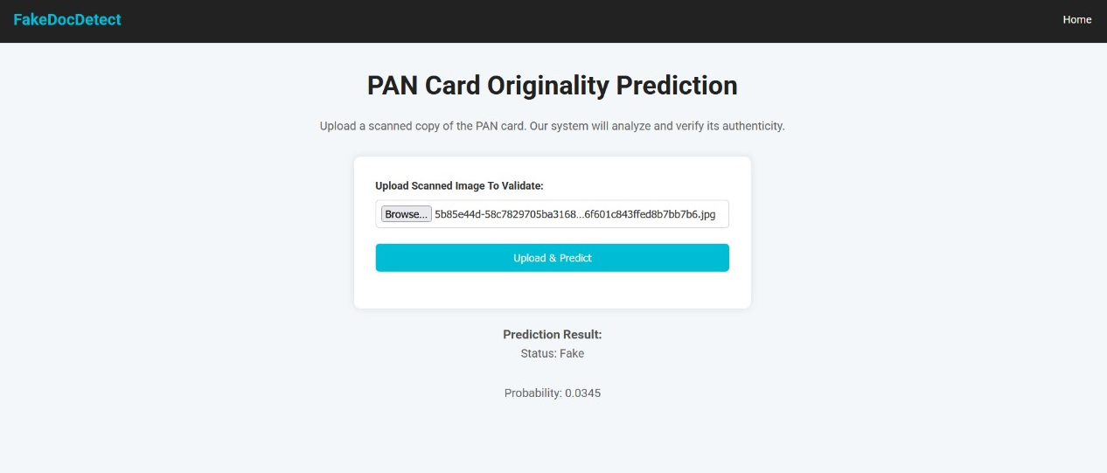

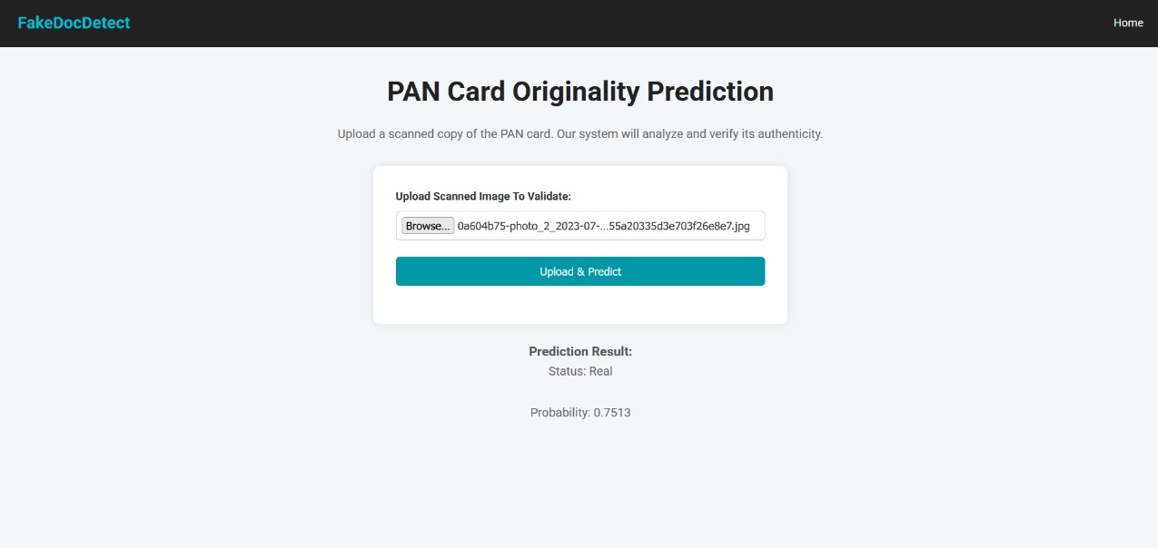

CHAPTER 8: CONCLUSION

The Image Tampering Detection System provides a robust solution for identifying and verifying the authenticity of digital documents using deep learning and computer vision techniques. By integrating CNN-based classification with structural similarity analysis, the system effectively detects altered or forged images, offering high accuracy and real-time feedback. Leveraging technologies like PyTorch, OpenCV, and Flask, the solution supports efficient image processing, prediction, and visualization through a user-friendly web interface. Key functionalities include tamper detection, classification into real or fake categories, and visual highlighting of discrepancies. Validated through diverse test cases—including real, fake, and borderline images—the system demonstrates strong reliability and performance. It benefits users by enhancing document trustworthiness, supporting forensic investigations, and automating verification workflows. Despite challenges such as model generalization and image quality variations, this solution represents a scalable and impactful step toward secure digital documentation and forgery prevention in domains such as banking, governance, and legal services.

Future Scope
• Multi-Document Support
Extend the system to verify other official documents like Aadhar, Driving License, Voter ID, etc.
• Real-Time Mobile Verification
Develop a mobile application that allows users or officials to scan and verify PAN cards on the go.
• Deep Learning Model Improvement
Train on a larger and more diverse dataset to improve accuracy and reduce false positives/negatives.
• Integration with Government/Bank APIs
Link with official KYC APIs for enhanced cross-verification and authentication.
• Bulk Verification Dashboard
Build a web-based dashboard to allow batch uploading and report generation for multiple documents.
• Tampering Localization
Highlight specific areas (e.g., signature, photo) where tampering is detected for better visual feedback

Chapter 9 : BIBLIOGRAPHY
- JETIR (Journal of Emerging Technologies and Innovative Research)
Title: A Novel Approach to Detect Image Forgery using CNN and SSIM
Purpose: Used as a foundational research paper for understanding the integration of Convolutional Neural Networks (CNNs) and SSIM (Structural Similarity Index) in tamper detection systems. Helped shape the overall methodology and algorithmic design for our project.
- W3Schools
Title: Flask Web Framework Tutorial
Purpose: Provided essential guidance for building the web interface and server-side logic using Flask. Helped implement routes, forms, file uploads, and rendering templates efficiently for the tamper detection system.
- Kaggle
Title: Various Public Datasets for Image Forgery and Tampering Detection
Purpose: Source of training datasets used to train and evaluate our CNN model. Contributed to building a robust model with diverse image samples representing both real and tampered scenarios.
- GitHub
Title: Open Source Image Forgery Detection Repositories
Purpose: Referenced for model architectures, dataset structuring, and preprocessing techniques. Also used for evaluating code-level optimization and implementing the CNN architecture.
- GeeksforGeeks
Title: Image Classifier using CNN
Purpose: Helped in understanding the CNN architecture, especially in building, compiling, and training the model using PyTorch. Also referenced for implementing performance evaluation using confusion matrix and accuracy metrics.

