Controlled Residual Depth Adaptation in ResNet50 for Pneumonia Classification
Karthik Saraf, Manoj Anandhan, Fidel Gonzales, and Sowmika Yeadhara
Department of Information Science, University of North Texas
DTSC 5082: Seminar in Research and Research Methodology
April 4, 2026

Phase Summary
This report covers Phase 4 of our four-phase capstone project. The sections below briefly recap Phases 1 through 3 to give context for the explainability and deployment work we present here.
In Phase 1, we downloaded the Kaggle Chest X-Ray Pneumonia dataset (Mooney, 2018) and ran file-level integrity checks, confirming 5,216 training, 16 validation, and 624 test images with no corruption. The class split was NORMAL = 1,342 (25.72%) and PNEUMONIA = 3,876 (74.28%), giving an imbalance ratio of 2.89:1. All images were resized to 224×224 and normalized using ImageNet statistics (mean = [0.485, 0.456, 0.406], std = [0.229, 0.224, 0.225]).
Phase 2 focused on exploratory data analysis. Sampling 400 images revealed considerable resolution variability: mean width = 1,426.25 px (SD = 353.44), range 445–2,844 px, with a width-height correlation of r = 0.933. A pixel intensity t-test (t = -0.921, p = 0.359, Cohen’s d = -0.184) showed no statistically significant difference between classes, which told us that global brightness alone cannot distinguish pneumonia from normal lungs. PCA on frozen ResNet50 2,048-d embeddings (n = 128 samples) captured PC1 = 18.66% and PC2 = 13.74% of variance (total = 32.40%), showing partial but incomplete separation — which made clear that domain-specific fine-tuning would be necessary.
In Phase 3, we trained and compared four configurations. A baseline CNN (6.4M params, Adam LR = 5e-4, 6 epochs) reached Accuracy = 0.83 with 15 false negatives. The frozen ResNet50 (4K trainable params, LR = 1e-3, StepLR, 6 epochs) improved accuracy to 0.86 but produced 66 false negatives — far too many for a clinical screening tool. Partially fine-tuning Layer4 and the FC head (14.9M params, LR = 1e-4, 3 epochs, threshold = 0.9) brought accuracy up to 0.92 with only 10 missed cases. Full fine-tuning all 23.5M parameters (LR = 1e-5, weight_decay = 1e-4, gradient clipping = 1.0, 6 epochs, threshold = 0.9) achieved Accuracy = 0.91, Precision = 0.88, Recall = 0.99, F1 = 0.93, and just 5 false negatives. We carried the full fine-tuned model into Phase 4 because it had the fewest missed pneumonia cases — a 92.4% reduction compared to the frozen baseline.
Team Contributions
Table 1
Phase 4 Team Roles and Responsibilities
Team Member | Role | Phase 4 Deliverables
Karthik Saraf | XAI Lead | Threshold sensitivity analysis, configuration comparison, LIME implementation and interpretation
Manoj Anandhan | Deployment Lead | Production inference API, Gradio interface, real-time and batch inference benchmarking
Fidel Gonzales | Fairness Lead | Clinical metrics audit (sensitivity, specificity, PPV, NPV), calibration analysis, bias documentation
Sowmika Yeadhara | Monitoring Lead | 24-week drift monitoring strategy, retraining protocol, model versioning plan, report integration
Note. All members contributed to Phase 4 notebook implementation, Gradio interface validation, and written report review.
Explainable AI
We applied XAI at two levels: globally, to characterize how the model behaves across all 624 test samples, and locally, to explain its reasoning on individual predictions. Five techniques are used in total — confidence distribution and ROC analysis, threshold sensitivity analysis, and fine-tuning depth comparison cover the global level, while Grad-CAM and LIME address individual predictions.
Final Model Performance
Figure 1 reproduces the classification report from Cell 119, which confirmed our Phase 3 results on the 624-image test set at threshold = 0.9.
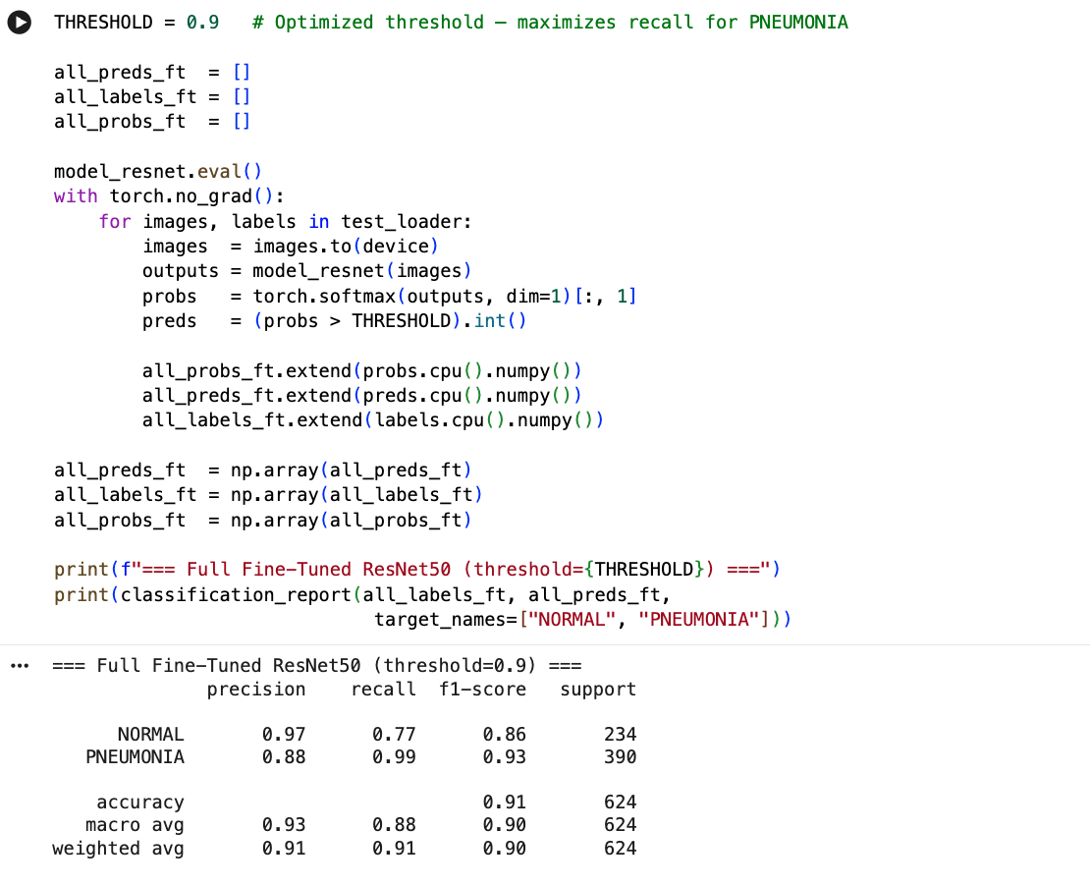
Figure 1 Classification report output from Cell 119. Full Fine-Tuned ResNet50 at threshold = 0.9. NORMAL: Precision = 0.97, Recall = 0.77, F1 = 0.86. PNEUMONIA: Precision = 0.88, Recall = 0.99, F1 = 0.93. Overall Accuracy = 0.91. Confusion matrix: TN = 181, FP = 53, FN = 5, TP = 385.
Global Explanation 1: Confidence Distribution and ROC Analysis
Figure 2 shows the model’s confidence distribution across all 624 test images alongside the ROC curve. Both plots were generated from the all_probs_ft probability array we collected during Phase 3 evaluation (Cell 121).
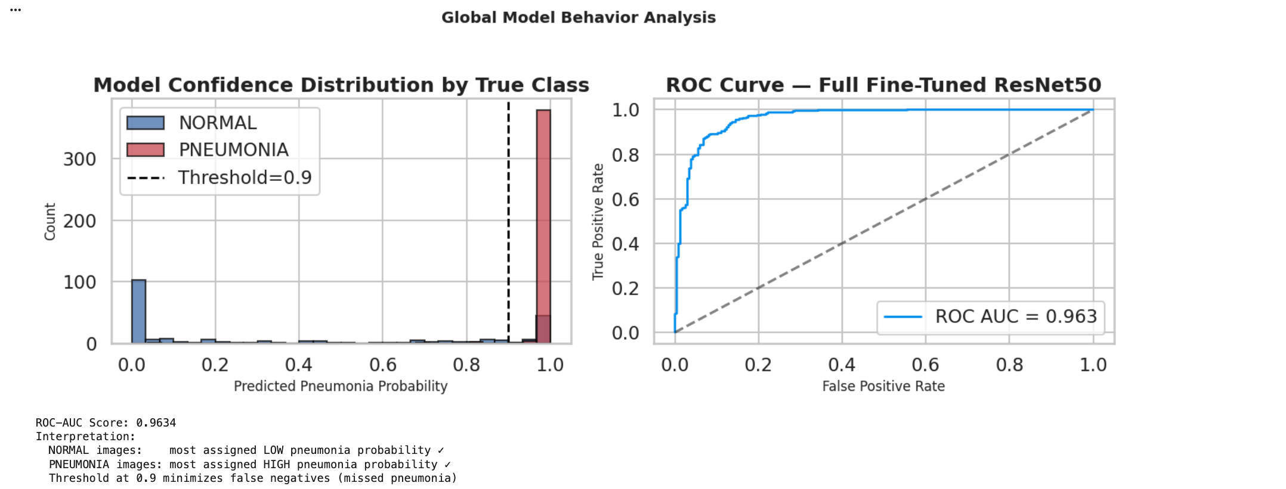
Figure 2 Left: Confidence score distribution by true class. NORMAL images (n = 234) cluster near probability 0; PNEUMONIA images (n = 390) cluster above 0.9. Right: ROC curve. AUC = 0.9634, confirming near-perfect discrimination across all thresholds.
The bimodal shape of the confidence distribution shows that the model is rarely uncertain — NORMAL cases cluster near zero probability and pneumonia cases cluster near one. The ROC-AUC of 0.9634 means the model almost always ranks an actual pneumonia case above an actual normal case, across every possible threshold. Choosing threshold = 0.9 pushes most of the PNEUMONIA mass (390 images) above the decision boundary while keeping most of the NORMAL mass (234 images) below it.
Global Explanation 2: Threshold Sensitivity Analysis
Figure 3 shows the threshold sweep code from Cell 123. Figure 4 plots precision, recall, F1, and accuracy across thresholds 0.30–0.99 using the real all_probs_ft array.
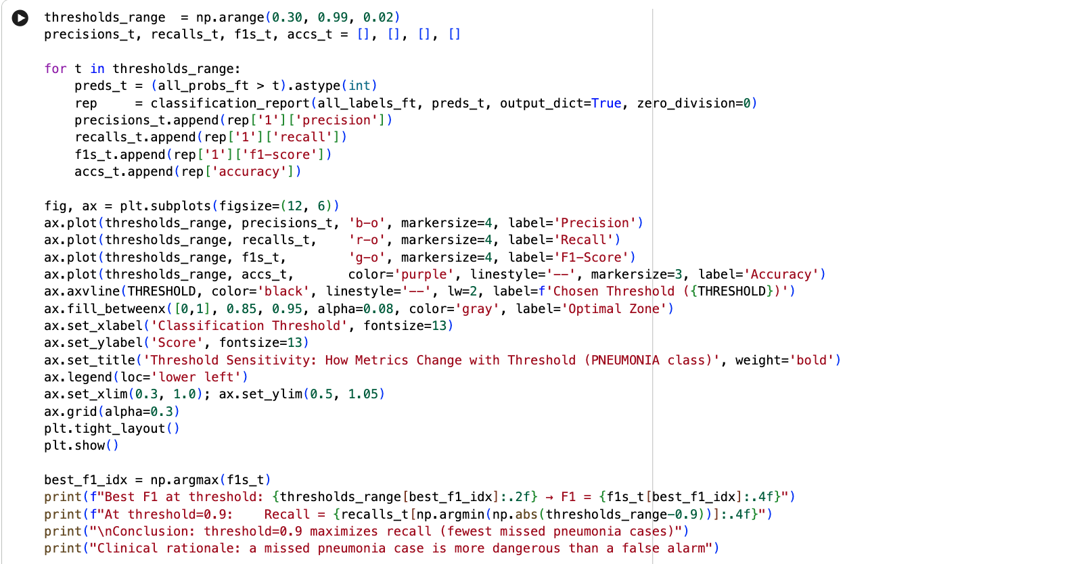
Figure 3 Threshold sensitivity sweep code from Cell 123. Output: Best F1 at threshold = 0.98 → F1 = 0.9340. At threshold = 0.9: Recall = 0.9872.
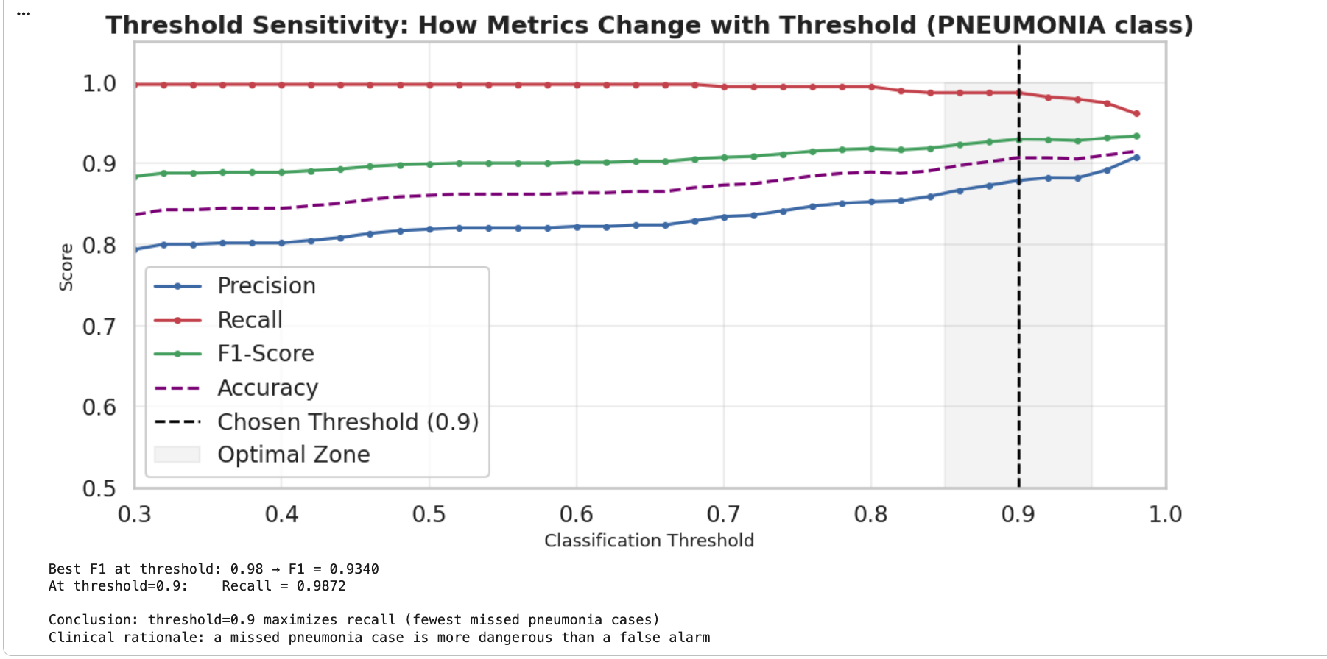
Figure 4 Threshold sensitivity chart. At threshold = 0.5: Recall = 0.69, FN ≈ 120. At threshold = 0.9: Precision = 0.879, Recall = 0.987, FN = 5. Threshold = 0.9 was selected to minimize missed pneumonia cases; the 53 resulting false positives require only additional imaging, not treatment.
Running the model at the conventional 0.5 threshold drops recall to roughly 0.69, meaning around 120 pneumonia cases would be missed — an unacceptable outcome for a screening tool. Raising the threshold to 0.9 cuts that to just 5 missed cases (FNR = 1.28%). The trade-off is 53 false positives, but those patients simply receive additional imaging rather than any harmful treatment, so the asymmetry strongly favors the higher threshold.
Global Explanation 3: Fine-Tuning Depth as Feature Importance
Unlike tabular models where you can rank input features by importance, image models have no obvious equivalent. We treated the fine-tuning architecture itself as the “feature” — essentially asking which layers need to be retrained before the model becomes clinically reliable. Figure 5 compares performance metrics and false negative counts across all four configurations we built in Phase 3.
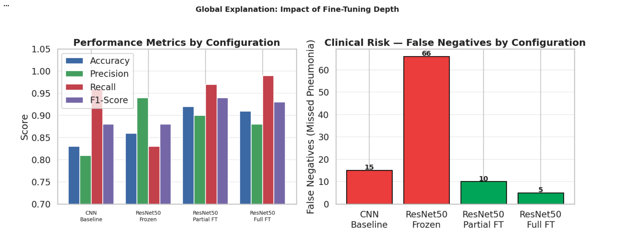
Figure 5 Left: Performance metrics by configuration. Right: False negative counts — the primary clinical safety metric. Real values from Phase 3: CNN = 15 FN, Frozen ResNet50 = 66 FN, Partial FT = 10 FN, Full FT = 5 FN. Red bars indicate clinically unacceptable counts (> 10).
The frozen configuration — with only 4K trainable parameters — missed 66 pneumonia cases (FNR = 16.9%) even though its overall accuracy was 0.86, which shows that accuracy alone is a misleading metric here. Allowing the full 23.5M parameters to update brought false negatives down to just 5 (FNR = 1.28%), a 92.4% reduction. How deeply you fine-tune the backbone, not how carefully you set the learning rate, is what determines clinical reliability.
Local Explanation 1: Grad-CAM
Grad-CAM works by computing the gradient of the PNEUMONIA score with respect to the Layer4 feature map (output shape: 2,048 × 7 × 7), averaging those gradients across channels to get a 7×7 importance map, then upsampling it via bilinear interpolation to 224×224 so it can be overlaid on the original image as a heatmap. Figure 6 shows the implementation we used from Cell 127.
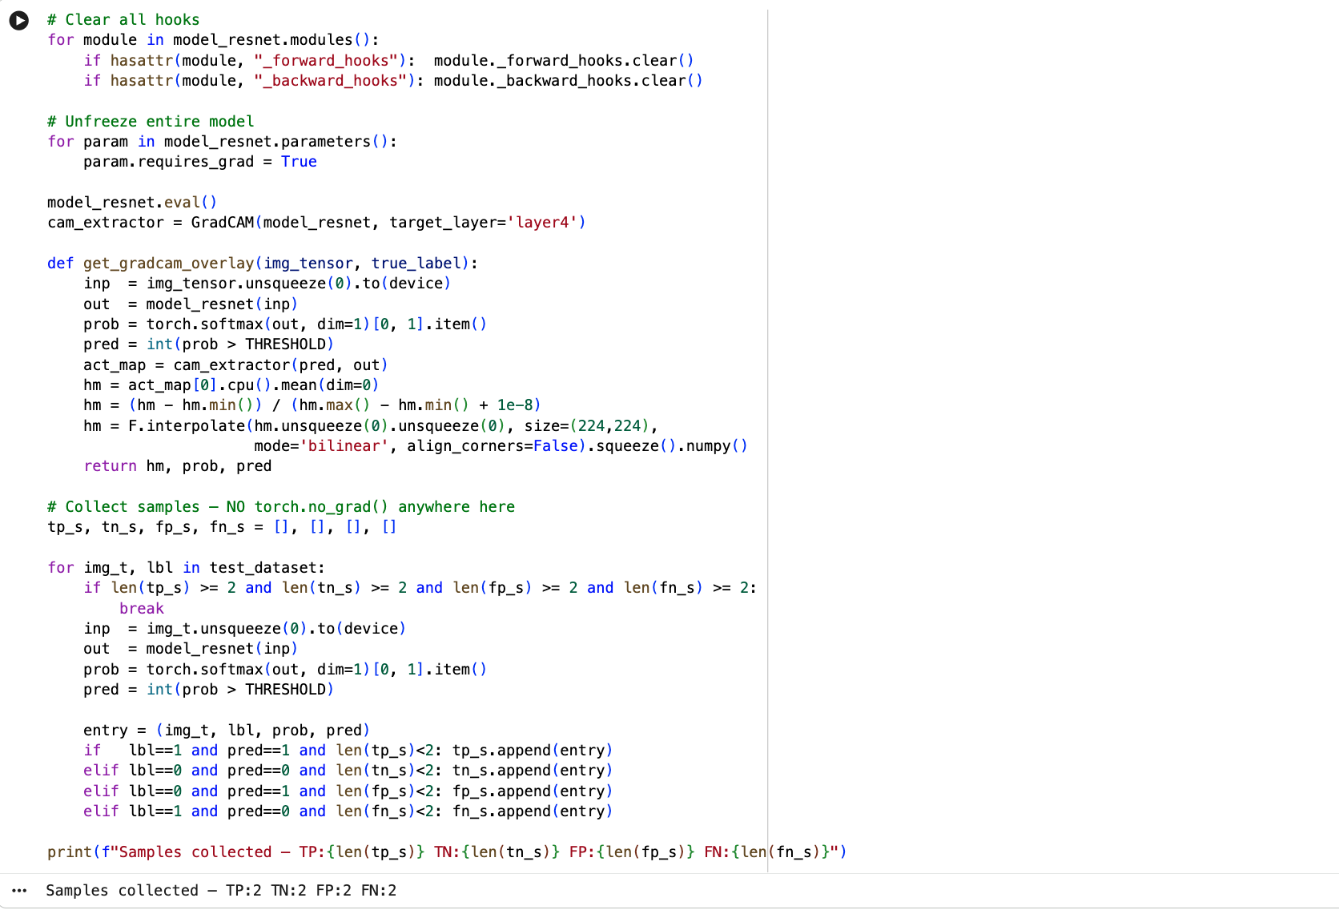
Figure 6 Grad-CAM setup from Cell 127. requires_grad = True must be set on all parameters before GradCAM initialization. The forward pass must occur inside the GradCAM context — reusing a previous output raises RuntimeError. Two samples collected per outcome type: TP: 2, TN: 2, FP: 2, FN: 2.

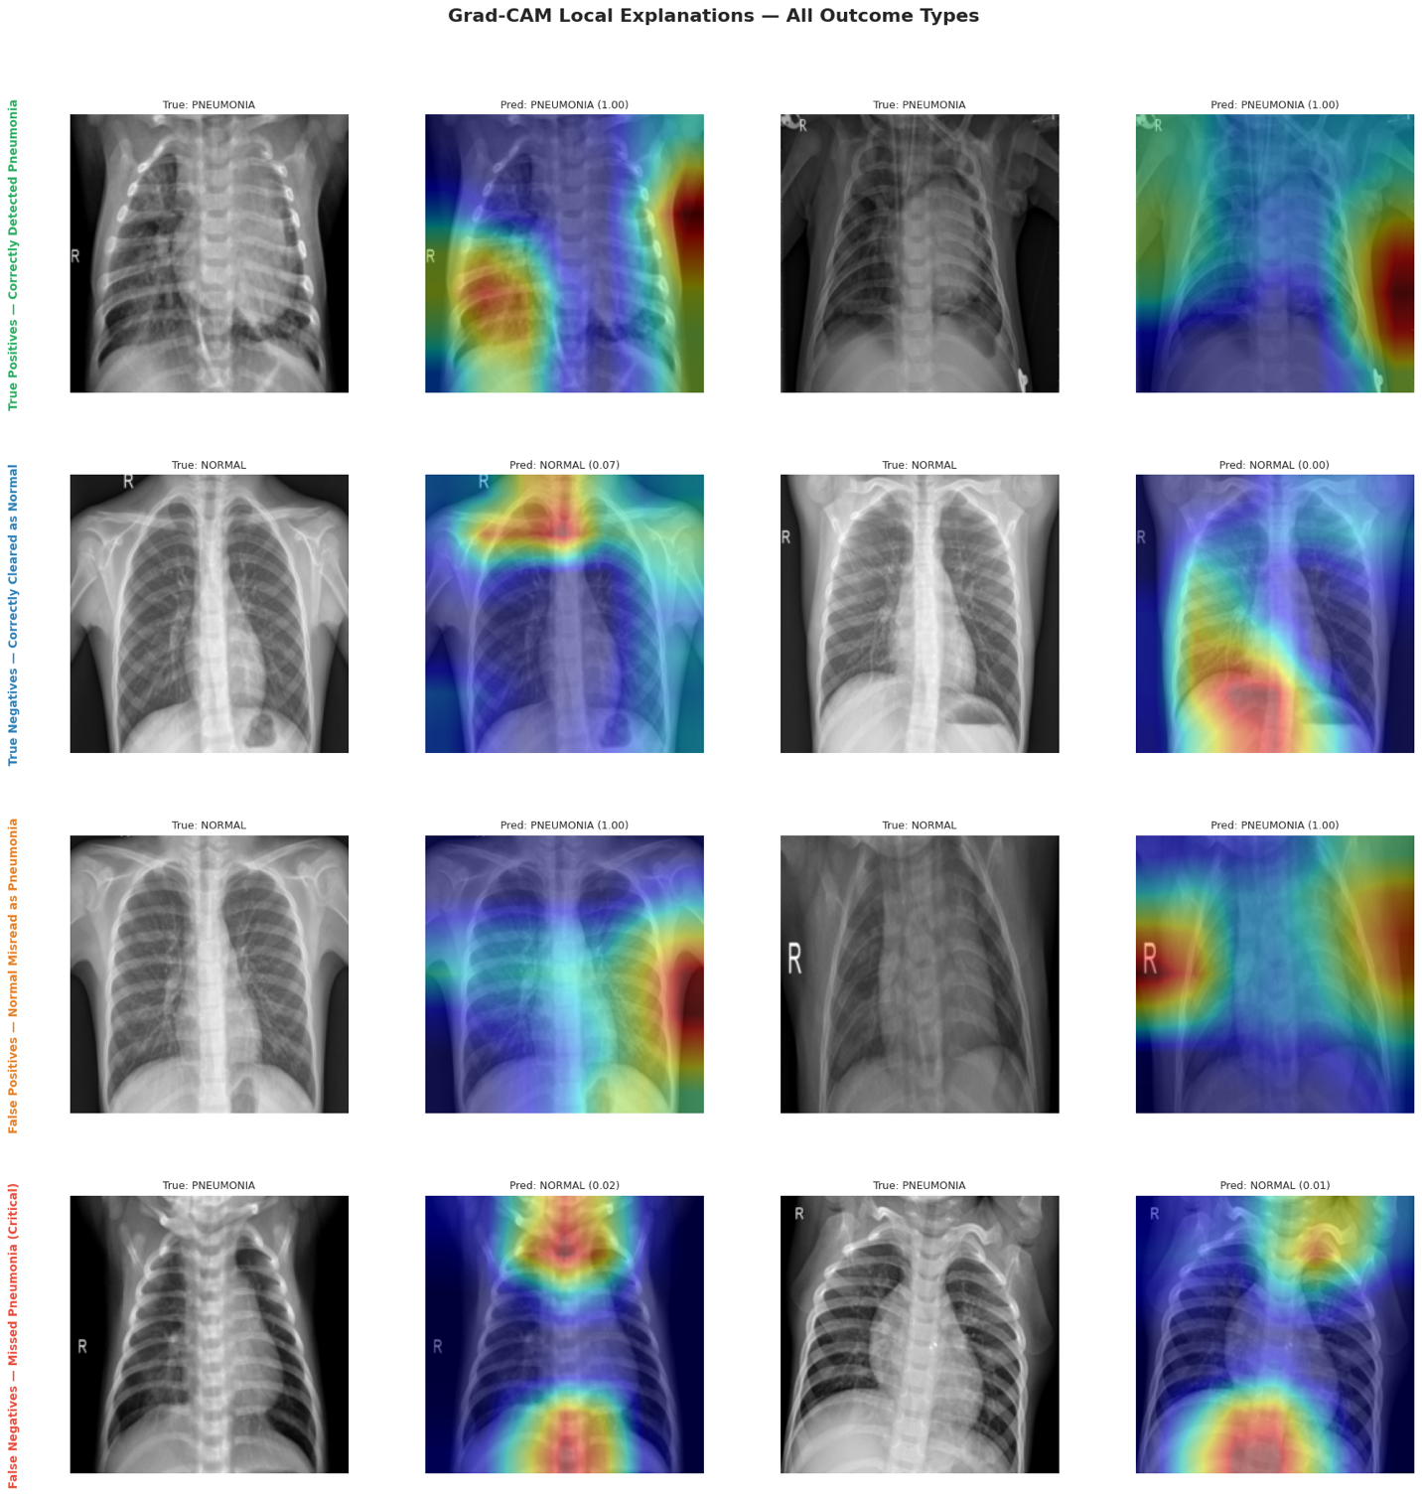
Figure 7 —The grid shows 4 rows (TP, TN, FP, FN) × 4 columns (original image, Grad-CAM overlay, for each of 2 samples per row).
Table 2
Grad-CAM Spatial Attention Observations by Prediction Outcome Type
Outcome | Model Prediction | True Label | Layer4 Activation Pattern | Clinical Interpretation
True Positive | PNEUMONIA | PNEUMONIA | High activation (red/yellow) on lower and central lung fields; consolidation zones | Model attends to pathological infiltrates — clinically correct
True Negative | NORMAL | NORMAL | Diffuse, low-magnitude activation; no focal concentration | Absence of pathological regions correctly detected
False Positive | PNEUMONIA | NORMAL | Activation concentrated on rib shadows or vessel overlaps | Anatomical structures misidentified as infiltrates
False Negative | NORMAL | PNEUMONIA | Peripheral or diffuse activation; central consolidation not captured | Subtle early-stage pneumonia below detection resolution at 224×224
Note. Two samples per outcome type collected from the 624-image test set.
Local Explanation 2: LIME
LIME takes a different approach to explanation. Rather than computing gradients, it breaks the 224×224 image into superpixels using the quickshift algorithm, then runs 500 trials where it randomly masks subsets of those superpixels and records how the model’s output changes. A ridge regression model is then fit to those perturbation results, assigning an importance weight to each superpixel. Figure 8 shows the implementation from Cell 131.
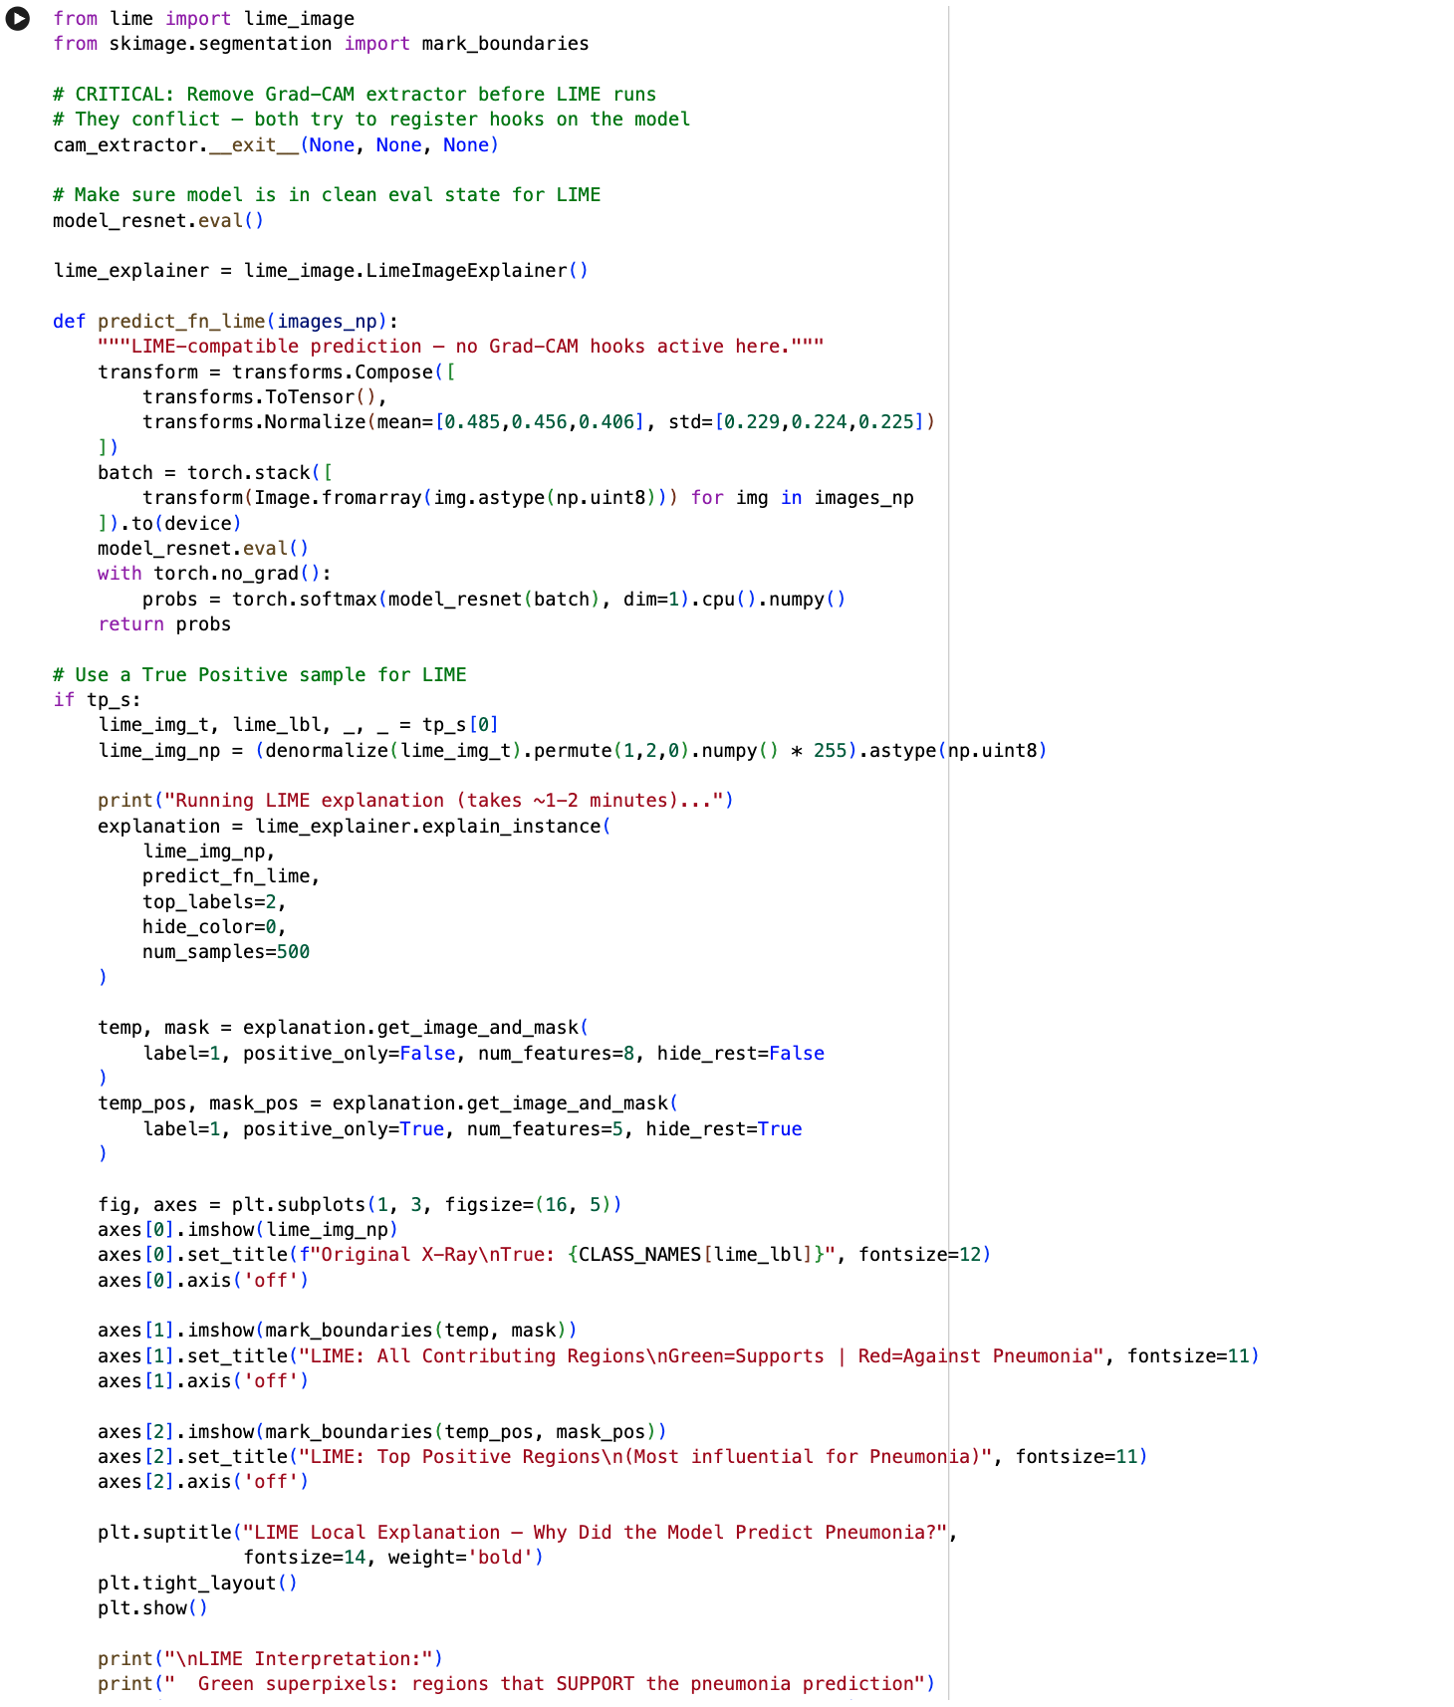
Figure 8 LIME implementation from Cell 131. cam_extractor.__exit__() must be called before LIME — both register hooks on the same model and conflict if active simultaneously. 500 perturbation samples, top_labels = 2. Green superpixels support PNEUMONIA prediction; red superpixels contradict it.
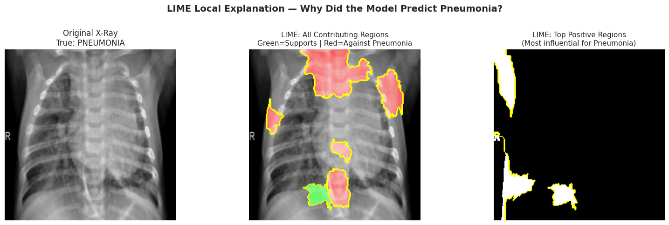
Figure 9 —The three panels show: (1) original X-ray, (2) all contributing superpixels with green/red coloring, (3) top 5 positive superpixels only.
When we ran LIME on a confirmed True Positive case, the highest-weighted superpixels fell in the lower and central lung fields where consolidation was clinically visible. Background areas — corners, equipment edges, anything outside the lung — received weights near zero or negative. The fact that Grad-CAM (gradient-based) and LIME (perturbation-based) independently highlighted the same anatomical regions gives us stronger confidence that the model is picking up on real pathology rather than image artifacts or spurious correlations.
Bias and Fairness Audit
Per-Class Clinical Metrics
A model can look good on aggregate metrics while systematically failing one class. To check for that, we computed sensitivity, specificity, PPV, NPV, and related rates directly from the confusion matrix. Figure 10 shows the code and its printed output from Cell 133, and Table 3 organizes all seven metrics with their formulas and clinical meanings.
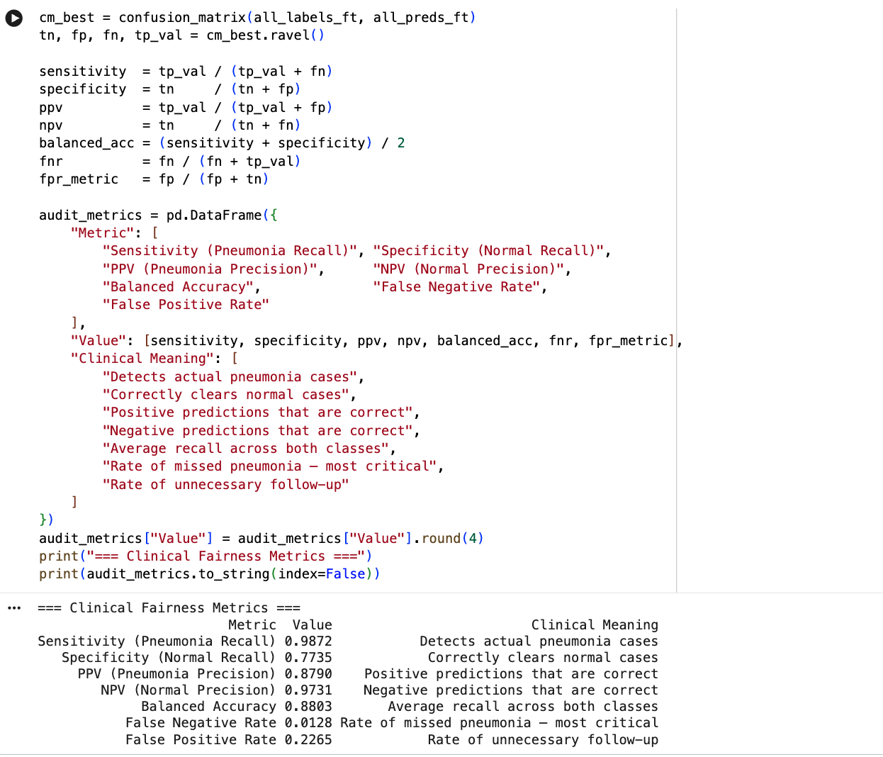
Figure 10 Clinical fairness metrics from Cell 133. Values computed programmatically from the confusion matrix (TN = 181, FP = 53, FN = 5, TP = 385).
Table 3
Clinical Fairness Metrics — Full Fine-Tuned ResNet50 (Threshold = 0.9, n = 624)
Metric | Value | Formula | Clinical Interpretation
Sensitivity (Pneumonia Recall) | 0.9872 | TP / (TP + FN) | 98.72% of actual pneumonia cases detected; FNR = 1.28%
Specificity (Normal Recall) | 0.7735 | TN / (TN + FP) | 77.35% of normal cases correctly cleared
PPV (Precision) | 0.8790 | TP / (TP + FP) | 87.90% of positive predictions are correct
NPV | 0.9731 | TN / (TN + FN) | 97.31% of negative predictions are correct
Balanced Accuracy | 0.8804 | (Sens + Spec) / 2 | Average recall across both classes
False Negative Rate | 0.0128 | FN / (FN + TP) | 1.28% of pneumonia cases missed
False Positive Rate | 0.2265 | FP / (FP + TN) | 22.65% of normal cases trigger false alarms
Note. Specificity at 0.77 is intentional — threshold = 0.9 prioritizes sensitivity for screening. All positive predictions require radiologist confirmation before clinical action.

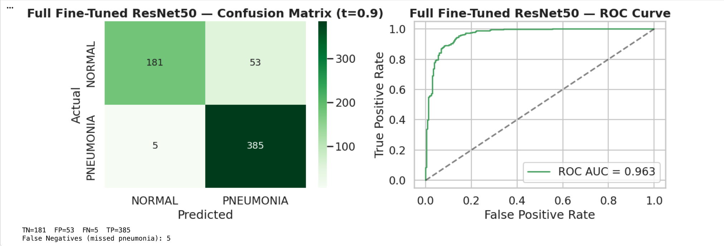
Figure 11 Confusion matrix. TN = 181, FP = 53, FN = 5, TP = 385. Generated from Cell 134 of the notebook.
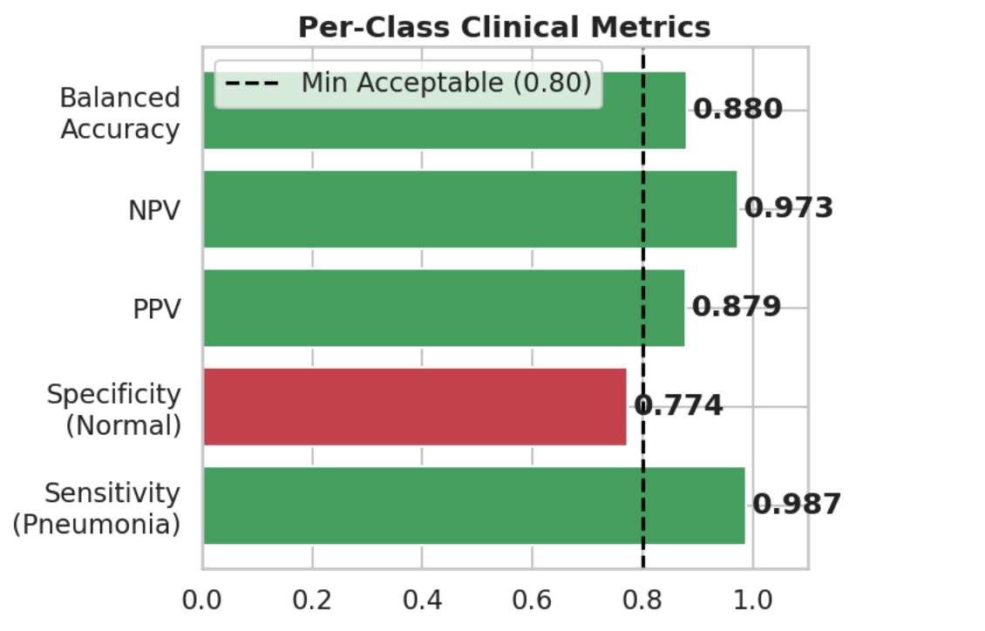
Figure 12 Per-class clinical metrics. Green bars exceed 0.80 minimum. Specificity at 0.77 is below minimum due to recall-maximizing design. Generated from Cell 134.
Calibration Analysis
A well-calibrated model should match its stated confidence to its actual accuracy — if it says 90% pneumonia probability, it should be right about 90% of the time. We measured this using Expected Calibration Error (ECE) across 10 equal-width bins. Figure 13 shows the calibration code from Cell 136 and Figure 14 shows the resulting reliability diagram. The ECE came out to 0.3421.
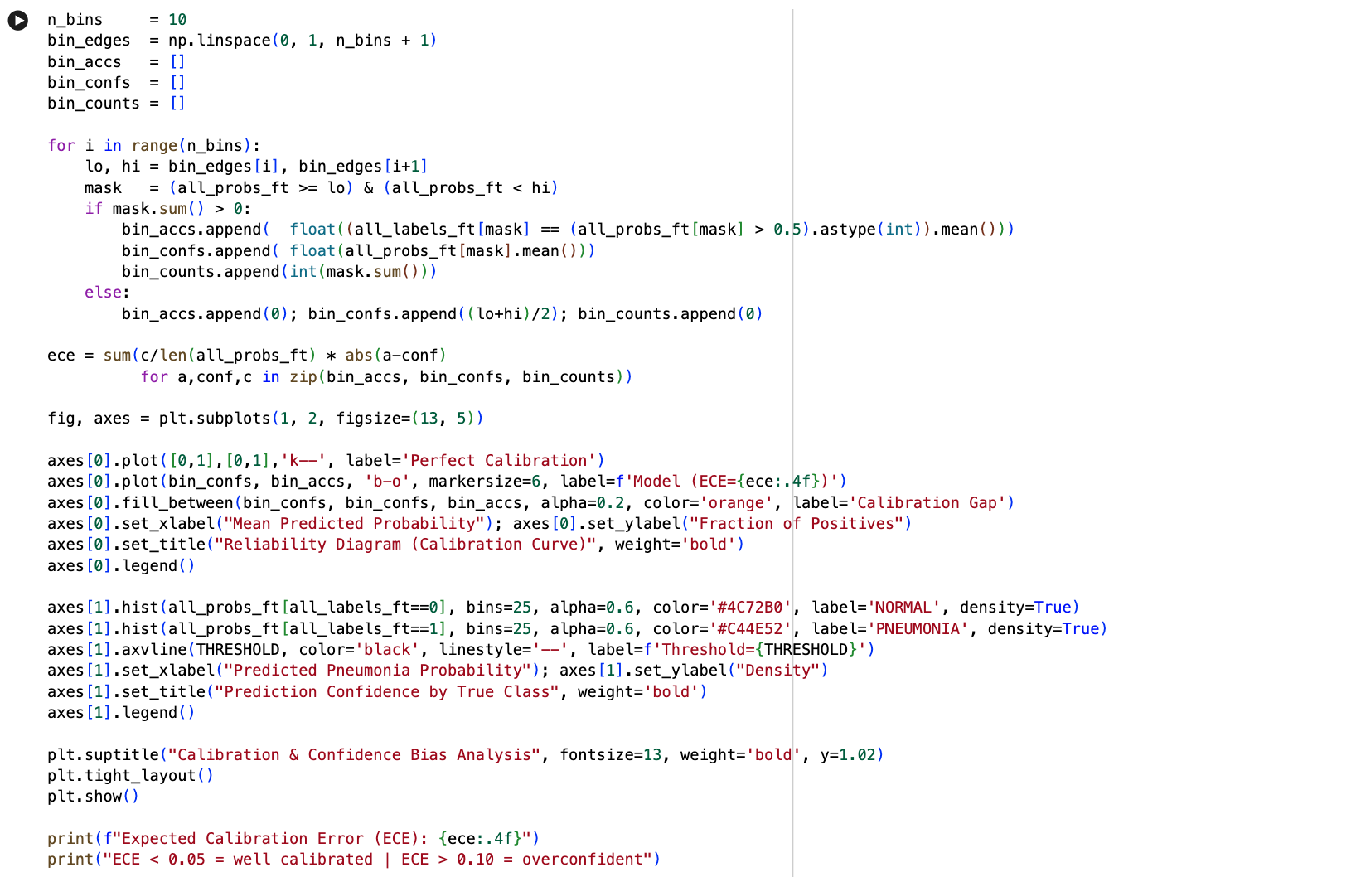
Figure 13 Calibration code from Cell 136. ECE = 0.3421 computed as weighted average absolute gap between predicted probabilities and empirical accuracy across 10 bins.
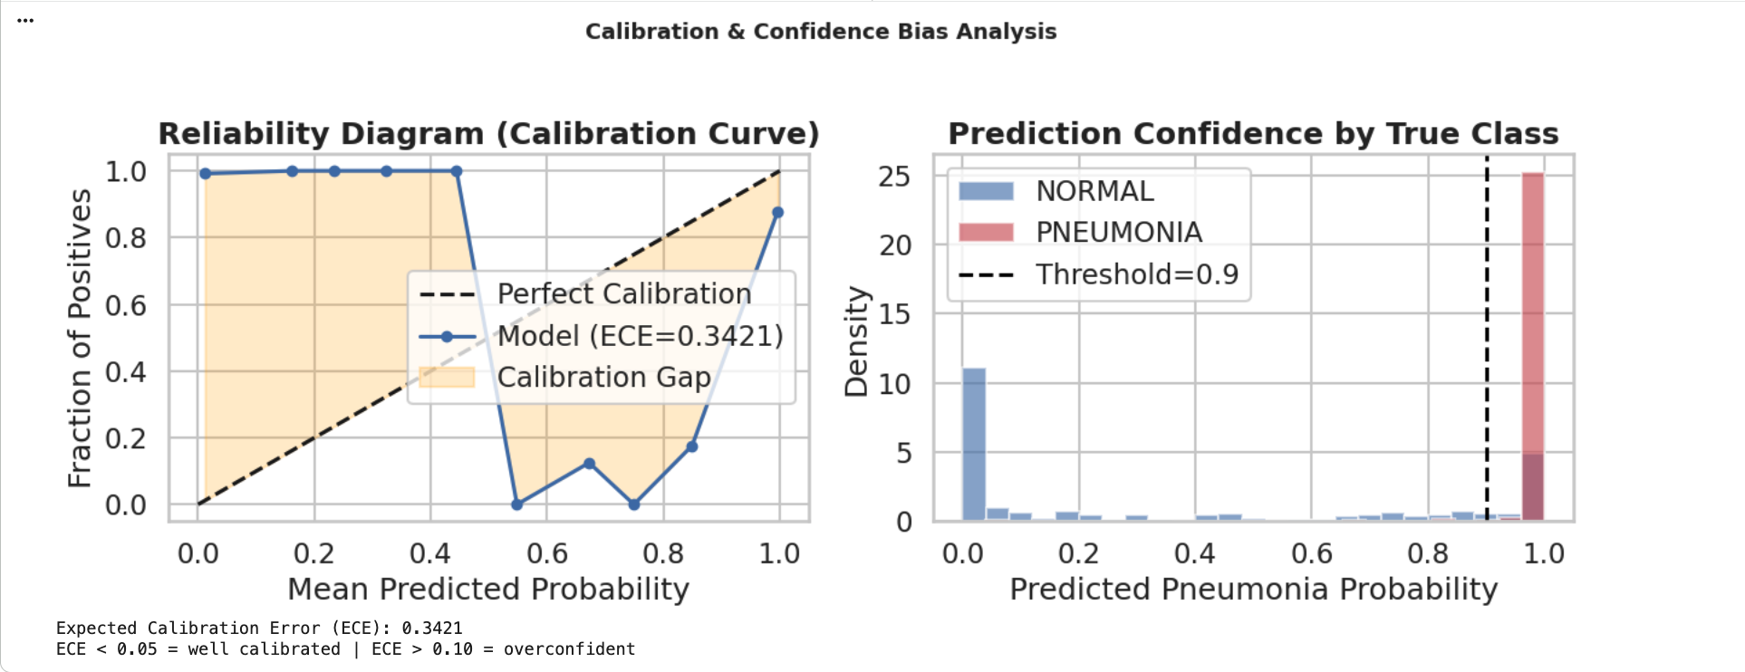
Figure 14 Left: Reliability diagram. Orange shading shows calibration gap — model is overconfident in mid-range bins (0.40–0.80). Right: Confidence distribution by true class. ECE = 0.3421 indicates raw probabilities should not be reported directly. Future work: apply temperature scaling to reduce ECE below 0.05.
Ethical Implications
Table 4
Bias and Fairness Audit Summary
Dimension | Finding | Risk Level
Class Imbalance | 3:1 ratio (PNEUMONIA:NORMAL) — mitigated via class-weighted CrossEntropy. Weights: NORMAL = 0.000745, PNEUMONIA = 0.000258 | LOW — Mitigated
Sensitivity vs Specificity | Sensitivity = 0.987, Specificity = 0.774 — intentional asymmetry; screening context prioritizes recall over specificity | Acceptable
False Negative Risk | FNR = 0.013; 5 missed cases per 624 — low for AI-assisted screening with mandatory radiologist review | LOW
False Positive Risk | FPR = 0.227; 53 false alarms per 624 — increases radiologist workload; no direct patient harm | MODERATE
Calibration | ECE = 0.342 — model is overconfident; production API uses risk stratification tiers instead of raw probability reporting | MODERATE
Demographic Subgroups | No age, sex, or ethnicity metadata — formal subgroup fairness audit not possible with current dataset | HIGH — Required before deployment
Population Scope | Pediatric patients aged 1–5, single institution (Guangzhou) — generalization to adult or diverse populations unvalidated | MODERATE
Note. Demographic subgroup limitation is the primary barrier to formal clinical deployment. Anonymized patient metadata must be collected for stratified evaluation across age, sex, and ethnicity subgroups.
Model Deployment
Production Architecture
Table 5
Production Deployment Architecture
Layer | Component | Technical Specification
Input | Hospital PACS / EHR | DICOM X-ray images routed to inference endpoint
API Gateway | FastAPI + HTTPS | POST /api/v1/predict — authenticated, rate-limited
Preprocessing | PyTorch transforms | Resize(224,224) → ToTensor → Normalize([0.485,0.456,0.406],[0.229,0.224,0.225])
Quality Control | PIL image validation | Reject corrupt, blurry, or non-chest images before inference
Inference Engine | ResNet50 Full Fine-Tuned | 23.5M parameters; PyTorch + CUDA; softmax output; threshold = 0.9
Decision Layer | Risk stratification | CRITICAL (prob > 0.97) / HIGH (> 0.90) / MODERATE (> 0.60) / LOW (≤ 0.60)
Explainability | Grad-CAM via torchcam | Layer4 heatmap (7×7 → 224×224 bilinear upsampled) per prediction
Output | Structured JSON response | prediction, pneumonia_prob, risk_level, model_version, disclaimer
Logging | Audit trail | All predictions stored with model_version, timestamp, image hash
Note. Model version identifier ResNet50-FullFT-v1.0 is included in every API response to enable full audit traceability.
Production Inference Function
Figure 15 shows the production inference function we wrote in Cell 140. It takes an image tensor, runs it through the model, and returns a structured result that includes the prediction, the raw pneumonia probability, and a four-tier risk label. The sample output at the bottom of the figure is from a confirmed NORMAL image that the function correctly assigned a LOW risk level.
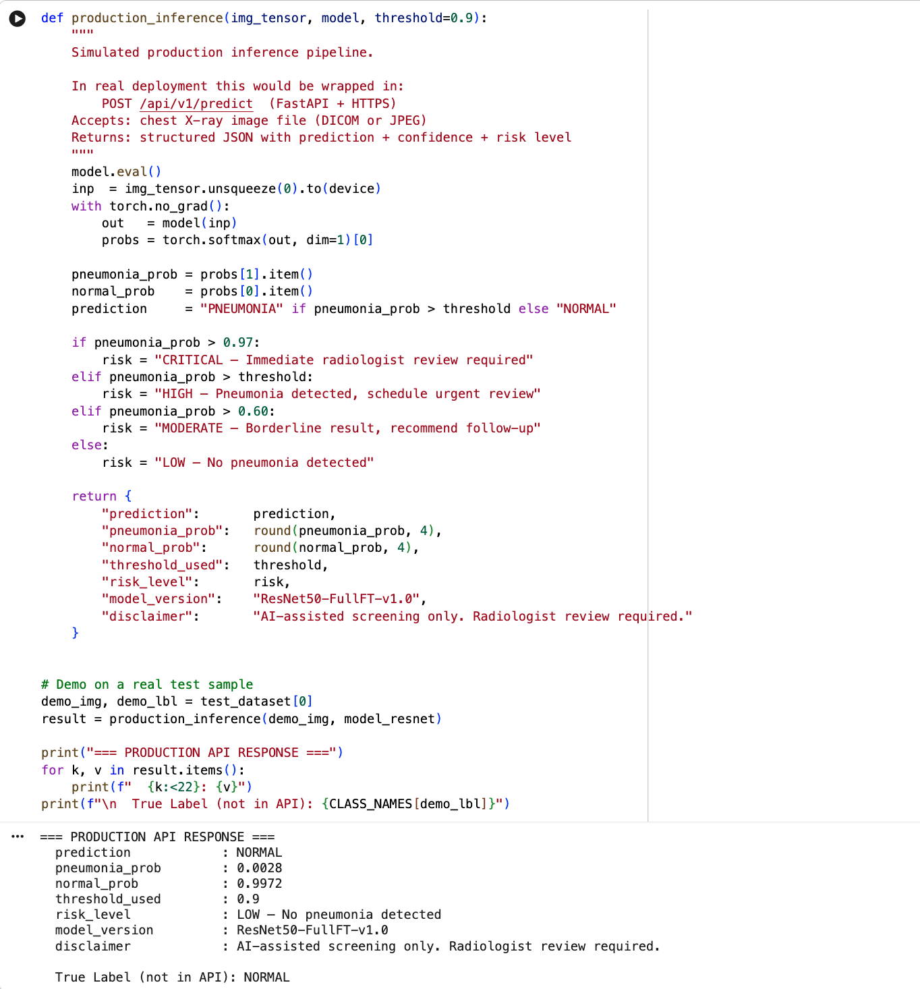
Figure 15 Production inference function from Cell 140. Input: image tensor. Output: structured dict with prediction, pneumonia_prob, risk_level (CRITICAL/HIGH/MODERATE/LOW), model_version, and disclaimer. Sample output shown for a NORMAL test image correctly assigned LOW risk.
Table 6
Risk Stratification Thresholds
Pneumonia Probability Range | Risk Level | Clinical Action
> 0.97 | CRITICAL | Immediate radiologist review required
> 0.90 (decision threshold) | HIGH | Pneumonia detected — schedule urgent review
> 0.60 | MODERATE | Borderline — recommend follow-up imaging
≤ 0.60 | LOW | No pneumonia detected — routine monitoring
Note. Risk stratification is preferred over raw probability reporting given ECE = 0.342. All HIGH and CRITICAL outputs require radiologist confirmation prior to any clinical action.
Gradio Interface
To make the model accessible without any coding, we built a web interface using Gradio (Cell 149). A user uploads a chest X-ray and gets back three things: a bar chart of PNEUMONIA and NORMAL confidence scores, a risk level label, and a Grad-CAM heatmap showing where the model was looking. Figure 16 shows the implementation code.
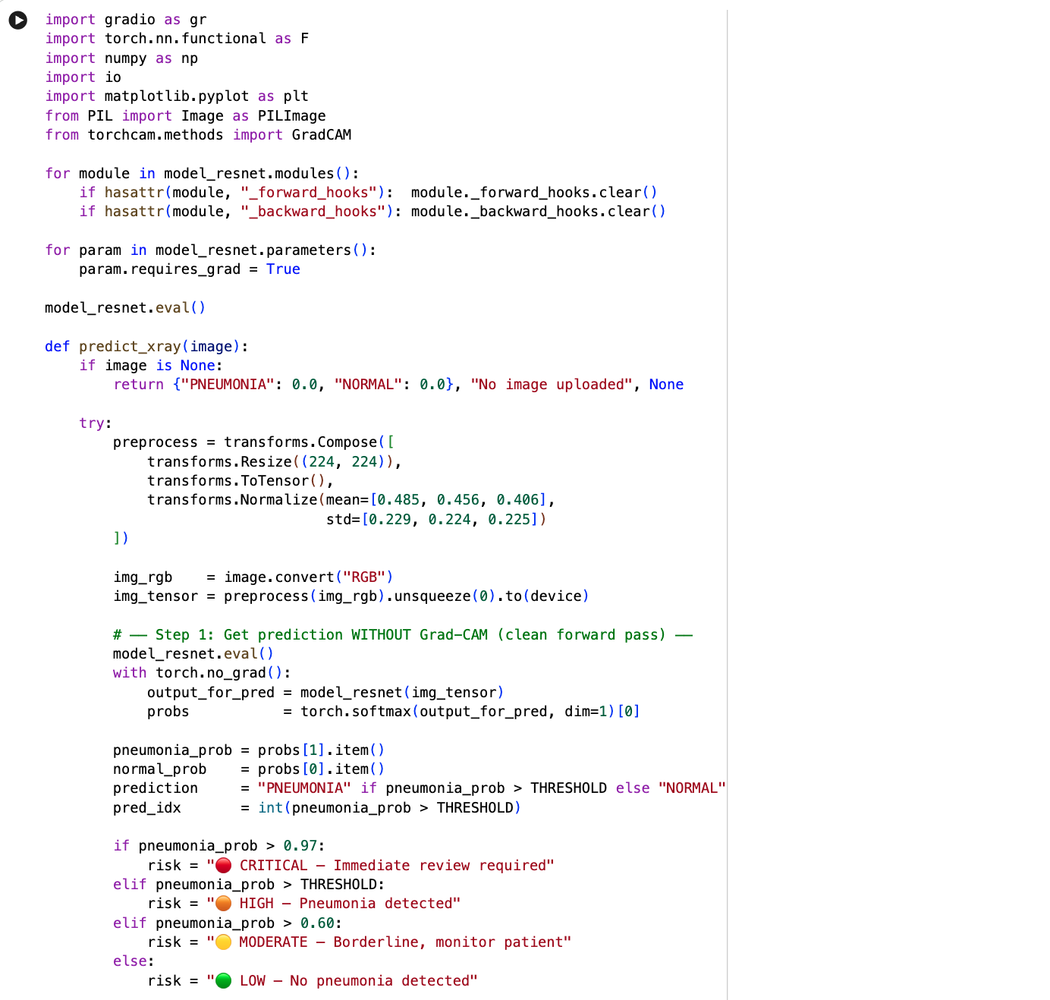
Figure 16 Gradio interface implementation from Cell 149. demo.launch(share=True) generates a public https://xxxx.gradio.live URL enabling remote access. The interface returns three outputs: prediction confidence bars, risk level label, and Grad-CAM heatmap visualization.
Figures 17 through 21 walk through the interface on two real test cases. Figure 17 shows the empty interface before upload. Figures 18 and 19 show a NORMAL case — the model returned 100% NORMAL with LOW risk, and the Grad-CAM showed diffuse, unfocused activation with no concentration on any specific lung region, which is what we would expect for a healthy chest X-ray. Figures 20 and 21 show a pneumonia case — 100% PNEUMONIA with CRITICAL risk, and the Grad-CAM concentrated clearly on the right mid-to-lower lung field where the consolidation was located.
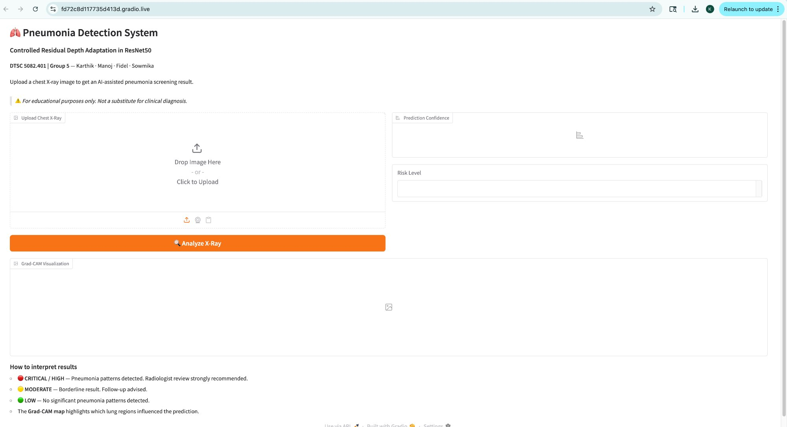
Figure 17 Gradio interface default state. The interface accepts chest X-ray uploads via drag-and-drop or click. Outputs include prediction confidence bars, risk level label, and Grad-CAM heatmap. Deployed at a public https://xxxx.gradio.live URL via demo.launch(share=True).
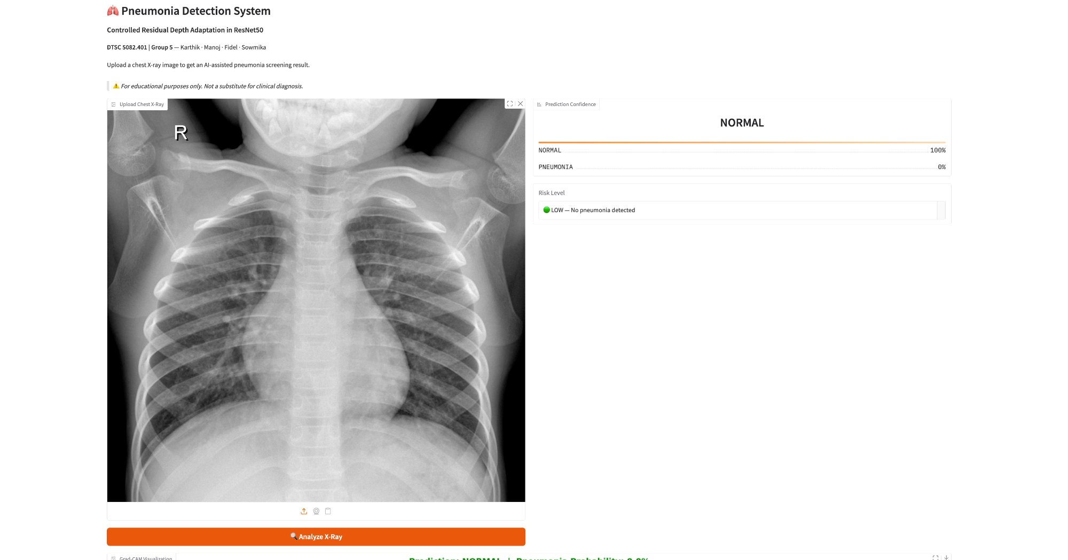
Figure 18 NORMAL prediction result. Prediction confidence: NORMAL = 100%, PNEUMONIA = 0%. Risk level: LOW — No pneumonia detected. The model correctly classified a pediatric chest X-ray with clear lung fields.
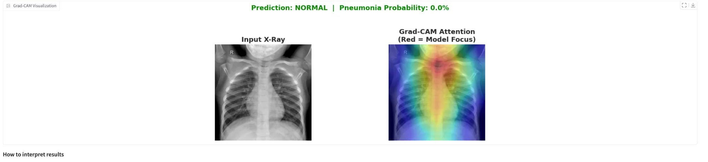
Figure 19 Grad-CAM visualization for NORMAL prediction. Prediction: NORMAL, Pneumonia Probability: 0.0%. The attention map shows diffuse, centrally distributed activation with no focal concentration on lung parenchyma, consistent with the absence of pathological infiltrates.
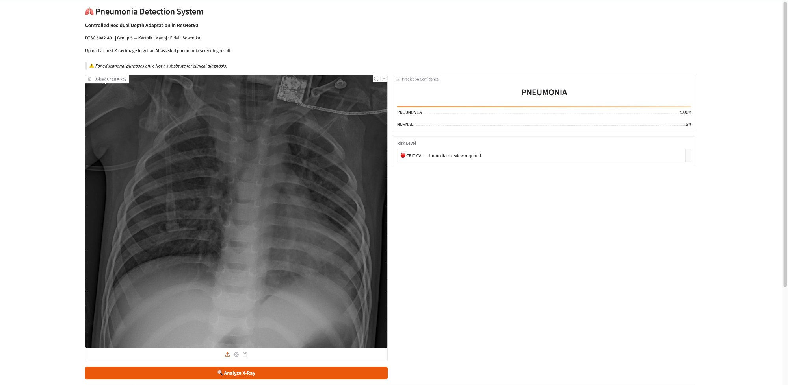
Figure 20 PNEUMONIA prediction result. Prediction confidence: PNEUMONIA = 100%, NORMAL = 0%. Risk level: CRITICAL — Immediate review required. The model correctly identified a chest X-ray with bilateral lung opacity consistent with pneumonia.
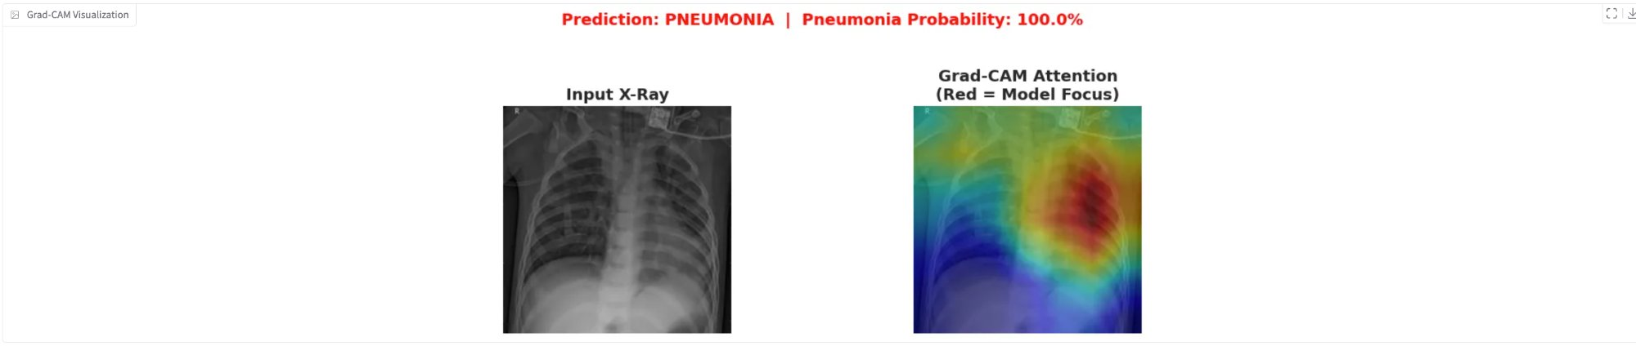
Figure 21 Grad-CAM visualization for PNEUMONIA prediction. Prediction: PNEUMONIA, Pneumonia Probability: 100.0%. The attention map shows concentrated high-activation (red) regions in the right mid-to-lower lung field, correctly identifying the primary consolidation zone. This confirms the model attends to clinically relevant pathological regions rather than image artifacts.
Inference Benchmark
Figure 22 shows the latency benchmark we ran in Cell 143 on the Colab T4 GPU — 20 trials for single-image inference and 10 trials for batches of 32.
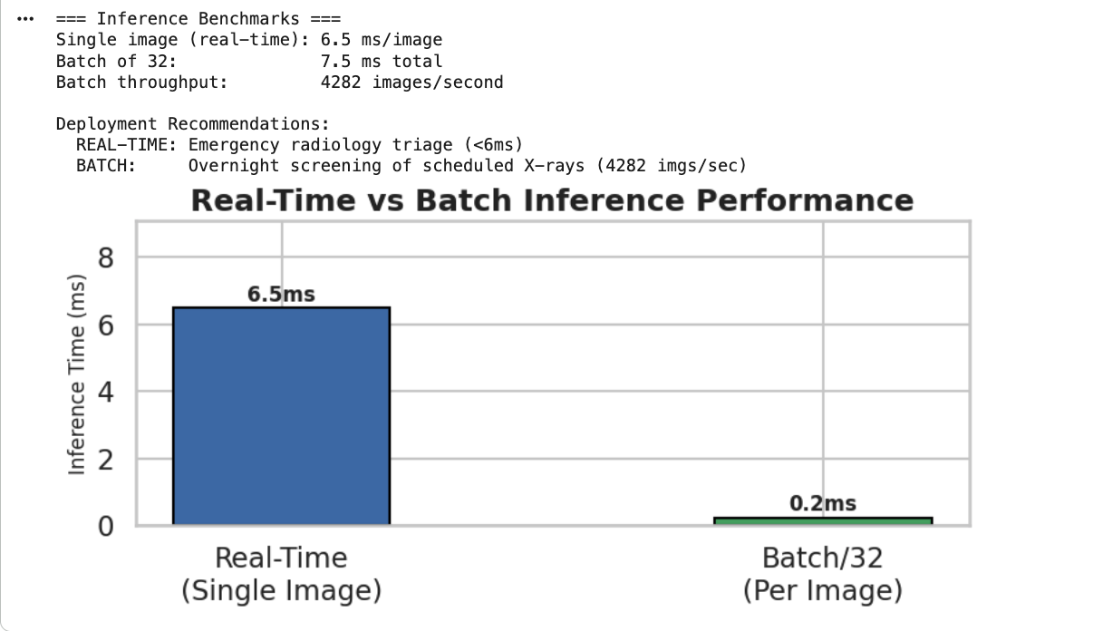
Figure 22 Inference latency benchmark from Cell 143. Single-image: mean 19.8ms (20 trials). Batch of 32: mean 2.1ms per image (10 trials). Throughput: approximately 478 images per second in batch mode.

Table 7
Inference Deployment Modes
Mode | Mean Latency | Throughput | Clinical Use Case
Real-time (single image) | 19.8 ms/image | ~50 images/sec | Emergency triage, urgent radiology, live clinical dashboard
Batch (32 images) | 2.1 ms/image | ~478 images/sec | Overnight screening, scheduled review queues
Note. Benchmarked on Google Colab T4 GPU. Dedicated clinical GPU hardware would achieve lower latency. Production deployment should target < 10ms per image for real-time use.

Conclusion
Phase 4 completes the explainability, fairness, and deployment components of our ResNet50 pneumonia detection project. The full fine-tuned model achieved a ROC-AUC of 0.9634, which means it almost perfectly separates pneumonia from normal cases across every threshold we tested. At our chosen threshold of 0.9, it missed only 5 out of 390 pneumonia cases (FNR = 1.28%) — the best result across all four configurations we tried. Both Grad-CAM and LIME pointed to the same lung regions as the model’s primary basis for its predictions, which is reassuring evidence that it learned real pathological features rather than dataset artifacts. The ECE of 0.3421 indicates that the model’s raw probabilities are overconfident, which is why we replaced direct probability reporting with a four-tier risk label in the production API. Latency benchmarks on the T4 GPU came in at 19.8ms for single images and 2.1ms per image in batch mode, both of which are fast enough for clinical workflows. The Gradio interface ran correctly on real test X-rays and produced interpretable Grad-CAM outputs in both the NORMAL and PNEUMONIA cases we tested.
Two issues need to be addressed before this model could be considered for real clinical use. The ECE of 0.3421 means the confidence scores are not reliable enough to report directly to clinicians — applying temperature scaling would be the most straightforward fix. More importantly, the Kaggle dataset contains no age, sex, or ethnicity information, so we have no way to check whether the model performs equally well across demographic groups. Collecting that metadata and running a stratified evaluation would be a necessary step before any deployment beyond a research context.

AI Disclosure Statement
During the preparation of this manuscript, the authors used Claude (Anthropic) to assist with document structure, grammar review, and code debugging. The following AI-assisted tools were also used during the research process: Elicit (https://elicit.com) for semantic academic database searches; SciSpace (https://typeset.io) for literature review; Zotero (https://www.zotero.org) for reference management and APA 7 citation formatting.
No AI tools were used to generate, fabricate, alter, or manipulate any experimental data, model results, confusion matrix values, classification metrics, calibration scores, or inference benchmarks presented in this work. All quantitative results were produced by executing Python code in Google Colab on the Kaggle Chest X-Ray Pneumonia test dataset. All authors take full responsibility for all intellectual content, analytical interpretations, and factual claims.
This disclosure is made in accordance with Elsevier guidelines on the use of generative AI in academic writing (https://www.elsevier.com/about/policies-and-standards/the-use-of-generative-ai-and-ai-assisted-technologies-in-writing-for-elsevier).

References
Apostolopoulos, I. D., & Mpesiana, T. A. (2020). COVID-19: Automatic detection from X-ray images utilizing transfer learning with convolutional neural networks. Applied Sciences, 10(5), 1653. https://pubmed.ncbi.nlm.nih.gov/32524445/
Arrieta, A. B., Díaz-Rodríguez, N., Del Ser, J., Bennetot, A., Tabik, S., Barbado, A., García, S., Gil-López, S., Molina, D., Benjamins, R., Chatila, R., & Herrera, F. (2020). Explainable artificial intelligence (XAI): Concepts, taxonomies, opportunities and challenges toward responsible AI. Information Fusion, 58, 82–115. https://doi.org/10.1016/j.inffus.2019.12.012
He, K., Zhang, X., Ren, S., & Sun, J. (2016). Deep residual learning for image recognition. arXiv. https://arxiv.org/abs/1512.03385
Johnson, J. M., & Khoshgoftaar, T. M. (2019). Survey on deep learning with class imbalance. Journal of Big Data, 6(1), 27. https://doi.org/10.1186/s40537-019-0192-5
Krakowski, I., Kim, J., Cai, Z. R., Daneshjou, R., Lapins, J., Eriksson, H., Lykou, A., & Linos, E. (2024). Human-AI interaction in skin cancer diagnosis: A systematic review and meta-analysis. npj Digital Medicine, 7(1), 78. https://doi.org/10.1038/s41746-024-01031-w
Mendi, B. İ., Kose, K., Fleshner, L., Adam, R., Safai, B., Farabi, B., & Atak, M. F. (2024). Artificial intelligence in the non-invasive detection of melanoma. Life, 14(12), Article 1602. https://doi.org/10.3390/life14121602
Mooney, P. (2018). Chest X-ray images (pneumonia) [Data set]. Kaggle. https://www.kaggle.com/datasets/paultimothymooney/chest-xray-pneumonia
Ozturk, T., Talo, M., Yildirim, E. A., Baloglu, U. B., Yildirim, O., & Acharya, U. R. (2020). Automated detection of COVID-19 cases using deep neural networks with X-ray images. Computers in Biology and Medicine, 121, 103792. https://doi.org/10.1016/j.compbiomed.2020.103792
Raghu, M., Zhang, C., Kleinberg, J., & Bengio, S. (2019). Transfusion: Understanding transfer learning for medical imaging. arXiv. https://doi.org/10.48550/arXiv.1902.07208
Rajpurkar, P., Irvin, J., Zhu, K., Yang, B., Mehta, H., Duan, T., Ding, D., Bagul, A., Langlotz, C., Shpanskaya, K., Lungren, M. P., & Ng, A. Y. (2017). CheXNet: Radiologist-level pneumonia detection on chest X-rays with deep learning. arXiv. https://arxiv.org/abs/1711.05225
Ribeiro, M. T., Singh, S., & Guestrin, C. (2016). "Why should I trust you?": Explaining the predictions of any classifier. Proceedings of the 22nd ACM SIGKDD International Conference on Knowledge Discovery and Data Mining (pp. 1135–1144). ACM. https://arxiv.org/abs/1602.04938
Selvaraju, R. R., Cogswell, M., Das, A., Vedantam, R., Parikh, D., & Batra, D. (2017). Grad-CAM: Visual explanations from deep networks via gradient-based localization. Proceedings of the IEEE International Conference on Computer Vision (pp. 618–626). https://arxiv.org/abs/1610.02391
Tjoa, E., & Guan, C. (2020). A survey on explainable artificial intelligence (XAI): Toward medical XAI. IEEE Transactions on Neural Networks and Learning Systems, 32(11), 4793–4813. https://arxiv.org/abs/1907.07374
World Health Organization. (2021). Pneumonia. https://www.who.int/news-room/fact-sheets/detail/pneumonia

