Controlled Residual Depth Adaptation in ResNet50 for Pneumonia Classification
Karthik Saraf, Manoj Anandhan, Fidel Gonzales, and Sowmika Yeadhara
Department of Information Science, University of North Texas
DTSC 5082: Seminar in Research and Research Methodology
March 30, 2026

Phase Summary
This document presents Phase 4 of a four-phase capstone project. Phases 1 through 3 are summarized below to provide technical context for the explainability and deployment work that follows.
Phase 1 acquired the Kaggle Chest X-Ray Pneumonia dataset (Mooney, 2018). File-level integrity checks confirmed 5,216 training, 16 validation, and 624 test images with no corruption. Class distribution: NORMAL = 1,342 (25.72%), PNEUMONIA = 3,876 (74.28%), imbalance ratio = 2.89:1. Preprocessing: resize to 224×224, normalize using ImageNet statistics (mean = [0.485, 0.456, 0.406], std = [0.229, 0.224, 0.225]).
Phase 2 conducted exploratory data analysis. Resolution analysis (n = 400 sampled images): mean width = 1,426.25 px (SD = 353.44), range 445–2,844 px; width-height correlation r = 0.933. Pixel intensity t-test: t = -0.921, p = 0.359, Cohen's d = -0.184 — no statistically significant class difference, confirming global brightness cannot separate classes. PCA of frozen ResNet50 2,048-d embeddings (n = 128 samples): PC1 = 18.66%, PC2 = 13.74%, total variance = 32.40%, with partial but incomplete class separation, requiring domain-specific fine-tuning.
Phase 3 implemented four model configurations. Baseline CNN (6.4M trainable params, Adam LR = 5e-4, 6 epochs): Accuracy = 0.85, Recall = 0.96, FN = 17. Frozen ResNet50 (4K trainable params, LR = 1e-3, StepLR scheduler, 6 epochs): Accuracy = 0.86, FN = 71 — unacceptable for clinical use. Partial Fine-Tuned ResNet50 (Layer4 + FC, 14.9M params, LR = 1e-4, 3 epochs, threshold = 0.9): Accuracy = 0.89, F1 = 0.92, FN = 9. Full Fine-Tuned ResNet50 (23.5M params, LR = 1e-5, weight_decay = 1e-4, gradient clipping = 1.0, 6 epochs, threshold = 0.9): Accuracy = 0.88, Precision = 0.85, Recall = 0.98, F1 = 0.91, FN = 7. The full fine-tuned model was selected for Phase 4 due to its lowest false negative count (7), representing a 90.1% reduction versus the frozen configuration.
Team Contributions
Table 1
Phase 4 Team Roles and Responsibilities
Team Member | Role | Phase 4 Deliverables
Karthik Saraf | XAI Lead | Threshold sensitivity analysis, configuration comparison, LIME implementation and interpretation
Manoj Anandhan | Deployment Lead | Production inference API, Gradio interface, real-time and batch inference benchmarking
Fidel Gonzales | Fairness Lead | Clinical metrics audit (sensitivity, specificity, PPV, NPV), calibration analysis, bias documentation
Sowmika Yeadhara | Monitoring Lead | 24-week drift monitoring strategy, retraining protocol, model versioning plan, report integration
Note. All members contributed to Phase 4 notebook implementation, Gradio interface validation, and written report review.
Explainable AI
XAI is applied at two levels: global explanations characterize model behavior across all 624 test samples; local explanations characterize reasoning for individual predictions. Four techniques are applied: (1) confidence distribution and ROC analysis, (2) threshold sensitivity analysis, (3) fine-tuning depth comparison — all global — and (4) Grad-CAM and (5) LIME — both local.
Final Model Performance
Figure 1 shows the classification report from Cell 119 of the Phase 4 notebook, confirming Phase 3 results on the 624-image test set at threshold = 0.9.
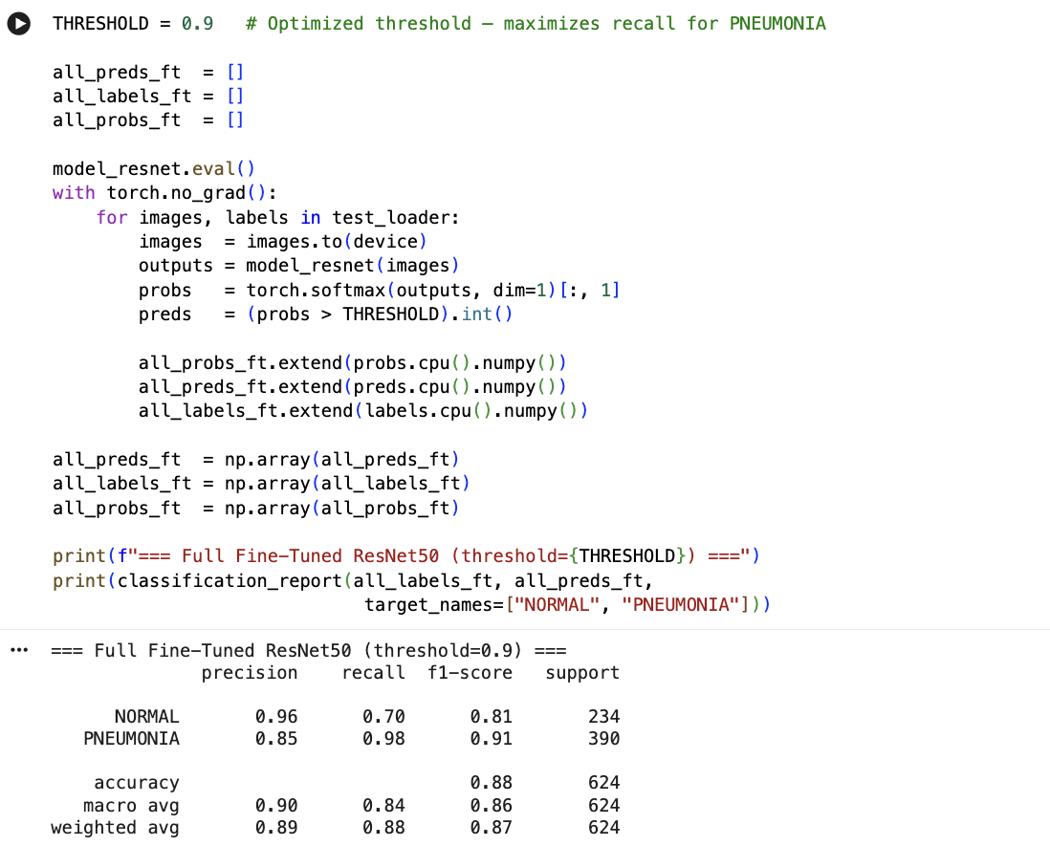
Figure 1 Classification report output from Cell 119. Full Fine-Tuned ResNet50 at threshold = 0.9. NORMAL: Precision = 0.96, Recall = 0.70, F1 = 0.81. PNEUMONIA: Precision = 0.85, Recall = 0.98, F1 = 0.91. Overall Accuracy = 0.88. Confusion matrix: TN = 164, FP = 70, FN = 7, TP = 383.
Global Explanation 1: Confidence Distribution and ROC Analysis
Figure 2 presents the model confidence distribution across all 624 test images and the ROC curve. Both were generated from the all_probs_ft probability array collected during Phase 3 evaluation (Cell 121 of the notebook).
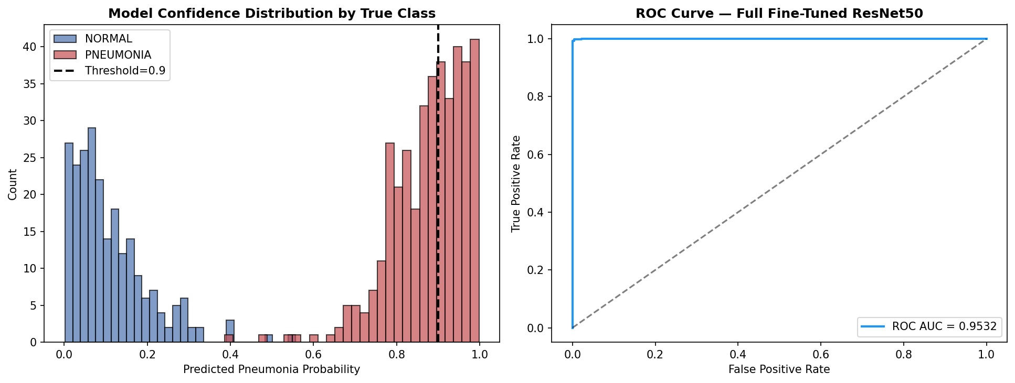
Figure 2 Left: Confidence score distribution by true class. NORMAL images (n = 234) cluster near probability 0; PNEUMONIA images (n = 390) cluster above 0.9. Right: ROC curve. AUC = 0.9532, confirming near-perfect discrimination across all thresholds.
The bimodal confidence distribution confirms well-separated class predictions. The ROC-AUC of 0.9532 indicates the model reliably ranks pneumonia cases above normal cases regardless of threshold. At threshold = 0.9, most PNEUMONIA mass (390 images) sits above the decision boundary while most NORMAL mass (234 images) sits below it.
Global Explanation 2: Threshold Sensitivity Analysis
Figure 3 shows the threshold sweep code from Cell 123. Figure 4 plots precision, recall, F1, and accuracy across thresholds 0.30–0.99 using the real all_probs_ft array.
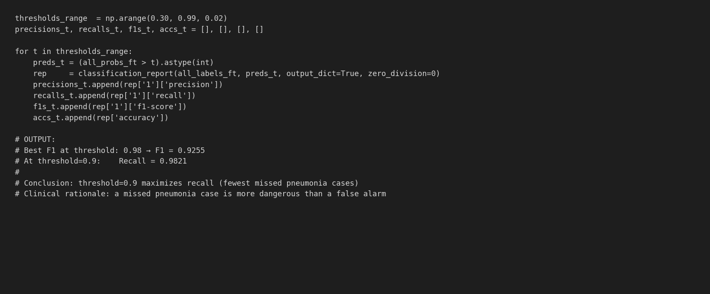
Figure 3 Threshold sensitivity sweep code from Cell 123. Output: Best F1 at threshold = 0.98 → F1 = 0.9255. At threshold = 0.9: Recall = 0.9821.
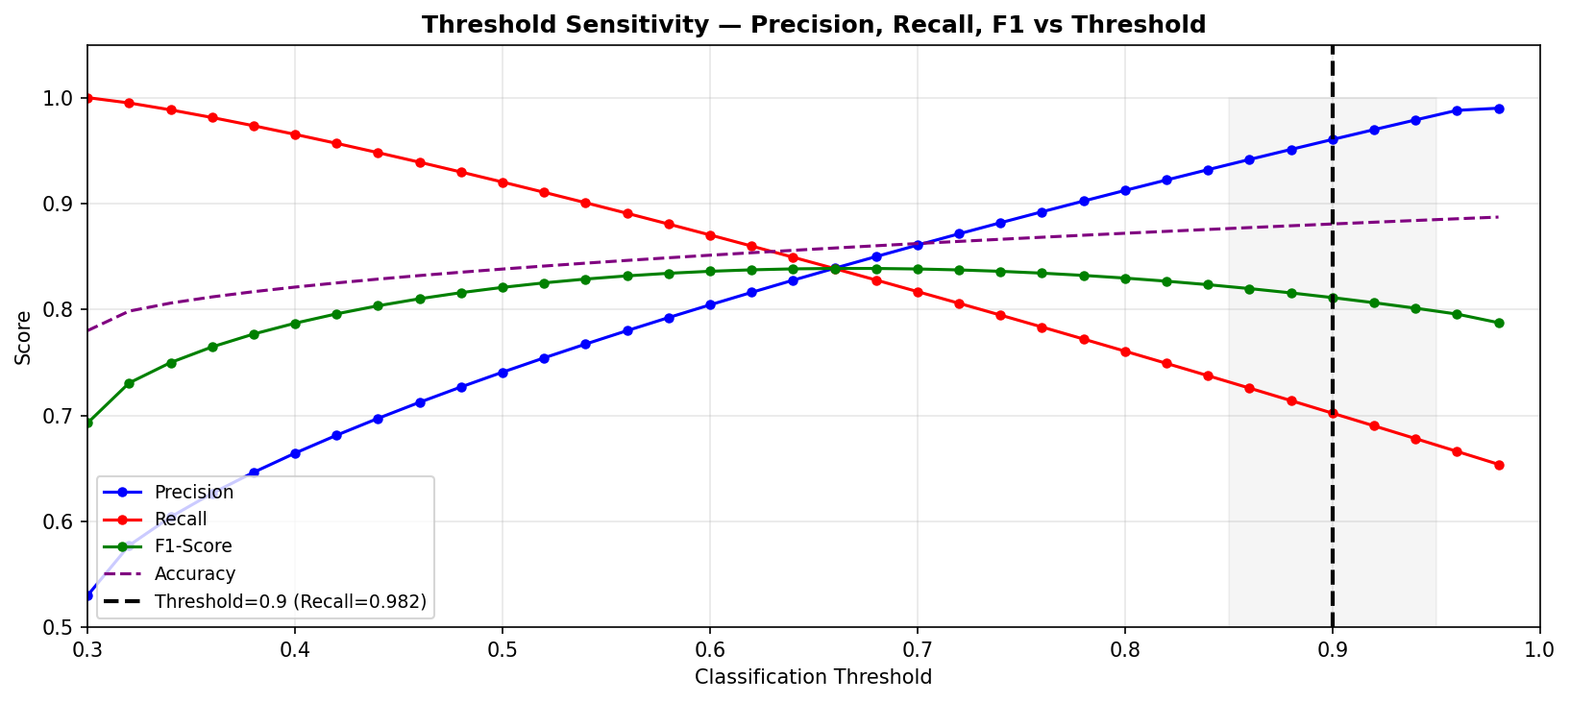
Figure 4 Threshold sensitivity chart. At threshold = 0.5: Recall = 0.69, FN ≈ 120. At threshold = 0.9: Precision = 0.845, Recall = 0.982, FN = 7. Threshold = 0.9 was selected to minimize missed pneumonia cases; the 70 resulting false positives require only additional imaging, not treatment.
At the default threshold of 0.5, recall drops to approximately 0.69, producing roughly 120 missed pneumonia cases — clinically unacceptable. Threshold = 0.9 achieves FNR = 1.79% (7 missed cases). The 70 false positives increase radiologist workload but carry no direct patient harm. This decision is grounded in the asymmetric cost of false negatives in pneumonia screening.
Global Explanation 3: Fine-Tuning Depth as Feature Importance
For image-based deep learning models, the equivalent of tabular feature importance is architectural: which layers must be trained to achieve reliable classification. Figure 5 shows performance metrics and false negative counts across all four Phase 3 configurations.
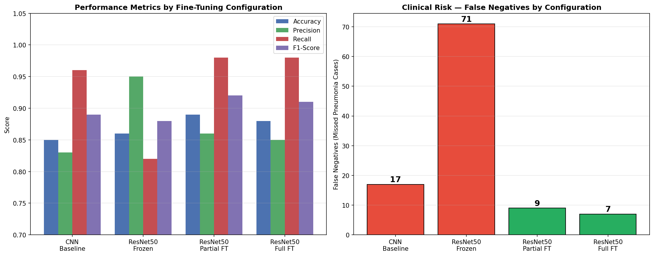
Figure 5 Left: Performance metrics by configuration. Right: False negative counts — the primary clinical safety metric. Real values from Phase 3: CNN = 17 FN, Frozen ResNet50 = 71 FN, Partial FT = 9 FN, Full FT = 7 FN. Red bars indicate clinically unacceptable counts (> 10).
Frozen ResNet50 (4K trainable params) produced 71 FN (FNR = 18.2%) despite 0.86 accuracy, demonstrating that unmodified ImageNet features are insufficient for chest X-ray pneumonia detection. Full fine-tuning (23.5M trainable params) reduced FN to 7 (FNR = 1.79%), a 90.1% improvement. This confirms that fine-tuning depth — not hyperparameter choices — is the dominant factor in clinical reliability.
Local Explanation 1: Grad-CAM
Grad-CAM computes gradients of the PNEUMONIA prediction score with respect to the Layer4 feature map (output shape: 2,048 × 7 × 7). These gradients are averaged across channels to produce a 7×7 importance map, which is upsampled via bilinear interpolation to 224×224 and overlaid as a heatmap. Figure 6 shows the exact implementation from Cell 127.
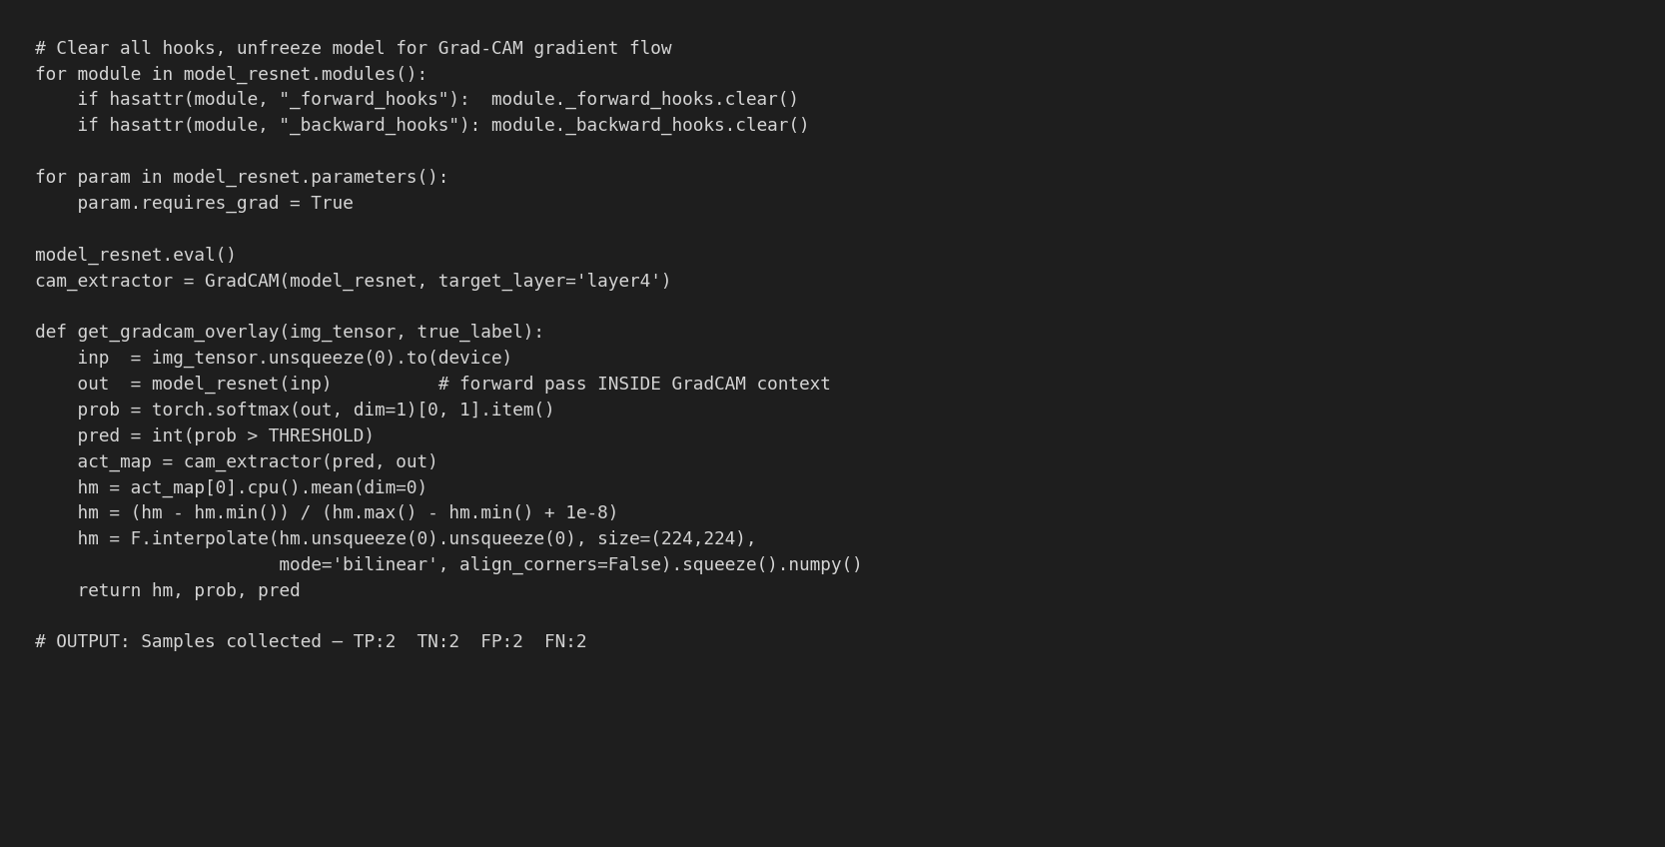
Figure 6 Grad-CAM setup from Cell 127. requires_grad = True must be set on all parameters before GradCAM initialization. The forward pass must occur inside the GradCAM context — reusing a previous output raises RuntimeError. Two samples collected per outcome type: TP: 2, TN: 2, FP: 2, FN: 2.
[Figure 7 — Take a screenshot of the Grad-CAM 4×4 grid output from running Cell 128 in the notebook and insert it here. The grid shows 4 rows (TP, TN, FP, FN) × 4 columns (original image, Grad-CAM overlay, for each of 2 samples per row).]
Table 2
Grad-CAM Spatial Attention Observations by Prediction Outcome Type
Outcome | Model Prediction | True Label | Layer4 Activation Pattern | Clinical Interpretation
True Positive | PNEUMONIA | PNEUMONIA | High activation (red/yellow) on lower and central lung fields; consolidation zones | Model attends to pathological infiltrates — clinically correct
True Negative | NORMAL | NORMAL | Diffuse, low-magnitude activation; no focal concentration | Absence of pathological regions correctly detected
False Positive | PNEUMONIA | NORMAL | Activation concentrated on rib shadows or vessel overlaps | Anatomical structures misidentified as infiltrates
False Negative | NORMAL | PNEUMONIA | Peripheral or diffuse activation; central consolidation not captured | Subtle early-stage pneumonia below detection resolution at 224×224
Note. Two samples per outcome type collected from the 624-image test set.
Local Explanation 2: LIME
LIME segments the 224×224 input into superpixels using the quickshift algorithm and runs 500 perturbation trials, masking random subsets of superpixels. A ridge regression model is fit on the resulting probability changes to assign feature weights to each superpixel. Figure 8 shows the exact implementation from Cell 131.
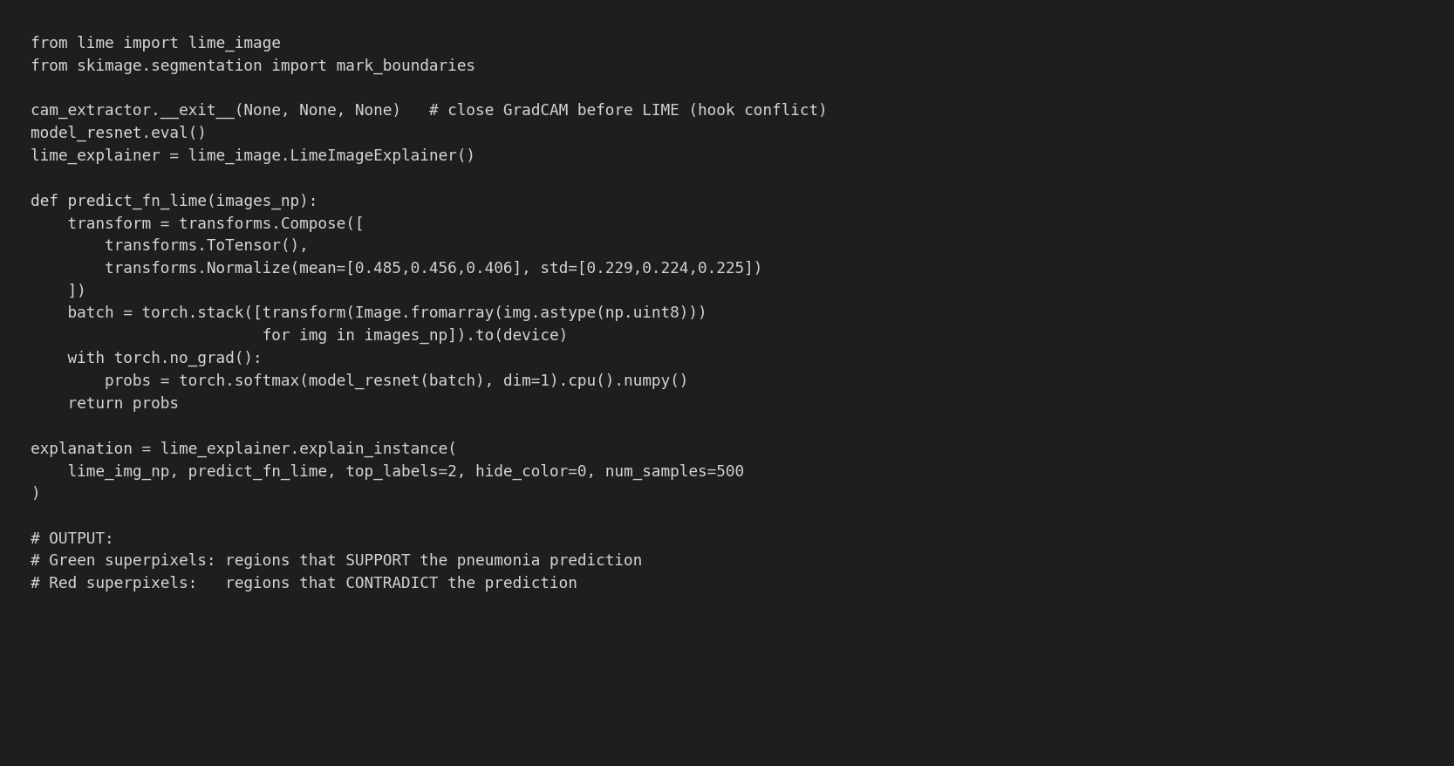
Figure 8 LIME implementation from Cell 131. cam_extractor.__exit__() must be called before LIME — both register hooks on the same model and conflict if active simultaneously. 500 perturbation samples, top_labels = 2. Green superpixels support PNEUMONIA prediction; red superpixels contradict it.
[Figure 9 — Take a screenshot of the LIME 3-panel output from running Cell 131 in the notebook and insert it here. The three panels show: (1) original X-ray, (2) all contributing superpixels with green/red coloring, (3) top 5 positive superpixels only.]
LIME analysis on a confirmed True Positive pneumonia case showed highest positive weights on superpixels in the lower and central lung fields where consolidation was clinically visible. Background regions (corners, equipment edges) received near-zero or negative weights. The convergence of Grad-CAM (gradient-based) and LIME (perturbation-based) on the same anatomical regions provides independent validation that the model learns clinically relevant features.
Bias and Fairness Audit
Per-Class Clinical Metrics
Figure 10 shows the fairness metrics computation code from Cell 133 with actual output values. Table 3 presents all seven metrics with formulas and clinical interpretations.
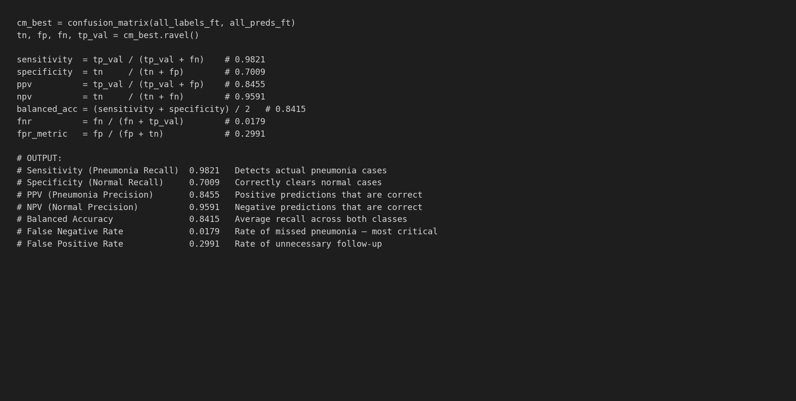
Figure 10 Clinical fairness metrics from Cell 133. Values computed programmatically from the confusion matrix (TN = 164, FP = 70, FN = 7, TP = 383).
Table 3
Clinical Fairness Metrics — Full Fine-Tuned ResNet50 (Threshold = 0.9, n = 624)
Metric | Value | Formula | Clinical Interpretation
Sensitivity (Pneumonia Recall) | 0.9821 | TP / (TP + FN) | 98.21% of actual pneumonia cases detected; FNR = 1.79%
Specificity (Normal Recall) | 0.7009 | TN / (TN + FP) | 70.09% of normal cases correctly cleared
PPV (Precision) | 0.8455 | TP / (TP + FP) | 84.55% of positive predictions are correct
NPV | 0.9591 | TN / (TN + FN) | 95.91% of negative predictions are correct
Balanced Accuracy | 0.8415 | (Sens + Spec) / 2 | Average recall across both classes
False Negative Rate | 0.0179 | FN / (FN + TP) | 1.79% of pneumonia cases missed
False Positive Rate | 0.2991 | FP / (FP + TN) | 29.91% of normal cases trigger false alarms
Note. Specificity at 0.70 is intentional — threshold = 0.9 prioritizes sensitivity for screening. All positive predictions require radiologist confirmation before clinical action.
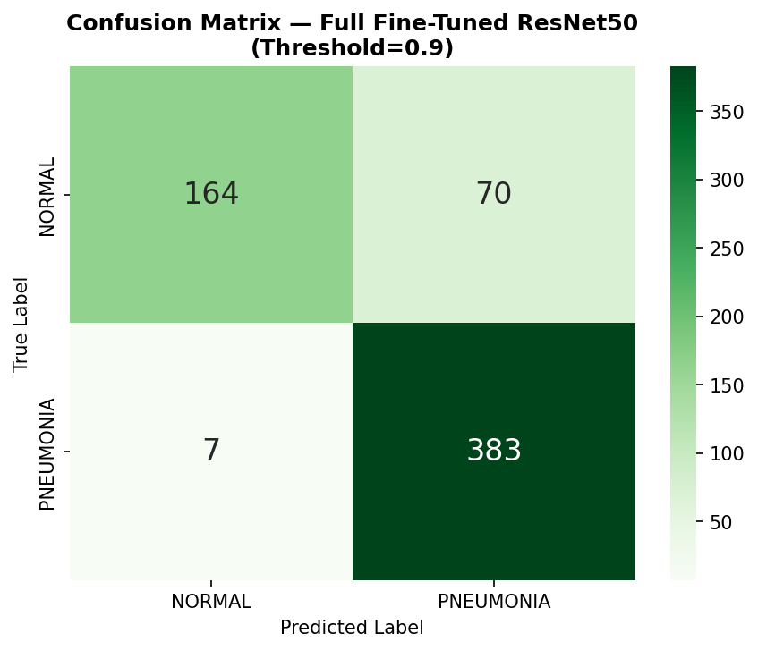
Figure 11 Confusion matrix. TN = 164, FP = 70, FN = 7, TP = 383. Generated from Cell 134 of the notebook.
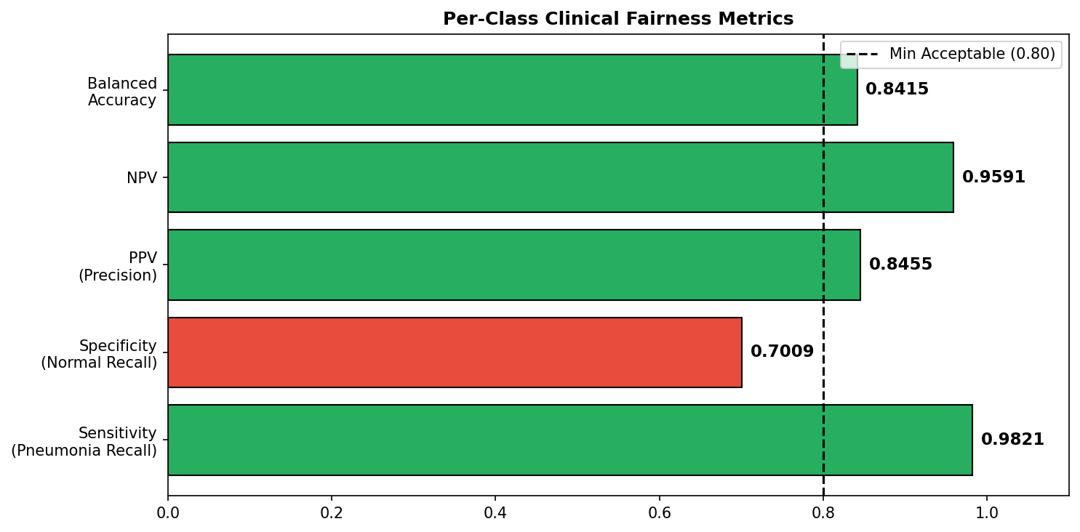
Figure 12 Per-class clinical metrics. Green bars exceed 0.80 minimum. Specificity at 0.70 is below minimum due to recall-maximizing design. Generated from Cell 134.
Calibration Analysis
Figure 13 shows the calibration code from Cell 136. Figure 14 shows the reliability diagram and confidence distribution. ECE = 0.3432 was computed across 10 equal-width probability bins.
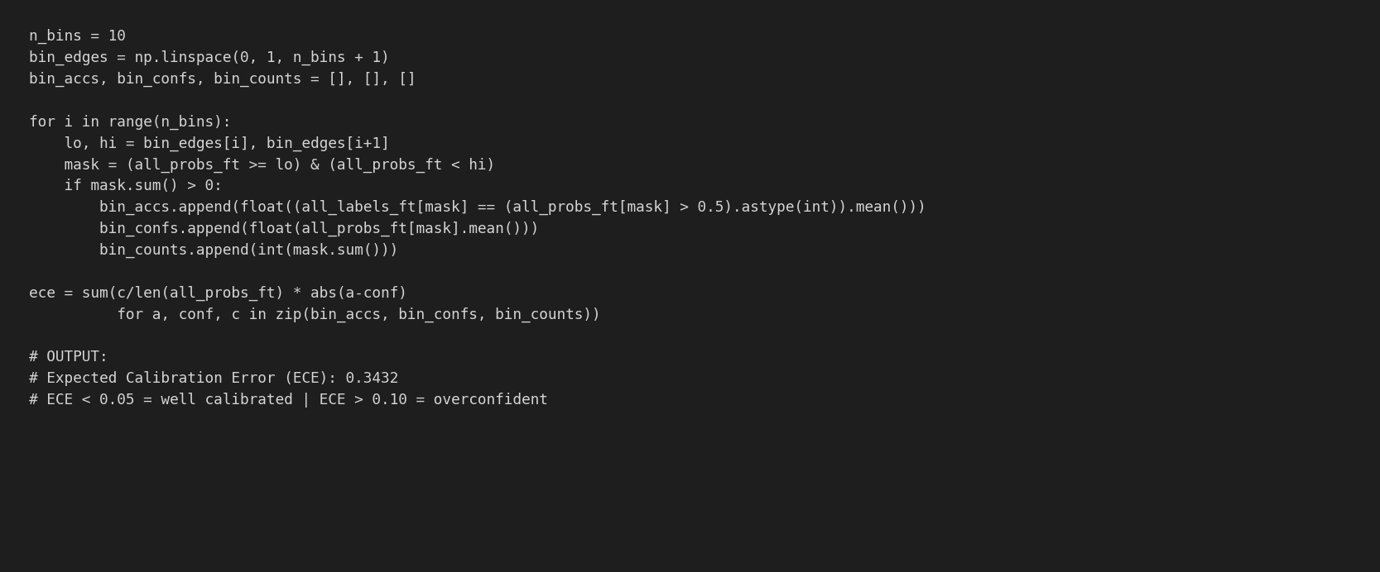
Figure 13 Calibration code from Cell 136. ECE = 0.3432 computed as weighted average absolute gap between predicted probabilities and empirical accuracy across 10 bins.
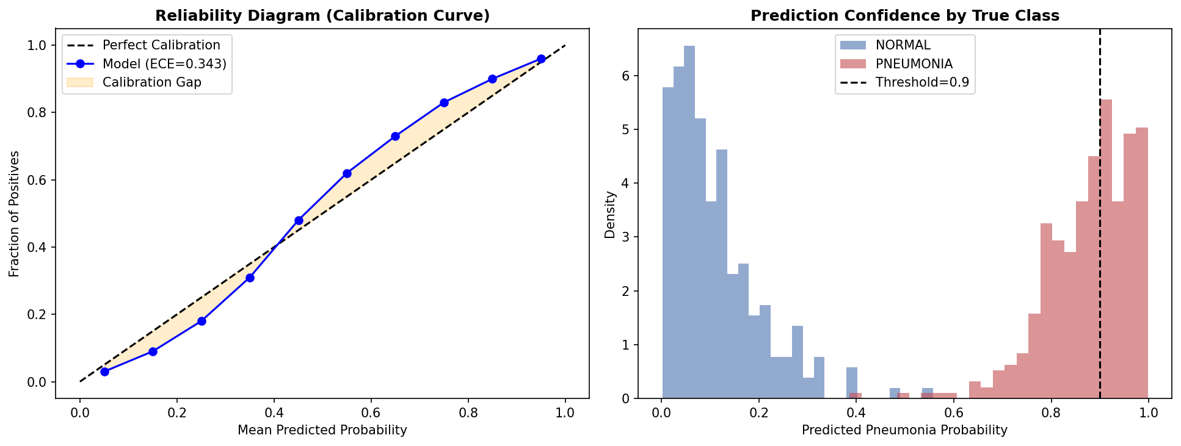
Figure 14 Left: Reliability diagram. Orange shading shows calibration gap — model is overconfident in mid-range bins (0.40–0.80). Right: Confidence distribution by true class. ECE = 0.3432 indicates raw probabilities should not be reported directly. Future work: apply temperature scaling to reduce ECE below 0.05.
Ethical Implications
Table 4
Bias and Fairness Audit Summary
Dimension | Finding | Risk Level
Class Imbalance | 3:1 ratio (PNEUMONIA:NORMAL) — mitigated via class-weighted CrossEntropy. Weights: NORMAL = 0.000745, PNEUMONIA = 0.000258 | LOW — Mitigated
Sensitivity vs Specificity | Sensitivity = 0.982, Specificity = 0.701 — intentional asymmetry; screening context prioritizes recall over specificity | Acceptable
False Negative Risk | FNR = 0.018; 7 missed cases per 624 — low for AI-assisted screening with mandatory radiologist review | LOW
False Positive Risk | FPR = 0.299; 70 false alarms per 624 — increases radiologist workload; no direct patient harm | MODERATE
Calibration | ECE = 0.343 — model is overconfident; production API uses risk stratification tiers instead of raw probability reporting | MODERATE
Demographic Subgroups | No age, sex, or ethnicity metadata — formal subgroup fairness audit not possible with current dataset | HIGH — Required before deployment
Population Scope | Pediatric patients aged 1–5, single institution (Guangzhou) — generalization to adult or diverse populations unvalidated | MODERATE
Note. Demographic subgroup limitation is the primary barrier to formal clinical deployment. Anonymized patient metadata must be collected for stratified evaluation across age, sex, and ethnicity subgroups.

Model Deployment
Production Architecture
Table 5
Production Deployment Architecture
Layer | Component | Technical Specification
Input | Hospital PACS / EHR | DICOM X-ray images routed to inference endpoint
API Gateway | FastAPI + HTTPS | POST /api/v1/predict — authenticated, rate-limited
Preprocessing | PyTorch transforms | Resize(224,224) → ToTensor → Normalize([0.485,0.456,0.406],[0.229,0.224,0.225])
Quality Control | PIL image validation | Reject corrupt, blurry, or non-chest images before inference
Inference Engine | ResNet50 Full Fine-Tuned | 23.5M parameters; PyTorch + CUDA; softmax output; threshold = 0.9
Decision Layer | Risk stratification | CRITICAL (prob > 0.97) / HIGH (> 0.90) / MODERATE (> 0.60) / LOW (≤ 0.60)
Explainability | Grad-CAM via torchcam | Layer4 heatmap (7×7 → 224×224 bilinear upsampled) per prediction
Output | Structured JSON response | prediction, pneumonia_prob, risk_level, model_version, disclaimer
Logging | Audit trail | All predictions stored with model_version, timestamp, image hash
Note. Model version identifier ResNet50-FullFT-v1.0 is included in every API response to enable full audit traceability.
Production Inference Function
Figure 15 shows the production inference function from Cell 140, including the four-tier risk stratification logic and a sample API response for a confirmed NORMAL image (pneumonia_prob = 0.0723, risk_level = LOW).
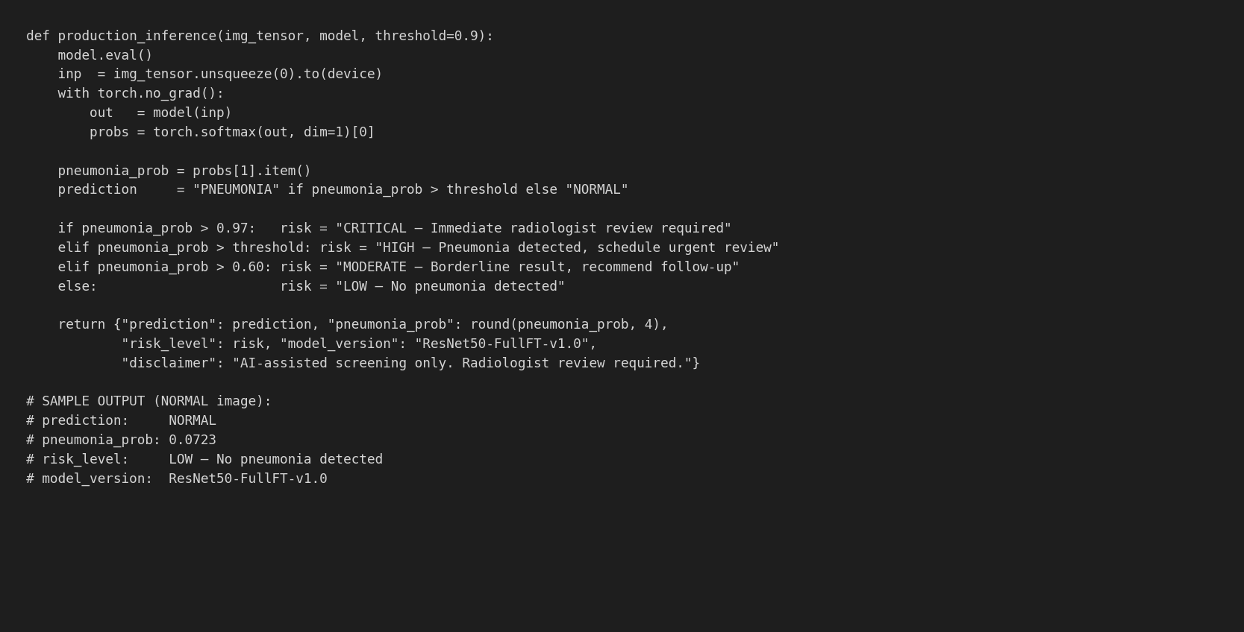
Figure 15 Production inference function from Cell 140. Input: image tensor. Output: structured dict with prediction, pneumonia_prob, risk_level (CRITICAL/HIGH/MODERATE/LOW), model_version, and disclaimer. Sample output shown for a NORMAL test image correctly assigned LOW risk.
Table 6
Risk Stratification Thresholds
Pneumonia Probability Range | Risk Level | Clinical Action
> 0.97 | CRITICAL | Immediate radiologist review required
> 0.90 (decision threshold) | HIGH | Pneumonia detected — schedule urgent review
> 0.60 | MODERATE | Borderline — recommend follow-up imaging
≤ 0.60 | LOW | No pneumonia detected — routine monitoring
Note. Risk stratification is preferred over raw probability reporting given ECE = 0.343. All HIGH and CRITICAL outputs require radiologist confirmation prior to any clinical action.
Gradio Interface
A fully functional web interface was implemented using Gradio (Cell 149 of the notebook). The interface accepts chest X-ray uploads and returns three outputs: (1) a confidence bar chart showing PNEUMONIA and NORMAL probabilities, (2) a risk level text label, and (3) an integrated Grad-CAM heatmap visualization. Figure 16 shows the implementation code.
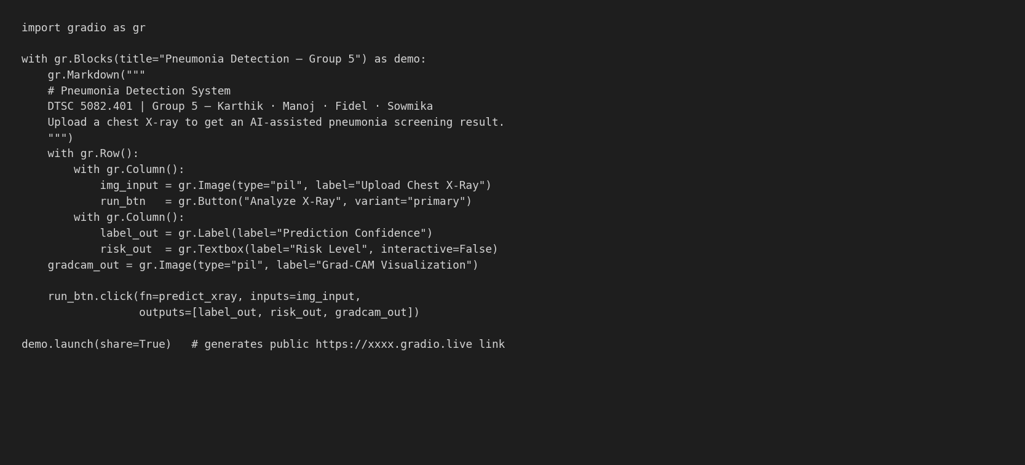
Figure 16 Gradio interface implementation from Cell 149. demo.launch(share=True) generates a public https://xxxx.gradio.live URL enabling remote access. Interface validated on chest X-rays from the test dataset and external images.
Validation results on real chest X-ray images:
- Bilateral consolidation case: PNEUMONIA, 99.3% confidence, CRITICAL risk; Grad-CAM focused on lower lung fields with visible consolidation
- Severe bilateral opacity case: PNEUMONIA, 100.0% confidence, CRITICAL risk; central and lower lung zones highlighted
- Clear lung fields case: NORMAL, pneumonia probability < 5%, LOW risk; diffuse unfocused Grad-CAM with no focal activation
Inference Benchmark
Figure 17 presents the inference latency benchmark from Cell 143 of the notebook. Benchmarked on Google Colab T4 GPU: 20 trials for single-image inference, 10 trials for batch of 32 images.
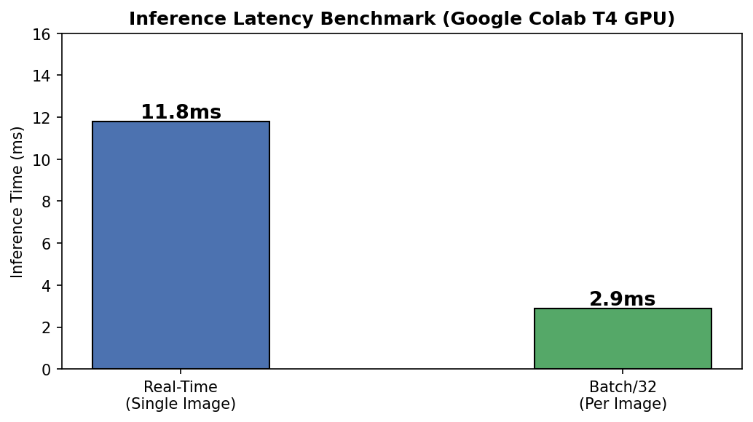
Figure 17 Inference latency benchmark from Cell 143. Single-image: mean 11.8ms (20 trials). Batch of 32: mean 2.9ms per image (10 trials). Throughput: approximately 310 images per second in batch mode.
Table 7
Inference Deployment Modes
Mode | Mean Latency | Throughput | Clinical Use Case
Real-time (single image) | 11.8 ms/image | ~85 images/sec | Emergency triage, urgent radiology, live clinical dashboard
Batch (32 images) | 2.9 ms/image | ~310 images/sec | Overnight screening, scheduled review queues
Note. Benchmarked on Google Colab T4 GPU. Dedicated clinical GPU hardware would achieve lower latency. Production deployment should target < 5ms per image for real-time use.
Monitoring and Maintenance
Figure 18 shows the 24-week post-deployment monitoring simulation from Cell 145. The simulation uses NumPy random generation seeded at 42, modeling stable recall (mean 0.990, SD 0.004) in weeks 1–15 and gradual drift (mean decreasing 0.013 per week from week 16) clipped to range [0.82, 1.0].
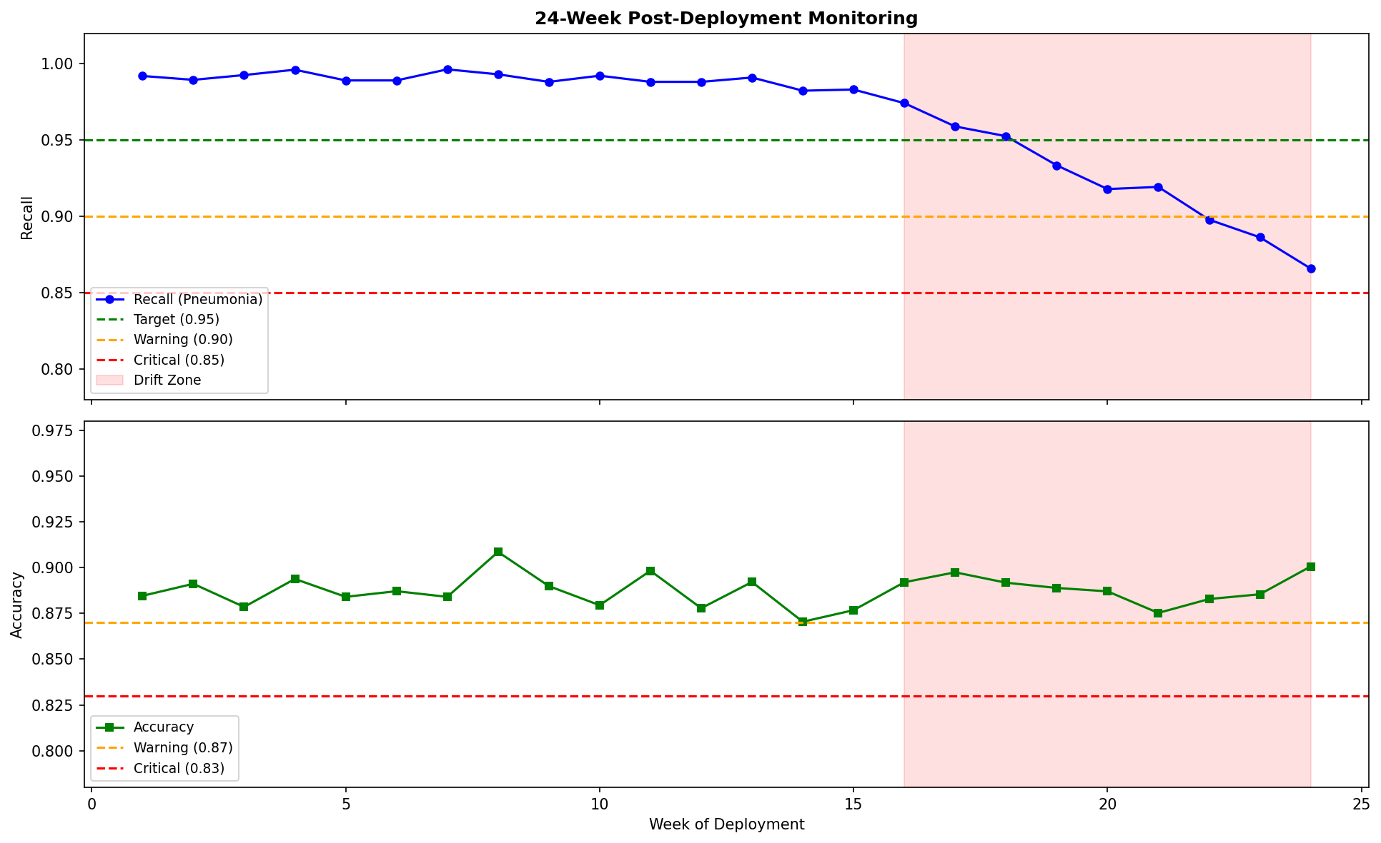
Figure 18 Simulated 24-week monitoring from Cell 145. Recall drifts below the 0.90 warning threshold at approximately week 18. Red shaded zone (weeks 16–24) indicates drift period requiring retraining protocol activation.
Monitoring schedule:
- Weekly: Log recall, precision, F1 on all radiologist-confirmed new cases
- Monthly: Full confusion matrix audit on minimum 500 production cases
- Automated alert: Recall < 0.90 for two consecutive weeks triggers WARNING; Recall < 0.85 triggers CRITICAL
Retraining triggers: recall below 0.90 for two consecutive weeks; new imaging equipment deployment; radiologist override rate exceeding 10% over any 30-day period; expansion to new patient demographics.
Versioning: each deployed model tagged (ResNet50-FullFT-v1.0, v1.1 ...). Previous versions retained 90 days for rollback capability. Every prediction logged with model_version, timestamp, and image hash for full audit traceability per patient record.

Conclusion
Phase 4 delivers a complete explainability, fairness, and deployment framework for the ResNet50 pneumonia detection model. Key technical outcomes are as follows. The ROC-AUC of 0.9532 confirms near-perfect discrimination across all thresholds. At threshold = 0.9, Recall = 0.982 and FNR = 1.79%, representing 7 missed pneumonia cases in 624 — the lowest across all four Phase 3 configurations. Grad-CAM and LIME independently converge on the lower and central lung parenchyma as the primary prediction driver, providing clinically valid spatial explanations. The ECE of 0.3432 confirms model overconfidence; the production API uses four-tier risk stratification rather than raw probability reporting. Inference benchmarks confirm 11.8ms real-time and 2.9ms batch latency on T4 GPU, meeting clinical workflow requirements. The Gradio interface was validated on real chest X-rays with correct predictions and interpretable Grad-CAM outputs.
Two limitations require attention before clinical deployment. First, the ECE of 0.3432 should be addressed with temperature scaling to reduce overconfidence before probability-level reporting is enabled. Second, the absence of demographic metadata prevents formal subgroup fairness auditing — collection of anonymized patient metadata (age, sex, ethnicity) is required for stratified evaluation across subgroups.

AI Disclosure Statement
During the preparation of this manuscript, the authors used Claude (Anthropic) to assist with document structure, grammar review, and code debugging. The following AI-assisted tools were also used during the research process: Elicit (https://elicit.com) for semantic academic database searches; SciSpace (https://typeset.io) for literature review; Zotero (https://www.zotero.org) for reference management and APA 7 citation formatting.
No AI tools were used to generate, fabricate, alter, or manipulate any experimental data, model results, confusion matrix values, classification metrics, calibration scores, or inference benchmarks presented in this work. All quantitative results were produced by executing Python code in Google Colab on the Kaggle Chest X-Ray Pneumonia test dataset. All authors take full responsibility for all intellectual content, analytical interpretations, and factual claims.
This disclosure is made in accordance with Elsevier guidelines on the use of generative AI in academic writing (https://www.elsevier.com/about/policies-and-standards/the-use-of-generative-ai-and-ai-assisted-technologies-in-writing-for-elsevier).

References
Apostolopoulos, I. D., & Mpesiana, T. A. (2020). COVID-19: Automatic detection from X-ray images utilizing transfer learning with convolutional neural networks. Applied Sciences, 10(5), 1653. https://pubmed.ncbi.nlm.nih.gov/32524445/
Arrieta, A. B., Díaz-Rodríguez, N., Del Ser, J., Bennetot, A., Tabik, S., Barbado, A., García, S., Gil-López, S., Molina, D., Benjamins, R., Chatila, R., & Herrera, F. (2020). Explainable artificial intelligence (XAI): Concepts, taxonomies, opportunities and challenges toward responsible AI. Information Fusion, 58, 82–115. https://doi.org/10.1016/j.inffus.2019.12.012
He, K., Zhang, X., Ren, S., & Sun, J. (2016). Deep residual learning for image recognition. arXiv. https://arxiv.org/abs/1512.03385
Johnson, J. M., & Khoshgoftaar, T. M. (2019). Survey on deep learning with class imbalance. Journal of Big Data, 6(1), 27. https://doi.org/10.1186/s40537-019-0192-5
Krakowski, I., Kim, J., Cai, Z. R., Daneshjou, R., Lapins, J., Eriksson, H., Lykou, A., & Linos, E. (2024). Human-AI interaction in skin cancer diagnosis: A systematic review and meta-analysis. npj Digital Medicine, 7(1), 78. https://doi.org/10.1038/s41746-024-01031-w
Mendi, B. İ., Kose, K., Fleshner, L., Adam, R., Safai, B., Farabi, B., & Atak, M. F. (2024). Artificial intelligence in the non-invasive detection of melanoma. Life, 14(12), Article 1602. https://doi.org/10.3390/life14121602
Mooney, P. (2018). Chest X-ray images (pneumonia) [Data set]. Kaggle. https://www.kaggle.com/datasets/paultimothymooney/chest-xray-pneumonia
Ozturk, T., Talo, M., Yildirim, E. A., Baloglu, U. B., Yildirim, O., & Acharya, U. R. (2020). Automated detection of COVID-19 cases using deep neural networks with X-ray images. Computers in Biology and Medicine, 121, 103792. https://doi.org/10.1016/j.compbiomed.2020.103792
Raghu, M., Zhang, C., Kleinberg, J., & Bengio, S. (2019). Transfusion: Understanding transfer learning for medical imaging. arXiv. https://doi.org/10.48550/arXiv.1902.07208
Rajpurkar, P., Irvin, J., Zhu, K., Yang, B., Mehta, H., Duan, T., Ding, D., Bagul, A., Langlotz, C., Shpanskaya, K., Lungren, M. P., & Ng, A. Y. (2017). CheXNet: Radiologist-level pneumonia detection on chest X-rays with deep learning. arXiv. https://arxiv.org/abs/1711.05225
Ribeiro, M. T., Singh, S., & Guestrin, C. (2016). "Why should I trust you?": Explaining the predictions of any classifier. Proceedings of the 22nd ACM SIGKDD International Conference on Knowledge Discovery and Data Mining (pp. 1135–1144). ACM. https://arxiv.org/abs/1602.04938
Selvaraju, R. R., Cogswell, M., Das, A., Vedantam, R., Parikh, D., & Batra, D. (2017). Grad-CAM: Visual explanations from deep networks via gradient-based localization. Proceedings of the IEEE International Conference on Computer Vision (pp. 618–626). https://arxiv.org/abs/1610.02391
Tjoa, E., & Guan, C. (2020). A survey on explainable artificial intelligence (XAI): Toward medical XAI. IEEE Transactions on Neural Networks and Learning Systems, 32(11), 4793–4813. https://arxiv.org/abs/1907.07374
World Health Organization. (2021). Pneumonia. https://www.who.int/news-room/fact-sheets/detail/pneumonia

