**Barter System**

**Created for:**

**Professor Moshe Cohen**

**Sacred Heart University**

**5151 Park Avenue**

**Fairfield, CT 06825**

**Spring 2022**

**Created 4/27/2022**

|  |  |  |
| --- | --- | --- |
| **Name** | **Email** | **Phone** |
| Desiree Brinn-Rodriguez | [brinn-rodriguezd@sacredheart.edu](mailto:brinn-rodriguezd@sacredheart.edu) | 203-695-1992 |
| Keerti Kumar Pasupula | [pasupulak@mail.sacredheart.edu](mailto:pasupulak@mail.sacredheart.edu) | 457-258-0586 |
| Christopher Sikorski | [sikorskic@mail.sacredheart.edu](mailto:sikorskic@mail.sacredheart.edu) | 203-939-5066 |
| Jagdeep Singh | [singhj2@mail.sacredheart.edu](mailto:singhj2@mail.sacredheart.edu) | 732-318-8785 |

Table of Contents

1.0 Introduction to Group Employee Automatic Rideshare System 7

1.3 Abstract 7

2.0 Preliminary Investigation Phase 8

2.1 Summary of Problems, Opportunities, and Directives 8

2.2 Statement of Preliminary Scope 10

2.2.1 Data Description of System 10

2.2.2 Business Processes 10

2.2.3 System Interfaces: Users, Locations, and Other Systems 12

2.3. Cost Effectiveness (Cost vs. Value) 13

2.4. Preliminary Project Plan 15

2.4.1. Master Schedule for Entire Project 15

2.4.2 Resource Assignment 16

3.0 Problem Analysis Phase 17

3.1 Study the problem domain 17

3.1.1 Data collected by the system 17

3.1.1.1 Methods 18

3.1.1.2 Storage 18

3.1.1.3 Personnel involved 19

3.1.1.4 Time involved 19

3.1.1.5 Sample data model 20

3.1.2 For each report reproduced by the system 20

3.1.2.1 List name and format 20

3.1.2.2 List inputs and outputs 21

3.1.2.3 List responsible personnel 21

3.1.3 Processes currently implemented 21

3.1.3.1 List all processes 21

3.1.3.2 List all hardware and software used 22

3.1.3.3 Functional decomposition diagram of current system 23

3.1.4 System Interfaces 25

3.1.4.1 Locations served by the system 25

3.1.4.2 Users served by system 25

3.1.4.3 Other systems it interacts with if any 25

3.1.4.4 Context diagrams of current system 26

3.1.5 Current business structure hierarchy chart 26

3.2 Analyze Problems and Opportunities in Current System 26

3.2.1 Cause and Effect for Each Problem 26

3.2.2 Update Problem from Preliminary Phase 30

3.3 Establish System Improvement Objectives 30

3.3.1 State New System Objectives 30

3.3.2 List new system constraints 32

3.3.2.1 Schedule 32

3.3.2.2 Cost 33

3.3.2.3 Technology 33

3.3.2.4 Policy 34

3.4 Re-evaluate and update project scope 34

4.0 Requirements Analysis Phase 35

4.1 Identify Requirements for New System 35

4.1.1 Functional Requirements: Inputs, Outputs, Processes, Storage and Control 35

4.1.2 Non-functional Requirements 36

4.2 Analyze Functional Requirements for New System 37

4.2.1 Preliminary Data Model - Entity Relationship (ER) diagram 37

4.2.2 Preliminary Process Model - Data Flow diagram (DFD) 38

4.2.3 Preliminary Interface model - Context diagram 39

4.2.4 Event Table 40

4.3 Master List of Requirements 40

4.3.1 Priority 40

4.3.2 Deadlines for each 41

4.3.3 Supporting requirements 42

4.4 Re-evaluation and update project scope 42

5.0 Decision Analysis Phase 43

5.1 Identify Candidate Solutions 43

5.2 Analyze candidate solutions 44

5.2.1 Feasibility Analysis 44

5.2.2 Cost-Benefit Analysis 46

5.2.2.1 Cost Analysis of Design 48

5.2.2.2 Cost Analysis of Hardware, Software, Miscellaneous Purchases 49

5.2.2.3 Cost Analysis of System Operation and Maintenance 50

5.2.2.4 Cost Analysis of Training 50

5.2.2.5 Analysis of Budget, Costs, and Business Benefits 51

5.3 Compare Candidate Solutions 55

5.4 Recommended Solution 56

6.0 Design Phase 57

6.1 Design the Application Architecture 57

6.1.1 Networks 57

6.1.2 Database distribution 58

6.1.3 Customization and Integration of “Off the Shelf” Software 58

6.1.4 User Interface Technology 58

6.1.5 System Interface Technology 58

6.2 Construct Detailed Models 59

6.2.1 Context Model 59

6.2.2 Data flow diagram (DFD) Decomposition to System Modules, and Tasks 60

6.2.3 Use-Case Model Diagram with Use-Case Narratives 69

6.2.4 Event Table. (Event Diagrams) 78

6.2.5 Activity Diagram 79

6.2.6 Systems Sequence Diagram for Use Cases 84

6.2.7 Software Structure Chart Showing Module Hierarchy 89

6.3 Design the System Database 89

6.3.1 Detailed Entity Relationship (ER) Diagram 89

6.3.2 Perform the 3 Normalization forms, Listing Dependencies 91

6.3.3 Chart Entities, Attributes, Domain, Primary keys and Foreign keys 94

6.3.4 Data Dictionary of All the Attributes 94

6.4 System Interface 98

1. **INTRODUCTION**

Today, it is often unsuccessful to be able to cope with the expansion of national and international trade volume and financial crises with standard financing and marketing techniques. The methods such as leasing, factoring and forfaiting are still money based and are ineffective at lowering the cost of money. For this reason, the best way to reduce the cost of money is not using money, which is the most important cost element of trade, to use non-money-based techniques that can transform business resources economically. One of the methods that companies apply to increase the competitiveness both in the national and international markets and to overcome the cash troubles they have during crisis periods is barter method which is based on the principle of buying and selling goods and services without the use of money.

Barter is an economy that has been practiced for centuries as the exchange of goods and services with other goods and services without using money. Today, barter transactions are made in two types, bilateral (classical) and multilateral (modern) barter; barter industry operates in three different ways, retail barter, corporate barter, and international barter; barter applications are performed in two types, full barter (%100 barter) and partial barter.

Barter offers exceptional solution alternatives for increasing sales, moving overstock, utilizing idle capacity, appropriate financing, marketing, and advertising, protection from crises, cash saving. The purpose of this study is to introduce barter technique, to explain operation process of barter in our country, to examine the benefits of barter for companies with commercial and financial aspects.

In this context, firstly barter concept and its development are discussed. Then the barter types are explained with examples and the advantages, and the difficulties of each type are explained.

**1.1ABSTRACT**

Today, increasing trade and financial integration between countries with globalization leads to intense competition and global economic crises in national and international markets. Due to these developments, the companies have some difficulties carrying on their business with traditional marketing and financing techniques and use alternative methods.

One of them is barter system, which is based on the principle of buying and selling goods and services without using money.

Barter is innovated form of exchange system, which has been used as a trading method since the early ages; today, it is also used as a counter-trade type.

Barter offers companies various benefits such as moving overstock, utilizing idle capacity, increasing sales, finding new markets, supplying interest-free credit, conserving cash, debt configuration, foreign trade facilitation.

The aim of this study is to examine the benefits of bartering in terms of commercial and financial dimensions. As a result of the study, it has been determined that barter is an innovative alternative to traditional mentality based on interest, and It is a type of trade and finance that will contribute to the country's economy by relaxing companies even in times of crisis.

Nevertheless, it has been determined that barter instrument is not well recognized in Turkey, barter industry is not institutionalized, national and international barter transactions has not become widespread enough. Legal regulations are needed for effective, safe and widespread application of barter.

**2. Preliminary Investigation Phase**

**2.1 Summary of problems, opportunities and/or directives**

Conceptually, barter is a trading and financing tool that is based on centuries ago in the economy, though it is still new today. Simple definition of barter system is the exchange of goods or services without money (Edwards, 1996: 7). The Barter word is derived from the English language and is described as "Exchange (goods or services) for other goods or services without using money" in the Oxford Dictionary (Oxford Dictionaries, 2017).

In Turkish, there is no barter word, but in many definitions of barter, the word "exchange" is used. In Turkish Language Dictionary prepared by Turkish Language Association (TDK), the exchange word is defined as "payment of the cost of deal made between two countries via reciprocal goods”.

In TDK's Dictionary of Economic Terms, the exchange word has been shown as the meaning of the English word "barter”. Barter is a technique developed by inspiration from the exchange system which is the oldest and simplest form of trading methods.

Barter as an international trade method means the exchange of goods between two countries without using money. As a corporate trade type, barter is the name of a system in which companies exchange goods and services directly with other companies, especially to relieve liquid position and overstock. In foreign sources, barter is defined as the exchange of what you have for what you need. As a matter of fact, barter system in Turkey is also introduced with the concept of "give your excess and take your need".1

In emerging economies, the activities of barter traders do not only make it easier to spread existing resources more efficiently, but also provide for the growth of resources. Barter is therefore a special financial instrument that transforms the economic resources of countries and companies into economic gain. Today's modern barter system provides the exchange of goods and services in an organized market.

In the literature, this organized barter type is referred to as "multilateral barter” and "financial exchange". But barter is a financing tool more contemporary and comprehensive than simple exchange.

Today, barter system is also referred to as "stock exchange of the goods and services" and "free trade". Indeed, today's modern barter system is created by the organizer company, there is a common market where companies that are members of the system can shop with each other and the goods or services purchased in this market are paid by goods or services produced or traded, not by money.

Therefore, barter is a financing instrument that a firm can buy goods and services needed and a trading technique by which a firm can sell goods and services produced.

**2.2 Statement of preliminary scope**

Based on barter, there is the exchange of something you have for something you need. In the early ages when trade was made in the simplest form, mankind was using their excess for their needs, so that goods and services were exchanged between sides. First the coin, then banknote, started to be used in the economy, then exchange and similar contracts have fallen into desuetude.

The exchange system, which lost its significance along with the invention of money, become a current issue of companies and countries again to get rid of the world economic crisis of 1929. Due to the collapse of trade, from 1930 to 1933, most European countries have made many barter agreements. Germany has supplied food and raw materials from European and Latin American countries through barter.

In those years, due to the war and the economic crisis, international barter, one of the counter-trade techniques, was applied. But then barter applications began to spread to the business level as well.

On the other hand, private sector companies have always used the corporate barter method by themselves, they have bought their needs from the company, and they have sold their products to same company, so they made bilateral barter. Over time, barter technique was renewed, innovated, and systematized with the effect of technological developments, organized barter applications operated by barter companies has started, thus barter started to be applied as multilateral changes between goods and services.

**2.3 History of Bartering**

The history of bartering dates all the way back to 6000 BC. Introduced by Mesopotamia tribes, bartering was adopted by Phoenicians. Phoenicians bartered goods to those located in various other cities across oceans. Babylonians also developed an improved bartering system. Goods were exchanged for food, tea, weapons, and spices. At times, human skulls were used as well. Salt was another popular item exchanged. Salt was so valuable that Roman soldiers' salaries were paid with it. In the Middle Ages, Europeans traveled around the globe to barter crafts and furs in exchange for silks and perfumes. Colonial Americans exchanged musket balls, deer skins, and wheat. When money was invented, bartering did not end, it became more organized and adapted to the times. Due to lack of money, bartering became popular again in the 1930s during the Great Depression. It was used to obtain food and various other services. It was done through groups or between people who acted like banks. If any items were sold, the owner would receive credit and the buyer's account would be debited.

**2.4 Advantages and Disadvantages of Barter System**

Just as with most things, there are advantages and disadvantages of bartering. A complication of bartering is determining how trustworthy the person you are trading with is. The other person does not have any proof or certification that they are legitimate, and there is no consumer protection or warranties involved.

This means that services and goods you are exchanging may be for poor or defective items. You would not want to exchange a toy that is almost brand new and in perfect working condition for a toy that is worn and does not work at all, would you? It may be a good idea to limit exchanges to family and friends in the beginning because good bartering requires skill and experience. At times, it is easy to think the item you desire is worth more than it is and overestimate the value of your own item.

On the positive side, there are great advantages to bartering. As mentioned earlier, you do not need money to barter. Another advantage is that there is flexibility in bartering. For instance, related products can be traded such as portable tablets in exchange for laptops. Or, items that are completely different can be traded such as lawn mowers for televisions. Homes can now be exchanged when people are traveling, which can save both parties money.

For instance, if your parents have friends in another state and they need somewhere to stay while on a family vacation, their friends may trade their home for a week or so in exchange for your parents allowing them to use your home.

Another advantage of bartering is that you do not have to part with material items. Instead, you can offer a service in exchange for an item. For instance, if you are good at fixing things, you may offer to fix a friend’s bike in exchange for the skateboard they have. With bartering two parties can get something they want or need from each other without having to spend any money.

* 1. **Uses of Bartering**

Bartering is usually conducted directly between two parties; however, it may be done multilaterally through a [trade](https://cleartax.in/g/terms/trade) exchange. Developed countries typically don’t engage in barters unless they’re done in association with the standard monetary system of your country, and even then, it is only practiced in rare instances. In times of monetary crisis, a barter system is often established as a means to maintain the [trading](https://cleartax.in/g/terms/trading) of goods and services as well as to [hold](https://cleartax.in/g/terms/hold) a country functioning. This may occur if physical money is not available or if a country sees [hyperinflation](https://cleartax.in/g/terms/hyperinflation) or a deflationary spiral.

**2.4 Preliminary Project Plan**

**2.4.1 Master Schedule for Entire Project Start: 04/11/2022**

|  |  |  |  |  |  |  |
| --- | --- | --- | --- | --- | --- | --- |
| **ID** | **Task Name** | **Duration** | **Start** | **Finish** | **Resource Names** | **%Completion** |
| 1 | **Introduction** | **1 Day** |  |  |  |  |
| 2 | Cover, Title page, Abstract | 1 day | 04/11/22 | 01/09/16 | AJAY | 2.429% |
| 3 | **Preliminary Investigation Phase** | **4 Days** |  |  |  |  |
| 4 | Summary of problems, opportunities, and directives | 1 day | 04/18/22 | 04/20/22 | SHIVA KRISHNA ARUTLA | 2.857% |
| 5 | Statement of preliminary scope | 1 day | 04/18/22 | 04/20/22 | SANDEEP | 3.286% |
| 6 | Assess project worth in terms of Cost vs. Value | 1 day | 04/18/22 | 04/20/22 | AJAY,SHIVA,SANDEEP | 5.714% |
| 7 | Preliminary Project Plan | 1 day | 04/18/22 | 04/20/22 | Group | 7.143% |
| 8 |  |  |  |  |  |  |

**2.4.2ResourceAssignment**

**Personnel:**

System Analyst

Java Programmers

Web Developer

System Architect

Security Analyst

Network Specialist

**Hardware/Software:**

**3.0 Problem Analysis Phase**

**3.1 Study the Problem Domain**

The main goal of our research on this barter system is to fully implement it in the current financial and trade industry to increase the value of money by trading between multiple parties for their goods and services exchange. The end solutions can improve the trade exchange between the companies and improves the value of money in the international markets. We are focusing on introducing this barter system to the vast expanded trading sectors to improve the country’s economic status.

**3.1.1 Data Collected by Current System.**

In the current system, most of the trading is performed by exchanging the goods and services by money as the exchanging agent. For this each of the involving parties for first get signed in the agreements and then start with trading with their goods and services.

**3.1.1.1 Methods**

* In the current system, interested candidates communicate with the other parties to whom they are willing to tie up for business trading.
* They then exchange their business information and comes to a conclusion of trading between them.
* Being Money as medium of transaction, the trading for all available goods and services were carried out.

**3.1.1.2 Storage**

* As the companies directly communicate with each other, they maintain a software to temporarily store the data which is shared between the involving parties.
* They themselves follow up setting the regular follow up alerts in the software they use or adopt to any third party software.

**3.1.1.3 Personnel Involved**

In this system, there are no much personnel involved except the trading parties and their authorized members to main inventory and alerts.

**3.1.1.4 Time Involved**

Attempting to accomplish a function that our system would give manually could take a long time. If no predefined module is provided, the products agreed for exchanging and performing regular sale or purchase analyses for intervals of one week, one month, three months, and six months, for example, might take roughly thirty minutes. Our technology, on the other hand, would do the identical operation in a couple of seconds with a single button press.

**3.1.1.5 Sample Data Model**

There is currently no complete system, and thus no data model.

**3.1.2 For Each Report Reproduced by the System**

**3.1.2.1 Name and format:**

**Authorized Business partner X:**

He is one of the involving parties, lets say X who agreed for the exchange of the goods and services to another party Y. He is responsible for the available products with him and also about the products are services that are under exchange with either one or multiple friends or partners.

**Authorized Business partner Y:**

He is another involving partner who also have the same roles and responsibilities as partner X.

**3.1.2.2 Inputs and outputs:**

The primary inputs for this system is the involving partners name and personal details along with the products & their quantities that are ready for exchange services.

**3.1.3.2 Hardware and Software Used**

**Hardware**

* Physical files
* Computers

**Software – Custom off the shelf software**

* MediTouch
* NueMD
* PrognoCIS
* Microsoft Outlook

**3.1.4 System Interfaces**

**3.1.4.1 Location Served by the System**

Any of the generic Commercial Off-The-Shelf systems is currently the closest systemto this barter system where data is maintained manually but stored in a certain format.

**3.1.4.2 Users Served by the System**

Business owners or merchants who are looking for best trade options.

**3.2 Analyze Problems and Opportunities**

**3.2.1 Define Cause and Effect for Each Problem**

The Cause-and-Effect Analysis, as well as System Improvement Objectives, are summarized in the graph below.We looked at commercial off-the-shelf trading trends to see what functions they employ to perform the trading. The study that follows is based on a patchwork of systems that all work together to execute a function. All referrals and follow-ups will be centralized on one system using the Hospital Bed Management System.

**3.3.2 New System Constraints**

**3.3.2.1 Schedule**

By June 15, 2022, the Barter system will be analyzed and designed. This allows you around three months to make sure the new system meets all design requirements. In two months after the design, the system will be developed. The system will provide a pre-determined routine with weekly, monthly, three-month, and six-month intervals. If new applications are added that require various reporting intervals, this becomes a problem.

|  |  |
| --- | --- |
| **Cause-and-Effect Analysis** | |
| **Problem or Opportunity** | **Cause and Effects** |
| 1. **Current systems are not program based.** | * Official officers do not have a robust tool for maintaining their trade or exchange data. * A new system is required. |
| 1. **Method of data input is not user friendly.** | * Because offices are scrambling to maintain and organize the data areas, they may make mistakes. |
| 1. **Current system does not produce graphical reports.** | * Offices must manually analyze and allocate a person to take the process forward. |
| 1. **Current referral system is outdated and may not integrate into the entire system.** | * Reporting on new referrals is difficult. |
| 1. **Current system does not have a treatment database.** | * Office workers must rely on memory, a textbook, or the Internet to remember their product or service opted for exchanging with others. * Because none of these sources are in a consistent format, personnel must shift through irrelevant data before finding what they need. |
| 1. **No way to track referring hospital’s information.** | * Managing all trade partnersand their * Product or service data is difficult. * Using a ledger or an excel sheet to track information might be tedious. |
| 1. **No integrated follow-up system.** | * Follow-ups must be managed using other patchwork mechanisms. * Using a paper calendar or other path work software to track the regular trading between the partners. |
| 1. **Build an application that can run on laptops and tablets without regard to different operating system.** | * Users and developers are not limited by technology when an application can run across platforms. * It also gives the goods a positive image. |

**3.3.2.2 Cost**

The cost of developing the Barter system will be around $103,203. Furthermore, annual operational expenditures are expected to rise at a pace of 4% per year, while revenue is expected to rise at a rate of 6%. The project is expected to break even in the third year of operations, based on current projections.

**3.3.2.3 Technology**

There will be no external network access to the new system. All data will be kept on a local server in a database. The application will retrieve data from the database. Regardless of operating system, the application can be installed on a laptop or tablet.

**3.3.2.4 Policy**

The system is only accessible and usable by the authorized staff. The office is in charge of giving approval to the system. They are responsible for ensuring that the system is not accessed by a third party using stolen credentials. During and after the development process, the authorized official is also responsible for ensuring that the system is functionally acceptable. During and after the development period, the officials must confirm that the system is completely HIPPA compliant.

**3.4 Re-Evaluate and Update Project Scope**

The scope of the project does not need to be re-evaluated!

**4.0 Requirements Analysis Phase**

**4.1Identify requirements (for objectives stated in 3.3.1)**

**4.1.1 Functional requirements in terms of inputs, outputs, processes, storage and control.**

*Functional Requirements*

|  |  |  |  |  |  |
| --- | --- | --- | --- | --- | --- |
| **Requirement** | **Inputs** | **Outputs** | **Processes** | **Storage** | **Control** |
| **User-Friendly Program Based Application** | Provider login credentials must be accepted by the system. | Reports will be shown in a graphical style by the system. | A new user data will be created by the system. | The system will save the user's data in the database. | The system will provide access using validated login credentials. |
| **All Input Fields Must be in a Form** | The technology will enable for the creation and modification of new user data for further references | A complete data of users over time will be generated by the system. |  | The technology will save authorized officials profiles in the database of the particular office | The technology will give authorized users access to a database of all user shared information. |
| **Easy to Read Comprehensive Reports Associated with Each section of the office** | User actual requirement is recorded as the basic data | On request, the system will generate a report of merchant data over time. | Existing merchants data will be searched and retrieved by the system. | Updated Merchant information will be saved in the system. | The technology will give authorized users access to the database of system user information. |
| **Application Runs on Different Platforms Accessible with Laptops and Tablets** | System authenticates provider’s login credentials. | System shall display treatment resource information upon request. | The system shall run on multiple operating systems. | System shall maintain functionality across various platforms. | System shall access databases from remote devices off-line. |

**4.1.2 List and Defend Non-Functional Requirements**

**Non-Functional Requirements**

|  |  |  |  |  |  |  |  |
| --- | --- | --- | --- | --- | --- | --- | --- |
| **Requirement** | **Performance** | **Ease of use** | **Cost savings** | **Timelines and deadlines** | **Training** | **Quality Management** | **Security and Audits** |
| **Forms to Open** | Response time < 100 milliseconds | Intuitive forms and buttons direct user. | Cost of training users in technical matters. | One month to test and code. | Help menu | Mean system errors < 5 per business day. | User authentication and verification procedures. |
| **Auto-Complete Query** | Response time < 250 milliseconds | Two mouse clicks to get to patient information from drop down box. | 10% - 50% outsource IT services | Two months to test and code. | Help menu | Backup and restore time no more than 30 minutes. | Secure data transmittal and storage. |
| **Populate forms** | Response time <250 milliseconds | One mouse click tab or add/edit button. | 10%- 50% outsource IT services | Two months to test and code. | N/A | Mean system errors < 5 per business day. | Backup and restore and off-site storage. |
| **Report** | Production of report will take less than 2 seconds in 95% of the cases. | Check box to vary graph views, tab to select report. | 10%-50% outsource IT services | Three months to test and code. | Help menu | Mean system errors < 5 per business day. | Secure data transmittal and storage. |
| **Manage Referrals** | Process each new patient profile addition per second at peak load. | One mouse click add/edit patient profile. | 25%-45% compared with outsourced data storage | Three months to test and code. | Help menu | Backup and restore time no more than 30 minutes. | Backup and restore and off-site storage. |
| **Follow-Up Requests** | Process each new follow-up request per second at peak load. | One mouse click add new/select existing. | 25%-45% compared with outsourced data storage | Three months to test and code. | Help menu | Backup and restore time no more than 30 minutes. | Secure data transmittal and storage. |

**4.2. Analyze functional requirements for new system using system modeling approach.**

**4.2.1. Construct preliminary process model –Entity Relationship(ER) diagram**

**4.2.2. Construct preliminary process model - Data Flow diagram (DFD)**

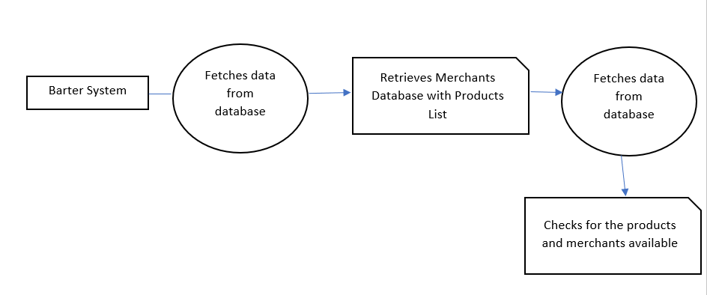

**Fig: Data Flow Diagram Barter System**

**4.2.2.1 Merchant Data Flow Diagram**

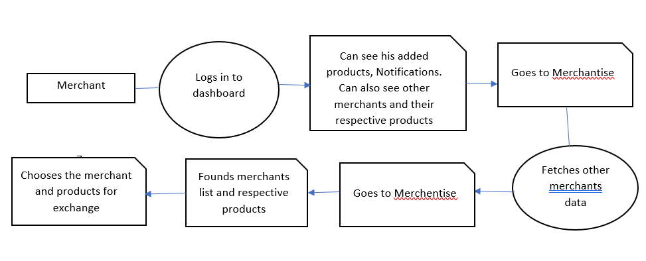

**Fig: Data Flow Diagram Merchant Role**

**4.3Master list of all requirements**

**4.3.1 Priority**

*Functional Requirements*

|  |  |
| --- | --- |
| **Requirements** | **Priority** |
| User-Friendly Program Based Application | High |
| All Input Fields Must be in a Form | High |
| Easy to Read Comprehensive Reports Associated with Each Diagnosis | High |
| Integrated Text recognition System | High |
| Integrated numbers recognition System | High |
| Application Runs on Different Platforms Accessible with Laptops and Tablets | Medium |

*Non-Functional Requirements*

|  |  |
| --- | --- |
| **Requirements** | **Priority** |
| Forms to Open | High |
| Auto-Complete Query | High |
| Populate forms | High |
| Report | Medium |
| Manage Referrals | Medium |
| Follow-Up Requests | Medium |

**4.3.2 Deadlines**

*Functional Requirements*

|  |  |
| --- | --- |
| **Requirements** | **Timelines and Deadlines** |
| User-Friendly Program Based Application | One month to test and code. |
| All Input Fields Must be in a Form | Two months to test and code. |
| Easy to Read Comprehensive Reports Associated with Each Diagnosis | Two months to test and code. |
| Integrated Referral Management System | Three months to test and code. |
| Integrated Text recognition System | Three months to test and code. |
| Integrated numbers recognition System | Three months to test and code. |
| Application Runs on Different Platforms Accessible with Laptops and Tablets | Three months to test and code. |

*Non-Functional Requirements*

|  |  |
| --- | --- |
| **Requirements** | **Timelines and Deadlines** |
| Forms to Open | One month to test and code. |
| Auto-Complete Query | Two months to test and code. |
| Populate forms | Two months to test and code. |
| Report | Three months to test and code. |
| Manage Referrals | Three months to test and code. |
| Follow-Up Requests | Three months to test and code. |

**4.3.3 Supporting Requirements**

The modeling framework enables the creation of a handwriting detection system by defining the text and numerals that are available. Each organization’s forms specifying the required data to enter by the users with certain attributes like authorized partner, product or services under trading.

**4.4 Reevaluation and update project scope.**

The scope of the project does not need to be re-evaluated!

**5.0Decision Analysis Phase**

**5.1 Candidate solutions**

There are no proper systems or software to manage the authorized partners and their products or services under sale or trade. Even if there any system exists, it may not be fully developed to accommodate the data of multiple users and their products. Our barter system address the major issues of implementing it in real time in large traders and maintains a perfect database and user interfaces to maintain the data.

**5.2 Analyze candidate solutions**

**5.2.1 Feasibility Analysis**

|  |  |
| --- | --- |
| **Technical Feasibility** | The framework configuration is in fact attainable to build up the framework. Specialized Staff, Developers required to structure the framework. The structured framework can be bolstering new improvement effectively and can coordinate with it easily. |
| **Operational Feasibility** | The project has been developed in such a way that it becomes very easy even for a person with little computer knowledge to operate it. This software is very user friendly and does not require any technical person to operate.Thus the project is even operationally feasible. |
| **Economic Feasibility** | Economic analysis is the most frequently used method for evaluating the effectiveness of a new system. More commonly known as cost/benefit analysis. .net using visual C# and Sequential Query Language database is easily available on the internet**.** |
| **Schedule Feasibility** | The framework will require additional time and exertion for structure and improvement. The time assigned right now is sufficient to plan and build up the framework. |

**5.2.2 Cost-Benefit Analysis**

|  |  |  |  |  |  |
| --- | --- | --- | --- | --- | --- |
| **Development Cost** | | | | | |
| **Personal Cost** |  | | | | |
| **Position** | **Hourly Rate** | **Hours** | **No. Of Employees** | **Cost** |  |
| System Architect | $80 | 100 | 1 | $8,000 |  |
| Project Manager | $60 | 200 | 1 | $12,000 |  |
| Technical Lead | $50 | 200 | 1 | $10,000 |  |
| Sr. Programmers | $45 | 220 | 2 | $19,800 |  |
| Programmers | $20 | 250 | 3 | $15,000 |  |
| Database Specialist | $45 | 180 | 1 | $8,100 |  |
| System Analyst | $60 | 120 | 1 | $7,200 |  |
| QA | $25 | 200 | 2 | $10,000 |  |
| Marketing Manager | $65 | 200 | 1 | $13,000 |  |
| Sales Executive | $40 | 250 | 2 | $20,000 |  |
| Technical Content Writer | $20 | 260 | 1 | $5,200 |  |
| **Total Personnel Cost** |  | | | **$128,300** |  |

|  |  |  |  |  |  |
| --- | --- | --- | --- | --- | --- |
| **Hardware Costs** | | | | | |
| **Equipment** | **Quantity** | **Unit Cost** |  | **Cost** |  |
| Laptops/Computers | 10 | $800 |  | $8,000 |  |
| Server | 2 | $2,500 |  | $5,000 |  |
| **Total Equipment Cost** |  |  |  | **$13,000** |  |

|  |  |  |  |  |  |  |
| --- | --- | --- | --- | --- | --- | --- |
| **Projected Annual Revenue Analysis** | | | | | | |
| **Revenue Category** | **Year 1** | **Year 2** | **Year 3** | **Year 4** | **Year 5** | **Totals** |
| Revenue from commission | $21,000 | $24,000 | $28,000 | $32,000 | $36,000 | $141,000 |
| Revenue from Advertisements | $3,000 | $5,000 | $7,000 | $10,000 | $14,000 | $39,000 |
| Government Grant | $6,000 | $8,000 | $11,000 | $14,000 | $17,000 | $56,000 |
| Fundraiser | $11,000 | $14,000 | $19,000 | $26,000 | $30,000 | $100,000 |
| **Total Revenue** | **$41,000** | **$51,000** | **$65,000** | **$82,000** | **$97,000** | **$336,000** |

|  |  |  |  |
| --- | --- | --- | --- |
| **HR Attendance System** | | | |
| **Statement of Profit/Loss** | | | |
| **Revenue** |  |  |  |
|  | **5 Year Projected Revenue** |  |  |
|  | Revenue from commission | $140,000 |  |
|  | Revenue from Advertisements | $35,000 |  |
|  | Government Grant | $60,000 |  |
|  | Fundraiser | $100,000 |  |
|  | **Total Revenue $335,000** | |  |
| **Cost** |  |  |  |
|  | Development Cost | $114,200 |  |
|  | Total Equipment Cost | $12,000 |  |
|  | 5 Year Projected Operating Cost | $20,000 |  |
|  | System Maintenance | $62,000 |  |
|  | Marketing | $55,000 |  |
|  | New Development | $43,000 |  |
|  | Miscellaneous | $20,000 |  |
|  | **Total Cost $326,200** | |  |
| **Profit/Loss** | **$8,800** | |  |

### **5.2.2.1. Chart cost analysis of design**

### **5.2.2.2. Chart cost analysis of hardware, software, miscellanies purchases**

### 

### **5.2.2.3. Chart cost analysis of system operation, and maintenance**

### **5.2.2.4. Chart cost analysis of training**

### 

### **5.2.2.5. Analysis of budget, costs, and business benefits**

**5.3 Compare candidate solutions**

We have closely observed the current system and its drawbacks were noted to overcome with this proposed system. Our team have found solutions for each of the drawback to address it at sure shot solution. We put together all the observations and drawbacks in the existing manual system with a goal of devising the best usable software to address the major drawbacks first. Listed are the final approaches from the team to start with the existing barter system that makes use of the system more efficiently and contribute in increasing the value of money.

* Firstly, this Barter System is a web-based system to manage all the activities.
* This system includes below functionalities:
* The primary user of this system is the Traders or merchants usually referred here in this document as authorized user of the system of the particular area who keeps track of all the users data.
* Ability to manage the different user’s multiple data like products or services under trade with the associated partners, the exchange rates and the profit loss analysis.

**Idea:**Ultimately the idea of this proposed system is to save time and maintain the data in a more secure way. This system is proposed with the intention of maintaining the multiple users and their products or services in trade associated with different trading partners.

**5.4 Recommend a final "best" solution**

|  |  |  |
| --- | --- | --- |
| **Criteria** | **New (Recommended)** | **Existing** |
| **Operating Environment or Constraints** | * Must need Wi-Fi/data connection to communicate with the server. * Off-line viewings are not available | * It is a manual system that has no operating environment or any data storage system. |
| **Hardware new and existing** | **Windows**   * 2+ GHz processor. * 8+ GB RAM. * 500 MB of available hard-disk space * Sequential Query Language Database Server   **Mac**   * 2.1+ GHz Intel™ processor. * 8 GB RAM. * 500 MB of available hard-disk space. | * Existing is a manual system where a person is assigned to data enter, maintenance and retrieval. * No Virtual data storage and hence no hardware to access the data. * There is no proper software that can clearly convert the human written text to a soft copy of data. |
| **Software new and existing** | * Own personal development * WEEKLY UPDATES/BUG FIXES * Many customer services options. | * Phone number or meeting in person is the only medium to talk to helping professionals * No updates/bug fixes |
| **Staffing new and existing** | IT and Human Resources | Staff Member Incharge |
| **Training new and existing** | Online functions/classes to teach new users on how to use the software | User manual or from direct interactions. |
| **Installation requirements** | Microsoft Windows Installer 3.0 | Any generation web browser |
| **Performance requirements** | All page material is loaded in under 3 seconds | No such factor to influence as it is a manual system. |
| **Development requirements** | Client-Server model  Sequential Query Language Database | No software can be suggested as it is a manual system. |
| **Reports to be delivered** | Each user’s daily/weekly report with respect to the locations can be detected. | Reports generation is manually retrieving data from the data sheets. |
| **Security requirements** | * All personal data secured * Secure passwords | No software to maintain security factors. |
| **Auditing requirements** | Login and access log trails | NA |

**6.0Design Phase**

**6.1 Design the application architecture**

**6.1.1 Networks**: Internet.

**6.1.2 Database Distribution:** Network.

**6.1.3 Customization and integration of “Off the shelf” software**

As for the off the shelf software, in our system we have incorporated the necessary tools and software to make the system build unique and function in a more advanced way.

**6.1.4 User Interface Technology--With other Users**

There is no outside user access for this barter system unless registered, as it includes all the confidential data secured by the authorized staff member.

This system can be used by multiple authorized users associated to a particular location or branch.

**6.1.5 System Interface Technology--With other Systems**

The system will not be utilizing any other systems for the interface technology.

**6.2 Construct detailed models**

**6.2.3. Use-Case model diagram**

**6.2.3.1 Merchant Usecase Diagram**

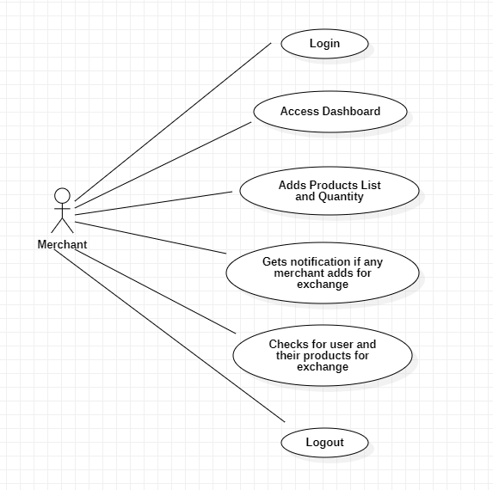

**Fig: Merchant Usecase Diagram**

**6.2.3.1 Barter Usecase Diagram**

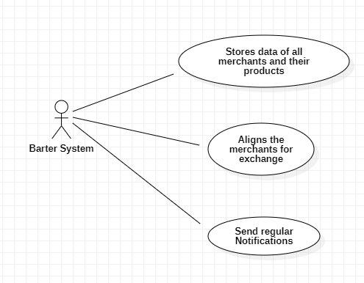

**Fig: Barter System Usecase Diagram**

**6.2.4 Merchant Activity Diagram**

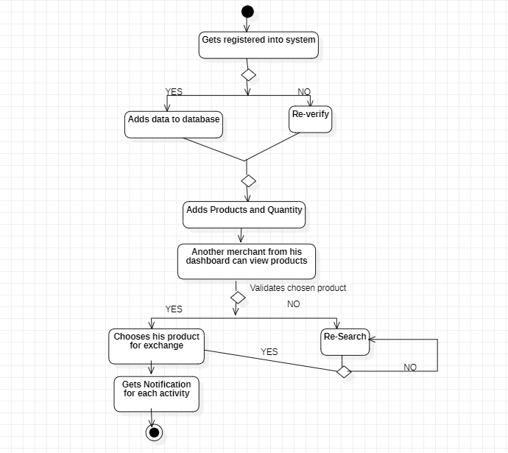

**Fig: Merchant Activity Diagram**

**6.2.5. Sequence Diagram**

**6.2.5.1 Merchant Login**

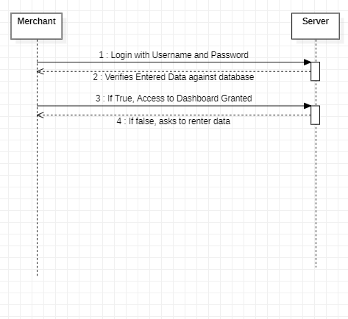

**Fig: Merchant Login Sequence Diagram**

**6.2.5.1 Merchant Role**

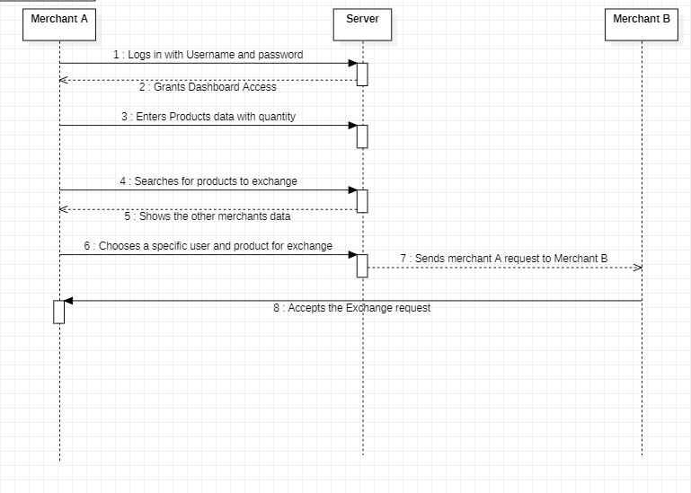

**Fig: Merchant Role Sequence Diagram**

**6.3.3 Data Dictionary of all the attributes**

**Table Name: Users**

|  |  |  |  |  |
| --- | --- | --- | --- | --- |
| **ID** | **Field Name** | **Data Type** | **Constraint** | **Description** |
| **0** | **Id** | **int** | **Primary Key** | **Auto Increment** |
| **1** | **Email** | **varchar(50)** | **Primary Key** |  |
| **2** | **Password** | **varchar(150)** |  |  |
| **4** | **Name** | **varchar(100)** |  |  |
| **5** | **Buyer** | **varchar(100)** | **Primary Key** |  |
| **6** | **ndate** | **varchar(100)** |  |  |

**Table Name: Item**

|  |  |  |  |  |
| --- | --- | --- | --- | --- |
| **ID** | **Field Name** | **Data Type** | **Constraint** | **Description** |
| **0** | **Id** | **int** | **Primary Key** | **Auto Increment** |
| **1** | **Name** | **varchar(50)** |  |  |
| **2** | **Description** | **varchar(150)** |  |  |
| **4** | **ProductType** | **varchar(100)** |  |  |
| **5** | **Expectations** | **varchar(10)** |  |  |
| **6** | **Quantity** | **varchar(100)** |  |  |
| **7** | **Image** | **varchar(10)** |  |  |
| **8** | **SellerID** | **varchar(10)** | **Primary Key** |  |
| **9** | **InsertedDate** | **date** |  |  |
| **10** | **Price** | **varchar(10)** |  |  |

**Table Name: Negotiations**

|  |  |  |  |  |
| --- | --- | --- | --- | --- |
| **ID** | **Field Name** | **Data Type** | **Constraint** | **Description** |
| **0** | **Id** | **int** | **Primary Key** | **Auto Increment** |
| **1** | **SellerID** | **varchar(50)** | **Primary Key** |  |
| **2** | **ReceiverID** | **varchar(150)** | **Primary Key** |  |
| **4** | **Status** | **varchar(100)** |  |  |
| **5** | **SoldItemID** | **varchar(10)** | **Primary Key** |  |
| **6** | **Borroweitemid** | **varchar(100)** | **Primary Key** |  |
| **7** | **BorrowItemOwner** | **varchar(10)** |  |  |
| **8** | **BorrowItemImage** | **varchar(10)** |  |  |
| **9** | **SoldItemImage** | **date** |  |  |
| **10** | **SoldItemName** | **varchar(10)** |  |  |
| **11** | **BorrowItemName** | **varchar(10)** |  |  |
| **12** | **SellerItemOwner** | **varchar(10)** |  |  |
| **13** | **BorrowItemPrice** | **varchar(10)** |  |  |
| **14** | **SoldItemPrice** | **varchar(10)** |  |  |

**Table Name: Notifications**

|  |  |  |  |  |
| --- | --- | --- | --- | --- |
| **ID** | **Field Name** | **Data Type** | **Constraint** | **Description** |
| **0** | **Id** | **int** | **Primary Key** | **Auto Increment** |
| **1** | **UserID** | **varchar(50)** | **Primary Key** |  |
| **2** | **Message** | **varchar(150)** |  |  |
| **4** | **Seller** | **varchar(100)** | **Primary Key** |  |
| **5** | **Buyer** | **varchar(100)** | **Primary Key** |  |
| **6** | **ndate** | **varchar(100)** |  |  |

**6.4 System Interface Design**

**6.4.1 Authorized Merchant**

|  |  |
| --- | --- |
| Model Name | Barter System - Login |
| Parameters Passed & Meaning | Email: Use your personal/professional email.  Password: Creating a password containing: capital letters, lowercase letters, numbers, and special characters. |
| Description of Module Function | The page will ask for the administrators username & password and will allow the authorized staff to move on to the next page. |
| Input | Click: Login/Enter |
| Output | Access to Barter System. However, if password/username is incorrect, a notification will appear asking the user to re-input. |
| Called Modules | Dashboard. |
| Report/  Screen Layout | |  | | --- | | [LOGIN SCREENSHOT] | |
| Story | After entering username & password to login page. The merchant will be granted access to the following page. |
| Error Message | If invalid credentials, prompt the user of invalid credentials. |

**6.4.2 Change Password**

|  |  |
| --- | --- |
| Model Name | BarterSystem – Change Password |
| Parameters Passed & Meaning | Confirm email address, old password and then enter new password |
| Description of Module Function | This module allows the user to change their password. |
| Input | Click: “Change Password” or “Cancel”. |
| Output | Return to the home page where the user can access the rest of the software. |
| Called Modules | Change Password |
| Report/  Screen Layout | [CHANGE PASSWORD SCREEN] |
| Story | Whenever the user would like to change their current password, they can simply find the change password tab in their student account. The change password will seek for the old password and the ask for an input of the new password. This will then confirm and verify the changes that have been made. |
| Error Msg. | If any fields are empty, prompt the user of the missing information. |

**6.4.3 Forgot Password.**

|  |  |
| --- | --- |
| Model Name | Barter System –Forgot Password |
| Parameters Passed & Meaning | Email address given while registering |
| Description of Module Function | This module allows the user to reset their password |
| Input | Click: “Send Mail” or “Back to log in”. |
| Output | Return to the home page where the user can access the rest of the software. |
| Called Modules | Forgot Password |
| Report/  Screen Layout | [FORGOT PASSWORD SCREEN] |
| Story | If the user forgets their account password. They will simply click on “Forgot password” and type in the email associated with the account. They will receive an email prompting the user how to reset their password. Once the password has been reset, the user will log in as normal. |
| Error Msg. | If any fields are empty, prompt the user of the missing information. |

**6.4.4Adding products**

|  |  |
| --- | --- |
| Model Name | Barter System- Adding products Page |
| Parameters Passed & Meaning | There are no parameters except the data from the authorized merchants about their products and services under for exchange. |
| Description of Module Function | The page will ask for the authorized user to upload the all products data into the dashboard for other merchants to check. |
| Input | Click: “Add Products”1 |
| Output | Ask user if they would like to add another products. |
| Called Modules | Add Products |
| Report/  Screen Layout | |  | | --- | | [Add Products Screen] | |
| Story | The user will upload the product data with some relevant information into the system. The user must then select to add product and click Add Products button to get the products list up to date. |
| Error Message | If uploaded data is incorrectly presented or cannot be read, a message will prompt “System could not understand the input. Please try again” |