Beyond Visual Quality: A Comprehensive Evaluation of Cartoonization Quality Preservation and Recognition Robustness Under JPEG Compression
Current-study manuscript draft — for review, not submission-ready
Author: Karthikeya Satya Sai Pavan Challapalli
Affiliation: Department of Computer Applications, Vignan’s University (verify official institutional wording before submission)

Abstract
Image cartoonization changes the appearance of photographs, but visual appearance alone does not establish whether transformed images preserve information useful for machine recognition. This study evaluates OpenCV cartoonization, pretrained AnimeGANv2, and a Stable Diffusion image-to-image pipeline using a matched set of 3,925 Imagenette images across ten classes. Recognition is measured using two ResNet18 classifiers: a standard classifier and a JPEG-augmented classifier. Four image conditions—original, OpenCV, AnimeGANv2, and Stable Diffusion—are evaluated in an uncompressed setting and at JPEG quality settings 95, 75, 50, and 25. Outcomes include Top-1 accuracy, macro-F1, balanced accuracy, prediction consistency, paired statistical comparisons, and PSNR/SSIM for JPEG-related distortion. The results show differences in recognition performance across transformation conditions and classifier configurations. Visual distortion metrics are interpreted relative to the corresponding decoded image, not as direct measures of cartoonization fidelity to the original photograph. Conclusions are limited to the selected dataset, pipelines, and classifiers.
Keywords: image cartoonization; AnimeGANv2; Stable Diffusion; OpenCV; ResNet18; JPEG compression; image recognition; robustness; PSNR; SSIM

1. Introduction
Image cartoonization transforms photographs into stylized images by changing contours, textures, and color distributions. These transformations may also change visual features used by image classifiers. Consequently, an image that appears visually plausible may not necessarily preserve its original recognition performance.
This study compares three cartoonization pipelines against original images and evaluates recognition under multiple JPEG quality settings. It also examines prediction consistency, class-level outcomes, image distortion metrics, and exploratory associations between image descriptors and classification correctness.

2. Research Questions
- RQ1: How does recognition performance differ across original and cartoonized images?
- RQ2: How does JPEG quality relate to recognition performance and prediction changes?
- RQ3: How do PSNR and SSIM vary across image conditions and JPEG quality settings?
- RQ4: Are selected shape and texture descriptors associated with classification correctness after adjusting for class?

3. Materials and Methods

3.1 Dataset and matched evaluation
The matched manifest contains 3,925 unique image records covering ten Imagenette classes. Each image is evaluated under four conditions: original, OpenCV cartoonization, AnimeGANv2, and Stable Diffusion. The tested compression settings are uncompressed, JPEG Q95, Q75, Q50, and Q25.

3.2 Transformation pipelines
The evaluated methods are OpenCV-based cartoonization, pretrained AnimeGANv2, and Stable Diffusion 1.5 image-to-image transformation. The recorded Stable Diffusion configuration uses 512 × 512 processing, strength 0.45, guidance scale 7.5, 20 inference steps, an empty prompt, FP16, deterministic per-image seeds, and a disabled safety checker. Exact checkpoint revisions, source repositories, and licenses must be verified from the experiment records.

3.3 Classifiers and preprocessing
Two ResNet18 classifiers are evaluated: a standard classifier and a JPEG-augmented classifier. The recorded inference preprocessing uses Resize(256), CenterCrop(224), and ImageNet normalization. The final paper must additionally document the training split, optimizer, learning-rate schedule, augmentation implementation, checkpoint-selection rule, and software versions from the original experiment notebook.

3.4 Metrics and statistical analysis
Recognition metrics include Top-1 accuracy, macro-F1, balanced accuracy, and mean confidence. Prediction-flip summaries measure changes in predicted labels. PSNR and SSIM summarize JPEG distortion relative to the corresponding decoded image; they are not direct measures of perceptual quality or fidelity to the original photograph. Saved statistical outputs include paired bootstrap confidence intervals, paired McNemar tests with Holm correction, per-class metrics, and class-adjusted logistic associations for image descriptors. Descriptor associations are interpreted as associations, not causal effects.

4. Results
The following tables are inserted from the saved experiment outputs. All reported values should be checked against the underlying CSV files during the final manuscript audit.

Table 1. Recognition results across models, conditions, and JPEG settings
model | condition | quality | n | top1_accuracy_percent | macro_f1 | balanced_accuracy | mean_confidence
standard | animegan2 | 25 | 3925 | 77.0700 | 0.7786 | 0.7713 | 0.8146
standard | animegan2 | 50 | 3925 | 77.1000 | 0.7787 | 0.7719 | 0.8152
standard | animegan2 | 75 | 3925 | 77.2500 | 0.7803 | 0.7734 | 0.8148
standard | animegan2 | 95 | 3925 | 76.9900 | 0.7778 | 0.7708 | 0.8146
standard | animegan2 | uncompressed | 3925 | 76.9200 | 0.7771 | 0.7701 | 0.8145
standard | opencv | 25 | 3925 | 60.9200 | 0.6037 | 0.6111 | 0.7138
standard | opencv | 50 | 3925 | 61.2200 | 0.6092 | 0.6141 | 0.7213
standard | opencv | 75 | 3925 | 60.4600 | 0.6016 | 0.6064 | 0.7191
standard | opencv | 95 | 3925 | 59.1800 | 0.5875 | 0.5936 | 0.7137
standard | opencv | uncompressed | 3925 | 58.7800 | 0.5836 | 0.5894 | 0.7111
standard | original | 25 | 3925 | 86.1900 | 0.8609 | 0.8637 | 0.8869
standard | original | 50 | 3925 | 86.4500 | 0.8628 | 0.8665 | 0.8899
standard | original | 75 | 3925 | 86.5700 | 0.8643 | 0.8676 | 0.8915
standard | original | 95 | 3925 | 86.6500 | 0.8652 | 0.8684 | 0.8916
standard | original | uncompressed | 3925 | 86.6500 | 0.8651 | 0.8684 | 0.8917
standard | stable_diffusion | 25 | 3925 | 79.5200 | 0.7944 | 0.7968 | 0.8228
standard | stable_diffusion | 50 | 3925 | 79.8200 | 0.7973 | 0.7998 | 0.8251
standard | stable_diffusion | 75 | 3925 | 79.7700 | 0.7971 | 0.7993 | 0.8250
standard | stable_diffusion | 95 | 3925 | 79.8700 | 0.7980 | 0.8004 | 0.8254
standard | stable_diffusion | uncompressed | 3925 | 79.7700 | 0.7969 | 0.7993 | 0.8256
jpeg_augmented | animegan2 | 25 | 3925 | 74.5700 | 0.7506 | 0.7434 | 0.7799
jpeg_augmented | animegan2 | 50 | 3925 | 74.3700 | 0.7482 | 0.7415 | 0.7812
jpeg_augmented | animegan2 | 75 | 3925 | 74.3700 | 0.7485 | 0.7416 | 0.7811
jpeg_augmented | animegan2 | 95 | 3925 | 74.2400 | 0.7472 | 0.7404 | 0.7810
jpeg_augmented | animegan2 | uncompressed | 3925 | 74.1400 | 0.7462 | 0.7394 | 0.7808
jpeg_augmented | opencv | 25 | 3925 | 51.9200 | 0.4902 | 0.5141 | 0.7316
jpeg_augmented | opencv | 50 | 3925 | 52.1000 | 0.4926 | 0.5159 | 0.7347
jpeg_augmented | opencv | 75 | 3925 | 51.3400 | 0.4811 | 0.5082 | 0.7349
jpeg_augmented | opencv | 95 | 3925 | 49.6800 | 0.4610 | 0.4915 | 0.7352
jpeg_augmented | opencv | uncompressed | 3925 | 48.9400 | 0.4528 | 0.4841 | 0.7360
jpeg_augmented | original | 25 | 3925 | 87.8700 | 0.8787 | 0.8780 | 0.8843
jpeg_augmented | original | 50 | 3925 | 88.0500 | 0.8804 | 0.8799 | 0.8881
jpeg_augmented | original | 75 | 3925 | 88.5600 | 0.8855 | 0.8850 | 0.8898
jpeg_augmented | original | 95 | 3925 | 88.5900 | 0.8858 | 0.8853 | 0.8900
jpeg_augmented | original | uncompressed | 3925 | 88.5600 | 0.8855 | 0.8850 | 0.8900
jpeg_augmented | stable_diffusion | 25 | 3925 | 77.2700 | 0.7708 | 0.7694 | 0.8117
jpeg_augmented | stable_diffusion | 50 | 3925 | 77.5000 | 0.7732 | 0.7718 | 0.8146
jpeg_augmented | stable_diffusion | 75 | 3925 | 77.6300 | 0.7744 | 0.7731 | 0.8151
jpeg_augmented | stable_diffusion | 95 | 3925 | 77.5000 | 0.7732 | 0.7718 | 0.8154
jpeg_augmented | stable_diffusion | uncompressed | 3925 | 77.6600 | 0.7749 | 0.7734 | 0.8155

Table 2. Visual-quality summary
condition | quality | n | unique_images | mean_psnr_db_finite_only | median_psnr_db | infinite_psnr_count | mean_ssim | mean_jpeg_size_kb | mean_png_size_kb
animegan2 | 25 | 3925 | 3925 | 34.0645 | 33.9345 | 0 | 0.9130 | 18.4692 | 293.1433
animegan2 | 50 | 3925 | 3925 | 37.0009 | 36.8496 | 0 | 0.9498 | 26.5654 | 293.1433
animegan2 | 75 | 3925 | 3925 | 39.6415 | 39.4905 | 0 | 0.9703 | 38.6806 | 293.1433
animegan2 | 95 | 3925 | 3925 | 45.2793 | 45.2545 | 0 | 0.9896 | 94.5547 | 293.1433
opencv | 25 | 3925 | 3925 | 24.7334 | 24.3603 | 0 | 0.8596 | 20.5455 | 158.2645
opencv | 50 | 3925 | 3925 | 27.4470 | 27.0522 | 0 | 0.9022 | 31.5607 | 158.2645
opencv | 75 | 3925 | 3925 | 31.1355 | 30.7799 | 0 | 0.9381 | 46.6911 | 158.2645
opencv | 95 | 3925 | 3925 | 41.1689 | 40.7978 | 0 | 0.9878 | 106.1424 | 158.2645
original | 25 | 3925 | 3925 | 30.2751 | 30.0835 | 0 | 0.8846 | 14.0721 | 25.5181
original | 50 | 3925 | 3925 | 32.7982 | 32.5163 | 0 | 0.9386 | 22.5639 | 25.5181
original | 75 | 3925 | 3925 | 46.7679 | 46.2185 | 2 | 0.9955 | 28.9539 | 25.5181
original | 95 | 3925 | 3925 | 49.3900 | 49.1477 | 0 | 0.9976 | 56.7605 | 25.5181
stable_diffusion | 25 | 3925 | 3925 | 32.4513 | 32.4068 | 0 | 0.9148 | 23.9851 | 407.9163
stable_diffusion | 50 | 3925 | 3925 | 35.3814 | 35.3447 | 0 | 0.9526 | 34.9888 | 407.9163
stable_diffusion | 75 | 3925 | 3925 | 38.0685 | 38.0055 | 0 | 0.9728 | 51.0889 | 407.9163
stable_diffusion | 95 | 3925 | 3925 | 43.9029 | 43.8982 | 0 | 0.9909 | 123.1504 | 407.9163

Table 3. Paired bootstrap confidence intervals
model | quality | comparison | n_pairs | original_accuracy | cartoon_accuracy | accuracy_difference | difference_percentage_points | bootstrap_95_ci_low | bootstrap_95_ci_high | bootstrap_replicates
jpeg_augmented | uncompressed | original_minus_opencv | 3925 | 0.8856 | 0.4894 | 0.3962 | 39.6178 | 0.3806 | 0.4127 | 2000
jpeg_augmented | uncompressed | original_minus_animegan2 | 3925 | 0.8856 | 0.7414 | 0.1442 | 14.4204 | 0.1317 | 0.1564 | 2000
jpeg_augmented | uncompressed | original_minus_stable_diffusion | 3925 | 0.8856 | 0.7766 | 0.1090 | 10.9045 | 0.0971 | 0.1215 | 2000
jpeg_augmented | 95 | original_minus_opencv | 3925 | 0.8859 | 0.4968 | 0.3890 | 38.9045 | 0.3727 | 0.4048 | 2000
jpeg_augmented | 95 | original_minus_animegan2 | 3925 | 0.8859 | 0.7424 | 0.1434 | 14.3439 | 0.1315 | 0.1559 | 2000
jpeg_augmented | 95 | original_minus_stable_diffusion | 3925 | 0.8859 | 0.7750 | 0.1108 | 11.0828 | 0.0986 | 0.1231 | 2000
jpeg_augmented | 75 | original_minus_opencv | 3925 | 0.8856 | 0.5134 | 0.3722 | 37.2229 | 0.3559 | 0.3880 | 2000
jpeg_augmented | 75 | original_minus_animegan2 | 3925 | 0.8856 | 0.7437 | 0.1419 | 14.1911 | 0.1294 | 0.1534 | 2000
jpeg_augmented | 75 | original_minus_stable_diffusion | 3925 | 0.8856 | 0.7763 | 0.1093 | 10.9299 | 0.0976 | 0.1218 | 2000
jpeg_augmented | 50 | original_minus_opencv | 3925 | 0.8805 | 0.5210 | 0.3595 | 35.9490 | 0.3439 | 0.3753 | 2000
jpeg_augmented | 50 | original_minus_animegan2 | 3925 | 0.8805 | 0.7437 | 0.1368 | 13.6815 | 0.1241 | 0.1496 | 2000
jpeg_augmented | 50 | original_minus_stable_diffusion | 3925 | 0.8805 | 0.7750 | 0.1055 | 10.5478 | 0.0935 | 0.1169 | 2000
jpeg_augmented | 25 | original_minus_opencv | 3925 | 0.8787 | 0.5192 | 0.3595 | 35.9490 | 0.3439 | 0.3753 | 2000
jpeg_augmented | 25 | original_minus_animegan2 | 3925 | 0.8787 | 0.7457 | 0.1330 | 13.2994 | 0.1205 | 0.1457 | 2000
jpeg_augmented | 25 | original_minus_stable_diffusion | 3925 | 0.8787 | 0.7727 | 0.1060 | 10.5987 | 0.0940 | 0.1180 | 2000
standard | uncompressed | original_minus_opencv | 3925 | 0.8665 | 0.5878 | 0.2787 | 27.8726 | 0.2637 | 0.2948 | 2000
standard | uncompressed | original_minus_animegan2 | 3925 | 0.8665 | 0.7692 | 0.0973 | 9.7325 | 0.0851 | 0.1096 | 2000
standard | uncompressed | original_minus_stable_diffusion | 3925 | 0.8665 | 0.7977 | 0.0688 | 6.8790 | 0.0573 | 0.0803 | 2000
standard | 95 | original_minus_opencv | 3925 | 0.8665 | 0.5918 | 0.2746 | 27.4650 | 0.2591 | 0.2912 | 2000
standard | 95 | original_minus_animegan2 | 3925 | 0.8665 | 0.7699 | 0.0966 | 9.6561 | 0.0848 | 0.1080 | 2000
standard | 95 | original_minus_stable_diffusion | 3925 | 0.8665 | 0.7987 | 0.0678 | 6.7771 | 0.0561 | 0.0797 | 2000
standard | 75 | original_minus_opencv | 3925 | 0.8657 | 0.6046 | 0.2611 | 26.1146 | 0.2456 | 0.2767 | 2000
standard | 75 | original_minus_animegan2 | 3925 | 0.8657 | 0.7725 | 0.0932 | 9.3248 | 0.0810 | 0.1047 | 2000
standard | 75 | original_minus_stable_diffusion | 3925 | 0.8657 | 0.7977 | 0.0680 | 6.8025 | 0.0561 | 0.0797 | 2000
standard | 50 | original_minus_opencv | 3925 | 0.8645 | 0.6122 | 0.2522 | 25.2229 | 0.2367 | 0.2678 | 2000
standard | 50 | original_minus_animegan2 | 3925 | 0.8645 | 0.7710 | 0.0935 | 9.3503 | 0.0820 | 0.1052 | 2000
standard | 50 | original_minus_stable_diffusion | 3925 | 0.8645 | 0.7982 | 0.0662 | 6.6242 | 0.0545 | 0.0777 | 2000
standard | 25 | original_minus_opencv | 3925 | 0.8619 | 0.6092 | 0.2527 | 25.2739 | 0.2380 | 0.2683 | 2000
standard | 25 | original_minus_animegan2 | 3925 | 0.8619 | 0.7707 | 0.0912 | 9.1210 | 0.0795 | 0.1039 | 2000
standard | 25 | original_minus_stable_diffusion | 3925 | 0.8619 | 0.7952 | 0.0668 | 6.6752 | 0.0555 | 0.0785 | 2000

Table 4. Paired McNemar tests with Holm correction
test_family | model | quality | comparison | n_pairs | first_correct_second_wrong | first_wrong_second_correct | accuracy_difference_cartoon_minus_original | p_value | p_holm | significant_holm_0_05
cartoon_vs_original | jpeg_augmented | 25 | opencv_vs_original | 3925 | 1474 | 63 | -0.3595 | 0.0000 | 0.0000 | True
cartoon_vs_original | jpeg_augmented | 25 | animegan2_vs_original | 3925 | 616 | 94 | -0.1330 | 0.0000 | 0.0000 | True
cartoon_vs_original | jpeg_augmented | 25 | stable_diffusion_vs_original | 3925 | 522 | 106 | -0.1060 | 0.0000 | 0.0000 | True
cartoon_vs_original | jpeg_augmented | 50 | opencv_vs_original | 3925 | 1478 | 67 | -0.3595 | 0.0000 | 0.0000 | True
cartoon_vs_original | jpeg_augmented | 50 | animegan2_vs_original | 3925 | 630 | 93 | -0.1368 | 0.0000 | 0.0000 | True
cartoon_vs_original | jpeg_augmented | 50 | stable_diffusion_vs_original | 3925 | 525 | 111 | -0.1055 | 0.0000 | 0.0000 | True
cartoon_vs_original | jpeg_augmented | 75 | opencv_vs_original | 3925 | 1527 | 66 | -0.3722 | 0.0000 | 0.0000 | True
cartoon_vs_original | jpeg_augmented | 75 | animegan2_vs_original | 3925 | 635 | 78 | -0.1419 | 0.0000 | 0.0000 | True
cartoon_vs_original | jpeg_augmented | 75 | stable_diffusion_vs_original | 3925 | 535 | 106 | -0.1093 | 0.0000 | 0.0000 | True
cartoon_vs_original | jpeg_augmented | 95 | opencv_vs_original | 3925 | 1590 | 63 | -0.3890 | 0.0000 | 0.0000 | True
cartoon_vs_original | jpeg_augmented | 95 | animegan2_vs_original | 3925 | 641 | 78 | -0.1434 | 0.0000 | 0.0000 | True
cartoon_vs_original | jpeg_augmented | 95 | stable_diffusion_vs_original | 3925 | 538 | 103 | -0.1108 | 0.0000 | 0.0000 | True
cartoon_vs_original | jpeg_augmented | uncompressed | opencv_vs_original | 3925 | 1617 | 62 | -0.3962 | 0.0000 | 0.0000 | True
cartoon_vs_original | jpeg_augmented | uncompressed | animegan2_vs_original | 3925 | 642 | 76 | -0.1442 | 0.0000 | 0.0000 | True
cartoon_vs_original | jpeg_augmented | uncompressed | stable_diffusion_vs_original | 3925 | 532 | 104 | -0.1090 | 0.0000 | 0.0000 | True
cartoon_vs_original | standard | 25 | opencv_vs_original | 3925 | 1097 | 105 | -0.2527 | 0.0000 | 0.0000 | True
cartoon_vs_original | standard | 25 | animegan2_vs_original | 3925 | 481 | 123 | -0.0912 | 0.0000 | 0.0000 | True
cartoon_vs_original | standard | 25 | stable_diffusion_vs_original | 3925 | 404 | 142 | -0.0668 | 0.0000 | 0.0000 | True
cartoon_vs_original | standard | 50 | opencv_vs_original | 3925 | 1097 | 107 | -0.2522 | 0.0000 | 0.0000 | True
cartoon_vs_original | standard | 50 | animegan2_vs_original | 3925 | 499 | 132 | -0.0935 | 0.0000 | 0.0000 | True
cartoon_vs_original | standard | 50 | stable_diffusion_vs_original | 3925 | 404 | 144 | -0.0662 | 0.0000 | 0.0000 | True
cartoon_vs_original | standard | 75 | opencv_vs_original | 3925 | 1132 | 107 | -0.2611 | 0.0000 | 0.0000 | True
cartoon_vs_original | standard | 75 | animegan2_vs_original | 3925 | 482 | 116 | -0.0932 | 0.0000 | 0.0000 | True
cartoon_vs_original | standard | 75 | stable_diffusion_vs_original | 3925 | 414 | 147 | -0.0680 | 0.0000 | 0.0000 | True
cartoon_vs_original | standard | 95 | opencv_vs_original | 3925 | 1182 | 104 | -0.2746 | 0.0000 | 0.0000 | True
cartoon_vs_original | standard | 95 | animegan2_vs_original | 3925 | 491 | 112 | -0.0966 | 0.0000 | 0.0000 | True
cartoon_vs_original | standard | 95 | stable_diffusion_vs_original | 3925 | 411 | 145 | -0.0678 | 0.0000 | 0.0000 | True
cartoon_vs_original | standard | uncompressed | opencv_vs_original | 3925 | 1198 | 104 | -0.2787 | 0.0000 | 0.0000 | True
cartoon_vs_original | standard | uncompressed | animegan2_vs_original | 3925 | 495 | 113 | -0.0973 | 0.0000 | 0.0000 | True
cartoon_vs_original | standard | uncompressed | stable_diffusion_vs_original | 3925 | 412 | 142 | -0.0688 | 0.0000 | 0.0000 | True
Display limited to 30 rows. The complete source CSV is preserved in the accompanying results appendix.

Table 5. Prediction-flip summary
model | condition | quality | n | prediction_flip_count | prediction_flip_rate | correct_to_wrong | wrong_to_correct
jpeg_augmented | animegan2 | 95 | 3925 | 14 | 0.0036 | 2 | 6
jpeg_augmented | animegan2 | 75 | 3925 | 30 | 0.0076 | 7 | 16
jpeg_augmented | animegan2 | 50 | 3925 | 37 | 0.0094 | 10 | 19
jpeg_augmented | animegan2 | 25 | 3925 | 85 | 0.0217 | 23 | 40
jpeg_augmented | opencv | 95 | 3925 | 59 | 0.0150 | 4 | 33
jpeg_augmented | opencv | 75 | 3925 | 182 | 0.0464 | 6 | 100
jpeg_augmented | opencv | 50 | 3925 | 261 | 0.0665 | 10 | 134
jpeg_augmented | opencv | 25 | 3925 | 297 | 0.0757 | 16 | 133
jpeg_augmented | original | 95 | 3925 | 4 | 0.0010 | 1 | 2
jpeg_augmented | original | 75 | 3925 | 3 | 0.0008 | 1 | 1
jpeg_augmented | original | 50 | 3925 | 80 | 0.0204 | 39 | 19
jpeg_augmented | original | 25 | 3925 | 107 | 0.0273 | 54 | 27
jpeg_augmented | stable_diffusion | 95 | 3925 | 11 | 0.0028 | 7 | 1
jpeg_augmented | stable_diffusion | 75 | 3925 | 16 | 0.0041 | 7 | 6
jpeg_augmented | stable_diffusion | 50 | 3925 | 35 | 0.0089 | 16 | 10
jpeg_augmented | stable_diffusion | 25 | 3925 | 51 | 0.0130 | 26 | 11
standard | animegan2 | 95 | 3925 | 14 | 0.0036 | 4 | 7
standard | animegan2 | 75 | 3925 | 26 | 0.0066 | 5 | 18
standard | animegan2 | 50 | 3925 | 36 | 0.0092 | 9 | 16
standard | animegan2 | 25 | 3925 | 77 | 0.0196 | 25 | 31
standard | opencv | 95 | 3925 | 36 | 0.0092 | 3 | 19
standard | opencv | 75 | 3925 | 163 | 0.0415 | 14 | 80
standard | opencv | 50 | 3925 | 246 | 0.0627 | 24 | 120
standard | opencv | 25 | 3925 | 306 | 0.0780 | 45 | 129
standard | original | 95 | 3925 | 6 | 0.0015 | 2 | 2
standard | original | 75 | 3925 | 8 | 0.0020 | 4 | 1
standard | original | 50 | 3925 | 102 | 0.0260 | 44 | 36
standard | original | 25 | 3925 | 90 | 0.0229 | 44 | 26
standard | stable_diffusion | 95 | 3925 | 9 | 0.0023 | 1 | 5
standard | stable_diffusion | 75 | 3925 | 18 | 0.0046 | 7 | 7
Display limited to 30 rows. The complete source CSV is preserved in the accompanying results appendix.

Table 6. Per-class metrics
model | condition | quality | class_label | precision | recall | f1_score | support
jpeg_augmented | animegan2 | 25 | n01440764 | 0.9366 | 0.8398 | 0.8856 | 387
jpeg_augmented | animegan2 | 25 | n02102040 | 0.9000 | 0.6835 | 0.7770 | 395
jpeg_augmented | animegan2 | 25 | n02979186 | 0.9313 | 0.6835 | 0.7884 | 357
jpeg_augmented | animegan2 | 25 | n03000684 | 0.7925 | 0.4352 | 0.5619 | 386
jpeg_augmented | animegan2 | 25 | n03028079 | 0.8923 | 0.7897 | 0.8379 | 409
jpeg_augmented | animegan2 | 25 | n03394916 | 0.8214 | 0.7005 | 0.7562 | 394
jpeg_augmented | animegan2 | 25 | n03417042 | 0.8719 | 0.6298 | 0.7313 | 389
jpeg_augmented | animegan2 | 25 | n03425413 | 0.4726 | 0.9069 | 0.6214 | 419
jpeg_augmented | animegan2 | 25 | n03445777 | 0.7986 | 0.8346 | 0.8162 | 399
jpeg_augmented | animegan2 | 25 | n03888257 | 0.6010 | 0.9308 | 0.7304 | 390
jpeg_augmented | animegan2 | 50 | n01440764 | 0.9419 | 0.8372 | 0.8865 | 387
jpeg_augmented | animegan2 | 50 | n02102040 | 0.9082 | 0.6759 | 0.7750 | 395
jpeg_augmented | animegan2 | 50 | n02979186 | 0.9154 | 0.6975 | 0.7917 | 357
jpeg_augmented | animegan2 | 50 | n03000684 | 0.7971 | 0.4275 | 0.5565 | 386
jpeg_augmented | animegan2 | 50 | n03028079 | 0.8867 | 0.7848 | 0.8327 | 409
jpeg_augmented | animegan2 | 50 | n03394916 | 0.8155 | 0.6954 | 0.7507 | 394
jpeg_augmented | animegan2 | 50 | n03417042 | 0.8727 | 0.6170 | 0.7229 | 389
jpeg_augmented | animegan2 | 50 | n03425413 | 0.4733 | 0.9093 | 0.6225 | 419
jpeg_augmented | animegan2 | 50 | n03445777 | 0.7929 | 0.8346 | 0.8132 | 399
jpeg_augmented | animegan2 | 50 | n03888257 | 0.5984 | 0.9359 | 0.7300 | 390
jpeg_augmented | animegan2 | 75 | n01440764 | 0.9370 | 0.8450 | 0.8886 | 387
jpeg_augmented | animegan2 | 75 | n02102040 | 0.9044 | 0.6709 | 0.7703 | 395
jpeg_augmented | animegan2 | 75 | n02979186 | 0.9121 | 0.6975 | 0.7905 | 357
jpeg_augmented | animegan2 | 75 | n03000684 | 0.8068 | 0.4326 | 0.5632 | 386
jpeg_augmented | animegan2 | 75 | n03028079 | 0.8911 | 0.7800 | 0.8318 | 409
jpeg_augmented | animegan2 | 75 | n03394916 | 0.8174 | 0.6929 | 0.7500 | 394
jpeg_augmented | animegan2 | 75 | n03417042 | 0.8710 | 0.6247 | 0.7275 | 389
jpeg_augmented | animegan2 | 75 | n03425413 | 0.4696 | 0.9045 | 0.6183 | 419
jpeg_augmented | animegan2 | 75 | n03445777 | 0.7915 | 0.8371 | 0.8136 | 399
jpeg_augmented | animegan2 | 75 | n03888257 | 0.6020 | 0.9308 | 0.7311 | 390
Display limited to 30 rows. The complete source CSV is preserved in the accompanying results appendix.

Table 7. Class-adjusted descriptor associations
model | condition | descriptor | odds_ratio_per_1SD | or_95_ci_low | or_95_ci_high | p_value | n | correct_rate | p_holm | significant_holm_0_05
jpeg_augmented | animegan2 | edge_density | 1.2706 | 1.0840 | 1.4893 | 0.0031 | 3925 | 0.7414 | 0.0592 | False
jpeg_augmented | animegan2 | laplacian_variance | 0.8182 | 0.6966 | 0.9611 | 0.0145 | 3925 | 0.7414 | 0.2325 | False
jpeg_augmented | animegan2 | grayscale_std | 1.1760 | 1.0756 | 1.2859 | 0.0004 | 3925 | 0.7414 | 0.0078 | True
jpeg_augmented | opencv | edge_density | 0.6059 | 0.5268 | 0.6969 | 0.0000 | 3925 | 0.4894 | 0.0000 | True
jpeg_augmented | opencv | laplacian_variance | 0.9107 | 0.7869 | 1.0539 | 0.2091 | 3925 | 0.4894 | 1.0000 | False
jpeg_augmented | opencv | grayscale_std | 0.9628 | 0.8685 | 1.0673 | 0.4711 | 3925 | 0.4894 | 1.0000 | False
jpeg_augmented | original | edge_density | 0.9442 | 0.7932 | 1.1240 | 0.5188 | 3925 | 0.8856 | 1.0000 | False
jpeg_augmented | original | laplacian_variance | 0.9825 | 0.8388 | 1.1508 | 0.8264 | 3925 | 0.8856 | 1.0000 | False
jpeg_augmented | original | grayscale_std | 0.9874 | 0.8836 | 1.1034 | 0.8231 | 3925 | 0.8856 | 1.0000 | False
jpeg_augmented | stable_diffusion | edge_density | 0.8259 | 0.7097 | 0.9612 | 0.0134 | 3925 | 0.7766 | 0.2285 | False
jpeg_augmented | stable_diffusion | laplacian_variance | 1.0096 | 0.8769 | 1.1625 | 0.8939 | 3925 | 0.7766 | 1.0000 | False
jpeg_augmented | stable_diffusion | grayscale_std | 0.9829 | 0.8982 | 1.0756 | 0.7075 | 3925 | 0.7766 | 1.0000 | False
standard | animegan2 | edge_density | 1.3119 | 1.1120 | 1.5476 | 0.0013 | 3925 | 0.7692 | 0.0257 | True
standard | animegan2 | laplacian_variance | 0.8274 | 0.7021 | 0.9751 | 0.0238 | 3925 | 0.7692 | 0.3569 | False
standard | animegan2 | grayscale_std | 1.0485 | 0.9559 | 1.1501 | 0.3150 | 3925 | 0.7692 | 1.0000 | False
standard | opencv | edge_density | 0.7891 | 0.6984 | 0.8914 | 0.0001 | 3925 | 0.5878 | 0.0031 | True
standard | opencv | laplacian_variance | 0.8997 | 0.7944 | 1.0190 | 0.0963 | 3925 | 0.5878 | 1.0000 | False
standard | opencv | grayscale_std | 0.8060 | 0.7316 | 0.8880 | 0.0000 | 3925 | 0.5878 | 0.0003 | True
standard | original | edge_density | 1.0551 | 0.8831 | 1.2607 | 0.5545 | 3925 | 0.8665 | 1.0000 | False
standard | original | laplacian_variance | 0.9741 | 0.8279 | 1.1462 | 0.7522 | 3925 | 0.8665 | 1.0000 | False
standard | original | grayscale_std | 0.8714 | 0.7825 | 0.9703 | 0.0121 | 3925 | 0.8665 | 0.2181 | False
standard | stable_diffusion | edge_density | 0.9015 | 0.7681 | 1.0580 | 0.2042 | 3925 | 0.7977 | 1.0000 | False
standard | stable_diffusion | laplacian_variance | 1.0151 | 0.8737 | 1.1794 | 0.8447 | 3925 | 0.7977 | 1.0000 | False
standard | stable_diffusion | grayscale_std | 0.9044 | 0.8238 | 0.9928 | 0.0348 | 3925 | 0.7977 | 0.4870 | False

Statistical comparison summary
Paired McNemar tests were evaluated across two comparison families, with Holm correction applied within the saved family of 62 tests. The summary below distinguishes cartoonization effects from JPEG compression effects. Statistical significance does not, by itself, measure the practical magnitude of an accuracy difference.
Comparison family | Number of tests | Significant after Holm correction
Cartoonized vs original | 30 | 30
JPEG-compressed vs uncompressed | 32 | 8
Interpretation: all 30 cartoonized-versus-original comparisons and 8 of 32 JPEG-versus-uncompressed comparisons were significant after Holm correction at the 0.05 level. These findings apply to the tested dataset, image pipelines, classifier configurations, and comparison protocol; they should not be generalized beyond this setup.

5. Figures
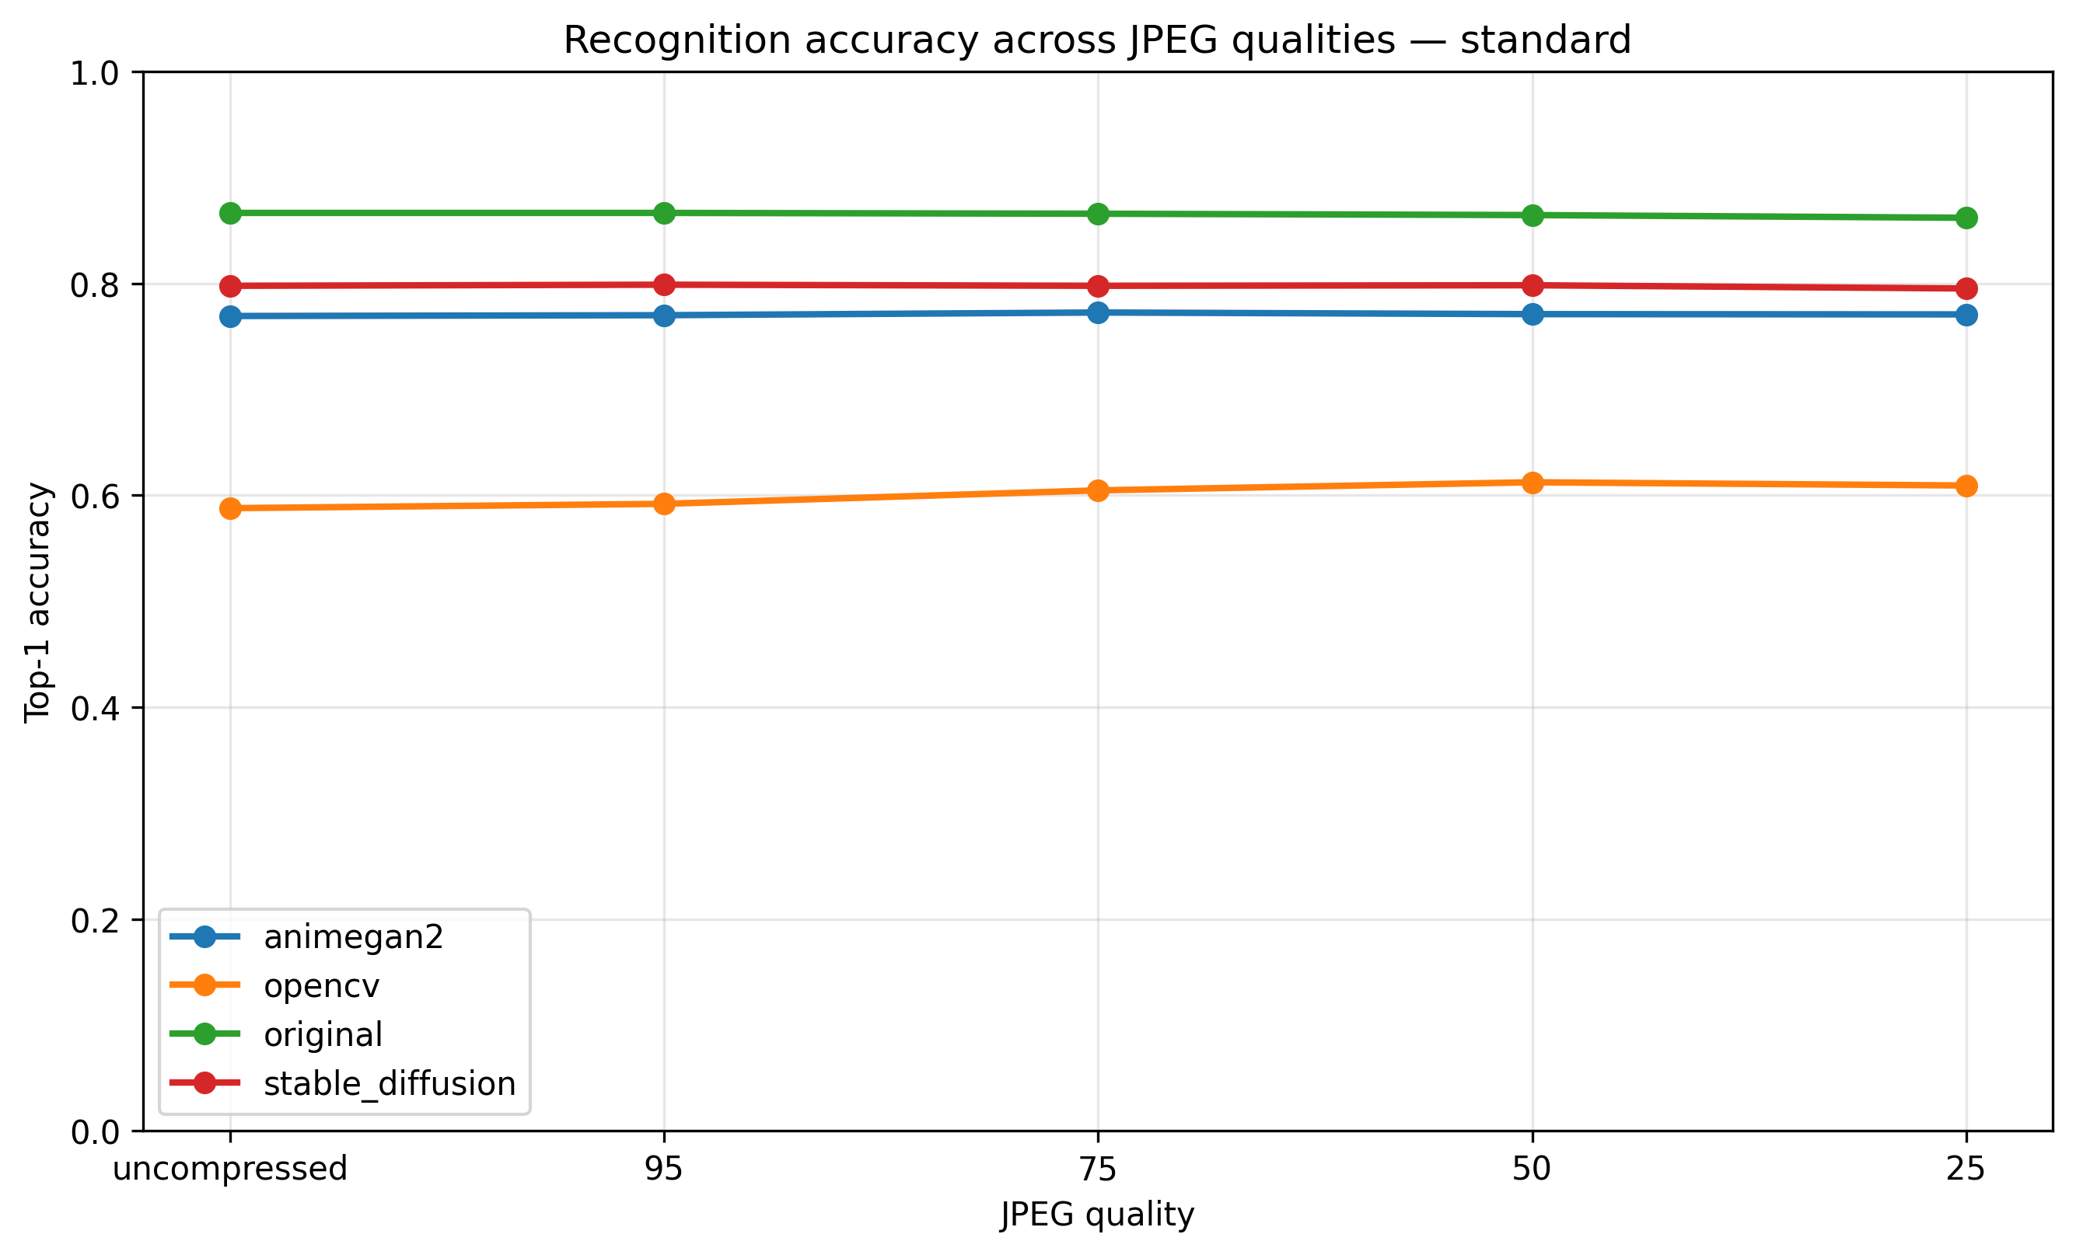
Recognition accuracy — standard classifier
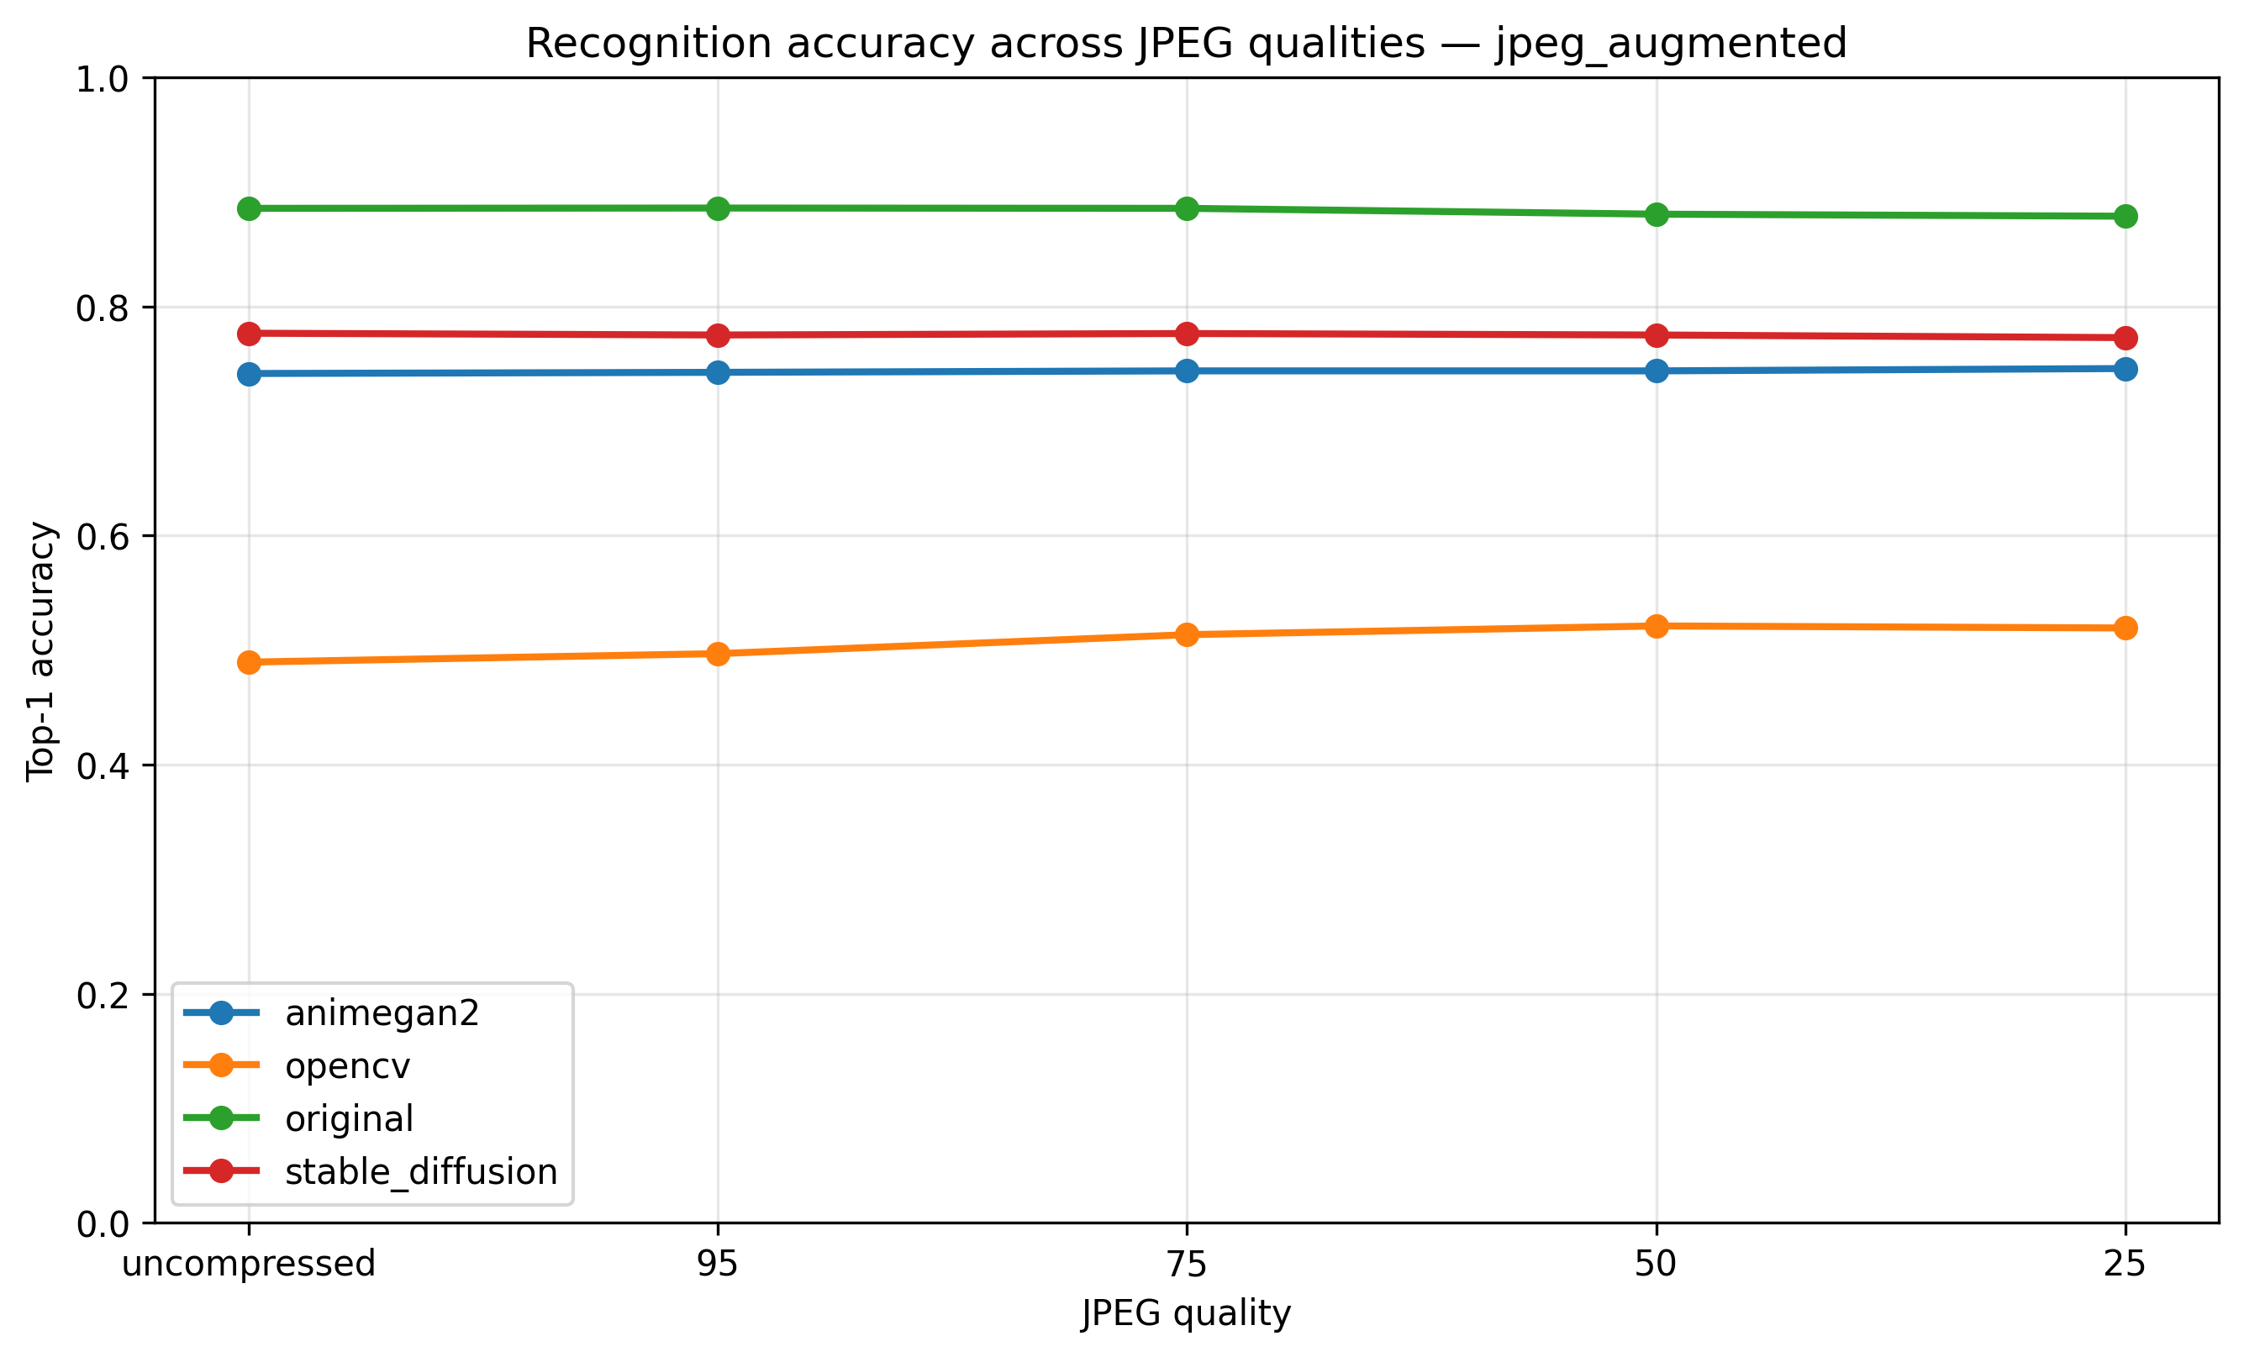
Recognition accuracy — JPEG-augmented classifier
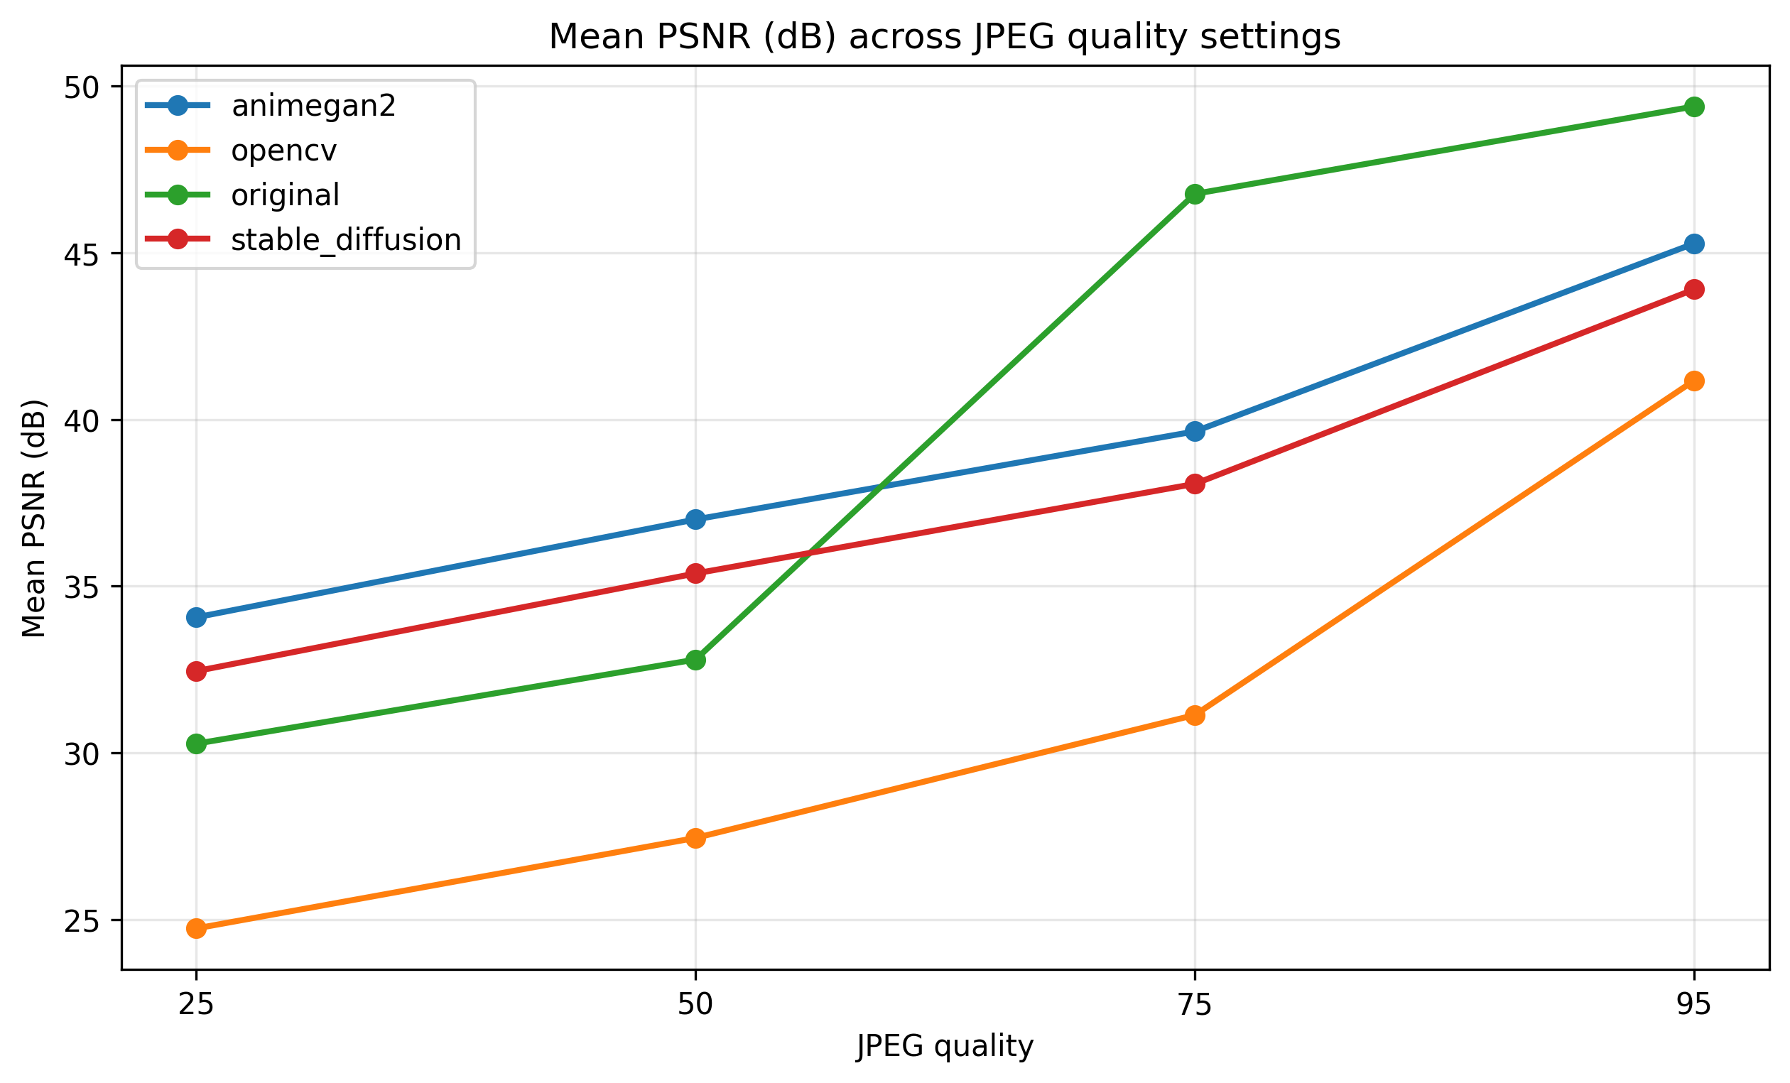
PSNR across JPEG quality settings
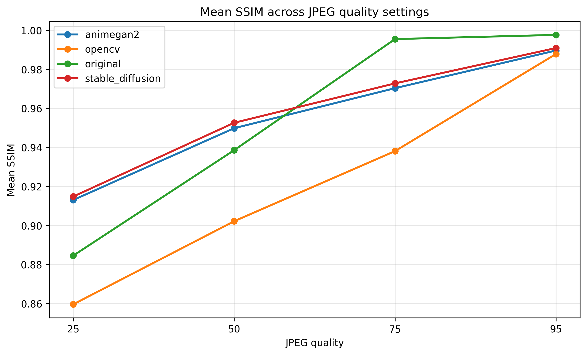
SSIM across JPEG quality settings
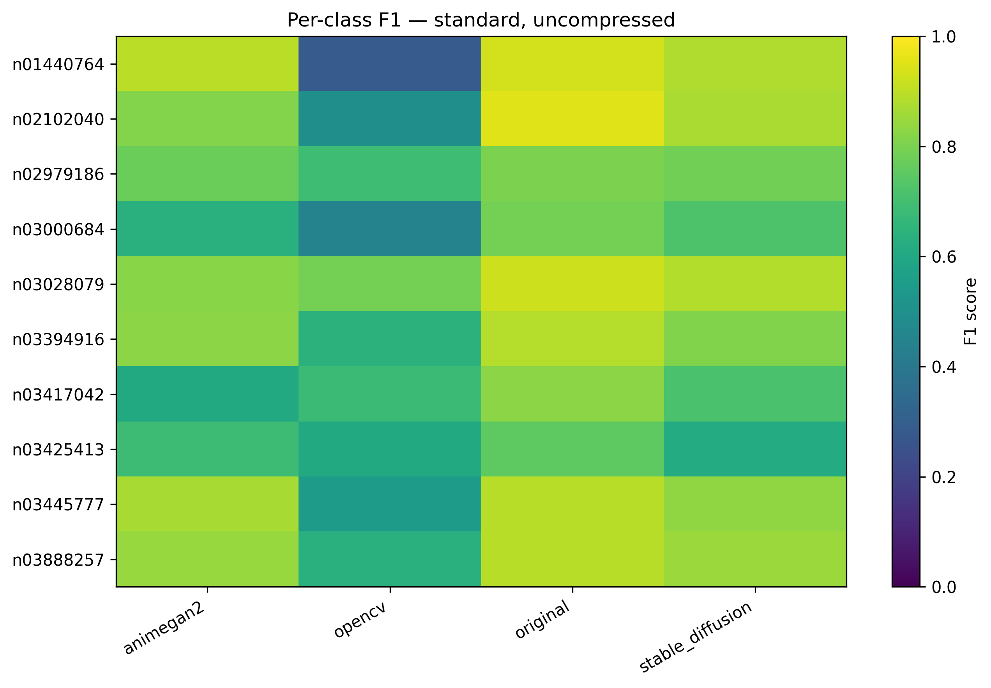
Per-class F1 — standard classifier
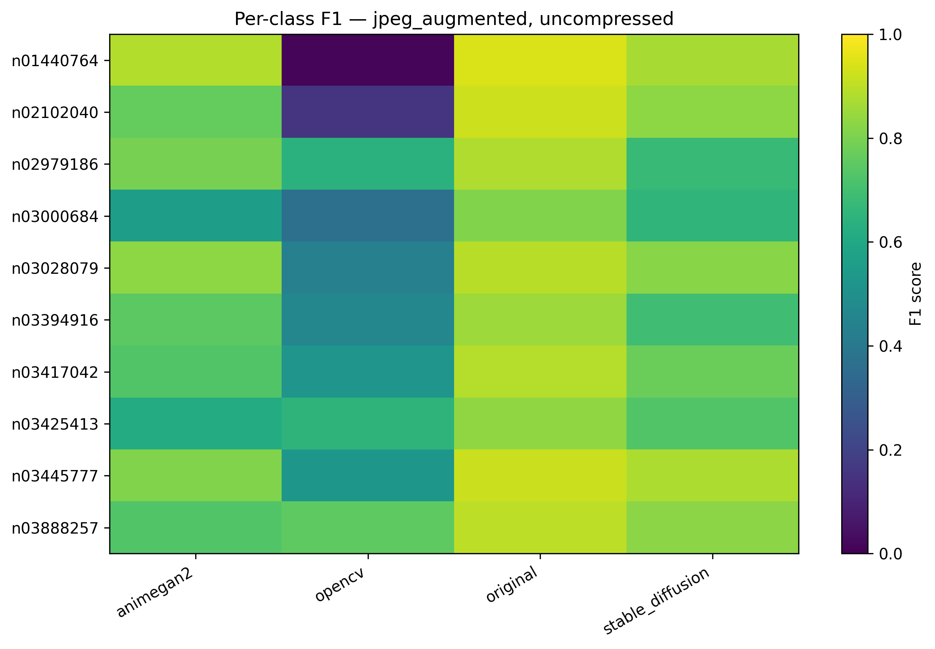
Per-class F1 — JPEG-augmented classifier
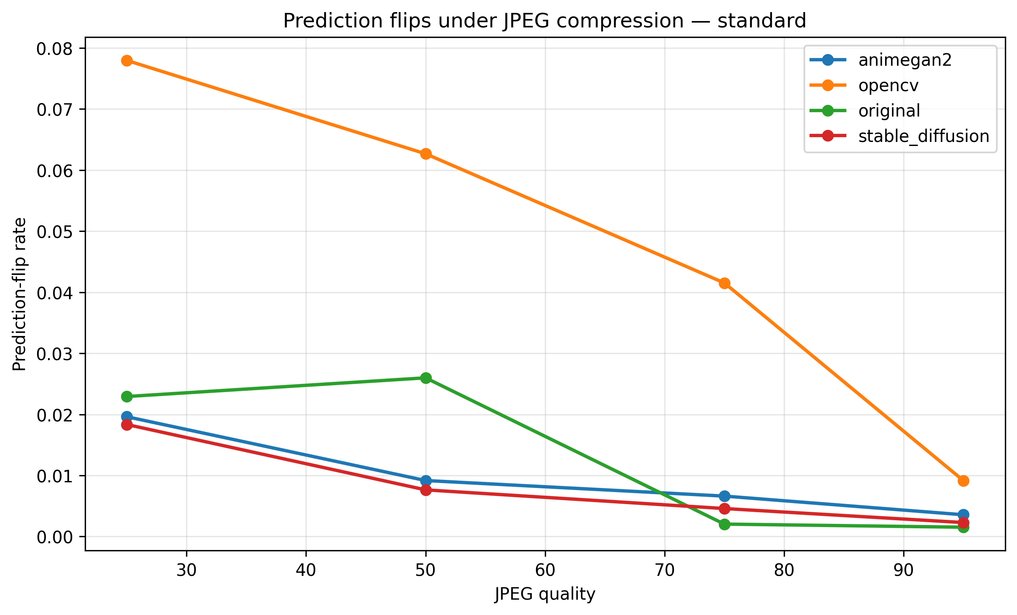
Prediction flips — standard classifier
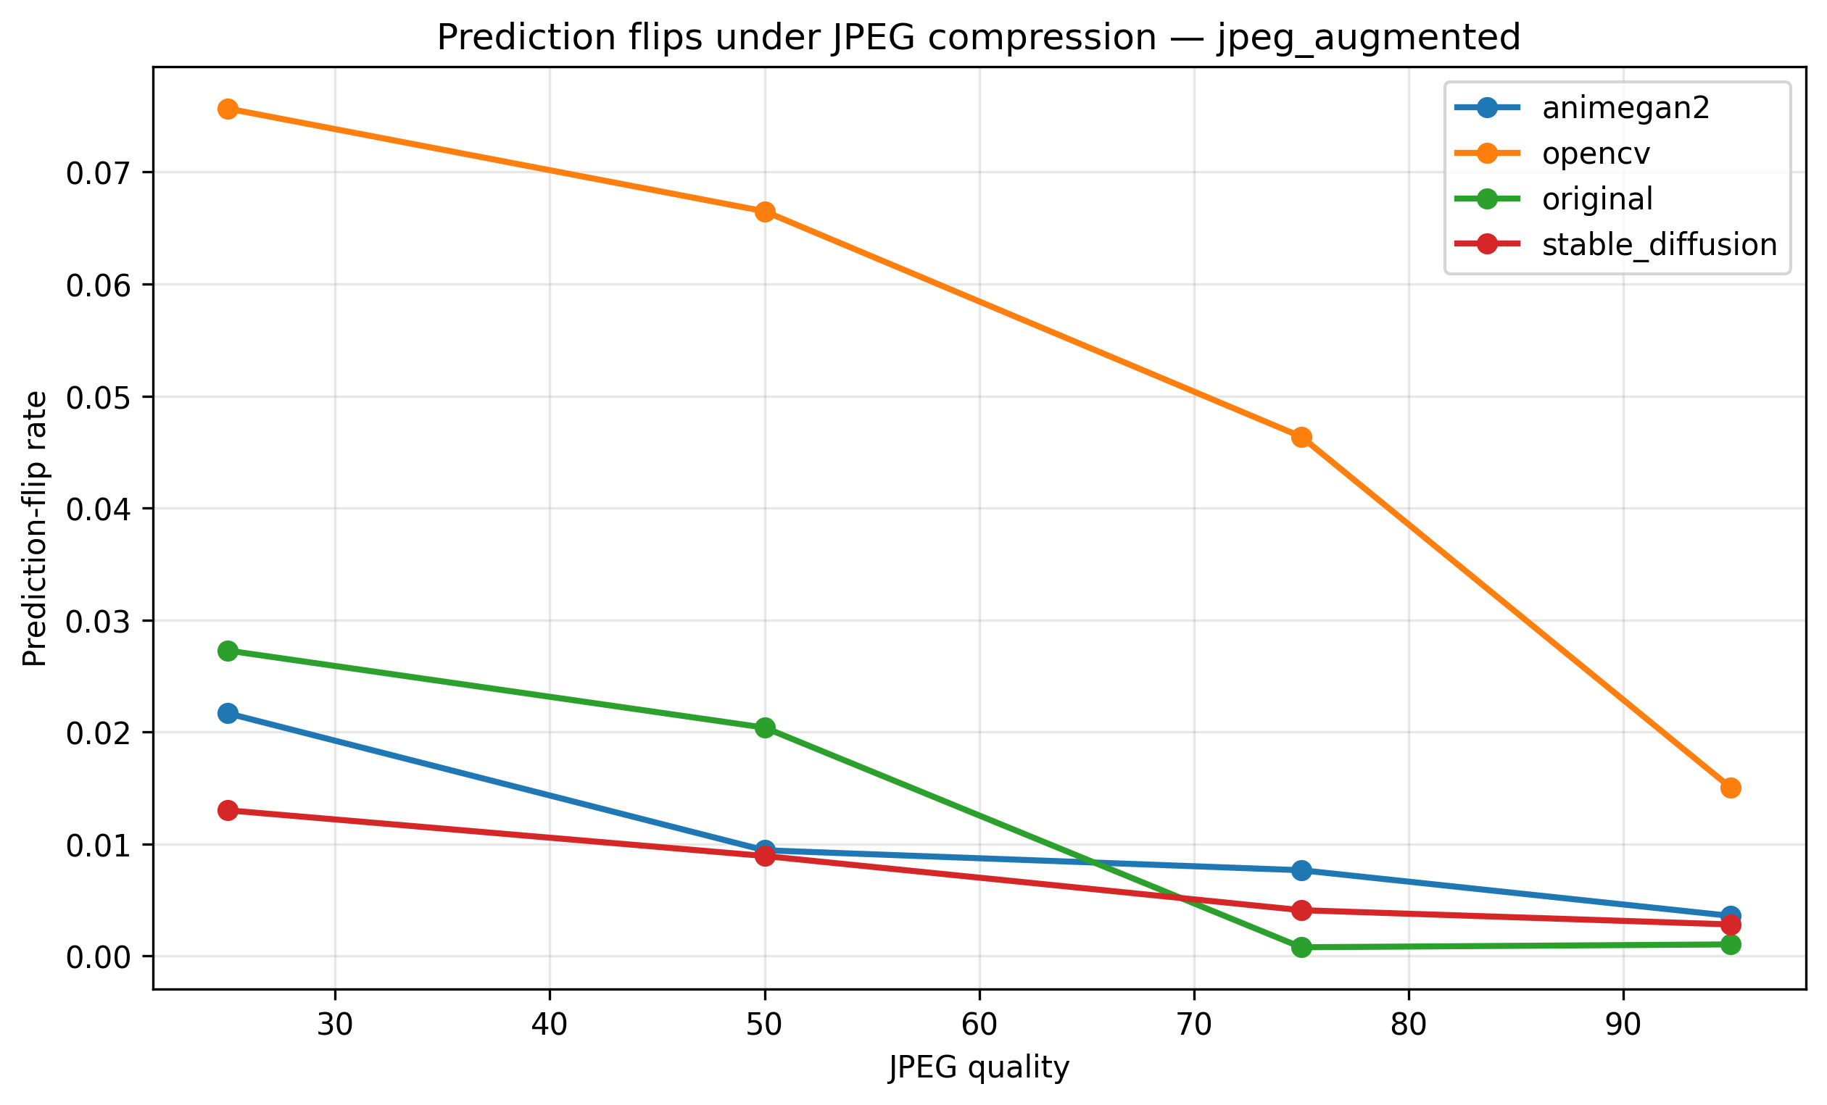
Prediction flips — JPEG-augmented classifier
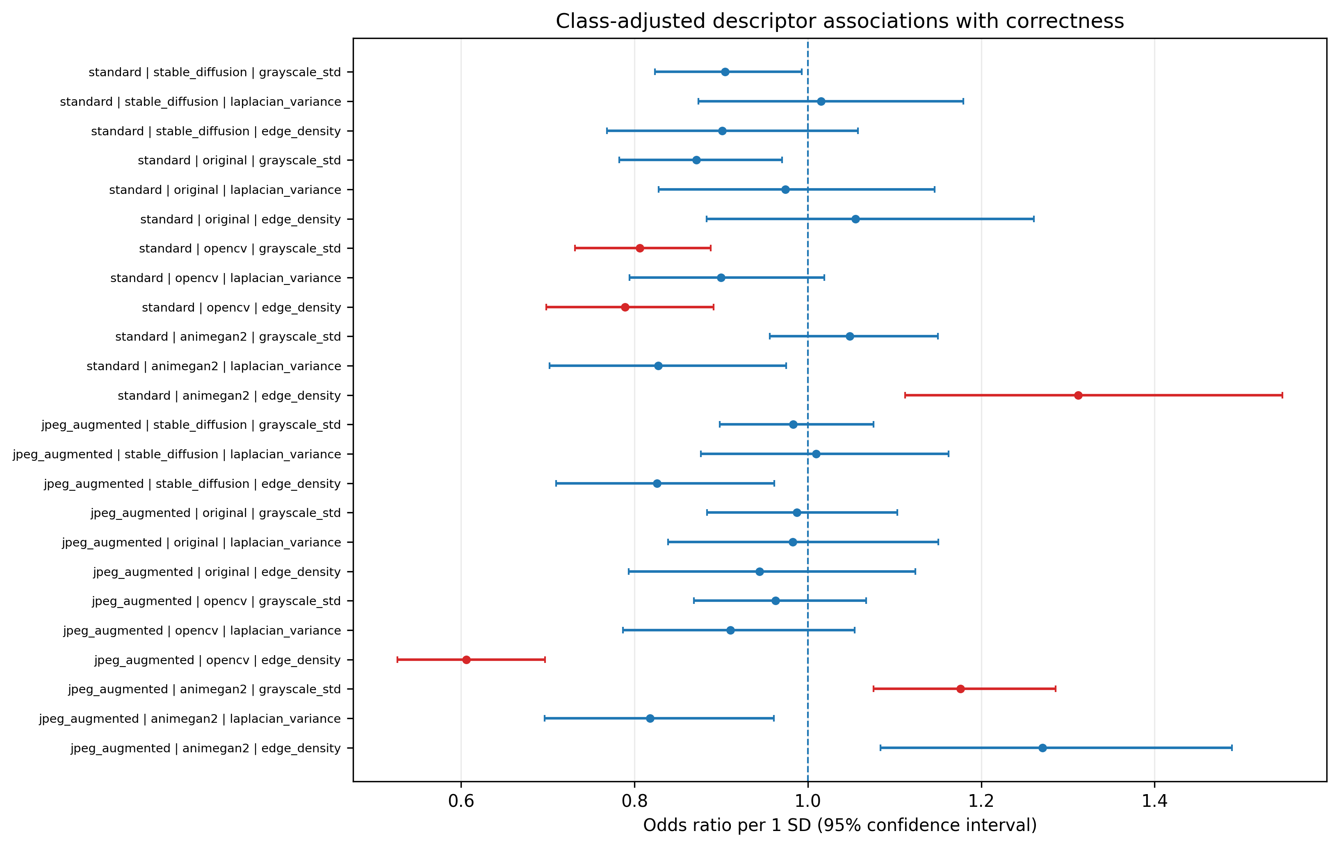
Class-adjusted descriptor odds ratios

6. Discussion
Recognition outcomes should be interpreted as evidence about the evaluated pipelines under this particular experimental protocol, not as a universal ranking of cartoonization methods. Differences between the two classifiers may reflect different sensitivities to transformed image characteristics. The effects of JPEG compression should be assessed by comparing each quality setting with its corresponding uncompressed condition and consulting the paired statistical outputs.

7. Limitations
- The evaluation uses one dataset and one classifier architecture, with two classifier configurations.
- Findings are specific to the selected methods, checkpoints, preprocessing, and compression settings.
- PSNR and SSIM do not fully capture perceptual quality or semantic preservation.
- Descriptor associations do not establish causal mechanisms.
- The study does not include LPIPS, calibration metrics, three-seed replication, or a second dataset or architecture.
- Literature novelty, dataset licensing, model licenses, citations, and full implementation details require final verification.

8. Conclusion
This study provides a matched comparison of original and cartoonized images under multiple JPEG quality settings using standard and JPEG-augmented ResNet18 classifiers. It jointly examines downstream recognition, compression distortion, prediction consistency, class-level outcomes, and exploratory descriptor associations. Conclusions should remain limited to the tested dataset and implementations until further validation across datasets, architectures, and independent random seeds is conducted.

9. References — to be verified
Insert and verify complete bibliographic references for Imagenette, ResNet18, OpenCV cartoonization, AnimeGANv2, Stable Diffusion, JPEG compression, PSNR/SSIM, and the statistical procedures. Do not submit until every in-text citation corresponds to a verified source.

Appendix A. Final reproducibility checklist
- Confirm dataset provenance, split, class counts, and manifest checksum.
- Record source repositories, licenses, checkpoint identifiers, and revisions.
- Record software versions, hardware, seeds, and complete preprocessing.
- Verify metric definitions, denominators, statistical assumptions, and correction families.
- Check all reported numbers against source CSV files.
- Inspect figure readability, axes, legends, captions, and table references.
- Complete the literature and novelty audit before selecting a journal.

