Introduction to Agentic AI in Quality Engineering
The landscape of Quality Engineering (QE) is shifting from rigid, script-based automation to autonomous, AI-driven frameworks. Agentic AI refers to artificial intelligence systems capable of autonomous planning, reasoning, and tool execution to achieve a specific goal. In the context of QE, this means moving beyond simple code-generation assistants to deploying multi-agent systems that can manage the entire testing lifecycle. Rather than a human engineer manually dissecting a requirement, an AI agent takes the initial user story, understands the business logic, and orchestrates the creation of a comprehensive quality net. This approach drastically reduces the time-to-market while simultaneously catching architectural edge cases early in the sprint.
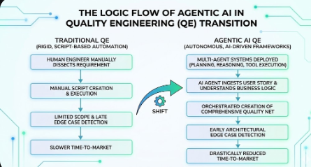

Ingestion and Contextual Analysis
The first critical step in the Agentic AI workflow is context ingestion. A dedicated "Requirements Agent" acts as the bridge between product management and quality assurance. This agent integrates seamlessly with issue-tracking tools like Jira. When a user story is moved to a specific status (e.g., "Ready for QA"), the agent uses APIs to pull not just the textual description, but also the acceptance criteria, past comments, and linked epics. By utilizing Large Language Models (LLMs) with high context windows, the agent maps the dependencies of the new feature against the existing application architecture. It identifies potential regression impacts and flags incomplete requirements back to the product owner before a single line of test code is written.

Scenario Generation via Multi-Agent Collaboration
Once the requirements are ingested and validated, the system employs a multi-agent debate mechanism to brainstorm Test Scenarios. A "Brainstorming Agent" generates a wide array of test ideas, while a "Critique Agent" evaluates them against the original acceptance criteria to ensure no hallucinated or out-of-scope scenarios are included. This collaborative AI process ensures a robust mix of positive paths, negative paths, security considerations, and boundary value edge cases. The output is a highly structured matrix of Test Scenarios that provides the human QE lead with a bird's-eye view of the planned test coverage. This stage serves as the vital "human-in-the-loop" checkpoint where engineers can approve, reject, or modify the high-level strategy.

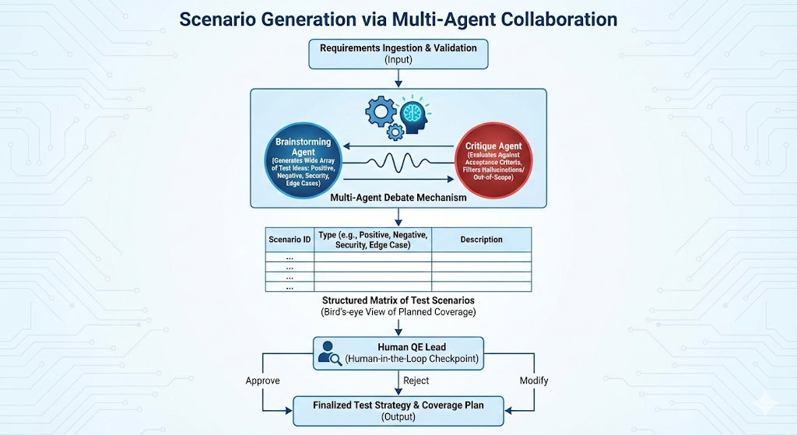

Formulating Precise Test Cases
Following the approval of the Test Scenarios, the "Authoring Agent" takes over. This agent is specifically trained on the structural requirements of test management tools like TestRail. It translates the high-level scenarios into granular, step-by-step test cases. Each generated test case includes a clear title, distinct pre-conditions, highly repeatable action steps, and unambiguous expected results. Furthermore, the agent tags the test cases with appropriate metadata—such as priority, component, and execution type (manual vs. automated). Using API integrations, the system automatically pushes these formatted test cases directly into the designated test suites, completely eliminating the tedious task of copy-pasting and manual data entry.

