# Page 1: Introduction

## FlightFinder: Navigating Your Air Travel Options

FlightFinder is the ultimate digital platform designed to revolutionize the way you book flight tickets. Our user-friendly web app empowers travelers to effortlessly discover, explore, and reserve flight tickets based on unique preferences.

Key Features:

* User-friendly interface
* Efficient search & booking
* Personalized recommendations
* Robust security measures
* Reliable performance
* Continuous improvement based on user feedback

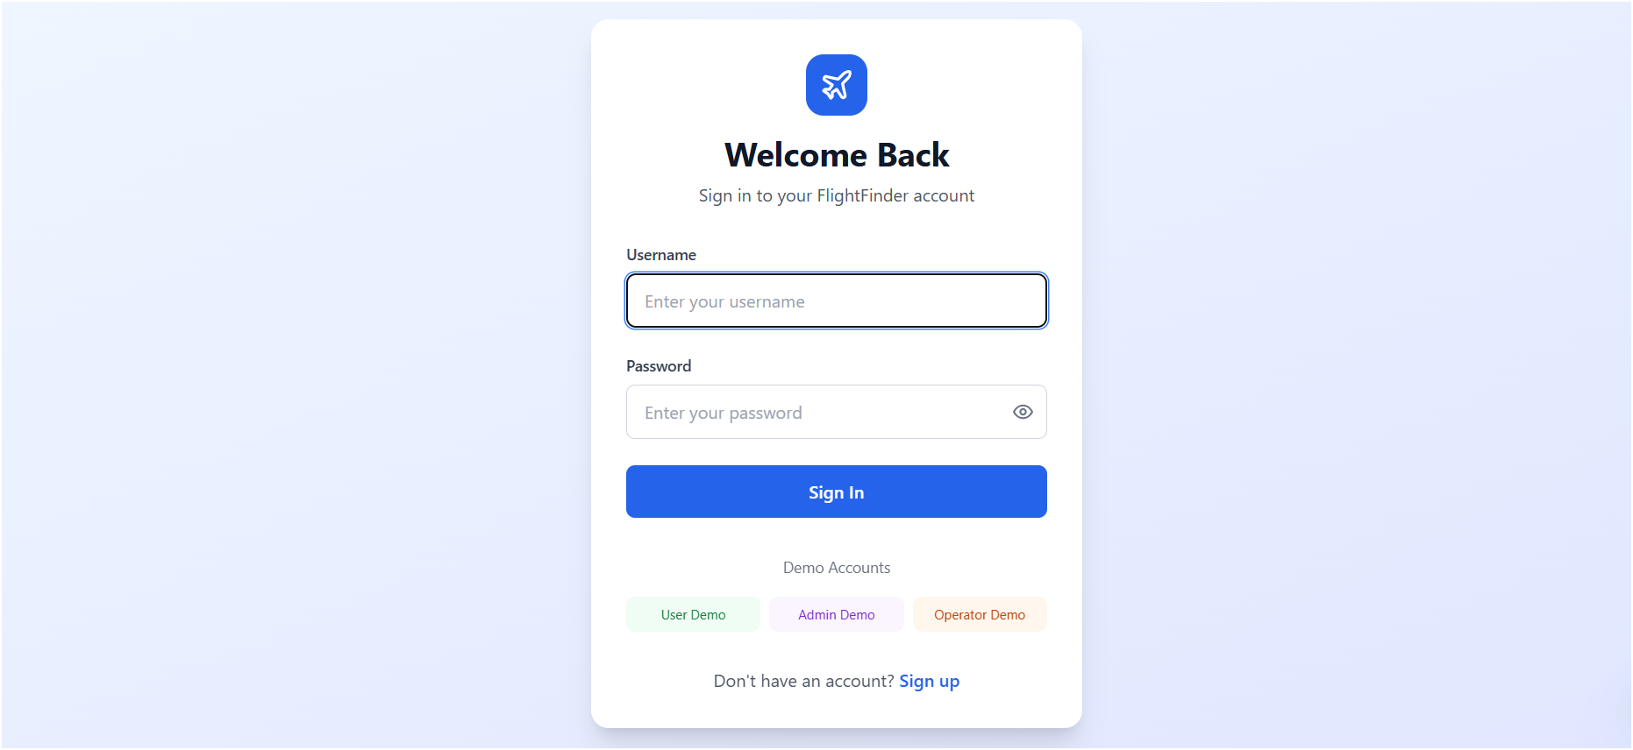

# Page 2: User Scenario

John, a frequent traveler and business professional, needs to book a flight for an upcoming conference in Paris.

* Departure: New York City
* Destination: Paris
* Departure Date: April 10th
* Return Date: April 15th
* Class: Business Class
* Passengers: 1

The app retrieves flight options instantly. John filters for direct flights, chooses his preferred airline, selects a window seat, enters payment securely, and receives his e-ticket and itinerary.



# Page 3: Technical Architecture

System Overview

* Frontend: User Authentication, Flight Search & Booking, Intuitive UI
* Backend: Node.js + Express.js APIs (Users, Flights, Bookings, Admin)
* Database: MongoDB storing Users, Flights, Bookings

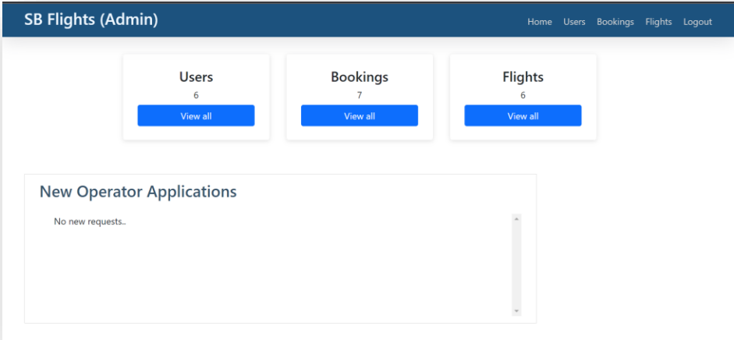

# Page 4: ER Diagram Overview

Entities & Relationships

* USER: Individuals booking flights and making payments
* BOOKING: Specific booking with flight & passenger details
* FLIGHT: Available flights for booking
* ADMIN: Manages backend, flights, and bookings

Relationships:  
• One User → Many Bookings  
• One Booking → One Flight  
• One Admin → Manages many Flights & Bookings

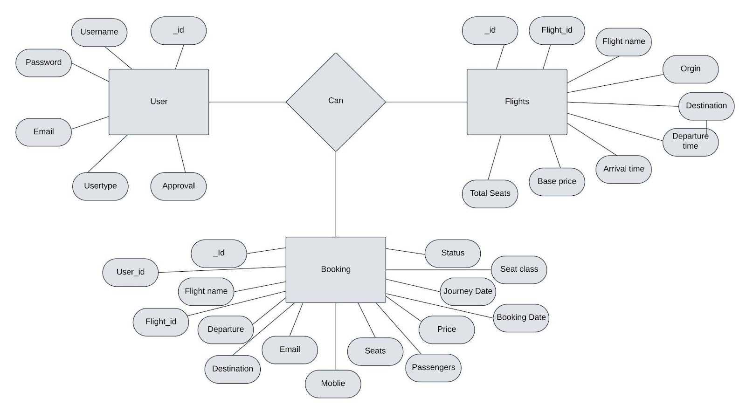

# Page 5: Tools & Installation

* MongoDB: https://www.mongodb.com/try/download/community
* Install Guide: https://docs.mongodb.com/manual/installation/
* Express.js: npm install express
* React.js: https://reactjs.org/docs/create-a-new-react-app.html
* Version Control: Git - https://git-scm.com/downloads
* IDEs: VS Code, Sublime, WebStorm

# Page 6: Running the Project Locally

Steps to Run:

* cd Flight-Booking-App-MERN
* Install Dependencies: npm install
* Run Development Server: npm run dev
* Open http://localhost:3000

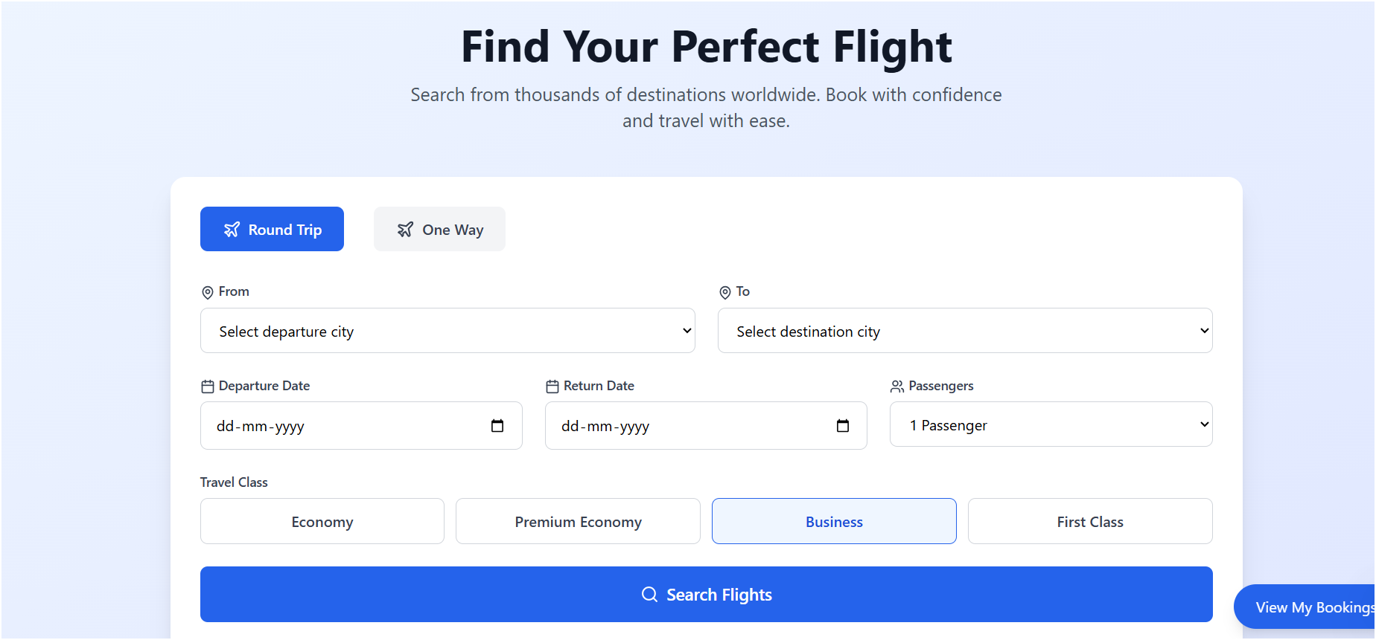

# Page 7: Backend Development

* Database: MongoDB Atlas or Compass
* Express Server: body-parser, cors, API routes
* Mongoose: schemas & CRUD
* User Auth: register/login/logout, middleware
* Admin: Add flights, manage bookings/users, auth checks
* Error Handling: Middleware & proper HTTP codes

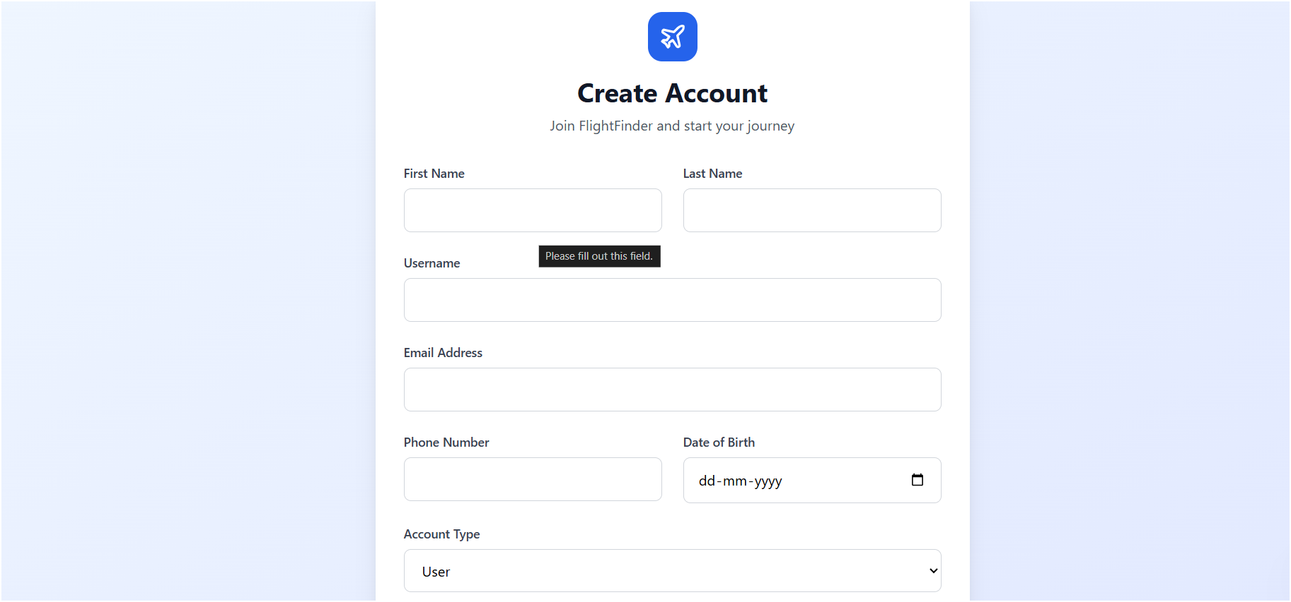

# Page 8: Frontend Development

Components:

* Login/Register forms and routing
* Flight Search inputs
* Booking Modal: seat selection
* User Dashboard: view/cancel bookings
* Admin Dashboard: add/update flights, view bookings/users

Tech Used: React.js, Bootstrap, Axios, Netlify for hosting

# Page 9: Application Flow

User Flow:

* Register/Login
* Search flights
* Apply filters
* Book flights & choose seats
* Secure payment
* View/cancel bookings

Admin Flow:

* Login to Dashboard
* Add/update flights
* Manage bookings
* Monitor user activity

# Page 10: GitHub Repository

Thank you for exploring FlightFinder!  
To collaborate, customize, or contribute, visit our open-source repository:

GitHub Repository: https://github.com/Karthik681-art/Airlines-management-system/blob/main/README.md