**About us**

Madanapalle Institute of Technology & Science (MITS) has inculcated the culture of entrepreneurship. MITS has initiated the incubation centre in the year 2023 with an intention to provide creative atmosphere, wherein new ideas and projects can flourish. The incubation centre is registered as Madanapalle Institute of Technology and Science Foundation (MITS Foundation), a section 8 company as per the Companies Act, 2013. The foundation was registered on 3rd October 2024. The Foundation is established to offer a platform for staffs, students, alumni and general public who are aligned with its theme, for the purpose of business incubation and innovation. The center is taking an active role in fostering an entrepreneurial culture and environment for ideating, establishing, and commercializing businesses. Also, it provides working spaces for incubation and offers counseling services on business management and technological solutions. The approach is intended to help innovators in transforming their ideas into products. It identifies tools, devices, and technology and putting together a network to commercialize the items or services, thereby innovators and entrepreneurs can get benefitted.

**Directors**

1. **Dwarakanath Nadella**
2. **Vijayabhaskar Choudary Nadella**
3. **Keerthi Nadella**

**Objectives**

The main objectives of Foundation are

* + - To inspire faculty, staff and students to participate in innovation, ideation, and product development.
    - To transfer technology-based entrepreneurial knowledge, methodology, and practice and support for students’ creative ideas.
    - To educate researchers, faculty, and students about patenting.
    - To connect scientific and technology related industries and higher education institutions
    - To establish a platform for information exchange and application in real-time research.

**Vision**

* To become a prominent incubation center for developing sustainable and successful startup ventures and contribute to the Socio-techno-economic development of the nation.

**Mission**

* MITS Foundation is committed to foster an innovation and entrepreneurship culture and support budding innovators in their early-stage business ventures.

**Thrust Areas**

* Education
* Cyber Security, Artificial Intelligence, Information & Communication Technology
* Drone Technology, Manufacturing & Automation and other emerging areas of social / national importance
* Building Materials/Construction Technology
* Renewable Energy, Electric Mobility and Environmental sustainability

**Incubation Facilities**

* Office space with basic infrastructure and Computing facility

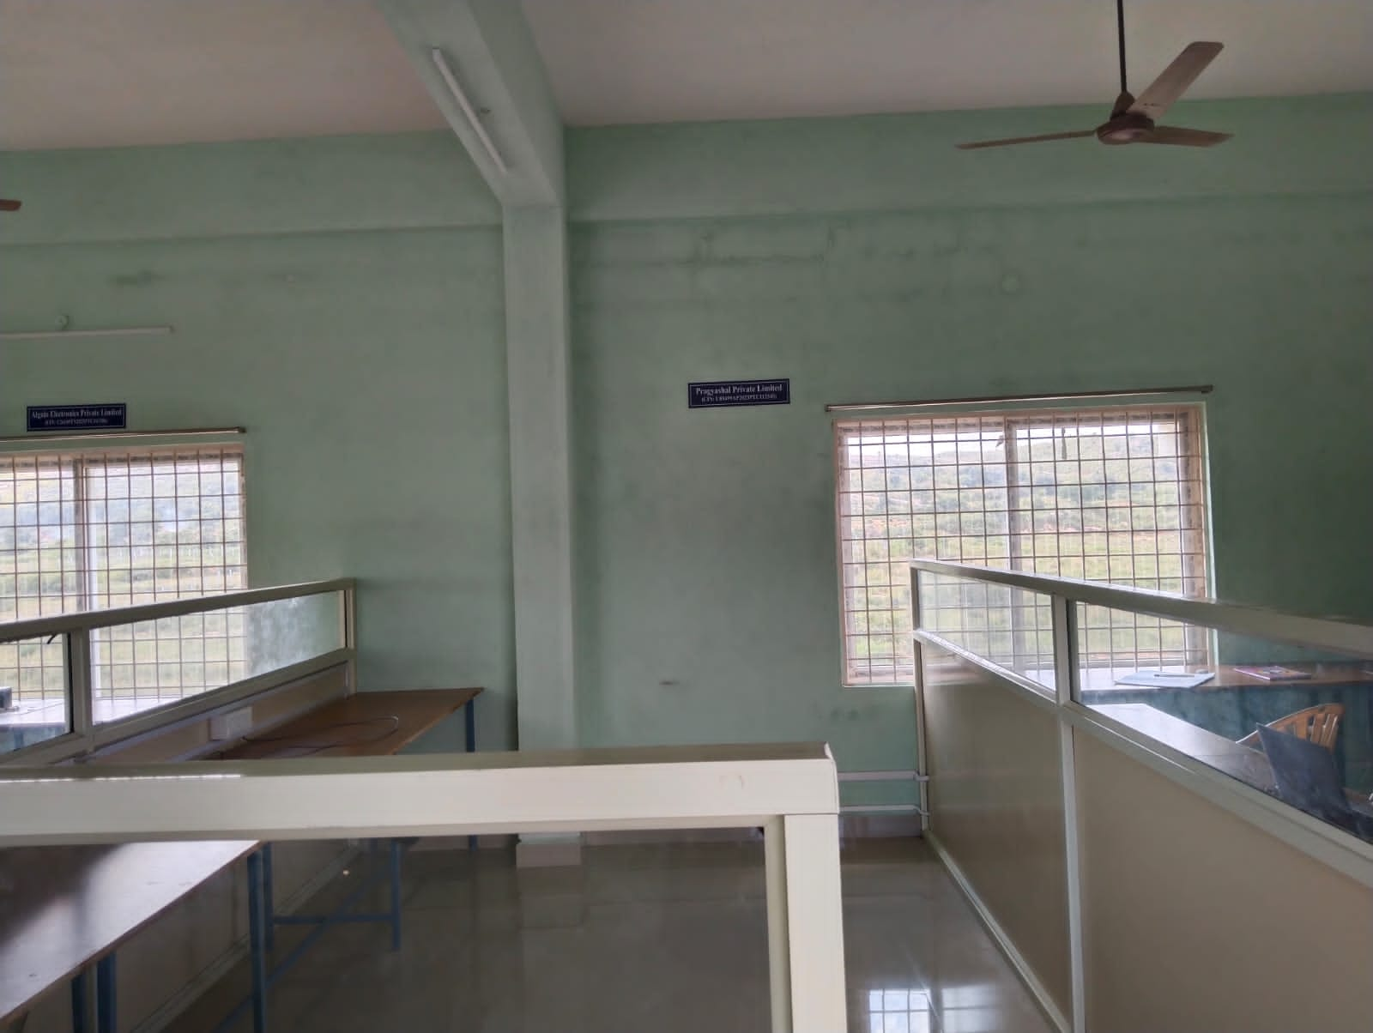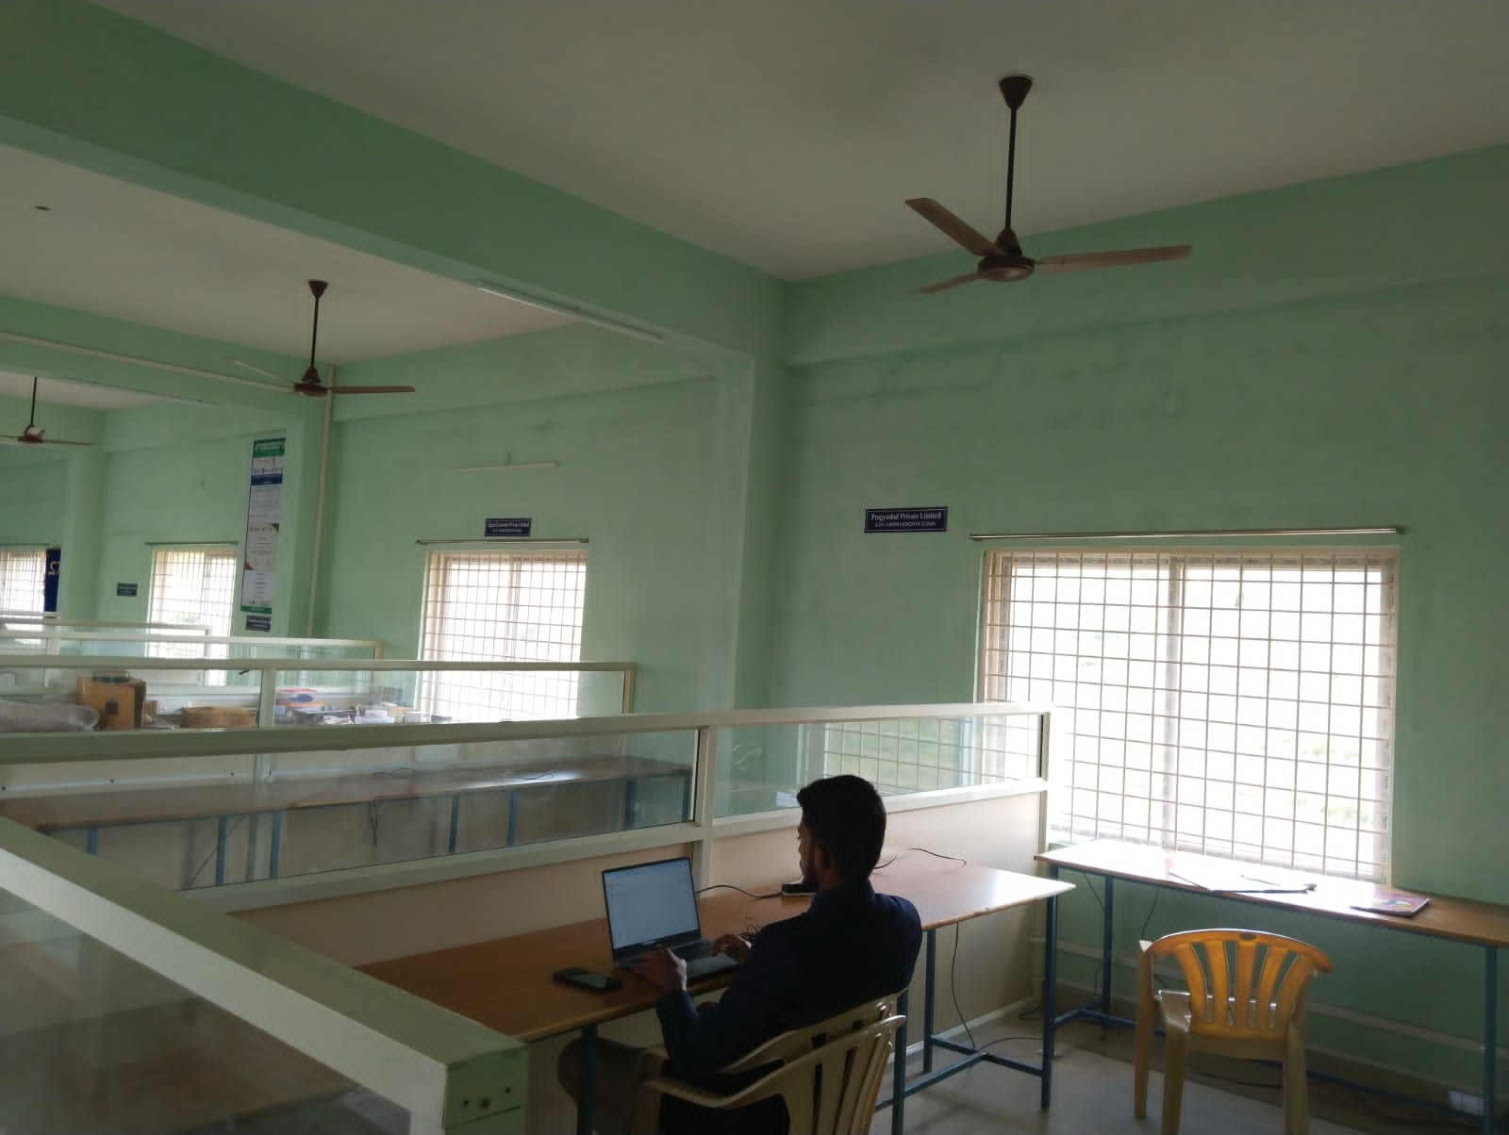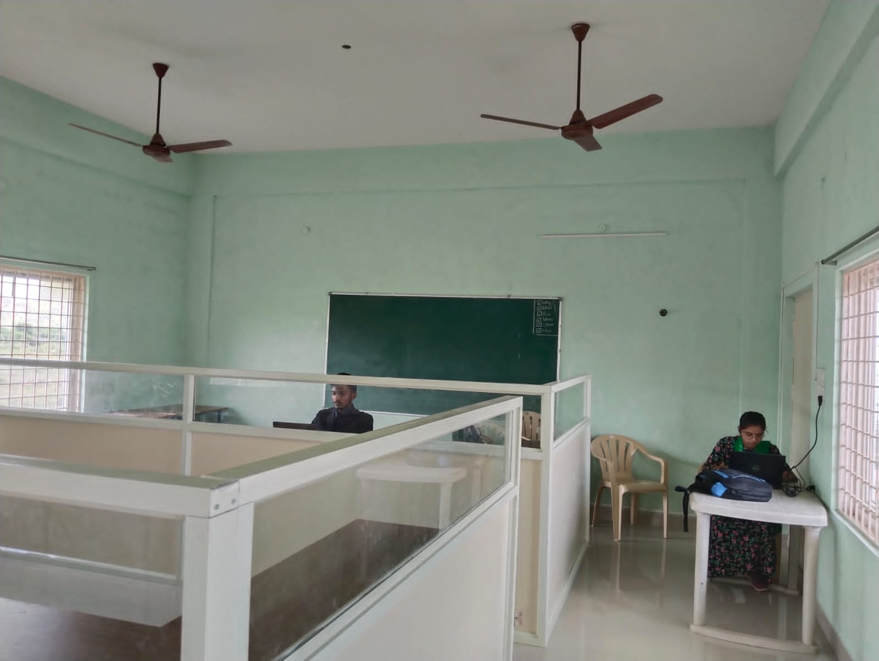

* Common meeting room
* Laboratory facilities

**Our Partners**



**Incubated Companies**

1. Motel Hub LLP

<https://motol.in/>

An online e-com platform to book accommodation at PGs and hotels as well as groceries, hotels, pick-up and delivery of items, etc.



1. Pragyashal Private Limited



PRAGYASHAL is a next-generation EdTech platform founded by students from IIT Madras, driven by a passion for transforming education through Artificial Intelligence (AI). As a recognized Google Cloud Partner, a proud member of the NVIDIA Inception Program, and a participant in Microsoft for Startups and Zoho for Startups, we are on a mission to revolutionize learning with cutting-edge AI-powered educational tools.

<https://www.linkedin.com/company/pragyashal/?originalSubdomain=in>

1. Algain Electronics Private Limited



<https://algainelectronics.com/>

Algain Electronics is an electronic product founded in 2023. Our product development includes energy saving LED lights & smart accessories. We investigate the problems and find right solutions. With the latest cutting-edge technology, domestic as well industry related optimal energy saving products are designed.

1. Aurv Organics Private Limited



<https://www.indiamart.com/aurv-organics-pvt-ltd/enquiry.html>

Aurv Organics Pvt. Ltd. provides you the best range of moong dal, organic soaps, body butter, handmade soap, face gel & eye kajal with effective & timely delivery.

1. Gyaantrix Technologies Private Limited

<https://www.linkedin.com/company/gyaantrix-technologies-private-limited/>



Gyaantrix Technologies is a forward-thinking technology company dedicated to driving innovation for a better world. Founded with a vision to revolutionize industries through cutting-edge technology, specialized in developing groundbreaking projects across various sectors. From streamlining legal processes and breaking language barriers to enhancing security in transportation hubs and providing comprehensive support for students planning to study abroad, committed to creating transformative solutions that address pressing global challenges.

1. Hexaind Technologies And Services LLP



<https://hexaind.com/>

HEXAIND Technologies & Services was started in the year 2010 as a web designing company. The simplicity and quality involved in the designs opened doors to multiple digital infrastructure and information technology services eventually. In the year 2014, HEXAIND T&S launched its cloud-based SaaS & IaaS services in association with global cloud giants. Now we offer services and assistance in versatile areas of cloud computing and digital infrastructure.

1. Creomind Innovations Private Limited

<https://sites.google.com/view/creomindinnovations>

Creomind Innovations is a startup company focused on creating solution to the projects, providing education and upskill the Technical Students.

We are passionate about providing the required skills to learners and experience by assigning projects to them.

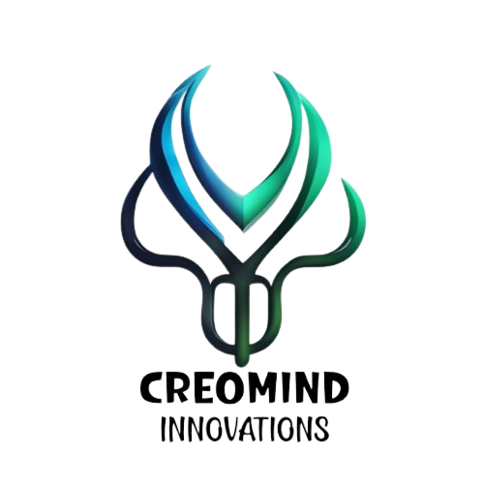

1. Srivari Farm Equipments

<https://www.indiamart.com/sri-vari-farm-equipments/>

1. Harebin Tech solutions Private Limited



<https://harebin.com/>

Harebin Tech Solutions is a dynamic service and product-based company dedicated to providing top-tier tech solutions. Our team of experts excels in offering a range of services, from software development and IT consulting to digital transformation and more.

**Contact us:**



<https://maps.app.goo.gl/N4NjEXFPNendteiC6>

Madanapalle Institute of Technology and Science Foundation

Madanapalle Institute of Technology & Science Campus,

Kadiri Road Angallu, Village, Madanapalle, Andhra Pradesh 517325

[manager@mitsfoundation.org](mailto:manager@mitsfoundation.org)