Batch Inspection Report: karthik

Table of Contents
1. Executive Summary
2. Batch Repair Summary
3. Defect Analysis
3.1 PD_1

1. Executive Summary
**Executive Summary: Maritime Vessel Inspection Findings**
This Executive Summary presents a concise overview of the findings from the recent comprehensive maritime vessel inspection.
The inspection identified a total of two (2) distinct deficiencies requiring attention. The cumulative estimated cost for rectifying these identified non-conformities is INR 138,611.76.
Analysis of the deficiencies indicates a mixed severity distribution. This profile suggests that while some identified items may represent minor observations or non-critical deviations, others present more significant technical or operational risks that warrant prompt remediation to maintain regulatory compliance and operational integrity.
Prompt review and action on these findings are recommended to ensure sustained vessel seaworthiness, compliance with maritime regulations, and to mitigate potential future operational liabilities.

2. Batch Repair Summary
Metric | Value
Total Defects | 2
Total Estimated Cost | 138611.76 INR
Material Cost | 83167.06 INR
Labor Cost | 41583.52 INR
Equipment Cost | 13861.18 INR

3. Defect Analysis

3.1 PD_1

Defect Overview
This report details the significant maritime defect identified as **DEFORMATION**, observed within a substantial portion of the **HULL_AREA** (with a detected overlap ratio of 0.33). This defect has been classified with a **high severity**, necessitating immediate professional attention.
---
### **Explanation of DEFORMATION**
1. **What the defect means:**
Deformation, in the context of a vessel's structure, refers to an out-of-plane bending or distortion of hull plating or its supporting stiffeners. This typically manifests as buckling (inward or outward bulges) or warping (twisting or uneven surfaces). Such damage can arise from various factors, including direct physical impacts like groundings, exposure to severe sea loads that exceed design limits, or localized stresses induced by processes such as uneven welding or thermal expansion/contraction.
2. **Why it is important:**
This defect is of paramount importance because even seemingly moderate instances of buckling or warping can severely compromise the structural integrity of the vessel. The hull plating and stiffeners are integral components of the ship's primary structure, forming the 'hull girder' which resists global bending and shearing forces. Any significant deviation from their designed geometry immediately reduces their load-carrying capacity and structural efficiency, making the vessel vulnerable. Classification societies rigorously monitor and require rectification for significant deformations due to their critical impact on safety.
3. **Risks if not repaired:**
Failure to promptly address significant deformation carries substantial risks. The most critical consequence is the progressive weakening of the hull girder strength, which can lead to catastrophic structural failure, particularly when the vessel encounters adverse weather conditions, heavy seas, or other dynamic loads. This weakening can also impair the watertight integrity of compartments, potentially leading to ingress of water. Furthermore, unrepaired deformation can accelerate fatigue damage in adjacent structures, reduce the vessel's overall operational safety, and will likely result in non-compliance with classification and statutory requirements, potentially leading to detention or restrictions on future operations.
4. **Structural implications:**
Structurally, deformation directly implies a significant reduction in both the local and global strength of the vessel. The out-of-plane bending of plating and stiffeners means these elements can no longer effectively transfer compressive and tensile loads as originally designed. This critically diminishes their contribution to the overall hull girder's ability to withstand longitudinal and transverse stresses, thereby reducing the vessel's primary strength. As per standard classification practice, significant buckling or warping necessitates structural renewal, typically involving cutting out and replacing the distorted metal with new, appropriately faired sections. While very minor, localized 'set-in' plating might occasionally be tolerated if it does not affect strength, the observed extent and high severity of this deformation affecting a substantial part of the HULL_AREA demands immediate and thorough repair to restore the vessel's structural robustness to its design standard.

Visual Evidence
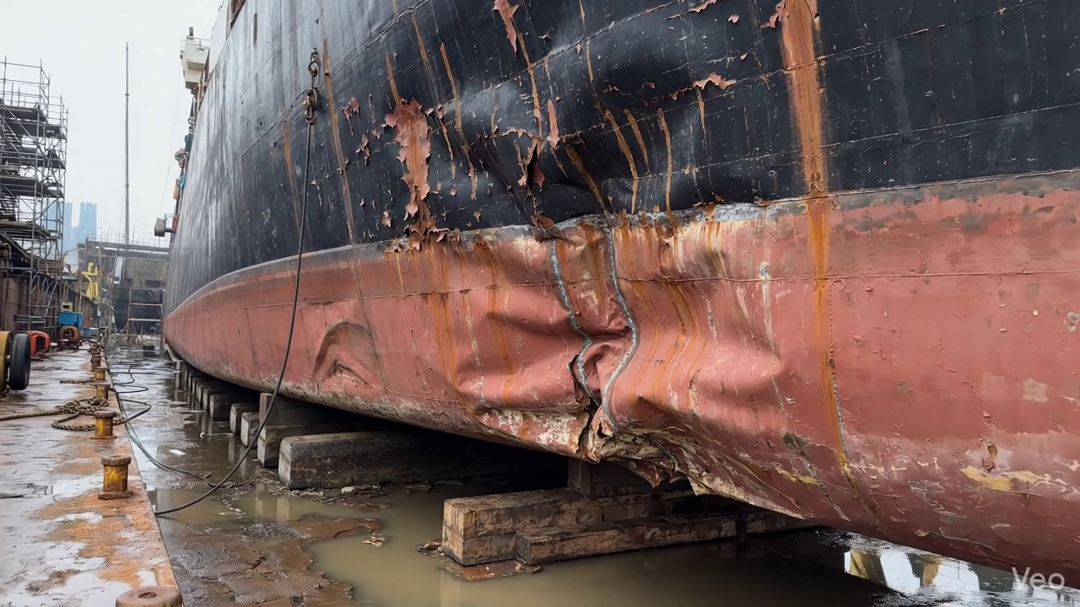

Repair Procedure
## Maritime Hull Plate Repair Process: Professional Explanation for Vessel Inspection Report
This document outlines the professional procedure for conducting structural repairs to vessel hull plating, specifically addressing localized deformation or buckling. The process emphasizes structural integrity, quality control, and adherence to classification society standards.
---
### **1. Repair Process Explanation**
The repair of a buckled hull plate involves a systematic approach to ensure the vessel's structural integrity, watertightness, and aesthetic fairness are fully restored. Each step is critical for a durable and compliant repair.
#### **1.1. Assessment**
* **Why Necessary:** This initial phase is paramount for accurately defining the scope of the repair. It prevents under-repairing (leaving compromised material) or over-repairing (unnecessary work), both of which have significant cost and safety implications. Understanding the deformation's extent ensures the subsequent repair addresses all affected areas.
* **What Happens:** A thorough visual inspection is conducted to identify and mark the exact boundaries of the deformed region. Technicians will determine if the buckling is localized to a single plate section or if it spans adjacent structural members such as frames, girders, or stiffeners. Precise measurements of any "out-of-flatness" are taken using appropriate gauges or straightedges to quantify the deformation and establish baseline data for repair planning.
#### **1.2. Preparation**
* **Why Necessary:** This step ensures that all compromised, fatigued, or distorted material is completely removed, providing a sound and clean base for the new steel plate. Welding new material to damaged or stressed existing material significantly weakens the repair and can lead to premature failure or crack propagation. The "margin of good plate" ensures the new weld is on material of full, unaffected thickness, optimizing weld quality and strength.
* **What Happens:** Using thermal cutting equipment, all visibly distorted plate sections, along with any buckled or significantly bent girders or stiffeners, are meticulously cut away. The cutting boundary extends into the "sound metal," leaving a margin of at least three-quarters of the original plate thickness beyond the visible damage. This margin guarantees that the new weld will be executed on structurally sound material. Any underlying bent framing that is not being replaced is either straightened to its original alignment or removed if straightening is not feasible or effective.
#### **1.3. Plate Replacement**
* **Why Necessary:** This stage is fundamental to restoring the structural continuity, load-bearing capability, and watertight/oiltight integrity of the hull. The new plate effectively replaces the removed, compromised section, reinstating the vessel's design specifications.
* **What Happens:** A new steel plate, matching or exceeding the original specified thickness and material grade, is fabricated. This new plate is precisely shaped and dimensioned to fit the aperture created by the removal of the damaged section. It is then carefully positioned against the remaining hull plating, ensuring correct alignment and minimal gaps. The new plate is secured in place with tack welds to maintain its position and alignment during the primary welding process. Subsequently, full-perimeter welding is initiated, ensuring good fusion with the existing hull structure. Appropriate preheat procedures are applied, particularly for thicker plates or higher-strength steels, to mitigate hydrogen cracking and ensure optimal weld mechanical properties. Full penetration welds are employed wherever design and accessibility allow, maximizing the strength and structural continuity of the repair.
#### **1.4. Alignment and Welding**
* **Why Necessary:** This step completes the permanent structural connection of the new plate to the vessel's hull. Proper alignment and distortion control are critical to prevent the introduction of new stresses or unfairness in the hull, which could negatively impact hydrodynamic performance, aesthetics, or even structural integrity under load.
* **What Happens:** Continuous weld passes are applied to complete the full penetration welds around the perimeter of the new plate. E7018 low-hydrogen electrodes are typically utilized due to their excellent mechanical properties, high deposition rates, and resistance to hydrogen-induced cracking, making them suitable for critical structural applications. Throughout the welding process, careful attention is paid to controlling heat input to minimize thermal distortion. Techniques such as strong-backs, clamps, sequence welding, or skip welding may be employed to maintain plate alignment and prevent buckling. Once welding is complete, all weld seams are meticulously ground fair with the surrounding hull surface. This reduces stress concentrations, improves hydrodynamics, and ensures a smooth, aesthetically pleasing finish. In instances of extensive original buckling or if the repair significantly alters the local stress distribution, additional strengthening, such as doublers (pads welded over the joint) or new stiffeners, may be designed and applied to enhance the section modulus and reduce localized stress.
#### **1.5. Finishing**
* **Why Necessary:** The final stage validates the quality of the repair, protects the new steel from environmental degradation, and restores the vessel's operational functionality and appearance.
* **What Happens:** The completed repair undergoes rigorous inspection. This includes comprehensive visual inspection for any surface defects, undercut, or incomplete fusion. Crucially, Non-Destructive Testing (NDT) methods, such as Magnetic Particle Testing (MPT), Liquid Penetrant Testing (LPT), or Ultrasonic Testing (UT), are employed to detect subsurface defects like cracks, porosity, or lack of fusion, ensuring the weld integrity meets classification society standards. Upon successful NDT, the new steel surface is thoroughly cleaned and prepared for coating. A primer coat is applied, followed by appropriate finish coats, meticulously restoring the corrosion protection system of the hull. Finally, the repaired deck or hull surface is faired back to its original contour, ensuring smooth lines, preventing drag, and maintaining the vessel's design profile.
---
### **2. Usage of Required Items: Cutting Torch**
The **Cutting Torch (rental)** is a critical tool specifically utilized during the **Preparation** phase of the repair process.
* **Why Used:** Its primary function is the rapid and efficient removal of the damaged and distorted steel plate, along with any buckled girders or stiffeners. Thermal cutting, typically via oxy-fuel or plasma torch, provides the necessary speed and precision to cut through thick steel sections, creating the precise aperture for the new replacement plate. The rental aspect suggests that while essential, its usage may be intermittent or project-specific, making rental a cost-effective solution rather than permanent ownership for the repair facility or specific repair scenario.
---
### **3. Safety and Structural Considerations**
#### **3.1. Structural Integrity**
* **Material Selection:** New steel plate must match or exceed the original material's mechanical properties and thickness (or be greater if designed for reinforcement) to maintain the vessel's design strength.
* **Sound Metal Requirement:** Welding must only occur on sound, unaffected base metal to prevent crack initiation and ensure full strength of the new joint. The specified "≥¾ thickness" margin is critical here.
* **Weld Quality:** Full penetration welds (where specified), proper fusion, and defect-free weld metal (verified by NDT) are fundamental to restoring the structural continuity and load-bearing capacity of the hull.
* **Distortion Control:** Uncontrolled heat input during welding can induce significant residual stresses and distortion, leading to new areas of weakness or unfairness in the hull. Effective distortion control techniques are vital.
* **Alignment:** Proper alignment of the new plate with existing structures and underlying framing is essential to distribute loads correctly and prevent localized stress concentrations.
* **Classification Society Rules:** All structural repairs must strictly adhere to the rules and requirements of the vessel's classification society (e.g., DNV, LR, ABS), which govern material, welding procedures, and inspection protocols.
#### **3.2. Safety Considerations (Personnel and Vessel)**
* **Hot Work Precautions:** Cutting and welding operations constitute "hot work" and require strict adherence to safety protocols. This includes fire watches, removal of combustible materials, availability of fire extinguishing equipment, and proper ventilation to dissipate fumes.
* **Personal Protective Equipment (PPE):** Welders and cutters must wear appropriate PPE, including welding helmets, flame-retardant clothing, gloves, safety shoes, and respirators to protect against arc flash, UV radiation, heat, sparks, and hazardous fumes.
* **Fume Management:** Adequate local exhaust ventilation or forced ventilation is mandatory, especially in enclosed spaces, to protect personnel from welding fumes and gases.
* **Electrical Safety:** Welding equipment must be properly maintained, grounded, and operated by trained personnel to prevent electrical shocks.
* **Confined Space Entry:** If the repair involves working inside tanks or other confined spaces, strict confined space entry procedures, including gas testing, ventilation, and stand-by personnel, must be followed.
* **Lifting and Rigging:** Safe practices for lifting and positioning heavy steel plates must be observed, utilizing certified lifting equipment and trained operators.
* **Environmental Protection:** Proper containment and disposal of waste materials, including metal scraps and paint residues, are necessary to prevent environmental pollution.
* **Preheat Procedures:** For certain steel grades and thicknesses, preheating is critical to prevent brittle fracture and hydrogen-induced cracking, which are significant safety risks.
By diligently following this detailed repair process and adhering to all safety and structural considerations, the vessel's hull integrity can be reliably restored, ensuring its continued seaworthiness and compliance with international maritime regulations.

Repair Cost Breakdown
Item | Quantity | Unit Cost | Total Cost | Currency
Cutting Torch (rental) | 0.12 | 10764.0 | 1345.5 | INR
Estimated Repair Cost: 69305.88 INR

