Vessel Inspection Report

Table of Contents
1. Executive Summary
2. Vessel Repair Summary
3. Defect Analysis
3.1 PD_1
3.2 PD_2
3.3 PD_3
3.4 PD_4

1. Executive Summary
**Executive Summary of Maritime Vessel Inspection**
**Date:** [Insert Date of Report Generation]
**Vessel Name/IMO No.:** [Insert Vessel Name/IMO Number, if available]
This executive summary outlines the key findings from the recent maritime vessel inspection, focusing on critical deficiencies, their severity, and estimated rectification costs.
**Overall Assessment:**
The inspection identified a total of four (4) deficiencies. While the absolute number of identified defects is relatively low, the severity profile indicates significant areas requiring immediate attention, particularly concerning operational safety and regulatory compliance.
**Key Findings:**
1. **Total Deficiencies Identified:** Four (4)
2. **Estimated Total Repair Cost:** INR 221,778.82
3. **Defect Severity Distribution:**
* **High Severity:** Two (2) deficiencies
* **Medium Severity:** Two (2) deficiencies
* **Low Severity:** Zero (0) deficiencies
**Analysis:**
The presence of two (2) high-severity defects is particularly critical and necessitates prompt, uncompromised corrective action to mitigate potential risks to vessel integrity, crew safety, and uninterrupted operational readiness. These high-severity items typically relate to core operational systems, structural integrity, or critical safety equipment where failure could lead to severe consequences or regulatory non-compliance. The two (2) medium-severity defects, while not immediately critical, also require scheduled rectification to prevent their escalation into more serious issues and to maintain the vessel's overall condition and asset value.
**Recommendation:**
It is strongly recommended that management review the detailed inspection report to understand the specific nature of each deficiency. Immediate action should be prioritized for all high-severity items to ensure the vessel remains in a safe, compliant, and operationally robust state. A corrective action plan, including timelines for all identified deficiencies, should be developed and rigorously executed.

2. Vessel Repair Summary
Metric | Value
Total Defects | 4
Total Estimated Cost | 221778.82 INR
Material Cost | 133067.29 INR
Labor Cost | 66533.65 INR
Equipment Cost | 22177.88 INR

3. Defect Analysis

3.1 PD_1

Defect Overview
Here is a professional explanation of the maritime defect "DEFORMATION" for a vessel inspection report:
---
**DEFECT: DEFORMATION**
**Severity:** Medium
**Location:** HULL_AREA (Approximately 13.26% of the bounding box of the hull area is affected by the defect)
---
**1. What the defect means:**
Deformation, specifically manifesting as buckling or warping, refers to an undesirable out-of-plane bending or distortion of the hull plating and/or its associated stiffeners. Unlike simple indentations (set-in plating), which might be tolerated if small and localized, deformation indicates a more significant structural change where the metal has been forced beyond its elastic limit. This condition is observed within a significant portion of the specified HULL_AREA.
**2. Why it is important:**
The presence of deformation is critically important because it directly impairs the vessel's primary structural integrity, particularly its hull girder strength. The hull girder is the fundamental structural element that resists longitudinal bending moments (hogging and sagging) and torsional forces experienced by the vessel at sea. Even moderate buckles can severely compromise this strength, as the affected material no longer contributes effectively to the overall structural resistance. Its importance is further emphasized by classification society practice, which typically mandates the correction of significant buckling through cut-out and replacement.
**3. Risks if not repaired:**
Failure to address and repair this deformation carries several significant risks:
* **Progressive Structural Failure:** The compromised hull girder strength increases the likelihood of further buckling, yielding, or tearing of the hull plating and internal structures, especially under dynamic sea loads, heavy weather, or cargo stresses.
* **Reduced Fatigue Life:** The distorted geometry creates stress concentrations that can accelerate the initiation and propagation of fatigue cracks in the affected plating, stiffeners, and adjacent welds.
* **Compromised Watertight Integrity:** In severe cases, or if progressive failure occurs, deformation can ultimately lead to a breach of the hull's watertight integrity, jeopardizing the vessel's buoyancy and stability.
* **Operational Restrictions:** Non-compliance with classification society standards regarding structural integrity can lead to operational restrictions, detention by port state control, or withdrawal of the vessel's class certificate, impacting the vessel's operational capability and commercial viability.
* **Safety Hazard:** Ultimately, the structural weakness poses a significant safety risk to the vessel, its crew, and cargo.
**4. Structural implications:**
Structurally, deformation has profound implications for the vessel's resilience and load-carrying capacity:
* **Diminished Hull Girder Efficiency:** The buckled plating and stiffeners are less effective, or entirely ineffective, in contributing to the vessel's section modulus and moment of inertia. This directly reduces the hull girder's ability to resist global bending and shearing forces.
* **Disrupted Load Paths:** The intended structural load paths are disrupted, forcing stresses to redistribute to adjacent, potentially sound, material. This can lead to localized overstressing and premature failure in areas not originally designed for such loads.
* **Loss of Stiffener Effectiveness:** If stiffeners are themselves buckled, their critical role in supporting the plating, preventing local buckling, and contributing to longitudinal strength is severely compromised, further weakening the overall structure.
* **Reduced Reserve Strength:** The vessel's inherent reserve strength – its margin to withstand unexpected or extreme loads beyond normal operating conditions – is significantly reduced, making it more vulnerable to unforeseen events.
* **Potential for Instability:** Severe deformation can lead to instability of the plating or local structure, where the component may suddenly collapse under relatively low loads.
---

Visual Evidence
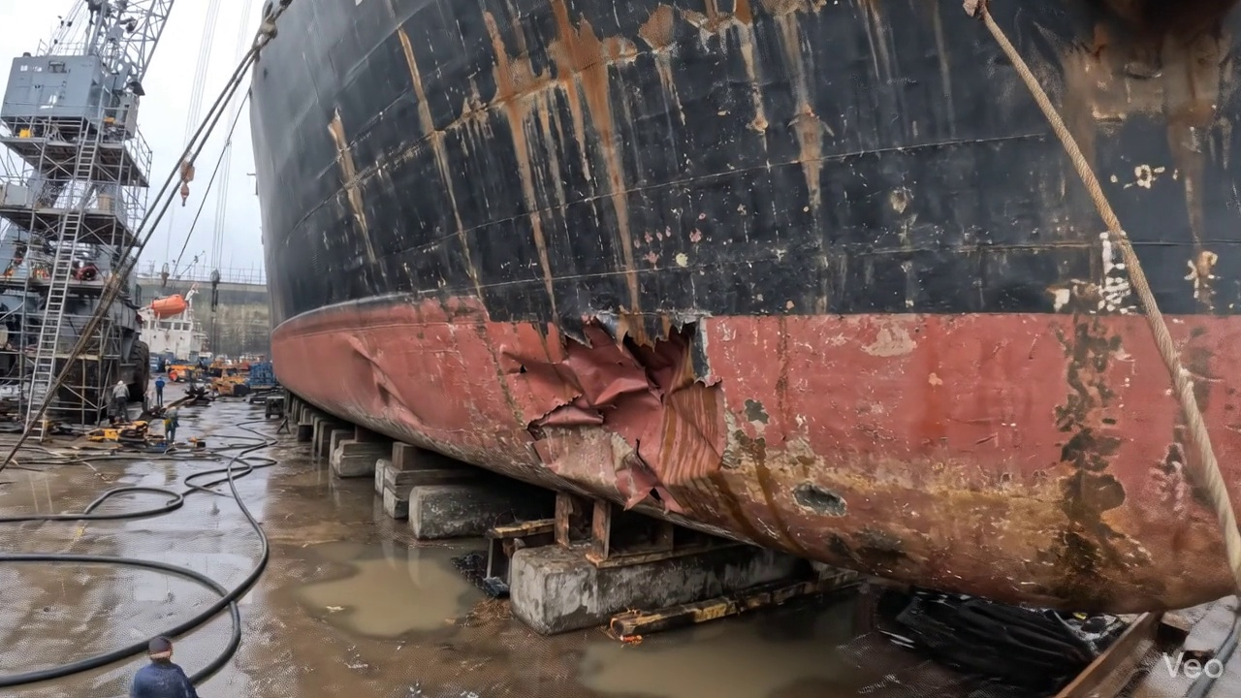

Repair Procedure
## Vessel Inspection Report: Explanation of Steel Structural Repair Process
This document provides a professional explanation of the outlined maritime steel structural repair process, detailing the rationale behind each step, the activities performed, the utilization of specified equipment, and critical safety and structural considerations. The repair focuses on addressing deformed and buckled plating and associated framing.
---
### Detailed Repair Process Explanation
**1. Assessment**
* **Why Necessary:** This initial phase is crucial for accurately defining the scope of damage, ensuring all affected areas are identified, and quantifying the extent of deformation. An accurate assessment prevents both over-repair (unnecessary material removal) and under-repair (leaving compromised material in place), which could lead to premature failure or recurrence of the defect.
* **What Happens:** Certified surveyors or experienced repair personnel conduct a meticulous inspection of the deformed region. This involves visually identifying and marking the boundaries of the buckled area. It is determined whether the deformation is localized to a single plate section or spans across multiple structural frames (e.g., web frames, stringers). Precise measurements of any "out-of-flatness" are taken using instruments such as straightedges, feeler gauges, or laser levels, to quantify the deviation from the original design contour.
* **Safety and Structural Considerations:** An exhaustive assessment is the foundation of a successful repair. It ensures that the subsequent repair strategy addresses the root cause and full extent of the damage, thereby restoring the complete structural integrity and load-bearing capacity of the affected section.
**2. Preparation**
* **Why Necessary:** This step aims to remove all structurally compromised or distorted material, creating a sound, clean, and stable base for the insertion of new steel. Removing fatigued or buckled components prevents stress concentrations from remaining defects and ensures the integrity of subsequent welds.
* **What Happens:** All distorted plate, buckled girders, and stiffeners within the identified repair zone are precisely cut away. The cutting is executed to "sound metal," meaning material free from cracks, fatigue, or significant metallurgical changes. A critical aspect is leaving a margin of good, undistorted plate around the cut-out, typically a minimum of three-quarters (¾) of the original plate thickness, to facilitate robust new welds. Any associated framing that is bent beyond acceptable limits and cannot be effectively straightened is similarly removed.
* **Why the Required Item is Used:** The **cutting torch** (e.g., oxy-acetylene or plasma cutting torch) is the primary tool for this operation. Its high-temperature flame or plasma stream allows for efficient and precise severance of steel plates and structural members. The rental cost reflects its specialized nature and intermittent use for such repair tasks.
* **Safety and Structural Considerations:** Proper execution of this step is paramount. Cuts must be clean and smooth to minimize the need for excessive grinding and to ensure optimal fit-up for the new plate. Hot work procedures, including fire watch, adequate ventilation, and the use of appropriate Personal Protective Equipment (PPE) such as welding helmets, flame-retardant clothing, and respirators, are strictly enforced during cutting operations to mitigate fire and fume hazards. The margin of good plate is vital for achieving full-penetration, high-integrity welds.
**3. Plate Replacement**
* **Why Necessary:** This step physically restores the structural continuity and the watertight/weathertight envelope of the vessel by introducing new, undamaged material.
* **What Happens:** A new steel plate, fabricated to match or exceed the original thickness and material grade, is custom-shaped to precisely fit the prepared cut-out. This new plate is then carefully positioned against the remaining sound hull plating. Once proper fit-up and alignment are achieved, the new plate is securely held in place by tack-welding along its perimeter. Subsequently, complete welding is performed all around, with particular attention to achieving good fusion between the new and existing steel, applying appropriate preheat (based on steel type, thickness, and ambient temperature to prevent hydrogen cracking and reduce residual stresses), and utilizing full-penetration welds where structurally required to ensure maximum load transfer.
* **Safety and Structural Considerations:** Selection of new plate material must comply with classification society rules and original vessel specifications. Proper fit-up minimizes gaps, which are detrimental to weld quality. Preheat is critical for thicker sections and higher-strength steels to avoid brittle fractures and ensure metallurgical integrity of the weld zone. Welders must be certified for the relevant welding processes and positions.
**4. Alignment and Welding (Continued)**
* **Why Necessary:** This phase completes the structural connection, ensuring the repair achieves the required strength, dimensional accuracy, and a smooth, hydrodynamically efficient surface.
* **What Happens:** Continuing weld passes are applied using low-hydrogen **E7018 electrodes**. These electrodes are specified for their superior mechanical properties, excellent toughness, and reduced risk of hydrogen-induced cracking, which is critical for structural welds. During the welding process, continuous monitoring for weld-induced distortion is conducted. If distortion is observed, it is actively managed using methods such as strategically placed clamps to restrain material movement or by employing minimal heat input techniques (e.g., skip welding, back-step welding). Once welding is complete, all weld seams are meticulously ground fair with the surrounding hull or deck plating. This grinding reduces stress concentrations, improves hydrodynamic flow, and prevents corrosion traps. In instances of extensive original buckling or in areas subject to high stress concentrations, additional strengthening elements such as doubler plates or stiffeners may be strategically applied to further enhance structural rigidity and reduce localized stresses.
* **Safety and Structural Considerations:** The use of low-hydrogen E7018 electrodes is a critical structural consideration, minimizing the risk of delayed hydrogen cracking in marine steels. Distortion control is vital to prevent residual stresses that could compromise the long-term integrity of the repair. Grinding welds fair eliminates potential stress risers and ensures that the repaired area performs optimally. Any additional strengthening must be designed and approved by a competent authority. Welders must adhere to qualified welding procedures.
**5. Finishing**
* **Why Necessary:** The final step ensures the quality of the repair is verified, adequate corrosion protection is restored, and the vessel's aesthetic and functional integrity are maintained.
* **What Happens:** The completed repair undergoes a rigorous inspection regime. This includes comprehensive visual inspection for surface defects, shape, and contour. In addition, Non-Destructive Testing (NDT) methods such as Magnetic Particle Testing (MPT), Dye Penetrant Testing (DPT), or Ultrasonic Testing (UT) are performed to detect any subsurface flaws, cracks, or lack of fusion within the weld. Upon satisfactory inspection, the new steel surface is thoroughly prepared (e.g., grit blasting or power tooling) to achieve the required profile for coating adhesion. It is then coated with an anti-corrosive primer, followed by appropriate finish coats, matching the vessel's original coating system to restore long-term corrosion protection. Finally, the repaired deck or hull surface is faired back to its original contour, often involving grinding or application of approved fairing compounds, to ensure smooth transitions, optimal hydrodynamic performance, and maintain functional aspects (e.g., deck drainage, non-trip surfaces).
* **Safety and Structural Considerations:** NDT provides critical assurance that the repair meets structural integrity standards. The application of a robust coating system is essential for preventing corrosion, which can rapidly degrade structural strength. Ensuring the surface is faired back to its original contour is not only aesthetic but also crucial for preventing localized turbulence, maintaining vessel speed and fuel efficiency, and ensuring safety on deck by eliminating trip hazards or pooling water.
---
This comprehensive repair process, from initial assessment to final finishing, ensures that damaged structural elements are renewed to Classification Society standards, thereby restoring the vessel's structural integrity, seaworthiness, and operational efficiency, while adhering to stringent safety and quality protocols.

Repair Cost Breakdown
Item | Quantity | Unit Cost | Total Cost | Currency
Cutting Torch (rental) | 0.08 | 10764.0 | 807.3 | INR
Estimated Repair Cost: 41583.53 INR

3.2 PD_2

Defect Overview
Here is a professional explanation of the "DEFORMATION" defect for a vessel inspection report:
---
**Defect: DEFORMATION**
**Severity: Medium**
**1. What the defect means:**
Deformation, specifically observed as buckling or warping, refers to an out-of-plane bending or distortion of a vessel's hull plating or internal stiffening members (e.g., frames, longitudinals). Unlike simple indentation, deformation indicates that the material has yielded and taken on a permanent, non-planar shape. This defect often results from external impacts such as groundings, exposure to severe sea loads, or thermal stresses induced during welding or repairs. The affected area identified is within the `HULL_AREA`, indicating a structural concern on the vessel's primary envelope.
**2. Why it is important:**
This defect is of medium importance because even moderate levels of buckling or warping can significantly compromise the structural integrity of the hull girder. The hull girder functions as the primary load-bearing beam of the ship, designed to withstand complex stresses (hogging, sagging, torsion). Any deviation from its intended planar form reduces its efficiency in resisting these forces. Classification societies rigorously monitor such deformations, often requiring rectification to maintain the vessel's class and operational safety.
**3. Risks if not repaired:**
Failure to repair significant deformation carries several critical risks:
* **Progressive Structural Weakening:** The existing deformation creates stress concentration points, accelerating material fatigue and potentially leading to the propagation of cracks under dynamic loads.
* **Reduced Resistance to Future Loads:** The compromised structure will have a diminished capacity to withstand subsequent impacts or heavy weather, increasing the likelihood of further damage or structural failure.
* **Loss of Watertight/Weathertight Integrity:** While not immediately creating a hole, severe deformation can distort surrounding structural connections, potentially compromising the integrity of compartments or tanks, leading to water ingress.
* **Operational Restrictions & Loss of Class:** Classification societies will typically impose conditions of class or even withdraw class if significant structural deformations are left unaddressed, leading to severe operational limitations or the inability to trade.
**4. Structural Implications:**
The structural implications of deformation are profound:
* **Impaired Hull Girder Strength:** Buckled plating or stiffeners are no longer fully effective in carrying their intended compressive or tensile loads. This reduces the hull girder's section modulus and moment of inertia, directly diminishing its overall bending and torsional strength.
* **Stress Redistribution:** Loads intended for the deformed member may be prematurely transferred to adjacent, potentially weaker, structural components, leading to secondary failures or overstressing.
* **Reduced Buckling Resistance:** Deformed plating has a significantly reduced critical buckling stress. This means it is more susceptible to further buckling or collapse under loads far below its original design capacity.
* **Accelerated Fatigue:** The localized curvatures and stress risers created by the deformation become prime locations for fatigue crack initiation and propagation, shortening the lifespan of the structure.
* **Diminished Stiffener Effectiveness:** If stiffeners are buckled, their ability to provide crucial support to the plating is compromised, leading to a cascade effect where the plating itself becomes more susceptible to further deformation or collapse.
---

Visual Evidence
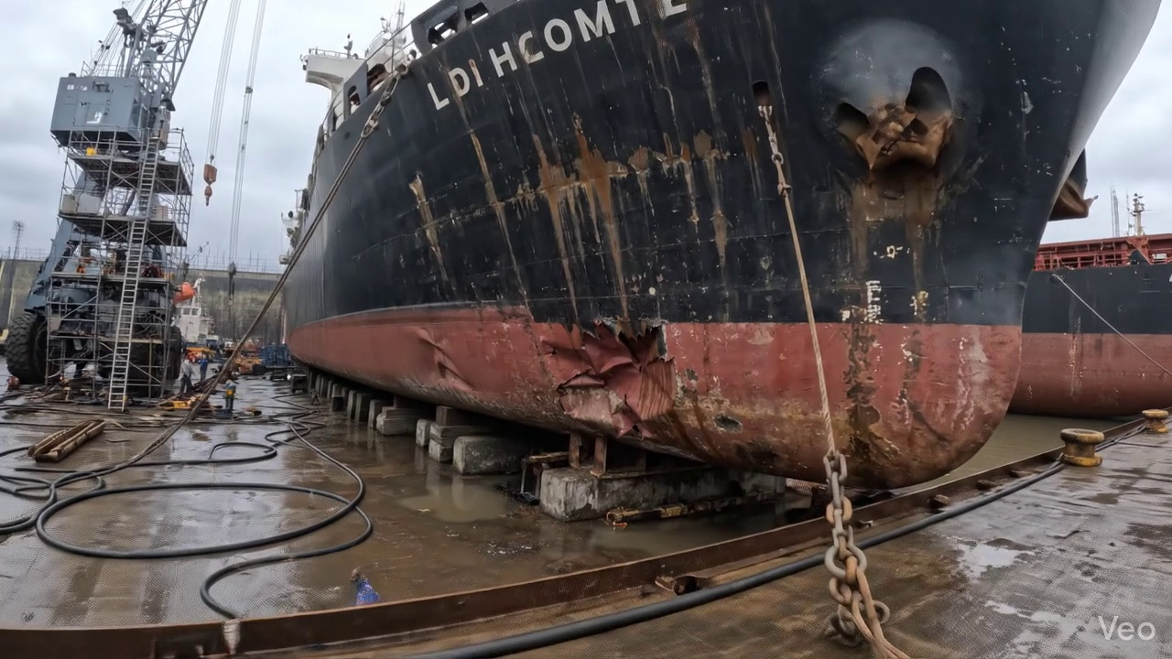

Repair Procedure
## Vessel Inspection Report: Localized Hull Plating Repair Process
This report details the standard procedure for localized hull plating repair, outlining the necessity of each step, the activities undertaken, the critical equipment utilized, and paramount safety and structural considerations. The aim is to restore the vessel's structural integrity, watertightness, and original design parameters in strict accordance with classification society requirements.
---
### 1. Repair Process Explanation
#### 1.1 Assessment Phase
* **Why Necessary:** This initial phase is crucial for accurately defining the scope of the damage, identifying any underlying structural compromises not immediately visible, and ensuring that the subsequent repair fully addresses all affected areas. It prevents partial repairs and ensures the long-term integrity of the vessel.
* **What Happens:** A thorough visual inspection is conducted on the deformed region. The buckled area is meticulously marked, and an assessment is made to determine if the damage is localized to a small area or if it extends to and impacts adjacent structural components such as frames, girders, or stiffeners. Precise measurements of any out-of-flatness are taken using appropriate tools (e.g., straight edges, gauges, optical leveling) to quantify the deformation and guide the repair plan.
#### 1.2 Preparation Phase
* **Why Necessary:** This step ensures that all compromised material, which has lost its structural integrity due to deformation or damage, is completely removed. By cutting away to "sound metal," it guarantees that the new material will be welded to a strong, undamaged base, preventing future failures at the repair interface. The specified margin (≥¾ thickness) provides adequate parent material for sound weld preparation and minimizes heat-affected zone issues in weakened material.
* **What Happens:** The distorted plate material, along with any buckled girders or stiffeners within the affected zone, is precisely cut away using thermal cutting methods (e.g., oxy-acetylene or plasma cutting) until sound, undamaged metal is reached. A margin of good plate, typically no less than three-quarters of the original plate thickness, is maintained around the cut-out. Any adjacent framing that is bent or deformed is either straightened to its original alignment and profile or, if severely damaged, completely removed and prepared for replacement.
#### 1.3 Plate Replacement Phase
* **Why Necessary:** This phase directly restores the primary structural strength, watertight integrity, and hydrodynamic profile of the hull. Fabrication of a new plate ensures that the vessel's scantlings and design strength are reinstated. Proper welding techniques are essential to achieve a defect-free, robust joint.
* **What Happens:** A new steel plate, matching the original scantling thickness or of greater thickness if specified by design or classification society requirements, is fabricated to precisely fit the prepared cut-out. This new plate is then carefully positioned against the remaining hull plating, ensuring correct alignment and minimal gap. It is secured in place with tack welds. Subsequently, complete welding is performed around the entire perimeter of the new plate, ensuring full fusion with the parent material. Appropriate preheat temperatures are applied, particularly for thicker plates or high-tensile steels, to prevent hydrogen cracking and control distortion. Full penetration welds are utilized wherever technically feasible to maximize joint efficiency and strength.
#### 1.4 Alignment and Welding Phase
* **Why Necessary:** This critical phase ensures the structural integrity and long-term durability of the weld joint, meeting stringent classification society standards. The choice of E7018 electrodes is vital for their low-hydrogen properties and excellent mechanical characteristics, suitable for critical structural applications. Distortion control is essential to maintain the structural fairness and prevent aesthetic and operational issues. Additional strengthening addresses localized stress concentrations, enhancing the overall resilience of the repair.
* **What Happens:** Continuing weld passes are applied to build up the weld seam, typically using E7018 low-hydrogen electrodes known for their superior mechanical properties and crack resistance. During the welding process, careful measures are taken to prevent or minimize welding-induced distortion. This may involve strategic clamping, balanced welding sequences, or applying minimal heat input techniques. Upon completion of welding, the weld seams are meticulously ground fair and smooth with the surrounding hull plating to restore the original contour, minimize turbulence, and facilitate coating application. In instances of extensive original buckling, or if deemed necessary by engineering assessment, additional strengthening such as doubler plates or stiffeners may be incorporated to further enhance local rigidity and reduce stress concentrations.
#### 1.5 Finishing Phase
* **Why Necessary:** This final stage is crucial for verifying the quality and integrity of the entire repair, restoring the vessel's protective coating system, and ensuring the operational efficiency and aesthetic appearance of the hull.
* **What Happens:** The completed repair undergoes rigorous inspection. This includes visual examination for surface defects (e.g., undercut, porosity, cracks) and non-destructive testing (NDT) methods such such as Magnetic Particle Inspection (MPI) or Ultrasonic Testing (UT) to detect subsurface discontinuities or lack of fusion. Once the repair passes inspection, appropriate surface preparation is carried out, followed by the application of marine-grade primer and finish coats to the new steel to restore its corrosion protection and match the surrounding hull finish. Finally, the repaired area is meticulously checked to ensure the deck or hull surface is faired back to its original contour, preserving the vessel's hydrodynamic efficiency and structural lines.
---
### 2. Why the Required Item is Used
* **Cutting Torch (rental):** The cutting torch is an indispensable tool specifically for the **Preparation Phase**. It utilizes an oxy-fuel or plasma cutting process to rapidly heat and melt, or sever, the steel. Its purpose is to precisely and efficiently remove the damaged and distorted hull plating, buckled girders, and stiffeners. The cutting torch allows for clean, controlled cuts necessary to create the required cut-out for the new plate insertion, ensuring that the surrounding material is sound and properly prepared for subsequent welding. The "rental" aspect indicates that this specialized equipment is acquired for the duration of the repair, optimizing cost-effectiveness for intermittent use.
---
### 3. Safety and Structural Considerations
#### 3.1 Safety Considerations
Throughout all stages of this repair process, stringent safety protocols are paramount to protect personnel and the vessel:
* **Hot Work Permits:** Mandatory for all cutting and welding operations, specifying precautions and fire watch requirements.
* **Fire Watch:** Continuous monitoring by trained personnel during and after hot work, with appropriate fire suppression equipment readily available.
* **Personal Protective Equipment (PPE):** Welders and nearby personnel must wear appropriate PPE, including welding helmets, flame-retardant clothing, gloves, safety glasses, and respiratory protection (e.g., respirators for welding fumes).
* **Ventilation:** Adequate ventilation is critical, especially in confined spaces, to prevent the accumulation of welding fumes, gases, and to ensure a safe breathing environment.
* **Confined Space Entry:** If the repair area involves a confined space (e.g., ballast tank, void space), strict confined space entry procedures must be followed, including gas testing, ventilation, and a standby person.
* **Lockout/Tagout:** Any adjacent machinery, electrical systems, or piping that could pose a hazard must be properly isolated and locked out/tagged out.
* **Fall Protection:** If working at height or over water, appropriate fall protection measures (e.g., scaffolding, safety harnesses, guardrails) must be in place.
#### 3.2 Structural Considerations
The primary objective of this repair is the full restoration of the vessel's structural integrity, local and global strength, and watertightness:
* **Scantling Restoration:** The new plate and any replaced structural members must meet or exceed the original design scantlings (dimensions and thickness) as specified by the vessel's drawings and classification society rules.
* **Material Compatibility:** The new steel plate and welding consumables (e.g., E7018 electrodes) must be fully compatible with the existing hull material to ensure metallurgical integrity of the weld joint.
* **Weld Procedure Qualification (WPQ) & Welder Qualification (WQ):** All welding procedures must be qualified in accordance with classification society requirements, and all welders performing structural welds must hold valid qualifications for the specific welding process and material.
* **Distortion Control:** Welding-induced distortion must be carefully managed to maintain the vessel's structural fairness, avoid internal stress buildup, and prevent further deformation of adjacent structures.
* **Non-Destructive Testing (NDT):** Comprehensive NDT (e.g., MPI, UT) is essential to verify the internal and surface integrity of the weld joints, ensuring they are free from critical defects that could compromise strength.
* **Stress Management:** In cases of extensive buckling or repairs in highly stressed areas, engineering analysis may be required to determine if additional strengthening (e.g., doubler plates, increased plate thickness, or redesigned stiffeners) is necessary to prevent recurrence of damage or to meet fatigue requirements.
* **Classification Society Approval:** All repair plans, procedures, and final inspections must be approved and witnessed by the attending classification society surveyor to ensure compliance with relevant rules and regulations.
---

Repair Cost Breakdown
Item | Quantity | Unit Cost | Total Cost | Currency
Cutting Torch (rental) | 0.08 | 10764.0 | 807.3 | INR
Estimated Repair Cost: 41583.53 INR

3.3 PD_3

Defect Overview
**Defect Name:** DEFORMATION
**Severity:** High
---
**Explanation for Vessel Inspection Report:**
This defect, classified as **DEFORMATION**, represents a significant structural integrity concern for the vessel.
1. **What the defect means:**
Deformation, in this context, refers to the **out-of-plane bending, buckling, or warping of the vessel's hull plating and/or stiffeners**. Specifically, the defect is noted in critical areas including the **HULL_AREA** and **KEEL_AREA**. Such distortions indicate that the metal has exceeded its elastic limit and undergone permanent structural alteration. Common causes for this type of damage include significant impact forces (e.g., from groundings), exposure to heavy sea loads, or localized stresses induced by welding heat. While minor localized set-in plating might sometimes be tolerated if small, the reported instance indicates significant buckling requiring attention.
2. **Why it is important:**
This defect is of high importance because even moderate deformation of hull plating or stiffeners can **severely impair the vessel's hull girder strength**. The hull girder is the primary structural element responsible for the vessel's overall longitudinal strength, resisting bending and torsional forces experienced at sea. Any compromise to its integrity fundamentally weakens the vessel's ability to withstand operational stresses. Its presence in the hull and keel areas further underscores its criticality, as these are foundational load-bearing structures.
3. **Risks if not repaired:**
If left unrepaired, the deformation poses several high risks:
* **Progressive Failure:** The compromised areas become stress concentrators, making them highly susceptible to progressive failure (e.g., crack initiation and propagation) under subsequent normal or adverse operational loads (heavy weather, docking impacts).
* **Reduced Structural Redundancy:** The ability of the structure to distribute loads efficiently is diminished, placing undue stress on adjacent components and increasing the risk of cascading failures.
* **Compromised Watertight Integrity:** Severe deformation, especially in the hull and keel, can lead to cracks or open seams, directly compromising the watertight integrity of the hull and risking ingress of water into compartments.
* **Regulatory Non-Compliance:** Classification societies and flag state authorities mandate the repair of such significant structural defects. Failure to do so will result in classification withdrawal or detention, rendering the vessel unseaworthy and unable to operate.
* **Safety Hazard:** Ultimately, the greatest risk is to the safety of the vessel, its crew, and cargo, as the weakened structure could fail catastrophically under extreme conditions.
4. **Structural implications:**
The structural implications of deformation are profound:
* **Loss of Sectional Properties:** The out-of-plane bending effectively reduces the sectional modulus and moment of inertia of the affected plating and stiffeners. These are critical parameters for resisting bending and buckling loads.
* **Impaired Load-Bearing Capacity:** Deformed structural members lose their designed load-bearing capacity. They can no longer efficiently carry compressive, tensile, or shear forces, leading to a redistribution of stresses to adjacent, potentially undamaged, areas.
* **Hull Girder Weakening:** The overall longitudinal strength and rigidity of the hull girder are significantly diminished, affecting the vessel's ability to withstand hogging and sagging moments.
* **Stress Concentrations:** The buckles create points of high stress concentration, which are prime locations for fatigue crack initiation and accelerated structural deterioration.
* **Requirement for Renewal:** As per classification practice, significant buckling necessitates the cutting out and replacement of the distorted metal to restore the original structural integrity and design margins.

Visual Evidence
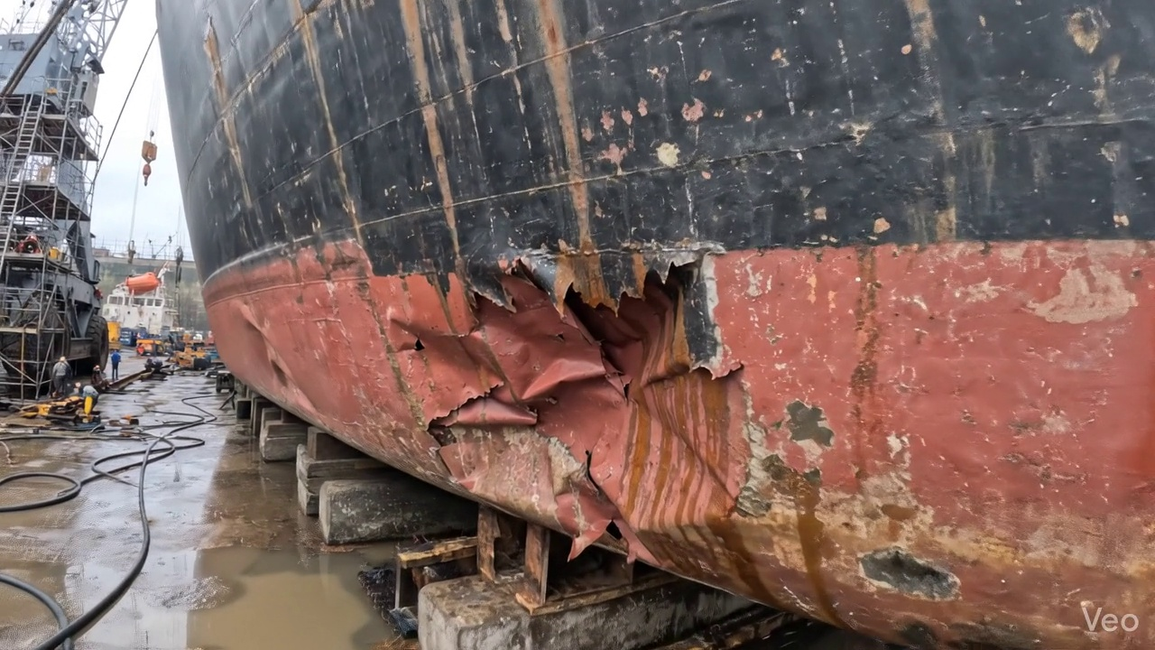

Repair Procedure
This report details a standard maritime steel plate repair process following damage, outlining the necessity of each step, the actions undertaken, the purpose of specific equipment, and critical safety and structural considerations.
---
**Vessel Inspection Report: Steel Plate Repair Process Explanation**
**Repair Process Overview:**
The outlined repair process involves the systematic removal of damaged steel plating and internal structures, followed by the fabrication and welding of new steel components to restore the vessel's structural integrity, watertightness, and original contour.
---
**1. Assessment**
* **Necessity:** This initial step is paramount to accurately define the scope of the repair. It ensures that all damaged areas, whether localized or extensive, are identified and quantified. Without a thorough assessment, there is a risk of incomplete repair, leading to residual stress points, compromised structural integrity, or future failure of the surrounding material.
* **What Happens:** Skilled technicians meticulously inspect the deformed region. This involves visual examination to identify cracks, buckling, and other distortions. The buckled area is clearly marked to delineate the repair boundaries. Further investigation determines if the damage is confined to a single plate or if it extends to adjacent plates, internal framing (girders, stiffeners), or even spans multiple structural frames. Out-of-flatness measurements are taken using straightedges, feeler gauges, or laser alignment tools to quantify the degree of deformation and inform the extent of material removal required.
* **Safety & Structural Considerations:** A precise assessment is fundamental for structural integrity, ensuring that no compromised material remains after the repair. It also allows for the identification of potential hazards or complex structural interactions that might require specialized attention during subsequent steps.
---
**2. Preparation**
* **Necessity:** This critical phase ensures that the new repair material will be welded to sound, undamaged metal. Removing all distorted and compromised material is vital to prevent future fatigue cracks, stress concentrations, and to achieve a high-quality, durable weldment. The specified margin of good plate (≥¾ thickness) guarantees that the heat-affected zone of the new weld will also fall entirely within sound material, minimizing metallurgical weaknesses.
* **What Happens:** Using specialized cutting equipment, all visibly distorted plating and any buckled internal structures (girders, stiffeners) are carefully cut away. This cutting extends into the sound, unaffected metal, leaving a clean, prepared edge with the specified margin. If internal framing is bent but not severely compromised, efforts may be made to straighten it; otherwise, it is also removed and replaced. The edges of the cut-out are then prepared for welding, which may involve grinding to achieve the correct bevel for full penetration welds.
* **Why Cutting Torch is Used:** The **Cutting Torch (rental)** is an essential tool at this stage. It provides a rapid and efficient method for severing steel plate and structural members. Its high-temperature flame melts and oxidizes the metal, allowing for precise and effective removal of damaged material. Given its specialized nature and potential for intermittent use, renting a cutting torch can be a cost-effective solution for a shipyard or repair crew, as indicated by the 'machine-days/sq.m' metric and 'rental' designation.
* **Safety & Structural Considerations:** This step involves significant heat, sparks, and fumes. Strict adherence to hot work procedures, fire watch protocols, and proper personal protective equipment (PPE) for cutting operators (e.g., eye protection, fire-resistant clothing, respiratory protection) is mandatory. Structurally, incomplete removal of damaged material will compromise the entire repair.
---
**3. Plate Replacement**
* **Necessity:** This step restores the physical barrier and primary load-bearing capacity of the hull or deck. Using new steel plate of the same or greater thickness ensures that the original design strength of the vessel is maintained or enhanced, preventing localized weak spots.
* **What Happens:** A new steel plate is precisely fabricated. This involves measuring the exact dimensions of the cut-out, cutting the new plate from raw stock, and forming it to match the curvature of the hull or deck if necessary. The newly fabricated plate is then carefully positioned within the opening. Once alignment is confirmed, it is temporarily secured using tack-welds, which are small, intermittent welds designed to hold the plate in place before the main welding commences.
* **Safety & Structural Considerations:** Proper fit-up of the new plate is crucial. Gaps or misalignments can lead to excessive weld stresses, poor penetration, and a weakened repair. Ensuring the correct material grade (e.g., marine-grade steel) is used is also vital for long-term structural integrity and corrosion resistance.
---
**4. Alignment and Welding**
* **Necessity:** This is the core structural integrity restoration phase. Proper welding techniques ensure a permanent, high-strength metallurgical bond between the new plate and the existing structure. Good fusion, appropriate preheat (especially for thicker plates or high-tensile steels to prevent hydrogen-induced cracking and ensure proper grain structure), and full penetration welds maximize the strength and durability of the repair. Using E7018 electrodes, known for their low-hydrogen properties and high tensile strength, is critical for marine structures. Distortion control is essential to maintain the vessel's hydrodynamics, prevent locked-in stresses, and avoid further structural issues.
* **What Happens:** The main welding commences, typically in multiple passes using E7018 low-hydrogen electrodes. Welders meticulously apply continuing weld passes, focusing on achieving full penetration where possible, especially for primary structural members. Throughout the welding process, continuous monitoring for weld-induced distortion (warping) is conducted. If distortion occurs, clamps, strongbacks, or specialized welding techniques (e.g., skip welding, back-stepping, or controlled heat input sequences) are employed to mitigate it. Upon completion of welding, the weld seams are ground fair and smooth with the surrounding hull or deck surface to reduce stress concentrations, improve aesthetics, and maintain hydrodynamic efficiency. In cases of extensive original buckling, or if the area is subject to high stress, additional strengthening in the form of doublers (overlapping plates) or stiffeners may be permanently attached to further reduce stress and enhance structural rigidity.
* **Safety & Structural Considerations:** Welding poses significant safety risks, including exposure to intense UV radiation, high heat, fumes, and electric shock. Comprehensive PPE (welding helmet, gloves, leathers), adequate ventilation, and a designated fire watch are mandatory. Structurally, the quality of the weld is paramount. Improper preheat, insufficient penetration, or excessive distortion can lead to cold cracking, reduced fatigue life, and overall structural weakness. NDT after welding is often used to verify weld quality.
---
**5. Finishing**
* **Necessity:** This final stage confirms the quality and integrity of the entire repair and provides essential protection against corrosion, ensuring the longevity of the repair and the vessel. Restoring the original contour is crucial for maintaining hydrodynamic efficiency, preventing increased fuel consumption, and avoiding potential cavitation or localized erosion.
* **What Happens:** A thorough inspection of the completed repair is performed. This includes a visual inspection for surface defects such as cracks, undercut, or porosity. Subsequently, Non-Destructive Testing (NDT) methods, such as Magnetic Particle Testing (MPT), Dye Penetrant Testing (DPT) for surface defects, or Ultrasonic Testing (UT) for subsurface flaws, are often employed to ensure the structural integrity and quality of the welds. Once the repair passes inspection, the newly exposed steel surfaces are prepared (e.g., abrasive blasting) and promptly coated with marine-grade primer, followed by appropriate finish coats (e.g., anti-corrosive and anti-fouling paints) to restore complete corrosion protection. Finally, the deck or hull surface is faired back to its original smooth contour through grinding, sanding, or applying fairing compounds to ensure optimal performance.
* **Safety & Structural Considerations:** NDT is a critical safety measure, detecting hidden defects that could compromise the repair. Proper application of coatings is essential for corrosion prevention, which directly impacts the structural lifespan of the repair. Maintaining the original fair contour prevents increased drag and ensures the vessel's hydrodynamic performance.
---
**Summary of Required Items:**
* **Cutting Torch (rental):** This item is utilized during the **Preparation** phase. Its necessity stems from its ability to efficiently and precisely cut through thick steel plates and structural members. Given its rental status, it suggests that such specialized, high-cost equipment is procured on an as-needed basis, optimizing operational costs for the repair facility by avoiding outright purchase and storage for intermittent usage.
This detailed explanation provides a professional overview of the steel plate repair process, addressing the "why," "what," and critical considerations for a vessel inspection report.

Repair Cost Breakdown
Item | Quantity | Unit Cost | Total Cost | Currency
Cutting Torch (rental) | 0.12 | 10764.0 | 1345.5 | INR
Estimated Repair Cost: 69305.88 INR

3.4 PD_4

Defect Overview
## Defect Explanation: DEFORMATION (Buckling/Warping)
**Defect Name:** DEFORMATION
**Severity:** HIGH
**Location:** KEEL_AREA (approx. 45.8% overlap), HULL_AREA (approx. 45.8% overlap)
---
### 1. What the defect means:
Deformation, specifically observed as buckling or warping, refers to an out-of-plane bending or distortion of the vessel's hull plating and/or its supporting stiffeners. This is a deviation from the designed flat or contoured shape. It typically manifests as inward or outward bulges, undulations, or creases in the metal. In this instance, the significant overlap with both the KEEL_AREA and HULL_AREA indicates the deformation is present on the bottom plating and/or lower side shell, likely extending across the keel structure.
### 2. Why it is important:
This defect is classified with a **HIGH** severity due to its critical implications for the vessel's structural integrity. Even seemingly moderate buckles can severely compromise the designed strength and load-carrying capacity of the hull girder. The presence of such deformation in critical areas like the keel and lower hull suggests exposure to substantial forces, such as grounding impacts or severe sea loads, which have exceeded the material's elastic limit. Classification societies typically mandate prompt correction for such significant distortions, acknowledging their profound impact on vessel safety.
### 3. Risks if not repaired:
Failure to repair this deformation poses severe risks, primarily the progressive reduction of the vessel's overall hull girder strength. If left unaddressed, the distorted material can experience localized stress concentrations, making it highly susceptible to:
* **Progressive Failure:** Under subsequent dynamic loads (e.g., heavy seas, slamming), the weakened structure is prone to further deformation, localized fracturing, or tearing of plating.
* **Catastrophic Structural Failure:** In extreme conditions, the compromised hull girder integrity could lead to catastrophic structural failure, potentially resulting in rapid ingress of water, loss of buoyancy, stability issues, or even foundering.
* **Operational Restrictions:** Continued operation with significant deformation could lead to operational restrictions imposed by classification societies, flag states, or port state control, severely impacting the vessel's seaworthiness, insurability, and commercial operations.
* **Accelerated Corrosion/Fatigue:** The distortion can create pockets for water accumulation or alter stress patterns, accelerating corrosion or fatigue cracking in surrounding sound material.
### 4. Structural Implications:
The structural implications of this deformation are profound and directly impact the vessel's primary strength members:
* **Reduced Hull Girder Strength:** The primary implication is a direct and severe reduction in the longitudinal and transverse strength of the hull girder. Buckled or warped plating cannot effectively carry compressive or tensile loads as designed, leading to a significant decrease in the vessel's ability to withstand bending moments and shear forces.
* **Compromised Load Distribution:** The deformation disrupts the intended load distribution across the hull structure. Loads that should be evenly distributed across stiffeners and plating become concentrated in sound areas, potentially overloading them and accelerating fatigue or further localized damage.
* **Loss of Stability and Watertight Integrity:** While not immediately a breach, severe deformation significantly weakens the integrity of the watertight envelope. Under subsequent loading or impact, this weakness could easily lead to localized breaches, affecting buoyancy, trim, and stability.
* **Altered Section Modulus and Moment of Inertia:** The out-of-plane bending fundamentally alters the section modulus and moment of inertia of the affected hull sections, reducing the vessel's resistance to global bending and torsional forces.
* **Requirement for Renewal:** Classification practice is to correct significant buckling by cutting out and replacing the distorted metal with new, correctly formed plates and stiffeners, as simply attempting to fair or heat-correct severe deformation is typically insufficient to restore original strength.

Visual Evidence
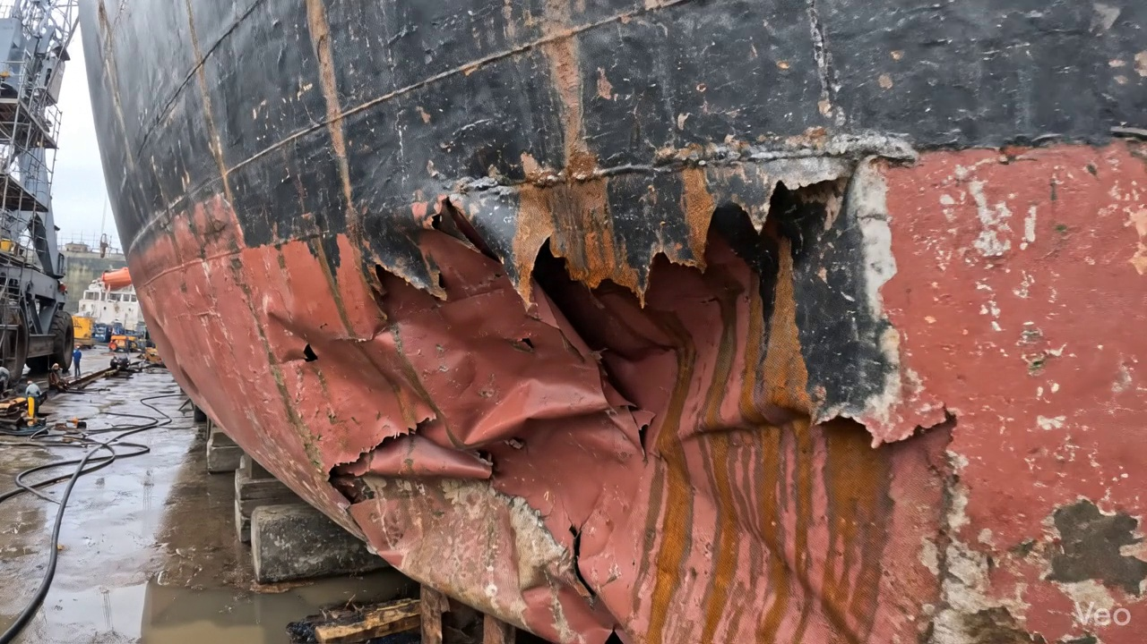

Repair Procedure
**Vessel Inspection Report: Explanation of Maritime Plate and Framing Repair Process**
This section details a standard repair process for addressing localized deformation or buckling in a vessel's steel plating and associated framing. The explanation covers the necessity of each step, the actions performed, the utility of required equipment, and key safety and structural considerations.
---
**1. Assessment**
* **Necessity:** The initial assessment is critical to accurately define the extent of damage, determine the root cause, and formulate an effective, compliant repair strategy. It prevents undertaking inadequate repairs that leave compromised material or over-scoping, which leads to unnecessary cost and downtime.
* **What Happens:** A thorough visual inspection is conducted on the deformed region. Technicians meticulously mark the buckled area and evaluate whether the damage is isolated or indicative of broader structural issues spanning multiple frames or stiffeners. Precise measurements of out-of-flatness are taken using suitable instruments (e.g., straightedges, optical levels, or laser scanners) to quantify the deformation and guide the scope of material removal.
* **Item Usage:** Not directly applicable to the listed item.
* **Safety & Structural Considerations:**
* **Structural:** Accurate damage mapping ensures that all structurally compromised material is identified for removal, preventing the recurrence of failure and ensuring the load-carrying capacity of the area is fully restored.
* **Safety:** Personnel must be aware of potential hazards such as unstable structures or sharp edges in the damaged area.
---
**2. Preparation**
* **Necessity:** This step ensures that all damaged, fatigued, or distorted material is completely removed, providing a clean, sound, and structurally robust foundation for the new steel plate and associated welding. This is fundamental for the integrity and longevity of the repair.
* **What Happens:** Using specialized cutting equipment, such as the `Cutting Torch (rental)`, all distorted plate material and any buckled or compromised girders and stiffeners are precisely cut away. This cutting continues until only sound, unaffected base metal remains. A specified margin of good plate (typically ≥¾ of the original plate thickness) is deliberately left around the cutout to provide a stable, undisturbed heat-affected zone for subsequent welding. Any bent internal framing that cannot be effectively straightened to its original structural integrity is also removed for replacement.
* **Item Usage:**
* **Cutting Torch (rental):** The cutting torch is indispensable in this phase. It provides a high-temperature flame (e.g., oxy-acetylene or plasma) capable of rapidly and effectively severing steel plate and structural members. Its use facilitates the efficient removal of damaged sections, preparing the opening for the new insert plate.
* **Safety & Structural Considerations:**
* **Structural:** The removal of material to a "sound metal" margin is critical. This prevents welding to fatigued or micro-cracked material, which could compromise the new weld's integrity. Ensuring proper edge preparation (e.g., beveling) is also a part of structural integrity.
* **Safety:** Hot work permits are mandatory. This operation generates intense heat, sparks, and potentially hazardous fumes. Essential safety measures include strict fire watches, removal of combustible materials, adequate ventilation, appropriate personal protective equipment (PPE) such as welding shields with proper shade, fire-resistant clothing, and respiratory protection (e.g., FFP3 masks) to protect against airborne contaminants.
---
**3. Plate Replacement**
* **Necessity:** The objective of this phase is to reinstate the structural and watertight/weathertight integrity of the vessel by installing new, dimensionally accurate, and suitably specified steel plating.
* **What Happens:** A new steel plate is fabricated to precisely match the dimensions of the cutout. This plate is typically of the same grade and thickness as the original, or of a greater thickness if specific strengthening is required by engineering assessment. Edges of the new plate are prepared (e.g., beveled) to facilitate full penetration welds. The plate is then carefully positioned into the opening, ensuring proper alignment with the existing hull plating to minimize gaps and ensure a flush fit. Tack-welds are applied at strategic points to temporarily hold the plate securely in position, preventing movement during the main welding process. The primary welding then commences, with careful attention paid to achieving good fusion. Preheat may be applied, particularly for thicker materials or specific steel grades, to manage the cooling rate of the weld and reduce the risk of hydrogen-induced cracking and residual stresses. Full penetration welds are employed wherever possible to maximize joint strength and structural continuity.
* **Item Usage:** Not directly applicable to the listed item.
* **Safety & Structural Considerations:**
* **Structural:** Material selection (marine-grade steel), precise fit-up, and high-quality welding (including appropriate preheat and interpass temperature control) are paramount for restoring the original structural strength and continuity. Poor fit-up can lead to increased stress concentrations and compromised weld quality.
* **Safety:** Standard welding safety protocols must be rigorously followed, including the use of appropriate PPE (welding helmet, gloves, fire-resistant clothing), ensuring proper ventilation, and establishing fire watches due to the ongoing hot work. If welding occurs in confined spaces, strict entry procedures and atmospheric monitoring are essential.
---
**4. Alignment and Welding**
* **Necessity:** This step completes the structural integration of the new plate, ensuring the weld joint achieves the required strength and minimizing any adverse effects such as material distortion induced by thermal stresses.
* **What Happens:** Weld passes are progressively applied, typically utilizing E7018 low-hydrogen electrodes. These electrodes are chosen for their excellent mechanical properties, good ductility, and resistance to hydrogen-induced cracking, making them suitable for critical structural applications. Throughout the welding process, operators constantly monitor for welding-induced distortion. If distortion occurs due to thermal expansion and contraction, corrective measures are implemented. These can include physical clamping with strongbacks, strategic weld sequencing (e.g., skip welding, back-step welding), or employing minimal heat input techniques. Upon completion of welding, the weld seams are carefully ground fair with the surrounding hull surface. This process removes stress concentrators, improves hydrodynamic flow, and prepares the surface for coating. In situations where the area has experienced extensive prior buckling or is subjected to high operational stresses, additional strengthening measures, such as the application of doubler plates or supplementary stiffeners, may be engineered and incorporated to enhance local structural integrity and mitigate future stress concentrations.
* **Item Usage:** Not directly applicable to the listed item.
* **Safety & Structural Considerations:**
* **Structural:** The use of E7018 electrodes is a critical engineering decision for weld quality. Proper distortion control is vital to prevent residual stresses that could lead to premature fatigue cracking. Grinding welds fair removes potential initiation points for cracks. The decision to add doublers or stiffeners reflects a proactive engineering approach to enhance the long-term robustness of the repaired area, preventing recurrence of the original damage.
* **Safety:** Grinding operations require appropriate PPE including ear protection, dust masks, and eye/face shields to mitigate hazards from noise, dust, and flying debris. Continuous awareness of hot surfaces and ongoing hot work safety protocols is maintained.
---
**5. Finishing**
* **Necessity:** The final stage confirms the quality and integrity of the entire repair, reinstates the vessel's corrosion protection system, and restores the aesthetic and functional contours of the deck or hull.
* **What Happens:** A comprehensive inspection regimen is undertaken. This typically includes a visual inspection (VT) to check for surface defects (e.g., porosity, undercut, cracks) and ensure appropriate weld profile. This is often supplemented by Non-Destructive Testing (NDT) methods such as Magnetic Particle Testing (MPT) for surface-breaking defects, or Ultrasonic Testing (UT) to detect internal weld flaws and verify material thickness. Following successful inspection, the new steel surface is thoroughly cleaned and prepared. A multi-layer coating system, typically commencing with primer coats followed by appropriate finish coats (e.g., anti-corrosion and antifouling paints for submerged areas), is applied. This restores the vessel's vital corrosion protection system, extending the lifespan of the repair. Finally, the repaired area, including the new plate and ground welds, is faired back to its original contour. This ensures optimal hydrodynamic performance (for hull sections), proper drainage (for deck areas), and an aesthetically consistent appearance.
* **Item Usage:** Not directly applicable to the listed item.
* **Safety & Structural Considerations:**
* **Structural:** NDT is paramount for verifying the integrity of the repair welds against classification society rules and engineering standards. The correct application of the coating system is critical to prevent premature corrosion of the new steel, which would otherwise compromise the structural longevity of the repair.
* **Safety:** Painting operations require adequate ventilation and respiratory protection due to paint fumes and solvents. Fire safety precautions are essential given the flammability of many coating products. If NDT methods such as radiography are used, strict radiation safety protocols must be observed.

Repair Cost Breakdown
Item | Quantity | Unit Cost | Total Cost | Currency
Cutting Torch (rental) | 0.12 | 10764.0 | 1345.5 | INR
Estimated Repair Cost: 69305.88 INR

