Vessel Inspection Report

Table of Contents
1. Executive Summary
2. Vessel Repair Summary
3. Defect Analysis
3.1 PD_1

1. Executive Summary
**Executive Summary: Maritime Vessel Inspection Findings**
This executive summary outlines the principal findings from the recent maritime vessel inspection.
The comprehensive assessment identified a single non-conformity. This critical finding has been assigned a 'high' severity rating, indicating a significant potential impact on vessel safety, operational integrity, or regulatory compliance.
The estimated cost for rectifying this issue is projected at **INR 69,305.88**.
Given the high-severity classification, immediate and decisive action is strongly recommended to remediate this non-conformity, thereby ensuring the vessel's continued seaworthiness and adherence to statutory requirements.

2. Vessel Repair Summary
Metric | Value
Total Defects | 1
Total Estimated Cost | 69305.88 INR
Material Cost | 41583.53 INR
Labor Cost | 20791.76 INR
Equipment Cost | 6930.59 INR

3. Defect Analysis

3.1 PD_1

Defect Overview
## Defect Explanation: DEFORMATION
**Defect Name:** DEFORMATION
**Severity:** High
**Overlapping Parts:** HULL_AREA
---
### 1. What the defect means.
The defect "Deformation" refers to the out-of-plane bending or distortion of a vessel's structural components, specifically the hull plating and/or stiffeners within the HULL_AREA. This manifests as buckling (a sudden change in shape due to compressive forces) or warping (twisting or bending from uneven stresses). Essentially, the affected metalwork deviates significantly from its original, intended flat or straight profile, indicating a loss of structural rigidity and shape. Common causes include impacts from grounding incidents, severe dynamic loads from heavy seas, or localized stress induced by welding processes.
### 2. Why it is important.
This defect is of high importance due to its direct and severe impact on the vessel's structural integrity. The hull structure, particularly the plating and stiffeners, forms the primary strength members that contribute to the overall hull girder strength. Even moderate out-of-plane deformation can severely impair this strength, compromising the vessel's ability to withstand operational stresses, wave forces, and internal loads. Its presence indicates that the affected section is no longer performing its intended structural function effectively, making it a critical concern for seaworthiness and safety.
### 3. Risks if not repaired.
Failure to address and repair significant deformation carries substantial risks:
* **Progressive Structural Failure:** The weakened area can become a point of high stress concentration, leading to the initiation and propagation of fatigue cracks, especially under dynamic loading from waves or varying internal pressures. This can escalate to brittle fracture or tear propagation, compromising adjacent structures.
* **Compromised Watertight Integrity:** Severe deformation can lead to cracking of the plating or distortion of welded seams, potentially breaching the watertight or weathertight envelope of the vessel. This could result in water ingress into compartments, affecting stability, buoyancy, and the safety of cargo or machinery.
* **Reduced Vessel Safety:** In extreme cases, unrepaired significant deformation could lead to localized or catastrophic structural collapse of the hull girder, particularly during severe weather conditions or other emergencies, endangering the vessel, crew, and cargo.
* **Non-Compliance and Detentions:** Classification societies and flag state administrations typically have strict requirements regarding structural integrity. Unrepaired severe deformation would likely result in non-compliance, leading to operational restrictions, detentions, or withdrawal of certificates.
### 4. Structural implications.
Structurally, deformation signifies a critical reduction in the affected component's load-bearing capacity and stiffness.
* **Reduced Section Modulus and Moment of Inertia:** Buckling effectively reduces the contributing cross-sectional area and geometric properties of the plating and stiffeners, thereby lowering the local section modulus and moment of inertia. This directly diminishes the ability of the structure to resist bending and compressive forces.
* **Stress Redistribution and Concentration:** The deformed area will no longer carry its designed share of the overall hull girder stresses. This forces surrounding, possibly undamaged, structures to bear a disproportionately higher load, potentially leading to overloading and premature failure elsewhere. Furthermore, the crests and troughs of the buckles, along with any abrupt changes in geometry, become severe stress concentration points where cracks are highly likely to initiate.
* **Loss of Stability:** For stiffeners, buckling represents a loss of their primary function to stabilize the plating and carry axial loads. When plating buckles, the stiffeners lose their support, and the entire panel's stability is compromised.
* **Classification Mandate:** Due to these severe implications, classification practice typically mandates the correction of significant buckling or deformation by cutting out the distorted metal and replacing it with new, correctly aligned material. Localized, minor set-in plating may occasionally be tolerated if assessed as structurally insignificant by the classification society, but any "significant" deformation (as described) requires renewal to restore the vessel's designed structural strength and ensure its long-term integrity.

Visual Evidence
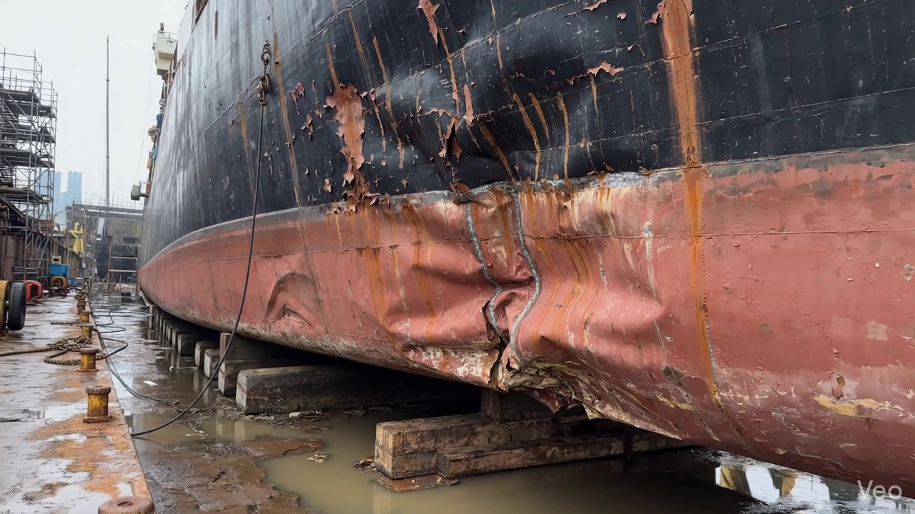

Repair Procedure
This report outlines the essential steps, rationale, and considerations for the steel plate repair process detailed, focusing on its application in a vessel inspection context.
---
**Vessel Inspection Report: Steel Plate Repair Process Explanation**
**Repair Process Overview:**
This repair methodology describes the systematic approach to restoring the structural integrity and watertight/weathertight envelope of a vessel following localized deformation or damage to its steel plating and associated framing. The process ensures that compromised material is removed, replaced with sound steel, and integrated effectively into the existing structure, adhering to classification society standards and best maritime practices.
**Detailed Explanation of Repair Steps:**
**1. Assessment**
* **Why Necessary:** This initial phase is critical for accurately defining the scope of damage and the required repair. It prevents under-scoping the repair, which could leave compromised material in place, or over-scoping, which leads to unnecessary work and costs. Precise identification of damage extent ensures that the subsequent repair fully addresses all structural deficiencies.
* **What Happens:** A thorough visual inspection is conducted to identify the boundaries of the deformed region. The area is marked to delineate the repair zone. Engineers or experienced personnel determine if the buckling is confined to a small area or extends across multiple structural frames (e.g., transverse frames, longitudinals). Out-of-flatness measurements (e.g., using straight edges, laser alignment tools, or feeler gauges) are taken to quantify the degree of deformation and verify the extent of the impact on the vessel's lines and scantlings.
* **Safety and Structural Considerations:** Correct assessment is fundamental for ensuring the structural integrity of the repair. Failing to identify all affected areas could lead to latent structural weaknesses. From a safety perspective, understanding the extent of damage helps in planning a safe work environment, especially if damage is near critical systems or involves potential instability.
**2. Preparation**
* **Why Necessary:** This step removes all structurally compromised material, creating a clean, sound base for the new steel plate. Retaining distorted or fatigued material would compromise the effectiveness and longevity of the repair, as new welds could induce stress in damaged areas or fail prematurely. Leaving a margin of good plate (≥¾ thickness) ensures that the new weld is made on unaffected, sound metal, promoting optimal fusion and strength.
* **What Happens:** Using thermal cutting equipment (e.g., a cutting torch) or mechanical means, all buckled, distorted, or otherwise damaged plate material is carefully cut away. Any girders or stiffeners that are bent beyond acceptable limits or show signs of fatigue are also removed to sound metal. If existing framing is only slightly bent, it may be straightened to its original alignment; otherwise, it is removed and prepared for replacement. The cut edges are prepared (e.g., beveled) for subsequent welding.
* **Why the Required Item (Cutting Torch) is Used:** The **Cutting Torch (rental)** is an essential tool in this phase. It provides an efficient and effective method for thermally cutting away the damaged steel plate, girders, and stiffeners. Its use minimizes the time required for material removal compared to mechanical methods, especially for intricate cuts or thicker steel sections. The specified quantity (0.01 machine-days/sq.m for 0.12 total required machine-days) indicates its deployment for the precise removal of a localized damaged area, covering approximately 12 square meters (0.12 / 0.01).
* **Safety and Structural Considerations:** Proper preparation is vital for structural integrity. Removing all damaged material ensures that no "weak links" remain. Safety during cutting operations includes: strict adherence to hot work procedures, fire watch personnel, provision of adequate ventilation to disperse fumes, and use of appropriate Personal Protective Equipment (PPE) such as eye protection, welding gloves, and flame-retardant clothing.
**3. Plate Replacement**
* **Why Necessary:** This step directly restores the structural continuity, load-bearing capacity, and watertight/weathertight integrity of the vessel. The new plate must match or exceed the original thickness and material properties to ensure it can withstand anticipated operational stresses.
* **What Happens:** A new steel plate is fabricated to precisely match the dimensions and contour of the excised opening. This plate is typically of the same grade and thickness as the original, or thicker if specified by engineering assessment or classification society requirements. The new plate is carefully positioned against the remaining hull plating, ensuring proper alignment. It is then secured in place using tack welds, followed by full circumferential welding. Critical attention is paid to achieving good fusion, and appropriate preheat (especially for thicker plates or in cold conditions) is applied to prevent hydrogen-induced cracking. Full penetration welds are prioritized where structural strength is paramount.
* **Safety and Structural Considerations:** The choice of plate material and thickness directly impacts structural integrity. Full penetration welds are crucial for achieving maximum joint strength. Preheat is a key safety measure against brittle fracture and hydrogen cracking, especially in high-strength steels. Safety during welding includes protection from arc flash, welding fumes, hot metal, and potential fire hazards.
**4. Alignment and Welding**
* **Why Necessary:** This phase completes the structural integration of the new plate, ensuring the weld joint possesses the required strength and ductility. Controlling welding-induced distortion is critical to maintain the vessel's hydrodynamic profile, prevent residual stresses, and ensure the long-term fatigue life of the structure. Grinding weld seams fair reduces stress concentrations and maintains the vessel's aesthetics and hydrodynamic efficiency.
* **What Happens:** Continuous weld passes are applied using specified welding electrodes, such as E7018. E7018 is a low-hydrogen electrode known for producing high-quality welds with good mechanical properties, making it suitable for critical structural applications. Throughout the welding process, techniques are employed to manage and minimize distortion; these may include strategic clamping, back-stepping, skip welding, or controlled heat input. Upon completion of welding, the weld seams are ground smooth and fair with the surrounding hull plating to remove any irregularities and reduce stress risers. In cases of extensive initial buckling or if the repair is in a high-stress area, additional strengthening elements like doublers (extra plate layers) or stiffeners may be incorporated to augment the local strength and redistribute stress effectively.
* **Safety and Structural Considerations:** The use of E7018 electrodes is a structural safety measure against hydrogen cracking. Distortion control is vital to prevent internal stresses that could lead to premature fatigue failure. Grinding welds fair not only improves hydrodynamics but also enhances fatigue resistance by eliminating potential crack initiation points. The application of doublers or additional stiffeners is a direct structural enhancement to address areas of high stress or historical extensive damage, ensuring the long-term integrity of the repair. Safety precautions include proper ventilation for welding fumes, eye and skin protection from arc flash and spatter, and careful handling of hot materials. Grinding operations require eye protection, hearing protection, and dust masks.
**5. Finishing**
* **Why Necessary:** This final stage ensures the quality and durability of the repair. Inspection verifies the integrity of the work, while corrosion protection is applied to prevent degradation of the new steel. Restoring the original contour ensures the vessel's hydrodynamic efficiency and aesthetic appearance.
* **What Happens:** The completed repair undergoes rigorous inspection. This typically involves visual inspection for weld quality, proper contour, and absence of defects. Non-Destructive Testing (NDT) methods, such as Magnetic Particle Inspection (MPI) or Ultrasonic Testing (UT), are employed to detect sub-surface or surface discontinuities in the welds, confirming their integrity. Once approved, the new steel surface is prepared (e.g., abrasive blasting) and coated with a suitable marine primer, followed by subsequent finish coats, restoring the vessel's corrosion protection system. Finally, the deck or hull surface is faired back to its original contour, ensuring smooth lines and minimal hydrodynamic drag.
* **Safety and Structural Considerations:** NDT methods are a crucial safety measure, providing objective evidence that the structural repair meets specified standards and is free from critical defects. The application of primer and finish coats is essential for preventing corrosion, which, if unchecked, would compromise the long-term structural integrity of the new steel. Fairing the surface prevents localized turbulence and potential fatigue points. Safety during coating application includes ensuring adequate ventilation, use of appropriate PPE (respirators, gloves), and adherence to material safety data sheets (MSDS) for chemical handling.
This comprehensive approach ensures that the repair not only addresses the immediate damage but also contributes to the long-term structural soundness and operational safety of the vessel.

Repair Cost Breakdown
Item | Quantity | Unit Cost | Total Cost | Currency
Cutting Torch (rental) | 0.12 | 10764.0 | 1345.5 | INR
Estimated Repair Cost: 69305.88 INR

