Vessel Inspection Report

Table of Contents
1. Executive Summary
2. Vessel Repair Summary
3. Defect Analysis
3.1 PD_1
3.2 PD_2
3.3 PD_3
3.4 PD_4

1. Executive Summary
**Executive Summary: Maritime Vessel Condition Assessment**
This executive summary outlines the key findings from a recent comprehensive maritime vessel inspection. The assessment identified a total of four (4) deficiencies requiring attention.
The total estimated cost for the necessary remediation of these identified items is INR 221,778.82. A detailed severity analysis categorized the deficiencies as follows: two (2) of medium severity and two (2) of high severity, with no low-severity findings.
The presence of two high-severity deficiencies is particularly notable, indicating issues that may pose significant operational risks, compromise safety standards, or lead to regulatory non-compliance if not promptly addressed. The medium-severity items also warrant timely resolution to prevent potential escalation and ensure optimal vessel performance and integrity.
Proactive and comprehensive remediation of all identified deficiencies is strongly recommended to maintain seaworthiness, operational reliability, and adherence to international maritime regulations and classification society requirements.

2. Vessel Repair Summary
Metric | Value
Total Defects | 4
Total Estimated Cost | 221778.82 INR
Material Cost | 133067.29 INR
Labor Cost | 66533.65 INR
Equipment Cost | 22177.88 INR

3. Defect Analysis

3.1 PD_1

Defect Overview
Here is a professional explanation of the defect "DEFORMATION" for a vessel inspection report:
---
**DEFECT EXPLANATION: DEFORMATION**
**Defect Name:** DEFORMATION
**Severity:** Medium
**Location:** Identified within the HULL_AREA, affecting approximately 13.26% of the segmented area.
---
**1. What the defect means:**
Deformation, specifically observed as buckling or warping, refers to an out-of-plane bending or distortion of the vessel's hull plating or its supporting stiffeners. This is distinct from simple indentation, as it involves a larger area bending away from its original plane. Such distortions typically arise from significant external forces like grounding impacts, sustained heavy sea loads, or internal stresses, such as those induced by uneven welding or excessive localized heat.
**2. Why it is important:**
This defect is of medium severity and requires attention because the hull structure is fundamental to the vessel's overall integrity and seaworthiness. Even moderate out-of-plane bending significantly compromises the designed strength and stiffness of the affected hull girder components. Classification societies generally stipulate that such structural irregularities, especially when significant, must be corrected to maintain the vessel's class and ensure compliance with safety standards. While small, localized set-in plating might occasionally be tolerated, any significant buckling mandates renewal.
**3. Risks if not repaired:**
If left uncorrected, the existing deformation poses several risks:
* **Progressive Damage:** The deformed area is a weakened point and is highly susceptible to propagating or worsening under continued operational stresses, particularly dynamic loads experienced in heavy seas.
* **Structural Failure:** The compromised strength increases the risk of localized structural failure, including the development of cracks in the plating or fracture of stiffeners, especially in areas of high stress concentration.
* **Compromised Watertight Integrity:** Severe deformation can lead to a loss of watertight integrity in the hull, potentially resulting in water ingress into compartments, which could affect stability and operational safety.
* **Loss of Class & Operational Restrictions:** Unaddressed significant deformation will likely lead to adverse findings by classification societies, potential refusal of class, imposition of operational restrictions, or even detention by port state control, impacting the vessel's commercial viability and safety certification.
**4. Structural Implications:**
The primary structural implication of deformation (buckling or warping) is a direct reduction in both the local and global strength of the hull.
* **Local Strength:** Locally, the buckled plating loses its intended ability to effectively carry compressive and shear loads. This forces adjacent, potentially unaffected, structural members to bear increased stresses, which can lead to premature fatigue or failure in those areas.
* **Global Strength (Hull Girder):** On a global scale, the overall longitudinal strength of the hull girder is diminished. The vessel's resistance to hogging and sagging bending moments, as well as torsional forces encountered during voyages, is compromised. This directly impacts the vessel's ability to maintain its structural integrity along its entire length.
* **Stress Concentration:** The distorted geometry creates stress concentrations that can accelerate fatigue cracking in the surrounding unaffected structure. To restore the original design strength and structural integrity, classification practice mandates that significant buckling be corrected by cutting out and replacing the distorted metal with new, appropriately sized and welded plating and stiffeners.

Visual Evidence
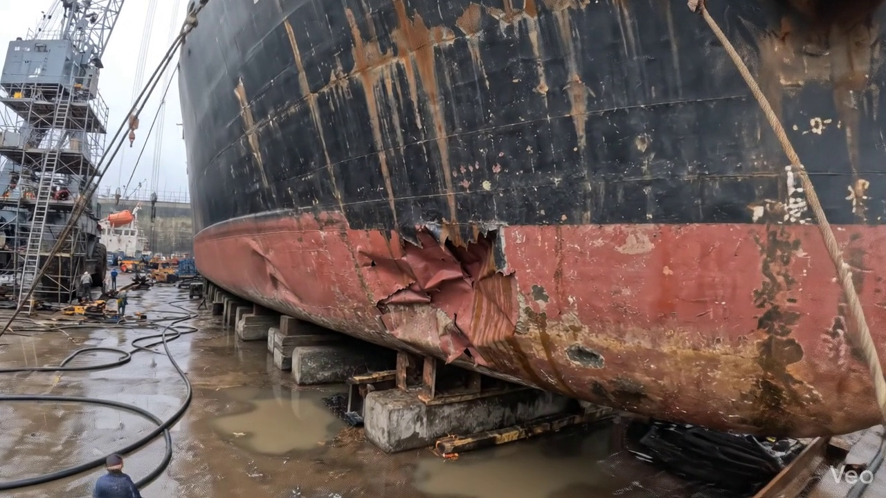

Repair Procedure
## Vessel Inspection Report: Explanation of Maritime Steel Plate and Framing Repair Process
This document outlines the professional procedure for addressing deformed steel plating and associated framing on a vessel, detailing each step's necessity, execution, and critical considerations for structural integrity and safety.
---
### 1. Explanation of Repair Process Steps
**a. Assessment**
* **What happens:** Ship's personnel or a surveyor visually inspects the damaged area. The extent of deformation, including any buckling or distortion, is meticulously mapped. Marks are made to delineate the buckled region, and a determination is made whether the damage is localized to a single plate section or propagates across multiple frames and structural members. Crucially, any out-of-flatness is quantified using appropriate measuring tools (e.g., straightedges, feeler gauges, laser alignment tools).
* **Why necessary:** This initial phase is paramount for defining the scope of the repair. It ensures that all affected material is identified, preventing localized repairs from overlooking broader structural issues. Accurate assessment allows for proper planning, material requisition, and estimation of labor and time. Quantifying out-of-flatness establishes a baseline for repair objectives and compliance with classification society standards for fairness and structural alignment.
**b. Preparation**
* **What happens:** Using thermal cutting tools (such as the specified cutting torch) or mechanical cutting methods, all visibly distorted or structurally compromised steel plate, as well as any buckled girders or stiffeners, are carefully cut away. This removal continues until sound, unaffected base metal is reached, leaving a clean margin of good plate, typically specified as $\geq \frac{3}{4}$ of the plate thickness, to ensure a stable foundation for new welds. If any adjacent framing (e.g., frames, longitudinals) is merely bent but not severely compromised, efforts are made to straighten it back to its original contour. Severely bent or cracked framing is removed for replacement.
* **Why necessary:** This step is fundamental to ensure the integrity of the subsequent repair. Removing all fatigued, cracked, or excessively distorted material prevents the propagation of existing defects into the new structure. The margin of sound plate provides a robust area for new weld connections, preventing new welds from being made on stressed or substandard material. Straightening or replacing damaged framing restores the primary and secondary structural support, maintaining the vessel's original design strength and shape.
**c. Plate Replacement**
* **What happens:** A new steel plate, meticulously fabricated to the exact dimensions and contour of the excised section, is prepared. This new plate must be of the same or greater thickness and material grade as the original hull plating to ensure equivalent or superior strength. The fabricated plate is then carefully positioned within the cut-out, ensuring precise alignment with the remaining hull plating. Once alignment is verified, it is temporarily secured using tack welds at strategic points. Subsequently, full welding commences around the entire periphery of the new plate, with strict attention paid to achieving good fusion with the existing structure and maintaining appropriate preheat temperatures as per welding procedures. The aim is to utilize full penetration welds wherever design and access allow.
* **Why necessary:** This phase directly restores the vessel's structural skin and watertight integrity. Fabricating a new plate to match or exceed original specifications ensures the restored area is capable of withstanding operational stresses. Precise fitting and alignment minimize stress concentrations and ensure a smooth hull surface. Tack welding secures the plate for final welding, preventing movement or misalignment. Full welding with proper fusion and preheat is critical for creating a homogenous and strong connection between the new and existing steel, preventing defects like lack of fusion or cracking. Full penetration welds maximize load transfer and minimize stress raisers.
**d. Alignment and Welding**
* **What happens:** The main welding operation proceeds with multiple passes, typically employing E7018 low-hydrogen electrodes, which are known for their excellent mechanical properties and resistance to hydrogen-induced cracking in structural steels. Throughout the welding process, continuous monitoring is performed to detect and mitigate weld-induced distortion. Techniques such as strong-backs, hydraulic clamps, or controlled, minimal heat input welding sequences (e.g., skip welding, back-step welding) are employed to maintain the structural alignment and prevent warping of the surrounding structure. Upon completion of welding, all weld seams are meticulously ground fair and smooth with the surrounding hull surface. In cases where the original buckling was extensive or indicates an area of high stress, additional strengthening components such such as doublers (pads welded over the repair) or stiffeners (new structural members) may be applied to distribute loads more effectively and reduce localized stress concentrations.
* **Why necessary:** This stage ensures the quality and durability of the welded repair. E7018 electrodes are chosen for their robustness in structural applications. Controlling distortion is vital to preserve the vessel's hydrodynamic profile, maintain structural alignment, and prevent the introduction of residual stresses that could lead to premature fatigue or cracking. Grinding welds fair eliminates stress risers, improves hydrodynamic flow, and facilitates proper coating application. The application of doublers or stiffeners provides localized reinforcement, addressing areas of historical weakness or high operational stress, thereby enhancing the long-term reliability of the repair and preventing recurrence of buckling.
**e. Finishing**
* **What happens:** Following completion of all welding, a comprehensive inspection of the repaired area is conducted. This includes visual inspection for surface defects, as well as Non-Destructive Testing (NDT) methods such as Magnetic Particle Inspection (MPI) or Ultrasonic Testing (UT) to check for subsurface defects and ensure full penetration and sound welds. Once the repair is verified to be structurally sound, the new steel surfaces are thoroughly cleaned and prepared for coating. A suitable marine primer is applied, followed by appropriate finish coats, meticulously matched to the vessel's existing paint system. The final step involves ensuring that the repaired deck or hull surface is faired back to its original smooth contour, addressing any minor irregularities from welding or grinding.
* **Why necessary:** This concluding phase confirms the quality and longevity of the repair. Visual and NDT inspections are critical quality control measures to ensure the repair meets classification society and owner requirements, guaranteeing the absence of welding defects that could compromise structural integrity. Application of primer and finish coats restores the essential corrosion protection, safeguarding the new steel from the harsh marine environment and extending its service life. Fairing the surface back to its original contour is important for maintaining the vessel's hydrodynamic efficiency, preventing localized turbulence, and preserving the aesthetic appearance and Class compliance of the hull or deck.
---
### 2. Justification for Required Items
**Cutting Torch (rental):**
* **Why used:** The cutting torch is an essential tool for the "Preparation" phase of this repair process. Its primary function is the efficient and precise removal of the distorted plate and buckled framing. Given the nature of steel plate repairs, thermal cutting offers significant advantages in speed and capability to cut through various thicknesses of steel, allowing for clean and accurate cuts to sound metal. The item being a "rental" suggests it's either for a project-specific need, where ownership is not justified, or to manage project costs by utilizing specialized equipment only when required for the duration of the repair. The quantity metric (machine-days/sq.m) directly correlates with the amount of material to be cut.
---
### 3. Safety and Structural Considerations
**a. Safety Considerations:**
* **Hot Work Permits:** Strict adherence to "Hot Work Permit" procedures is mandatory prior to any cutting or welding operations, especially in confined spaces or near flammable materials.
* **Fire Watch:** A dedicated fire watch personnel must be present with appropriate fire extinguishing equipment throughout all hot work activities and for a prescribed period afterward.
* **Personal Protective Equipment (PPE):** All personnel involved in cutting, welding, grinding, and coating application must utilize appropriate PPE, including welding helmets, cutting goggles, flame-retardant clothing, leather gloves, safety footwear, hearing protection, and respiratory protection where fumes or dust are present.
* **Ventilation:** Adequate ventilation is crucial during cutting, welding, and painting to dissipate hazardous fumes and gases, especially in enclosed spaces.
* **Confined Space Entry:** If the repair takes place within a confined space, strict confined space entry protocols must be followed, including gas testing, continuous monitoring, and stand-by rescue personnel.
* **Electrical Safety:** All welding equipment and power tools must be properly grounded and maintained to prevent electrical hazards.
* **Material Handling:** Safe lifting and positioning techniques must be employed when handling heavy steel plates and structural members.
**b. Structural Considerations:**
* **Classification Society Rules:** All repairs must strictly comply with the rules and regulations of the relevant Classification Society (e.g., Lloyd's Register, DNV, ABS) and flag state administration. This includes material specifications, welding procedures, and inspection requirements.
* **Material Selection:** The replacement steel plate and any new framing must match or exceed the original material's grade, thickness, and mechanical properties to ensure the restored area is structurally equivalent or superior.
* **Weld Procedure Specification (WPS) & Welder Qualification (WPQ):** All welding must be performed according to approved WPS documents by qualified and certified welders, ensuring consistent weld quality and integrity.
* **Distortion Control:** Effective measures to control welding-induced distortion are paramount to maintain the vessel's original lines, prevent residual stresses, and ensure the structural stability of adjacent components.
* **Fatigue Life:** The repair must be designed and executed to maintain or improve the original fatigue life of the structure, avoiding stress concentrations that could lead to premature cracking.
* **Watertight/Oiltight Integrity:** For hull plating repairs, the paramount consideration is to restore full watertight or oiltight integrity, depending on the location, to prevent ingress of water or leakage of cargo/fuel.
* **Load Path Continuity:** The repair must ensure continuous and effective load paths through the structure, restoring the original strength and stiffness of the vessel.
* **Inspection and Certification:** Thorough visual inspection and NDT are non-negotiable to verify the quality of welds and the absence of defects, with subsequent certification by a Class Society surveyor.
---

Repair Cost Breakdown
Item | Quantity | Unit Cost | Total Cost | Currency
Cutting Torch (rental) | 0.08 | 10764.0 | 807.3 | INR
Estimated Repair Cost: 41583.53 INR

3.2 PD_2

Defect Overview
Generation failed.

Visual Evidence
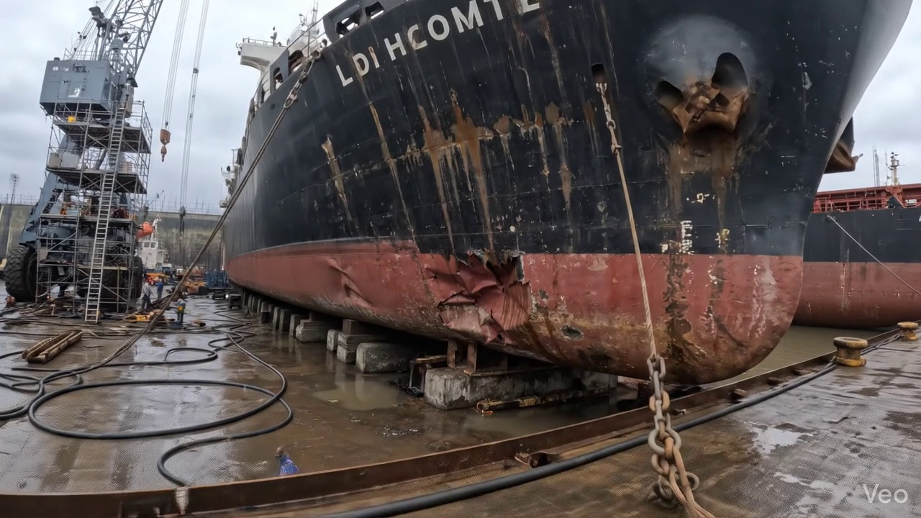

Repair Procedure
Generation failed.

Repair Cost Breakdown
Item | Quantity | Unit Cost | Total Cost | Currency
Cutting Torch (rental) | 0.08 | 10764.0 | 807.3 | INR
Estimated Repair Cost: 41583.53 INR

3.3 PD_3

Defect Overview
Generation failed.

Visual Evidence
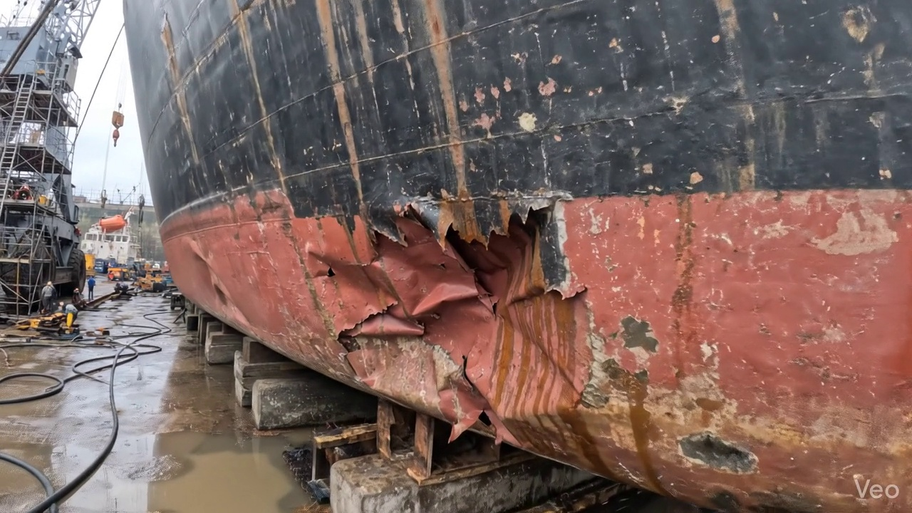

Repair Procedure
Generation failed.

Repair Cost Breakdown
Item | Quantity | Unit Cost | Total Cost | Currency
Cutting Torch (rental) | 0.12 | 10764.0 | 1345.5 | INR
Estimated Repair Cost: 69305.88 INR

3.4 PD_4

Defect Overview
Generation failed.

Visual Evidence
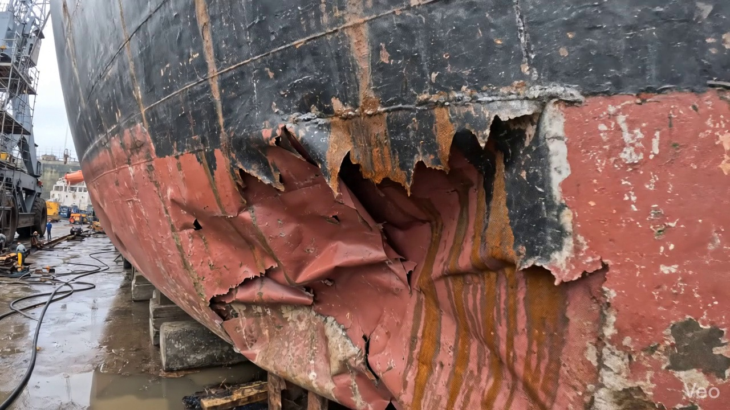

Repair Procedure
Generation failed.

Repair Cost Breakdown
Item | Quantity | Unit Cost | Total Cost | Currency
Cutting Torch (rental) | 0.12 | 10764.0 | 1345.5 | INR
Estimated Repair Cost: 69305.88 INR

