Vessel Inspection Report

Table of Contents
1. Executive Summary
2. Vessel Repair Summary
3. Defect Analysis
3.1 PD_1
3.2 PD_2
3.3 PD_3
3.4 PD_4

1. Executive Summary
**Executive Summary: Maritime Vessel Inspection Findings**
This executive summary presents the findings of a recent comprehensive inspection conducted on a designated maritime vessel, assessing its operational readiness, structural integrity, and compliance with applicable maritime regulations.
The inspection identified a total of **four (4) deficiencies** requiring corrective action. The distribution of these defects by severity is as follows:
* **High-Severity:** 2 items
* **Medium-Severity:** 2 items
* **Low-Severity:** 0 items
The presence of two high-severity defects necessitates immediate attention to maintain vessel seaworthiness, operational safety, and regulatory compliance. The two medium-severity items also warrant prompt corrective action to prevent potential escalation and ensure long-term reliability.
The total estimated repair cost to address all identified deficiencies is **INR 221,778.82**.
**Recommendation:**
It is strongly recommended that a detailed action plan be developed and executed promptly to address all identified deficiencies, prioritizing the high-severity items, to mitigate risks, ensure operational continuity, and restore the vessel to optimal safety and compliance standards.

2. Vessel Repair Summary
Metric | Value
Total Defects | 4
Total Estimated Cost | 221778.82 INR
Material Cost | 133067.29 INR
Labor Cost | 66533.65 INR
Equipment Cost | 22177.88 INR

3. Defect Analysis

3.1 PD_1

Defect Overview
**Defect Name:** DEFORMATION
**Severity:** Medium
---
**Explanation:**
**1. What the defect means:**
Deformation, specifically identified as buckling or warping, refers to an out-of-plane bending or distortion of the vessel's structural components. In this instance, the defect is located within the **HULL_AREA**, affecting either the hull plating, stiffeners (such as frames, longitudinals, or girders), or both. This condition indicates that the metal has bent or twisted beyond its original, intended flat or straight configuration. Common causes for such deformation include localized impact forces (e.g., groundings), excessive heavy sea loads imposing undue stress, or thermal stresses induced by uneven welding processes.
**2. Why it is important:**
This defect is of significant importance because it directly compromises the fundamental structural integrity of the vessel. Even moderate levels of buckling or warping can severely impair the hull girder strength. The hull girder acts as the primary structural beam of the ship, resisting bending and shear forces experienced during operations. Any reduction in its strength can have far-reaching implications for the vessel's overall seaworthiness and safety margin.
**3. Risks if not repaired:**
If this deformation is not promptly repaired, several risks emerge:
* **Reduced Structural Capacity:** The deformed area, and by extension the entire hull girder, will have a reduced capacity to withstand operational stresses, potentially leading to localized or widespread structural failure.
* **Loss of Watertight Integrity:** Severe deformation, especially in plating, can lead to cracking or fracturing, resulting in loss of watertight integrity and potential flooding of compartments.
* **Accelerated Fatigue:** Deformed areas often create stress concentration points, which are prone to the initiation and propagation of fatigue cracks under cyclical loading, potentially leading to sudden failure.
* **Adverse Load Redistribution:** The buckled structure can no longer effectively carry its intended load, forcing adjacent, sound structures to bear increased stress, which can lead to progressive damage or premature failure elsewhere.
* **Regulatory Non-Compliance:** Unrepaired significant deformation is typically considered a non-conformity by classification societies, which can affect the vessel's certification, insurance, and operational clearance.
**4. Structural implications:**
Structurally, deformation has several critical implications:
* **Reduced Sectional Modulus:** Buckled plating effectively reduces the sectional modulus of the hull girder. The sectional modulus is a geometric property that dictates a beam's resistance to bending. A reduction in this value means the hull is less resistant to bending moments, increasing the risk of structural failure.
* **Impaired Stiffener Function:** When stiffeners buckle or warp, they lose their ability to provide rigid support to the plating and effectively transfer loads. This can lead to further plating deformation and a general weakening of the local structure.
* **Altered Stress Distribution:** The presence of a buckle alters the designed stress distribution within the hull. Areas around the buckle may experience abnormally high stress concentrations, while the buckled section itself may contribute less effectively to the overall strength.
* **Requirement for Renewal:** As per classification society practice, significant deformation often cannot be adequately rectified by simple fairing or heating. To restore the original design strength and structural integrity, the distorted metal must be cut out and replaced with new, correctly formed material. This ensures that the structural geometry and material properties are fully restored.

Visual Evidence
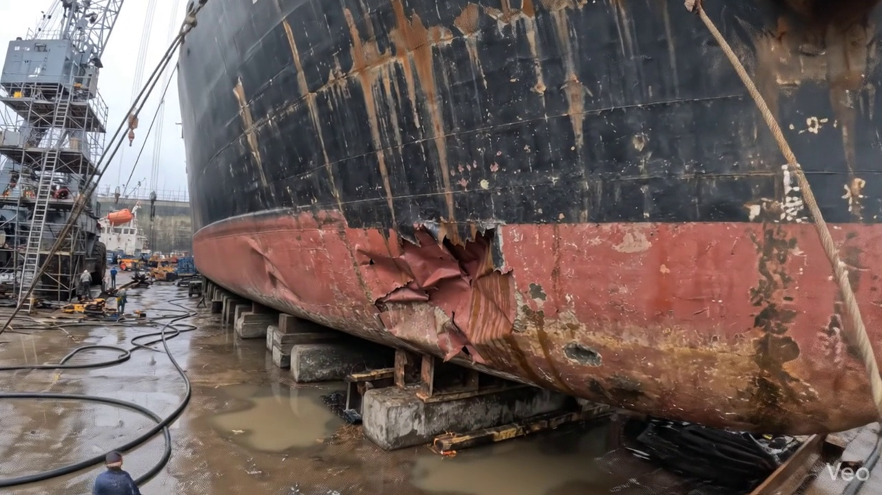

Repair Procedure
**Vessel Inspection Report: Explanation of Structural Steel Repair Process**
This report details a standard procedure for the repair of localized deformation or buckling in a vessel's hull or internal structural steelwork. Each step is critical to ensuring the structural integrity, watertightness/oil-tightness, and classification compliance of the repaired area.
---
**1. Assessment Phase**
* **Necessity:** This initial phase is indispensable for accurately diagnosing the extent and nature of the damage. Without a thorough assessment, the repair scope could be misjudged, leading to an incomplete repair or unnecessary work. It forms the basis for planning subsequent repair stages, material requirements, and safety protocols.
* **What Happens:** Skilled personnel visually inspect the deformed region, marking the boundaries of the buckled area. They determine if the deformation is localized to a single plate or if it extends to adjacent plates, stiffeners, or primary supporting members (frames, girders). Out-of-flatness measurements quantify the deviation from the original design contour, providing objective data on the severity of the damage. This data informs decisions regarding replacement versus fairing, and potential need for strengthening.
* **Safety and Structural Considerations:** Accurate assessment prevents perpetuation of existing damage or overlooking hidden structural weaknesses that could lead to future failures. It also helps identify potential stress concentration points that require particular attention during repair.
**2. Preparation Phase**
* **Necessity:** The preparation phase is crucial for removing all compromised material and creating a clean, sound base for the new structural components. Cutting to "sound metal" and leaving a "margin of good plate (≥¾ thickness)" ensures that the new welds will be deposited on undamaged, structurally sound material, preventing stress risers and ensuring optimal weld quality and strength.
* **What Happens:** Distorted plating, buckled girders, or stiffeners are precisely cut away using thermal cutting methods. The cuts are made to expose sound, undeformed material with a specified margin. Any internal framing that is bent or damaged is either straightened to its original profile using heat and mechanical means, or entirely removed for replacement. This step ensures that the foundation for the new steel is robust.
* **Why Required Items Are Used:**
* **Cutting Torch (rental):** This item is essential for efficiently and accurately cutting away the damaged steel plate and structural members. Thermal cutting methods, such as oxy-acetylene or plasma cutting, allow for quick removal of material, facilitating precise shaping of the repair opening to the specified dimensions and margin. The "rental" aspect suggests it's a specialized tool utilized for specific project durations, optimizing cost-effectiveness for intermittent use.
* **Safety and Structural Considerations:** This phase involves hot work, necessitating strict adherence to fire safety protocols, including hot work permits, fire watches, and readily available firefighting equipment. Proper ventilation is critical to mitigate exposure to fumes. Structurally, the meticulous removal of all fatigued or overstressed material is paramount to eliminate potential crack initiation sites and ensure the integrity of the subsequent weld joints.
**3. Plate Replacement Phase**
* **Necessity:** This phase restores the structural integrity, watertightness/oil-tightness, and original scantlings of the vessel's hull or internal structure. Using steel of "same or greater thickness" ensures that the repaired area meets or exceeds the original design strength requirements.
* **What Happens:** A new steel plate is fabricated to precisely match the dimensions and contour of the cut-out opening. This involves marking, cutting, and often forming (bending or rolling) the plate to achieve the correct shape. Once fabricated, the new plate is carefully positioned against the remaining hull plating. Tack-welds are applied at strategic points to temporarily hold the plate in place, ensuring proper fit-up and alignment prior to final welding.
* **Safety and Structural Considerations:** Correct fit-up of the new plate is vital to minimize residual stresses after welding. Any gaps or misalignment can lead to poor weld quality and potential structural weakness. The quality of the new material must be verified to conform to classification society requirements.
**4. Alignment and Welding Phase**
* **Necessity:** This is the critical phase where the new steel plate is permanently joined to the existing structure. High-quality welding ensures the continuity of structural strength, watertight/oil-tight integrity, and fatigue resistance of the repaired area. Proper welding techniques, material selection, and distortion control are paramount for a successful repair.
* **What Happens:** After tack-welding, continuous weld passes are applied around the entire perimeter of the new plate. Techniques such as preheating (to slow cooling rates and prevent hydrogen-induced cracking in thicker sections) and interpass temperature control are employed. "Full penetration welds" are utilized where design demands and access allow, ensuring the weld metal fuses completely through the thickness of the joint. If welding heat causes distortion, measures like strongbacks, clamps, or staggered welding sequences with minimal heat input are applied to maintain the plate's original contour. Once welding is complete, the weld seams are ground fair with the hull surface to improve hydrodynamics and reduce stress concentrations. In cases of significant prior buckling or where enhanced strength is desired, additional stiffening (e.g., doublers or new stiffeners) may be incorporated.
* **Why Required Items Are Used:**
* **E7018 Electrodes:** These are specific low-hydrogen electrodes commonly used in critical structural welding applications in the marine industry. Their properties include:
* **Low Hydrogen:** Reduces the risk of hydrogen-induced cracking, which is crucial for thick steel sections and restrained joints common in shipbuilding, especially in temperate and cold climates.
* **High Tensile Strength and Good Ductility:** Provides robust, flexible welds capable of withstanding the dynamic stresses and fatigue loading experienced by a vessel at sea.
* **Excellent Impact Properties:** Maintains strength and resistance to brittle fracture even at low temperatures.
* (Implied: Welding Machines, Grinders, Preheat Equipment, Clamps)
* **Safety and Structural Considerations:** This phase carries significant safety risks, including electrical hazards, arc flash, fumes, and intense heat. Welders must be qualified to relevant standards (e.g., ISO, AWS) and adhere to strict safety protocols and wear appropriate Personal Protective Equipment (PPE). Structurally, the quality of the weld determines the success of the repair. Defects such as lack of fusion, porosity, cracks, or excessive distortion can severely compromise the structural integrity, watertightness, and fatigue life of the repair. Non-destructive testing (NDT) is often performed to verify weld quality.
**5. Finishing Phase**
* **Necessity:** The finishing phase ensures the long-term durability of the repair, confirms its quality, and restores the vessel's aesthetic and hydrodynamic performance.
* **What Happens:** A final comprehensive inspection is carried out. This includes visual inspection for surface defects and verification of contour, followed by Non-Destructive Testing (NDT) methods such as ultrasonic testing (UT), magnetic particle inspection (MPI), or radiographic testing (RT) to detect internal flaws within the weld. Once the repair is deemed structurally sound and free of defects, the new steel surface is prepared (e.g., abrasive blasting) and protected with marine-grade primer and finish coats to prevent corrosion. The final grinding and fairing ensure the hull or deck surface is seamlessly blended to its original contour, maintaining hydrodynamic efficiency and load distribution.
* **Safety and Structural Considerations:** NDT plays a crucial role in validating the integrity of the repair, ensuring it meets classification society rules and industry standards. Applying protective coatings is fundamental for preventing corrosion, which would otherwise prematurely degrade the new steel and compromise the repair's longevity. A faired surface prevents turbulence, reduces fuel consumption, and avoids creating new stress concentration points.

Repair Cost Breakdown
Item | Quantity | Unit Cost | Total Cost | Currency
Cutting Torch (rental) | 0.08 | 10764.0 | 807.3 | INR
Estimated Repair Cost: 41583.53 INR

3.2 PD_2

Defect Overview
**DEFECT EXPLANATION: DEFORMATION (BUCKLING/WARPING)**
**1. What the defect means:**
Deformation, specifically observed as buckling or warping, refers to an out-of-plane bending or distortion of the vessel's hull plating or its associated stiffeners. This means the affected metal surface is no longer flat or in its intended geometric plane but has visibly bent inwards or outwards. This type of distortion is typically caused by external forces such as grounding impacts, heavy sea loads, or internal stresses like those induced by uneven welding or thermal expansion/contraction. In this instance, it affects a significant portion of the 'HULL_AREA', indicating a localized yet notable distortion.
**2. Why it is important:**
This defect is categorized as 'medium' severity because even moderate buckles can severely impair the hull girder strength, which is the primary structural element responsible for the vessel's overall longitudinal strength and its ability to resist global bending and shearing forces. Any deformation compromises the structural integrity and load-bearing capacity of these critical elements, reducing their ability to perform as designed and potentially leading to localized stress concentrations.
**3. Risks if not repaired:**
If left unaddressed, the localized stress concentrations around the deformed area can propagate over time, potentially leading to cracking or fatigue failures in the plating or stiffeners. This compromises the watertight integrity of the hull, posing a risk of water ingress into compartments. Furthermore, under dynamic conditions such as heavy seas, or subsequent impacts, the weakened area could experience accelerated failure, potentially affecting the overall structural stability and safety of the vessel. Failure to rectify significant deformations can also lead to non-compliance with classification society requirements, potentially impacting the vessel's class status or future survey outcomes.
**4. Structural implications:**
Structurally, deformation signifies a reduction in the effective section modulus and moment of inertia of the affected hull members. This directly diminishes the hull's ability to withstand compressive, tensile, and shear forces as designed. Buckling, in particular, indicates that the plate or stiffener has exceeded its elastic limit, and its capacity to carry its design load has been significantly reduced, making it susceptible to further collapse under normal operating stresses. The outer shell plating and the internal framing (stiffeners) are crucial for maintaining the vessel's form and resisting external pressures; their distortion compromises these fundamental functions. As per classification practice, significant buckles typically necessitate cutting out and replacing the distorted metal to restore the original design strength and structural continuity.

Visual Evidence
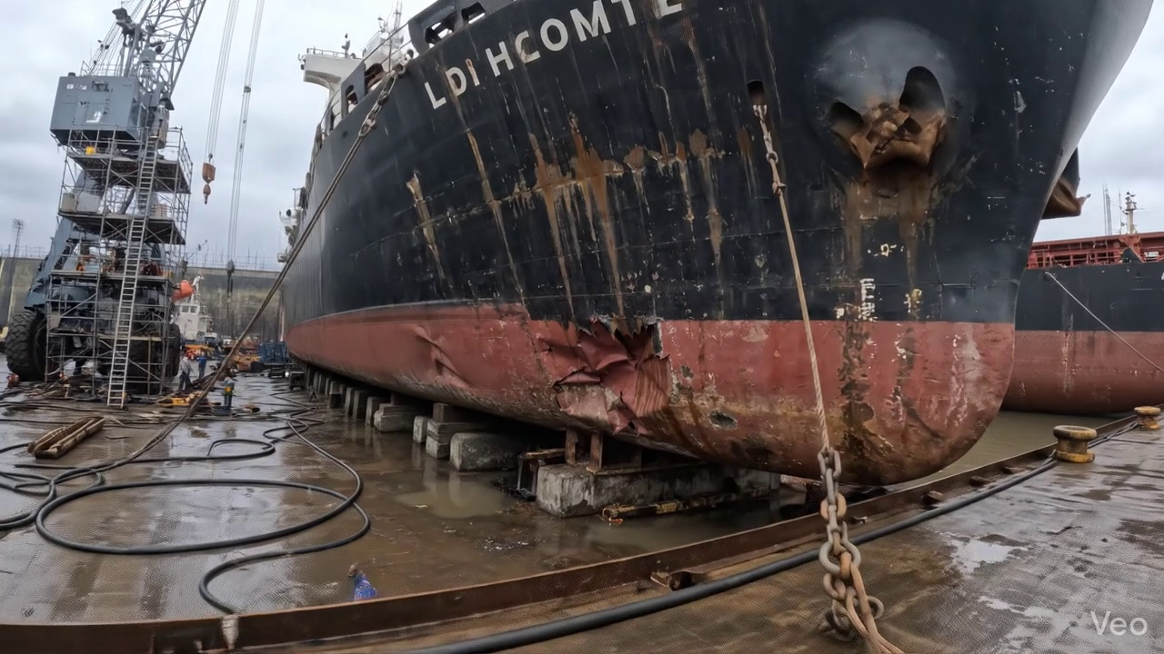

Repair Procedure
This report details the professional repair procedure for localized plate deformation on a vessel, ensuring the restoration of structural integrity, watertightness, and aesthetic fairing.
---
### **Detailed Repair Process Explanation**
**1. Assessment**
* **Why it's necessary:** This initial phase is crucial for accurately defining the scope of work and understanding the extent of the damage. It ensures that the repair addresses the full range of deformation, preventing localized fixes from masking broader structural issues and allowing for accurate material and labor estimation.
* **What happens during the repair:** Skilled technicians thoroughly inspect the deformed region. This involves precisely marking the buckled area and determining if the deformation is isolated or affects adjacent frames, bulkheads, or internal structures. Quantitative measurements of "out-of-flatness" are taken to establish the degree of distortion, providing critical data for the subsequent repair plan and material preparation.
**2. Preparation**
* **Why it's necessary:** The objective is to remove all compromised and fatigued material, ensuring that the new plate is welded to sound, undistorted original structure. Maintaining a margin of good plate (≥¾ thickness) guarantees that the heat-affected zone of the new welds does not extend into weakened or potentially stressed material, thereby preventing crack initiation in the future.
* **What happens during the repair:** All distorted plate sections and any associated buckled girders or stiffeners are precisely cut away using thermal cutting equipment (e.g., a cutting torch) until sound, uncompromised metal is reached. A minimum margin of ¾ of the plate's original thickness is maintained around the perimeter of the cutout. Any adjacent framing that exhibits bending or deformation is either meticulously straightened back to its original alignment or, if severely compromised, completely removed to be replaced.
**3. Plate Replacement**
* **Why it's necessary:** This step is fundamental to restoring the vessel's structural integrity, load-bearing capacity, and original design geometry. Using new steel of equivalent or greater thickness ensures that the repaired area meets or exceeds the original design specifications for strength and durability.
* **What happens during the repair:** A new steel plate, fabricated to precisely match the shape and dimensions of the cutout, is prepared. This plate will be of the same or greater thickness as the original to ensure adequate strength. It is then carefully positioned against the remaining hull plating, ensuring proper alignment and fit-up. The new plate is then tack-welded into place to maintain its position and alignment during the primary welding phase. Subsequent full perimeter welding is performed, ensuring proper fusion, adequate preheat application (critical for preventing cold cracking), and, where feasible, utilizing full penetration welds for maximum strength.
**4. Alignment and Welding**
* **Why it's necessary:** This stage focuses on creating a robust, high-integrity welded joint that integrates the new plate seamlessly into the existing structure. The use of specific electrodes and careful welding techniques is paramount to achieving the required mechanical properties, preventing distortion, and ensuring the structural longevity of the repair.
* **What happens during the repair:** Sequential weld passes are applied to complete the joint, typically employing low-hydrogen electrodes such as E7018. These electrodes are selected for their excellent mechanical properties and resistance to hydrogen-induced cracking. During welding, continuous monitoring and control measures are implemented to mitigate heat-induced distortion, including the strategic use of clamps, back-step welding techniques, or controlled minimal heat input. Upon completion of welding, all weld seams are meticulously ground fair and smooth with the surrounding hull surface to prevent stress concentrations and facilitate subsequent coating application. In instances where the original buckling was extensive, additional strengthening elements like doubler plates or stiffeners may be incorporated to enhance local strength and better distribute anticipated stresses.
**5. Finishing**
* **Why it's necessary:** The finishing stage verifies the quality and integrity of the entire repair process and provides essential corrosion protection to the newly installed steel. This ensures the longevity of the repair, maintains the vessel's hydrodynamic efficiency, and restores its aesthetic appearance.
* **What happens during the repair:** The completed weld repair undergoes stringent inspection. This includes comprehensive visual examination for surface defects and non-destructive testing (NDT) methods (e.g., Magnetic Particle Testing, Ultrasonic Testing) to detect any internal flaws within the weld or adjacent material. Following successful inspection, the new steel surface is prepared through abrasive blasting or mechanical cleaning, primed, and coated with the specified marine paint system to restore its original corrosion protection. Finally, the repaired area is meticulously faired back to its original contour, ensuring smooth flow lines and aesthetic uniformity with the vessel's hull or deck.
---
### **Why the Required Items Are Used**
* **Cutting Torch (rental):**
* **Purpose:** The cutting torch is an indispensable tool primarily utilized during the **Preparation** phase.
* **Application:** It is used for the precise and efficient thermal cutting and removal of the distorted plate material and any buckled associated framing. Thermal cutting provides a rapid and effective method to create the necessary cutout for the new plate section, allowing for accurate shaping and removal of damaged steel.
* **Relevance to Quantity/Cost:** The listed quantity of 0.08 machine-days/sq.m indicates the estimated operational time required for the cutting torch per square meter of repair, reflecting the intensity and extent of the cutting operations needed for a given repair scope. The rental aspect suggests it may be used intermittently or for specialized tasks rather than being a permanently owned asset.
---
### **Safety and Structural Considerations**
1. **Structural Integrity & Compliance:**
* All repair procedures and material choices must strictly adhere to the vessel's classification society rules (e.g., Lloyd's Register, DNV, ABS) and relevant statutory regulations (e.g., SOLAS, MARPOL).
* The selection of new plate material of the same or greater thickness, coupled with the use of high-quality, low-hydrogen welding electrodes like E7018, is critical for restoring or enhancing the original structural strength, fatigue life, and fracture toughness of the repaired area.
* Full penetration welds, where achieved, ensure optimal load transfer and structural continuity.
* Proper preheating, especially for thicker sections or high-strength steels, is vital to prevent hydrogen embrittlement and ensure a sound, crack-free weld, particularly in cold environments.
2. **Watertightness/Gastightness:**
* For hull plating repairs, ensuring absolute watertight integrity is paramount. This is achieved through continuous, defect-free welding and verified through NDT and potentially hydrostatic or hose testing.
* For internal structures that form tanks or compartments, gastightness or liquid tightness must be confirmed.
3. **Distortion Control:**
* Careful management of heat input during welding is essential to prevent secondary distortion in adjacent structures, which could compromise the overall structural integrity, impact machinery alignment, or affect the fairing of the hull. Techniques like balanced welding sequences, strong-backs, peening, and controlled cooling are employed.
4. **Safety Protocols:**
* **Hot Work:** All cutting and welding operations are classified as hot work and necessitate strict adherence to safety procedures, including comprehensive fire watch, removal of combustibles, adequate ventilation, and the provision of appropriate personal protective equipment (PPE) for all personnel involved.
* **Confined Space Entry:** If the repair is conducted within tanks or confined compartments, stringent confined space entry protocols, including gas testing, ventilation, and rescue plans, must be followed.
* **Lockout/Tagout:** Adjacent machinery, electrical systems, and piping must be properly isolated and tagged out to prevent accidental activation during the repair.
5. **Quality Assurance and Professional Competence:**
* All tasks, particularly welding, NDT, and material handling, must be performed by certified, qualified, and experienced personnel. Welders must hold current certifications for the specific welding processes and materials.
* Rigorous quality control throughout the process, from material verification to final NDT, is crucial to ensure the highest standards of workmanship and compliance.
This systematic and meticulously documented repair process ensures that any localized plate deformation is addressed effectively, restoring the vessel's structural integrity, operational safety, and long-term reliability in accordance with maritime industry standards.

Repair Cost Breakdown
Item | Quantity | Unit Cost | Total Cost | Currency
Cutting Torch (rental) | 0.08 | 10764.0 | 807.3 | INR
Estimated Repair Cost: 41583.53 INR

3.3 PD_3

Defect Overview
**Defect Explanation: Deformation (Buckling/Warping) - High Severity**
This report details a significant structural defect identified as "Deformation," specifically manifesting as buckling or warping, within the vessel's primary hull structure. The severity of this defect is classified as high.
1. **What the defect means:**
Deformation, in this context, refers to an out-of-plane bending or distortion of the vessel's hull plating and/or associated stiffeners. This type of damage is typically observed as either "buckling" (a sudden change in the shape of a structural element under compressive stress) or "warping" (a more general, uneven bending or twisting). The defect is noted to significantly overlap with the **HULL_AREA** and **KEEL_AREA**, indicating its presence on critical load-bearing components. Common causes for such deformation include severe impacts (e.g., grounding incidents), excessive heavy weather loads leading to overstressing, or localized thermal stresses induced by welding processes.
2. **Why it is important:**
This defect is critically important due to its direct and severe impact on the vessel's structural integrity. Even moderate levels of buckling or warping can significantly impair the overall longitudinal strength of the hull girder, which is the primary structural element resisting bending moments and shear forces during operation. Given its high severity classification and location on the hull and keel, the deformation indicates a compromised structural condition that demands immediate attention to ensure the vessel's continued seaworthiness and safety.
3. **Risks if not repaired:**
Failure to address significant deformation carries substantial risks. The compromised hull girder strength increases the potential for progressive structural failure, particularly under dynamic loads encountered in adverse weather or during future impact events. This could lead to catastrophic structural collapse, loss of watertight integrity, ingress of water, and ultimately, a potential loss of the vessel. The distorted plating also creates localized stress concentrations, making these areas highly susceptible to fatigue cracking, accelerated corrosion, and further deterioration over time, thereby reducing the vessel's operational lifespan and increasing maintenance burdens.
4. **Structural implications:**
Structurally, the presence of significant deformation directly reduces the effective cross-sectional area and the section modulus of the affected hull plating and stiffeners. This diminishes the vessel's ability to resist global bending moments and shear forces, which are critical for maintaining the hull girder's integrity. The deformation also compromises the local stiffness and stability of the plating, making it more prone to further collapse under compressive loads. As per classification society practice for significant buckling, and given the high severity and overlap with critical structural areas like the HULL_AREA and KEEL_AREA, rectification will necessitate the cutting out and replacement of the distorted metal to restore the original structural strength, geometric profile, and design specifications, rather than merely attempting to fair or repair the existing material.

Visual Evidence
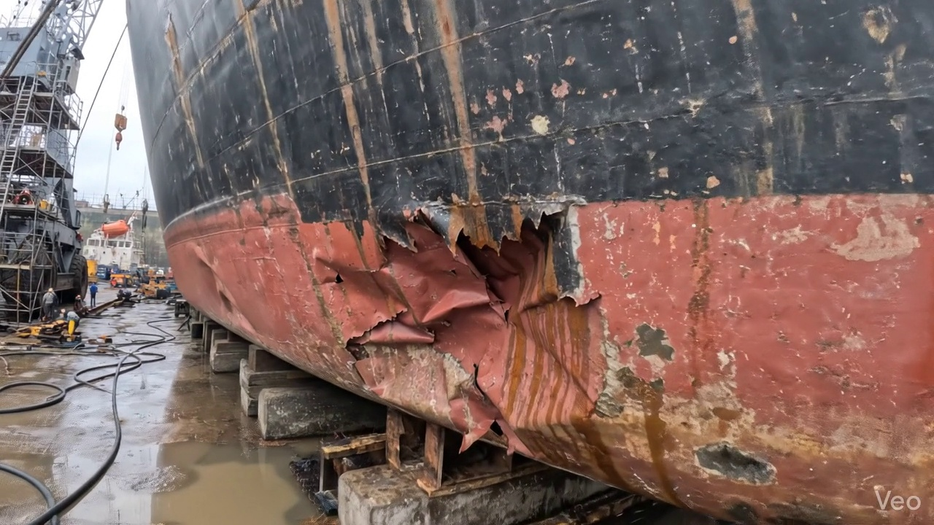

Repair Procedure
## Vessel Structural Repair Process Explanation for Inspection Report
**Date:** [Current Date]
**Vessel Name:** [Vessel Name - if applicable]
**Area of Repair:** [Specific Location on Vessel - e.g., Hull Plate, Deck Section]
**Nature of Damage:** [e.g., Localized buckling, deformation due to impact]
---
This section outlines the detailed procedure for a structural steel repair involving plate and framing replacement due to deformation, adhering to industry best practices and classification society requirements.
### 1. Repair Process Overview and Justification
The repair process is systematically executed to ensure the restoration of the vessel's structural integrity, watertightness (where applicable), and original contour. Each step is critical for a durable and compliant repair.
**1.1. Assessment**
* **What happens:** Ship's engineers or surveyors meticulously inspect the deformed region. This involves visually identifying the extent of the damage, marking the buckled area, and determining if the deformation is localized to a single plate or if it extends to adjacent plates, frames, girders, or stiffeners. Precise measurements of out-of-flatness (deviation from the original planar surface) are taken using straightedges, calipers, and measuring tapes.
* **Why necessary:** This initial phase is fundamental for accurately defining the scope of the repair. It ensures that all compromised material is identified and that the repair plan adequately addresses the full extent of damage, preventing hidden weaknesses or the premature recurrence of issues. This also informs the material selection and fabrication requirements.
* **Safety & Structural Considerations:** Proper assessment prevents under-repairing, which could compromise the vessel's structural strength, particularly in critical areas or during subsequent operational stresses.
**1.2. Preparation**
* **What happens:** Using an oxy-acetylene or plasma cutting torch, all distorted plating, buckled girders, and stiffeners are precisely cut away. The cutting continues until sound, unaffected base metal is reached, with a specified margin (typically ≥¾ of the plate thickness, as indicated by the reference) left beyond the visibly distorted area. This ensures that the weld preparation is on undamaged, structurally sound material. Any bent or compromised adjacent framing that supports the affected area is either carefully straightened back to its original alignment using heat and mechanical force, or completely removed and replaced if straightening is deemed ineffective or structurally compromising.
* **Why necessary:** This step removes all fatigued, cracked, or excessively stressed material, creating a clean, sound opening for the new insert plate. The margin ensures that any potential micro-cracks or material degradation extending beyond the visible damage are also removed, providing an optimal surface for welding and preventing future crack propagation or stress concentrations at the weld joint.
* **Safety & Structural Considerations:** This step is crucial for the long-term integrity of the repair. It eliminates sources of failure and ensures the new weld connection is strong and ductile. Proper ventilation and hot work safety protocols are paramount during cutting operations.
**1.3. Plate Replacement**
* **What happens:** A new steel plate, matching or exceeding the original plate's thickness and material specification (e.g., marine-grade mild steel or high-tensile steel), is precisely fabricated (cut and shaped) to fit the prepared opening. The edges are prepared (e.g., beveled) to facilitate full penetration welds. The new plate is then carefully positioned into the cut-out, aligning it flush with the existing hull plating. Temporary strongbacks and dog wedges, or mechanical clamps, are used to hold it securely in position while tack-welds are applied at strategic intervals. Following tacking, continuous welding progresses around the entire perimeter of the insert plate, ensuring good fusion with the parent material. Appropriate preheat (as per material specifications and welding procedure specifications) is applied to mitigate hydrogen cracking and reduce residual stresses. Full penetration welds are prioritized wherever joint accessibility and design allow, to maximize weld strength.
* **Why necessary:** This step restores the primary structural component of the hull/deck. Using equivalent or greater thickness ensures the repaired area maintains or exceeds its original strength. Proper fit-up, preheat, and fusion are critical to achieving a high-quality, structurally sound weld joint, preventing defects that could lead to premature failure. Full penetration welds maximize the load-carrying capacity of the joint.
* **Safety & Structural Considerations:** Material compatibility and proper welding procedures (WPS) are paramount. Inadequate preheat can lead to brittle fracture, particularly in thicker sections or high-strength steels. Poor fit-up or insufficient fusion can result in weak welds prone to cracking under operational stresses.
**1.4. Alignment and Welding**
* **What happens:** Subsequent weld passes are applied to complete the joint, typically utilizing low-hydrogen E7018 electrodes. These electrodes are specified for their excellent mechanical properties and reduced risk of hydrogen-induced cracking, which is critical for structural repairs. Throughout the welding process, diligent monitoring for welding-induced distortion is conducted. If distortion occurs, it is managed through techniques such as applying clamps, strategic weld sequencing, or using minimal heat input techniques (e.g., back-step welding, skip welding). Upon completion of welding, the weld seams are carefully ground fair and flush with the surrounding hull plating to eliminate stress concentrators, improve hydrodynamic flow (if external), and maintain aesthetics. In instances where the initial buckling was extensive, or the area is subject to high localized stresses, additional strengthening elements such as doublers (pads welded over the joint) or stiffeners (angle bars, flat bars) may be incorporated to enhance local structural rigidity and stress distribution.
* **Why necessary:** This phase completes the permanent structural connection. E7018 electrodes provide high-quality, robust welds essential for structural integrity. Managing distortion prevents the introduction of new residual stresses or changes in the vessel's original form, which could impact stability or performance. Grinding welds fair removes potential fatigue initiation points. Additional strengthening ensures the repaired area can withstand anticipated operational loads effectively, preventing future failures in complex or high-stress regions.
* **Safety & Structural Considerations:** Use of appropriate electrodes is vital for weld quality. Uncontrolled distortion can lead to internal stresses and reduced fatigue life. Grinding must be performed carefully to avoid removing too much parent material or creating new defects. Welders must be qualified to relevant standards.
**1.5. Finishing**
* **What happens:** After welding and grinding, the repaired area undergoes rigorous inspection. This includes comprehensive visual inspection to detect surface defects (e.g., undercut, porosity, cracks). Non-Destructive Testing (NDT) methods, such as Magnetic Particle Testing (MPT) or Ultrasonic Testing (UT), are then performed on the finished welds to identify any subsurface defects (e.g., lack of fusion, internal porosity, sub-surface cracks) that are not visible externally. Once the repair passes all inspections, the new steel surfaces are thoroughly cleaned and prepared, then coated with an anti-corrosive primer followed by appropriate finish coats (e.g., anti-fouling, topcoat) to match the surrounding structure and restore the vessel's corrosion protection system. Finally, the entire deck or hull surface encompassing the repair is faired back to its original contour, ensuring smooth transitions for hydrodynamic efficiency (if external) or structural alignment (if internal).
* **Why necessary:** This final phase verifies the quality and integrity of the entire repair process. NDT is indispensable for detecting hidden defects that could compromise the repair's strength and longevity. Restoring the coating system is crucial for protecting the new steel from corrosion, which would otherwise quickly degrade the repair. Fairing ensures the vessel's hydrodynamic performance is maintained and prevents localized turbulence or structural misalignment.
* **Safety & Structural Considerations:** Comprehensive NDT is the ultimate check for the structural soundness of the repair. Any detected defects must be rectified. Inadequate coating application will lead to premature corrosion and potential re-occurrence of structural issues.
### 2. Justification for Required Items
**Cutting Torch (rental):**
* **Purpose:** The cutting torch is a fundamental tool for the "Preparation" phase of this repair. It is utilized to precisely cut away the deformed and damaged steel plating, buckled girders, and stiffeners to reach sound, unaffected metal.
* **Usage During Repair:** During the "Preparation" step, the cutting torch provides the necessary heat to make accurate and clean cuts through the steel structures. Its mobility and effectiveness are critical for cleanly removing irregular sections of damaged material, thereby creating the precise opening required for the new insert plate and ensuring optimal edge preparation for welding.
* **Rental Rationale:** The item is listed as 'rental,' indicating that it is not a continuously used or owned asset but rather acquired for the specific duration of the repair project, optimizing cost efficiency for intermittent use. The calculated quantity (0.12 machine-days) and associated cost reflect its temporary but essential role in the overall repair budget.
---
**Inspector's Notes:**
The documented repair process is comprehensive and adheres to established maritime structural repair guidelines. The emphasis on assessment, sound metal preparation, controlled welding techniques with suitable consumables (E7018), and thorough NDT ensures a robust and reliable repair. The utilization of a cutting torch as a rental item aligns with efficient project management for intermittent specialized equipment needs.

Repair Cost Breakdown
Item | Quantity | Unit Cost | Total Cost | Currency
Cutting Torch (rental) | 0.12 | 10764.0 | 1345.5 | INR
Estimated Repair Cost: 69305.88 INR

3.4 PD_4

Defect Overview
**Defect Explanation: DEFORMATION (Buckling/Warping) - High Severity**
**1. What the defect means:**
The observed defect, identified as 'DEFORMATION' (buckling or warping), refers to an out-of-plane bending or deviation from the intended flat or curved profile of structural components, specifically the vessel's hull plating and/or supporting stiffeners. This is not merely a cosmetic blemish but a physical distortion where the metal has permanently changed shape, protruding inwards or outwards from its original position. Such deformations are commonly induced by external forces such as impacts from groundings, heavy sea loads, or internal stresses like those arising from uneven welding heat.
**2. Why it is important:**
The significance of this deformation is paramount, evidenced by its 'high' severity rating. Even seemingly moderate buckles are known to severely impair the overall hull girder strength, which is the vessel's fundamental ability to withstand bending forces along its length. Unlike minor indents, deformation indicates that the material has yielded and lost its original stiffness and load-carrying capacity. This defect is not merely a localized issue; it fundamentally compromises the structural integrity of primary strength members, making the vessel less robust against the various forces encountered during operation.
**3. Risks if not repaired:**
Failure to repair significant deformation carries substantial risks:
* **Progressive Structural Failure:** The weakened plating and stiffeners can experience increased stress concentrations at the deformed areas, leading to progressive fatigue cracking and potential structural failure, especially under dynamic loading conditions (e.g., heavy seas).
* **Compromised Watertight Integrity:** Particularly in areas like the Keel Area and Hull Area, severe deformation can compromise the watertight integrity of tanks or compartments, leading to water ingress, flooding, and potential stability issues.
* **Reduced Resistance to External Forces:** The vessel's ability to safely withstand future grounding impacts, wave slamming, or other external forces will be critically diminished, increasing the likelihood of catastrophic failure.
* **Regulatory Non-Compliance and Operational Restrictions:** Significant structural deformation violates classification society rules and international maritime regulations. This can lead to vessel detention, operational restrictions, increased insurance premiums, and potential refusal of port entry.
* **Safety Hazard:** Ultimately, unrepaired high-severity deformation poses a direct safety hazard to the vessel, its crew, cargo, and the marine environment.
**4. Structural implications:**
The structural implications of deformation are profound and far-reaching:
* **Loss of Load-Carrying Capacity:** The primary structural consequence is a direct reduction in the load-carrying capacity of the affected hull plating and stiffeners. Buckled plating cannot effectively contribute to the section modulus of the hull girder, reducing its resistance to longitudinal bending moments.
* **Compromised Hull Girder Strength:** The deformation directly compromises the vessel's global strength, known as the hull girder strength. This is crucial for resisting longitudinal bending, torsional forces, and hydrostatic pressures. Given its significant overlap with the **KEEL_AREA** and **HULL_AREA** (with overlap ratios exceeding 45% in both cases), this deformation directly impacts primary structural elements critical for the vessel's longitudinal strength, overall hull form, and bottom structure integrity.
* **Altered Stress Distribution:** The out-of-plane bending alters the intended stress distribution throughout the surrounding structure, potentially overstressing adjacent intact members and accelerating fatigue in those areas.
* **Mandatory Renewal:** Classification society practice dictates that significant buckling must be corrected by cutting out and replacing the distorted metal. Localized fairing or minor repairs are generally insufficient to restore the original structural properties, especially when the deformation is extensive and impacts critical areas like the keel and main hull plating. This requirement underscores the severity and the necessity of comprehensive structural renewal to ensure the vessel's continued fitness for service.

Visual Evidence
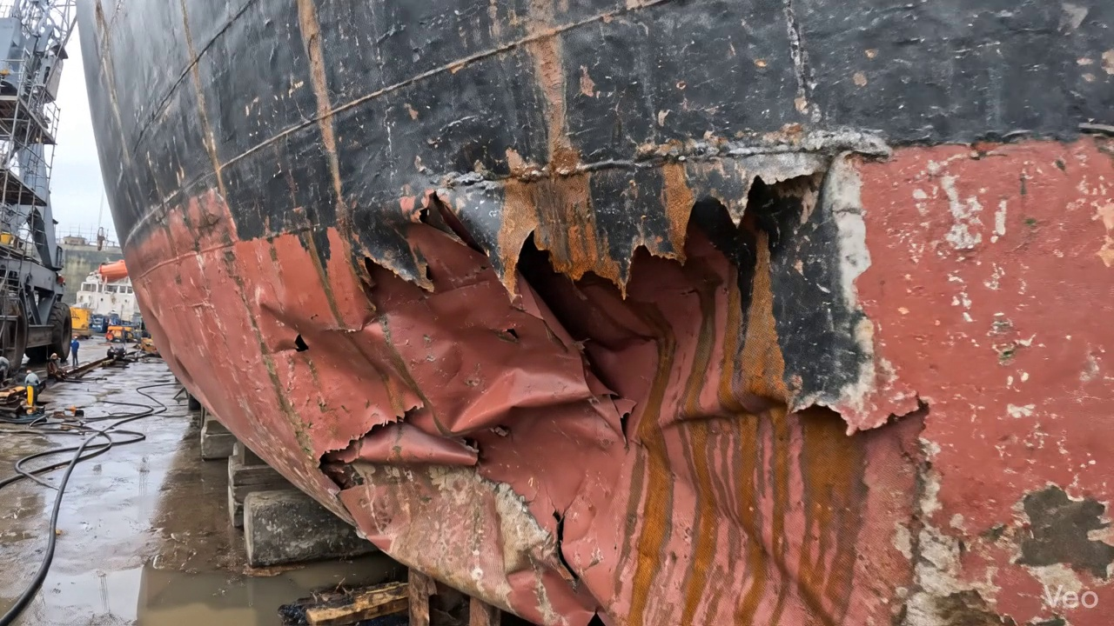

Repair Procedure
## Vessel Inspection Report: Explanation of Structural Steel Repair Process
**Repair Scope:** This report details the standard procedure for the repair of localized structural deformation and damage, involving plate and stiffener replacement, as observed on the vessel's hull/deck. The process is designed to restore the structural integrity, watertightness (where applicable), and original contour of the affected area in compliance with classification society rules and industry best practices.
---
### Detailed Explanation of Repair Steps:
**1. Assessment Phase:**
* **Why Necessary:** This is the critical initial step to accurately define the extent and nature of the damage. A thorough assessment ensures that the repair plan is comprehensive, addresses all compromised material, and prevents under-repairing, which could lead to recurrence of issues, or over-repairing, which would be inefficient and costly. It forms the foundation for a structurally sound repair.
* **What Happens:** Skilled personnel perform a detailed visual inspection of the deformed region. This includes marking the boundaries of the buckled area, identifying whether the damage is localized to a single plate or spans across multiple frames or stiffeners, and taking precise measurements of any out-of-flatness or permanent deformation using straight edges, feeler gauges, and other measuring tools. This data is crucial for planning the cut-out dimensions and the required material quantities.
* **Required Items Used:** While not explicitly listed, this phase implicitly utilizes measuring tapes, straight edges, feeler gauges, and chalk/markers.
* **Safety & Structural Considerations:** Ensures that the full scope of damage is understood, preventing a partial repair that could compromise the overall structural integrity.
**2. Preparation Phase:**
* **Why Necessary:** The primary goal is to remove all fatigued, cracked, or permanently deformed material. Welding new steel onto compromised or distorted parent metal would create a weak point, introduce residual stresses, and potentially lead to future cracking or failure. Leaving a margin of good plate ensures that the new weld deposit is placed on sound, unaffected material, promoting excellent fusion and metallurgical integrity.
* **What Happens:** All identified distorted plate material, along with any buckled or bent girders or stiffeners, are meticulously cut away. This cutting continues until only sound, unaffected metal remains, with a minimum margin of good plate equal to or greater than ¾ of the original plate thickness. Any framing that is bent but not severely compromised may be straightened; otherwise, it is also removed.
* **Required Items Used:** The **Cutting Torch (rental)** is indispensable in this phase. It provides an efficient and effective method for thermal cutting of steel plates and profiles. Its use facilitates rapid and precise removal of damaged sections, ensuring clean cut edges for subsequent fit-up and welding. The "rental" aspect implies a cost-effective approach for intermittent use.
* **Safety & Structural Considerations:** This phase involves "hot work," requiring strict adherence to hot work permits, fire watch protocols, personal protective equipment (PPE), and appropriate ventilation to mitigate fire hazards and exposure to fumes. Structurally, it's paramount that *all* compromised material is removed to ensure the longevity and strength of the subsequent repair.
**3. Plate Replacement Phase:**
* **Why Necessary:** This step directly restores the structural continuity, load-bearing capacity, and watertight/weathertight integrity of the vessel. The new plate must be of equivalent or greater thickness and material grade to meet or exceed the original design strength.
* **What Happens:** A new steel plate, sourced to the same or greater thickness and material specification as the original, is precisely fabricated to match the dimensions and contour of the cut-out. This new plate is then carefully positioned against the remaining hull plating. Once accurate fit-up is achieved, it is secured with tack-welds to maintain its position. The primary welding then commences, ensuring full penetration welds where structurally required, good fusion with the parent material, and the application of appropriate preheat as per welding procedure specifications (WPS) to control cooling rates and prevent hydrogen-induced cracking.
* **Required Items Used:** While not explicitly listed, this phase requires welding machines, grinding equipment for edge preparation, and fabrication tools (e.g., presses, shears, rolls) to shape the new plate.
* **Safety & Structural Considerations:** Correct material selection is crucial for structural equivalence. Preheat application is a critical metallurgical control to prevent cold cracking, especially in thicker sections or high-strength steels. Proper edge preparation and fit-up are vital for achieving sound, full penetration welds.
**4. Alignment and Welding Phase:**
* **Why Necessary:** This phase completes the structural integration of the new plate, ensuring the repair achieves its full design strength and that the hull form is maintained. Controlling welding-induced distortion is vital for the vessel's hydrodynamic efficiency and to prevent undesirable residual stresses that could lead to premature failure.
* **What Happens:** Continuous weld passes are applied to complete the joint between the new plate and the existing structure. **E7018 electrodes** are specifically used for this purpose. Throughout the welding process, techniques such as strategic clamping, back-stepping, or controlled heat input are employed to mitigate welding-induced distortion. Upon completion of welding, the weld seams are carefully ground fair and smooth with the surrounding hull surface to minimize stress concentrations and maintain the vessel's hydrodynamic profile. In instances where the original buckling was extensive or the area is subjected to high stresses, additional strengthening components such as doubler plates or stiffeners may be added as per engineering assessment to enhance local strength and distribute loads more effectively.
* **Required Items Used:** **E7018 electrodes** are selected for their low-hydrogen properties, excellent mechanical strength, toughness, and good weldability in all positions. These characteristics make them ideal for critical structural applications in shipbuilding, minimizing the risk of hydrogen-induced cracking and ensuring high-integrity welds. Other items include welding power sources, grinding machines, and various clamps and strongbacks for distortion control.
* **Safety & Structural Considerations:** Strict adherence to welding procedures (WPS) is essential for weld quality. Proper use of E7018 electrodes minimizes hydrogen entrapment. Distortion control is paramount for maintaining the vessel's structural geometry and avoiding significant residual stresses. Grinding fair eliminates stress risers, contributing to fatigue resistance. The addition of strengthening members (if required) must be carefully designed to avoid creating new hard spots.
**5. Finishing Phase:**
* **Why Necessary:** This final phase ensures the integrity and quality of the repair, provides long-term corrosion protection to the newly installed steel, and restores the vessel's aesthetic and functional surface characteristics.
* **What Happens:** The completed repair undergoes thorough inspection. This includes visual examination for surface defects, porosity, or poor contour, followed by Non-Destructive Testing (NDT) methods such as Ultrasonic Testing (UT) for internal defects or Magnetic Particle Inspection (MPI) for surface and near-surface cracks. Once the repair is verified to meet acceptance criteria, the new steel surface is prepared (e.g., blast cleaning or power tool cleaning) and then coated with a multi-layer paint system, typically comprising a primer coat followed by appropriate finish coats. This restores the corrosion protection and matches the surrounding hull/deck area. Finally, the deck or hull surface is faired back to its original contour, ensuring smooth transitions and proper drainage.
* **Required Items Used:** This phase involves NDT equipment (e.g., ultrasonic flaw detectors, MPI units), surface preparation equipment (e.g., grinders, needle guns, potentially blasting equipment), and painting equipment (e.g., spray guns, brushes, rollers).
* **Safety & Structural Considerations:** NDT provides objective evidence of repair quality, ensuring no hidden defects. Proper surface preparation and paint application are vital for long-term corrosion protection, preventing premature degradation of the new steel. Ventilation during painting is crucial due to hazardous fumes. The final fairing ensures hydrodynamic efficiency and prevents localized stress concentrations due to abrupt changes in contour.
---
This comprehensive repair process, from initial assessment to final finishing and inspection, is designed to ensure the permanent restoration of the vessel's structural integrity, operational safety, and compliance with all applicable maritime regulations and classification society requirements.

Repair Cost Breakdown
Item | Quantity | Unit Cost | Total Cost | Currency
Cutting Torch (rental) | 0.12 | 10764.0 | 1345.5 | INR
Estimated Repair Cost: 69305.88 INR

