Vessel Inspection Report

Table of Contents
1. Executive Summary
2. Vessel Repair Summary
3. Defect Analysis
3.1 PD_1
3.2 PD_2
3.3 PD_3

1. Executive Summary
## Executive Summary: Maritime Vessel Inspection Report
This executive summary outlines the key findings from a recent maritime vessel inspection. The primary objective of the inspection was to assess the vessel's current material state, identify potential deficiencies, and estimate associated remediation costs.
**Key Findings:**
* **Total Deficiencies Identified:** Three (3)
* **Severity Distribution:**
* Low Severity: One (1)
* Medium Severity: Two (2)
* High Severity: Zero (0)
* **Estimated Remediation Cost:** INR 110,889.41
**Summary of Observations:**
The inspection revealed a total of three (3) deficiencies, none of which were classified as high-severity. The identified issues include one (1) low-severity item requiring routine maintenance attention and two (2) medium-severity items that warrant prompt corrective action to prevent potential escalation and ensure continued operational integrity. The cumulative estimated cost for the remediation of these identified deficiencies is INR 110,889.41.
**Recommendation:**
It is recommended that the identified medium-severity deficiencies be addressed expeditiously, followed by attention to the low-severity item, to maintain optimal vessel condition and compliance with relevant maritime standards. A comprehensive understanding of each deficiency is detailed within the full inspection report.

2. Vessel Repair Summary
Metric | Value
Total Defects | 3
Total Estimated Cost | 110889.41 INR
Material Cost | 66533.65 INR
Labor Cost | 33266.82 INR
Equipment Cost | 11088.94 INR

3. Defect Analysis

3.1 PD_1

Defect Overview
Generation failed.

Visual Evidence
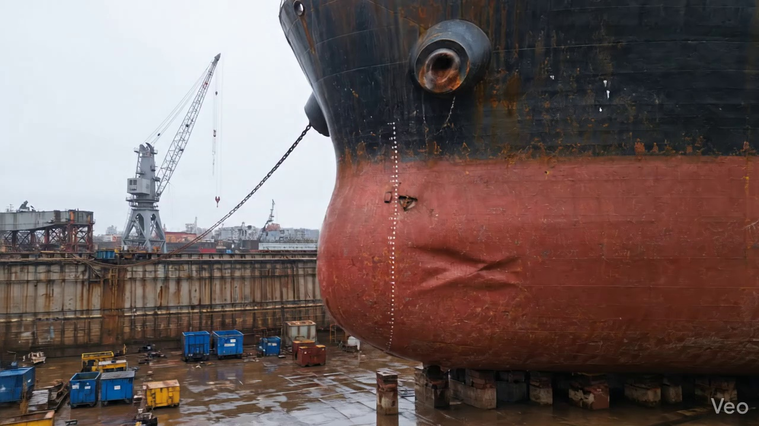

Repair Procedure
Generation failed.

Repair Cost Breakdown
Item | Quantity | Unit Cost | Total Cost | Currency
Cutting Torch (rental) | 0.08 | 10764.0 | 807.3 | INR
Estimated Repair Cost: 41583.53 INR

3.2 PD_2

Defect Overview
Generation failed.

Visual Evidence
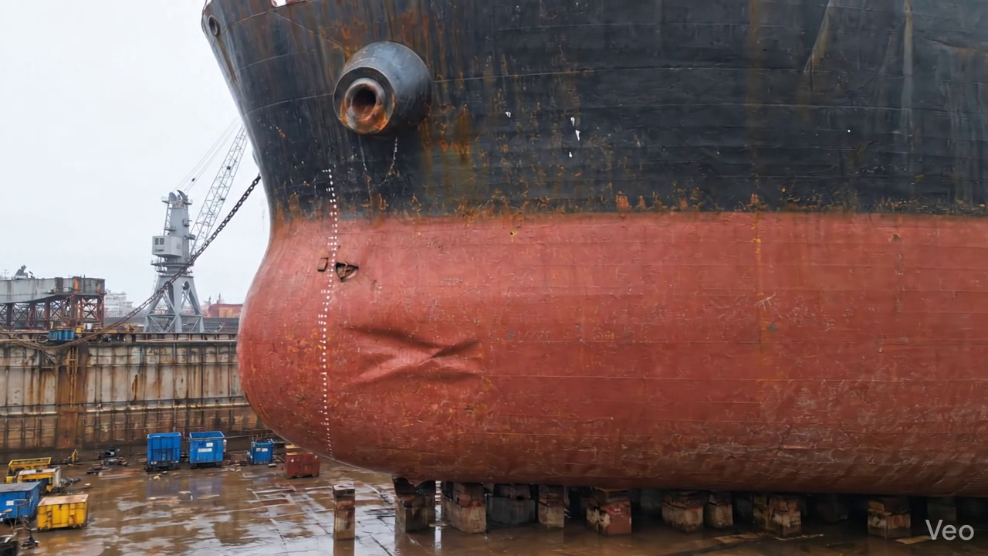

Repair Procedure
Generation failed.

Repair Cost Breakdown
Item | Quantity | Unit Cost | Total Cost | Currency
Cutting Torch (rental) | 0.08 | 10764.0 | 807.3 | INR
Estimated Repair Cost: 41583.53 INR

3.3 PD_3

Defect Overview
Generation failed.

Visual Evidence
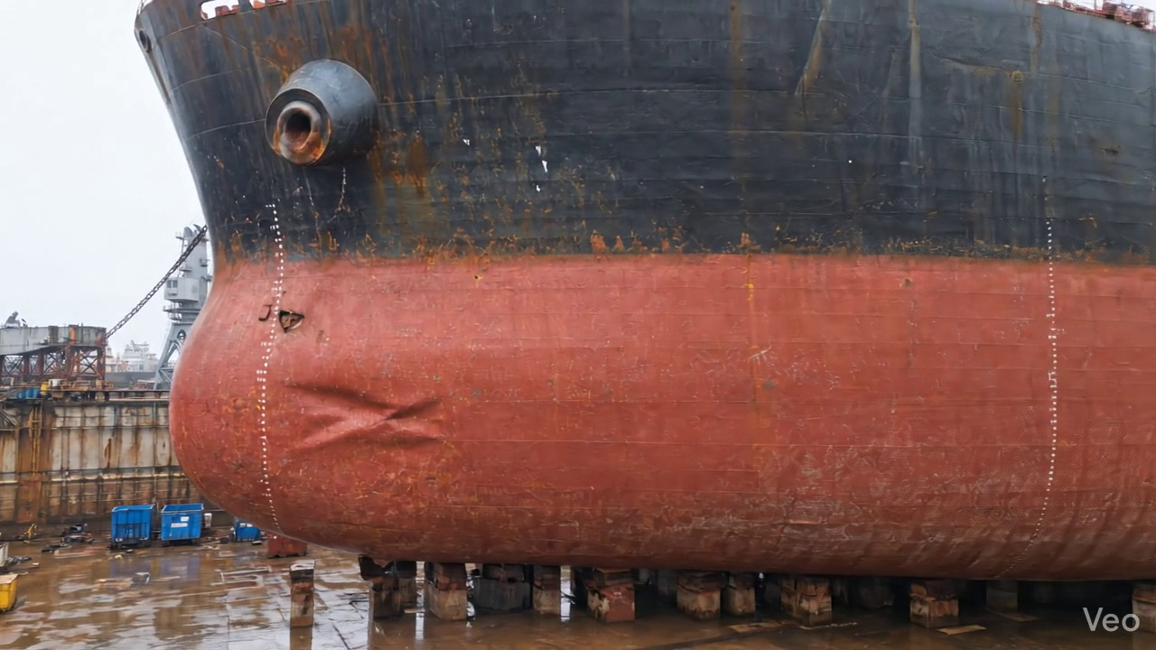

Repair Procedure
Generation failed.

Repair Cost Breakdown
Item | Quantity | Unit Cost | Total Cost | Currency
Cutting Torch (rental) | 0.05 | 10764.0 | 538.2 | INR
Estimated Repair Cost: 27722.35 INR

