Vessel Inspection Report

Table of Contents
1. Executive Summary
2. Vessel Repair Summary
3. Defect Analysis
3.1 PD_1
3.2 PD_2
3.3 PD_3
3.4 PD_4

1. Executive Summary
### Executive Summary: Maritime Vessel Condition Assessment
This Executive Summary provides a high-level overview of the findings from the recent comprehensive maritime vessel inspection. The assessment aimed to evaluate the current operational integrity, safety compliance, and overall material condition of the vessel.
**Key Findings:**
The inspection revealed a total of **four (4) deficiencies** across various systems and components. The aggregate estimated cost for the rectification of these identified deficiencies is **INR 221,778.82**.
**Severity Distribution:**
The severity analysis of the identified deficiencies indicates a critical need for attention:
* **High-Severity Defects:** Two (2)
* **Medium-Severity Defects:** Two (2)
* **Low-Severity Defects:** Zero (0)
**Analysis:**
The absence of low-severity findings, coupled with an equal distribution of medium and high-severity defects, highlights that all identified issues pose a significant risk to the vessel's operational performance, crew safety, and potential regulatory compliance. The two (2) High-severity defects necessitate immediate planning and execution of corrective actions to mitigate critical risks. The two (2) Medium-severity defects, while perhaps not requiring immediate cessation of operations, nonetheless warrant prompt attention to prevent escalation and ensure long-term vessel reliability.
**Recommendation:**
Based on these findings, it is strongly recommended that a detailed rectification plan be developed and implemented without delay, prioritizing the High-severity defects. The estimated repair cost serves as a preliminary financial benchmark for the necessary remedial actions. A comprehensive report detailing each deficiency, including specific locations, technical descriptions, and recommended corrective measures, is available for further review.

2. Vessel Repair Summary
Metric | Value
Total Defects | 4
Total Estimated Cost | 221778.82 INR
Material Cost | 133067.29 INR
Labor Cost | 66533.65 INR
Equipment Cost | 22177.88 INR

3. Defect Analysis

3.1 PD_1

Defect Overview
Generation failed.

Visual Evidence
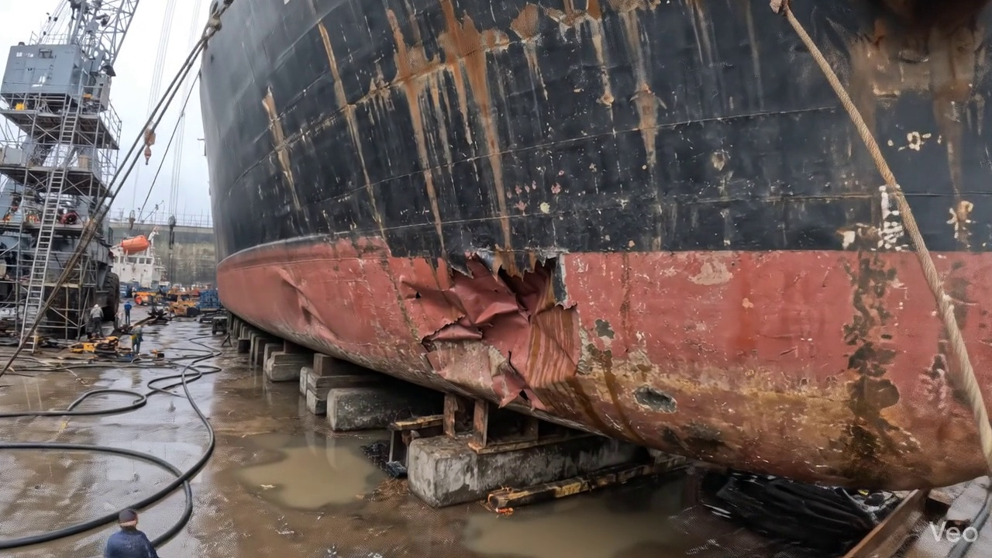

Repair Procedure
Generation failed.

Repair Cost Breakdown
Item | Quantity | Unit Cost | Total Cost | Currency
Cutting Torch (rental) | 0.08 | 10764.0 | 807.3 | INR
Estimated Repair Cost: 41583.53 INR

3.2 PD_2

Defect Overview
Generation failed.

Visual Evidence
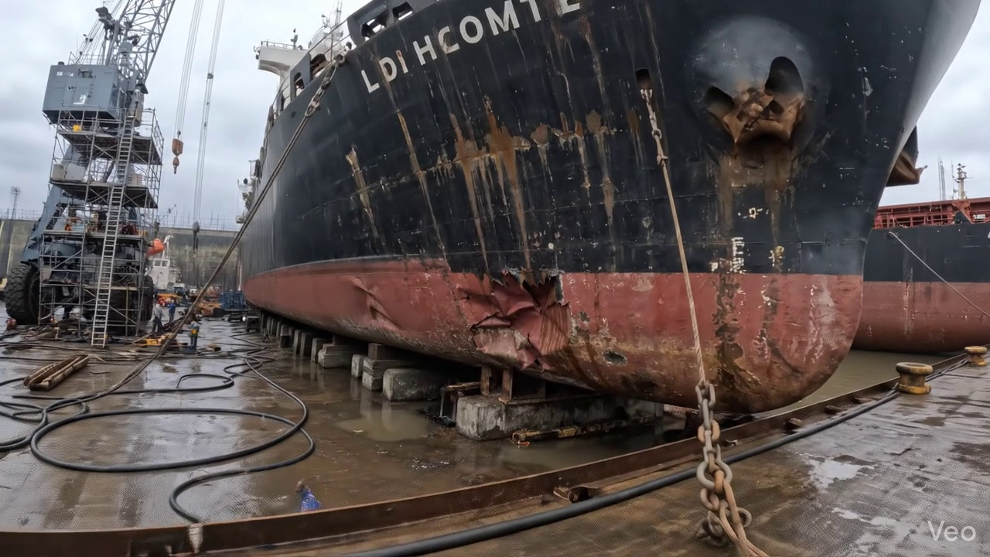

Repair Procedure
Generation failed.

Repair Cost Breakdown
Item | Quantity | Unit Cost | Total Cost | Currency
Cutting Torch (rental) | 0.08 | 10764.0 | 807.3 | INR
Estimated Repair Cost: 41583.53 INR

3.3 PD_3

Defect Overview
Generation failed.

Visual Evidence
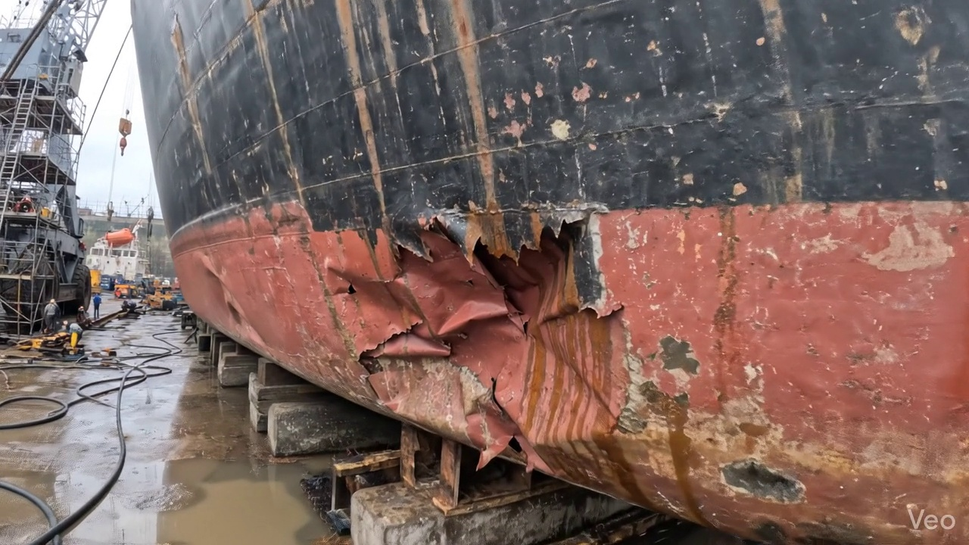

Repair Procedure
Generation failed.

Repair Cost Breakdown
Item | Quantity | Unit Cost | Total Cost | Currency
Cutting Torch (rental) | 0.12 | 10764.0 | 1345.5 | INR
Estimated Repair Cost: 69305.88 INR

3.4 PD_4

Defect Overview
Generation failed.

Visual Evidence
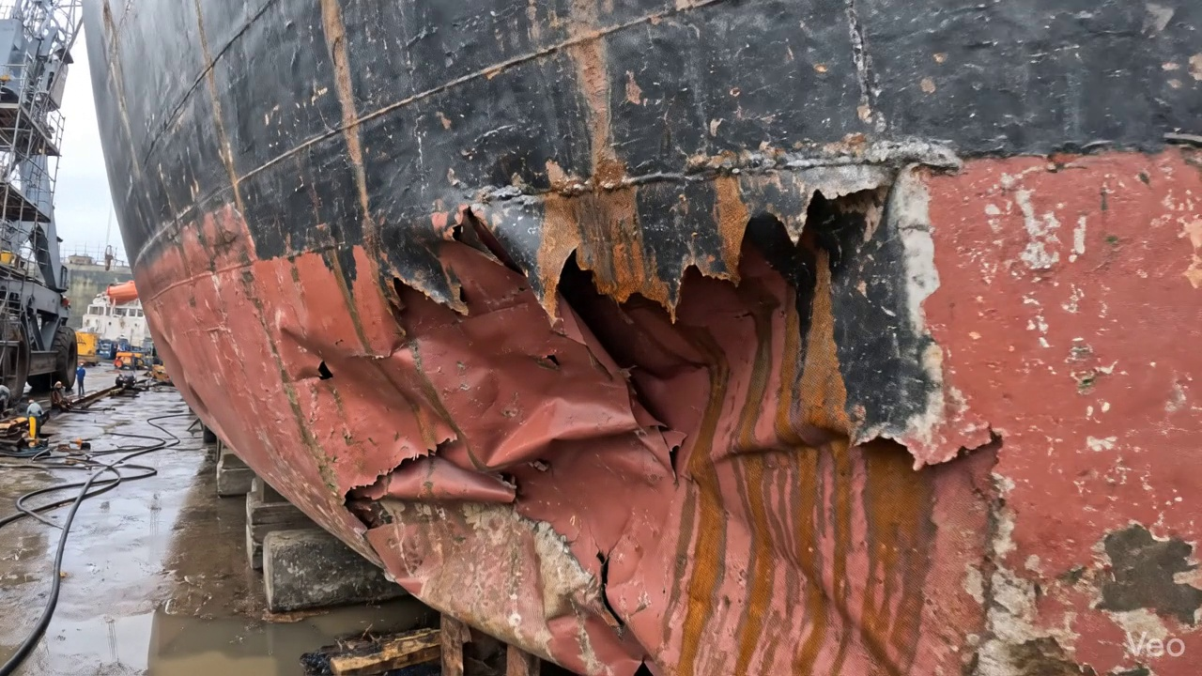

Repair Procedure
Generation failed.

Repair Cost Breakdown
Item | Quantity | Unit Cost | Total Cost | Currency
Cutting Torch (rental) | 0.12 | 10764.0 | 1345.5 | INR
Estimated Repair Cost: 69305.88 INR

