Vessel Inspection Report

Table of Contents
1. Executive Summary
2. Vessel Repair Summary
3. Defect Analysis
3.1 PD_1

1. Executive Summary
## Executive Summary: Maritime Vessel Inspection Findings
This Executive Summary presents the key findings from a recent comprehensive maritime vessel inspection.
**Overall Assessment:**
The inspection identified a total of one (1) non-conformity. The estimated cost for its remediation is quantified at **INR 27,722.35**.
**Severity Distribution:**
The singular identified finding has been assessed with a **'low'** severity rating. No medium or high-severity non-conformities were observed.
**Conclusion:**
The vessel demonstrates a high level of operational integrity, with only one minor, low-severity issue requiring attention. It is recommended that this item be addressed through standard corrective action to ensure continuous optimal vessel performance and compliance.

2. Vessel Repair Summary
Metric | Value
Total Defects | 1
Total Estimated Cost | 27722.35 INR
Material Cost | 16633.41 INR
Labor Cost | 8316.7 INR
Equipment Cost | 2772.24 INR

3. Defect Analysis

3.1 PD_1

Defect Overview
## Defect Report: DEFORMATION
**Defect Name:** DEFORMATION
**Severity:** Low
**Overlapping Parts:** HULL_AREA (0.029 overlap ratio)
---
### Explanation of Defect: DEFORMATION
#### 1. What the defect means.
Deformation, specifically observed as buckling or warping, refers to an out-of-plane bending or distortion of the vessel's hull plating or integral structural stiffeners. This defect indicates that the affected material has moved from its original flat or intended planar shape, displaying convex or concave deviations. Common causes include localized impact from groundings, excessive stress from heavy sea loads, or thermal stresses induced by welding processes. While the present severity is noted as low, it signifies a deviation from the designed structural geometry.
#### 2. Why it is important.
Even seemingly minor or moderate deformation is a critical defect due to its direct impact on the structural integrity of the vessel. It signifies that the material has experienced stresses beyond its elastic limit, potentially compromising its designed structural performance and its ability to withstand operational loads. Buckling directly reduces the inherent strength and load-carrying capacity of the affected plating and the overall hull girder. Classification societies mandate specific repair criteria for such defects to maintain approved structural standards and ensure vessel safety.
#### 3. Risks if not repaired.
If not adequately addressed, even low-severity deformation presents several escalating risks:
* **Progressive Failure:** The deformed area acts as a stress concentration point, making it more susceptible to further distortion or propagation under normal operational loads, potentially leading to increased buckling or localized collapse.
* **Fatigue Cracking:** Repeated stress cycles on a deformed area can accelerate fatigue, leading to the initiation and propagation of cracks, which can compromise watertight or weathertight integrity.
* **Reduced Structural Redundancy:** A weakened area reduces the vessel's ability to withstand unexpected forces, increasing the risk of catastrophic structural failure during severe weather, collisions, or further groundings.
* **Compromised Compartmentation:** In critical areas, severe deformation could compromise the effectiveness of bulkheads or tank boundaries, affecting floodability and stability.
#### 4. Structural implications.
Structurally, deformation implies a direct reduction in the local stiffness and strength of the affected plating or stiffeners. The out-of-plane distortion diminishes the section modulus and moment of inertia in the affected area, thereby reducing its contribution to the overall hull girder strength and its ability to resist global bending moments and shear forces.
* **Loss of Load-Bearing Capacity:** The deformed material loses its efficiency in bearing compressive and tensile loads, leading to inefficient stress transfer to adjacent, sound structural members.
* **Stiffener Instability:** For stiffeners, buckling reduces their ability to provide critical support to the plating, which can lead to larger areas of plating deformation and a cascade effect on structural integrity.
* **Mandatory Repair:** To restore the original design strength and structural continuity, classification practice often requires deformed metal, especially significant buckles, to be cut out and replaced with new material, rather than merely attempting to fair or heat-shrink the distortion. This underscores the fundamental structural compromise caused by the defect.

Visual Evidence
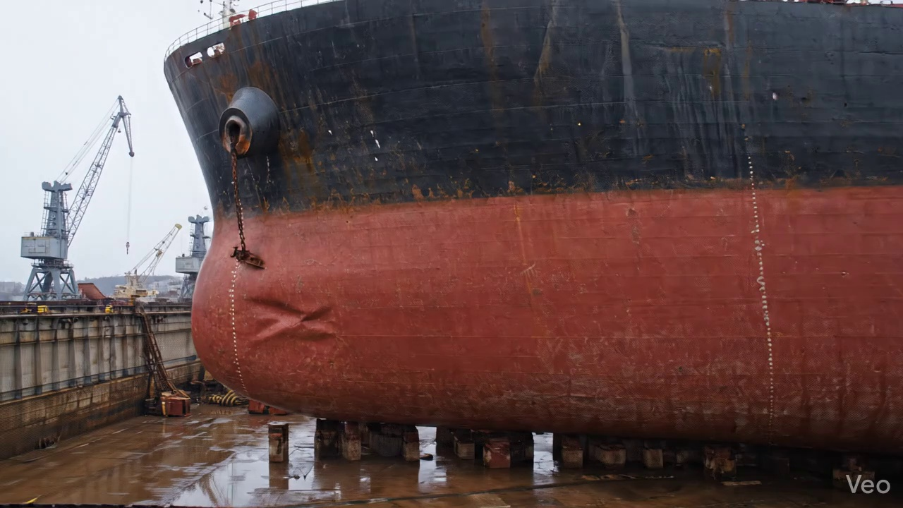

Repair Procedure
This explanation outlines the critical steps for structural plate repair following localized damage, designed for a professional vessel inspection report.
---
**Vessel Inspection Report: Structural Plate Repair Process Explanation**
**Repair Process Overview:**
The described repair process addresses localized structural deformation or damage to a vessel's hull or deck plating, involving the removal of compromised material and its replacement with new, sound steel plate. This systematic approach ensures the restoration of the vessel's structural integrity, watertight/weathertight integrity, and original fair form.
---
**1. Assessment:**
* **Why Necessary:** This initial phase is crucial for comprehensively understanding the nature, extent, and severity of the damage. It prevents "spot repairs" that might overlook underlying or propagating structural issues. Proper assessment dictates the scope of work, material requirements, and repair methodology.
* **What Happens:** Skilled technicians meticulously inspect the deformed area, visually identifying and marking buckled or compromised regions. Measurements are taken to quantify out-of-flatness and determine if the damage is confined to a single plate section or involves adjacent structural members like frames, girders, or stiffeners. This information informs the cut-out dimensions and subsequent repair plan.
* **Safety & Structural Considerations:** Inadequate assessment can lead to incomplete repairs, leaving residual stresses or undetected cracks that may propagate under operational loads, compromising the vessel's structural integrity and potentially leading to catastrophic failure.
**2. Preparation:**
* **Why Necessary:** This step ensures that all fatigued, distorted, or structurally compromised material is removed, providing a sound, clean base for the new plate. Leaving a margin of good plate (≥¾ thickness) around the cut ensures the new weld seams are established on robust parent material, promoting optimal fusion and preventing crack initiation in the heat-affected zone of already stressed material.
* **What Happens:** Using thermal cutting equipment, the distorted plate, along with any buckled girders or stiffeners, is precisely cut away. This process continues until sound, unaffected metal is reached. Any remaining bent or deformed framing beyond the cut-out margin is either straightened to its original alignment or completely removed and replaced to ensure the integrity of the surrounding structure.
* **Why Required Items Are Used (Cutting Torch):** The **Cutting Torch (rental)** is indispensable for this phase. It provides the high-temperature flame necessary to efficiently and accurately cut through thick steel plating and structural members. Its use facilitates rapid removal of damaged material, enabling the precise shaping of the repair opening.
* **Safety & Structural Considerations:** Hot work permits are mandatory. This phase involves significant fire risk from sparks and molten metal, requiring a dedicated fire watch, appropriate fire suppression equipment, and strict adherence to personal protective equipment (PPE) guidelines (e.g., welding helmet, fire-resistant clothing, gloves, respiratory protection for fumes). Structurally, ensuring removal to "sound metal" is paramount to prevent re-initiation of damage from residual stresses or micro-cracks.
**3. Plate Replacement:**
* **Why Necessary:** This step directly restores the structural continuity, load-bearing capacity, and watertight/weathertight integrity of the vessel's hull or deck. Using plate of the same or greater thickness ensures the repaired section meets or exceeds the original design strength.
* **What Happens:** A new steel plate is fabricated, precisely cut and formed to match the dimensions and curvature of the removed section. This new plate is then carefully positioned against the remaining hull plating. Tack welds are strategically applied to temporarily secure the plate and maintain alignment. Subsequently, full-penetration welds are applied where feasible, ensuring complete fusion through the joint thickness. Appropriate preheating of the joint area is performed, especially on thicker plates or specific steel grades, to mitigate thermal stresses and prevent hydrogen-induced cracking.
* **Safety & Structural Considerations:** Weld quality is critical. Poor fusion, porosity, or cracking can severely compromise the repair's strength and watertight integrity. Welding operations generate fumes, intense UV radiation, and heat, necessitating proper ventilation, welding shields, fire watch, and full PPE. Preheating is a key metallurgical control to prevent brittle fracture, particularly in colder environments or with high-strength steels.
**4. Alignment and Welding:**
* **Why Necessary:** This phase completes the permanent structural connection, ensuring the repair seamlessly integrates with the existing structure and maintains the vessel's original contour. The specified electrode type is chosen for its structural properties.
* **What Happens:** Continuous weld passes are applied to complete the joint. **E7018 electrodes** are specifically chosen for their low-hydrogen characteristics, excellent mechanical properties, and suitability for high-strength structural welding, which minimizes the risk of hydrogen-induced cracking. During welding, continuous monitoring for distortion is performed. If significant thermal distortion occurs, corrective measures such as strategic clamping, back-stepping techniques, or minimizing heat input are employed. Upon completion of welding, the weld seams are ground fair and smooth with the surrounding hull or deck, restoring the hydrodynamic/aerodynamic profile and preventing localized stress concentrations. In situations where the original buckling was extensive, additional structural reinforcement such as doubler plates or stiffeners may be added to enhance load distribution and reduce future stress concentrations.
* **Safety & Structural Considerations:** Welding distortion can induce new stresses in the structure, potentially leading to future cracking or affecting fairing. Grinding operations produce sparks and metal dust, requiring eye and respiratory protection. The structural integrity is directly dependent on the quality of these final weld passes; visual and often non-destructive testing (NDT) is applied to verify integrity. The decision to add doublers or stiffeners is a critical engineering judgment to ensure the repair has adequate fatigue life and strength.
**5. Finishing:**
* **Why Necessary:** This final stage confirms the quality of the entire repair process, protects the newly installed steel from environmental degradation, and restores the vessel's aesthetic and functional surface.
* **What Happens:** The completed repair undergoes thorough inspection. This includes visual inspection for surface defects, and typically, Non-Destructive Testing (NDT) methods such as Magnetic Particle Testing (MT) or Dye Penetrant Testing (PT) for surface cracks, and Ultrasonic Testing (UT) for subsurface flaws within the weld metal. Once the repair is verified as structurally sound, the new steel surface is thoroughly cleaned and prepared for coating. A multi-coat paint system, typically commencing with an anti-corrosive primer followed by intermediate and finish coats, is applied to restore full corrosion protection and match the existing vessel coating scheme. Finally, the deck or hull surface is faired back to its original contour, ensuring smooth flow and preventing drag.
* **Safety & Structural Considerations:** NDT is essential to identify hidden defects that could compromise the repair's longevity and safety. Inadequate coating application will lead to premature corrosion of the new steel, necessitating future repairs. Paint application involves hazardous fumes, requiring strict ventilation protocols and respiratory protection. The final fairing ensures hydrodynamic efficiency and prevents localized turbulence or stress.
---

Repair Cost Breakdown
Item | Quantity | Unit Cost | Total Cost | Currency
Cutting Torch (rental) | 0.05 | 10764.0 | 538.2 | INR
Estimated Repair Cost: 27722.35 INR

