Vessel Inspection Report

Table of Contents
1. Executive Summary
2. Vessel Repair Summary
3. Defect Analysis
3.1 PD_1
3.2 PD_2
3.3 PD_3
3.4 PD_4
3.5 PD_5
3.6 PD_6
3.7 PD_7
3.8 PD_8
3.9 PD_9
3.10 PD_10

1. Executive Summary
Generation failed.

2. Vessel Repair Summary
Metric | Value
Total Defects | 10
Total Estimated Cost | 499002.34 INR
Material Cost | 299401.4 INR
Labor Cost | 149700.7 INR
Equipment Cost | 49900.23 INR

3. Defect Analysis

3.1 PD_1

Defect Overview
Generation failed.

Visual Evidence
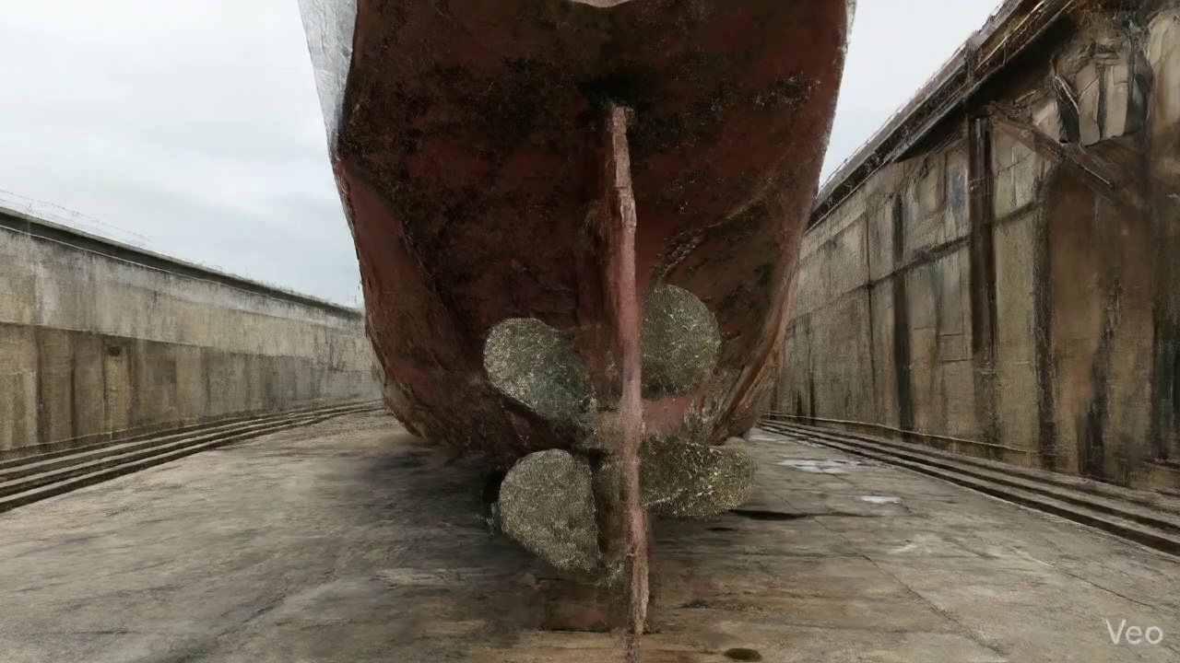

Repair Procedure
Generation failed.

Repair Cost Breakdown
Item | Quantity | Unit Cost | Total Cost | Currency
Cutting Torch (rental) | 0.08 | 10764.0 | 807.3 | INR
Estimated Repair Cost: 41583.53 INR

3.2 PD_2

Defect Overview
Generation failed.

Visual Evidence
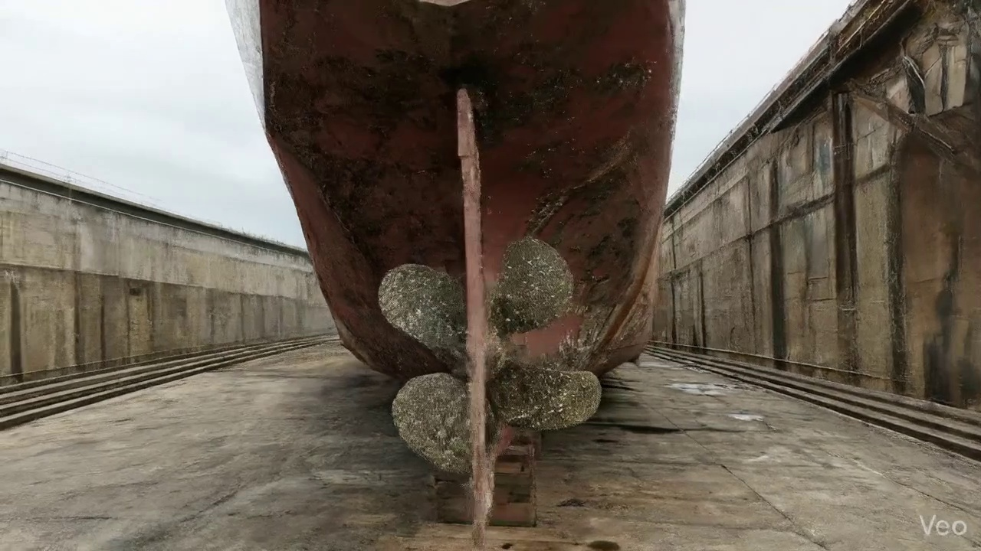

Repair Procedure
Generation failed.

Repair Cost Breakdown
Item | Quantity | Unit Cost | Total Cost | Currency
Cutting Torch (rental) | 0.08 | 10764.0 | 807.3 | INR
Estimated Repair Cost: 41583.53 INR

3.3 PD_3

Defect Overview
Generation failed.

Visual Evidence
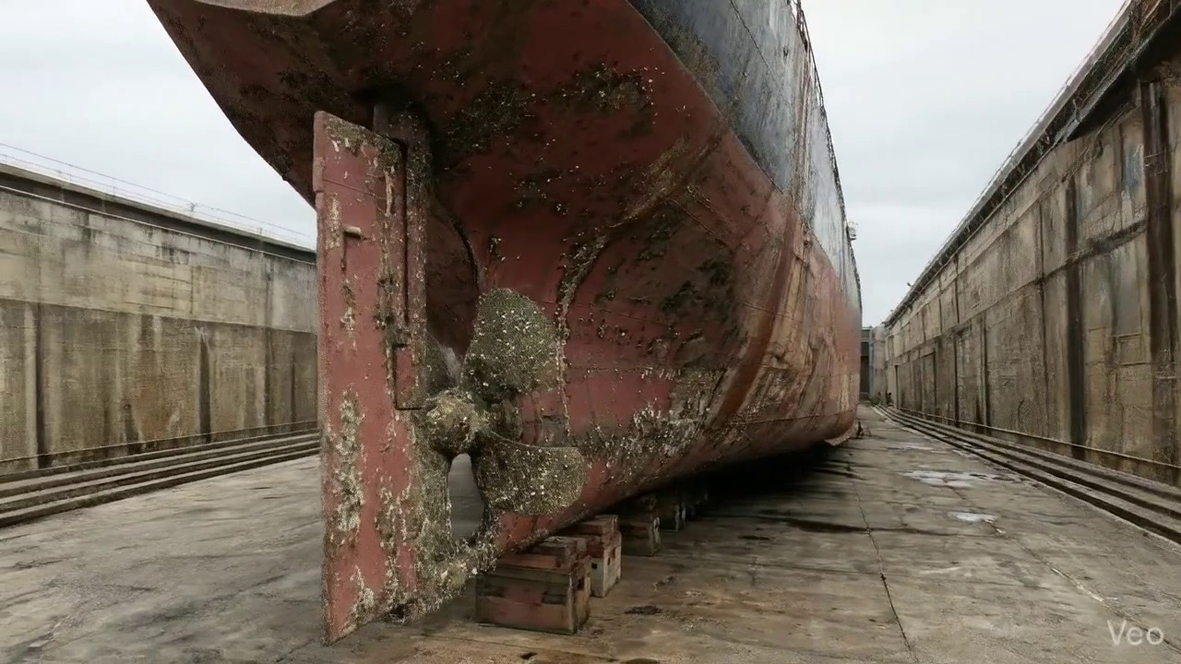

Repair Procedure
Generation failed.

Repair Cost Breakdown
Item | Quantity | Unit Cost | Total Cost | Currency
Cutting Torch (rental) | 0.08 | 10764.0 | 807.3 | INR
Estimated Repair Cost: 41583.53 INR

3.4 PD_4

Defect Overview
Generation failed.

Visual Evidence
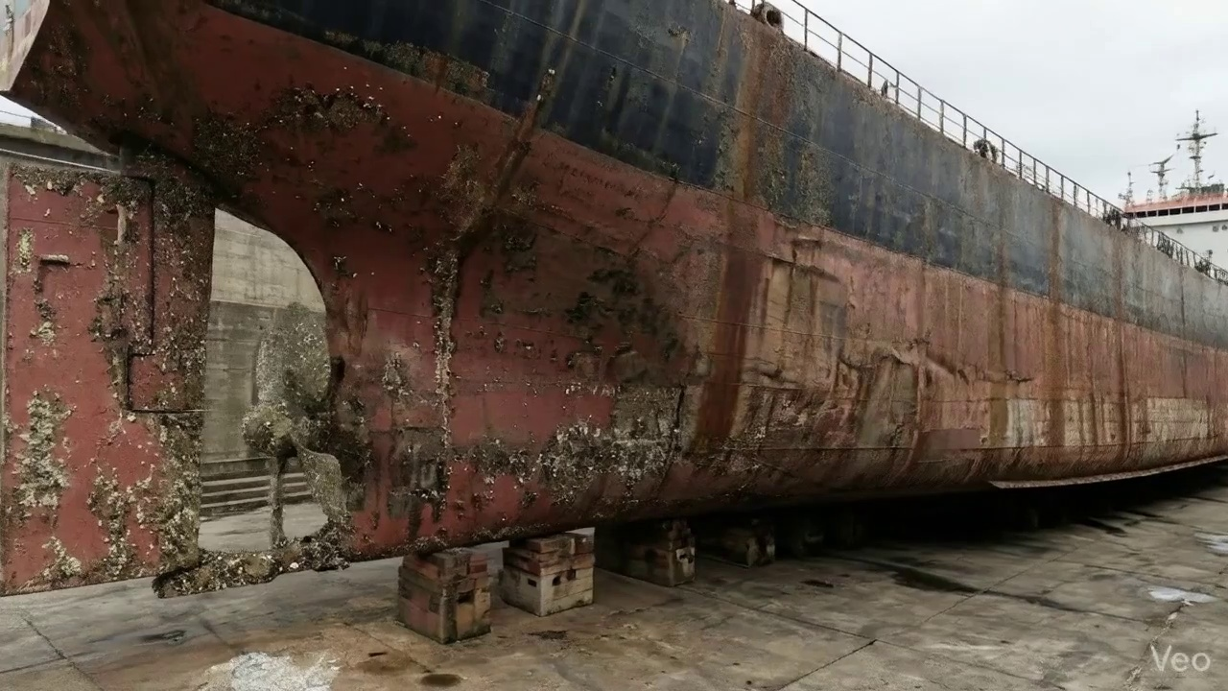

Repair Procedure
Generation failed.

Repair Cost Breakdown
Item | Quantity | Unit Cost | Total Cost | Currency
Cutting Torch (rental) | 0.12 | 10764.0 | 1345.5 | INR
Estimated Repair Cost: 69305.88 INR

3.5 PD_5

Defect Overview
Generation failed.

Visual Evidence
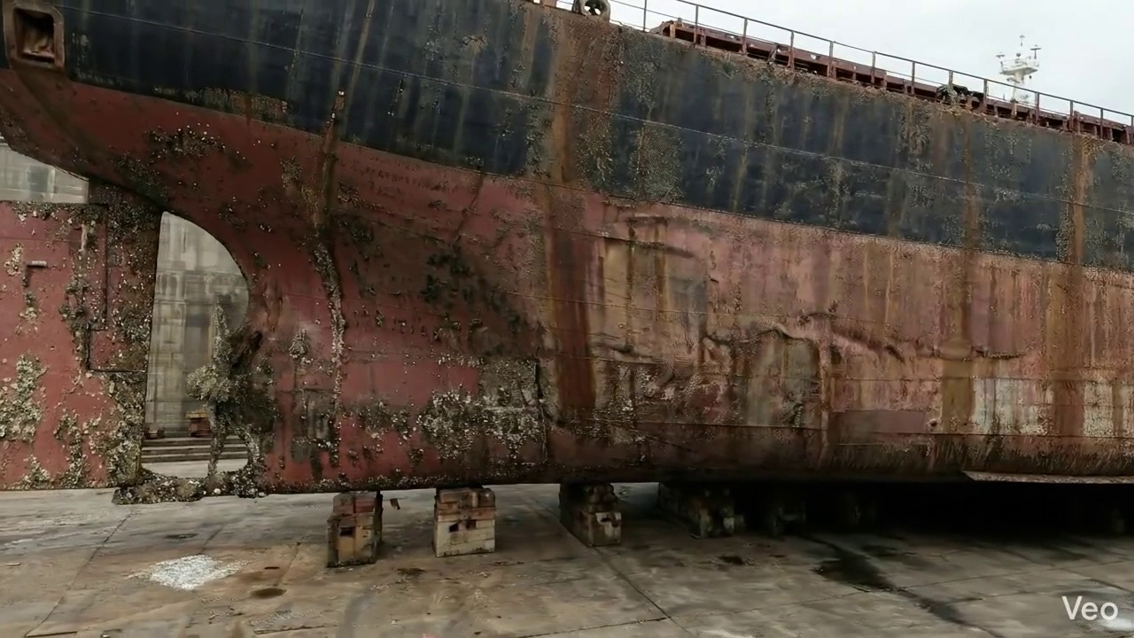

Repair Procedure
Generation failed.

Repair Cost Breakdown
Item | Quantity | Unit Cost | Total Cost | Currency
Cutting Torch (rental) | 0.12 | 10764.0 | 1345.5 | INR
Estimated Repair Cost: 69305.88 INR

3.6 PD_6

Defect Overview
Generation failed.

Visual Evidence


Repair Procedure
Generation failed.

Repair Cost Breakdown
Item | Quantity | Unit Cost | Total Cost | Currency
Cutting Torch (rental) | 0.12 | 10764.0 | 1345.5 | INR
Estimated Repair Cost: 69305.88 INR

3.7 PD_7

Defect Overview
Generation failed.

Visual Evidence
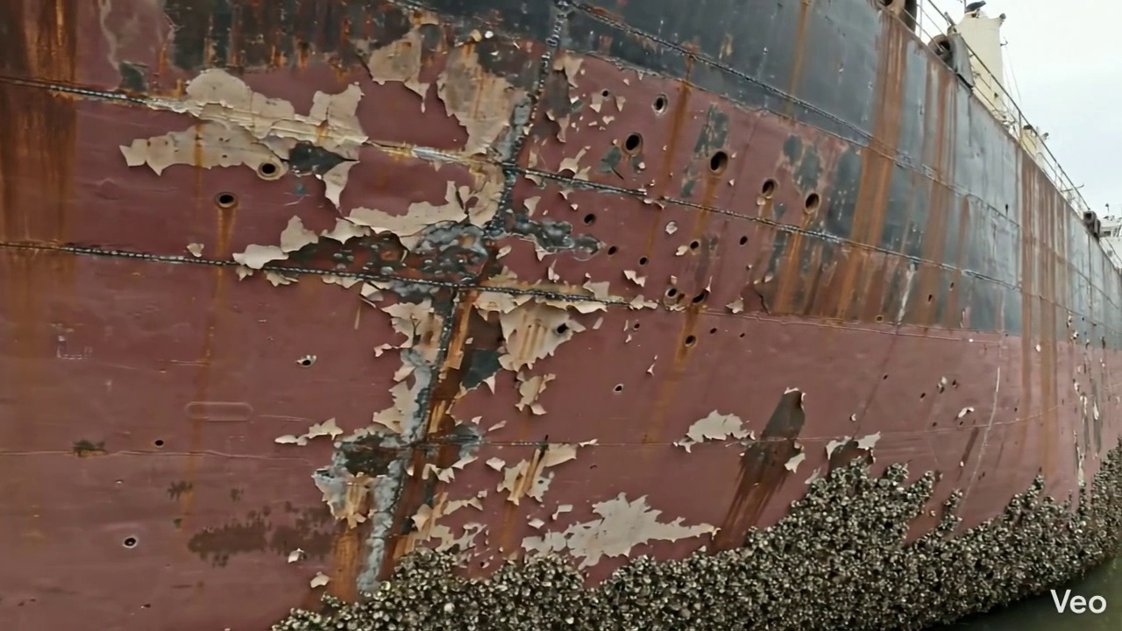

Repair Procedure
Generation failed.

Repair Cost Breakdown
Item | Quantity | Unit Cost | Total Cost | Currency
Cutting Torch (rental) | 0.12 | 10764.0 | 1345.5 | INR
Estimated Repair Cost: 69305.88 INR

3.8 PD_8

Defect Overview
Generation failed.

Visual Evidence
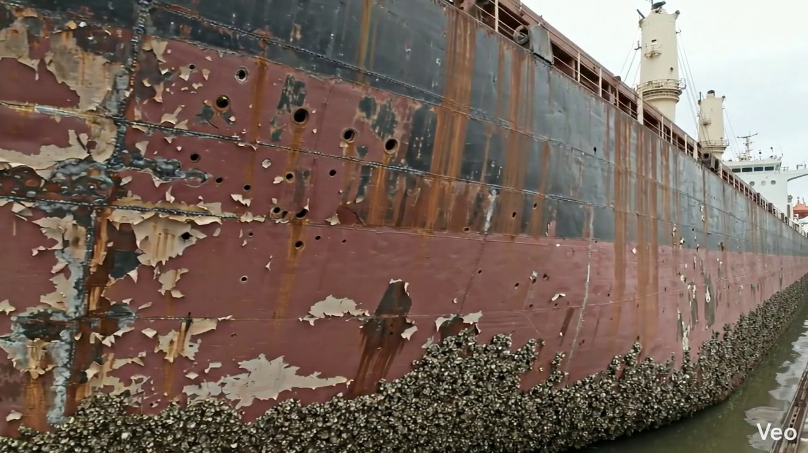

Repair Procedure
Generation failed.

Repair Cost Breakdown
Item | Quantity | Unit Cost | Total Cost | Currency
Cutting Torch (rental) | 0.08 | 10764.0 | 807.3 | INR
Estimated Repair Cost: 41583.53 INR

3.9 PD_9

Defect Overview
Generation failed.

Visual Evidence
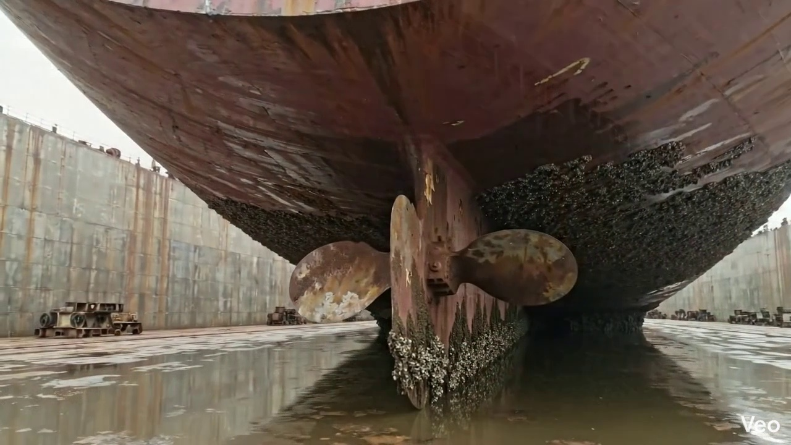

Repair Procedure
Generation failed.

Repair Cost Breakdown
Item | Quantity | Unit Cost | Total Cost | Currency
Cutting Torch (rental) | 0.05 | 10764.0 | 538.2 | INR
Estimated Repair Cost: 27722.35 INR

3.10 PD_10

Defect Overview
Generation failed.

Visual Evidence
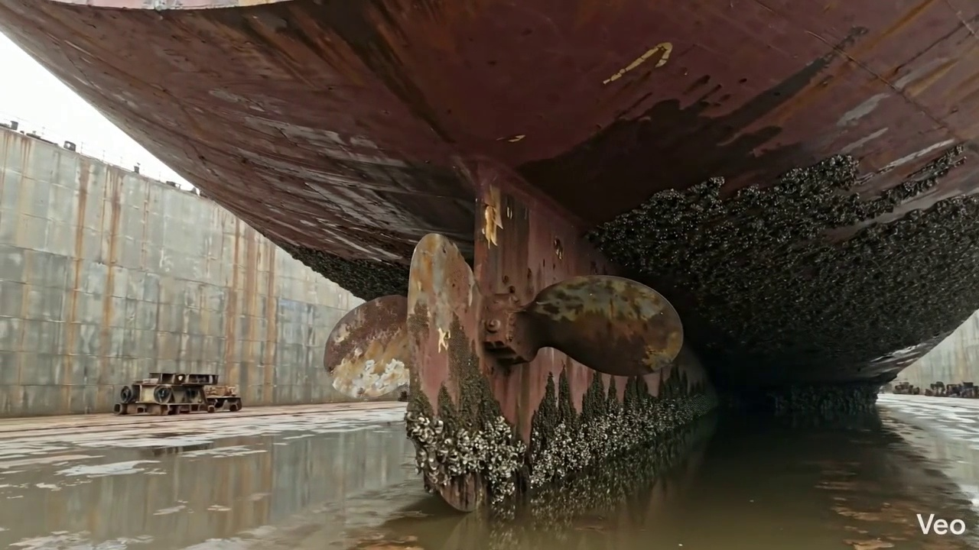

Repair Procedure
Generation failed.

Repair Cost Breakdown
Item | Quantity | Unit Cost | Total Cost | Currency
Cutting Torch (rental) | 0.05 | 10764.0 | 538.2 | INR
Estimated Repair Cost: 27722.35 INR

