Vessel Inspection Report

Table of Contents
1. Executive Summary
2. Vessel Repair Summary
3. Defect Analysis
3.1 PD_1
3.2 PD_2
3.3 PD_3
3.4 PD_4
3.5 PD_5
3.6 PD_6
3.7 PD_7
3.8 PD_8
3.9 PD_9
3.10 PD_10

1. Executive Summary
## Executive Summary: Vessel Condition Assessment
This executive summary provides an overview of the recent comprehensive inspection conducted on the subject vessel to assess its current operational integrity and material state. The assessment aimed to identify deficiencies impacting seaworthiness, safety, and regulatory compliance.
The inspection identified a total of **ten (10) distinct defects** across various systems and structural components. The cumulative estimated cost for the rectification of these identified deficiencies is **INR 499,002.34**.
A detailed analysis of the defect severity distribution reveals:
* **High Severity (4 defects):** These issues represent critical deficiencies with the potential to significantly impact vessel safety, operational reliability, or regulatory compliance if not promptly addressed. Urgent remediation is required.
* **Medium Severity (4 defects):** These defects indicate conditions requiring attention to prevent escalation, optimize performance, or ensure long-term integrity, though they do not pose an immediate critical threat.
* **Low Severity (2 defects):** These represent minor deficiencies with minimal immediate impact on operations or safety, typically requiring attention during routine maintenance cycles.
The presence of four high-severity defects mandates immediate strategic planning and resource allocation for their resolution to mitigate operational risks and ensure the vessel's continued safe and compliant operation. A detailed report outlining each defect, recommended actions, and specific cost breakdowns has been provided for further review.

2. Vessel Repair Summary
Metric | Value
Total Defects | 10
Total Estimated Cost | 499002.34 INR
Material Cost | 299401.4 INR
Labor Cost | 149700.7 INR
Equipment Cost | 49900.23 INR

3. Defect Analysis

3.1 PD_1

Defect Overview
**Defect Explanation: DEFORMATION**
**Vessel Inspection Report - Defect Analysis**
**Defect Name:** DEFORMATION
**Severity:** Medium
---
**1. What the defect means:**
Deformation, specifically observed as buckling or warping, refers to an undesirable out-of-plane bending or distortion of the vessel's hull plating or structural stiffeners. Unlike simple indentation, deformation involves a change in the original geometric plane of the material. This typically arises from external forces such as grounding impacts, heavy sea loads, or internal stresses like those induced by uneven welding processes. In this instance, deformation has been noted with significant overlap in the vicinity of the **KEEL_AREA** (11.5% overlap) and the **PROPELLER_AREA** (15.7% overlap), indicating localized structural compromise in these critical regions.
**2. Why it is important:**
The importance of addressing deformation stems from its direct correlation with the structural integrity and operational safety of the vessel. Even seemingly moderate instances of buckling or warping can significantly compromise the overall hull girder strength, which is fundamental for resisting global bending moments experienced at sea. Given its location in critical areas such as the keel and propeller regions, these deformations are particularly pertinent as these areas are crucial for longitudinal strength, propulsion efficiency, and protection against grounding. The keel is the backbone of the vessel, while the propeller area houses vital propulsion components and contributes to the stern's structural rigidity.
**3. Risks if not repaired:**
If not adequately addressed, the vessel faces a heightened risk of:
* **Localized Structural Failure:** The deformed sections become stress concentrations and are prone to premature yielding or failure, especially under dynamic loading conditions or subsequent impacts.
* **Progressive Damage:** The compromised structural integrity can lead to accelerated fatigue cracking in the affected and adjacent areas, potentially escalating to larger structural failures over time.
* **Loss of Watertight Integrity:** Buckling, particularly in areas exposed to water, can compromise watertight boundaries, leading to ingress of water into tanks or compartments.
* **Operational Impairment:** Deformation in the propeller area can affect the alignment or clearance of propulsion components, potentially leading to vibrations, reduced efficiency, or mechanical damage to the propeller or shafting system.
* **Regulatory Non-Compliance:** Continued operation with significant deformation carries regulatory implications, potentially leading to restrictions, detention by classification societies, or refusal of port entry by port state control.
**4. Structural implications:**
The primary structural implication of deformation is a reduction in the vessel's ultimate longitudinal strength and stiffness. Buckled plating or stiffeners cannot carry compressive or shear loads as effectively as intact structures, leading to a diminished ability to resist design loads. This alters the intended distribution of stresses throughout the hull, potentially overloading adjacent intact structures and accelerating their fatigue.
* **Hull Girder Strength:** Even moderate buckling severely impairs the vessel's overall longitudinal strength, making it more susceptible to hull girder collapse under severe sea states or loading conditions.
* **Stress Redistribution:** Deformed areas can no longer sustain their design loads, forcing surrounding, intact structures to bear additional stress, potentially leading to secondary failures.
* **Keel Area Impact:** Deformation in the keel area directly compromises the vessel's primary longitudinal strength member, affecting global bending moment resistance and local impact resistance.
* **Propeller Area Impact:** Buckling near the propeller area can affect the structural rigidity of the stern frame, impact propulsion machinery alignment, and potentially lead to increased vibration or cavitation.
Classification practice generally mandates the correction of significant buckling or warping by cutting out and replacing the distorted metal to restore the original design strength and geometry. While localized set-in plating may sometimes be tolerated if small and assessed as non-critical, significant buckles require renewal to prevent catastrophic failure and ensure the vessel's continued fitness for purpose.

Visual Evidence
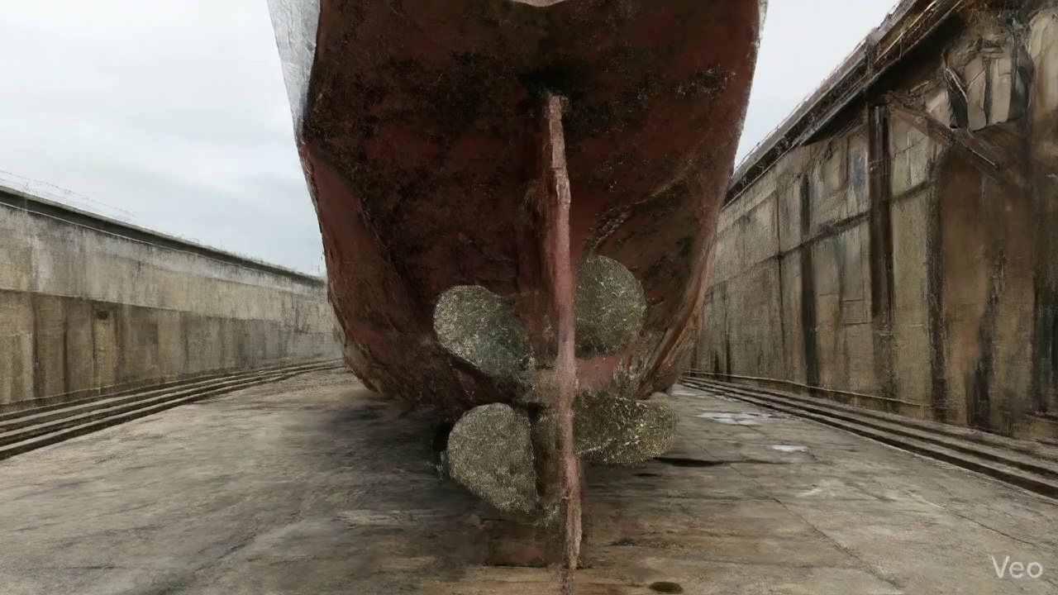

Repair Procedure
**Vessel Inspection Report: Explanation of Structural Steel Repair Process**
This report details a standard structural steel repair process for deformed or damaged hull plating and supporting members, focusing on the rationale, execution, necessary equipment, and critical safety and structural considerations.
---
**1. Assessment**
* **Why Necessary:** This initial phase is crucial for accurately defining the scope of the repair, identifying the extent of damage, determining appropriate repair methodology, and ensuring the complete restoration of structural integrity. Without a thorough assessment, there is a risk of under-repairing, which could lead to recurrence of damage, or over-repairing, which increases unnecessary cost and labor.
* **What Happens:** Qualified personnel visually inspect the deformed region. This involves marking the specific buckled area to delineate its boundaries and ascertain whether the deformation is localized or extends across multiple structural frames or stiffeners. Out-of-flatness measurements are taken using appropriate tools (e.g., straight edges, feeler gauges, laser alignment tools) to quantify the degree of deformation, which informs the decision on whether repair by straightening is feasible or if plate replacement is mandatory.
---
**2. Preparation**
* **Why Necessary:** The removal of all compromised material is fundamental to any sound structural repair. Damaged or distorted steel cannot provide the necessary strength or foundation for new welds and could harbor cracks or weaknesses that would propagate into the new structure. Leaving a margin of sound, undamaged plate (typically $\geq\frac{3}{4}$ of the original plate thickness) ensures that all new welds are performed on robust, unaffected material, thereby achieving optimal fusion and mechanical properties. Removal or straightening of bent internal framing (girders, stiffeners) is essential to provide proper support and alignment for the new plate section.
* **What Happens:** Using a cutting torch (see item explanation below) or other suitable cutting equipment (e.g., plasma cutter), all visibly distorted plate and any associated buckled internal girders or stiffeners are precisely cut away. The cut is made into sound, undamaged metal, leaving a specified margin. Any remaining bent or deformed internal framing that is not being cut out is either straightened to its original profile or completely removed if straightening is not feasible or effective.
---
**3. Plate Replacement**
* **Why Necessary:** This step is the direct restoration of the vessel's primary structure. A new steel plate, fabricated to match or exceed the original material specifications (grade, thickness), is vital to restore the hull's design strength, stiffness, watertight integrity, and continuity of load paths.
* **What Happens:** A new steel plate is custom fabricated to precisely fit the dimensions and contour of the opening created during the preparation phase. This new plate is then carefully positioned against the remaining sound hull plating. Once accurately aligned, it is temporarily secured with tack-welds to maintain its position and shape prior to full welding.
---
**4. Alignment and Welding**
* **Why Necessary:** This is the critical phase where the new plate becomes an integral part of the vessel's structure. Proper welding techniques ensure that the repaired area achieves mechanical properties equivalent to, or superior to, the original structure. Using appropriate electrodes (e.g., E7018 for high strength and toughness), applying preheat, and ensuring full penetration welds are paramount for achieving sound, defect-free joints that can withstand operational stresses and fatigue. Controlling welding-induced distortion is crucial to maintain the hull's designed shape, hydrodynamic efficiency, and to prevent additional stress concentrations. Grinding weld seams fair minimizes stress risers and restores the hull's smooth surface.
* **What Happens:** Continuous weld passes are applied around the entire perimeter of the new plate, fully fusing it with the existing hull structure. Low-hydrogen electrodes, such as E7018, are typically utilized for their superior mechanical properties and resistance to hydrogen-induced cracking. Appropriate preheat temperatures are applied, particularly for thicker plates or high-strength steels, to mitigate thermal stresses and ensure proper fusion. Full penetration welds are prioritized wherever design allows to maximize joint strength. During welding, continuous monitoring and techniques such as sequential welding, skip welding, or use of strongbacks and clamps are employed to minimize and control distortion. After welding, the weld seams are carefully ground fair and smooth with the surrounding hull surface to prevent stress concentrations and restore hydrodynamic flow. In cases of extensive original damage or if deemed necessary by structural analysis, additional strengthening elements like doubler plates or new stiffeners may be incorporated to enhance the local structural integrity and distribute loads more effectively.
---
**5. Finishing**
* **Why Necessary:** The finishing phase ensures the quality, durability, and complete restoration of the repaired area. Non-Destructive Testing (NDT) verifies the integrity of the welds, while corrosion protection is essential to prevent premature degradation of the new steel. Fairing the surface restores the vessel's operational performance and aesthetic appearance.
* **What Happens:** The completed weld repair undergoes rigorous inspection. This includes visual inspection for surface defects and profile, followed by Non-Destructive Testing (NDT) methods such as Ultrasonic Testing (UT) to detect internal defects (e.g., lack of fusion, porosity) or Magnetic Particle Testing (MPT) for surface and near-surface discontinuities. Upon successful inspection, the new steel surface is thoroughly cleaned and prepared. A marine-grade primer is applied to establish initial corrosion protection, followed by appropriate finish coats (e.g., anti-corrosive, anti-fouling) to match the surrounding hull or deck coating system. Finally, the repaired area is carefully faired (smoothed and contoured) back to its original design profile to ensure proper hydrodynamic flow and structural aesthetics.
---
**Required Item Explanation:**
* **Cutting Torch (rental):**
* **Why it is used:** The cutting torch is an essential tool utilized during the **Preparation** phase of the repair process. Its primary function is the efficient and precise removal of the distorted, damaged, or buckled steel plate, girders, and stiffeners. It allows for clean, well-defined cuts into sound metal, creating the necessary opening for the new plate insertion.
* **Why "rental":** The item is listed as a "rental," suggesting that while critical for this specific type of structural repair, it may not be a continuously required piece of equipment for the vessel's routine maintenance or may be procured for specific project-based repairs due to its specialized nature and potentially high acquisition cost or maintenance requirements.
---
**Safety and Structural Considerations:**
**Safety Considerations:**
1. **Hot Work Procedures:** The cutting and welding processes constitute hot work, necessitating strict adherence to hot work permits, fire watch protocols, and availability of appropriate fire extinguishing equipment.
2. **Personal Protective Equipment (PPE):** Welders and cutters must utilize full PPE, including welding helmets, flame-retardant clothing, gloves, safety glasses, and hearing protection to prevent burns, eye damage, and other injuries.
3. **Ventilation and Fume Extraction:** Adequate ventilation is paramount to prevent the inhalation of welding fumes and grinding dust, especially in enclosed or confined spaces. Fume extraction systems may be required.
4. **Confined Space Entry:** If the repair takes place within a confined space (e.g., double bottom tanks, void spaces), strict confined space entry procedures must be followed, including gas testing, atmospheric monitoring, and standby rescue personnel.
5. **Equipment Safety:** All cutting and welding equipment must be regularly inspected, properly maintained, and operated by trained and certified personnel.
6. **Fall Protection:** If work is conducted at height or over water, appropriate fall protection measures (e.g., safety harnesses, lifelines, scaffolding) must be in place.
**Structural Considerations:**
1. **Material Compatibility:** The replacement plate must be of the same or equivalent (or higher) grade and thickness as the original material to maintain design strength and stiffness, adhering to classification society rules.
2. **Weld Quality:** Weld integrity is paramount. This includes achieving full penetration where specified, minimizing defects (porosity, slag inclusions, cracks), ensuring proper fusion, and avoiding undercuts. Weld procedures must be qualified in accordance with classification society requirements.
3. **Heat Input and Distortion Control:** Excessive heat input during welding can lead to significant distortion, residual stresses, and potentially reduced material properties. Techniques like preheat, controlled welding sequences, back-step welding, and use of strongbacks are critical to manage distortion and maintain the vessel's designed lines and structural stability.
4. **Load Path Continuity:** The repair must restore the continuous load paths of the hull structure, ensuring that stresses are distributed as originally designed, without creating new stress concentrations.
5. **Fatigue Performance:** Weld design and execution must consider the fatigue life of the structure, particularly in areas subjected to dynamic loading. Grinding welds fair reduces stress risers that could initiate fatigue cracks.
6. **Classification Society Approval:** All major structural repairs must be approved by the vessel's classification society, and their surveyors must inspect various stages of the repair, including material identification, fit-up, welding, and final NDT.
7. **Impact on Stability and Strength:** Any significant structural modification, even a repair, must not adversely affect the vessel's overall intact or damage stability, longitudinal strength, or torsional rigidity.
---
**End of Report**

Repair Cost Breakdown
Item | Quantity | Unit Cost | Total Cost | Currency
Cutting Torch (rental) | 0.08 | 10764.0 | 807.3 | INR
Estimated Repair Cost: 41583.53 INR

3.2 PD_2

Defect Overview
Here is a professional explanation of the "DEFORMATION" defect for a vessel inspection report:
---
**Defect Name:** DEFORMATION
**Severity:** Medium
**Explanation:**
1. **What the defect means:**
Deformation, specifically observed as buckling or warping, refers to an out-of-plane deviation or bending of the vessel's hull plating or structural stiffeners from their original, designed profile. This is not merely a cosmetic flaw but an alteration of the structural geometry. It typically arises from external forces like grounding impacts, heavy dynamic sea loads (e.g., slamming), or internal stresses such as uneven welding procedures or excessive heat input during repairs or construction. Localized set-in plating, if minor, can also be considered a form of localized deformation.
2. **Why it is important:**
This defect is critically important because even seemingly moderate instances of buckling or warping can significantly compromise the inherent strength and structural integrity of the hull girder. The hull girder acts as the primary structural beam resisting global bending moments experienced by the ship during operation. Maintaining its designed shape and strength is paramount for the vessel's operational safety, seaworthiness, and compliance with classification society rules and international maritime regulations.
3. **Risks if not repaired:**
Unrepaired deformation poses several significant risks. It can lead to progressive structural failure, particularly when the vessel encounters subsequent heavy weather conditions, increased cargo loads, or further localized impacts. The altered stress distribution around the deformed area can accelerate fatigue crack initiation and propagation, leading to premature material failure. In severe cases, localized buckling can result in a sudden brittle fracture or tearing of the plating, which would compromise watertight integrity, potentially leading to compartment flooding, loss of stability, and ultimately, an increased risk of capsizing or sinking. Furthermore, significant unrepaired deformation will invariably lead to conditional class notations or detention by port state control, impacting the vessel's operational schedule and financial viability.
4. **Structural implications:**
The primary structural implication of deformation is a direct reduction in the local and global stiffness and ultimate strength of the affected structural members and the overall hull girder. Buckled or warped plating can no longer effectively carry compressive or shear loads as designed, leading to an inefficient redistribution of stresses to adjacent, undamaged members, potentially overloading them. This disrupts the intended "composite action" between plating and stiffeners, meaning the entire section doesn't work together efficiently to resist applied forces. Consequently, the vessel's built-in structural reserve strength, crucial for surviving extreme events, is severely diminished, leaving less margin for safety. Classification societies explicitly require the correction of significant buckling, typically by cutting out and replacing the distorted metal, to restore the original structural integrity and load-bearing capacity. Small, localized set-in plating may sometimes be tolerated if assessed as non-critical by a surveyor, but any deformation impacting primary strength members or exceeding classification limits necessitates renewal.
---

Visual Evidence
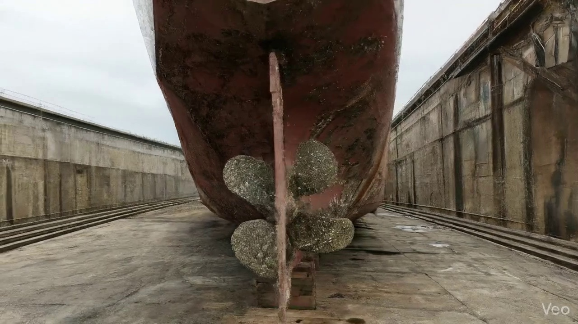

Repair Procedure
## Vessel Inspection Report: Explanation of Structural Steel Repair Process
**Repair Description:** This section details the repair methodology employed for rectifying localized structural deformation and material degradation on the vessel's hull/deck plating and associated internal framing. The process ensures restoration of structural integrity, watertight/weathertight capabilities, and surface contouring in accordance with recognized maritime standards.
---
### Detailed Explanation of Repair Steps:
**1. Assessment**
* **Necessity:** This initial step is paramount to accurately define the scope of damage, determine the root cause, and formulate an effective repair strategy. It prevents both under-repair (leaving compromised material) and over-repair (unnecessary work).
* **What Happens:** Skilled personnel meticulously inspect the affected area. This involves visually identifying the boundaries of deformation, marking the buckled region, and determining if the damage is confined to a localized area or extends to critical structural components such as adjacent frames, stiffeners, or girders. Out-of-flatness measurements are taken using appropriate tools (e.g., straightedges, optical methods, or laser scanning) to quantify the degree of distortion. This data informs the extent of material removal required.
* **Why the Required Items are Used:** No cutting torch is typically used at this stage. Measurement and marking tools are the primary equipment.
* **Safety and Structural Considerations:**
* **Structural:** Accurate assessment ensures that all compromised material is identified for removal, preventing residual stresses or weakened areas that could lead to future structural failure.
* **Safety:** While not directly involving immediate hazards, a thorough assessment is crucial for planning safe work procedures (e.g., hot work permits, confined space entry) in subsequent steps.
**2. Preparation**
* **Necessity:** The preparation phase is critical for removing all damaged, fatigued, or distorted material and creating a clean, sound base for the subsequent welding operations. This ensures that the new repair material will be joined to structurally sound parent metal, maximizing weld integrity and overall strength.
* **What Happens:** All identified distorted plate, buckled girders, and stiffeners are carefully cut away. The objective is to reach sound, undamaged metal, leaving a clean margin of good plate (typically $\ge\frac{3}{4}$ of the original plate thickness) around the cutout perimeter. Any bent or compromised internal framing that cannot be straightened to acceptable tolerances is similarly removed. This creates an opening ready for the new insert plate.
* **Why the Required Items are Used:**
* **Cutting Torch (rental):** The cutting torch (e.g., oxy-acetylene, plasma, or carbon arc) is the primary tool for this operation. It provides the high temperature necessary to efficiently sever steel plate and structural members, facilitating the removal of damaged material. The "quantity per sq.m" (0.01 machine-days/sq.m) and "required quantity" (0.08 machine-days) indicate the estimated operational time the torch is needed for the specific area of repair, justifying its rental for efficiency and cost-effectiveness.
* **Safety and Structural Considerations:**
* **Structural:** Removing all non-sound metal is fundamental for the integrity of the subsequent weld. The specified margin ensures that the heat-affected zone of the new weld does not overlap with compromised material.
* **Safety:** This is a "hot work" operation involving open flame or plasma. Strict adherence to hot work permits, fire watch protocols, provision of appropriate personal protective equipment (PPE - e.g., welding helmet, fire-retardant clothing, gloves), proper ventilation to dissipate fumes, and clear work area demarcation are mandatory to prevent fires, explosions, burns, and respiratory hazards.
**3. Plate Replacement**
* **Necessity:** This step restores the physical integrity of the hull or deck by introducing new, appropriately specified material into the void created during preparation. It is essential for maintaining the vessel's structural strength, watertight/weathertight integrity, and continuity of load paths.
* **What Happens:** A new steel plate, matching or exceeding the original material's thickness and grade (e.g., AH36, DH36), is fabricated and precisely shaped to fit the cutout. This new insert plate is then positioned accurately against the existing hull plating, ensuring proper alignment. It is secured in place using tack-welds to prevent movement during the main welding process. Subsequently, continuous full penetration welds (where feasible and specified) are applied around the entire perimeter, ensuring good fusion with the parent metal. Appropriate preheat temperatures are maintained, especially for thicker plates or high-tensile steels, to mitigate the risk of cold cracking and improve weld quality.
* **Why the Required Items are Used:** No cutting torch is directly used for *inserting* the plate, but welding machines, electrodes, and associated welding consumables are used. The fabricated plate might require minor trimming with a cutting torch for final fitment.
* **Safety and Structural Considerations:**
* **Structural:** Correct material selection and thickness are vital for restoring load-bearing capacity. Full penetration welds, combined with proper preheat and fusion, are crucial for achieving the required joint strength and preventing lamellar tearing or other weld defects. Proper fit-up prevents excessive gaps that compromise weld quality.
* **Safety:** Hot work procedures, including fire watch and appropriate PPE (welding mask, gloves, flame-retardant clothing), are essential due to welding operations. Good ventilation is required to manage welding fumes.
**4. Alignment and Welding**
* **Necessity:** This phase is dedicated to completing the permanent metallurgical bond between the new insert plate and the existing structure, while simultaneously controlling distortion and ensuring the final repair meets design tolerances.
* **What Happens:** Multiple weld passes are applied using specified electrodes, typically E7018, which are low-hydrogen electrodes known for their excellent mechanical properties and crack resistance. Throughout the welding process, continuous monitoring for distortion is performed. If welding-induced distortion occurs, mitigation techniques such as the use of strongbacks and clamps, specific welding sequences (e.g., skip welding), or minimal heat input techniques are applied to maintain the desired hull contour and prevent residual stresses. Upon completion of welding, all weld seams are ground fair and smooth with the surrounding hull surface to eliminate stress concentrations and reduce hydrodynamic drag. In instances where the original buckling was extensive or the area is subject to high stresses, additional strengthening components like doublers (patches) or stiffeners may be strategically applied to enhance the local structural integrity.
* **Why the Required Items are Used:** No cutting torch is directly used here. Welding equipment, grinding tools, and potentially clamping/pulling systems are utilized.
* **Safety and Structural Considerations:**
* **Structural:** E7018 electrodes ensure high-strength, ductile welds resistant to hydrogen-induced cracking. Control of distortion is critical to maintaining the vessel's hydrodynamic profile, avoiding additional stress concentrations, and ensuring proper load distribution. Grinding weld seams fair minimizes stress risers, improving fatigue life and reducing corrosion initiation points. Additional strengthening addresses potential areas of weakness or high stress.
* **Safety:** All welding hazards (arc flash, fumes, heat, electrical shock) persist. Grinding operations require eye and respiratory protection, and precautions against sparks and flying debris.
**5. Finishing**
* **Necessity:** The final stage focuses on verifying the quality of the repair, protecting the new steel from environmental degradation, and restoring the vessel's aesthetic and functional surface.
* **What Happens:** A comprehensive inspection of the repair is conducted. This includes visual inspection to check for surface defects, proper contour, and weld quality. Non-Destructive Testing (NDT) methods, such as Magnetic Particle Testing (MPT) or Dye Penetrant Testing (DPT) for surface cracks, and Ultrasonic Testing (UT) for internal weld integrity, are performed as required by class society rules or repair specifications. Once the repair is deemed satisfactory, the new steel is prepared (e.g., grit blasting) and coated with marine-grade primer and subsequent finish coats (e.g., anti-corrosive, anti-fouling) to restore its corrosion protection and cosmetic appearance. The deck or hull surface is ensured to be faired back to its original design contour, which is vital for vessel performance and structural aesthetics.
* **Why the Required Items are Used:** No cutting torch is used at this stage. NDT equipment, surface preparation tools, and painting equipment are utilized.
* **Safety and Structural Considerations:**
* **Structural:** NDT is essential for verifying the internal and surface integrity of the welds, ensuring that no hidden defects compromise the structural repair. Restoration of corrosion protection is critical for the long-term durability of the new steel and prevents degradation. Fairing the surface prevents unnecessary hydrodynamic drag and maintains the vessel's design speed and fuel efficiency.
* **Safety:** Personnel involved in NDT may require specific certifications. Painting operations necessitate proper ventilation, respiratory protection, and adherence to paint product safety data sheets (MSDS) to prevent exposure to hazardous chemicals. Environmental protocols for paint waste disposal must be followed.
---
This comprehensive explanation ensures that all aspects of the repair process, its necessity, execution, resource utilization, and critical safety/structural considerations are clearly documented for a professional vessel inspection report.

Repair Cost Breakdown
Item | Quantity | Unit Cost | Total Cost | Currency
Cutting Torch (rental) | 0.08 | 10764.0 | 807.3 | INR
Estimated Repair Cost: 41583.53 INR

3.3 PD_3

Defect Overview
Here's a professional explanation of the "DEFORMATION" defect for a vessel inspection report:
---
**DEFECT: DEFORMATION**
**Severity:** Medium
**1. What the defect means:**
Deformation refers to the unintended alteration of a structural component's shape from its original design, specifically manifesting as buckling (an out-of-plane bending of plates under compressive stress) or warping (a twist or bend across a surface). This defect is observed in hull plating or stiffeners, and the current instance indicates a localized occurrence on or immediately adjacent to the Rudder Area (with a 1.43% overlap of the rudder area noted). Common causes include significant external forces like grounding impacts, heavy sea loads experienced during operations, or internal stresses induced by welding processes.
**2. Why it is important:**
Even moderate levels of deformation are critical because they signify a compromise in the intended structural integrity of the vessel. The hull girder, composed of numerous interconnected plates and stiffeners, is designed to withstand specific loads and distribute stresses efficiently. Buckling or warping disrupts this load-bearing mechanism, potentially creating stress concentrations and reducing the overall stiffness and strength of the affected area. Given its proximity to the Rudder Area, this deformation could impact the structural support for the rudder assembly or potentially affect hydrodynamic flow, even if the rudder itself is not directly deformed. Classification societies typically mandate the correction of such defects due to their direct bearing on a vessel's seaworthiness.
**3. Risks if not repaired:**
Failure to address this deformation carries several risks:
* **Progressive Failure:** The compromised strength of the deformed section makes it more vulnerable to further damage under subsequent operational loads, leading to an escalation of the defect.
* **Fatigue Crack Initiation:** Deformed areas act as stress risers, significantly increasing the likelihood of fatigue crack initiation and propagation, which can lead to more serious structural failures over time.
* **Compromised Watertight Integrity:** Severe deformation can lead to fracturing of plating or compromised integrity of welds, potentially breaching watertight or weathertight boundaries, which is a significant safety hazard.
* **Impact on Adjacent Structures:** The altered stress distribution from the deformed area can transfer undue loads to surrounding plating, stiffeners, and internal structures, potentially initiating secondary damage.
* **Classification and Operational Implications:** Unrepaired defects can lead to detentions, restrictions on trading, or withdrawal of classification, directly impacting the vessel's operational viability and value. In the vicinity of the rudder, it could also subtly affect steering performance or increase wear on rudder bearings if structural support is compromised.
**4. Structural implications:**
The structural implications of deformation are fundamental to the vessel's integrity:
* **Reduced Hull Girder Strength:** The out-of-plane bending effectively reduces the sectional modulus and moment of inertia of the affected area, directly diminishing the hull's resistance to global bending and torsional stresses.
* **Loss of Stiffness:** Deformed plating or stiffeners lose their rigidity, making the structure more susceptible to excessive deflections and vibrations under dynamic loads.
* **Stress Redistribution:** The deformation alters the designed load paths, forcing stresses to concentrate in localized areas or reroute through less robust structural components, leading to an unpredictable and potentially unsafe stress distribution throughout the hull.
* **Localized Weak Points:** The deformed section becomes a critical weak point in the structure, prone to catastrophic failure if subjected to loads exceeding its now-reduced capacity.
* **Impact on Rudder Support (Specific to this case):** While the overlap with the Rudder Area is minor, any deformation in the supporting structure for the rudder post or stock could lead to misalignment, increased wear on bearings, or reduced structural reliability for this critical steering component.
---

Visual Evidence
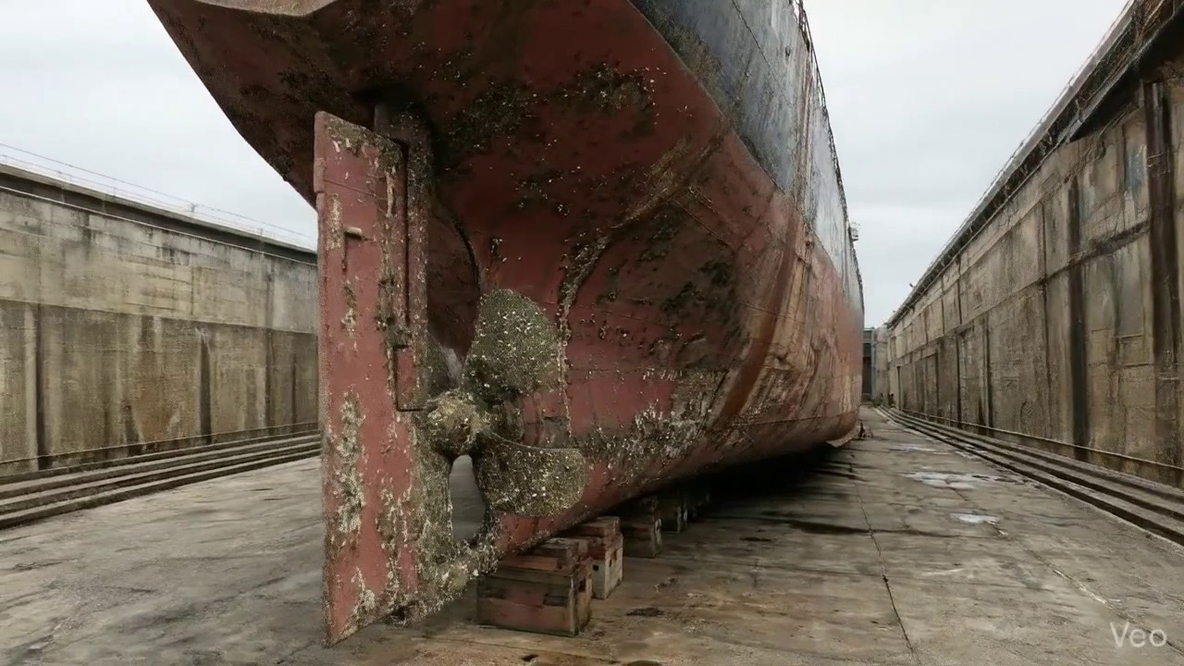

Repair Procedure
## Vessel Inspection Report: Explanation of Structural Steel Repair Process
This report details the standard procedure for repairing localized structural steel damage, such as buckling or deformation, on a vessel's hull or deck plating. The process ensures the restoration of the vessel's structural integrity, watertight/weathertight integrity, and surface fairness, adhering to industry best practices and classification society standards.
---
### **1. Repair Process Breakdown and Rationale:**
**A. Assessment:**
* **What happens:** Highly trained personnel visually inspect the deformed region, meticulously marking the exact boundaries of the damage. Measurements are taken to quantify the degree of out-of-flatness (e.g., deviation from original contour) and to determine if the damage is confined to the plate or extends to adjacent structural members like frames, girders, or stiffeners.
* **Why necessary:** This initial phase is paramount for accurately defining the scope of the repair. It ensures that all affected areas, including those not immediately obvious, are identified. A thorough assessment prevents partial repairs that could leave underlying structural weaknesses or stress concentrators unaddressed, thereby guaranteeing the long-term efficacy and safety of the repair.
**B. Preparation:**
* **What happens:** Using thermal cutting methods, all distorted plate material and any buckled or compromised internal girders, frames, or stiffeners are systematically removed. This cutting extends beyond the visibly damaged area into sound, undamaged metal, leaving a clean margin (typically equal to or greater than ¾ of the plate thickness). If internal framing is only slightly bent, it may be carefully straightened; otherwise, it is also removed.
* **Why necessary:** The objective is to provide a clean, sound base for the new material. Welding new steel to compromised, fatigued, or micro-cracked material would result in a weak and unreliable joint. The margin of sound plate ensures that residual stresses or material degradation immediately adjacent to the visible damage are fully eliminated, preventing premature failure of the repair.
**C. Plate Replacement:**
* **What happens:** A new steel plate, fabricated to match or exceed the original material specifications (grade and thickness), is precisely cut and shaped to fit the opening created in the previous step. This new plate is then carefully positioned against the remaining sound hull plating. Initial tack welds are applied to secure it in place and maintain alignment, followed by the application of continuous welds around the entire perimeter. Critical considerations include ensuring excellent fusion between the new and existing material and applying appropriate preheat where required (e.g., for thicker plates or high-tensile steels) to prevent hydrogen-induced cracking and minimize residual stress. Full penetration welds are utilized wherever structurally feasible.
* **Why necessary:** This step directly restores the structural continuity and the integrity of the watertight or weathertight envelope. Precise fit-up and high-quality welding are crucial to distribute loads effectively across the new and existing structures, preventing stress concentrations and ensuring the repair is as strong as, or stronger than, the original structure. Preheat management is vital for metallurgical soundness.
**D. Alignment and Welding:**
* **What happens:** Subsequent weld passes are meticulously applied using specified low-hydrogen electrodes, typically E7018, known for their excellent mechanical properties and resistance to cracking. Throughout this process, measures are taken to mitigate welding-induced distortion; this may include the strategic use of strongbacks and clamps, or the application of low-heat input welding techniques. Once welding is complete, all weld seams are ground fair and flush with the surrounding hull surface to ensure smooth contours. In instances of extensive original buckling or where structural design dictates, additional strengthening elements such as doubler plates or supplementary stiffeners may be incorporated to enhance local rigidity and reduce stress.
* **Why necessary:** This phase completes the integration of the new plate, building up the required weld cross-section. The use of E7018 electrodes is critical for achieving welds with superior strength and ductility, minimizing the risk of defects. Controlling distortion is essential to maintain the vessel's hydrodynamic profile, prevent adverse residual stresses, and ensure the overall fairness of the hull. Grinding makes the surface suitable for subsequent coating and facilitates accurate NDT. Additional strengthening, if applied, provides enhanced structural robustness against future operational stresses.
**E. Finishing:**
* **What happens:** The completed repair undergoes rigorous inspection. This involves a comprehensive visual examination for surface discontinuities, weld profile adherence, and overall fairness. Non-Destructive Testing (NDT) methods (e.g., Magnetic Particle Testing, Ultrasonic Testing, or Radiographic Testing) are employed to verify the internal integrity of the welds and detect any subsurface flaws. Subsequently, the new steel surface is thoroughly prepared (e.g., grit blasting) and coated with appropriate primer and finish paint systems to restore full corrosion protection. Finally, the deck or hull surface is faired back to its original contour, ensuring a seamless blend with the adjacent plating.
* **Why necessary:** The finishing stage is crucial for ensuring the quality, longevity, and performance of the repair. NDT provides objective evidence of weld integrity, assuring compliance with classification society rules and mitigating latent defects. The coating system is vital for protecting the new steel from environmental corrosion, which could otherwise compromise the structural integrity over time. Fairing the surface is essential for maintaining the vessel's hydrodynamic efficiency, preventing unnecessary drag, and ensuring aesthetic consistency.
---
### **2. Why the Required Items are Used:**
* **Cutting Torch (rental):**
* **Usage:** The cutting torch is a primary tool utilized extensively during the **Preparation** phase. It is essential for the rapid and efficient thermal cutting and removal of damaged steel plate, buckled girders, and stiffeners. It provides the concentrated heat required to sever thick steel sections cleanly and expeditiously.
* **Rationale:** Given the item is listed as "rental," it suggests that the scale or frequency of such repair work might not warrant permanent ownership of specialized heavy-duty cutting equipment. Renting provides cost-effectiveness for intermittent or large-scale repair projects by supplying high-performance equipment on demand.
* **Cost Relevance:** The "quantity per sqm," "required quantity," and associated costs (e.g., 0.08 machine-days for 807.3 INR) indicate the financial allocation for the rental duration required to execute the cutting tasks for a specific repair area.
---
### **3. Safety and Structural Considerations:**
**A. Structural Considerations:**
* **Material Specification:** It is paramount that replacement steel matches or exceeds the original's material grade and thickness. Substitution with inferior material could compromise the vessel's overall strength.
* **Weld Quality:** Achieving full penetration welds where specified, utilizing appropriate electrodes (e.g., E7018 for structural applications), and maintaining correct preheat and interpass temperatures are critical for metallurgical soundness, preventing cracking, and ensuring maximum weld strength.
* **Structural Continuity:** The repair must restore the structural continuity of the hull and any internal framing. Misalignment or poor welding can introduce stress concentrations.
* **Distortion Control:** Welding inherently induces stresses and can cause distortion. Effective distortion control (clamping, strongbacks, controlled heat input) is essential to maintain the vessel's designed shape and avoid residual stresses that could lead to premature fatigue or buckling.
* **Load Path Integrity:** The repair must ensure that existing load paths within the hull structure are fully restored and can effectively transfer stresses across the repaired area.
* **Classification Society Requirements:** All repairs must comply with the vessel's classification society rules and applicable international conventions (e.g., SOLAS, MARPOL) to maintain its certificate of class and operational validity.
* **Non-Destructive Testing (NDT):** NDT methods are crucial for verifying the internal integrity of welds, detecting flaws not visible to the naked eye, and confirming the quality of the repair.
**B. Safety Considerations:**
* **Hot Work Procedures:** Cutting and welding operations are classified as hot work and require strict adherence to established procedures, including obtaining hot work permits, maintaining a dedicated fire watch with appropriate extinguishing equipment, and ensuring fire-safe conditions in the work area and adjacent compartments.
* **Personal Protective Equipment (PPE):** All personnel involved in the repair must wear appropriate PPE, including welding helmets (with correct shade lenses), flame-retardant clothing, leather gloves, safety glasses, respirators (for welding fumes), and safety footwear.
* **Ventilation:** Adequate ventilation is critical, especially in confined spaces, to prevent the accumulation of toxic fumes from welding and cutting operations. Forced ventilation or local exhaust systems may be required.
* **Confined Space Entry:** If the repair involves working inside tanks or other confined spaces, strict confined space entry procedures must be followed, including gas testing, atmospheric monitoring, standby person, and emergency rescue plans.
* **Electrical Safety:** Welding equipment must be properly maintained, grounded, and operated according to manufacturer's instructions to prevent electrical shocks.
* **Material Handling:** Safe handling procedures for steel plates, cutting equipment, and welding consumables must be observed to prevent injuries.
* **Hazardous Materials:** Proper handling and disposal of hazardous materials such as paint thinners, old coatings, and welding consumables are essential.
---

Repair Cost Breakdown
Item | Quantity | Unit Cost | Total Cost | Currency
Cutting Torch (rental) | 0.08 | 10764.0 | 807.3 | INR
Estimated Repair Cost: 41583.53 INR

3.4 PD_4

Defect Overview
### Defect Explanation: DEFORMATION
**Defect Name:** DEFORMATION
**Severity:** High
**Explanation:**
**1. What the defect means:**
Deformation refers to an undesirable change in the original shape of a structural component, specifically manifesting as out-of-plane bending or distortion of hull plating, frames, or stiffeners. It encompasses phenomena such as **buckling** (a sudden lateral instability under compressive stress, causing a bulge or wave) and **warping** (a twist or bend across a surface). These distortions deviate from the designed planar or curved surfaces and typically occur due to excessive forces or stresses exceeding the material's elastic limit.
**2. Why it is important:**
This defect is of high importance due to its direct and severe impact on the fundamental structural integrity and overall safety of the vessel. Even seemingly moderate instances of deformation, particularly buckling or significant warping, can drastically reduce the designed strength and stiffness of the affected structures. Classification societies and maritime regulations regard significant deformation as a critical defect that compromises seaworthiness and mandates corrective action.
**3. Risks if not repaired:**
Failure to repair significant deformation carries substantial risks, including:
* **Progressive Structural Failure:** Deformed areas act as stress concentrators, which can lead to fatigue crack initiation and propagation, ultimately escalating to more extensive structural failures, especially under dynamic loads from heavy seas.
* **Loss of Watertight Integrity:** Buckled or warped plating can compromise the watertight boundaries of compartments, leading to uncontrolled water ingress, potential loss of buoyancy, stability, and flooding.
* **Reduced Operational Safety:** The diminished strength of the hull girder makes the vessel more vulnerable to damage during normal operations, adverse weather conditions, or potential impacts, increasing the risk to crew, cargo, and the vessel itself.
* **Regulatory Non-Compliance:** Unrepaired significant deformation will result in non-compliance with classification society rules and international maritime conventions (e.g., SOLAS, Load Line Convention), leading to potential detentions, revocation of class certificates, or denial of port entry.
* **Catastrophic Failure:** In extreme cases, severe, unaddressed deformation can lead to the ultimate structural collapse of a section of the hull or even the entire vessel, particularly when subjected to extreme longitudinal or transverse bending moments.
**4. Structural implications:**
The structural implications of deformation are profound and include:
* **Impairment of Hull Girder Strength:** Deformation directly reduces the effective section modulus and moment of inertia of the hull girder, which are critical parameters for resisting global bending and shearing forces. This significantly diminishes the vessel's ability to maintain its overall structural integrity.
* **Localized Stress Concentrations:** The distorted geometry creates areas of high stress concentration, where stresses can far exceed the design limits, making these points susceptible to brittle fracture or fatigue failure.
* **Reduced Load-Bearing Capacity:** Affected plating and stiffeners lose their ability to effectively carry compressive, tensile, or shear loads, forcing adjacent, sound structures to bear increased loads, potentially leading to their premature failure.
* **Alteration of Designed Load Paths:** The presence of deformation can alter the intended distribution of forces throughout the ship's structure, creating unpredictable stress patterns and potentially overloading components not designed for such loads.
* **Loss of Structural Redundancy:** Deformation reduces the inherent redundancy within the ship's structure, meaning that if one deformed component fails, there are fewer alternative load paths to prevent cascading failures.
* **Mandatory Renewal:** In line with classification society practices, significant buckling or warping necessitates the renewal of the distorted metal through cutting out and replacing the affected sections with new, compliant material to restore the original design strength and integrity. Attempting to fair out significant deformation is generally not an acceptable permanent repair due to the potential for residual stresses and material weakening.

Visual Evidence
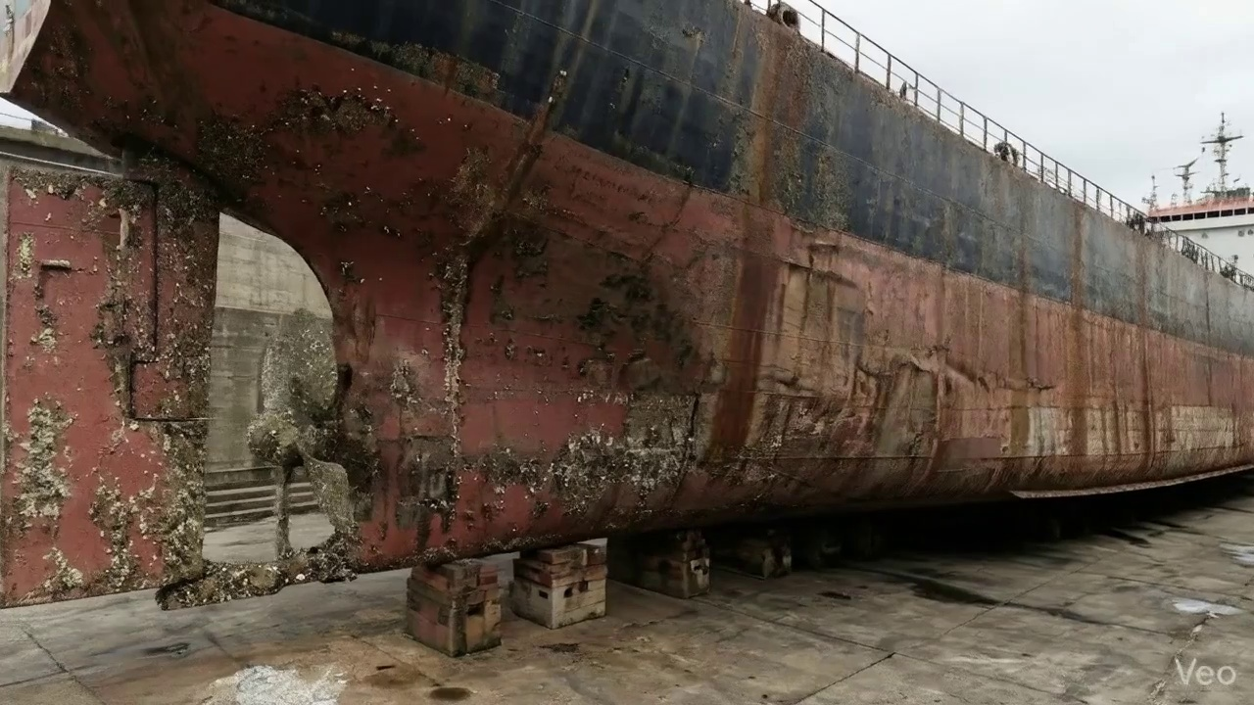

Repair Procedure
This report details a standard steel repair process implemented to restore the structural integrity and operational functionality of a vessel's hull or deck plating, following observed deformation or damage. The process adheres to recognized maritime repair best practices to ensure the repaired section meets or exceeds original design specifications and classification society requirements.
---
### **Detailed Explanation of Repair Process**
**1. Assessment**
* **Necessity:** This initial phase is crucial for accurately defining the scope, nature, and severity of the damage. Without a thorough assessment, there is a risk of either under-repairing (leaving compromised material) or over-repairing (unnecessary work), both of which have significant implications for safety, cost, and schedule. It ensures that the repair plan precisely addresses all affected areas.
* **What Happens:** Skilled technicians conduct a detailed visual inspection of the deformed region. They clearly mark the boundaries of the buckled or damaged area. The inspection determines if the damage is localized to a small section or extends across multiple structural frames, girders, or stiffeners. Precise measurements of any out-of-flatness are taken using tools such as straight edges, feeler gauges, or laser-leveling devices to quantify the extent of distortion. This data informs the extent of material removal required and the fabrication of new components.
**2. Preparation**
* **Necessity:** The objective of this step is to remove all compromised material – plate, girders, and stiffeners – to ensure that the subsequent new steel replacement is welded only to sound, unaffected base metal. This prevents potential propagation of cracks, stress concentrations, or reduced strength from existing damage into the new repair. The specified margin (≥¾ thickness) provides sufficient sound material for a robust and high-quality weld joint.
* **What Happens:** All identified distorted plate, buckled girders, and stiffeners are carefully cut away from the vessel structure. This removal continues until sound, uncompromised metal is reached, leaving a clean, prepared edge with the specified margin. Any remaining bent or deformed framing that is not being entirely replaced is either removed or carefully straightened to its original alignment using heat and mechanical force, as necessary, to ensure proper fit-up for new components.
* **Why the Required Item is Used:**
* **Cutting Torch (rental):** The cutting torch is an indispensable tool in this phase. It is used to efficiently and accurately cut away the damaged steel plating, girders, and stiffeners. Its ability to generate high heat rapidly allows for precise severance of thick steel sections, which is critical for preparing a clean edge for subsequent welding. The "machine-days/sq.m" metric indicates its operational time requirement per square meter of repair area.
**3. Plate Replacement**
* **Necessity:** This step directly addresses the restoration of the vessel's structural integrity and watertightness. Replacing the removed damaged section with new steel of equivalent or superior properties ensures that the vessel's load-bearing capacity and resilience against external forces are fully restored to design standards.
* **What Happens:** A new steel plate, meticulously fabricated to match the exact dimensions and contour of the removed section, is prepared. The new plate is typically of the same grade and thickness as the original, or occasionally of a greater thickness for enhanced strength if specified. This new plate is then carefully positioned into the cut-out aperture against the remaining sound hull plating, ensuring minimal gaps and proper fit-up. It is then secured in place by intermittent tack-welds, which temporarily hold it for final welding. Once alignment is confirmed, complete welding is performed around the entire perimeter of the new plate. Emphasis is placed on achieving good fusion between the new and existing steel, and appropriate preheat temperatures are applied, particularly for thicker plates or certain steel grades, to mitigate the risk of hydrogen-induced cracking and ensure optimal weld quality. Full penetration welds are utilized where feasible and structurally required to maximize joint strength.
**4. Alignment and Welding**
* **Necessity:** This stage builds up the weld joint to full strength and profile, managing the critical aspects of heat input and potential distortion. Proper welding techniques and material selection are paramount to ensuring the long-term structural integrity of the repair. Control of distortion is essential to maintain the vessel's fair lines and avoid internal stresses.
* **What Happens:** Continuous weld passes are applied using **E7018 electrodes**. These electrodes are chosen for their low-hydrogen properties, excellent mechanical strength, good ductility, and crack resistance, which are critical for marine structural applications. Throughout the welding process, close attention is paid to potential heat-induced distortion. Techniques such as strongbacks, clamps, specific weld sequencing, or minimal heat input strategies are employed to control and mitigate any buckling or warping. After welding is complete and allowed to cool, excess weld material is ground fair with the surrounding hull or deck surface. This not only improves aesthetics but also ensures smooth water flow (for hull surfaces) and facilitates subsequent coating applications. In instances where the initial buckling was extensive, indicating high localized stresses, additional strengthening components like doublers (plates welded over a larger area) or stiffeners (angle bars, flat bars) may be incorporated to enhance the repaired area's load-bearing capacity and distribute stress more effectively.
**5. Finishing**
* **Necessity:** This final stage confirms the quality and integrity of the repair and provides essential protection against corrosion, ensuring the longevity and continued performance of the repaired section.
* **What Happens:** A comprehensive inspection is carried out. This includes thorough visual inspection to check for surface defects, porosity, or improper weld profiles. Crucially, **Non-Destructive Testing (NDT)** methods, such as Ultrasonic Testing (UT) for internal flaws or Magnetic Particle Testing (MPT) for surface and near-surface cracks, are applied to verify the structural integrity and quality of the welds. Once the repair passes NDT, the new steel surface is thoroughly cleaned and prepared for coating. Marine-grade primer and subsequent finish coats are applied to restore the corrosion protection system, matching the original specifications of the vessel's paint scheme. Finally, the repaired deck or hull surface is faired back to its original contour, ensuring smooth lines, proper drainage on decks, and optimal hydrodynamic performance for hull areas.
---
### **Safety and Structural Considerations**
**Safety Considerations:**
1. **Hot Work Procedures:** The use of cutting torches and welding equipment necessitates strict adherence to hot work permits, fire watches, and availability of fire-fighting equipment.
2. **Personal Protective Equipment (PPE):** Welders, cutters, and support personnel must utilize appropriate PPE, including welding masks, gloves, flame-retardant clothing, and safety footwear.
3. **Ventilation and Fume Extraction:** Adequate ventilation is critical, especially in confined spaces, to prevent the accumulation of welding fumes and hazardous gases.
4. **Confined Space Entry:** If the repair takes place within tanks or other confined spaces, strict entry procedures, gas monitoring, and rescue plans must be in place.
5. **Electrical Safety:** All welding machines and electrical tools must be properly grounded and maintained to prevent electrical hazards.
6. **Fall Protection:** When working at heights or over open decks, fall protection measures (e.g., harnesses, guardrails) are essential.
**Structural Considerations:**
1. **Classification Society Approval:** The entire repair plan, including material selection, welding procedures (WPS), and NDT requirements, must be reviewed and approved by the relevant classification society surveyor.
2. **Material Traceability:** All new steel plates and welding consumables must have full material traceability certificates to confirm they meet design specifications.
3. **Certified Welders:** All welding personnel must hold valid welder qualifications and certifications for the specific welding processes and materials involved.
4. **Distortion Control:** Managing welding-induced distortion is critical to prevent residual stresses, which can lead to premature fatigue or cracking. Techniques such as balanced welding sequences, pre-setting, and strongbacks are employed.
5. **Pre- and Post-Weld Heat Treatment:** Depending on the steel grade and thickness, preheating before welding and post-weld heat treatment may be required to prevent hydrogen cracking and relieve residual stresses.
6. **Load Distribution:** For extensive repairs or areas subjected to high stresses, careful consideration is given to how loads will be distributed through the repaired section, sometimes necessitating reinforcement (e.g., doublers, stiffeners) to prevent future failures.
7. **Fit-Up and Alignment:** Precise fit-up of new plates and structural members is essential to ensure weld quality and proper load transfer. Poor fit-up leads to increased stress concentrations and weaker welds.
8. **Quality Control and Documentation:** Comprehensive quality control throughout the process, including NDT, dimensional checks, and detailed documentation, ensures the repair meets all specified standards and provides an auditable record.
---

Repair Cost Breakdown
Item | Quantity | Unit Cost | Total Cost | Currency
Cutting Torch (rental) | 0.12 | 10764.0 | 1345.5 | INR
Estimated Repair Cost: 69305.88 INR

3.5 PD_5

Defect Overview
**Defect Name: DEFORMATION**
**Severity: High**
---
**Explanation for Vessel Inspection Report:**
This report addresses the observed defect of **Deformation**, identified as buckling and/or warping, affecting significant structural components of the vessel. This condition is categorized with a **High Severity** due to its substantial implications for the vessel's structural integrity and operational safety.
---
**1. What the defect means:**
Deformation, in this context, refers to a localized, out-of-plane deviation or bending of the vessel's structural elements from their original, intended flat or curved shape. Specifically, it manifests as buckling (an unstable structural response to compressive stress causing sudden out-of-plane displacement) or warping (a twist or distortion that deviates from a true plane). This defect has been identified affecting the **hull plating and stiffeners within the HULL_AREA** (with a significant overlap ratio of 20.46%) and also structural elements within the **RUDDER_AREA** (with an overlap ratio of 16.98%). These distortions indicate that the affected metal has been subjected to stresses beyond its elastic limit or has undergone metallurgical changes due to thermal stress.
**2. Why it is important:**
This defect is of paramount importance because, even moderate levels of buckling or warping, can severely impair the overall strength of the hull girder and the localized strength of critical components. The hull girder is the primary load-bearing structure of the vessel, responsible for maintaining its longitudinal strength and resisting hogging and sagging forces encountered at sea. Deformation fundamentally alters the load-carrying capacity and stiffness of these elements. Furthermore, the presence of deformation often indicates exposure to significant external forces (e.g., grounding impacts, heavy sea loads) or internal stresses (e.g., uneven welding heat stress), which are critical events requiring thorough investigation and corrective action. Classification societies typically mandate the correction of such significant distortions to ensure continued compliance with structural requirements and maintain the vessel's seaworthiness certificate.
**3. Risks if not repaired:**
Failure to adequately repair this deformation carries several significant risks:
* **Progressive Structural Failure:** Deformed areas become points of high stress concentration. Under dynamic operational loads (e.g., wave impacts, engine vibrations), these stress raisers can initiate and propagate cracks, leading to further structural deterioration, and potentially catastrophic local or global failure.
* **Reduced Seaworthiness:** The impaired hull girder strength directly compromises the vessel's ability to safely navigate in adverse weather conditions. This increases the risk of more severe structural damage or, in extreme cases, the vessel breaking up at sea.
* **Compromised Watertight Integrity:** If the deformation affects external hull plating, especially below the waterline, it can compromise the watertight integrity, leading to water ingress into compartments, which could result in stability issues, flooding, and potential capsizing.
* **Regulatory Non-Compliance:** Unrepaired significant deformation will result in non-compliance with classification society rules and international statutory requirements. This can lead to the vessel being detained by port state control, operational restrictions, and the potential revocation of its certificates, incurring substantial financial penalties and operational downtime.
* **Reduced Performance and Maneuverability:** Deformation in the RUDDER_AREA can adversely affect its hydrodynamic efficiency, leading to impaired steering response, increased drag, and potentially a reduction in the vessel's maneuverability and fuel efficiency.
**4. Structural implications:**
The structural implications of this deformation are profound and far-reaching:
* **Impairment of Hull Girder Strength:** The most critical implication is the direct reduction in the vessel's longitudinal strength and stiffness. Buckled plating loses its effectiveness in contributing to the overall section modulus of the hull girder, making the vessel weaker against bending moments.
* **Localized Stress Concentrations:** The out-of-plane bending creates highly stressed points at the apexes and edges of the deformation. These areas are prone to accelerated fatigue cracking under cyclic loading, significantly reducing the lifespan of the affected components.
* **Reduced Stiffening Effectiveness:** If stiffeners themselves are buckled, their primary function of supporting the plating and transferring loads is severely compromised. This can lead to further buckling of the attached plating and a general weakening of the local structure.
* **Altered Load Distribution:** The deformed structure no longer distributes loads as designed. Adjacent, sound structural members may be forced to carry higher-than-intended stresses, potentially leading to secondary failures in previously unaffected areas.
* **Impact on Rudder Performance:** Deformation of the rudder structure can alter its foil shape, affecting lift and drag characteristics. This can lead to reduced steering efficiency, increased fuel consumption, and potential issues with rudder control mechanisms due to altered load transfer.
* **Increased Fatigue Susceptibility:** The altered stress patterns and stress concentrations inherent in deformed structures accelerate the process of metal fatigue, necessitating earlier and more extensive repairs than would typically be expected.
In summary, the observed deformation constitutes a serious structural defect that requires immediate attention. Classification practice dictates that significant buckling must be corrected by cutting out and replacing the distorted metal to restore the structural integrity and ensure the vessel's continued safe operation and compliance with all relevant regulations.

Visual Evidence
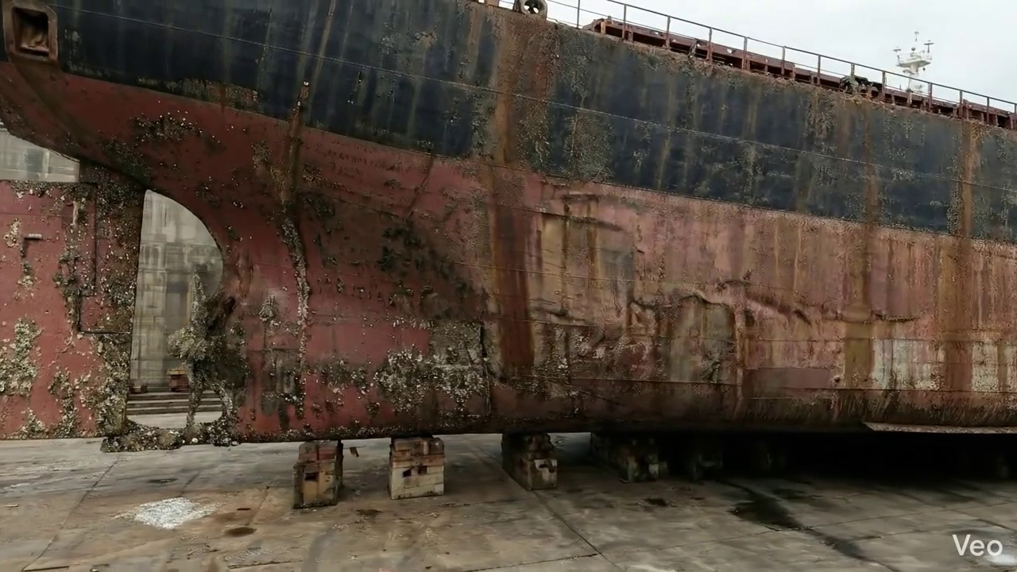

Repair Procedure
## Vessel Inspection Report: Explanation of Structural Steel Repair Process
This report details the comprehensive repair process for localized structural damage, specifically addressing buckled steel plating and associated framing. The methodology ensures the restoration of the vessel's structural integrity, watertightness, and aesthetic contour to original or enhanced standards.
### 1. Necessity of Each Repair Step
Each step in this repair process is meticulously designed to ensure a robust, durable, and compliant outcome:
* **Assessment:** This initial phase is critical for defining the scope and nature of the damage. Without a thorough assessment, the repair might be inadequate, leading to premature failure, or over-extensive, incurring unnecessary costs and downtime. It identifies the exact areas requiring intervention and informs the subsequent planning.
* **Preparation:** The removal of all distorted and compromised material is fundamental. Welding new, sound steel to damaged, fatigued, or distorted material would result in a structurally weak repair prone to cracking and re-failure. The specified margin of sound plate (≥¾ thickness) ensures the new weld joint will be made on material with its full design strength.
* **Plate Replacement:** This step directly restores the structural continuity and watertight integrity of the hull or deck. The fabrication of a new plate to precise dimensions, with appropriate material properties, is essential for a seamless and strong integration with the existing structure.
* **Alignment and Welding:** This is the core structural integration phase. Proper welding techniques, electrode selection (E7018 for its low-hydrogen properties and excellent mechanical strength), and distortion control measures are paramount to achieve a full-strength, homogenous joint. Grinding welds fair ensures hydrodynamic efficiency, proper coating adhesion, and prevents stress concentrations. Additional strengthening directly addresses root causes of extensive buckling, enhancing structural resilience.
* **Finishing:** This final stage confirms the quality of the repair and restores the vessel's protective layers. Visual and Non-Destructive Testing (NDT) are essential for verifying the integrity of the welds, both externally and internally. Applying primer and finish coats is crucial for long-term corrosion protection, preventing degradation of the newly installed steel and ensuring the longevity of the repair. Fairing ensures the structural surface meets design specifications for performance and aesthetics.
### 2. What Happens During the Repair
The repair unfolds through a series of sequential, controlled operations:
* **Assessment:** Qualified personnel visually inspect the deformed region, using chalk or markers to delineate the buckled area. Measurements of out-of-flatness are taken using straight edges and measuring tapes. The extent of damage is determined, identifying if it is confined to localized plating or extends to underlying structural members such as frames, girders, or stiffeners.
* **Preparation:** Using specialized cutting equipment, the identified distorted plate material is precisely cut away. Any buckled girders or stiffeners found within the damaged region are also removed to a point of sound, undistorted metal. A minimum margin of sound original plate, equivalent to three-quarters of the plate's thickness, is intentionally left to provide a robust base for the new weld. Any bent or deformed primary framing is either straightened using heat and mechanical means or removed and replaced.
* **Plate Replacement:** A new steel plate, matching or exceeding the original thickness and material grade, is fabricated to the exact dimensions and contours required to fit the prepared cut-out. Its edges are typically bevelled to facilitate full penetration welding. The new plate is then carefully positioned into the opening, ensuring precise fit-up. It is temporarily secured with tack welds to maintain its position before comprehensive welding begins. Preheating, if required by material specifications or thickness, is applied, and full penetration welds are initiated to ensure maximum strength and fusion.
* **Alignment and Welding:** Continuous welding passes are applied using E7018 electrodes, known for their low-hydrogen content and excellent strength characteristics. Throughout the welding process, close attention is paid to heat input and sequence to minimize distortion. If distortion becomes apparent, clamps are utilized to maintain alignment, or specific welding techniques (e.g., skip welding, back-stepping) are employed to control thermal stresses. Upon completion of welding, the weld seams are meticulously ground fair with the surrounding hull or deck plating, achieving a smooth, continuous surface. In instances of significant historical or recurrent buckling, additional structural strengthening, such as doubler plates or supplementary stiffeners, may be designed and welded into place to reinforce the area and mitigate future stress concentrations.
* **Finishing:** The completed repair is subjected to rigorous quality control, including a thorough visual inspection for surface defects, porosity, or incomplete fusion. Non-Destructive Testing (NDT) methods, such as Magnetic Particle Testing (MPT) or Ultrasonic Testing (UT), are then performed on the welds to verify their internal integrity and freedom from hidden defects. Finally, the new steel is thoroughly cleaned, prepared, and coated with appropriate marine primer and subsequent finish coats, restoring the vessel's corrosion protection system. The entire deck or hull surface encompassing the repair is faired to its original design contour, ensuring proper hydrodynamics and drainage.
### 3. Why the Required Items Are Used
The specified item, the **Cutting Torch (rental)**, is indispensable for the "Preparation" phase of this repair process.
* **Cutting Torch (rental):** This piece of equipment provides a highly efficient and effective means of thermally cutting steel. It is utilized to precisely remove the deformed and compromised sections of the steel plate and any associated buckled girders or stiffeners. The ability to make accurate cuts ensures that only damaged material is removed, leaving a clean, sound edge for the new plate to be fitted against. The "rental" aspect is pragmatic for a vessel repair yard, as it provides access to specialized equipment without the overhead of ownership, particularly for tasks that may not be required daily, thereby optimizing operational costs.
### 4. Safety and Structural Considerations
This repair process involves critical safety and structural considerations to ensure both personnel well-being and the long-term integrity of the vessel:
**Structural Considerations:**
* **Material Selection:** Using new steel of the same or greater thickness and grade (e.g., marine-grade steel) is paramount to maintain or enhance the original structural strength.
* **Weld Quality:** Full penetration welds are specified where possible to maximize joint efficiency and strength, ensuring the new plate is fully integrated into the vessel's structure.
* **Electrode Selection:** The use of E7018 electrodes is critical. These are low-hydrogen electrodes designed for high-strength, low-alloy steels, minimizing the risk of hydrogen-induced cracking, which can severely compromise weld integrity.
* **Preheat and Post-Weld Heat Treatment (PWHT):** Appropriate preheat is vital for thicker sections or certain steel grades to reduce the cooling rate of the weld, preventing cracking and ensuring good metallurgical properties. While not explicitly mentioned, PWHT might be considered for highly critical or specialized applications to relieve residual stresses.
* **Distortion Control:** Welding inherently introduces thermal stresses and distortion. The use of clamps, proper welding sequence, and minimal heat input techniques are crucial to prevent plate deformation, maintain dimensional accuracy, and avoid introducing undesirable residual stresses that could weaken the structure.
* **NDT:** Non-Destructive Testing methods are essential to verify the internal soundness of the welds, ensuring freedom from defects such as cracks, lack of fusion, or porosity that would compromise structural integrity.
* **Fairing:** Grinding welds fair not only improves aesthetics and coating adhesion but also eliminates potential stress concentrators, which could otherwise initiate fatigue cracks.
* **Additional Strengthening:** The application of doublers or stiffeners in cases of extensive buckling demonstrates a proactive approach to address underlying structural weaknesses, enhancing the vessel's resilience in the affected area.
**Safety Considerations:**
* **Hot Work Procedures:** Cutting and welding operations are "hot work" and require strict adherence to established safety protocols, including hot work permits, designated fire watches, and readily available firefighting equipment.
* **Personal Protective Equipment (PPE):** All personnel involved must wear appropriate PPE, including welding helmets (with proper shade lenses), flame-retardant clothing, leather gloves, safety glasses, hearing protection, and safety footwear.
* **Ventilation:** Especially in confined spaces (e.g., tank spaces, double bottoms), adequate ventilation is critical to remove welding fumes and gases, preventing respiratory hazards and ensuring sufficient oxygen levels. Confined Space Entry procedures must be strictly followed.
* **Equipment Safety:** Proper handling and operation of cutting torches, welding machines, and grinding equipment are essential. This includes regular inspection of hoses, cables, and connections, and ensuring adequate grounding.
* **Fall Protection:** If work is conducted at height (e.g., on staging or scaffolding), appropriate fall protection measures, including harnesses, lanyards, and secure platforms, must be in place.
* **Material Handling:** Safe lifting and positioning techniques for new steel plates and structural members are necessary to prevent injuries.
* **Environmental Protection:** Measures must be taken to contain welding slag, grinding dust, and paint overspray to prevent environmental contamination.
By rigorously adhering to these steps and considerations, the structural steel repair will be executed to the highest standards, ensuring the continued safe and reliable operation of the vessel.

Repair Cost Breakdown
Item | Quantity | Unit Cost | Total Cost | Currency
Cutting Torch (rental) | 0.12 | 10764.0 | 1345.5 | INR
Estimated Repair Cost: 69305.88 INR

3.6 PD_6

Defect Overview
Here is a professional explanation of the maritime defect "DEFORMATION" for a vessel inspection report:
---
**Defect Name:** DEFORMATION
**Severity:** HIGH
**1. What the defect means:**
Deformation, specifically observed as buckling or warping, refers to an out-of-plane bending or distortion of the vessel's hull plating or its supporting stiffening members. Unlike simple indentations or dents, deformation involves a change in the original flat or curved profile of a structural member, pushing it out of its intended plane. This type of damage typically arises from external forces such as grounding impacts, heavy sea loads, or internal stresses like those induced by uneven welding heat. In this instance, the deformation affects a significant portion of the HULL_AREA, indicating a structural issue within a primary boundary.
**2. Why it is important:**
This defect is critically important due to its high severity rating and direct impact on the vessel's fundamental strength. Even moderate levels of buckling or warping can severely compromise the hull girder's structural integrity. The hull girder acts as the primary load-bearing structure of the entire vessel, distributing forces, resisting bending moments (hogging and sagging), and maintaining overall shape and strength. Deformation introduces irregularities and weakens the structural components, making the affected areas less capable of bearing their designed loads.
**3. Risks if not repaired:**
Failure to address significant deformation poses substantial risks to the vessel's operational safety and seaworthiness. These risks include:
* **Progressive Structural Failure:** The deformed areas become points of concentrated stress, making them highly susceptible to crack initiation and propagation, especially under dynamic loads experienced at sea (e.g., wave impacts, cargo shifts).
* **Loss of Watertight and Weathertight Integrity:** Severe buckling can compromise the sealing ability of hull boundaries, potentially leading to water ingress into compartments or void spaces, which can affect stability and cause further damage.
* **Reduced Resistance to External Forces:** The weakened structure is less capable of withstanding normal operational stresses, adverse weather conditions, or future accidental impacts, increasing the likelihood of further, more severe damage.
* **Catastrophic Failure:** In extreme cases, particularly in heavy weather or during another incident, unaddressed significant deformation could lead to a localized structural collapse or even overall hull girder failure, jeopardizing the vessel, crew, and cargo.
* **Regulatory Non-Compliance:** Classification societies typically mandate the correction of significant deformation, and non-compliance can lead to operational restrictions, detention, or refusal of class certification.
**4. Structural implications:**
The structural implications of deformation are profound and directly impact the vessel's fundamental strength characteristics. Specifically:
* **Reduced Section Modulus & Moment of Inertia:** Buckling effectively reduces the effective cross-sectional area and its distribution, thereby lowering the section modulus and moment of inertia of the affected members. These are critical parameters that define the hull girder's resistance to bending and torsional stresses.
* **Impaired Longitudinal & Transverse Strength:** The hull plating and stiffeners contribute significantly to both the longitudinal strength (resisting hogging and sagging stresses along the ship's length) and transverse strength (maintaining the vessel's cross-sectional shape). Deformation compromises these contributions, leading to an overall weaker structure.
* **Loss of Load-Carrying Capacity:** The deformed material's ability to carry compressive or tensile loads is significantly reduced. This means that forces intended to be distributed across a structural panel or stiffener are instead concentrated, exceeding design limits.
* **Pre-stressing & Residual Stresses:** Deformed material often retains residual stresses from the event that caused the deformation. These residual stresses can compound with operational stresses, accelerating fatigue and further reducing the material's load-carrying capacity.
* **Classification Requirements:** Classification practice dictates that significant buckling must be corrected by cutting out and replacing the distorted metal, rather than attempting to fair or repair in situ. This underscores the severe impact of deformation on the vessel's design specifications and safety margins, affirming that localized set-in plating may only be tolerated if minor and not impacting overall strength.
---

Visual Evidence


Repair Procedure
Generation failed.

Repair Cost Breakdown
Item | Quantity | Unit Cost | Total Cost | Currency
Cutting Torch (rental) | 0.12 | 10764.0 | 1345.5 | INR
Estimated Repair Cost: 69305.88 INR

3.7 PD_7

Defect Overview
Generation failed.

Visual Evidence
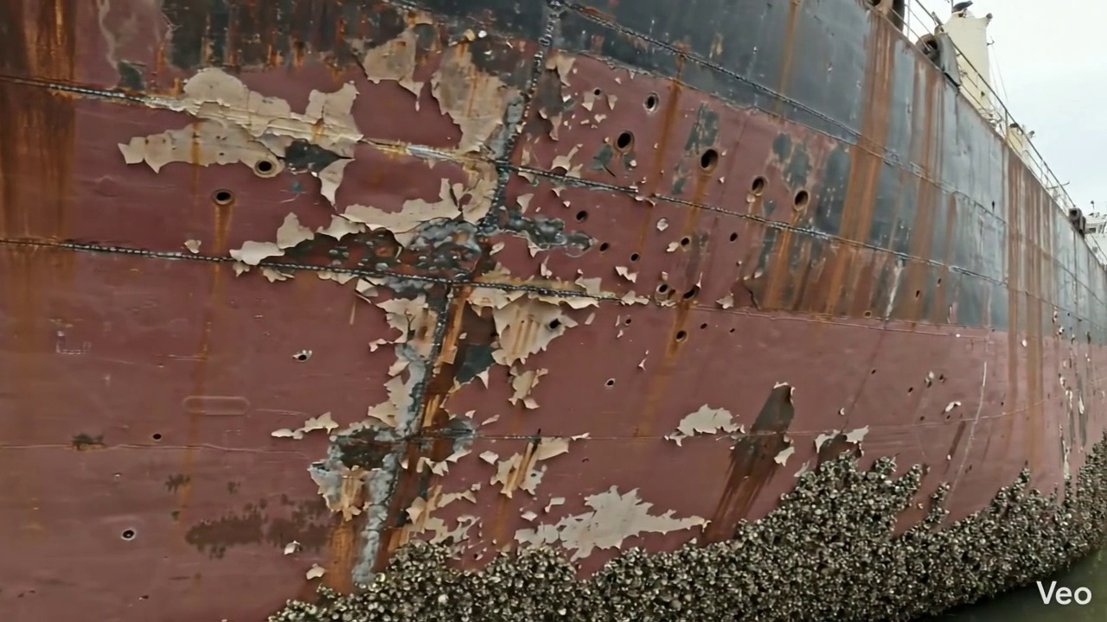

Repair Procedure
Generation failed.

Repair Cost Breakdown
Item | Quantity | Unit Cost | Total Cost | Currency
Cutting Torch (rental) | 0.12 | 10764.0 | 1345.5 | INR
Estimated Repair Cost: 69305.88 INR

3.8 PD_8

Defect Overview
Generation failed.

Visual Evidence
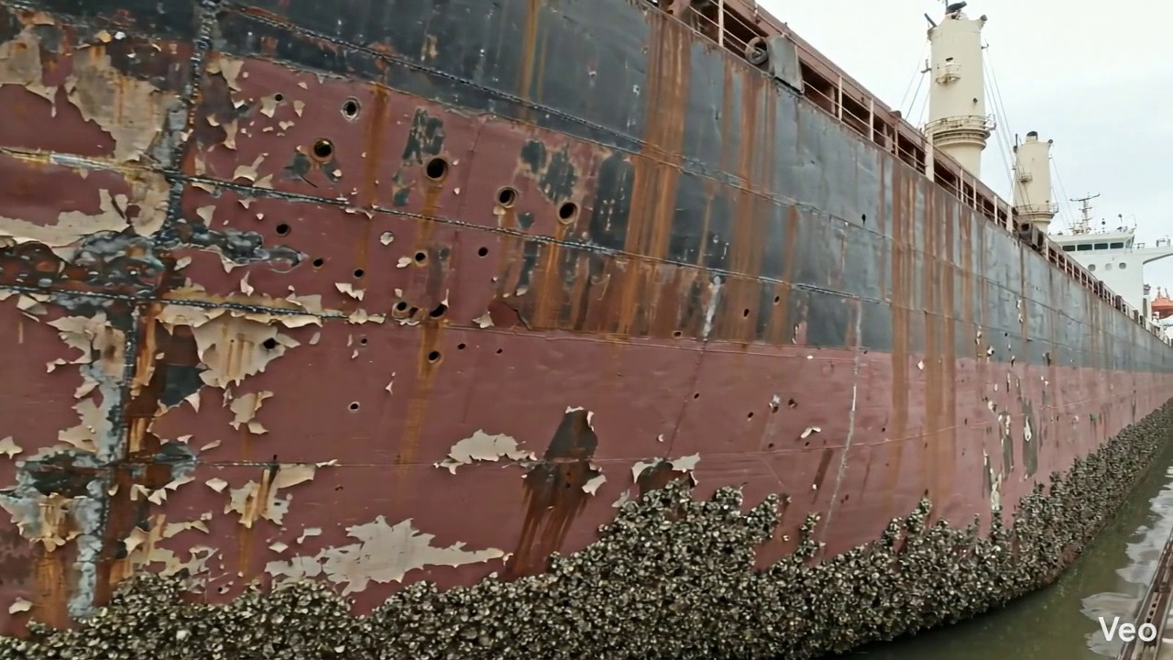

Repair Procedure
Generation failed.

Repair Cost Breakdown
Item | Quantity | Unit Cost | Total Cost | Currency
Cutting Torch (rental) | 0.08 | 10764.0 | 807.3 | INR
Estimated Repair Cost: 41583.53 INR

3.9 PD_9

Defect Overview
Generation failed.

Visual Evidence
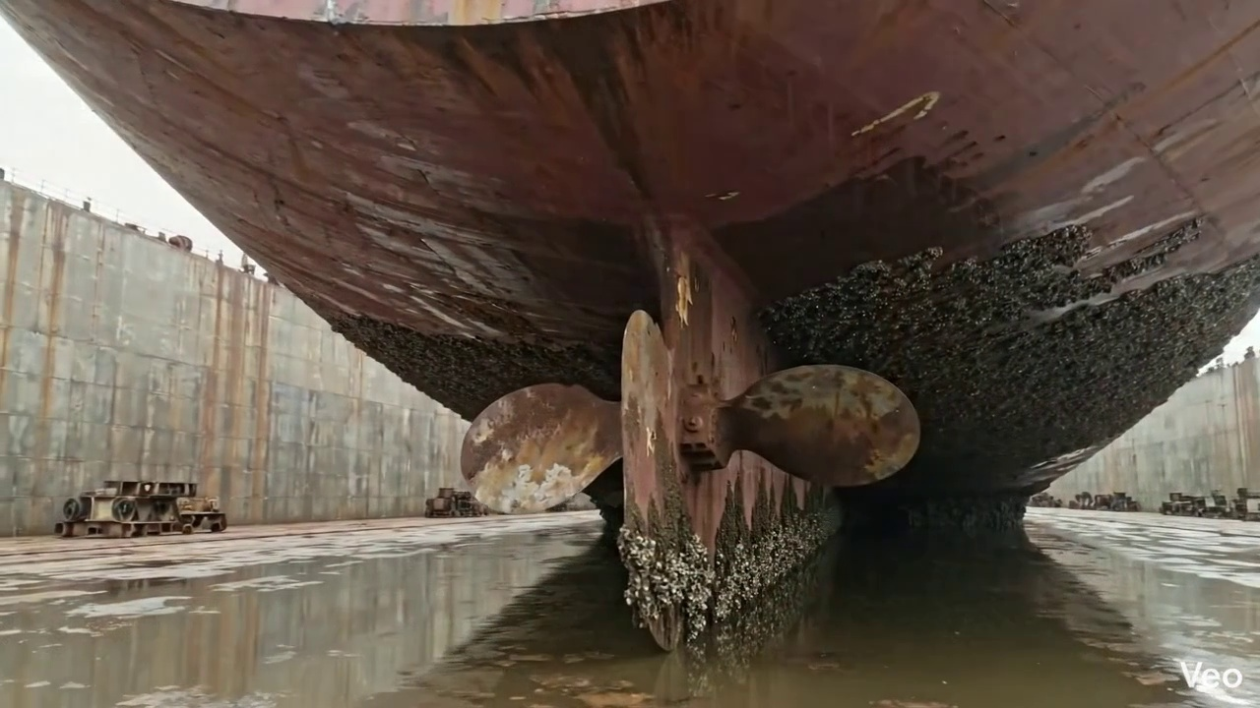

Repair Procedure
Generation failed.

Repair Cost Breakdown
Item | Quantity | Unit Cost | Total Cost | Currency
Cutting Torch (rental) | 0.05 | 10764.0 | 538.2 | INR
Estimated Repair Cost: 27722.35 INR

3.10 PD_10

Defect Overview
Generation failed.

Visual Evidence
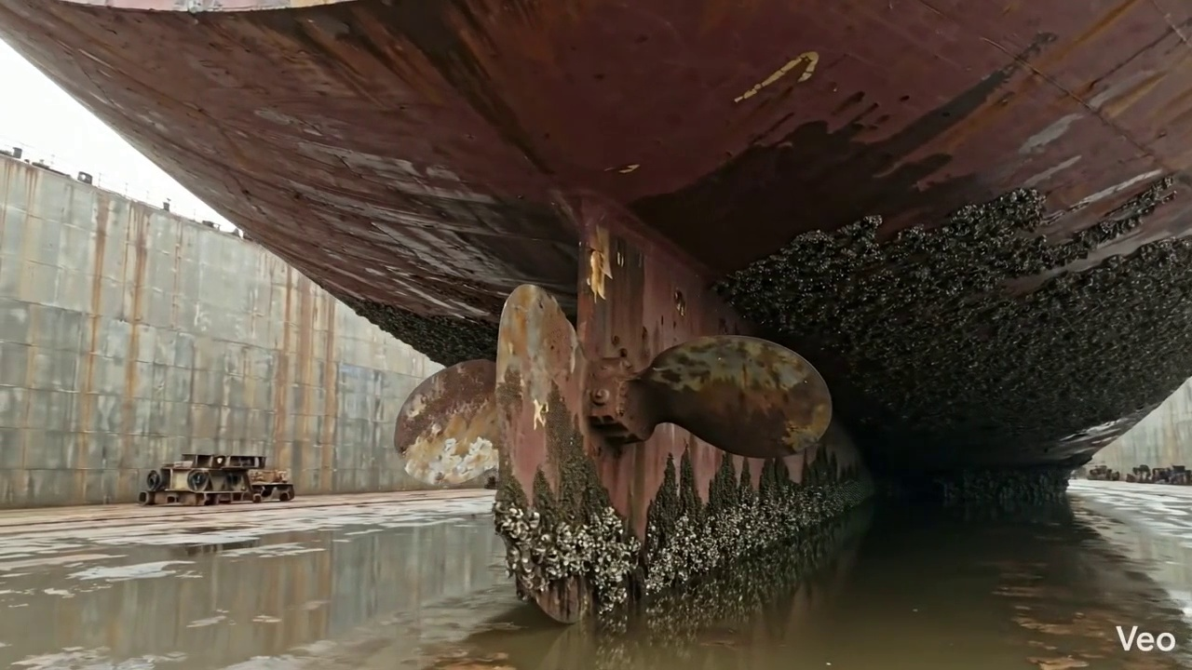

Repair Procedure
Generation failed.

Repair Cost Breakdown
Item | Quantity | Unit Cost | Total Cost | Currency
Cutting Torch (rental) | 0.05 | 10764.0 | 538.2 | INR
Estimated Repair Cost: 27722.35 INR

