Vessel Inspection Report

Table of Contents
1. Executive Summary
2. Vessel Repair Summary
3. Defect Analysis
3.1 PD_1
3.2 PD_2
3.3 PD_3
3.4 PD_4
3.5 PD_5
3.6 PD_6
3.7 PD_7
3.8 PD_8
3.9 PD_9
3.10 PD_10

1. Executive Summary
## Executive Summary: Maritime Vessel Condition Assessment
This executive summary presents the findings of a comprehensive maritime vessel inspection, conducted to assess its operational readiness and compliance with relevant standards.
The inspection identified a total of **ten (10) deficiencies** across various systems and compartments, with an estimated aggregate repair cost of **499,002.34 INR**.
Deficiencies were categorized by severity as follows:
* **Low Severity:** 2 items (Minor issues, typically routine maintenance items without immediate operational impact.)
* **Medium Severity:** 4 items (Requiring attention to prevent deterioration or minor operational inefficiencies.)
* **High Severity:** 4 items (Critical issues potentially impacting safety, regulatory compliance, structural integrity, or primary operational systems. These demand immediate remediation.)
The presence of four (4) high-severity deficiencies indicates critical issues that may impact safety, regulatory compliance, or vessel operational integrity. This distribution highlights a significant number of items requiring prompt attention to mitigate operational risks and ensure continued seaworthiness.
**Recommendation:**
Based on these findings, it is strongly recommended that immediate action be taken to address all identified deficiencies, particularly those categorized as high severity. A detailed remediation plan, including timelines and assigned responsibilities, should be developed and executed promptly to restore the vessel to optimal operational and safety standards.
---
[Date of Report]
[Inspector's Name/Department - Placeholder]

2. Vessel Repair Summary
Metric | Value
Total Defects | 10
Total Estimated Cost | 499002.34 INR
Material Cost | 299401.4 INR
Labor Cost | 149700.7 INR
Equipment Cost | 49900.23 INR

3. Defect Analysis

3.1 PD_1

Defect Overview
**Defect Name:** DEFORMATION
**Severity:** Medium
---
### Professional Explanation of Defect: DEFORMATION
**1. What the Defect Means:**
Deformation, as observed in this instance, refers to the out-of-plane bending of the vessel's hull plating or stiffeners, specifically presenting as buckling or warping. This means the affected metal surface is no longer flat or aligned with its intended structural plane but has undergone a visible change in shape. The inspection report indicates this deformation affects critical areas including the **keel area** and, to a lesser extent, the **propeller area**. Common causes for such deformation include significant impact events (e.g., groundings), exposure to heavy sea loads that exceed design parameters, or residual stresses induced by welding processes during construction or repairs.
**2. Why It Is Important:**
This defect is of medium severity and significant importance because even moderate buckles can severely impair the vessel's hull girder strength. The hull girder acts as the primary structural beam of the ship, resisting longitudinal bending and torsional forces. Any deformation compromises the structural integrity and load-carrying capacity of the affected plating and stiffeners, thereby directly impacting the overall strength and stiffness of the vessel. Classification societies typically mandate correction for such defects due to their potential to undermine seaworthiness and operational safety standards.
**3. Risks If Not Repaired:**
Failure to address deformation carries several critical risks:
* **Progressive Structural Weakening:** Unrepaired deformation can lead to further weakening of the affected areas over time, especially under continued operational stresses, heavy seas, or additional impacts.
* **Reduced Resistance to Loads:** The buckled or warped sections are less capable of resisting the designed compressive, tensile, and shear stresses. This increases the risk of localized failure, such as crack initiation and propagation, particularly in areas of stress concentration.
* **Compromised Watertight Integrity:** Severe deformation, especially in critical areas like the keel, could potentially lead to cracks or openings, compromising the watertight integrity of the hull and risking water ingress into compartments.
* **Operational Restrictions:** Classification societies or Port State Control authorities may impose operational restrictions (e.g., reduced speed, limitations on cargo loading, or specific routes) until the defect is satisfactorily repaired, leading to significant operational delays and financial penalties.
* **Increased Repair Complexity and Cost:** Delaying repairs often results in the need for more extensive and costly interventions later, as the damage may propagate or worsen.
**4. Structural Implications:**
The structural implications of deformation are substantial:
* **Impairment of Hull Girder Strength:** The primary implication is a direct reduction in the vessel's longitudinal strength and stiffness. The buckled plating and stiffeners cannot effectively contribute to the hull girder's ability to resist global bending and shear forces, making the vessel more susceptible to structural failure under dynamic loads.
* **Loss of Section Modulus and Moment of Inertia:** Locally, the out-of-plane bending reduces the effective section modulus and moment of inertia of the affected structural members. This means they are less efficient at resisting bending and axial loads than their original design intended.
* **Stress Concentrations:** The peaks and troughs of the deformation create localized stress concentrations. These areas are significantly more vulnerable to fatigue damage and crack initiation, which can propagate rapidly under cyclic loading conditions experienced during normal vessel operations.
* **Instability of Structural Elements:** Buckling is a form of structural instability. While small, localized set-in plating might sometimes be tolerated if carefully assessed, significant buckles indicate that the plating or stiffeners have exceeded their elastic limit or critical buckling load, and their load-carrying capacity is severely compromised.
* **Impact on Adjacent Structures:** Deformation in areas like the keel can affect the alignment and integrity of adjacent structures and components, potentially impacting foundations for machinery or tank structures. The involvement of the propeller area suggests potential implications for localized hydrodynamic performance and stress distribution around the propulsion system.
Classification practice mandates that significant buckling be rectified by cutting out and replacing the distorted metal to restore the structural integrity to design specifications.

Visual Evidence
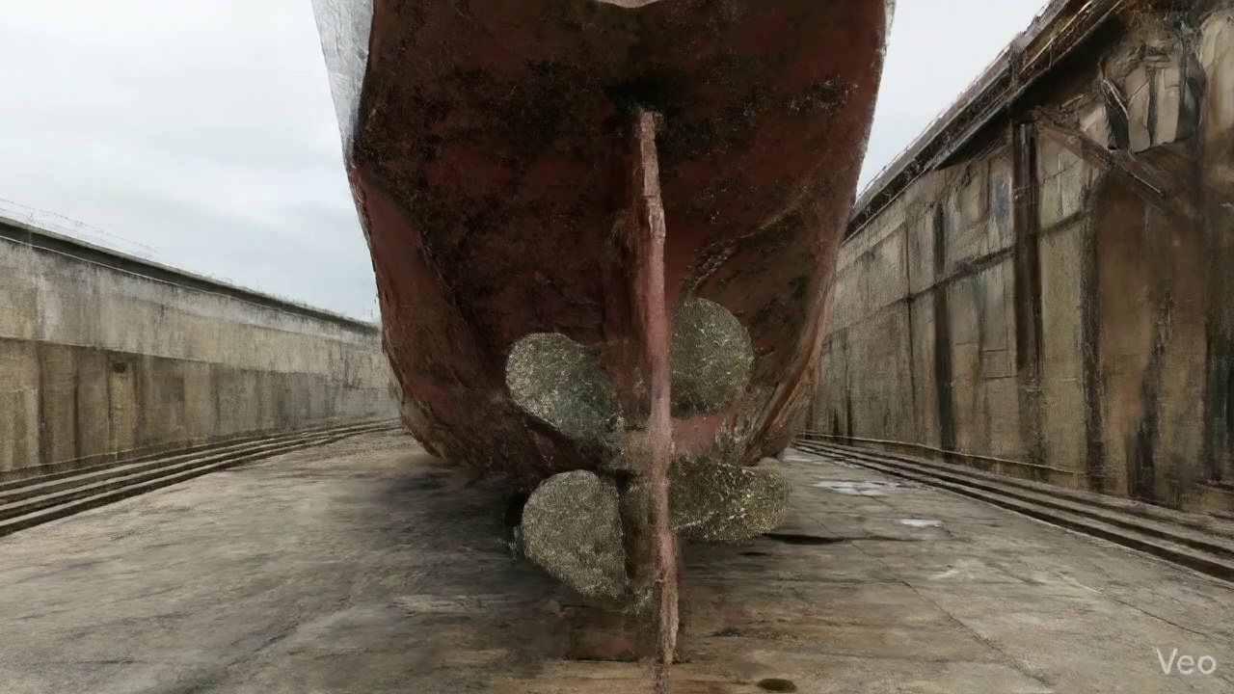

Repair Procedure
## Vessel Inspection Report: Explanation of Structural Steel Repair Process
**Date:** [Current Date]
**Vessel Name:** [If applicable, otherwise leave blank]
**Report Section:** Structural Steel Repair Methodology
This section outlines the detailed methodology for executing structural steel repairs on marine vessels, specifically addressing deformed or buckled plating and associated framing. The process adheres to established industry best practices, aiming to restore structural integrity, design strength, and hydrodynamic fairness.
---
### Detailed Repair Process Explanation:
#### 1. Assessment
* **Why Necessary:** This initial phase is critical for accurately defining the scope, nature, and extent of the damage. A thorough assessment prevents under-repair, which could compromise structural integrity, or over-repair, leading to unnecessary costs and downtime. It ensures that the proposed repair addresses the root cause and all affected components.
* **What Happens:** Skilled personnel visually inspect the deformed region. This involves identifying the precise boundaries of the buckled area and determining if the deformation is localized to a single plate or if it extends to or affects adjacent structural members such as frames, girders, or stiffeners. Precise measurements of out-of-flatness are taken to quantify the deformation, informing the subsequent repair design. The affected area is typically marked for clear identification during subsequent stages.
* **Why Required Items are Used:** (No specific item listed for this step, but relies on standard inspection tools like straight edges, measuring tapes, and calipers.)
* **Safety & Structural Considerations:** Inaccurate assessment can lead to inadequate repairs, leaving latent weaknesses that may propagate under stress. Early identification of the extent of damage is paramount for planning appropriate safety measures and ensuring full structural restoration.
#### 2. Preparation
* **Why Necessary:** The primary objective of this stage is to remove all compromised material and create a clean, sound foundation for the new steel. Damaged, fatigued, or highly stressed material cannot be reliably welded to and must be removed. Leaving a margin of good plate ensures that the new weld seam is placed on structurally sound parent material, free from pre-existing stresses or micro-cracks. Adherence to specified margins (e.g., ≥¾ thickness, often 50-75mm) is crucial as per regulatory guidelines (e.g., referenced standards like [35†L1098-L1103] and [18†L79-L87] which would typically specify plate preparation requirements).
* **What Happens:** Using appropriate cutting tools, all distorted plate material is precisely cut away. Simultaneously, any buckled girders, stiffeners, or other internal framing components within or adjacent to the affected area are either cut out to sound metal or carefully straightened if their deformation is minor and reversible without material degradation. The goal is to create a well-defined aperture with clean, prepared edges suitable for welding.
* **Why Required Items are Used:**
* **Cutting Torch (rental):** This item is essential for efficiently and accurately cutting away large sections of steel plate and structural members. Thermal cutting methods, such as oxy-fuel or plasma cutting, are chosen for their speed and ability to cut through thick steel. The "rental" aspect indicates that this equipment is not a routinely purchased asset, suggesting its use is project-specific or for intermittent repairs, optimizing cost-effectiveness while providing the necessary heavy-duty capability.
* **Safety & Structural Considerations:** This is a "hot work" activity, requiring strict adherence to hot work permits, fire watches, and appropriate personal protective equipment (PPE). Proper ventilation is critical to manage fumes. Structurally, the precise removal of damaged material and preparation of weld edges directly impacts the quality and strength of subsequent welds.
#### 3. Plate Replacement
* **Why Necessary:** This step directly addresses the restoration of the vessel's primary structure. A new steel plate, identical to or exceeding the original thickness and material grade, is fabricated to restore the hull's integrity, strength, and original contour. This ensures the vessel's design strength, load-carrying capacity, and hydrodynamic performance are reinstated.
* **What Happens:** A new steel plate, often sourced from certified stock, is precisely measured, cut, and formed (if necessary) to perfectly fit the aperture created in the preparation stage. The new plate is then carefully positioned against the remaining sound hull plating. Tack-welds are applied to secure the plate in place, maintaining proper alignment and fit-up before continuous welding commences. Full penetration welds are prioritized to ensure maximum strength and continuity of the structure. Appropriate preheating, especially for thicker plates or specific steel grades, is applied to minimize thermal stresses and prevent hydrogen-induced cracking in the weld and heat-affected zones.
* **Why Required Items are Used:** (No specific items listed in the "Required Items" section for this step, but requires welding machines, welding electrodes (e.g., E7018), preheating equipment, and fabrication tools.)
* **Safety & Structural Considerations:** Material compatibility and proper fit-up are paramount for a successful repair. Preheat is a critical structural consideration, particularly in marine environments, to ensure weld integrity. Full penetration welds are essential for restoring the design strength of the plating. Welding fumes and arc flash necessitate appropriate PPE and ventilation.
#### 4. Alignment and Welding
* **Why Necessary:** This stage completes the structural joining of the new plate to the vessel. The selection of specific electrodes (E7018) is crucial for achieving high-strength, ductile welds with good low-temperature toughness, suitable for marine applications. Control of welding-induced distortion is vital to maintain the vessel's designed shape, avoid new stress concentrations, and ensure hydrodynamic efficiency. Grinding weld seams fair improves fatigue life and reduces drag. The potential for additional strengthening addresses cases of extensive localized stress or historical buckling.
* **What Happens:** Following tack-welding, continuous weld passes are applied around the periphery of the new plate, building up the weld metal. E7018 electrodes, known for their low hydrogen content and excellent mechanical properties, are utilized. Throughout the welding process, careful monitoring for thermal distortion occurs. If distortion is observed, techniques such as sequential welding, skip welding, back-step welding, or the use of strongbacks and clamps are employed to minimize deformation. Upon completion of welding, all weld seams are ground smooth and fair with the surrounding hull plating to remove stress risers and ensure a smooth surface. In instances where the original buckling was extensive or the area is subject to high localized stresses, additional stiffening (e.g., doubler plates or new stiffeners) may be applied to enhance structural redundancy and reduce future stress concentrations.
* **Why Required Items are Used:** (No specific items listed in the "Required Items" section for this step, but requires welding machines, E7018 electrodes, clamps, strongbacks, grinding machines, and appropriate consumables.)
* **Safety & Structural Considerations:** Welding safety protocols (arc flash protection, fume extraction, fire watch) are continuous. The use of E7018 electrodes is a key structural decision, ensuring high-quality, crack-resistant welds. Proper distortion control is critical; uncontrolled distortion can lead to residual stresses, reduced fatigue life, and impaired hydrodynamic performance. Grinding improves the structural integrity by eliminating stress concentration points and ensures class society aesthetic requirements are met. Any additional strengthening must be designed and implemented in accordance with classification society rules.
#### 5. Finishing
* **Why Necessary:** The final stage is essential for validating the quality of the repair, protecting the new steel from corrosion, and restoring the vessel's original appearance and performance characteristics. Without proper corrosion protection, the integrity of the new steel would rapidly degrade.
* **What Happens:** A comprehensive inspection of the repair is conducted. This includes visual inspection for surface defects and non-destructive testing (NDT) methods, such as Magnetic Particle Testing (MPT) or Ultrasonic Testing (UT), to detect any sub-surface weld flaws that may not be visible. Once the repair is verified as sound, the new steel surface is thoroughly cleaned and prepared for coating. Marine-grade primer is applied, followed by appropriate finish coats, matching the vessel's existing paint system. This restores the cathodic protection and corrosion resistance of the hull. Finally, the deck or hull surface is faired back to its original contour, ensuring smooth transitions and maintaining the vessel's hydrodynamic efficiency and aesthetic uniformity.
* **Why Required Items are Used:** (No specific items listed in the "Required Items" section for this step, but requires NDT equipment, surface preparation tools, painting equipment, and fairing compounds.)
* **Safety & Structural Considerations:** NDT is a paramount safety and structural verification step, ensuring the absence of hidden defects that could compromise the repair's long-term integrity. Proper coating application is critical for long-term corrosion prevention, which is fundamental to maintaining structural integrity in a marine environment. Fume control during painting and proper disposal of hazardous waste are important safety considerations.
---
### Overall Safety and Structural Considerations:
Throughout the entire repair process, adherence to international maritime regulations, classification society rules (e.g., Lloyd's Register, DNV, ABS), and national safety standards is non-negotiable.
**Safety:**
* **Hot Work Procedures:** Strict control, permits, fire watches, and immediate access to fire-fighting equipment are required for all cutting and welding operations.
* **Personal Protective Equipment (PPE):** All personnel must wear appropriate PPE, including welding masks, flame-retardant clothing, safety glasses, gloves, steel-toed boots, and hearing protection.
* **Ventilation:** Adequate ventilation is crucial to protect workers from welding fumes, grinding dust, and paint solvents. Confined space entry procedures must be strictly followed if working inside tanks or enclosed compartments.
* **Fall Protection:** When working at height or over water, appropriate fall protection measures (ladders, scaffolding, safety harnesses) must be in place.
* **Hazardous Materials:** Proper handling, storage, and disposal of welding electrodes, paints, solvents, and other hazardous materials are essential.
**Structural:**
* **Material Certification:** All replacement steel and welding consumables must be certified to meet the required specifications and be compatible with the existing hull material. The use of "same or greater thickness" is a fundamental principle to ensure the restored area is not a point of weakness.
* **Weld Quality:** Achieving full penetration welds, proper bead profiles, and inter-pass cleaning is vital for structural integrity. Welding procedures must be qualified and welders certified.
* **Distortion Control:** Managing heat input and employing appropriate clamping/welding sequences are essential to prevent new stresses and maintain the vessel's form.
* **Load Path Continuity:** The repair must ensure the continuous and effective transfer of structural loads through the repaired area, restoring the original load paths.
* **Fatigue Life:** The design and execution of the repair should consider the vessel's operational stresses to prevent premature fatigue failure in the repaired region. Grinding welds fair contributes significantly to improved fatigue resistance.
* **Regulatory Compliance:** All aspects of the repair must be overseen and approved by a recognized classification society surveyor to ensure compliance with international conventions and classification rules.
This comprehensive approach ensures that structural steel repairs are executed to the highest standards, restoring the vessel's structural integrity, safety, and operational readiness.

Repair Cost Breakdown
Item | Quantity | Unit Cost | Total Cost | Currency
Cutting Torch (rental) | 0.08 | 10764.0 | 807.3 | INR
Estimated Repair Cost: 41583.53 INR

3.2 PD_2

Defect Overview
**Defect Name:** DEFORMATION
**Severity:** Medium
### Explanation of DEFORMATION
Deformation, specifically observed as **buckling** or **warping**, is a critical maritime defect signifying an out-of-plane bending or distortion of the vessel's hull plating, structural stiffeners, or other structural members.
---
**1. What the defect means:**
Deformation refers to any deviation of a structural component from its intended original shape, where it has bent or twisted out of its plane. This is often visible as creases, bulges, or waves on otherwise flat surfaces. Common causes include:
* **External Forces:** Such as impacts from grounding, collision, or contact with fendering/docks.
* **Heavy Sea Loads:** Excessive wave action or panting/pounding forces during severe weather.
* **Thermal Stress:** Uneven heating and cooling during welding or repair operations, causing residual stresses that lead to distortion.
* **Overloading:** Exceeding the design load limits of a compartment or structural area.
**2. Why it is important:**
Deformation is important because even moderate buckles can severely impair the hull girder strength and localized load-bearing capacity of the affected structure. It is not merely a cosmetic issue; it indicates that the material has yielded or been subjected to forces beyond its elastic limit, compromising its original design integrity. Classification societies view significant deformation as a critical defect that demands attention to ensure the vessel's continued seaworthiness. While small, localized set-in plating might occasionally be tolerated if it poses no immediate structural threat, any noticeable buckling or warping is a clear indication of a structural deficiency.
**3. Risks if not repaired:**
If deformation is not adequately repaired, it poses several significant risks to the vessel:
* **Progressive Weakening:** The deformed area becomes a point of stress concentration, making it susceptible to fatigue cracking under cyclic loading from sea forces. These cracks can propagate over time.
* **Reduced Structural Integrity:** The weakened structure has a significantly reduced capacity to withstand operational loads, increasing the likelihood of further damage or local structural failure during normal voyages or adverse conditions.
* **Compromised Watertight Integrity:** In hull plating, severe deformation can lead to the loss of watertightness, allowing water ingress into compartments, which can affect stability, damage cargo, or impair machinery.
* **Cascading Failure:** Localized failure due to deformation can overload adjacent structural members, potentially leading to a chain reaction of failures and a more widespread structural collapse, endangering the vessel, crew, and cargo.
* **Regulatory Non-Compliance:** Unrepaired significant deformation can lead to detention by port state control or withdrawal of classification, preventing the vessel from operating.
**4. Structural implications:**
The structural implications of deformation are profound, primarily impacting the vessel's **hull girder strength** – the overall longitudinal strength required to resist global bending and shear forces imposed by waves. Specifically:
* **Reduced Section Modulus:** Buckling effectively reduces the "working" or effective cross-sectional area of the plating and stiffeners, diminishing their ability to resist compressive and bending stresses. This directly lowers the section modulus and moment of inertia of the hull girder.
* **Loss of Stiffness and Stability:** Deformed plating loses its inherent stiffness and stability, making it less effective in distributing loads evenly. Stiffeners that buckle become less efficient columns, unable to transfer loads as designed.
* **Altered Load Paths:** Stresses are no longer distributed uniformly along the designed load paths but concentrate at the crests and troughs of the buckles, leading to localized overstressing.
* **Compromised Global Strength:** The cumulative effect of weakened plating and stiffeners over a significant area can critically undermine the vessel's overall longitudinal strength, making it vulnerable to catastrophic failure under severe hogging or sagging moments.
* **Repair Mandate:** Classification societies typically mandate that significant buckling be rectified by cutting out and replacing the distorted metal with new, appropriately sized and welded sections to restore the original structural integrity, strength, and design margins of the vessel.

Visual Evidence
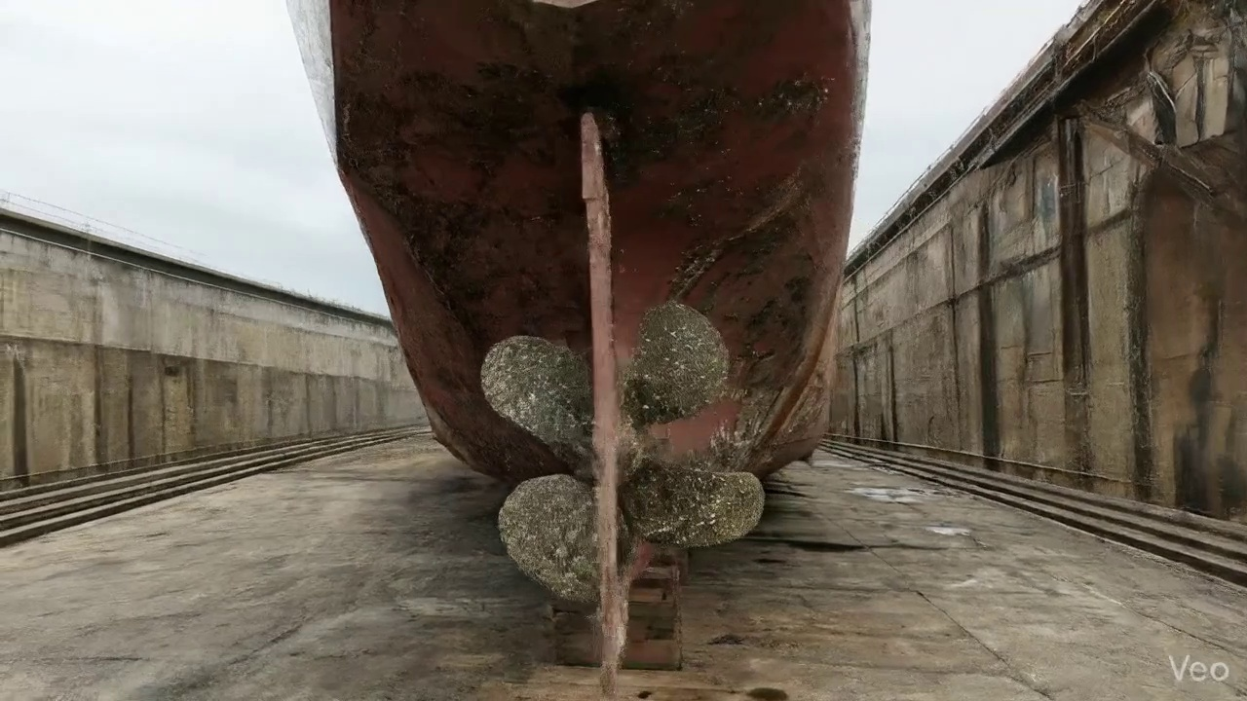

Repair Procedure
## Vessel Inspection Report: Explanation of Localized Structural Repair Process
This section details the standard procedure for localized structural repair involving plate and framing replacement, as observed in the vessel's maintenance records. The process outlined ensures the restoration of the hull's structural integrity, watertightness, and original design parameters.
---
### Detailed Explanation of Repair Steps:
**1. Assessment**
* **What happens:** Qualified personnel meticulously inspect the visibly deformed region of the hull or deck structure. This involves marking the buckled area, visually determining if the deformation is localized to a small section or spans across several structural frames, and precisely measuring any out-of-flatness using straight edges, rulers, or specialized gauges.
* **Why necessary:** This initial phase is critical for accurately defining the extent and nature of the damage. It allows for a comprehensive understanding of whether the deformation is purely cosmetic or indicative of underlying structural fatigue or damage. Accurate assessment ensures that the repair plan is appropriately scoped, preventing both undersized repairs (which could lead to premature failure) and oversized, unnecessarily costly repairs. It also informs decisions regarding material requirements and temporary support needs.
* **Safety and Structural Considerations:** A thorough assessment is paramount for structural integrity. It identifies potential stress concentrations, areas of incipient cracking, and determines if temporary shoring or support is required before cutting commences to prevent further structural collapse or instability.
**2. Preparation**
* **What happens:** All distorted or damaged steel plate, along with any buckled girders or stiffeners, is precisely cut away. This cutting extends to "sound metal," meaning material that is free from deformation, cracking, or material degradation. A minimum margin of good plate, typically equal to or greater than ¾ of the plate thickness, is maintained around the cut-out. Any bent or damaged internal framing that is not cut out is either straightened or carefully removed for subsequent replacement.
* **Why necessary:** The objective is to remove all compromised material that could harbor hidden defects, act as stress concentrators, or lead to future fatigue and failure. By cutting to sound metal, the new weld connection will be made to structurally reliable parent material, ensuring the integrity of the repair. The specified margin provides a stable, undeformed base for welding the new plate.
* **Why the required item (Cutting Torch) is used:** The **Cutting Torch (rental)** is an indispensable tool during this preparation phase. It provides the high-temperature flame necessary to quickly and efficiently cut through thick steel plates and structural members. Its use allows for precise removal of the damaged sections, preparing the edges for the new insert plate and ensuring clean, stable cut lines for subsequent fit-up and welding.
* **Safety and Structural Considerations:** This is a hot work operation, necessitating strict adherence to fire safety protocols, including a hot work permit, dedicated fire watch, and availability of fire extinguishing equipment. If the repair area is a tank or void, gas freeing and confined space entry procedures must be rigorously followed. Ensuring that damaged material is completely removed to sound metal is fundamental to preventing the propagation of existing defects and ensuring the long-term structural integrity of the repair.
**3. Plate Replacement**
* **What happens:** A new steel plate, matching or exceeding the original plate's thickness and material specification (e.g., shipbuilding steel grade A, B, D, E), is accurately fabricated to precisely fit the contours of the cut-out. This new plate is then carefully positioned against the remaining hull or deck plating. Once correctly aligned, it is secured in place with tack welds, followed by a complete weld sequence around its entire perimeter. Emphasis is placed on achieving good fusion, applying appropriate preheat (especially for thicker plates or high-tensile steels) to control cooling rates, and using full penetration welds where design and access allow, to maximize joint strength.
* **Why necessary:** This step restores the structural continuity and watertight integrity of the hull or deck. Matching or increasing the plate thickness ensures that the local strength is maintained or enhanced. Tack welds temporarily hold the plate in perfect alignment, preventing movement during the primary welding phase. Full welding with good fusion ensures a robust, continuous, and watertight connection between the new plate and the existing structure. Preheat mitigates the risk of hydrogen cracking and reduces residual stresses, particularly in thicker sections, by slowing the cooling rate of the weld metal and heat-affected zone. Full penetration welds offer the highest strength and fatigue resistance for critical structural joints.
* **Safety and Structural Considerations:** Correct material selection and traceability (e.g., mill certificates) are crucial. Welders must be qualified to relevant standards (e.g., AWS, EN ISO). Proper fit-up is essential to minimize welding stresses and prevent misalignment. Failure to achieve good fusion or adequate penetration can lead to weak points prone to cracking under operational stresses.
**4. Alignment and Welding**
* **What happens:** Subsequent weld passes are applied to build up the weld joint, typically utilizing low-hydrogen E7018 electrodes. During this process, measures are taken to control welding-induced distortion, such as strategic clamping of the plate or employing minimal heat input techniques (e.g., skip welding, back-step welding). Once welding is complete, the weld seams are ground fair and smooth with the surrounding hull or deck plating. In instances where the original buckling was extensive or the design stresses are high, additional strengthening elements like doubler plates or new stiffeners may be added to further reinforce the repaired area and distribute stresses more effectively.
* **Why necessary:** E7018 electrodes are specified due to their excellent mechanical properties, good ductility, and low hydrogen content, which reduces the risk of hydrogen-induced cracking in structural steel applications. Controlling welding distortion is vital to prevent unintended stresses, maintain the vessel's designed hydrodynamic profile, and ensure the aesthetic integrity of the structure. Grinding weld seams fair eliminates stress risers, improves fatigue life, and prepares the surface for coating application. Additional strengthening provides localized reinforcement, compensating for any potential local weakening or accommodating higher operational stresses.
* **Safety and Structural Considerations:** Welders must operate under a valid Welding Procedure Specification (WPS). Proper ventilation is required to remove welding fumes. Distortion control is critical not only for cosmetic reasons but also to prevent locked-in stresses that could lead to premature structural failure or reduced fatigue life. The quality of the completed weld bead directly impacts the long-term structural integrity and reliability of the repair.
**5. Finishing**
* **What happens:** The completed repair undergoes thorough inspection, including visual examination for surface defects and verification of weld profile. Non-Destructive Testing (NDT) methods, such as Magnetic Particle Testing (MT) or Ultrasonic Testing (UT), are employed to detect subsurface defects or lack of fusion. Following successful inspection, the new steel is prepared (e.g., abrasive blasting) and immediately coated with a marine-grade primer, followed by appropriate finish coats, to restore its corrosion protection. Finally, the repaired deck or hull surface is faired back to its original contour, ensuring smooth transitions and optimal hydrodynamic performance.
* **Why necessary:** Inspection is paramount to verify the quality and integrity of the entire repair, ensuring that no defects compromise the structural strength or watertightness. NDT provides an objective assessment of internal weld quality that visual inspection cannot reveal. Coating is essential to protect the new steel from the harsh marine environment, preventing corrosion that could rapidly degrade the repair. Fairing the surface ensures that the vessel's original hydrodynamic efficiency is maintained, preventing increased drag or turbulent flow, and also ensures aesthetic consistency.
* **Safety and Structural Considerations:** NDT ensures hidden flaws are detected before the vessel returns to service. Proper surface preparation and coating application are critical for long-term corrosion prevention, which directly impacts the structural lifespan of the repair. Any compromise in fairing could lead to increased fuel consumption or localized turbulence, potentially affecting vessel performance.
---
This meticulously executed repair process, adhering to established maritime standards and classification society rules, ensures the safe and reliable return of the affected structure to operational service.

Repair Cost Breakdown
Item | Quantity | Unit Cost | Total Cost | Currency
Cutting Torch (rental) | 0.08 | 10764.0 | 807.3 | INR
Estimated Repair Cost: 41583.53 INR

3.3 PD_3

Defect Overview
Here is a professional explanation of the defect "DEFORMATION" for a vessel inspection report:
---
**Defect Name:** DEFORMATION
**Severity:** Medium
**Explanation:**
1. **What the defect means:**
Deformation, specifically categorized as buckling or warping, refers to an out-of-plane bending or distortion of the vessel's structural components, such as hull plating or stiffeners. Unlike a simple dent, deformation involves a significant change in the original geometric shape, moving the affected material out of its intended plane. In this specific instance, a deformation is observed in the vicinity of the Rudder Area. Common causes for such deformation include severe impact from groundings, excessive stress from heavy sea loads, or localized thermal stress induced by welding processes.
2. **Why it is important:**
This defect is important because even moderate levels of buckling or warping can severely impair the overall hull girder strength, which is fundamental to the vessel's structural integrity. The hull girder functions as the primary beam of the ship, designed to withstand global bending moments and shear forces. Any compromise to its shape directly reduces its load-carrying capacity and resistance to these forces. Classification societies consider significant buckling a serious defect requiring corrective action due to its direct impact on vessel safety and seaworthiness. The assigned 'medium' severity indicates that while not immediately critical, the condition warrants planned and thorough rectification to prevent escalation and ensure compliance.
3. **Risks if not repaired:**
If left unaddressed, the deformation poses several significant risks:
* **Progressive Failure:** The buckled area becomes a point of weakness. Under continued operational stresses (e.g., further heavy weather, maneuvering loads, cargo operations), the deformation can worsen, potentially leading to progressive structural failure in the affected plating and adjacent stiffeners.
* **Reduced Structural Reliability:** The compromised strength reduces the vessel's ability to safely withstand its design loads, increasing the risk of structural collapse or fracturing during severe conditions.
* **Fatigue Cracking:** The sharp geometric changes and localized stress concentrations associated with deformation can accelerate fatigue crack initiation and propagation in the affected metal and surrounding structures.
* **Loss of Watertight Integrity:** In extreme cases, severe deformation can lead to cracking, potentially compromising the watertight or weathertight integrity of compartments, leading to water ingress.
* **Operational Limitations & Regulatory Actions:** Failure to correct significant deformation can lead to operational restrictions imposed by the vessel's management, classification society, or Port State Control, potentially resulting in detentions, withdrawal of class certificates, and severe financial implications.
4. **Structural implications:**
The primary structural implication of deformation is a substantial reduction in both the local and global strength and stiffness of the affected structure.
* **Load-Carrying Capacity:** Buckled plating or stiffeners can no longer efficiently carry their intended compressive or shear loads. This forces a redistribution of stresses to adjacent, often undamaged, structural members, potentially overstressing them beyond their design limits.
* **Stress Concentration:** The abrupt changes in geometry at the edges of the deformed area create severe stress concentration points. These areas are significantly more susceptible to brittle fracture or fatigue failure under dynamic loading.
* **Reduced Ultimate Strength:** The presence of deformation diminishes the vessel's ultimate load-carrying capacity, meaning it can withstand less force before structural failure occurs, thereby eroding the safety margins inherent in its design.
* **Localised Impact on Rudder Area:** While the overlap is small, any deformation near the Rudder Area, a critical maneuvering component, warrants particular attention. Even minor changes could potentially affect the local stress distribution around rudder supports or compromise the hydrodynamic flow, although direct impact on the rudder mechanism itself is less likely with minor overlap.
* **Remedial Action:** As per standard classification practice, significant buckles necessitate renewal. This involves cutting out the distorted metal and replacing it with new plating and/or stiffeners to fully restore the original structural integrity and design margins of the hull.

Visual Evidence
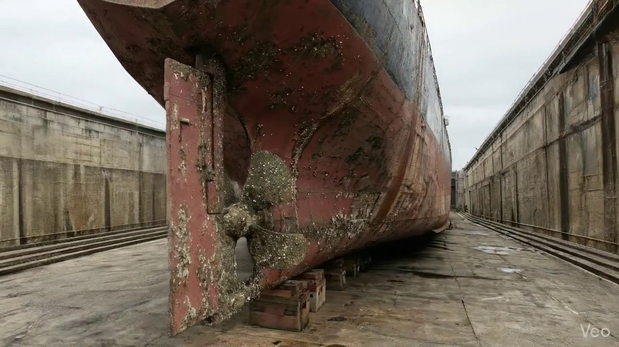

Repair Procedure
## Vessel Inspection Report: Deformed Hull Plate Repair Process
**Executive Summary:** This report details the standard operating procedure for the repair of deformed hull plating, including underlying structural members, as observed on [Vessel Name/Location - if known, otherwise omit]. The process emphasizes restoration of structural integrity, watertight/weathertight boundaries, and compliance with classification society requirements.
---
### Detailed Repair Process Explanation:
#### 1. Assessment
* **Why Necessary:** This initial phase is critical for accurately defining the scope of damage, determining the appropriate repair methodology, and ensuring that all affected areas, both visible and latent, are identified. It prevents under-scoping the repair, which could lead to premature failure or recurrence of damage.
* **What Happens:** A thorough visual inspection is conducted to identify and mark the precise boundaries of the buckled or deformed region. This includes examining the adjacent structure (frames, girders, stiffeners) to ascertain if the deformation is localized or extends further, potentially impacting multiple structural elements. Out-of-flatness measurements are taken to quantify the severity of the distortion.
* **Why Required Items Are Used:** No specific items are listed for this stage, however, standard inspection tools such as measuring tapes, straight edges, chalk or paint markers, and possibly optical survey equipment would be employed to accurately document the extent and nature of the damage.
* **Safety and Structural Considerations:** Accurate assessment directly impacts structural safety. Misjudging the extent of damage can compromise the vessel's overall strength and stability. Personnel safety during assessment involves ensuring stable access to the damaged area.
#### 2. Preparation
* **Why Necessary:** This step is fundamental to ensuring the quality and longevity of the repair. It removes all compromised material, including fatigued, cracked, or excessively thinned sections, creating a clean, sound base for new welding. Leaving a margin of good plate ensures that the new weld is not initiated on weakened or micro-damaged material.
* **What Happens:** All distorted hull plate material, along with any buckled or bent girders or stiffeners, is precisely cut away. The cutting extends into sound, undamaged metal, leaving a minimum margin of good plate equal to or greater than ¾ of the plate thickness (e.g., for a 12mm plate, at least 9mm margin). Any remaining bent framing is either carefully straightened using controlled heating and mechanical means or entirely removed and replaced.
* **Why Required Items Are Used:** The **Cutting Torch (rental)** is the primary tool used at this stage. It allows for efficient and precise removal of the damaged steel plate and structural members. The rental aspect indicates it is acquired as needed for specific repair operations.
* **Safety and Structural Considerations:** Proper execution of this step is vital for structural integrity. Incomplete removal of damaged material will lead to stress concentrations and potential re-initiation of cracks. Safety precautions during cutting include fire watch, proper ventilation, personal protective equipment (PPE) such as welding helmets, gloves, and flame-retardant clothing, and ensuring no flammable materials are in the vicinity.
#### 3. Plate Replacement
* **Why Necessary:** This stage restores the physical integrity and intended load-bearing capacity of the hull or deck. The new plate acts as a structural component, re-establishing the watertight/weathertight boundary and contributing to the vessel's overall strength.
* **What Happens:** A new steel plate, matching or exceeding the original specification (in terms of grade and thickness), is fabricated to the exact dimensions and contour required to fit the prepared cut-out. This new plate is then accurately positioned against the remaining hull plating. It is initially secured with tack welds to hold it in place and ensure correct alignment, followed by complete welding all around its perimeter. Emphasis is placed on achieving good fusion with the parent material and applying appropriate preheat to manage thermal stresses and prevent hydrogen-induced cracking. Full penetration welds are utilized where design and accessibility permit, to maximize weld strength.
* **Why Required Items Are Used:** While not explicitly listed as a 'required item', welding machines, electrodes (specifically E7018 as mentioned later), and tools for fitting and clamping are essential. The preheat process requires specialized heating equipment (e.g., induction heaters, propane torches with temperature monitoring).
* **Safety and Structural Considerations:** Material traceability for the new plate is crucial to ensure it meets classification society requirements. Proper preheat and controlled welding parameters prevent metallurgical defects. Inadequate fit-up or poor fusion can create stress risers and areas of weakness, compromising the structural integrity of the repair. Welder qualifications are paramount.
#### 4. Alignment and Welding
* **Why Necessary:** This stage builds upon the plate replacement by completing the robust structural connection and ensuring the final repair is fair and free from detrimental residual stresses. The choice of welding consumables and techniques directly impacts the mechanical properties and service life of the repair.
* **What Happens:** Continuous weld passes are applied using low-hydrogen electrodes, specifically E7018, known for their excellent mechanical properties and resistance to hydrogen embrittlement. Throughout the welding process, diligent monitoring for potential distortion is maintained. Should distortion occur, mitigation techniques such as strong-backs, clamps, or controlled, minimal heat input welding sequences are employed to maintain the intended hull contour. Upon completion of welding, the weld seams are meticulously ground fair with the surrounding hull plating to eliminate stress concentrations and ensure a smooth hydrodynamic surface. In instances of extensive buckling that may have induced significant residual stresses in the surrounding structure, additional strengthening measures such as doubler plates or supplementary stiffeners may be incorporated to enhance local structural resilience.
* **Why Required Items Are Used:** E7018 electrodes are critical consumables. Grinding equipment (angle grinders) is used to fair the welds. Clamps and strong-backs are utilized for distortion control.
* **Safety and Structural Considerations:** Use of E7018 electrodes is a critical measure against hydrogen cracking, enhancing the long-term integrity of the weld. Controlling distortion prevents the introduction of new stress points or changes to the vessel's lines. Grinding welds fair removes potential fatigue initiation points. Any additional strengthening must be designed and implemented in accordance with approved repair specifications to ensure uniform load distribution and avoid creating new stress concentrators. Personnel must use appropriate respiratory protection during grinding and welding.
#### 5. Finishing
* **Why Necessary:** This final step verifies the quality of the repair, restores the vessel's protective coatings, and ensures the repaired area is aesthetically and hydrodynamically integrated with the rest of the hull or deck.
* **What Happens:** A comprehensive inspection of the completed repair is conducted. This includes visual examination for surface defects, as well as Non-Destructive Testing (NDT) methods such as ultrasonic testing (UT) for internal weld soundness and magnetic particle inspection (MPI) for surface and near-surface discontinuities. Once the repair passes inspection, the new steel surface is thoroughly cleaned and prepared for coating. An approved marine primer is applied, followed by appropriate finish coats, restoring the critical corrosion protection system. Finally, the repaired deck or hull surface is faired back to its original contour, ensuring smooth lines and minimizing hydrodynamic drag.
* **Why Required Items Are Used:** NDT equipment (e.g., UT probes, MPI yoke), painting equipment (sprayers, rollers), and quality control tools (e.g., thickness gauges for coating) are necessary.
* **Safety and Structural Considerations:** NDT confirms the internal integrity of the weld, providing assurance that no hidden defects compromise the repair. The application of proper coatings is essential for corrosion prevention, which directly impacts the long-term structural integrity of the new plate. Fairing the surface prevents localized turbulence and potential erosion, contributing to the vessel's operational efficiency and longevity. Environmental regulations regarding paint application and waste disposal must be strictly adhered to.

Repair Cost Breakdown
Item | Quantity | Unit Cost | Total Cost | Currency
Cutting Torch (rental) | 0.08 | 10764.0 | 807.3 | INR
Estimated Repair Cost: 41583.53 INR

3.4 PD_4

Defect Overview
**Defect Explanation: DEFORMATION**
**1. What the defect means:**
Deformation, specifically referring to buckling or warping, indicates an out-of-plane bending or distortion of a vessel's hull plating or structural stiffeners (such as frames, longitudinals, or girders). This means the affected metal is no longer flat or straight as designed but has acquired a visible curve or ripple. It can be caused by significant external forces like grounding impacts, excessive heavy weather loading, or localized heat stress introduced during welding operations. While minor, localized "set-in" plating may occasionally be tolerated if very small and without sharp kinks, significant and pronounced out-of-plane displacement constitutes a deformation that requires attention.
**2. Why it is important:**
This defect is of high severity because it directly and significantly impairs the hull girder strength of the vessel. The hull girder acts as the primary structural beam of the ship, responsible for resisting global bending, shear, and torsional forces. Even moderate buckles can severely compromise this fundamental strength, reducing the vessel's overall ability to withstand the stresses encountered during normal operations and in adverse conditions. Classification societies explicitly mandate the correction of significant deformation due to its critical impact on a vessel's seaworthiness and fundamental structural integrity.
**3. Risks if not repaired:**
Failure to repair significant deformation carries substantial risks:
* **Structural Failure:** The weakened area is highly susceptible to further damage or catastrophic failure under dynamic loads (e.g., in heavy seas), potentially leading to progressive structural collapse.
* **Fatigue Cracking:** The deformed areas create stress concentrations, acting as initiation points for fatigue cracks, which can propagate over time and lead to brittle fracture.
* **Loss of Watertight Integrity:** If the deformation occurs on the external hull plating or bulkheads, it can compromise the watertight integrity, leading to water ingress into compartments, affecting buoyancy, stability, and potentially cargo.
* **Operational Restrictions & Detention:** Vessels with unrepaired significant deformation may face operational restrictions, be detained by Port State Control, or have their classification and insurance coverage invalidated, leading to severe commercial and regulatory penalties.
* **Loss of Vessel and Lives:** In extreme cases, unchecked and progressive deformation can lead to catastrophic hull failure, posing an imminent threat to the vessel, cargo, and all personnel onboard.
**4. Structural implications:**
The structural implications of deformation are profound and affect both local components and the overall hull girder:
* **Reduced Section Modulus:** Buckled plating loses its effective cross-sectional area and moment of inertia, significantly reducing its contribution to the overall hull girder's section modulus – a key indicator of its bending strength.
* **Loss of Stiffener Effectiveness:** Deformed stiffeners (frames, longitudinals) lose their designed rigidity and compressive strength. They become ineffective in supporting the plating, distributing loads, and resisting compressive forces, essentially failing to perform their intended structural role.
* **Compromised Hull Girder Strength:** The collective weakening of plating and stiffeners directly diminishes the hull girder's ability to resist global bending moments (hogging and sagging), torsional forces, and shear forces experienced by the vessel. This reduces the vessel's factor of safety against structural collapse.
* **Stress Redistribution and Concentration:** Deformation causes an uneven redistribution of stresses within the structure, leading to areas of high-stress concentration around the buckles. These localized stress peaks can exceed the material's yield strength, initiating plastic deformation or fracture.
* **Reduced Redundancy:** The affected structural elements can no longer effectively share the load, reducing the structure's inherent redundancy and making it more vulnerable to a single point of failure.
Classification practice explicitly requires the correction of significant buckling by cutting out and replacing the distorted metal to restore the original structural integrity and design strength.

Visual Evidence
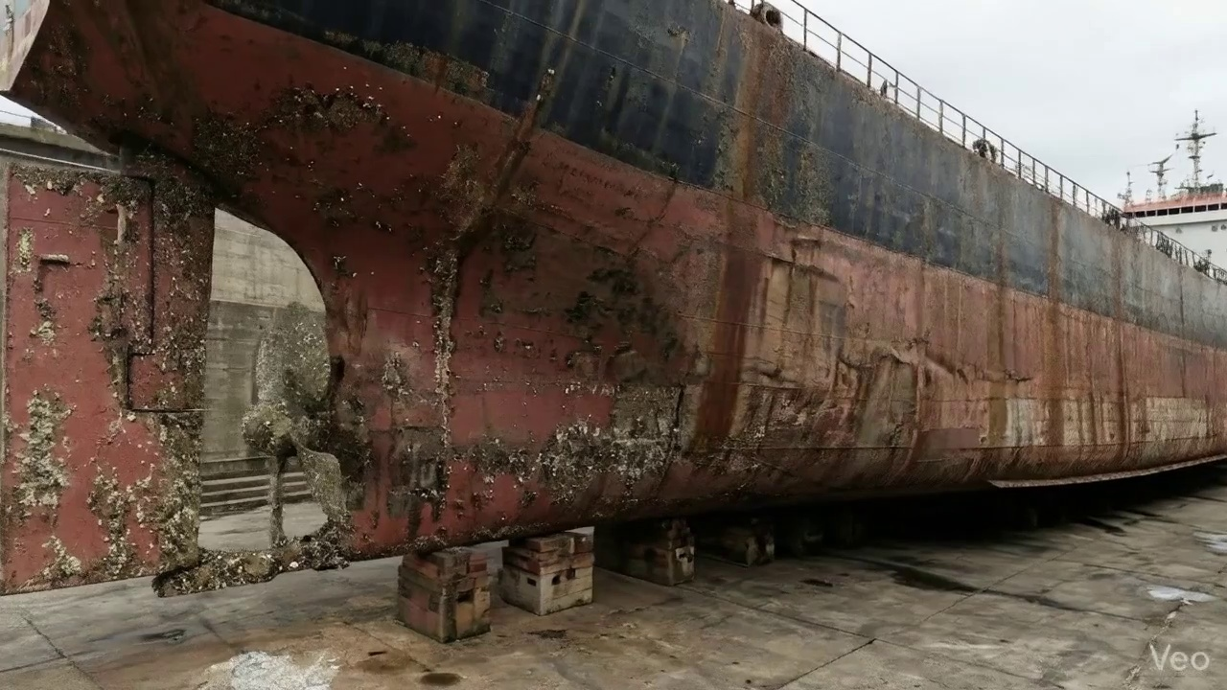

Repair Procedure
## Maritime Structural Steel Repair Protocol: Localized Hull Deformity
This section details the established procedure for rectifying localized steel hull deformities, ensuring the restoration of structural integrity and seaworthiness as part of the vessel's ongoing maintenance and class compliance.
---
### **Overview of Repair Process**
The repair process systematically addresses the assessment, removal of damaged material, fabrication and installation of new plating, and final inspection to restore the original structural design and protective coatings.
---
### **Detailed Explanation of Repair Steps:**
**1. Assessment**
* **Why Necessary:** This initial phase is paramount for accurately defining the scope of damage. It prevents insufficient repair (leaving compromised material) or excessive repair (unnecessary removal of sound structure). A thorough assessment ensures all affected areas are identified, preventing future reoccurrence or propagation of damage from unaddressed stresses.
* **What Happens:** Skilled technicians meticulously inspect the deformed region. This involves visual examination to identify the extent of buckling, deformation, and potential cracks. The buckled area is clearly marked, and a determination is made whether the damage is localized to a single plate section or extends to adjacent structural members such as frames, girders, or stiffeners. Precise measurements of any out-of-flatness are taken using tools like straight edges, feeler gauges, or laser alignment systems to quantify the deformation.
* **Safety and Structural Considerations:** Accurate assessment is critical for structural integrity, as it informs the repair strategy. Misjudging the extent of damage could lead to a repair that fails to adequately restore the vessel's strength, potentially compromising its structural safety at sea.
**2. Preparation**
* **Why Necessary:** This step is crucial for creating a sound base for the new steel plate. Welding new material to distorted, stressed, or fatigued metal will result in a weak, unreliable joint prone to premature failure. Removing all compromised material ensures that the subsequent welding operation achieves optimal fusion and strength. The specified margin (≥¾ thickness) ensures the cut is into undisputed sound material, providing a robust edge for welding. Straightening or removing bent framing ensures the correct geometry and support for the new plate.
* **What Happens:** Using thermal cutting equipment, all visibly distorted plate material, along with any buckled or damaged internal girders or stiffeners, are carefully cut away. The cutting continues until sound, unaffected metal is reached, leaving a clean, bevelled edge of sufficient margin. Simultaneously, any adjacent framing that has been bent or deformed is either carefully heated and straightened to its original alignment or completely removed and replaced if irreparable.
* **Required Items: Cutting Torch (rental)**
* **Why Used:** The cutting torch is an indispensable tool in this phase. It provides the necessary thermal energy to efficiently and precisely sever and remove damaged steel plate and structural members. Its high heat output allows for quick cutting through various steel thicknesses, significantly expediting the preparation stage. The "rental" aspect suggests it's a specialized tool not in constant use, procured on-demand for specific repair projects.
* **Safety and Structural Considerations:** Hot work procedures are paramount, requiring fire watch, combustible material removal, and adequate ventilation to mitigate fire and fume hazards. Structural integrity is improved by ensuring only sound metal remains for the new weld, preventing residual stresses from propagating into the repair.
**3. Plate Replacement**
* **Why Necessary:** This step directly restores the primary structural barrier and hydrodynamic surface of the vessel. Fabricating a new plate to precisely fit the cut-out ensures that the original hull contour and structural continuity are re-established. Tack-welding temporarily secures the plate in position, allowing for final adjustments before full welding commences. Full penetration welds and appropriate preheat are critical to achieving a weld joint that matches or exceeds the strength and fatigue resistance of the original hull material, especially important in high-stress areas or for classification society requirements. Preheat mitigates thermal stress and reduces the risk of hydrogen-induced cracking.
* **What Happens:** A new steel plate, identical in grade and typically of the same or greater thickness as the original, is fabricated. This involves marking, cutting, and often forming (rolling or pressing) the plate to the exact dimensions and curvature required to fit seamlessly into the prepared cut-out. The fabricated plate is then carefully positioned against the remaining hull plating, ensuring correct alignment. It is then tack-welded at intervals to hold it securely in place, followed by initial full weld passes around the entire perimeter, focusing on achieving good fusion.
* **Safety and Structural Considerations:** The quality of the new plate material and its fit are fundamental to restoring structural integrity. Poor fit-up or inadequate tack welds can introduce stresses, while improper welding (lack of fusion, porosity) creates weak points susceptible to failure. Proper preheating is essential, particularly for thicker steels or in cold conditions, to prevent brittle fracture and ensure a robust weld.
**4. Alignment and Welding**
* **Why Necessary:** This is the core structural re-establishment phase. Applying continuous weld passes builds up the joint to its required strength. The use of E7018 electrodes is critical due to their low-hydrogen content, excellent mechanical properties, and ability to produce high-quality, crack-resistant welds suitable for marine applications and thicker sections. Managing welding-induced distortion is vital to maintain the vessel's designed geometry and prevent the introduction of new stress points. Grinding the weld seams fair improves hydrodynamic performance, prevents localized stress concentrations, and improves resistance to fatigue. Additional strengthening addresses underlying structural weaknesses that may have contributed to the original buckling.
* **What Happens:** Following tack-welding and initial passes, continuous weld passes are systematically applied using E7018 low-hydrogen electrodes. Welding parameters (current, voltage, travel speed) are carefully controlled. If thermal stresses from welding cause distortion, techniques such as sequential welding, skip welding, or the application of clamps and strongbacks are employed to maintain alignment. Upon completion of welding, the weld seams are meticulously ground smooth and fair with the surrounding hull plating to eliminate stress risers and ensure a smooth surface. In situations where the original buckling was extensive or indicates an area of high stress, additional strengthening, such as doublers (plates welded over a larger area) or stiffeners, may be designed and applied to enhance structural resilience.
* **Safety and Structural Considerations:** Welding operations pose significant hazards including electric shock, fumes, arc flash, and fire. Proper PPE, ventilation, and hot work permits are mandatory. Structurally, the integrity of the repair hinges on the quality of these final welds. E7018 electrodes are chosen to minimize the risk of hydrogen-induced cracking, crucial for long-term structural reliability. Proper distortion control prevents residual stresses that could lead to premature fatigue or buckling elsewhere.
**5. Finishing**
* **Why Necessary:** This final stage ensures that the repair is structurally sound, protected from the marine environment, and aesthetically and hydrodynamically integrated with the rest of the hull. Inspection (visual and NDT) provides objective verification of weld quality, assuring compliance with classification society rules and owner requirements. Coating application restores essential corrosion protection, crucial for the longevity of the steel structure. Fairing the surface minimizes drag and prevents turbulence.
* **What Happens:** The completed repair undergoes rigorous inspection. This includes comprehensive visual inspection for surface defects, proper weld profile, and alignment. Non-Destructive Testing (NDT) methods, such as Ultrasonic Testing (UT) for internal defects or Magnetic Particle Inspection (MPI) for surface cracks, are typically employed to verify the integrity of the weld. Once approved, the new steel is thoroughly cleaned, prepared, and coated with a suitable marine primer, followed by subsequent finish coats, restoring the vessel's protective paint system. Finally, the deck or hull surface is ensured to be faired back to its original contour, often involving additional grinding or fairing compound application, to maintain design performance.
* **Safety and Structural Considerations:** NDT methods are paramount for confirming the structural integrity of the internal weld, identifying any hidden defects that could compromise the repair. The paint system provides vital corrosion protection, preventing the degradation of the new steel in the harsh marine environment. Improper coating application can lead to premature corrosion and require further costly repairs. Confined space entry procedures may be required for internal coating work, necessitating gas detection and ventilation protocols.

Repair Cost Breakdown
Item | Quantity | Unit Cost | Total Cost | Currency
Cutting Torch (rental) | 0.12 | 10764.0 | 1345.5 | INR
Estimated Repair Cost: 69305.88 INR

3.5 PD_5

Defect Overview
**Defect Name:** DEFORMATION
**Severity:** High
---
**1. What the defect means:**
Deformation, specifically manifesting as buckling or warping, refers to an out-of-plane bending or distortion of structural components. This means the affected material is no longer flat or aligned as designed, exhibiting a wave-like or collapsed form rather than simply a dent or indentation. In this instance, the deformation affects both the **HULL_AREA** and the **RUDDER_AREA**. Such defects are commonly caused by significant external forces, such as grounding impacts or heavy sea loads, or by internal stresses introduced during construction or repair, such as uneven welding heat.
**2. Why it is important:**
The presence of deformation, particularly categorized as high severity, is critically important because even moderate buckles can severely impair the structural integrity and strength of the vessel. The hull and rudder are primary structural elements, and any significant deviation from their designed geometry directly compromises their ability to withstand operational stresses. This defect indicates a fundamental compromise in the vessel's physical strength, impacting its seaworthiness and safety. The specified classification practice of cutting out and replacing distorted metal underscores the non-tolerable nature of significant deformation.
**3. Risks if not repaired:**
Failure to address significant deformation carries several high risks:
* **Reduced Hull Girder Strength:** The primary risk is a substantial reduction in the vessel's longitudinal and transverse hull girder strength. This compromises the vessel's ability to resist global bending moments and shear forces encountered during normal operations and adverse weather, increasing the risk of catastrophic structural failure.
* **Progressive Damage and Fatigue:** Deformed plating and stiffeners act as stress concentration points. These areas are prone to developing fatigue cracks prematurely, which can propagate rapidly under cyclic loading, leading to further buckling, tearing, or even a breach of watertight boundaries.
* **Compromised Watertight Integrity:** Severe deformation in the **HULL_AREA** can distort watertight bulkheads or tank boundaries, potentially leading to ingress of water, loss of buoyancy, and stability issues, particularly in damaged conditions.
* **Impaired Rudder Performance and Failure:** Deformation in the **RUDDER_AREA** can significantly impair its hydrodynamic efficiency, leading to sluggish or unpredictable steering response. More critically, it can weaken the rudder structure itself or its connection points (e.g., rudder stock, pintles), increasing the risk of structural failure of the rudder system under maneuvering loads.
* **Operational Restrictions and Classification Non-Compliance:** Unrepaired deformation of this severity will lead to severe operational restrictions, potential detentions by port state control, and non-compliance with classification society rules, severely impacting the vessel's ability to trade.
**4. Structural implications:**
Structurally, deformation signifies a local and potentially global failure of the affected elements to withstand applied loads within their elastic limits. The key implications are:
* **Loss of Section Modulus and Moment of Inertia:** Buckling effectively reduces the designed cross-sectional area and moment of inertia of the affected plates and stiffeners. This directly diminishes their capacity to resist bending moments and shear forces, which are fundamental properties governing a structure's resistance to deformation and failure.
* **Stress Redistribution and Concentration:** The distorted geometry forces a redistribution of stresses away from the deformed area, but often creates highly localized stress concentrations at the edges or apexes of the buckles. These points become critical failure locations for crack initiation.
* **Compromised Global Strength:** For the **HULL_AREA**, when main deck, bottom, side shell plating, or their associated stiffeners buckle, their contribution to the overall longitudinal strength of the vessel (the hull girder) is severely reduced. This directly compromises the vessel's ability to act as a single, rigid beam in response to global sea loads.
* **Reduced Local Stiffness:** The deformed structure becomes significantly less rigid. This allows for greater deflection under load and can lead to a cascade of further damage to adjacent or connected components.
* **Rudder Structural Integrity:** For the **RUDDER_AREA**, deformation compromises the designed airfoil shape crucial for generating lift and control. It also introduces eccentric loading on the rudder stock and pintles, potentially accelerating wear, fatigue, or leading to structural failure of the steering system components.

Visual Evidence
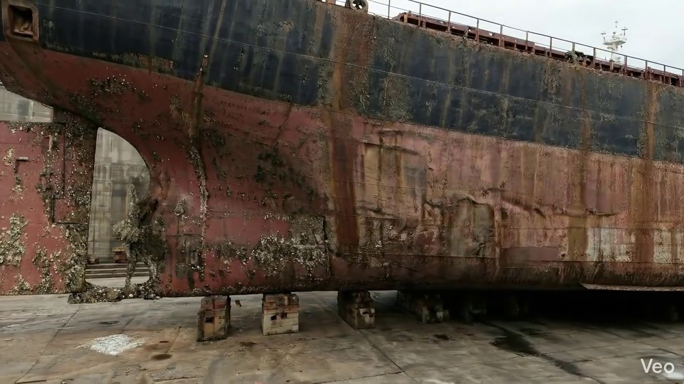

Repair Procedure
**Vessel Inspection Report: Explanation of Maritime Steel Repair Process**
This section provides a professional explanation of the specified maritime steel repair process, detailing the necessity of each step, the actions undertaken, the rationale for equipment usage, and critical safety and structural considerations. The repair aims to restore the vessel's structural integrity, watertight/oiltight boundaries, and corrosion protection following damage such as buckling or deformation.
---
**1. Overall Repair Philosophy:**
The fundamental principle of this repair process is to accurately assess the extent of damage, surgically remove all compromised material, replace it with new, fit-for-purpose steel, and integrate this new material seamlessly into the existing structure to meet or exceed original design specifications.
**2. Explanation of Each Repair Step:**
* **Assessment:**
* **Why Necessary:** This initial phase is crucial for accurately defining the scope and nature of the damage. Without a thorough assessment, there is a risk of either under-repairing (leaving compromised material) or over-repairing (unnecessary work), both of which are inefficient and potentially unsafe. It guides subsequent planning, material selection, and resource allocation.
* **What Happens:** Skilled personnel visually inspect the deformed region. They mark the precise boundaries of the buckled area and determine if the damage is localized to a single plate or propagates across multiple structural frames (girders, stiffeners). Measurements are taken to quantify any "out-of-flatness," providing a baseline for repair and ensuring the original contour can be restored.
* **Preparation:**
* **Why Necessary:** This step ensures that all fatigued, cracked, or excessively distorted material, which would compromise the integrity of new welds, is completely removed. By cutting to "sound metal" and leaving a margin of good plate (typically ≥¾ of the plate thickness), a stable, strong foundation is created for the new weld, minimizing the risk of welding-induced defects or premature failure of the repair.
* **What Happens:** Using thermal cutting equipment, all distorted plate material, along with any buckled or compromised internal girders or stiffeners, is precisely cut away. Any adjacent framing that is bent but not severely damaged may be straightened to its original alignment; otherwise, it is also removed. The cut edges are prepared (e.g., beveled) as per welding procedure specifications to ensure optimal weld penetration.
* **Plate Replacement:**
* **Why Necessary:** This step physically restores the structural continuity and, where applicable, the watertight or oiltight integrity of the vessel's hull or deck. The new plate must match or exceed the original's strength and physical properties to maintain structural equivalence.
* **What Happens:** A new steel plate, fabricated to the exact dimensions and contour of the removed section and typically of the same or greater thickness, is prepared. This new plate is then carefully positioned against the remaining sound hull plating. It is initially secured in place with tack welds to maintain alignment, followed by complete welding around its perimeter. Critical attention is paid to achieving good fusion between the new and existing material, and appropriate preheat (if required by the material or environmental conditions) is applied to prevent hydrogen cracking. Full penetration welds are employed wherever structurally feasible to maximize strength.
* **Alignment and Welding:**
* **Why Necessary:** This phase completes the metallurgical bond and integrates the new plate into the vessel's structure. Proper welding techniques and distortion control are paramount to prevent new structural weaknesses or cosmetic deficiencies. Grinding ensures a smooth transition, reducing stress concentrations and improving fatigue life.
* **What Happens:** Continuous weld passes are applied, typically utilizing E7018 low-hydrogen electrodes known for their excellent mechanical properties and resistance to cracking, especially in structural applications. Throughout the welding process, diligent monitoring for heat-induced distortion is conducted. If distortion occurs, it is managed through the use of clamps, strongbacks, or controlled, minimal heat input welding sequences. Once welding is complete, all weld seams are ground fair and smooth with the surrounding hull or deck surface to restore the original contour and reduce hydrodynamic drag or localized stress points. In cases where the initial buckling was extensive, additional strengthening (e.g., doubler plates or supplementary stiffeners) may be strategically applied to redistribute stress and enhance local structural rigidity.
* **Finishing:**
* **Why Necessary:** The final step verifies the quality of the repair, protects the newly exposed steel from environmental degradation, and restores the vessel's exterior or interior to its operational standard.
* **What Happens:** A comprehensive inspection of the repair is performed. This includes visual inspection for surface defects, proper weld profile, and alignment. This is typically augmented by Non-Destructive Testing (NDT) methods (e.g., Magnetic Particle Testing, Dye Penetrant Testing, Ultrasonic Testing, or Radiography) to detect any subsurface defects. Following successful inspection, the new steel surface is thoroughly cleaned and prepared. Primer coats are applied to provide initial corrosion protection, followed by final finish coats to match the surrounding structure and provide long-term resistance to corrosion and abrasion. The deck or hull surface is meticulously faired back to its original contour, ensuring structural and hydrodynamic efficiency.
**3. Why the Required Items are Used:**
* **Cutting Torch (rental):**
* **Why Used:** The cutting torch is a fundamental tool for the "Preparation" phase of the repair. It provides an efficient and precise method for thermally cutting away the distorted and compromised plate material, as well as any buckled girders or stiffeners, down to sound metal. It is also used for shaping and beveling the edges of the new replacement plate. Its rental indicates it's a specialized tool not always owned but necessary for the specific task of metal removal and preparation. The quantity of 0.12 machine-days suggests it's required for a relatively short but critical duration per square meter of repair area.
**4. Safety and Structural Considerations:**
* **Structural Integrity:**
* **Material Selection:** New steel must be of equivalent or superior grade and thickness to the original material to maintain design strength.
* **Weld Quality:** Full penetration welds, good fusion, proper preheat/post-weld heat treatment (if applicable), and the use of low-hydrogen electrodes (e.g., E7018) are critical to prevent cracking and ensure the weld is as strong as the parent material.
* **Distortion Control:** Managing heat input and using strongbacks/clamps are vital to prevent new buckles or residual stresses that could compromise the structure's integrity or lead to future fatigue issues.
* **Fatigue Life:** Grinding welds fair reduces stress concentrations, which is crucial for components subject to cyclic loading, thereby extending the fatigue life of the repair.
* **Reinforcement:** The consideration of doublers or stiffeners for extensive buckling demonstrates a proactive approach to prevent re-occurrence of damage by enhancing local strength where stress concentrations might be higher.
* **Safety:**
* **Hot Work Permits:** All cutting and welding activities constitute hot work and require strict adherence to hot work permit procedures, including fire watches and appropriate fire suppression equipment.
* **Personal Protective Equipment (PPE):** Welders and cutters must wear appropriate PPE, including welding helmets, flame-retardant clothing, gloves, safety shoes, and eye/ear protection.
* **Ventilation:** Adequate ventilation is paramount during welding and cutting to prevent the accumulation of hazardous fumes and gases in confined spaces.
* **Confined Space Entry:** If the repair takes place in a confined space, strict confined space entry procedures must be followed, including gas testing and attendant standby.
* **Lifting and Rigging:** The handling and positioning of large steel plates require proper lifting gear, trained personnel, and adherence to safe rigging practices to prevent injuries.
* **Electrical Safety:** Welding equipment must be properly maintained, insulated, and grounded to prevent electrical shock.
---
This detailed explanation provides a comprehensive overview of the maritime steel repair process, ensuring that the repair is not only effective but also performed safely and in full compliance with structural integrity requirements.

Repair Cost Breakdown
Item | Quantity | Unit Cost | Total Cost | Currency
Cutting Torch (rental) | 0.12 | 10764.0 | 1345.5 | INR
Estimated Repair Cost: 69305.88 INR

3.6 PD_6

Defect Overview
**Defect: DEFORMATION**
**Severity: High**
This defect refers to **DEFORMATION** observed as either buckling or warping of the vessel's hull plating and/or its supporting stiffeners. This condition represents an out-of-plane bending or distortion from the original designed profile.
Here's a detailed explanation:
---
**1. What the defect means:**
Deformation, in the context of a vessel's structure, signifies a physical change in the shape of the hull plating or stiffeners, causing them to deviate from their intended flat or straight configuration. This manifests as either:
* **Buckling:** A sudden, often visible, out-of-plane bending or crumpling, typically under compressive loads.
* **Warping:** A more generalized distortion or twisting, often caused by uneven heating and cooling stresses (e.g., during welding) or prolonged uneven loading.
The provided information indicates these are not minor deflections but significant distortions that affect the structural integrity. Common causes include direct impacts such as grounding, excessive external forces from heavy sea loads, or internal stresses generated by welding heat.
**2. Why it is important:**
This defect is critically important and rated with **high severity** because it directly compromises the structural integrity and load-bearing capacity of the vessel. The hull plating and stiffeners are primary components of the hull girder, which acts as the main longitudinal strength member of the ship. Even moderate instances of buckling or warping can severely impair the hull girder strength, reducing its ability to withstand operational stresses. Its presence in the 'HULL_AREA' further emphasizes its significance, as this is the vessel's primary structural shell.
**3. Risks if not repaired:**
Failure to promptly and adequately repair significant deformation carries substantial risks, including:
* **Reduced Seaworthiness:** The vessel's ability to safely navigate and withstand normal sea conditions is compromised.
* **Increased Vulnerability to Damage:** The weakened structure becomes more susceptible to further deformation, cracking, or catastrophic failure under design loads, heavy weather, or subsequent impacts.
* **Progressive Failure:** The distorted areas can lead to stress concentrations, potentially causing adjacent structural members to yield or fail prematurely.
* **Compromised Watertight Integrity:** Severe deformation, especially in plating, can lead to cracking, which could breach the watertight envelope, leading to flooding.
* **Classification Non-Compliance:** Such significant structural defects are generally not tolerated by classification societies, leading to potential operational restrictions or detentions until repairs are completed.
**4. Structural implications:**
The structural implications of deformation are profound and directly impact the vessel's overall strength and safety:
* **Loss of Hull Girder Strength:** The hull girder relies on the collective strength and stiffness of its plating and stiffeners to resist global bending moments (hogging and sagging) and shear forces. Buckling significantly reduces the effective cross-sectional area and moment of inertia of these components, thereby diminishing the vessel's longitudinal strength.
* **Reduced Local Stiffness and Stability:** The distorted plating and stiffeners lose their ability to effectively resist local loads, leading to further deformation under less severe conditions than they were designed for.
* **Uneven Stress Distribution:** The presence of a buckle or warp alters the intended load path, concentrating stresses in surrounding, potentially unaffected, areas. This can overstress these areas, leading to fatigue cracks or premature yielding.
* **Compromised Structural Redundancy:** In a well-designed structure, there is a degree of redundancy. Deformation reduces this redundancy, meaning the failure of one component has a more critical impact on the entire structure.
* **Mandated Renewal:** Classification practice mandates that significant buckling requires renewal, typically by cutting out and replacing the distorted metal. This highlights that the structural integrity cannot be restored by simple fairing or reinforcement, emphasizing the severe nature of the damage. Only very small, localized set-in plating, which does not impair structural strength, might be tolerated.

Visual Evidence


Repair Procedure
### Vessel Inspection Report: Explanation of Structural Plate Repair Process
This report details the professional procedure undertaken for the repair of a structural plate, specifically addressing the rationale behind each step, the activities performed, the utilization of specified equipment, and critical safety and structural considerations.
---
#### Repair Process Explanation
**1. Assessment:**
* **Why Necessary:** This initial phase is crucial for accurately defining the scope of damage and ensuring that the subsequent repair addresses all affected areas. It prevents localized repair of a symptom while a broader structural issue remains unaddressed, which could compromise the vessel's long-term integrity.
* **What Happens:** Skilled technicians meticulously inspect the deformed region. This involves visually identifying buckled areas, marking them to delineate the repair zone, and ascertaining whether the damage is confined to a single plate or extends to adjacent structural members (frames, girders, stiffeners). Precise measurements of out-of-flatness are taken to quantify the deformation, informing the extent of material removal and replacement.
**2. Preparation:**
* **Why Necessary:** This step is fundamental to ensuring the integrity of the new weldment. Removing all distorted, fatigued, or otherwise compromised material guarantees that the new plate is welded to sound, structurally robust metal. The specified margin of good plate (≥¾ thickness) provides a sufficient base for achieving full-strength, sound welds, preventing premature failure at the repair boundary.
* **What Happens:** Using specialized cutting equipment, all visibly distorted plating and any associated buckled internal structural members (girders, stiffeners) are carefully cut away. This process continues until only sound, undamaged metal remains. If internal framing is only mildly bent, efforts may be made to straighten it; otherwise, severely deformed framing is also removed for replacement.
**3. Plate Replacement:**
* **Why Necessary:** This step directly restores the vessel's structural integrity, hull contour, and watertightness (if applicable). Replacing the removed section with new material of equivalent or superior mechanical properties ensures the vessel's original design strength is regained.
* **What Happens:** A new steel plate, fabricated to match the exact dimensions and contour of the cut-out, is prepared. This plate is then carefully positioned against the remaining sound hull plating. Initial tack-welds are applied to secure the new plate in place, ensuring precise alignment. Subsequently, full-perimeter welding commences, prioritizing full penetration welds where feasible to maximize joint strength. Appropriate preheat is applied, especially for thicker steels or in colder environments, to prevent hydrogen-induced cracking and ensure optimal fusion.
**4. Alignment and Welding:**
* **Why Necessary:** This phase completes the structural connection, achieving the full design strength of the repair. The use of E7018 electrodes is critical due to their low-hydrogen properties, high deposition rate, and excellent mechanical properties, making them ideal for structural applications. Techniques to mitigate distortion are essential to maintain the vessel's hydrodynamic profile and prevent introducing new stresses.
* **What Happens:** Continuous weld passes are systematically applied using E7018 shielded metal arc welding (SMAW) electrodes. Throughout the welding process, diligent monitoring for heat-induced distortion is conducted. Should distortion occur, corrective measures such as strategic clamping, back-stepping techniques, or controlled minimal heat input are employed. Upon completion of welding, the weld seams are meticulously ground fair with the surrounding hull surface to eliminate stress concentrators, improve fatigue life, and restore the original smooth contour. In instances of extensive initial buckling, additional strengthening, such as doubler plates or supplementary stiffeners, may be integrated to reinforce the affected area and prevent recurrence of deformation.
**5. Finishing:**
* **Why Necessary:** The finishing stage provides final verification of the repair's quality, restores essential corrosion protection, and ensures the vessel's operational efficiency and aesthetic standards are met.
* **What Happens:** A comprehensive inspection of the completed repair is performed. This includes visual inspection for surface defects and typically involves Non-Destructive Testing (NDT) methods (e.g., Magnetic Particle Testing, Dye Penetrant Testing, or Ultrasonic Testing) to verify internal weld integrity and absence of subsurface defects. Once the repair is confirmed sound, the new steel surface is prepared (e.g., abrasive blasting) and coated with marine-grade primer and finish coats to reinstate the vessel's corrosion protection system. Finally, the repaired deck or hull surface is faired back to its original contour, ensuring hydrodynamic efficiency and structural continuity.
---
#### Utilization of Required Items
* **Cutting Torch (rental):**
* **Why Used:** The cutting torch is an indispensable tool primarily employed during the **"Preparation"** phase. It is essential for the precise and efficient removal of distorted steel plate and any buckled internal girders or stiffeners. Its ability to quickly cut through various thicknesses of steel ensures that all compromised material is effectively excised to create a clean, sound edge for the new plate installation. The "rental" aspect indicates it may be a specialized tool not permanently owned, reflecting project-specific needs.
---
#### Safety and Structural Considerations
**Structural Considerations:**
1. **Sound Metal Foundation:** The fundamental principle of cutting to sound metal (with the specified margin) is paramount. Welding new material to fatigued or stressed parent metal will inevitably lead to premature failure of the repair.
2. **Weld Quality and Integrity:**
* **Full Penetration Welds:** These are crucial for ensuring the repair achieves the full strength of the original structure, particularly in primary strength members.
* **Preheat:** Essential for thicker steel sections or in colder temperatures to control cooling rates, preventing hydrogen-induced cracking and ensuring proper fusion.
* **E7018 Electrodes:** Their low-hydrogen characteristic is critical in preventing hydrogen embrittlement, a significant cause of brittle fracture in high-strength steel structures. Their excellent mechanical properties ensure a robust weldment.
3. **Distortion Control:** Heat input from welding can induce significant residual stresses and distortion. Proper techniques (clamping, strongbacks, sequential welding, low heat input) are vital to maintain the vessel's designed geometry and prevent the introduction of new stress points.
4. **Load Path Continuity:** The repair must ensure the continuous and effective transfer of loads through the structure, maintaining the original load paths. Reinforcements (doublers, stiffeners) may be necessary if the original damage suggests a systemic weakness.
5. **Surface Fairing:** Grinding welds fair with the hull eliminates stress concentrations at sharp transitions, which are potential sites for fatigue crack initiation, thereby extending the repair's service life.
6. **Verification:** NDT methods are non-negotiable for confirming the internal soundness of welds, detecting any porosity, lack of fusion, or cracking that would compromise structural integrity.
**Safety Considerations:**
1. **Hot Work Permits:** Strict adherence to hot work procedures, including securing permits, is mandatory for all cutting and welding operations, especially in potentially hazardous environments (e.g., fuel tanks, cargo holds).
2. **Fire Watch:** A dedicated fire watch team equipped with appropriate extinguishing agents must be present during all cutting and welding activities to mitigate the risk of fire from sparks or slag.
3. **Ventilation:** Adequate ventilation is critical during cutting, welding, and painting to disperse hazardous fumes and gases (e.g., metal fumes, ozone, paint solvents) and maintain breathable air quality within confined spaces.
4. **Personal Protective Equipment (PPE):** All personnel involved must wear appropriate PPE, including welding helmets/goggles, flame-retardant clothing, leather gloves, safety footwear, and hearing protection. Respiratory protection may be required based on exposure assessments.
5. **Confined Space Entry:** If the repair involves work inside tanks or enclosed compartments, strict confined space entry procedures must be followed, including atmospheric testing, standby personnel, and emergency rescue plans.
6. **Electrical Safety:** All welding equipment must be properly earthed, and cables inspected for damage to prevent electrical shock hazards. Lockout/Tagout procedures should be implemented for associated machinery.
7. **Material Handling:** Safe lifting and handling practices must be employed for the new steel plate and other heavy components to prevent injuries.
8. **Environmental Protection:** Proper disposal of waste materials (e.g., slag, paint residues) and containment of overspray during painting are essential to prevent marine pollution.
---

Repair Cost Breakdown
Item | Quantity | Unit Cost | Total Cost | Currency
Cutting Torch (rental) | 0.12 | 10764.0 | 1345.5 | INR
Estimated Repair Cost: 69305.88 INR

3.7 PD_7

Defect Overview
Here is a professional explanation of the "DEFORMATION" defect for a vessel inspection report:
---
**Defect Name:** DEFORMATION
**Severity:** HIGH
**Location:** HULL_AREA
---
**1. What the defect means:**
Deformation, specifically observed as buckling or warping, refers to an out-of-plane bending or distortion of the vessel's hull plating or its supporting stiffeners (e.g., frames, girders). Instead of maintaining their original flat or curved profile, the affected structural elements have become misshapen, deviating significantly from their design plane. This defect is typically caused by excessive external forces such as grounding impacts, heavy sea loads, or internal stresses like those induced by uneven welding processes. While minor, localized "set-in" plating might sometimes be deemed tolerable if very small and stable, the presence of significant buckling or warping, as indicated by the high severity, signifies a substantial structural anomaly.
**2. Why it is important:**
This defect is classified as **high severity** because even moderate instances of buckling or warping can severely impair the structural integrity and strength of the vessel. As it affects the 'HULL_AREA', it directly impacts the primary structural envelope of the ship, which is fundamental for its safety and operational capability. Classification societies universally consider significant deformation a critical defect that mandates corrective action, as it undermines the vessel's designed resistance to various operational loads and environmental conditions.
**3. Risks if not repaired:**
Failure to address significant deformation carries several critical risks that can compromise the vessel's safety and operational viability:
* **Reduced Hull Girder Strength:** The most immediate and serious risk is a substantial reduction in the vessel's overall hull girder strength. This directly impairs its ability to withstand longitudinal bending moments (hogging and sagging) that arise from wave action, cargo distribution, and vessel movements, increasing the risk of catastrophic structural failure.
* **Progressive Structural Failure:** Deformed plating and stiffeners are subject to increased stress concentrations that were not accounted for in the original design. These localized stresses can lead to accelerated fatigue cracking, further progressive buckling under normal operational loads, or even sudden fracture of structural components, especially in adverse weather conditions or during dynamic loading.
* **Compromised Watertight/Weathertight Integrity:** Severe deformation, particularly if associated with tearing, cracks, or distortion of joints, can breach the watertight integrity of the hull, leading to water ingress into compartments, which could affect stability, machinery, and cargo.
* **Operational Restrictions and Detention:** A vessel with significant unresolved deformation will likely face operational restrictions, such as reduced permissible loading, speed limitations, or restricted sea areas. It is also highly susceptible to detention by Port State Control or rejection by charterers until permanent repairs are completed, leading to significant financial losses and operational delays.
**4. Structural implications:**
The structural implications of significant deformation are profound and directly impact the fundamental strength and stability of the vessel:
* **Loss of Section Modulus and Moment of Inertia:** Buckling effectively reduces the active cross-sectional area and the moment of inertia of the affected hull plating and stiffeners. This directly diminishes the vessel's section modulus, which is a critical measure of its resistance to bending stresses, thereby weakening the hull girder.
* **Impaired Stiffener Effectiveness:** Stiffeners (e.g., frames, longitudinals) are designed to provide rigidity and support to the hull plating, preventing it from buckling. When these stiffeners themselves deform or are compromised by plate buckling, their ability to transfer loads and provide essential support is severely reduced, leading to increased localized stresses and potential for further or wider-area plate deformation.
* **Stress Redistribution and Overloading:** The deformed areas no longer carry their intended share of structural loads efficiently. This results in an undesirable and potentially dangerous redistribution of stresses to adjacent, unaffected structural members, which may become overstressed and prone to premature failure, initiating a cascade effect.
* **Reduced Ultimate Strength:** The ultimate load-carrying capacity of the entire hull structure is significantly diminished. The vessel's ability to absorb energy from impacts or extreme environmental loads is compromised, making it more vulnerable to damage and collapse under conditions it was originally designed to withstand.
---

Visual Evidence
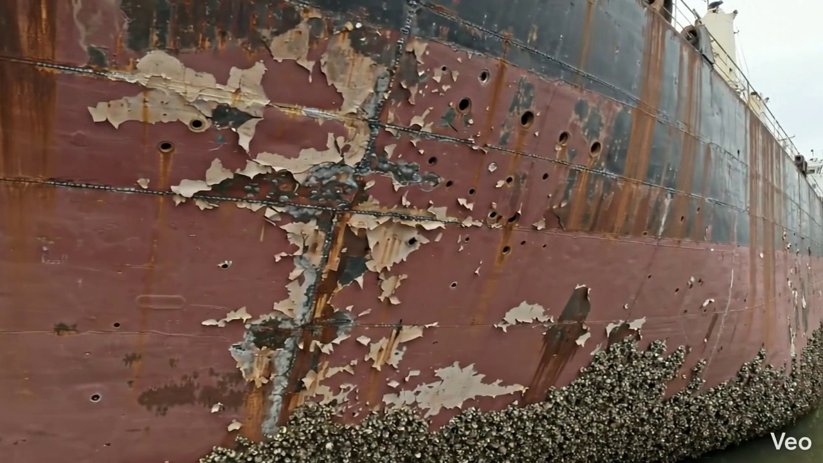

Repair Procedure
## Explanation of Maritime Hull Plate Repair Process for Vessel Inspection Report
This document outlines the detailed process for repairing localized deformation and structural damage to a vessel's hull or deck plating, ensuring structural integrity, watertightness, and compliance with maritime standards.
---
### **1. Assessment**
**What happens:**
The repair process commences with a thorough inspection of the deformed area. This involves visual examination to identify the extent of buckling, dents, or other physical damage. The affected region is carefully marked on the vessel's structure. Technicians then assess whether the deformation is confined to a small, localized area or if it extends across multiple structural frames or stiffeners, indicating a broader impact on the vessel's primary strength members. Precise measurements are taken to quantify any out-of-flatness, deviations from the original contour, or misalignment of structural components.
**Why necessary:**
This initial assessment is crucial for defining the scope of the repair. It ensures that all damaged material is identified and that the repair plan adequately addresses the full extent of the structural compromise. Accurately mapping the damage prevents partial repairs that could lead to residual stresses or future failures. It also guides the selection of appropriate repair techniques and materials, ensuring the new structure integrates seamlessly and effectively.
### **2. Preparation**
**What happens:**
Following the assessment, all identified distorted plate material, along with any buckled girders or stiffeners, are carefully cut away. This removal extends to sound, undamaged metal, ensuring no compromised material remains to undermine the integrity of the new repair. A margin of good plate, typically specified as equal to or greater than ¾ of the original plate thickness, is left around the cut-out to provide a robust base for welding. Any secondary framing that is bent or damaged but not part of the primary strength member needing full replacement, is either straightened or removed as required.
**Why necessary:**
The removal of all distorted and compromised material is paramount for several reasons:
* **Structural Integrity:** Damaged metal, even if seemingly minor, can harbor micro-cracks or areas of reduced strength, which could propagate under stress.
* **Weld Quality:** Welding to sound, clean metal free from deformation ensures optimal fusion, minimizing the risk of weld defects like porosity or lack of penetration.
* **Fit-up:** Removing damaged material allows for precise fit-up of the new plate, reducing internal stresses during welding and ensuring the correct geometry.
* **Corrosion:** Distorted areas can trap moisture and accelerate corrosion.
### **3. Plate Replacement**
**What happens:**
A new steel plate, matching or exceeding the original material's specified thickness and grade, is fabricated to the precise dimensions and contour required for the cut-out. This may involve cutting, bending, or forming the plate to ensure an exact fit. Once fabricated, the new plate is carefully positioned against the remaining sound hull or deck plating. It is then secured in place using tack welds, which are small, intermittent welds designed to hold the plate in alignment while allowing for minor adjustments before the final, continuous welding process begins. Complete welding is then performed around the entire periphery, prioritizing good fusion with the existing structure and applying appropriate preheat to manage thermal stresses. Full penetration welds are utilized wherever design and access allow, to maximize structural strength.
**Why necessary:**
This step directly restores the structural integrity, watertightness, and strength of the vessel's hull or deck.
* **Material Specification:** Using a plate of equivalent or greater thickness and grade ensures the repaired section meets or exceeds the original design strength.
* **Precision Fabrication:** A precise fit minimizes gaps, reduces the amount of weld metal required, and helps control welding distortion.
* **Tack Welding:** Ensures the plate remains accurately positioned throughout the welding process, preventing misalignment and induced stresses.
* **Full Penetration Welds:** Provide maximum strength and continuity across the joint, critical for primary structural members and watertight boundaries.
* **Preheat:** Manages the cooling rate of the weld and adjacent material, reducing the risk of hydrogen-induced cracking and minimizing residual stresses, especially in thicker or higher-strength steels.
### **4. Alignment and Welding**
**What happens:**
After tack welding, continuous weld passes are systematically applied using E7018 low-hydrogen electrodes. These electrodes are selected for their excellent mechanical properties, good ductility, and resistance to hydrogen-induced cracking, making them suitable for critical structural applications. Throughout the welding process, close attention is paid to potential heat-induced distortion of the surrounding hull structure. If distortion is observed, measures such as the use of clamps, strongbacks, or specialized welding sequences (e.g., skip welding, back-step welding, or controlled heat input techniques) are employed to mitigate it. Upon completion of welding, the weld seams are ground fair and smooth with the surrounding hull or deck plating to restore the original hydrodynamic or deck contour and eliminate stress concentrations. In situations where the initial buckling was extensive or the design analysis indicates a need for enhanced local strength, additional reinforcement, such as doubler plates or stiffeners, may be designed and welded in place to further reduce stress and prevent recurrence.
**Why necessary:**
This stage is critical for achieving a robust, durable, and structurally sound repair.
* **E7018 Electrodes:** Ensure high-quality welds with excellent mechanical properties, crucial for the structural integrity of the hull. Their low-hydrogen characteristic minimizes the risk of delayed cracking.
* **Distortion Control:** Prevents residual stresses that can lead to future cracking, maintains the vessel's designed shape, and ensures the integrity of adjacent structures.
* **Grinding Weld Seams Fair:** Removes stress concentrators, improves hydrodynamic flow (for external hull plating), and restores the aesthetic and functional surface of the deck.
* **Additional Strengthening:** Provides localized reinforcement in areas prone to high stress or recurrent damage, enhancing the long-term reliability of the repair and potentially addressing underlying structural design limitations.
### **5. Finishing**
**What happens:**
The repaired area undergoes a comprehensive final inspection. This includes detailed visual inspection to check for surface defects, proper weld profile, and dimensional accuracy. Non-Destructive Testing (NDT) methods, such as Ultrasonic Testing (UT) for internal flaws, Magnetic Particle Inspection (MPI) for surface and near-surface cracks, or Radiographic Testing (RT) for internal volumetric defects, are performed as required by classification society rules or the repair specification to verify the internal soundness and integrity of the welds. Once the repair is confirmed to be satisfactory, the new steel surface is thoroughly cleaned and prepared. A multi-coat paint system, typically starting with an appropriate primer and followed by finish coats, is applied to restore corrosion protection. Finally, the deck or hull surface is faired back to its original contour, ensuring a smooth transition between the new and existing plating.
**Why necessary:**
The finishing steps are vital for verifying the quality of the repair and ensuring the long-term service life of the vessel.
* **Visual and NDT Inspection:** Provides objective verification of the repair's quality, confirming freedom from defects that could compromise structural integrity or watertightness. This is a critical step for classification society approval.
* **Corrosion Protection:** Application of primer and finish coats is essential to protect the new steel from the harsh marine environment, preventing rust and preserving the structural integrity over time. Without adequate protection, the new steel would quickly degrade.
* **Fairing to Original Contour:** Restores the vessel's hydrodynamic efficiency (for underwater hull) or functional integrity (for deck), prevents water ingress or tripping hazards, and maintains the vessel's aesthetic appearance.
---
### **Why the Required Items Are Used**
**Cutting Torch (rental):**
The cutting torch is an indispensable tool primarily utilized during the **Preparation** phase of the repair process. Its high-temperature flame, often oxy-fuel or plasma-based, enables the rapid and precise cutting of steel plate, girders, and stiffeners. This allows for the efficient and clean removal of all distorted and damaged material, ensuring that the new plate can be fitted to a sound and accurately shaped opening. The ability to cut various thicknesses of steel with control makes it a fundamental tool for fabricating the precise cut-out required for the new plate insertion.
---
### **Safety and Structural Considerations**
**Safety Considerations:**
1. **Hot Work Permits:** Cutting and welding operations are classified as hot work and require strict adherence to hot work permit systems to prevent fires or explosions. This includes designated hot work areas, fire watches, and readily available fire suppression equipment.
2. **Confined Space Entry:** If the repair area is within a tank or enclosed compartment, strict confined space entry procedures must be followed, including gas testing, ventilation, and a standby rescue team.
3. **Personal Protective Equipment (PPE):** Welders and cutters must wear appropriate PPE, including welding helmets, flame-retardant clothing, gloves, safety shoes, and respirators (if ventilation is inadequate or specific fumes are present). Grinding operations require eye, ear, and respiratory protection.
4. **Ventilation:** Adequate ventilation is critical to remove welding fumes, grinding dust, and hazardous gases from the work area, protecting personnel from respiratory hazards.
5. **Electrical Safety:** Welding equipment requires proper grounding and insulation to prevent electrical shocks.
6. **Fall Protection:** When working at heights (e.g., on staging for hull repairs), appropriate fall protection equipment and procedures are mandatory.
7. **Lifting and Rigging:** The handling of new steel plates and removed sections requires safe lifting practices, proper rigging, and certified equipment to prevent injuries.
**Structural Considerations:**
1. **Material Compatibility:** The replacement steel must be of the same or equivalent (or greater) strength and metallurgical properties as the original hull material to maintain structural integrity. This includes tensile strength, yield strength, and impact resistance.
2. **Classification Society Rules:** All repairs must comply with the rules and regulations of the vessel's classification society (e.g., ABS, DNV, Lloyd's Register). This often dictates welding procedures, NDT requirements, material specifications, and repair design.
3. **Weld Procedure Qualification:** Welding procedures (WPS) must be qualified to ensure the resulting welds meet required mechanical properties and defect limits. Welders must be qualified and certified for the specific processes used.
4. **Distortion Control:** Heat input from welding can induce significant stresses and deformation. Effective distortion control techniques are vital to maintain the vessel's original lines, prevent residual stresses, and avoid buckling of adjacent plating.
5. **Continuity of Strength Members:** Any primary structural members (e.g., girders, frames, stiffeners) that are cut or replaced must have their structural continuity fully restored through proper connection to the new plating or other members.
6. **Stress Concentration:** Abrupt changes in section, poor weld profiles, or un-faired surfaces can act as stress concentrators, leading to fatigue cracks. Grinding welds fair and ensuring smooth transitions are critical.
7. **Watertight and Airtight Integrity:** For hull plating and internal tanks, the repair must guarantee complete watertightness and, where applicable, airtight integrity.
8. **Load Path Integrity:** The repair must ensure that the load paths within the hull structure are fully restored and capable of safely distributing operational stresses.
9. **Corrosion Protection:** The application of a high-quality marine coating system after repair is essential to prevent premature corrosion of the new steel, which could compromise the long-term structural integrity.
---
This detailed explanation provides a professional overview of the maritime repair process, addressing the necessity of each step, the actions involved, the use of specified equipment, and crucial safety and structural considerations for a vessel inspection report.

Repair Cost Breakdown
Item | Quantity | Unit Cost | Total Cost | Currency
Cutting Torch (rental) | 0.12 | 10764.0 | 1345.5 | INR
Estimated Repair Cost: 69305.88 INR

3.8 PD_8

Defect Overview
The defect, DEFORMATION, represents a critical structural concern on a vessel.
---
**1. What the Defect Means:**
The identified defect, DEFORMATION, manifests as an out-of-plane bending, buckling, or warping of the vessel's hull plating and/or internal structural stiffeners. This is a departure from the intended flat or smoothly curved design profile. This specific instance affects the **HULL_AREA**, encompassing approximately 5.59% of the surveyed segment within that area. Common causes include localized impact damage (e.g., groundings), excessive loads from heavy seas, or thermal stresses induced during fabrication or repair, such as uneven welding. While minor, localized "set-in" plating might occasionally be deemed acceptable, any significant or widespread buckling is considered a structural deficiency.
**2. Why It Is Important:**
Despite being classified with a **medium severity** at this stage, deformation is critically important because it directly impacts the fundamental structural integrity and safety of the vessel. Hull plating and stiffeners are primary load-carrying components designed to work in concert to resist global forces (like hogging and sagging) and local pressures (from waves or cargo). Even moderate buckling can severely impair their ability to perform this function, leading to a significant reduction in the overall hull girder strength. Classification societies universally mandate the correction of such defects due to their profound implications for seaworthiness and operational safety.
**3. Risks If Not Repaired:**
Failure to promptly and adequately repair deformation presents several escalating risks:
* **Progressive Structural Weakening:** The deformed area acts as a focal point for stress concentration. Under continuous cyclic loading (e.g., wave action), this significantly increases the likelihood of fatigue crack initiation and propagation from the distorted region into adjacent, seemingly sound structure.
* **Reduced Fatigue Life:** The overall fatigue life of the affected structural members and the surrounding plating will be substantially diminished, leading to premature failure.
* **Compromised Watertight/Weathertight Integrity:** In more severe cases, significant deformation can lead to material failure (tearing or rupture), potentially compromising watertight or weathertight boundaries and risking ingress of water.
* **Operational Limitations & Non-Compliance:** Unrepaired deformation can result in conditions of class imposed by the classification society, leading to operational restrictions, increased insurance premiums, or even detention by port state control authorities, impacting the vessel's commercial viability.
**4. Structural Implications:**
Structurally, deformation has profound and detrimental implications for the vessel's load-carrying capacity:
* **Impaired Hull Girder Strength:** The hull girder functions as the primary structural beam of the vessel, resisting global bending moments and shear forces. Buckling within the hull plating and stiffeners reduces the effective cross-sectional area and the moment of inertia of the affected region. This directly diminishes the hull girder's ability to withstand these global stresses, weakening the entire vessel's ability to resist external loads.
* **Loss of Local Stiffness and Load-Carrying Capacity:** Stiffeners are specifically designed to enhance the buckling strength of plating panels. When stiffeners themselves are deformed, or the plating buckles between them, their reinforcing effect is compromised or nullified. The deformed section can no longer carry its intended share of the load, causing a redistribution of stresses to adjacent, sound structural elements.
* **Reduced Post-Buckling Strength:** While structures can sometimes carry some load even after initial buckling, severe deformation drastically reduces this post-buckling capacity, increasing the risk of sudden and catastrophic failure under ultimate load conditions.
* **Reduced Reserve Strength:** The vessel's inherent reserve strength, which is the margin of safety built into its design to withstand unforeseen or extreme loading conditions, is significantly eroded by deformation, making the vessel more vulnerable in adverse weather or impact events.

Visual Evidence
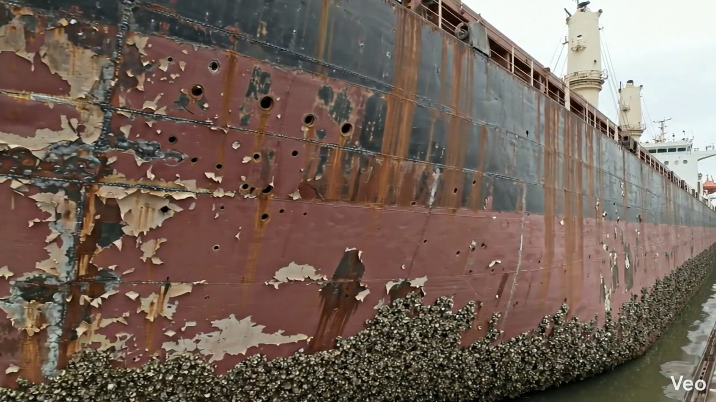

Repair Procedure
Generation failed.

Repair Cost Breakdown
Item | Quantity | Unit Cost | Total Cost | Currency
Cutting Torch (rental) | 0.08 | 10764.0 | 807.3 | INR
Estimated Repair Cost: 41583.53 INR

3.9 PD_9

Defect Overview
Generation failed.

Visual Evidence
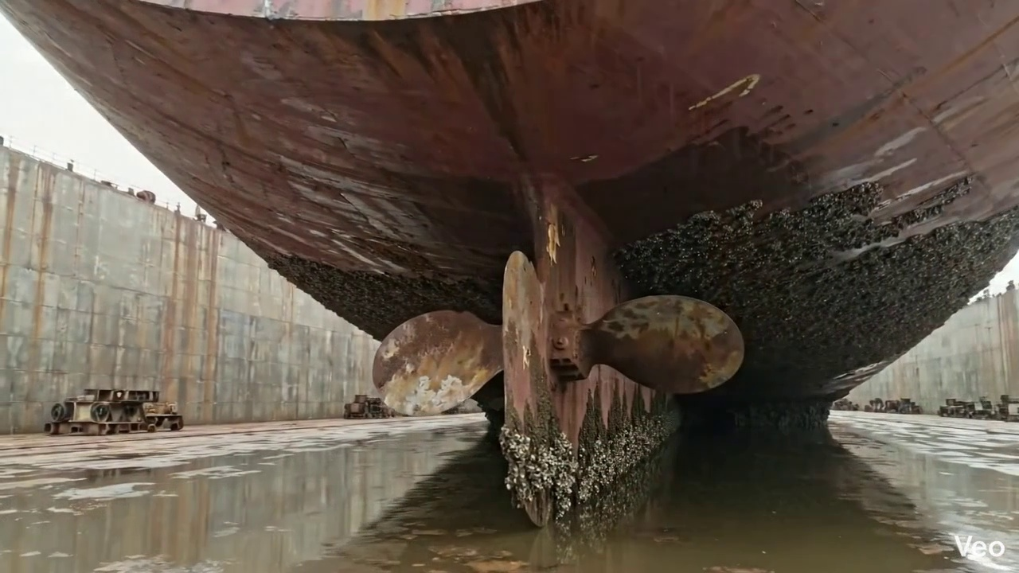

Repair Procedure
Generation failed.

Repair Cost Breakdown
Item | Quantity | Unit Cost | Total Cost | Currency
Cutting Torch (rental) | 0.05 | 10764.0 | 538.2 | INR
Estimated Repair Cost: 27722.35 INR

3.10 PD_10

Defect Overview
Generation failed.

Visual Evidence
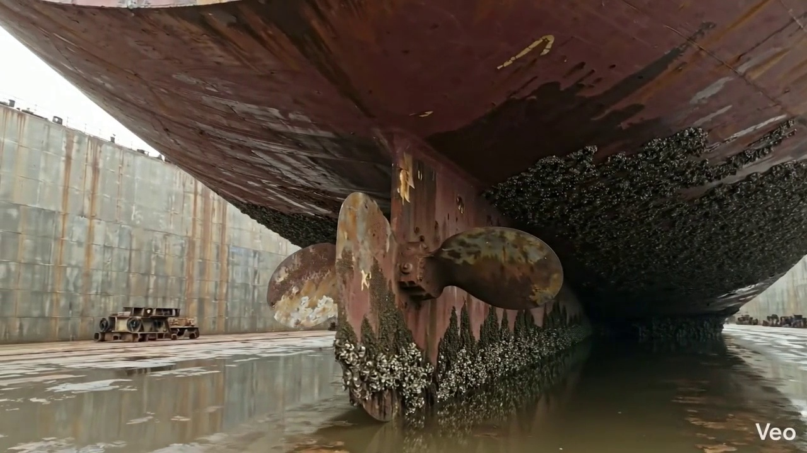

Repair Procedure
Generation failed.

Repair Cost Breakdown
Item | Quantity | Unit Cost | Total Cost | Currency
Cutting Torch (rental) | 0.05 | 10764.0 | 538.2 | INR
Estimated Repair Cost: 27722.35 INR

