Vessel Inspection Report

Table of Contents
1. Executive Summary
2. Vessel Repair Summary
3. Defect Analysis
3.1 PD_1
3.2 PD_2
3.3 PD_3

1. Executive Summary
Generation failed.

2. Vessel Repair Summary
Metric | Value
Total Defects | 3
Total Estimated Cost | 110889.41 INR
Material Cost | 66533.65 INR
Labor Cost | 33266.82 INR
Equipment Cost | 11088.94 INR

3. Defect Analysis

3.1 PD_1

Defect Overview
Generation failed.

Visual Evidence
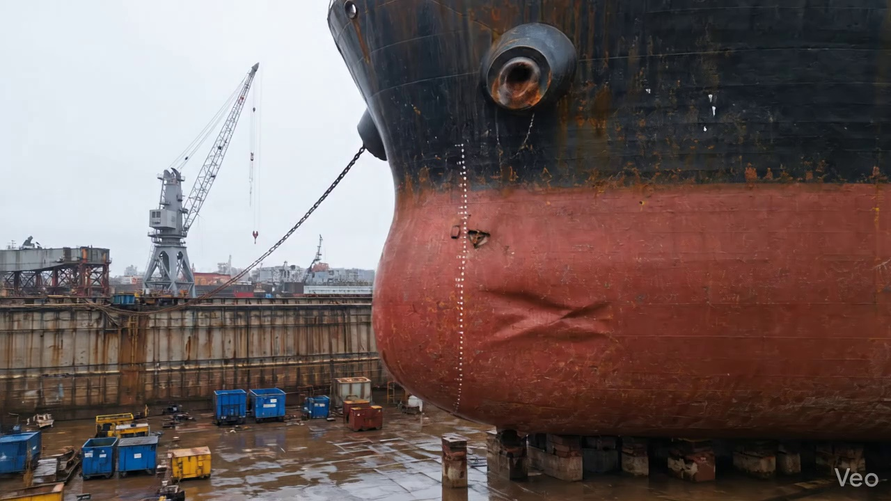

Repair Procedure
Generation failed.

Repair Cost Breakdown
Item | Quantity | Unit Cost | Total Cost | Currency
Cutting Torch (rental) | 0.08 | 10764.0 | 807.3 | INR
Estimated Repair Cost: 41583.53 INR

3.2 PD_2

Defect Overview
Generation failed.

Visual Evidence
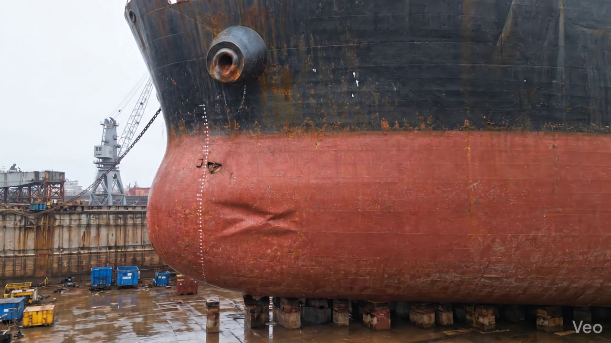

Repair Procedure
Generation failed.

Repair Cost Breakdown
Item | Quantity | Unit Cost | Total Cost | Currency
Cutting Torch (rental) | 0.08 | 10764.0 | 807.3 | INR
Estimated Repair Cost: 41583.53 INR

3.3 PD_3

Defect Overview
Generation failed.

Visual Evidence
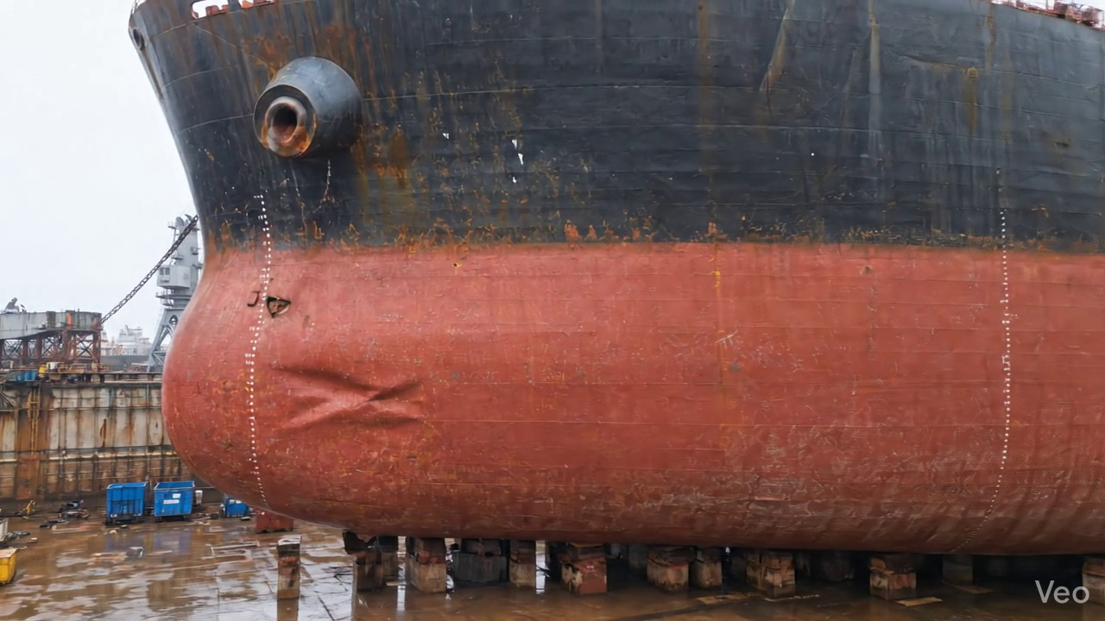

Repair Procedure
Generation failed.

Repair Cost Breakdown
Item | Quantity | Unit Cost | Total Cost | Currency
Cutting Torch (rental) | 0.05 | 10764.0 | 538.2 | INR
Estimated Repair Cost: 27722.35 INR

