Vessel Inspection Report

Table of Contents
1. Executive Summary
2. Vessel Repair Summary
3. Defect Analysis
3.1 PD_1

1. Executive Summary
**EXECUTIVE SUMMARY: Maritime Vessel Inspection**
This executive summary outlines the principal findings from the recent maritime vessel inspection.
The inspection identified a solitary defect, classified as 'low' severity. There were no medium or high-severity defects detected.
The total estimated repair cost for the identified defect is 27,722.35 INR.
This indicates a generally sound operational status for the vessel, with no immediate high-priority concerns impacting safety or principal operational capabilities. The identified low-severity defect should be addressed during scheduled maintenance to prevent potential escalation.

2. Vessel Repair Summary
Metric | Value
Total Defects | 1
Total Estimated Cost | 27722.35 INR
Material Cost | 16633.41 INR
Labor Cost | 8316.7 INR
Equipment Cost | 2772.24 INR

3. Defect Analysis

3.1 PD_1

Defect Overview
Here is a professional explanation of the maritime defect "DEFORMATION" for a vessel inspection report:
---
**Defect Name: DEFORMATION**
**Severity: Low**
**Overlapping Parts: HULL_AREA**
**1. What the defect means:**
Deformation, specifically observed as buckling or warping, refers to an out-of-plane bending or distortion of the vessel's hull plating or its supporting stiffeners. This physical change from the original design profile typically occurs due to external forces such as grounding impacts, heavy dynamic loads from severe sea conditions, or internal stresses, most notably those induced by welding heat during construction or repairs. While some minor, localized "set-in" plating might be observed, significant buckles represent a more pronounced and structurally concerning deviation.
**2. Why it is important:**
Even moderate instances of buckling or warping are critically important because they can severely impair the overall hull girder strength of the vessel. The structural integrity of a vessel relies heavily on the geometric stability and precise alignment of its components. Out-of-plane deformation directly undermines this stability, thereby reducing the affected structure's ability to effectively carry and distribute intended loads. Classification societies universally consider significant buckling as a critical defect that necessitates corrective action to maintain seaworthiness and compliance.
**3. Risks if not repaired:**
Although the current severity is noted as 'low', if this deformation progresses or is not properly managed, it poses several significant risks:
* **Reduced Structural Integrity:** The primary risk is a progressive reduction in the vessel's inherent ability to withstand operational stresses from waves, cargo, or potential impacts, increasing the likelihood of failure under design conditions.
* **Stress Concentration:** Deformed areas can act as focal points for concentrated stresses, potentially leading to premature fatigue cracking or accelerated material degradation in both the affected and adjacent sound structural members.
* **Progressive Failure:** Under future adverse conditions (e.g., severe weather, minor collisions), the compromised structural areas are more susceptible to progressive failure, which could escalate into wider structural damage or even collapse.
* **Regulatory Non-Compliance:** Unrepaired or worsening deformation, especially if it exceeds classification society tolerances, can lead to non-compliance with statutory requirements and class rules. This may result in operational restrictions, detention, or the refusal of class certificates, impacting the vessel's ability to trade.
**4. Structural implications:**
Structurally, deformation directly impacts the hull's ability to function as a unified girder, which is fundamental to a vessel's design:
* **Impaired Hull Girder Strength:** Buckling directly reduces the effective cross-sectional area and the moment of inertia of the affected structural elements (plating and stiffeners). This consequently diminishes the vessel's resistance to global bending moments and shear forces, which are critical for maintaining overall longitudinal strength.
* **Loss of Local Stability:** For plating, buckling compromises its capacity to carry compressive loads, potentially leading to instability and further collapse under normal design loads, particularly in bottom and deck structures.
* **Altered Load Path:** The presence of deformation alters the intended load path within the structure, forcing adjacent, sound members to carry increased loads for which they were not originally designed. This can create new stress points and initiate a cascade of failures.
* **Requirement for Renewal:** To restore the original structural integrity and strength, classification practice typically dictates that significant buckling must be corrected by carefully cutting out and replacing the distorted metal with new, properly aligned plating and stiffeners. Even for 'low' severity, continued monitoring or a repair plan may be prudent depending on location and potential for growth.
---

Visual Evidence
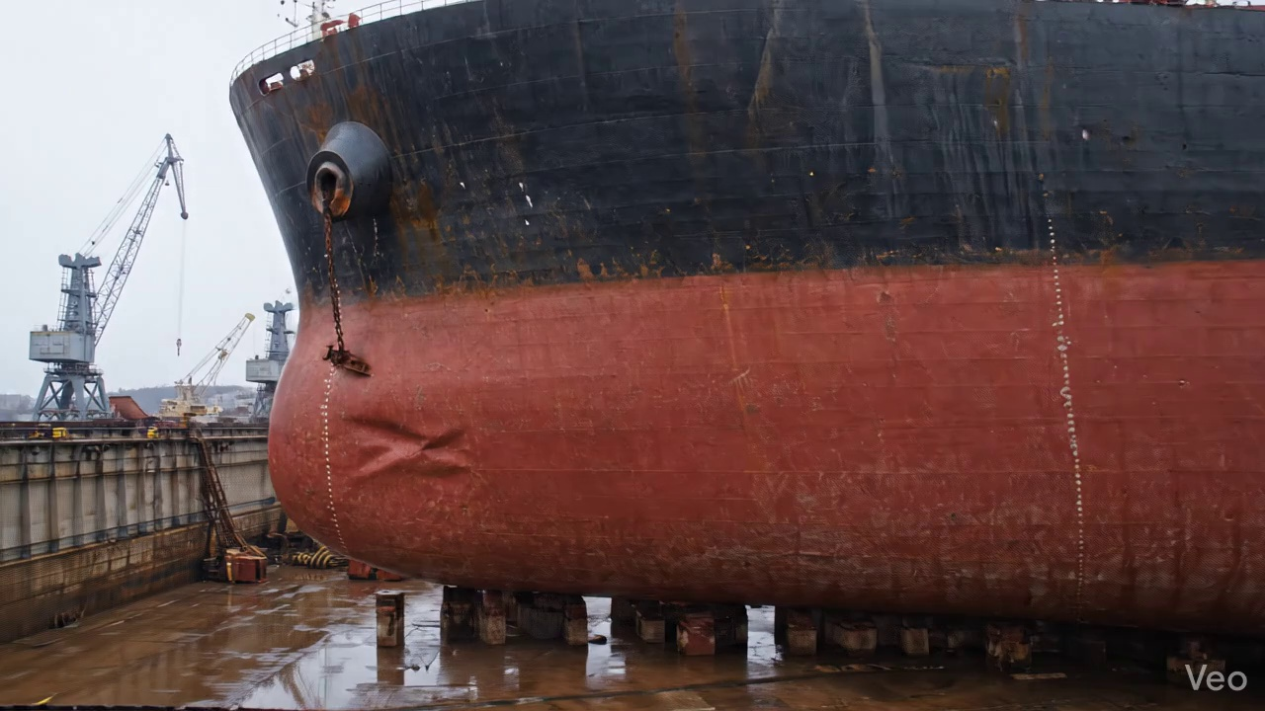

Repair Procedure
## Vessel Inspection Report: Explanation of Maritime Plate Repair Process
This report details the systematic repair process for localized deformation and material loss in a vessel's plating, ensuring the restoration of structural integrity, watertight/weathertight boundaries, and adherence to classification society standards.
---
### **1. Assessment Phase**
* **Necessity:** This initial phase is crucial for comprehensively understanding the extent and nature of the damage. It allows for accurate planning of the repair, definition of the repair scope, and selection of appropriate materials and techniques. Without thorough assessment, the risk of an incomplete repair or over-extensive work increases, potentially compromising structural integrity or incurring unnecessary costs.
* **What Happens:** Skilled personnel visually inspect the deformed region, marking its boundaries. They determine if the buckling or deformation is localized to the plate itself or if it extends to and impacts adjacent structural members such as frames, girders, or stiffeners. Precise measurements of any out-of-flatness (e.g., using straight edges, feeler gauges, or laser measurement tools) are taken to quantify the deformation and inform the required fairing or replacement dimensions. This data forms the basis for engineering assessment and repair methodology.
* **Required Items Usage:** No specific items listed for this phase, but it typically involves basic measuring tools and marking equipment.
* **Safety & Structural Considerations:** Ensures the repair strategy addresses the full scope of damage, preventing hidden weaknesses. Safety in assessment involves proper access to the damaged area.
### **2. Preparation Phase**
* **Necessity:** This phase is critical for removing all compromised material that could otherwise harbor cracks, reduce strength, or lead to future failure. By cutting to sound metal, a robust foundation is established for the new replacement plate, ensuring the subsequent weld achieves optimal strength and integrity. The specified margin of good plate (≥¾ thickness) ensures the new weld is not placed on potentially fatigued or micro-cracked material at the very edge of the damage. Straightening or removing bent framing restores the underlying support structure for the new plate.
* **What Happens:** Following the assessment, the precise area for removal is marked. Using thermal cutting equipment, all distorted plating, along with any buckled or damaged girders or stiffeners, are carefully cut away. The cutting proceeds until only "sound metal"—material free of cracks, deformation, or metallurgical changes due to impact—remains. The edges of the cutout are then prepared, often by grinding, to ensure a clean surface suitable for welding. Any underlying bent framing that cannot be effectively straightened to its original alignment and strength is removed for replacement.
* **Required Items Usage:**
* **Cutting Torch (rental):** This item is indispensable during the Preparation phase. The cutting torch utilizes a high-temperature flame to rapidly and efficiently sever marine-grade steel plates and structural members. Its use allows for the quick and precise removal of the distorted sections, enabling access to sound metal as required by the repair specification. The rental model implies a project-specific need for specialized cutting capabilities.
* **Safety & Structural Considerations:** Hot work permits are essential due to fire hazards. Adequate ventilation is required to mitigate exposure to fumes. Proper Personal Protective Equipment (PPE) including eye protection, gloves, and fire-resistant clothing is mandatory. Structurally, ensuring the cut is clean and to sound metal prevents residual stress concentrations and ensures a strong base for the new plate.
### **3. Plate Replacement Phase**
* **Necessity:** This phase is fundamental to restoring the vessel's structural integrity, watertight/weathertight envelope, and intended hull/deck contour. Fabricating a new plate to precise dimensions ensures proper fit-up, which is paramount for achieving high-quality, strong welds. The specification for "same or greater thickness" guarantees that the repaired area is structurally equivalent or enhanced compared to its original design.
* **What Happens:** Based on the dimensions of the cutout from the Preparation phase, a new steel plate is precisely fabricated. This typically involves marking, cutting, and sometimes forming (e.g., rolling or bending) the plate to match the original curvature of the hull or deck. The edges of the new plate and the existing hull plating are prepared for welding, often by creating a bevel. The new plate is then carefully maneuvered into position, aligned accurately with the remaining structure, and temporarily secured using clamps or strongbacks. Tack-welds are then applied to hold the plate firmly in place, maintaining alignment before the full welding process begins. Pre-heating, if specified (based on steel type, thickness, and ambient temperature), is applied to prevent hydrogen-induced cracking and ensure good fusion.
* **Required Items Usage:** No specific items listed, but this phase requires fabrication tools (e.g., marking tools, shears, presses, rolling machines), lifting equipment, clamps, and welding machines for tack welding.
* **Safety & Structural Considerations:** Accurate fit-up is crucial for minimizing weld stresses and ensuring a strong joint. Proper preheat, if required, is a critical metallurgical control. Safety involves safe lifting and handling of the new plate and ensuring personnel are clear during placement and tack-welding.
### **4. Alignment and Welding Phase**
* **Necessity:** This phase is the core of the repair, permanently integrating the new plate into the vessel's structure. Full penetration welds, where achievable, ensure the strongest possible joint by fusing the entire thickness of the plates. The use of E7018 electrodes is specified due to their low-hydrogen properties, excellent mechanical strength, and ductility, making them ideal for critical structural applications in marine environments. Controlling weld-induced distortion is vital to maintain the vessel's hydrodynamic shape, prevent residual stresses that could lead to fatigue, and avoid misalignment with adjacent structures. Grinding weld seams fair reduces stress concentrations and improves corrosion resistance and aesthetics. Additional strengthening addresses underlying structural weaknesses or severe damage.
* **What Happens:** Following tack-welding, a series of continuous weld passes are applied to permanently join the new plate to the existing hull structure. Welders meticulously control travel speed, amperage, and voltage to ensure good fusion and penetration, particularly aiming for full penetration welds as specified. During this process, careful monitoring for thermal distortion is conducted. If distortion occurs, mitigation techniques such as sequential welding patterns (e.g., back-step welding), skip welding, the use of clamps or strongbacks, or controlling heat input are employed to maintain the intended hull shape. Upon completion of all weld passes, the weld seams are carefully ground smooth and fair with the surrounding plating, removing any irregularities or sharp transitions. In cases where the initial buckling was extensive or the area is historically prone to stress, additional strengthening, such as doublers (pads welded over the repair) or new stiffeners, may be installed to enhance the structural resilience of the repaired section.
* **Required Items Usage:** No specific items listed, but this phase relies heavily on arc welding machines, E7018 welding electrodes, grinding tools, clamps, strongbacks, and potentially heating equipment for preheat/post-weld heat treatment.
* **Safety & Structural Considerations:** Strict adherence to welding procedures (WPS) is paramount. Welding fumes require robust ventilation. Arc eye protection, welding helmets, and fire-resistant clothing are mandatory. Structurally, the quality of the weld (absence of defects, proper fusion, penetration) is directly linked to the long-term integrity of the repair. Distortion control is critical for maintaining overall hull form and avoiding secondary stresses. E7018 electrodes require proper storage to maintain their low-hydrogen properties.
### **5. Finishing Phase**
* **Necessity:** This final phase ensures the repair is fit for service, protected from the harsh marine environment, and aesthetically consistent with the vessel's original design. Thorough inspection, particularly NDT, verifies the quality of the work and identifies any subsurface defects that visual inspection might miss. Applying protective coatings restores corrosion resistance, crucial for the longevity of the steel structure. Fairing the surface minimizes hydrodynamic drag and prevents localized turbulence.
* **What Happens:** After welding and grinding are complete, the repaired area undergoes rigorous inspection. This includes a thorough visual inspection for surface defects, weld profile, and overall fairness. Non-Destructive Testing (NDT) methods, such as Magnetic Particle Testing (MPT) for surface cracks or Ultrasonic Testing (UT) for internal flaws like lack of fusion or porosity, are performed to verify the integrity of the welds and the surrounding material. Once the repair passes inspection, the area is cleaned to remove all welding spatter, slag, and contaminants. A marine-grade primer is then applied, followed by subsequent finish coats (e.g., anti-corrosive, anti-fouling, or topcoats) to restore the vessel's original corrosion protection system. Finally, the deck or hull surface is ensured to be faired back to its original contour, ensuring smooth flow and optimal performance.
* **Required Items Usage:** No specific items listed, but this phase requires NDT equipment, cleaning tools, abrasive tools, painting equipment (brushes, rollers, spray guns), and marine-grade paints/coatings.
* **Safety & Structural Considerations:** NDT ensures hidden defects are identified, preventing premature failure. Proper application of coatings is vital for long-term corrosion protection. Safety involves proper handling of paints and solvents (MSDS review, ventilation) and safe use of NDT equipment. The final fairness of the hull contributes to fuel efficiency and structural load distribution.

Repair Cost Breakdown
Item | Quantity | Unit Cost | Total Cost | Currency
Cutting Torch (rental) | 0.05 | 10764.0 | 538.2 | INR
Estimated Repair Cost: 27722.35 INR

