Vessel Inspection Report

Table of Contents
1. Executive Summary
2. Vessel Repair Summary
3. Defect Analysis
3.1 PD_1
3.2 PD_2
3.3 PD_3
3.4 PD_4

1. Executive Summary
**Executive Summary: Maritime Vessel Inspection Findings**
This executive summary presents the key findings from a recent comprehensive maritime vessel inspection. The objective was to assess the current condition of the vessel and identify any deficiencies impacting operational integrity, safety, or regulatory compliance.
The inspection identified a total of **four (4) deficiencies**, with an estimated rectification cost of **INR 221,778.82**.
A detailed analysis of the deficiency severity distribution is as follows:
* **High Severity:** Two (2) deficiencies
* **Medium Severity:** Two (2) deficiencies
* **Low Severity:** Zero (0) deficiencies
The presence of high-severity deficiencies necessitates immediate attention to ensure sustained operational safety, prevent potential downtime, and maintain compliance with maritime regulations. Remedial actions for all identified deficiencies are recommended to uphold the vessel's seaworthiness and operational efficiency.

2. Vessel Repair Summary
Metric | Value
Total Defects | 4
Total Estimated Cost | 221778.82 INR
Material Cost | 133067.29 INR
Labor Cost | 66533.65 INR
Equipment Cost | 22177.88 INR

3. Defect Analysis

3.1 PD_1

Defect Overview
Generation failed.

Visual Evidence
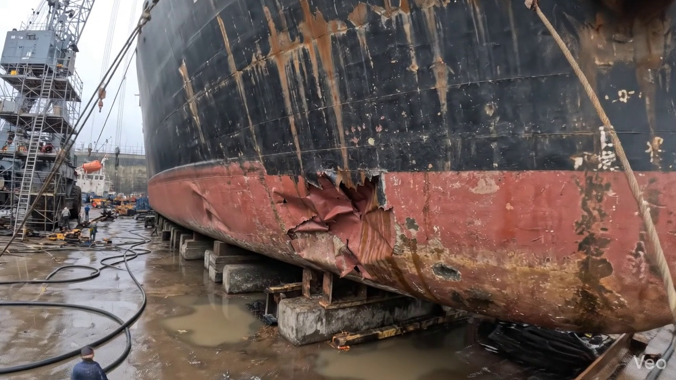

Repair Procedure
Generation failed.

Repair Cost Breakdown
Item | Quantity | Unit Cost | Total Cost | Currency
Cutting Torch (rental) | 0.08 | 10764.0 | 807.3 | INR
Estimated Repair Cost: 41583.53 INR

3.2 PD_2

Defect Overview
Here is a professional explanation of the DEFORMATION defect for a vessel inspection report:
**Defect Name:** DEFORMATION
**Severity:** Medium
**Location:** HULL_AREA (approximately 11.5% of the inspected hull segment is affected)
---
**1. What the defect means:**
Deformation, in the context of this inspection, refers to an out-of-plane bending, buckling, or warping of the vessel's hull plating or structural stiffeners. This manifests as a visible distortion or unevenness on the affected surface. Common causes for such structural distortions include significant localized impacts (e.g., grounding incidents), exposure to heavy and repetitive sea loads over time, or localized thermal stresses induced during welding processes (uneven welding).
**2. Why it is important:**
This defect is of medium importance due to its direct and significant impact on the vessel's structural integrity. Even moderate levels of buckling or warping can severely compromise the hull girder strength, which is the fundamental load-bearing capacity of the vessel's main structure. The hull girder is crucial for resisting global bending moments (hogging and sagging) that the vessel experiences during operations. Classification Societies generally consider such deformations to be critical defects, often requiring correction by cutting out and replacing the distorted metal to restore design strength. While small, localized set-in plating might occasionally be tolerated if assessed as minor, significant buckles always warrant attention and repair.
**3. Risks if not repaired:**
Failure to adequately address and repair this deformation carries several significant risks:
* **Reduced Structural Integrity and Strength:** The primary risk is a progressive reduction in the vessel's overall load-carrying capacity and its resistance to operational stresses, thereby weakening the hull girder.
* **Initiation and Propagation of Fatigue Cracks:** Deformed areas often act as stress concentrators. Under dynamic loading from sea conditions, these concentrated stresses can lead to the initiation and propagation of fatigue cracks in the plating or stiffeners, potentially leading to localized breaches or progressive structural failure over time.
* **Compromised Seaworthiness:** A significant reduction in hull girder strength directly diminishes the vessel's overall seaworthiness, increasing the risk of structural failure during severe weather, heavy seas, or unforeseen incidents.
* **Non-Compliance and Operational Restrictions:** Unrepaired defects of this nature are likely to result in non-compliance with classification society rules and international statutory requirements. This can lead to operational restrictions, detention by port state control, or even withdrawal of the vessel's class certification.
**4. Structural implications:**
The structural implications of deformation are multifaceted and affect both local and global strength:
* **Global Hull Girder Strength:** The most critical implication is a direct reduction in the vessel's longitudinal strength. The deformed section can no longer effectively contribute to the overall rigidity of the hull girder, thereby diminishing its ability to withstand global hogging and sagging bending moments and shear forces.
* **Local Strength and Stiffening:** If stiffeners are involved, their critical role in supporting the plating and preventing localized buckling is compromised. This can lead to further plate deformation, reduced resistance to hydrostatic and dynamic pressures, and increased susceptibility to damage in adjacent areas.
* **Undesirable Stress Redistribution:** A deformed structural member cannot bear its designed share of the structural load. This forces an undesirable redistribution of stresses to adjacent, intact structures, which may then become overstressed, potentially leading to a cascade of further damage or premature fatigue in otherwise sound material.
* **Reduced Energy Absorption:** In the event of future impacts (e.g., another grounding or collision), a pre-deformed area will have a reduced capacity to absorb energy, making the vessel more susceptible to extensive and severe damage than an intact structure.

Visual Evidence
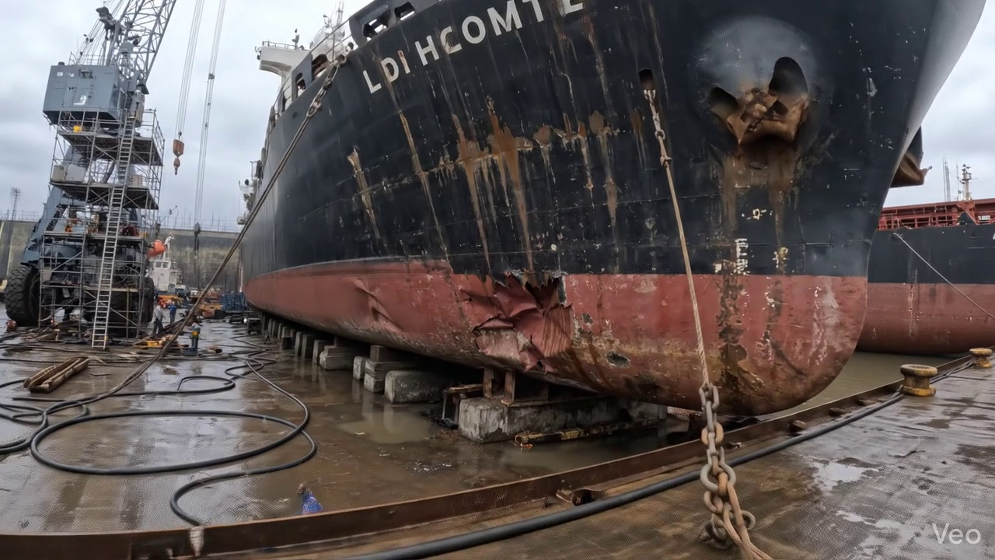

Repair Procedure
Generation failed.

Repair Cost Breakdown
Item | Quantity | Unit Cost | Total Cost | Currency
Cutting Torch (rental) | 0.08 | 10764.0 | 807.3 | INR
Estimated Repair Cost: 41583.53 INR

3.3 PD_3

Defect Overview
Generation failed.

Visual Evidence
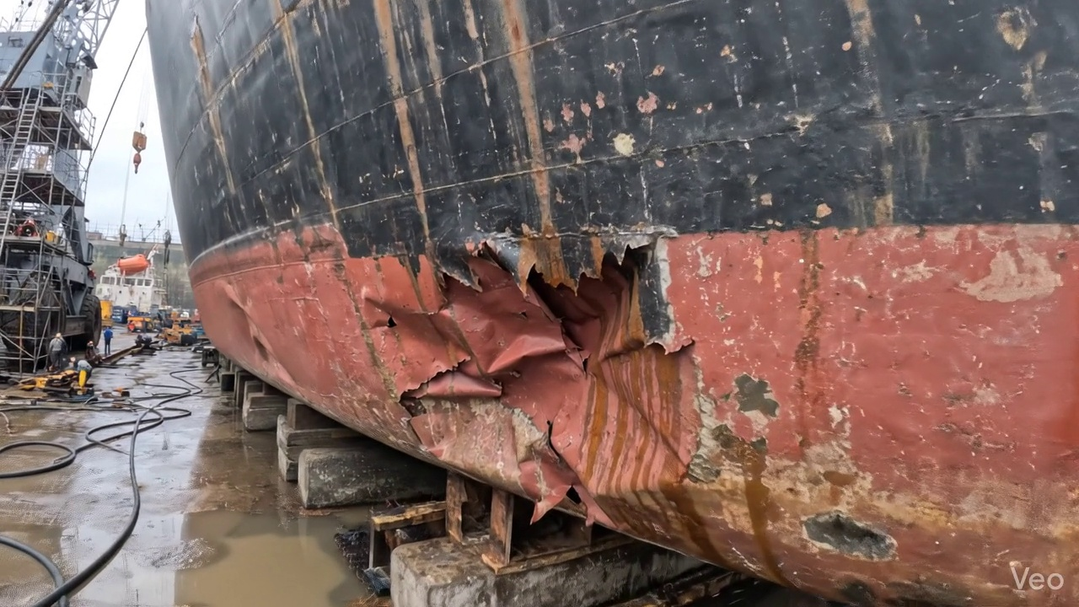

Repair Procedure
Generation failed.

Repair Cost Breakdown
Item | Quantity | Unit Cost | Total Cost | Currency
Cutting Torch (rental) | 0.12 | 10764.0 | 1345.5 | INR
Estimated Repair Cost: 69305.88 INR

3.4 PD_4

Defect Overview
Generation failed.

Visual Evidence
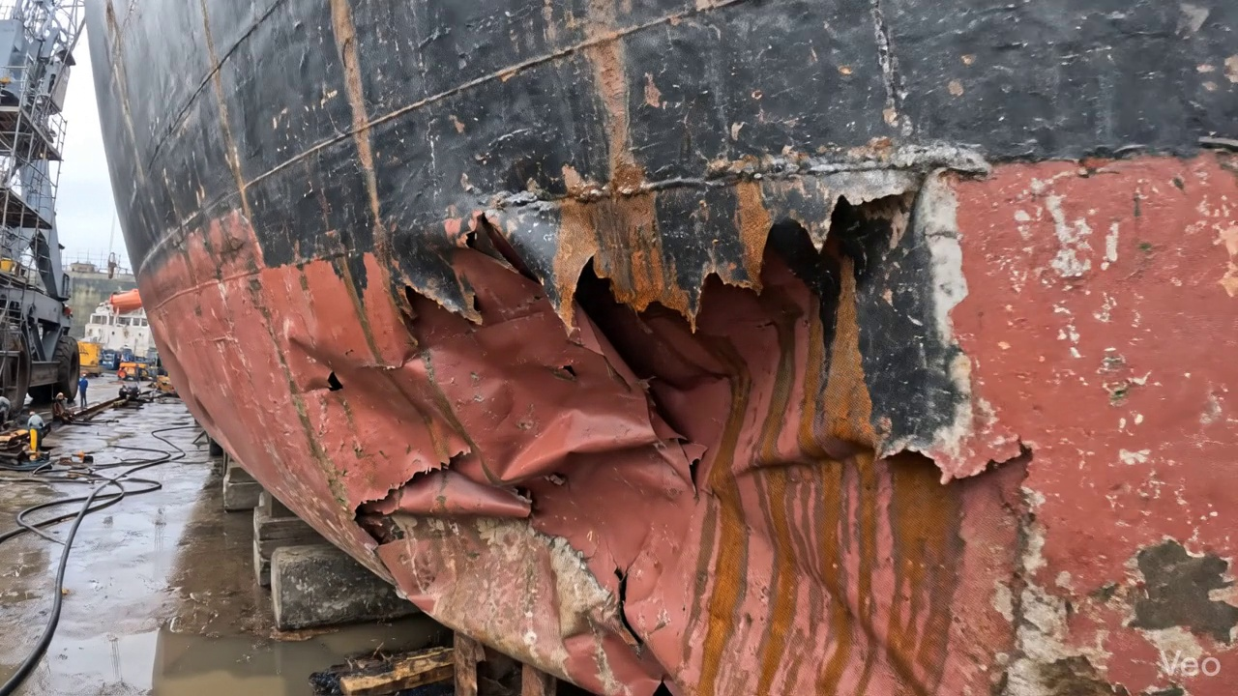

Repair Procedure
Generation failed.

Repair Cost Breakdown
Item | Quantity | Unit Cost | Total Cost | Currency
Cutting Torch (rental) | 0.12 | 10764.0 | 1345.5 | INR
Estimated Repair Cost: 69305.88 INR

