Vessel Inspection Report

Table of Contents
1. Executive Summary
2. Vessel Repair Summary
3. Defect Analysis
3.1 PD_1
3.2 PD_2
3.3 PD_3
3.4 PD_4

1. Executive Summary
**Executive Summary: Vessel Condition Assessment**
This executive summary provides an overview of the recent comprehensive condition assessment conducted on [Vessel Name/IMO Number, if applicable]. The inspection aimed to evaluate the vessel's current operational readiness, structural integrity, and compliance with maritime regulations.
A total of **four (4) deficiencies** were identified during the survey. The severity distribution of these findings is as follows:
* **Low Severity:** 0 items
* **Medium Severity:** 2 items
* **High Severity:** 2 items
The presence of two high-severity deficiencies indicates critical areas requiring prompt intervention to ensure continued safe operation, regulatory compliance, and to mitigate potential risks of asset degradation or operational disruption. The medium-severity items necessitate planned remediation to prevent escalation and maintain long-term vessel reliability.
The estimated total cost for rectifying all identified deficiencies is **INR 221,778.82**.
It is strongly recommended that an immediate action plan be developed to address the high-severity deficiencies, followed by scheduled remediation for the medium-severity items within the upcoming maintenance cycle or dry-docking period. Further detailed technical specifications and repair recommendations for each deficiency are provided in the full inspection report.

2. Vessel Repair Summary
Metric | Value
Total Defects | 4
Total Estimated Cost | 221778.82 INR
Material Cost | 133067.29 INR
Labor Cost | 66533.65 INR
Equipment Cost | 22177.88 INR

3. Defect Analysis

3.1 PD_1

Defect Overview
**Defect Name:** DEFORMATION
**Severity:** Medium
**Explanation:**
**1. What the defect means:**
Deformation, specifically categorized as buckling or warping, refers to an unintended out-of-plane bending, distortion, or creasing of the vessel's hull plating or structural stiffeners. This defect manifests as a deviation from the original flat or designed curvature of the metal structure, often appearing as an inward or outward bend. It is typically caused by significant mechanical stresses such as grounding impacts, heavy sea loads, or internal stresses induced by uneven welding. This particular deformation has been observed within the HULL_AREA, affecting approximately 13.26% of the identified segment. While minor, localized set-in plating might sometimes be tolerated if small and stable, any significant buckles indicate a compromised structural condition.
**2. Why it is important:**
The presence of deformation, even if categorized as moderate, is of critical importance due to its direct and severe impact on the vessel's structural integrity and overall hull girder strength. Hull plating and stiffeners are primary structural components designed to maintain the vessel's form and provide resistance against operational loads. Any significant deviation from their intended geometry implies that these components can no longer effectively bear their design loads, making the vessel susceptible to further damage and compromising its inherent strength. Classification societies universally consider such distortions to be a serious structural concern requiring corrective action.
**3. Risks if not repaired:**
Failure to adequately address and repair significant deformation carries several serious risks:
* **Reduced Structural Integrity:** The most immediate risk is a severe reduction in the overall hull girder strength. This compromises the vessel's ability to withstand normal operational stresses, including bending moments from waves, cargo loads, and docking forces, potentially leading to an increased risk of structural failure.
* **Progressive Damage and Fatigue:** Deformed areas act as stress concentration points. Under dynamic loading conditions, these areas are highly susceptible to the initiation and propagation of fatigue cracks, which can rapidly escalate into more extensive structural damage.
* **Loss of Seaworthiness:** A compromised hull girder directly impacts the vessel's seaworthiness, increasing the risk of localized collapse, hull breach, ingress of water, and potentially catastrophic structural failure, especially in adverse weather conditions.
* **Operational and Regulatory Non-Compliance:** Unrepaired significant deformation will result in non-compliance with classification society rules and statutory regulations. This can lead to operational restrictions, detention by port state control authorities, refusal of insurance coverage, and ultimately, render the vessel unseaworthy for its intended trade.
**4. Structural implications:**
The structural implications of deformation are profound and extend beyond the immediately affected area:
* **Impairment of Hull Girder Strength:** Significant buckling directly reduces the effective cross-sectional area and moment of inertia of the hull girder, thereby diminishing its resistance to longitudinal bending and shear forces, which are critical for the vessel's structural integrity.
* **Loss of Local Stiffness and Stability:** The affected plating and stiffeners lose their designed stiffness and stability, making them prone to further buckling and local collapse under applied loads. This can create "soft spots" in the structure.
* **Redistribution of Stresses:** Deformed structural members can no longer efficiently carry their intended share of applied loads. This results in an abnormal redistribution of stresses to adjacent, intact structural components, potentially overstressing them and leading to secondary failures in otherwise sound areas.
* **Reduced Load-Carrying Capacity:** The overall load-carrying capacity of the vessel's structure is diminished, directly impacting its safe operational limits and potentially limiting the maximum cargo weight or types of cargo it can safely transport.
* **Potential for Instability:** In severe cases, significant buckling indicates that the structure is approaching or has exceeded its critical buckling limit, making it susceptible to sudden and complete collapse under design loads.

Visual Evidence
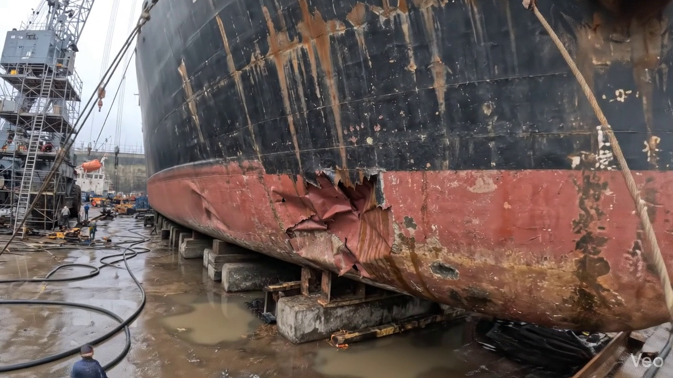

Repair Procedure
This report details a standard maritime repair process for localized hull deformation, outlining each step's necessity, execution, associated tooling, and critical safety and structural considerations.
---
### **Vessel Inspection Report: Maritime Hull Plate Repair Process**
**Repair Process Overview:**
The described process addresses localized deformation in a vessel's hull plating, aiming to restore structural integrity, watertightness, and the original hull contour. It follows a logical progression from damage assessment to final surface treatment and verification.
---
**Detailed Explanation of Repair Steps:**
**1. Assessment**
* **Why this step is necessary:** This initial phase is crucial for accurately defining the scope of the repair. It prevents unnecessary material removal, ensures all compromised areas are identified, and informs the repair strategy to maintain the vessel's structural integrity and class standards.
* **What happens during this step:** Skilled personnel visually inspect the deformed region. This includes marking the boundaries of the buckled area, assessing if the deformation is localized or extends across multiple structural frames (girders, stiffeners), and precisely measuring any deviations from the original flat or contoured surface (out-of-flatness) using straight edges, rulers, and possibly laser profiling equipment.
* **Relevant items used and their purpose:**
* **Measuring tools:** Tapes, straight edges, calipers, and contour gauges are used to quantify the extent of deformation and out-of-flatness.
* **Marking tools:** Chalk, paint markers, or soapstone are used to clearly delineate the repair area.
* **Key safety and structural considerations:** An accurate assessment is foundational for a safe and structurally sound repair. Misdiagnosis could lead to either an incomplete repair, leaving weakened areas, or an overly extensive repair, incurring unnecessary costs and downtime.
---
**2. Preparation**
* **Why this step is necessary:** The removal of all distorted or fatigued material is paramount. Compromised plate, girders, or stiffeners can harbor stress concentrations or micro-cracks that could propagate post-repair. Cutting to sound metal ensures a clean, stable base for the new plate, crucial for achieving strong, reliable welds. The specified margin of good plate (≥¾ thickness) provides sufficient material for proper weld fusion without overheating the adjacent, sound structure.
* **What happens during this step:** Using thermal cutting equipment (e.g., oxy-acetylene, plasma, or carbon arc) or mechanical means, the marked, distorted sections of plate, along with any buckled internal structural members, are precisely cut and removed. The cutting process is controlled to ensure smooth, clean edges on the remaining sound metal. Any bent framing adjacent to the cut-out that is intended to remain is either straightened using localized heating and mechanical force or completely removed and replaced if severely damaged.
* **Relevant items used and their purpose:**
* **Cutting Torch (rental):** This item is critical for the preparation phase. A cutting torch (e.g., oxy-acetylene or plasma) is used to efficiently and accurately cut away the distorted steel plating and internal framing. The rental aspect indicates its specialized nature and intermittent requirement for such repair operations.
* **Key safety and structural considerations:**
* **Safety:** This is a "hot work" operation requiring strict adherence to permits-to-work, fire watches, suitable personal protective equipment (PPE) for cutting (welding helmet with appropriate shade, flame-retardant clothing, gloves), and proper ventilation to manage fumes. Potential for falling debris must also be managed.
* **Structural:** The integrity of the remaining structure must be maintained. Excessive heat input during cutting should be avoided to prevent further material distortion or metallurgical changes in the adjacent sound metal.
---
**3. Plate Replacement**
* **Why this step is necessary:** This step restores the structural continuity, watertight integrity, and designed strength of the hull. The new plate must precisely match the dimensions and original contour to ensure a strong, fair repair that integrates seamlessly with the existing structure. Good fusion and preheat are vital for weld quality, preventing hydrogen-induced cracking and reducing residual stresses.
* **What happens during this step:** A new steel plate, typically of the same or greater thickness and material specification as the original, is fabricated. This involves cutting, forming (e.g., bending, rolling) to the exact shape and curvature of the removed section. The new plate is then carefully fitted into the cut-out opening, ensuring minimal gap between the new and existing plating. It is then secured in place with tack welds. Subsequently, full penetration welds, where feasible and specified by class rules, are applied around the entire perimeter, ensuring deep fusion with both the new and existing material. Preheat is applied as necessary, especially for thicker plates or certain steel grades, to slow the cooling rate of the weld metal and heat-affected zone.
* **Relevant items used and their purpose:**
* **Welding Machine and Consumables:** Essential for tack-welding and completing the perimeter welds.
* **Fabrication tools:** Shears, presses, rollers, and grinders are used to shape the new plate accurately.
* **Key safety and structural considerations:**
* **Safety:** Welding operations involve hazards such as arc flash, fumes, electrical shock, and fire. Proper PPE, ventilation, and fire watch are mandatory.
* **Structural:** Achieving full penetration welds, where required, is critical for maximum joint strength and fatigue resistance. Correct fit-up (minimal gaps) is essential for sound welds. Inadequate preheat can lead to brittle welds and cracking.
---
**4. Alignment and Welding**
* **Why this step is necessary:** This step ensures the robust and complete integration of the new plate into the hull structure. Multiple weld passes are often required to build up the weld metal to full thickness and strength. Controlling welding-induced distortion is crucial to maintain the hull's fair form and prevent residual stresses, which could compromise structural integrity. Grinding fair improves hydrodynamics and prevents stress concentrations.
* **What happens during this step:** Subsequent weld passes are applied to complete the joint, typically using low-hydrogen electrodes like E7018, which provide excellent mechanical properties and reduced risk of hydrogen-induced cracking. Throughout the welding process, diligent checks are made for distortion. If distortion occurs, methods such as strongbacks, clamps, or controlled welding sequences (e.g., skip welding, back-step welding) and minimal heat input techniques are employed to mitigate it. Once welding is complete, all weld seams are ground smooth and fair with the surrounding hull plating to restore the original contour and reduce hydrodynamic resistance or snagging points. For areas of extensive buckling or high stress, additional strengthening in the form of doubler plates or stiffeners may be strategically applied to distribute loads and enhance structural integrity.
* **Relevant items used and their purpose:**
* **E7018 Electrodes:** Specified for their high strength, ductility, and low hydrogen content, which reduces the risk of cold cracking, especially important in structural steel fabrication and repair.
* **Welding Machine:** Provides the necessary power for welding.
* **Grinding equipment:** Angle grinders are used to fair the weld seams smooth with the hull plate.
* **Clamps, strongbacks:** Mechanical tools used to hold components in alignment and counteract welding distortion.
* **Key safety and structural considerations:**
* **Safety:** Continuous adherence to welding safety protocols.
* **Structural:** Proper sequencing of weld passes and distortion control are paramount to prevent localized stresses and ensure the repair maintains the vessel's overall form and strength. The use of E7018 electrodes is a critical metallurgical choice for ensuring a high-quality, durable weld. Any additional strengthening must be designed and implemented in accordance with classification society rules.
---
**5. Finishing**
* **Why this step is necessary:** The final phase confirms the quality and completeness of the repair, restores essential corrosion protection, and ensures the repaired area meets aesthetic and functional requirements.
* **What happens during this step:** The entire repaired area undergoes thorough inspection. This includes visual inspection for defects, continuity, and fairness. Non-Destructive Testing (NDT) methods, such as Ultrasonic Testing (UT) for internal defects, Magnetic Particle Inspection (MPI) or Dye Penetrant Inspection (DPI) for surface cracks, are performed on welds to verify their integrity and freedom from flaws. Once verified, the new steel surface is thoroughly cleaned, prepared, and coated with appropriate marine primers and finish coats to match the existing protective scheme, restoring crucial corrosion resistance in the harsh marine environment. Finally, the repaired deck or hull surface is faired back to its original contour, ensuring smooth transitions, which is vital for hydrodynamic efficiency and deck operational safety.
* **Relevant items used and their purpose:**
* **NDT equipment:** UT machines, MPI yokes, DPI kits are used to verify weld quality.
* **Painting equipment:** Sprayers, brushes, rollers are used to apply primers and finish coats.
* **Fairing compounds/grinders:** Used to achieve the final smooth contour.
* **Key safety and structural considerations:**
* **Safety:** NDT procedures require trained personnel. Painting operations require proper ventilation and PPE to protect against solvent fumes.
* **Structural:** NDT is a critical quality control measure, ensuring the internal and surface integrity of the welds. Adequate surface preparation and proper paint application are essential to prevent premature corrosion of the new steel, which could compromise the long-term effectiveness of the repair.
---
**Overall Safety and Structural Considerations:**
* **Compliance:** All repair procedures must adhere strictly to the vessel's classification society rules, flag state regulations, and international maritime conventions (e.g., SOLAS, MARPOL).
* **Material Traceability:** New materials (plate, electrodes) must have certified mill certificates ensuring they meet the specified standards and are compatible with the existing structure.
* **Competent Personnel:** All tasks, especially hot work, welding, and NDT, must be performed by certified and experienced personnel.
* **Fire Safety:** Continuous fire watch, readily available extinguishing equipment, and removal of combustibles are non-negotiable for hot work.
* **Confined Spaces:** If the repair involves working in confined spaces, strict entry procedures, ventilation, gas monitoring, and rescue plans are mandatory.
* **Load Management:** During extensive repairs, careful consideration must be given to hull girder strength and stability. Temporary shoring or stiffening may be required to maintain structural integrity during the cutting and replacement phases.
* **Environmental Protection:** Measures to prevent pollution (e.g., containment of paint waste, welding slag) must be in place.
This comprehensive approach ensures that the repair is not only effective in the short term but also contributes to the long-term safety, reliability, and structural integrity of the vessel.

Repair Cost Breakdown
Item | Quantity | Unit Cost | Total Cost | Currency
Cutting Torch (rental) | 0.08 | 10764.0 | 807.3 | INR
Estimated Repair Cost: 41583.53 INR

3.2 PD_2

Defect Overview
**Defect Name:** DEFORMATION
**Severity:** Medium
**Location:** Hull Area (approximately 11.5% overlap detected on the hull plating)
---
### Explanation of Defect: DEFORMATION
1. **What the defect means:**
Deformation, in this context, refers to a permanent change in the shape of a structural component, specifically manifested as **buckling** (outward or inward bending under compressive stress) or **warping** (distortion from a flat or intended shape). This defect indicates an out-of-plane bending of the hull plating or associated stiffeners. It suggests that the material has been subjected to stresses exceeding its elastic limit, resulting in a permanent distortion rather than a temporary deflection. Common causes include external forces such as impacts from groundings, excessive operational loads from heavy seas, or internal stresses induced by welding heat during construction or repair.
2. **Why it is important:**
This defect is important because even moderate levels of buckling or warping can significantly compromise the structural integrity of the vessel. The hull plating and stiffeners are critical elements contributing to the overall **hull girder strength**, which is the ability of the ship's entire structure to resist bending and torsional forces. Deformation indicates a reduction in the section modulus and moment of inertia of the affected area, directly lessening its capacity to withstand anticipated operational loads and making the structure susceptible to further damage.
3. **Risks if not repaired:**
Failure to address deformation carries several significant risks:
* **Reduced Structural Integrity:** The primary risk is a substantial reduction in the vessel's overall structural strength, making it vulnerable to failure under normal operational stresses (e.g., wave impacts, cargo loads, docking stresses).
* **Progressive Damage:** Deformed areas can act as stress concentrators, leading to accelerated fatigue crack initiation and propagation in the distorted plating or adjacent welds and structural members.
* **Compromised Seaworthiness:** A structurally weakened hull compromises the vessel's ability to safely navigate adverse weather conditions or withstand unforeseen incidents.
* **Loss of Watertight/Weathertight Integrity:** While buckling itself doesn't always directly breach the hull, severe deformation can lead to cracking at boundaries or stiffener connections, potentially compromising watertight integrity and causing ingress of water.
* **Classification Non-Compliance:** Significant deformation is a condition that typically requires corrective action as per classification society rules, potentially leading to detentions, restrictions on trading, or withdrawal of class if left unaddressed.
4. **Structural implications:**
Structurally, deformation implies:
* **Loss of Effective Cross-Section:** Buckled plating is no longer fully effective in carrying compressive or tensile loads. Its contribution to the overall hull girder's bending moment resistance is diminished, effectively reducing the ship's longitudinal strength.
* **Altered Stress Distribution:** The deformation causes a redistribution of stresses throughout the adjacent structure. Areas originally designed for lower stress levels may become overloaded, accelerating fatigue or yielding in these areas.
* **Reduced Stiffener Effectiveness:** If stiffeners are also deformed, their primary role of supporting and stabilizing the plating is compromised, exacerbating the problem and potentially leading to a larger area of instability.
* **Potential for Instability:** Severe buckling can lead to structural instability, where a small increase in load can cause a sudden and catastrophic collapse of the affected section.
* **Increased Maintenance Costs:** Delayed repair can lead to more extensive damage over time, necessitating larger, more complex, and more costly repairs in the future.
Given the medium severity and the described nature of the defect, professional classification practice mandates the correction of significant buckling, typically by cutting out and replacing the distorted metal to restore the original design strength and integrity. Localized, minor set-in plating might be tolerated if small and assessed not to impair strength, but significant deformation observed on the hull plating, as indicated, requires renewal.

Visual Evidence
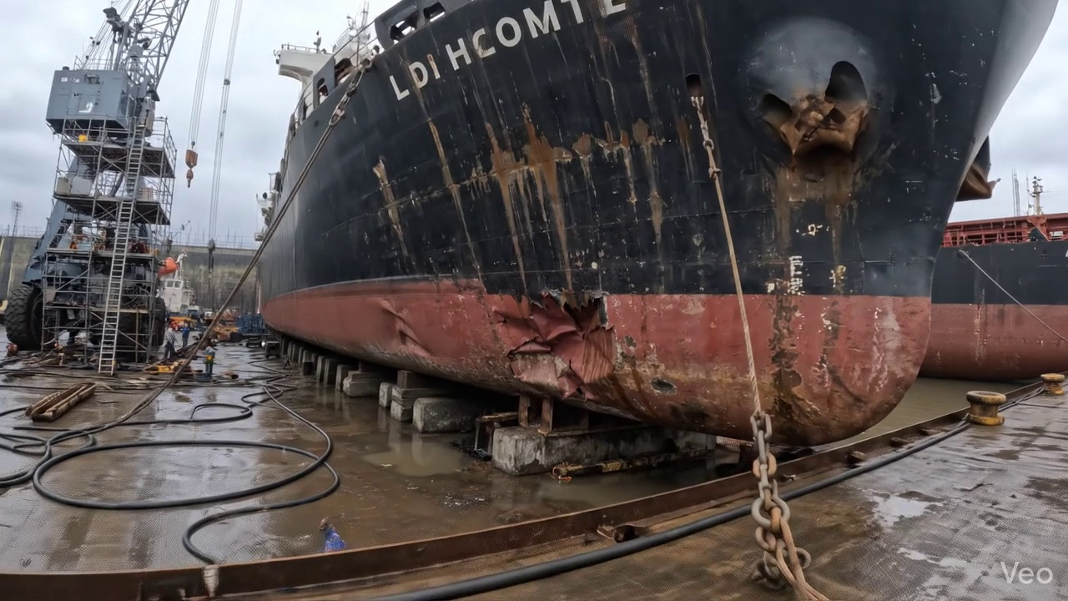

Repair Procedure
**Vessel Inspection Report - Explanation of Maritime Plate and Framing Repair Process**
This report details the standard professional procedures for repairing buckled plating and associated framing on a vessel, outlining the necessity, process, use of specified equipment, and critical safety and structural considerations for each stage.
---
**1. Assessment**
* **Necessity:** This initial step is critical for comprehensively understanding the full extent of the damage. It prevents both under-repairing (which could lead to premature failure) and over-repairing (which wastes resources). A precise assessment guides the entire repair strategy.
* **Process:** The damaged region is visually inspected to identify the extent of deformation. The buckled area is marked, and a determination is made whether the damage is localized to a small area or affects multiple structural frames and stiffeners. Measurements are taken to quantify any out-of-flatness or deviation from the original design contour.
* **Required Items Use:** No specialized equipment is specifically listed or used for this initial visual and measurement phase.
* **Safety & Structural Considerations:** Structurally, this ensures that the repair scope addresses all compromised material and does not leave hidden damage that could propagate. Safety involves identifying any immediate hazards posed by the compromised structure itself, such as areas of potential collapse or sharp edges.
---
**2. Preparation**
* **Necessity:** This step ensures that all compromised, distorted, or weakened material is removed, providing a sound, clean foundation for the new structural components. Welding to damaged material can lead to poor weld quality and premature failure of the repair. Leaving a margin of sound metal ensures that the heat-affected zone of new welds does not overlap with previously stressed or fatigued material.
* **Process:** All visibly distorted plating, along with any buckled girders or stiffeners, are carefully cut away. This cutting extends into sound, undamaged metal, leaving a minimum margin equal to three-quarters (¾) of the plate thickness beyond the visible damage. Any bent framing that is not to be replaced is either straightened in situ using controlled heat and mechanical force or removed for refurbishment/replacement.
* **Required Items Use:** The **Cutting Torch (rental)** is an essential tool in this phase. It is utilized to thermally cut away the compromised steel plate and structural members efficiently and precisely.
* **Safety & Structural Considerations:**
* **Safety:** This is a "hot work" operation requiring strict adherence to safety protocols. A hot work permit is mandatory, along with a dedicated fire watch, appropriate Personal Protective Equipment (PPE) (e.g., welding helmets, flame-retardant clothing, gloves), and readily available fire extinguishing equipment. Adequate ventilation is crucial to remove fumes generated by the cutting process.
* **Structural:** Precise cutting minimizes material waste while ensuring all fatigued or damaged material is removed. The specified margin of sound metal is a critical structural safeguard, ensuring subsequent welds are made to structurally competent material, thereby maintaining the integrity and strength of the repair.
---
**3. Plate Replacement**
* **Necessity:** To restore the vessel's original structural integrity, strength, and watertight/weathertight envelope by integrating new, undamaged material into the hull or deck structure.
* **Process:** A new steel plate is fabricated to precisely match the dimensions and contour of the cut-out section. The new plate typically matches or exceeds the original plate thickness and material specification. This plate is then carefully positioned against the remaining sound hull plating, ensuring accurate fit-up and alignment. It is temporarily secured in place with tack welds. Once alignment is verified, continuous welding commences along the entire perimeter, with careful attention to achieving full fusion and, where specified, applying appropriate preheat to manage material stresses and prevent cracking. Full penetration welds are employed where design and classification society requirements dictate, to maximize structural strength.
* **Required Items Use:** The listed **Cutting Torch (rental)** is not directly used in this phase, though related cutting equipment (e.g., plasma tables) would be used in the fabrication shop for shaping the new plate.
* **Safety & Structural Considerations:**
* **Safety:** Hot work protocols, fire watch, PPE, and ventilation remain critical during welding operations. Proper rigging and lifting procedures are necessary for handling the new plate.
* **Structural:** Correct material selection is paramount. Precise fit-up minimizes residual stress and ensures optimal weld quality. Proper preheat, especially for thicker or higher-strength steels, is crucial to prevent hydrogen-induced cracking. Full penetration welds are vital for primary structural elements to ensure maximum load transfer capability.
---
**4. Alignment and Welding**
* **Necessity:** This step completes the permanent integration of the new plate, ensuring it performs as a cohesive part of the vessel's structure. Effective distortion control is vital to maintain the vessel's original lines, prevent new stress concentrations, and ensure hydrodynamic efficiency.
* **Process:** Continuous weld passes are applied using approved electrodes, such as E7018, which is a low-hydrogen electrode known for its good mechanical properties and resistance to cracking, suitable for structural steel welding. Throughout the welding process, techniques such as controlled weld sequencing, intermittent welding, or the use of mechanical restraints (clamps, strongbacks) are employed to manage and minimize distortion induced by heat. Post-weld, all weld seams are ground fair and smooth to match the adjacent hull plating, reducing stress risers and improving the cosmetic appearance and hydrodynamic flow. In situations where the original buckling was extensive or the area is subject to high stresses, additional structural strengthening, such as doubler plates or new stiffeners, may be designed and applied to enhance the local resistance to future deformation.
* **Required Items Use:** The listed **Cutting Torch (rental)** is not directly used in this phase. Welding machines, electrodes, and grinding equipment are the primary tools.
* **Safety & Structural Considerations:**
* **Safety:** Continued adherence to hot work safety, PPE for welding and grinding, and fume extraction are essential.
* **Structural:** The use of specific electrodes like E7018 is a structural choice to ensure high-quality welds. Effective distortion control is vital for maintaining the vessel's geometry and preventing internal stresses. Grinding welds fair reduces stress concentrations and improves fatigue life. The application of additional strengthening is a proactive structural measure to enhance the long-term resilience of the repaired area.
---
**5. Finishing**
* **Necessity:** This final stage ensures that the repair meets all quality standards, provides long-term corrosion protection, and restores the vessel's aesthetic and functional contours.
* **Process:** The completed repair undergoes thorough inspection, including visual examination for defects, correct contour, and weld integrity. Non-Destructive Testing (NDT) methods (e.g., Dye Penetrant, Magnetic Particle, Ultrasonic, or Radiographic Testing) are performed on the welds as per classification society requirements to detect any subsurface flaws. Once the repair is verified, the new steel surfaces are meticulously cleaned and prepared. A multi-coat paint system, typically comprising primer and finish coats, is then applied to restore the corrosion protection to match the surrounding hull or deck. Finally, the repaired deck or hull surface is faired back to its original contour, ensuring smooth integration and preventing any adverse effects on hydrodynamic performance or deck drainage.
* **Required Items Use:** No specialized equipment is explicitly listed or used in this final inspection and coating application phase.
* **Safety & Structural Considerations:**
* **Safety:** Working with paints and coatings requires adequate ventilation, respiratory protection, and skin protection due to chemical exposure. Working at height protocols may apply if the repair is on the hull or superstructure.
* **Structural:** NDT is a critical quality assurance measure, ensuring the integrity and strength of the welds. The application of a robust coating system is essential for preventing corrosion, which is vital for the long-term structural integrity and lifespan of the repair. Fairing maintains the vessel's design hydrodynamics and structural continuity.

Repair Cost Breakdown
Item | Quantity | Unit Cost | Total Cost | Currency
Cutting Torch (rental) | 0.08 | 10764.0 | 807.3 | INR
Estimated Repair Cost: 41583.53 INR

3.3 PD_3

Defect Overview
**Defect Name: DEFORMATION**
**Severity: High**
**1. What the defect means:**
Deformation, specifically manifesting as buckling or warping, refers to an out-of-plane deviation of the vessel's hull plating or structural stiffeners from their intended planar configuration. This occurs when the material yields under excessive compressive or shear stresses, such as those imposed by grounding impacts, severe heavy sea loads, or localized heat stress from welding processes. This defect has been identified across significant portions of the HULL_AREA and KEEL_AREA, indicating its presence in critical structural zones.
**2. Why it is important:**
This defect is deemed of 'High' severity due to its direct and significant impact on the vessel's primary structural integrity. Even seemingly moderate buckles can severely impair the hull girder's ability to withstand operational stresses, compromising the fundamental strength and rigidity of the entire vessel. The presence of deformation in critical areas like the HULL_AREA and KEEL_AREA is particularly concerning as these regions are fundamental to the vessel's overall strength and watertight integrity.
**3. Risks if not repaired:**
Failure to rectify significant deformation poses critical risks. The compromised structural members are more susceptible to fatigue cracks, progressive yielding, or sudden brittle fracture under subsequent operational loads. This directly increases the probability of structural failure, potential breaches of the watertight envelope leading to water ingress, loss of stability, and ultimately, a severe risk to vessel safety, crew, and cargo. Continued operation with significant deformation can accelerate further damage and potentially lead to catastrophic structural collapse.
**4. Structural implications:**
Structurally, deformation signifies a reduction in the section modulus and moment of inertia of the affected components, which are critical parameters for resisting bending and shear forces. The out-of-plane distortion creates stress concentrations and reduces the effective load-bearing area, severely diminishing the hull girder's overall longitudinal and transverse strength. This impairment compromises the vessel's design margins for safety and operational resilience. Classification societies typically mandate that significant buckling be rectified by cutting out and replacing the distorted material to restore the original structural integrity and compliance with design specifications. Localized set-in plating may sometimes be tolerated if minimal and carefully assessed, but significant buckling on the hull and keel areas necessitates renewal to prevent catastrophic failure.

Visual Evidence
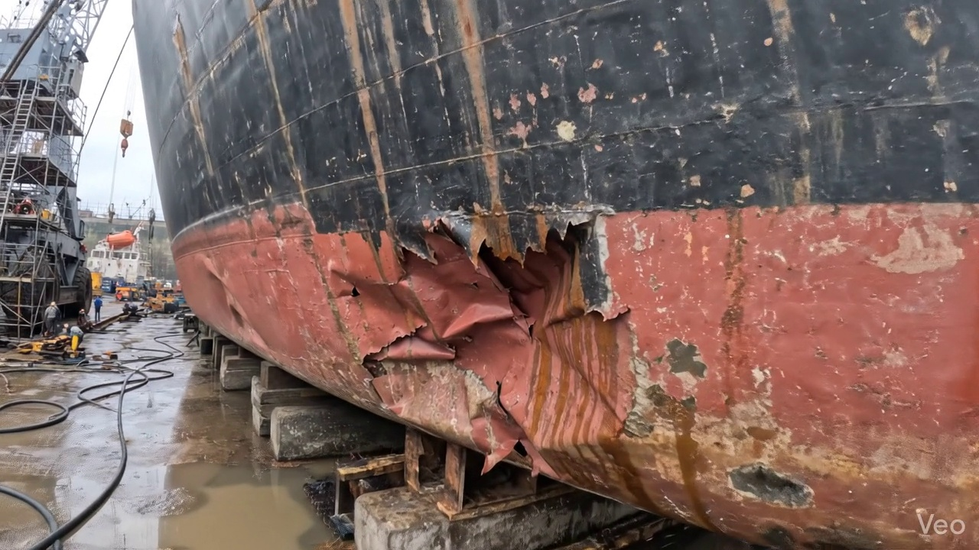

Repair Procedure
This document details the critical steps and considerations for a maritime steel repair process, as would be presented in a vessel inspection report. The objective of this repair is to restore the structural integrity, watertightness, and original contour of the affected hull or deck structure following localized deformation or damage.
---
### **Maritime Steel Repair Process: Detailed Explanation**
**Overall Repair Objective:** To effectively repair localized steel plate deformation and associated structural elements, ensuring the restored area meets classification society standards for structural integrity, fatigue resistance, and corrosion protection, thereby maintaining the vessel's seaworthiness and operational safety.
---
#### 1. Assessment
* **Purpose/Necessity:** This initial step is paramount for defining the scope of the repair. It ensures that the full extent of the damage is understood, preventing premature repair of only superficial deformation and overlooking critical structural weaknesses. Accurate assessment informs material selection, repair methodology, and resource allocation.
* **Procedure/Action:** Naval architects and experienced marine surveyors physically inspect the damaged region. They meticulously mark the buckled or deformed area to delineate its boundaries. Investigation involves determining if the deformation is localized to a single plate section or if it has propagated to adjacent stiffeners, girders, or multiple frames. Precise measurements of "out-of-flatness" (deviation from the original plane) are taken using appropriate tools (e.g., straight edges, feeler gauges, laser alignment tools) to quantify the degree of distortion.
* **Safety & Structural Considerations:** A thorough assessment is critical to identifying potential stress concentrations or micro-cracks that might not be immediately visible, which could compromise the repair if not addressed. It also helps to determine if temporary shoring or support is required before cutting commences to prevent further structural collapse.
#### 2. Preparation
* **Purpose/Necessity:** The objective of preparation is to remove all compromised material, including fatigued, cracked, or excessively deformed steel, ensuring that new steel is welded only to sound, undamaged parent metal. This foundation is crucial for achieving a robust and long-lasting repair joint free from latent defects. The specified margin (≥¾ thickness) provides ample clean surface for quality welding.
* **Procedure/Action:** Skilled hot-work technicians meticulously cut away all identified distorted plate material, along with any buckled girders, stiffeners, or other supporting structures that show signs of deformation or damage. This cutting is performed to "sound metal," meaning the remaining structure is free from cracks, fatigue, or significant distortion. A minimum margin of good, undamaged plate (at least three-quarters of the plate's thickness, e.g., for a 12mm plate, at least 9mm of sound material) is left around the cutout to provide a stable base for the new weld. Any bent framing adjacent to the cutout is either straightened to its original profile using heat and mechanical force or entirely removed and replaced if irreparable.
* **Associated Equipment/Materials:**
* **Cutting Torch (rental):** This item is indispensable during the preparation phase. A cutting torch (typically oxy-fuel or plasma) provides the high temperature and concentrated flame/arc necessary to efficiently and precisely sever steel plate and structural members. Its use is vital for rapidly removing the damaged sections to sound metal, creating the cutout for the new plate. The rental nature indicates project-specific use rather than permanent ownership, common for specialized equipment.
* **Safety & Structural Considerations:** Strict hot-work procedures are mandatory, including fire watches, gas detection, and ventilation to prevent fires or explosions. Care must be taken during cutting to avoid accidental damage to adjacent sound structure or internal components. The structural integrity of the remaining hull must be monitored, especially if large sections are removed, to prevent uncontrolled collapse.
#### 3. Plate Replacement
* **Purpose/Necessity:** This step restores the original structural continuity, watertight integrity (if applicable), and designed strength of the hull or deck. The new plate must precisely match the removed section to ensure proper fit-up and subsequent welding quality.
* **Procedure/Action:** A new steel plate, fabricated from material of the same or greater thickness and grade as the original (e.g., shipbuilding mild steel or high tensile steel), is precisely cut and shaped to match the dimensions and curvature of the created cutout. The edges of the new plate are prepared (e.g., chamfered) to facilitate welding. This new plate is then carefully positioned against the remaining hull plating. Once accurate alignment is achieved, the plate is secured with tack-welds – small, intermittent welds that temporarily hold it in place. Subsequently, continuous welding commences all around the perimeter of the new plate, ensuring good fusion with the parent material. Appropriate preheat (temperature application before welding) is applied, particularly for thicker plates or higher-strength steels, to mitigate hydrogen-induced cracking and reduce residual stress. Full penetration welds, where the weld metal extends through the entire thickness of the plate joint, are performed wherever structurally feasible to maximize strength and continuity.
* **Safety & Structural Considerations:** Proper fit-up is crucial; excessive gaps or misalignment lead to weaker welds. Preheat parameters must be strictly followed according to approved weld procedures. Welders must be qualified, and welding consumables (electrodes) stored correctly to prevent moisture absorption. Quality control checks (e.g., interpass cleaning, visual inspection) are performed throughout the welding process.
#### 4. Alignment and Welding
* **Purpose/Necessity:** This stage focuses on completing the permanent structural connection while managing the metallurgical effects of welding, specifically thermal distortion, to ensure the repaired area is structurally sound, free from excessive residual stresses, and fair with the hull profile.
* **Procedure/Action:** Continuous weld passes are systematically applied to build up the weld joint, typically utilizing low-hydrogen E7018 electrodes. These electrodes are preferred for their superior mechanical properties, good toughness, and reduced risk of hydrogen embrittlement. Throughout the welding process, technicians actively monitor for thermal distortion. If distortion occurs, it is controlled using mechanical clamps, strongbacks, or by employing minimal heat input techniques (e.g., skip welding, controlled cooling sequences) to prevent excessive warpage. Upon completion of welding, the weld seams are carefully ground fair with the surrounding hull surface. This grinding removes weld spatter, irregularities, and provides a smooth transition, which improves hydrodynamics, reduces stress concentration points, and enhances aesthetic appeal. In instances where the original buckling was extensive, or if the structural analysis indicates a need for enhanced strength, additional reinforcement in the form of doublers (overlapping plates) or stiffeners (structural members that increase rigidity) may be strategically applied to distribute stresses more effectively and increase the section's resistance to future deformation.
* **Safety & Structural Considerations:** Use of E7018 electrodes requires proper storage (drying ovens) to maintain their low-hydrogen properties. Distortion control is vital to prevent residual stresses that can lead to premature fatigue cracking. Grinding operations require eye and respiratory protection. The design and welding of doublers or stiffeners must be engineered to prevent new stress concentration points.
#### 5. Finishing
* **Purpose/Necessity:** The final step ensures the quality and integrity of the repair are verified through inspection, provides essential corrosion protection to the newly exposed steel, and restores the vessel's exterior profile for optimal performance and appearance.
* **Procedure/Action:** Following all welding and grinding, the repaired area undergoes rigorous inspection. This includes comprehensive visual inspection for surface defects (e.g., cracks, porosity, undercut, inadequate fusion) and non-destructive testing (NDT) methods. Common NDT techniques include Magnetic Particle Testing (MPT) for surface and near-surface cracks, Ultrasonic Testing (UT) for internal defects like porosity or lack of fusion, and occasionally Radiographic Testing (RT) for more critical internal flaw detection. Once the repair passes all inspections, the new steel surface is thoroughly cleaned to remove all contaminants, spatter, and grinding dust. A marine-grade primer coat is then applied, followed by appropriate finish coats (e.g., anti-corrosive, anti-fouling) to restore the vessel's original corrosion protection system and aesthetic appearance. Finally, the deck or hull surface is faired back to its original contour, ensuring a smooth, seamless transition that minimizes drag and maintains the vessel's hydrodynamic efficiency.
* **Safety & Structural Considerations:** NDT ensures that hidden defects are detected before the vessel returns to service, preventing catastrophic failure. Proper surface preparation and coating application are critical for long-term corrosion prevention. Personnel performing NDT must be certified, and all coatings applied in accordance with manufacturer specifications and environmental regulations.
---
This comprehensive repair methodology, when executed by qualified personnel and subject to stringent quality control, ensures the damaged structure is fully restored to a condition that meets or exceeds design specifications and regulatory requirements.

Repair Cost Breakdown
Item | Quantity | Unit Cost | Total Cost | Currency
Cutting Torch (rental) | 0.12 | 10764.0 | 1345.5 | INR
Estimated Repair Cost: 69305.88 INR

3.4 PD_4

Defect Overview
**Subject: Vessel Inspection Report – Defect Explanation: DEFORMATION (High Severity)**
This report details the nature, importance, risks, and structural implications of the identified "DEFORMATION" defect with a High Severity rating, predominantly affecting the Keel Area and Hull Area of the vessel.
---
### **1. What the Defect Means:**
Deformation, in the context of this inspection, refers to the **out-of-plane bending of the vessel's hull plating or structural stiffeners**. This manifests as visible **buckling or warping** of the metal surface. It indicates that the material has undergone plastic deformation beyond its elastic limit.
The identified deformation affects critical areas, with significant overlap in the **KEEL_AREA (45.8%)** and **HULL_AREA (45.8%)**. Common causes for such deformation include:
* **Grounding impacts:** Direct physical contact with the seabed or other objects.
* **Heavy sea loads:** Extreme forces exerted by waves during adverse weather conditions.
* **Uneven welding or welding heat stress:** Localized thermal stresses introduced during fabrication or repair processes, leading to distortion.
While minor, localized set-in plating might sometimes be tolerated if very small and non-critical, the identified deformation is significant, indicating a substantial structural anomaly.
### **2. Why It Is Important:**
This defect is classified with **HIGH SEVERITY** because even moderate buckles can **severely impair the hull girder strength** of the vessel. The hull girder is the primary load-bearing structure of the ship, analogous to the backbone of an animal. Any compromise to its integrity directly impacts the vessel's overall strength and ability to withstand operational stresses.
Classification societies universally mandate the correction of such buckling. Standard practice involves cutting out and replacing the distorted metal to restore the original structural integrity and design specifications. This underscores the critical nature of the defect and the immediate need for remedial action.
### **3. Risks If Not Repaired:**
Failure to repair significant deformation carries substantial risks, including:
* **Reduced Seaworthiness:** The vessel's ability to safely operate in its intended environment is compromised.
* **Progressive Failure:** The deformed area is a weak point. Under normal operational loads (e.g., wave bending, static loads), stresses will concentrate at these points, potentially leading to the propagation of cracks, further buckling, or even catastrophic tearing of the plating.
* **Loss of Watertight Integrity:** While deformation primarily affects strength, severe buckling could lead to cracking and subsequent breach of the hull, compromising watertight compartments.
* **Increased Fatigue Damage:** The localized stress concentrations at the buckle edges can accelerate metal fatigue, leading to premature cracking in adjacent, seemingly undamaged material.
* **Regulatory Non-Compliance:** Unrepaired high-severity deformation will result in detention or operational restrictions by classification societies and port state control, affecting the vessel's ability to trade.
### **4. Structural Implications:**
The structural implications of deformation are profound, particularly given its high severity and location in the Keel and Hull areas:
* **Compromised Hull Girder Strength:** The primary implication is a direct reduction in the vessel's ability to resist global bending, shear, and torsional forces. The deformed plating and stiffeners can no longer carry their intended share of the load, shifting stress to adjacent, potentially undamaged structures, which may then become overstressed.
* **Alteration of Load Paths:** Deformation redistributes stresses throughout the structure in an unintended manner. This can create new, highly stressed zones that were not designed for such loads, leading to accelerated wear or failure in those areas.
* **Loss of Section Modulus and Moment of Inertia:** The out-of-plane bending effectively reduces the cross-sectional area and effectiveness of the structural elements. This directly lowers the hull girder's resistance to bending, making the vessel more susceptible to collapse under longitudinal or transverse loads.
* **Local Instability:** The buckled area itself represents local instability. This can propagate, leading to larger-scale structural collapse if the overall stress level increases.
* **Necessity for Renewal:** Due to these critical implications, the only acceptable remedy for significant deformation is typically the **renewal (cutting out and replacing)** of the affected plating and stiffeners. This process restores the structural integrity to its original design specification, ensuring the vessel's safety and compliance with maritime regulations.
---
In conclusion, the identified deformation is a critical structural defect that significantly compromises the vessel's hull girder strength and seaworthiness. Prompt and thorough repair, involving the renewal of the affected material, is essential to mitigate the serious risks and restore the vessel's structural integrity to an acceptable standard.

Visual Evidence
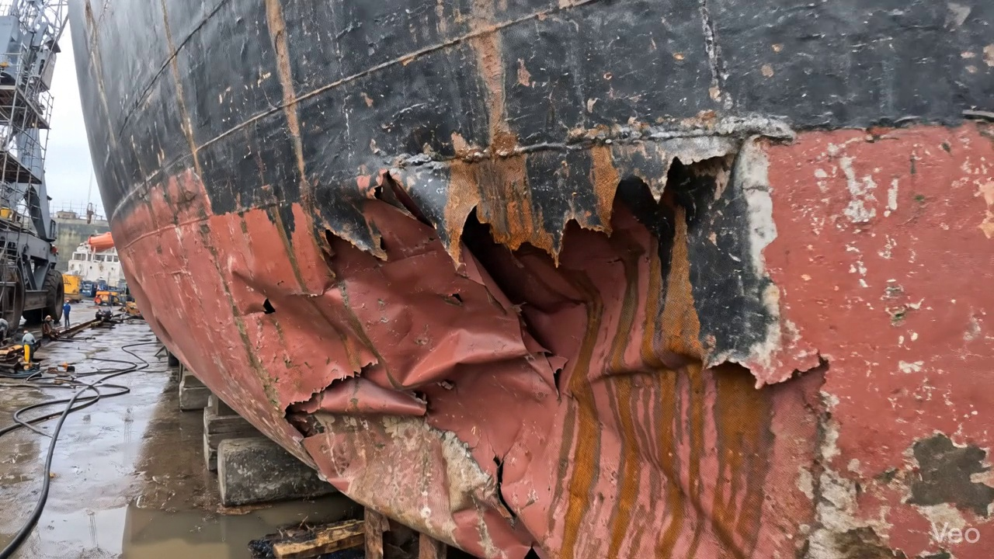

Repair Procedure
## Vessel Inspection Report: Explanation of Structural Steel Plate Renewal Process
**Subject:** Detailed explanation of the structural steel plate renewal process for a deformed region, including rationale for each step, procedural overview, equipment usage, and critical safety/structural considerations.
**Repair Process Overview:**
The outlined process details a standard procedure for renewing deformed or buckled steel plating on a vessel's hull or deck. This comprehensive approach ensures the restoration of the vessel's structural integrity, watertight/weathertight integrity, and compliance with classification society requirements.
---
### 1. Detailed Explanation of Each Repair Step:
**A. Assessment**
* **Why Necessary:** This initial phase is critical for accurately defining the scope and severity of the damage. It prevents insufficient repair (leaving compromised material) or excessive repair (unnecessary work). Proper assessment ensures that all affected structural members are identified, and the repair plan is tailored to fully restore the vessel's original strength and form.
* **What Happens:** Skilled personnel visually inspect the deformed region, meticulously marking the extent of the buckled area. They determine if the damage is localized to a single plate or extends to adjacent frames, girders, or stiffeners. Precise measurements of out-of-flatness are taken to quantify the deformation and inform the extent of material removal and replacement.
* **Safety & Structural Considerations:** Ensures that the entire compromised area is identified, preventing hidden defects from undermining the repair. Crucial for maintaining classification society standards and the vessel's overall structural integrity.
**B. Preparation**
* **Why Necessary:** This step removes all compromised material that cannot be effectively straightened or repaired, providing a sound, clean foundation for the new plate. Leaving a margin of good plate (≥¾ thickness) ensures that the new weld joints are made on structurally sound material, promoting optimal weld fusion and strength.
* **What Happens:** Utilizing thermal cutting equipment, all distorted plate, buckled girders, or stiffeners are precisely cut away to sound metal. The cut edges are then prepared (e.g., by grinding or bevelling) to facilitate good weld penetration. Any adjacent bent framing that would impede the fitting of the new plate or compromise the structural load path is either straightened in place or removed and renewed.
* **Safety & Structural Considerations:** Eliminates stress concentrators from the deformed material. Proper edge preparation is vital for achieving sound, full-penetration welds. Removal or straightening of bent framing ensures proper alignment and load transfer within the renewed structure, preventing future premature failure. Hot work safety protocols, including fire watch and combustible material removal, are paramount during this phase.
**C. Plate Replacement**
* **Why Necessary:** This step directly restores the structural continuity and design strength of the vessel's shell or deck. Using a plate of the same or greater thickness ensures that the renewed section meets or exceeds the original structural design specifications.
* **What Happens:** A new steel plate, fabricated to match the precise dimensions and contour of the cut-out, is prepared. This new plate is then carefully positioned against the remaining hull or deck plating. Tack welds are applied at strategic points to hold the plate securely in place while allowing for final adjustments. Once alignment is confirmed, continuous welding commences around the entire perimeter, ensuring good fusion between the new and existing material. Appropriate preheat is applied, especially for thicker plates or specific steel grades, to mitigate thermal stresses and prevent hydrogen-induced cracking. Full penetration welds are utilized where structural integrity demands it, maximizing joint strength.
* **Safety & Structural Considerations:** Selection of correct steel grade and thickness is paramount. Proper preheat and interpass temperatures are crucial for weld quality and preventing heat-affected zone (HAZ) issues. Certified welders are required to ensure compliance with approved welding procedures (WPS) and achieve sound welds.
**D. Alignment and Welding**
* **Why Necessary:** This phase completes the integration of the new plate into the vessel's structure, focusing on achieving a defect-free, structurally sound connection while minimizing residual stresses and distortion. E7018 electrodes are specifically chosen for their low hydrogen content, high ductility, and good mechanical properties, making them suitable for critical structural welding.
* **What Happens:** Continuing weld passes are applied using E7018 electrodes, following approved welding procedures. Throughout this process, close attention is paid to potential welding-induced distortion. If distortion occurs, remedial actions such as strategic clamping, controlled welding sequences (e.g., skip welding), or minimal heat input techniques are employed to maintain the plate's fairness and structural alignment. Once welding is complete, all weld seams are ground fair with the adjacent hull or deck surface to reduce stress concentrations, improve hydrodynamic efficiency, and present a smooth finish. In instances of extensive buckling, particularly if it indicates an underlying structural weakness, additional strengthening members like doubler plates or stiffeners may be incorporated to enhance local rigidity and reduce stress concentrations in the repaired area.
* **Safety & Structural Considerations:** Distortion control is essential to prevent new stress points and maintain the vessel's designed shape. E7018 electrodes help reduce the risk of hydrogen embrittlement in critical welds. Grinding welds fair reduces stress risers that can lead to fatigue cracking. Any additional strengthening must be properly engineered and integrated to ensure effective load transfer.
**E. Finishing**
* **Why Necessary:** This final stage confirms the quality and integrity of the entire repair and restores the vessel's corrosion protection and aesthetic appearance.
* **What Happens:** The completed repair is subjected to rigorous inspection. This includes visual inspection for surface defects and contour fairness, followed by Non-Destructive Testing (NDT) methods such as Magnetic Particle Testing (MPT), Dye Penetrant Testing (DPT), or Ultrasonic Testing (UT) to detect any subsurface or surface weld defects. Upon satisfactory inspection, marine-grade primer and subsequent finish coats are applied to the new steel, restoring the vessel's corrosion protection system. The deck or hull surface is carefully faired back to its original contour, ensuring smooth flow and preventing any adverse hydrodynamic or operational effects.
* **Safety & Structural Considerations:** NDT is paramount for validating weld quality and ensuring the structural integrity of the repair. Proper coating application is vital for long-term corrosion prevention, which directly impacts the structural lifespan of the renewed area. Fairing the surface prevents turbulence and stress points under operational conditions.
---
### 2. Why the Required Items are Used:
**A. Cutting Torch (rental)**
* **Why Used:** The cutting torch is an essential piece of equipment for the "Preparation" phase of this repair. It is utilized for the precise thermal cutting of the damaged and distorted steel plate, as well as any buckled girders or stiffeners that require removal. Its ability to quickly and effectively cut through steel is indispensable for creating the clean, defined opening required for the new plate insertion.
* **Cost Justification:** The item is listed as a "rental" (0.12 machine-days at a total cost of 1345.5 INR). This typically indicates that while critical for the repair, the specialized nature or infrequent requirement for such equipment makes renting a more cost-effective solution than outright purchase for the shipyard or repair facility. The `required_quantity` of 0.12 machine-days reflects the specific operational time estimated for cutting operations related to this particular repair scope.
---
### 3. Safety and Structural Considerations:
**A. Safety Considerations:**
* **Hot Work Procedures:** All cutting and welding operations constitute hot work, necessitating strict adherence to hot work permits, fire watch personnel, and the removal of combustible materials from the vicinity.
* **Personal Protective Equipment (PPE):** Welders and cutters must utilize appropriate PPE, including welding helmets, flame-retardant clothing, gloves, safety footwear, and eye/hearing protection.
* **Ventilation:** Adequate ventilation is crucial during welding and cutting to mitigate exposure to fumes and gases.
* **Confined Space Entry:** If the repair takes place within tanks or enclosed spaces, strict confined space entry protocols, including gas testing and attendant personnel, must be followed.
* **Stability:** For larger repairs, especially on the hull, temporary bracing or stability assessments may be required to maintain vessel stability during structural alterations.
**B. Structural Considerations:**
* **Classification Society Rules:** All repairs must comply with the relevant rules and regulations of the vessel's classification society (e.g., IACS Common Structural Rules), ensuring the structural equivalence or enhancement of the repaired area.
* **Material Specification:** New steel must be of the correct grade, thickness, and mechanical properties, as specified by original design or classification society requirements.
* **Welding Procedures (WPS & PQR):** Approved Welding Procedure Specifications (WPS) and Procedure Qualification Records (PQR) must be followed for all welding activities to ensure consistent weld quality and mechanical properties.
* **Welder Qualification:** Only certified welders, qualified to the specific welding processes and positions required, shall perform the work.
* **Load Path Integrity:** The repair must restore the original structural load paths, ensuring that stresses are effectively distributed throughout the vessel's structure without creating new stress concentrations.
* **Watertight/Weathertight Integrity:** The primary function of hull or deck plating, beyond structural strength, is to maintain the vessel's watertight or weathertight integrity. The repair must fully restore this function.
* **Non-Destructive Testing (NDT):** Mandatory NDT ensures the internal soundness and surface integrity of the welds, verifying the quality of the repair and preventing premature failure.
---
This detailed explanation confirms that the described repair process is structured to comprehensively address the damage, ensuring the professional and compliant restoration of the vessel's structural integrity.

Repair Cost Breakdown
Item | Quantity | Unit Cost | Total Cost | Currency
Cutting Torch (rental) | 0.12 | 10764.0 | 1345.5 | INR
Estimated Repair Cost: 69305.88 INR

