Vessel Inspection Report

Table of Contents
1. Executive Summary
2. Vessel Repair Summary
3. Defect Analysis
3.1 PD_1
3.2 PD_2
3.3 PD_3
3.4 PD_4
3.5 PD_5
3.6 PD_6
3.7 PD_7
3.8 PD_8
3.9 PD_9
3.10 PD_10

1. Executive Summary
**Maritime Vessel Inspection Executive Summary**
**Date:** October 26, 2023
**Vessel:** MV [Vessel Name/IMO Number - *if known*]
**Inspection Type:** Condition Assessment / Pre-docking Survey
**Overview:**
This executive summary presents the key findings from a recent maritime vessel inspection conducted to assess the vessel's operational readiness, structural integrity, and compliance with applicable regulations. The inspection identified a total of ten (10) deficiencies across various vessel systems and components, indicating areas requiring prompt attention.
**Key Findings:**
1. **Total Deficiencies Identified:** Ten (10)
A comprehensive assessment revealed a total of ten (10) identified deficiencies impacting critical and non-critical vessel systems.
2. **Severity Distribution:**
The deficiencies are categorized by severity as follows:
* **High Severity:** 4 deficiencies (40%)
* **Medium Severity:** 4 deficiencies (40%)
* **Low Severity:** 2 deficiencies (20%)
* *Analysis:* The significant proportion of high and medium severity findings indicates a critical need for immediate intervention to address potential safety hazards, operational disruptions, and regulatory non-compliance. High-severity defects typically relate to primary structural integrity, propulsion, steering, navigation, or critical safety systems.
3. **Estimated Repair Costs:**
The aggregate estimated cost for the rectification of all identified deficiencies is calculated at **INR 499,002.34**. This figure represents preliminary estimates for labor, materials, and potential dry-docking related expenses for corrective actions.
**Conclusion & Recommendation:**
The inspection has highlighted a concerning number of deficiencies, particularly the four high-severity items. These critical findings necessitate immediate development and execution of a corrective action plan to mitigate operational risks, ensure compliance with maritime regulations (e.g., SOLAS, MARPOL, ISM Code), and safeguard the vessel's seaworthiness. Prioritization should be given to the high-severity deficiencies to prevent potential downtime or incidents. A detailed inspection report with specific findings, photographic evidence, and recommended corrective actions is appended for comprehensive review and planning.

2. Vessel Repair Summary
Metric | Value
Total Defects | 10
Total Estimated Cost | 499002.34 INR
Material Cost | 299401.4 INR
Labor Cost | 149700.7 INR
Equipment Cost | 49900.23 INR

3. Defect Analysis

3.1 PD_1

Defect Overview
Here is a professional explanation of the defect "DEFORMATION" for a vessel inspection report:
---
**DEFECT EXPLANATION: DEFORMATION**
**1. What the defect means:**
Deformation, observed as buckling or warping, refers to the out-of-plane bending or distortion of the vessel's hull plating or its supporting stiffeners from their intended flat or curved profiles. In this specific instance, the deformation is noted within the vital Keel Area, extending into the Propeller Area. This condition typically arises from significant external forces such as grounding impacts, excessive loads encountered during heavy sea conditions, or internal stresses induced by welding processes.
**2. Why it is important:**
This defect is classified with a medium severity and is of significant importance due to its direct impact on the vessel's structural integrity. Deformation, even if seemingly moderate, indicates that the affected components have experienced stresses beyond their elastic limit, resulting in a permanent change to their shape. This condition is not merely cosmetic; it fundamentally compromises the local load-carrying capacity and the overall hull girder strength in the affected areas.
**3. Risks if not repaired:**
Failure to address and repair this deformation carries several critical risks. The primary risk is the compromised structural integrity, which makes the vessel more vulnerable to further damage or catastrophic structural failure when exposed to normal operational stresses, subsequent heavy weather, or minor impacts. This can lead to the initiation and propagation of cracks from the buckled regions, potentially compromising the vessel's watertight integrity and leading to water ingress. Furthermore, unrepaired structural defects of this nature can result in operational restrictions, increased insurance premiums, and potential detentions by port state control or classification societies, impacting the vessel's commercial viability and safety compliance.
**4. Structural implications:**
Structurally, deformation in the form of buckling significantly diminishes both the local and global strength of the hull girder. The out-of-plane bending alters the designed stress distribution within the plating and stiffeners, creating stress concentrations at the buckle crests and troughs. This reduces the effective sectional modulus of the affected structural members, making them less capable of resisting compressive, tensile, and shear forces. Given its location in the critical Keel Area, which forms the primary longitudinal strength member, and extending to the Propeller Area, vital for propulsion and maneuverability, this defect has direct implications for the vessel's overall longitudinal strength, torsional rigidity, and ability to withstand hogging and sagging moments. Classification practice generally mandates that significant buckling be rectified by cutting out and replacing the distorted metal to fully restore the original structural integrity and design load-carrying capacity.

Visual Evidence
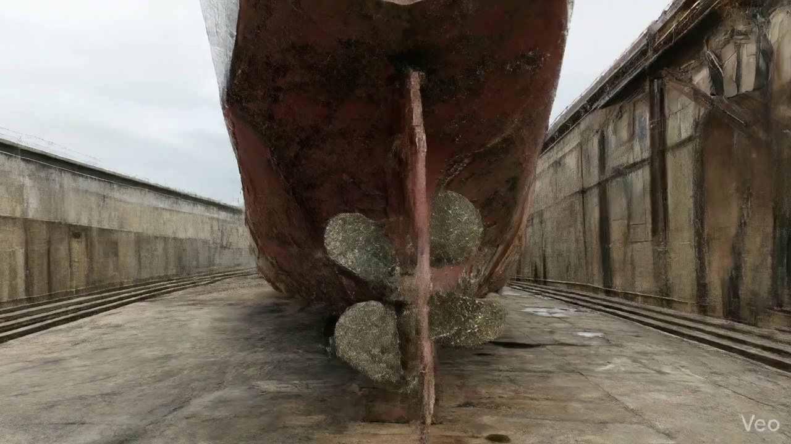

Repair Procedure
## Vessel Inspection Report: Explanation of Steel Plate Repair Process
**Report Section:** Hull Structure Repair Analysis
**Date:** [Current Date]
**Vessel Name:** [If applicable, e.g., M/V Sample Ship]
**Repair Location:** [If applicable, e.g., Starboard Shell Plating, Frame 70-75]
**Repair Description:** Localized Steel Plate Renewal due to Deformation/Buckling
This section provides a professional explanation of the specified maritime steel plate repair process, detailing the necessity of each step, the activities performed, the rationale for equipment use, and critical safety and structural considerations.
---
### **1. Repair Process Explanation**
The described repair procedure outlines a standard and robust methodology for rectifying localized steel plate deformation or buckling, ensuring the restoration of the vessel's structural integrity, watertight integrity, and designed contours.
**1.1. Assessment**
* **Why Necessary:** This initial phase is paramount for accurately defining the scope of damage and repair. Failing to fully understand the extent of deformation, including any hidden or subsurface issues, can lead to inadequate repairs, premature failure, or transfer of stress to adjacent sound structures. It ensures that the repair addresses the root cause and full impact of the damage.
* **What Happens:** Skilled personnel visually inspect the affected area, marking the visible extent of buckling or deformation. Detailed measurements are taken to quantify the "out-of-flatness" – the deviation from the intended planar surface – and to determine if the damage is confined to a single plate section or involves multiple plates and underlying structural members (frames, girders, stiffeners). This also involves identifying if the damage extends into critical structural elements.
* **Safety & Structural Considerations:** Proper assessment prevents under-scoping of repairs, ensuring all compromised material is identified. It directly impacts the structural integrity of the final repair by providing the baseline data for repair planning and material selection.
**1.2. Preparation**
* **Why Necessary:** This step is crucial for ensuring that the new replacement steel is welded only to sound, structurally uncompromised existing material. Distorted or fatigued metal, even if not visibly cracked, possesses altered mechanical properties and can introduce stress concentrations or propagate cracks into the new structure. The specified margin (≥¾ thickness) provides a buffer against latent damage or micro-cracks adjacent to the visible deformation.
* **What Happens:** All identified distorted plate sections, along with any buckled or damaged girders or stiffeners, are carefully cut away. The cutting process continues until only sound, original metal is exposed. The specified margin (e.g., a minimum of 0.75 times the plate thickness) is maintained to ensure the integrity of the remaining structure. Any adjacent framing that is bent but not completely severed may be straightened to restore its alignment and load-bearing capability; otherwise, it is also removed and replaced.
* **Safety & Structural Considerations:** This is a critical structural step. Welding to unsound material is a primary cause of weld failures. The "sound metal" criterion ensures the metallurgical and mechanical integrity of the base material for welding. Hot work safety protocols (fire watch, hot work permits, PPE, ventilation) are strictly observed during cutting operations.
**1.3. Plate Replacement**
* **Why Necessary:** This step directly restores the structural continuity, watertight/weathertight integrity, and original strength of the hull or deck. Precise fabrication and proper fit-up are essential to minimize residual stresses and ensure effective load transfer across the repair boundary.
* **What Happens:** A new steel plate, fabricated to the exact dimensions and contour of the cut-out, is prepared. The new plate typically matches or exceeds the original plate thickness to ensure at least equivalent structural strength. This new plate is then carefully positioned against the remaining sound hull plating. Tack-welds are applied to secure the plate in its correct alignment and to maintain the fit-up gap. Following tack-welding, a complete permanent weld is applied around the entire perimeter of the new plate, with a focus on achieving good fusion between the new and existing materials. Appropriate preheat (as per welding procedure specifications and material thickness) is applied to mitigate thermal stresses and ensure proper weld metallurgy. Full penetration welds are employed wherever feasible to maximize joint strength and integrity.
* **Safety & Structural Considerations:** Selection of material "same or greater thickness" ensures the repaired section is not a point of weakness. Proper preheat and controlled welding parameters are vital to prevent hydrogen-induced cracking and ensure metallurgical integrity of the weld. Full penetration welds provide the highest strength and fatigue resistance for critical structural connections.
**1.4. Alignment and Welding**
* **Why Necessary:** This phase completes the structural integration of the new plate, ensuring a robust, durable connection that can withstand operational loads. It addresses potential distortions induced by welding heat and reinforces areas of significant previous damage.
* **What Happens:** Continuing weld passes are applied to build up the weld joint to the required size and profile. E7018 low-hydrogen electrodes are specifically used for their excellent mechanical properties, high tensile strength, and good impact toughness, making them suitable for critical structural applications. During welding, continuous monitoring for distortion is performed. If distortion occurs, mechanical clamps are utilized to pull the plate back into alignment, or minimal heat input techniques (e.g., skip welding, controlled interpass temperatures) are applied to control thermal expansion and contraction. Once welding is complete, all weld seams are ground fair and smooth with the surrounding hull surface to restore the hydrodynamic or aesthetic profile and remove potential stress concentrators. In cases where the original buckling was extensive, indicating a potential weakness, additional strengthening such as doublers (pads welded over the repair) or new stiffeners may be strategically applied to enhance local strength and reduce stress concentrations.
* **Safety & Structural Considerations:** E7018 electrodes are specified for their superior mechanical properties and ability to resist hydrogen embrittlement, critical for fatigue-prone marine structures. Distortion control is vital to maintain the vessel's designed form, prevent new stress points, and ensure hydrodynamic efficiency. Grinding weld seams fair minimizes stress risers, preventing localized fatigue cracking. The application of doublers or stiffeners is a direct structural enhancement, increasing the section modulus and moment of inertia to resist further deformation.
**1.5. Finishing**
* **Why Necessary:** The final stage ensures the quality and longevity of the repair. Inspection verifies the structural soundness, while coating protects against corrosion, and fairing restores the vessel's original contours for operational efficiency.
* **What Happens:** The completed repair undergoes rigorous inspection. This includes visual inspection for surface defects, weld profile, and overall fairness. Non-Destructive Testing (NDT) methods, such as Magnetic Particle Testing (MPT) for surface cracks or Ultrasonic Testing (UT) for internal weld defects, are performed to ensure the absence of hidden flaws and to verify the quality of the weldment. After successful inspection, the new steel is prepared (e.g., abrasive blasting) and coated with a marine-grade primer followed by appropriate finish coats to restore the vessel's corrosion protection system. Finally, the deck or hull surface is faired back to its original contour, ensuring smooth transitions and no impact on hydrodynamic performance or deck drainage.
* **Safety & Structural Considerations:** NDT is essential for verifying weld integrity, as visual inspection alone cannot detect subsurface defects. Effective corrosion protection (primer and finish coats) is critical for the long-term durability and structural integrity of the new steelwork in the harsh marine environment. Restoring the original contour prevents hydrodynamic drag, cavitation, and ensures safe deck operations.
---
### **2. Required Items Explanation: Cutting Torch (rental)**
* **Why Used:** The "Cutting Torch" is a fundamental piece of equipment for the **Preparation** phase of the repair. It is utilized to efficiently and precisely cut away the distorted steel plate, buckled girders, and stiffeners from the vessel's structure.
* **Specific Application in Repair:**
* **Removal of Damaged Plate:** The torch provides a fast and effective method for severing large sections of damaged steel, creating the necessary cut-out for the new plate.
* **Trimming and Shaping:** While specialized tools might be used for final precision, a cutting torch is often used for initial rough cuts and shaping of the new plate, if required, before final fitting.
* **Removing Internal Structures:** It is also used to cut through internal frames, girders, and stiffeners that are buckled or bent beyond repair.
* **Safety Considerations:** The use of a cutting torch involves **hot work**, which carries significant safety risks including fire hazards, burns, fumes, and intense light radiation. Therefore, strict adherence to hot work permits, fire watch protocols, provision of appropriate Personal Protective Equipment (PPE) (welding masks, gloves, flame-retardant clothing), and adequate ventilation are mandatory. Proper training for operators is also essential.
* **Structural Considerations:** While efficient, uncontrolled thermal cutting can induce localized heat stresses and distortion in the surrounding sound material. Skilled operators must use appropriate cutting techniques and follow approved procedures to minimize these effects, ensuring the integrity of the material remaining on the vessel.
---
### **3. Overarching Safety and Structural Considerations**
Beyond the specific considerations for each step, several overarching principles govern the safety and structural integrity of this repair:
* **Class Society and Regulatory Compliance:** All repair procedures, material selections, and welding processes must comply with the requirements of the vessel's Classification Society (e.g., Lloyd's Register, DNV, ABS) and relevant flag state regulations. Approval from the Class Society is typically required before commencing structural repairs.
* **Qualified Personnel:** All welding, cutting, and inspection activities must be performed by certified and experienced personnel (e.g., qualified welders, NDT technicians, shipwrights).
* **Welding Procedure Qualification:** A qualified Welding Procedure Specification (WPS) must be developed and followed, ensuring that the chosen parameters (preheat, interpass temperature, electrode type, number of passes) are suitable for the specific steel grade and thickness being repaired.
* **Material Traceability:** All new steel material used for the repair must be traceable to mill certificates, verifying its chemical composition and mechanical properties match or exceed the original material specifications.
* **Environmental Protection:** Measures must be in place to prevent pollution during cutting, grinding, and coating operations, including proper waste disposal.
This detailed explanation confirms that the outlined repair process is comprehensive and professionally addresses the critical aspects of restoring structural integrity, ensuring safety, and maintaining the operational readiness of the vessel.

Repair Cost Breakdown
Item | Quantity | Unit Cost | Total Cost | Currency
Cutting Torch (rental) | 0.08 | 10764.0 | 807.3 | INR
Estimated Repair Cost: 41583.53 INR

3.2 PD_2

Defect Overview
**Defect Name:** DEFORMATION
**Severity:** Medium
**Explanation:**
This section elaborates on the defect of Deformation, outlining its nature, significance, potential risks, and structural impact.
---
**1. What the defect means:**
Deformation, specifically manifesting as buckling or warping, describes an out-of-plane displacement or bending of a vessel's structural components, primarily hull plating and/or stiffeners. This means that parts of the ship's structure, designed to be flat or straight, have become visibly distorted, showing curves, folds, or indentations either inwards or outwards from their original plane. Common causes for such deformations include direct impact forces (e.g., from groundings or collisions), sustained or extreme pressures from heavy sea loads, and localized thermal stresses introduced during welding processes.
**2. Why it is important:**
Deformation is of critical importance because it directly compromises the structural integrity and designed strength of the vessel. Even moderate or seemingly minor buckles can severely impair the overall hull girder strength, which is the primary load-bearing structure of the ship. This impairment reduces the vessel's inherent ability to withstand the various operational stresses it encounters, such as bending moments (hogging and sagging) and shear forces, thereby diminishing its safety margins.
**3. Risks if not repaired:**
Failure to adequately address and repair significant deformation poses several severe risks:
* **Progressive Failure:** The initial deformation can act as a stress concentrator, leading to the initiation and propagation of fatigue cracks in the affected plating or adjacent structures over time.
* **Reduced Resistance to Loads:** The weakened structure has a significantly reduced capacity to absorb design loads, increasing the likelihood of further structural damage or collapse under normal operating conditions, especially during adverse weather or extreme loading scenarios.
* **Loss of Integrity:** If the deformation affects boundaries of tanks, watertight compartments, or the outer shell, it can compromise the watertight or weathertight integrity of the vessel, leading to ingress of water, flooding, or cargo damage.
* **Catastrophic Failure:** In the most severe and unmitigated cases, unchecked deformation can contribute to a sudden and catastrophic failure of the hull girder, posing an extreme risk to the vessel, its cargo, and the safety of the crew.
**4. Structural implications:**
Structurally, deformation has profound implications:
* **Reduced Sectional Properties:** Buckling directly reduces the effective sectional modulus and moment of inertia of the affected structural members and the overall hull girder. These properties are crucial for resisting bending and shear stresses.
* **Compromised Compressive Strength:** Buckled plating has a significantly diminished ability to carry compressive loads, making it prone to further collapse under normal operating stresses, especially in areas subjected to hogging moments.
* **Stress Concentrations:** The altered geometry creates areas of high stress concentration at the edges of the deformed area, which can initiate and accelerate the development of cracks.
* **Altered Load Paths:** The intended distribution of loads throughout the vessel's structure is disrupted, potentially overloading adjacent, otherwise sound, components.
* **Classification Requirements:** Due to these critical structural implications, classification society practice mandates that significant buckling must be corrected. This typically involves cutting out and replacing the distorted metal with new, appropriately sized and welded plating and/or stiffeners to fully restore the original design strength and structural integrity. Only very small, localized set-in plating, after thorough assessment, might occasionally be tolerated without immediate renewal.

Visual Evidence
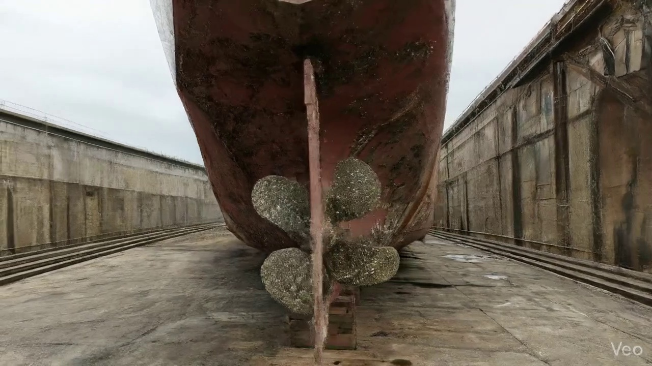

Repair Procedure
This document outlines a professional explanation of a maritime steel repair process, detailing each step's necessity, execution, equipment usage, and critical safety and structural considerations for a vessel inspection report.
---
**Vessel Inspection Report - Explanation of Steel Plate Repair Process**
**1. Explanation of Repair Steps:**
* **1.1. Assessment:**
* **Why Necessary:** This initial phase is critical for accurately determining the full extent of structural damage and defining the precise scope of the repair. It differentiates between localized deformation and more widespread issues affecting multiple structural members. Failure to accurately assess the damage can lead to insufficient repair, potential re-occurrence of defects, or compromise of adjacent sound structures.
* **What Happens:** Skilled personnel conduct a thorough visual inspection and utilize precise measurement techniques (e.g., straight edges, gauges, potentially laser scanning) to quantify out-of-flatness, identify the precise boundaries of the buckled or deformed area, and ascertain if primary or secondary supporting structures (frames, girders, stiffeners) are affected. This information forms the basis for the repair plan.
* **1.2. Preparation:**
* **Why Necessary:** The purpose of this step is to remove all material that has lost its structural integrity due to deformation, fatigue, or stress, thereby providing a sound, uncompromised foundation for the new plate installation. The specified margin (≥¾ thickness) ensures that welding operations are performed on healthy, undeteriorated metal, preventing weld defects and ensuring adequate strength at the joint.
* **What Happens:** All distorted plating, along with any buckled girders or stiffeners identified during assessment, is precisely cut away. This is typically achieved using thermal cutting equipment (e.g., oxy-acetylene or plasma torches). The cutting extends into "sound metal," leaving a minimum margin of good material equal to or greater than three-quarters of the plate thickness. Any bent framing that can be salvaged is either straightened in situ or removed for workshop rectification.
* **1.3. Plate Replacement:**
* **Why Necessary:** This step is fundamental to restoring the structural integrity, watertight/weathertight envelope, and intended design strength of the vessel. Using a plate of the same or greater thickness ensures that the renewed section meets or exceeds the original design specifications and classification society requirements for strength and stiffness.
* **What Happens:** A new steel plate, meticulously fabricated to match the precise dimensions and contour of the excised section, is prepared. Material selection ensures it is of the same grade and thickness as the original, or greater if design enhancements are mandated. The new plate is then carefully positioned against the remaining hull plating, ensuring proper fit-up and alignment. It is temporarily secured using tack welds to hold it in place before permanent welding. Appropriate preheating of the weld area is applied as per Weld Procedure Specifications (WPS) to control cooling rates and prevent cracking, especially in thicker materials or specific steel grades. Full penetration welds are prioritized to achieve maximum joint efficiency and strength.
* **1.4. Alignment and Welding:**
* **Why Necessary:** This is the core structural re-connection phase. It creates a robust, continuous, and structurally sound connection between the new plate and the existing structure, preventing future leaks, structural failures, or propagation of stresses. Managing welding-induced distortion is crucial to maintain the vessel's original hull lines, hydrodynamic efficiency, and prevent additional residual stresses.
* **What Happens:** Multi-pass welding is systematically applied around the perimeter of the new plate using E7018 low-hydrogen electrodes. These electrodes are selected for their high tensile strength, ductility, and excellent impact properties, making them suitable for critical structural applications. Welders meticulously manage heat input and follow approved welding sequences to minimize thermal distortion. Clamps, strongbacks, or other mechanical restraint techniques are employed to maintain alignment. After welding, the weld seams are carefully ground fair and flush with the surrounding hull surface. This reduces stress concentrations, improves hydrodynamic flow, and prepares the surface for protective coatings. In cases of extensive buckling or high-stress areas, additional strengthening, such as doubler plates or supplementary stiffeners, may be incorporated based on engineering assessment to enhance local strength and reduce stress.
* **1.5. Finishing:**
* **Why Necessary:** This final stage serves to verify the quality and integrity of the entire repair, restore the vessel's protective barrier against corrosion, and ensure the repaired area seamlessly integrates with the original structure, maintaining both functional and aesthetic continuity.
* **What Happens:** The completed weld repair undergoes stringent quality control. This includes thorough visual inspection for surface defects (e.g., undercut, porosity, slag inclusions). Non-Destructive Testing (NDT) methods, such as Magnetic Particle Testing (MPT) or Ultrasonic Testing (UT), are applied to verify internal weld integrity and detect any subsurface flaws, ensuring compliance with classification society requirements. Once the repair is verified as structurally sound, the new steel surface is prepared (e.g., abrasive blasting) and coated with appropriate marine-grade primer and finish coats to provide long-term corrosion protection. Finally, the repaired deck or hull surface is faired back to its original contour to ensure smooth transitions and maintain the vessel's operational performance.
**2. Why the Required Items are Used:**
* **Cutting Torch (rental):** This item is indispensable during the **"Preparation"** phase. A cutting torch, typically an oxy-acetylene or plasma cutting system, is used for the efficient and precise thermal cutting away of the distorted plate, buckled girders, and stiffeners. Its ability to quickly and effectively sever steel sections allows for rapid removal of damaged material down to sound metal, which is significantly more time and labor-efficient than mechanical cutting methods. The rental model provides flexibility and cost-effectiveness for intermittent or project-specific use, avoiding the capital expenditure of purchasing equipment that may not be continuously required.
**3. Safety and Structural Considerations:**
* **Safety Considerations:**
* **Hot Work Procedures:** All hot work (cutting and welding) must strictly adhere to vessel-specific and regulatory hot work permits and procedures. This includes mandatory fire watches, having appropriate fire extinguishing equipment readily available, and implementing proper shielding to prevent sparks and slag from igniting combustible materials.
* **Ventilation and Fume Control:** Adequate ventilation is paramount to disperse welding fumes and cutting gases, protecting personnel from respiratory hazards. In confined spaces, forced ventilation and continuous atmospheric monitoring are essential.
* **Personal Protective Equipment (PPE):** All personnel involved must wear appropriate PPE, including welding helmets, flame-retardant clothing, gloves, safety glasses, and hearing protection.
* **Confined Space Entry:** If repair work is conducted within tanks or enclosed compartments, strict confined space entry protocols, including gas testing, attendant monitoring, and rescue plans, must be followed.
* **Electrical Safety:** Proper grounding of welding equipment, inspection of cables, and adherence to electrical safety guidelines are critical to prevent electric shock.
* **Compressed Gas Safety:** Safe storage, handling, and use of compressed gas cylinders (e.g., oxygen, acetylene, argon) for cutting and welding are mandatory to prevent explosions or leaks.
* **Structural Considerations:**
* **Classification Society Approval:** All structural repairs must be conducted under the scrutiny and approval of the vessel's classification society. Repair procedures, material specifications, and NDT reports must be submitted for endorsement.
* **Material Specification:** The replacement plate must be of the same or equivalent (or superior) grade and thickness as the original material, ensuring compliance with approved drawings and regulatory requirements.
* **Weld Procedure Specification (WPS) and Welder Qualification (WPQ):** All welding must be performed in accordance with approved WPS documents by qualified and certified welders (WPQ), ensuring consistent weld quality, strength, and ductility.
* **Fit-Up and Alignment:** Precise fit-up of the new plate is crucial to minimize weld gaps, ensure proper fusion, and prevent excessive residual stress.
* **Preheat and Interpass Temperature Control:** For thicker plates, specific steel grades, or cold ambient conditions, preheating and maintaining interpass temperatures are vital to reduce the risk of hydrogen-induced cracking and ensure proper microstructure in the weld and heat-affected zone.
* **Distortion Control:** Effective techniques (e.g., balanced welding sequences, strongbacks, clamping, peening, heat input control) are necessary to minimize distortion, maintain hull fairness, and prevent additional induced stresses that could compromise the vessel's structural integrity or hydrodynamic performance.
* **Non-Destructive Testing (NDT):** Comprehensive NDT (e.g., MPT, UT) after welding is mandatory to verify the internal and surface integrity of the welds, ensuring freedom from critical defects and compliance with acceptance criteria.
* **Corrosion Protection:** Restoration of the full coating system (primer, intermediate, and finish coats) is essential to protect the new steel from corrosion, which could otherwise compromise the long-term integrity of the repair.
* **Fatigue Considerations:** Grinding welds fair reduces stress concentrations, which is critical for minimizing fatigue crack initiation, especially in dynamically loaded hull structures.
---
This comprehensive repair methodology ensures that structural damage is not only rectified effectively but also that the vessel's original design strength, integrity, seaworthiness, and operational safety are fully restored, meeting all regulatory and classification requirements.

Repair Cost Breakdown
Item | Quantity | Unit Cost | Total Cost | Currency
Cutting Torch (rental) | 0.08 | 10764.0 | 807.3 | INR
Estimated Repair Cost: 41583.53 INR

3.3 PD_3

Defect Overview
**DEFECT EXPLANATION: DEFORMATION**
**Defect Name:** DEFORMATION
**Severity:** Medium
**Location:** Detected in the **RUDDER_AREA** (minor overlap ratio, but present).
---
**1. What the defect means:**
Deformation, specifically observed as buckling or warping, refers to an out-of-plane bending or distortion of a vessel's structural components, such as hull plating or stiffeners. This condition deviates from the intended flat or smoothly curved design, often manifesting as localized dents, waves, or creases. It is typically a result of excessive forces acting on the structure, commonly stemming from incidents like grounding impacts, heavy sea loads, or stresses induced during welding processes (e.g., heat stress). While minor, localized set-in plating might sometimes be tolerated if small and stable, significant and extensive deformations are considered a structural concern.
**2. Why it is important:**
This defect is important because even moderate levels of buckling or warping can significantly impair the vessel's overall hull girder strength. The hull girder is the primary structural element responsible for resisting the global bending and shear forces experienced by the vessel. Deformation indicates that the material has yielded or permanently deflected beyond its elastic limit in that area. This reduces the structural efficiency of the affected plating and stiffeners, compromising their ability to bear designed loads. Its presence in the rudder area, even if localized, is particularly concerning as this region experiences complex and dynamic loads from steering forces.
**3. Risks if not repaired:**
Failure to repair significant deformation carries several risks:
* **Progressive Structural Failure:** The deformed area becomes a "weak link," attracting and concentrating stresses under normal operating conditions. This can lead to the propagation of the deformation, potentially affecting adjacent structural members.
* **Reduced Fatigue Life:** Stress concentrations at the edges or apex of buckles can accelerate metal fatigue, leading to the initiation and growth of cracks over time, especially in a dynamic marine environment.
* **Compromised Watertight Integrity:** While less common for general buckling, severe warping or deformation near seams, penetrations, or connections could potentially compromise watertight integrity if it affects seals or alignment.
* **Operational Limitations:** Classification societies and regulatory bodies may impose operational restrictions, such as reduced loading, speed limits, or restrictions on trading areas, if significant structural defects are not rectified, impacting the vessel's commercial viability.
* **Increased Risk of Damage in Future Incidents:** A structurally weakened hull is more susceptible to severe damage from subsequent groundings, collisions, or heavy weather, potentially leading to catastrophic failure.
**4. Structural implications:**
The primary structural implication of deformation is a direct reduction in the vessel's overall hull girder strength and localized structural integrity.
* **Loss of Stiffness:** Buckled plating loses its designed stiffness and its ability to effectively resist compressive and shear forces. It can no longer contribute fully to the vessel's bending moment resistance.
* **Ineffective Stiffeners:** If stiffeners (frames, beams, girders) are deformed, they can no longer provide adequate support to the plating, allowing the plating to buckle more easily. Conversely, buckled plating can exert unintended loads on stiffeners, leading to their deformation.
* **Stress Redistribution and Concentration:** Deformation alters the intended load path within the structure, forcing stresses to redistribute to adjacent, unaffected areas. This often results in localized stress concentrations around the deformed region, increasing the risk of brittle fracture or fatigue cracking.
* **Classification Requirements:** Classification societies generally mandate correction of significant buckling, typically by cutting out and replacing the distorted metal. This underscores the critical view taken on such defects regarding their impact on the vessel's fundamental structural integrity.
* **Rudder Area Specifics:** In the rudder area, deformation could compromise the structural integrity of the rudder stock support, pintles, rudder blade, or associated plating. This could lead to impaired steering capability, increased vibration, premature wear of components, or even catastrophic failure of the rudder system, posing a significant navigational risk.

Visual Evidence
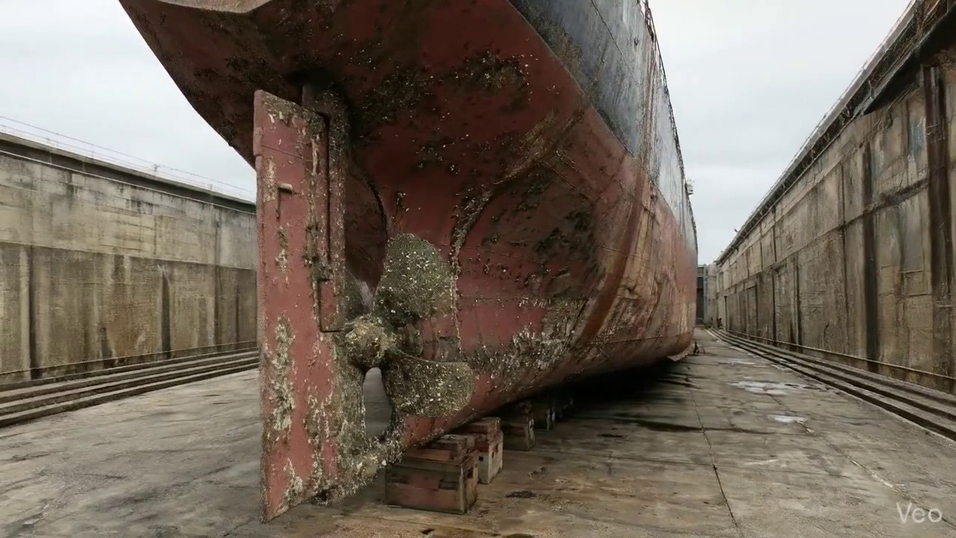

Repair Procedure
This report details a standard and comprehensive repair methodology for localized structural steel damage on a vessel, ensuring the restoration of structural integrity and compliance with maritime standards.
---
### **Vessel Structural Steel Repair Process Explanation**
**1. Assessment**
* **Why Necessary:** This initial step is crucial for accurately defining the scope and nature of the damage. A precise assessment prevents under-repair (leaving compromised material) or over-repair (unnecessary work), both of which have cost and structural implications. It informs the entire repair strategy.
* **What Happens:** A qualified inspector visually examines the deformed region. The extent of buckling, deformation, and any associated cracking is identified and marked. This includes determining if the damage is localized to a specific plate or extends to adjacent structural members like frames, girders, or stiffeners. Measurements of any out-of-flatness are taken to quantify the degree of deformation and verify the extent of the repair area.
* **Safety & Structural Considerations:** This step directly impacts the structural integrity by ensuring all compromised areas are identified. It also helps in anticipating potential stability issues during the repair, especially if extensive structural removal is planned.
**2. Preparation**
* **Why Necessary:** The objective of preparation is to remove all compromised, fatigued, or distorted material and create a clean, structurally sound foundation for the integration of new steel. Leaving any damaged material can lead to stress concentrations, premature failure of the new weld, or propagation of existing defects.
* **What Happens:** All distorted plate sections, along with any buckled or damaged girders and stiffeners, are precisely cut away. This cutting extends to "sound metal," meaning material free from cracks, deformation, or corrosion. A critical requirement is to leave a margin of good plate around the cut-out, typically at least ¾ of the original plate thickness, to ensure adequate sound base material for robust welding. Any bent framing within or adjacent to the repair zone is either straightened to its original contour or entirely removed and replaced if straightening is not feasible or effective.
* **Why the Required Item is Used:**
* **Cutting Torch (rental):** The "Cutting Torch" is the primary tool employed for this critical stage. It facilitates rapid and precise thermal cutting of the damaged steel sections. This enables efficient removal of compromised material and creates a clean, appropriately sized opening for the new insert plate, significantly reducing the manual effort and time compared to mechanical cutting methods.
* **Safety & Structural Considerations:** This step is vital for the long-term integrity of the repair. Ensuring sound metal for welding prevents weak points. Safety considerations include fire watch during thermal cutting due to sparks and molten metal, proper ventilation to disperse fumes (especially for coated steel), and appropriate personal protective equipment (PPE) for personnel.
**3. Plate Replacement**
* **Why Necessary:** This step directly restores the structural integrity, scantlings (dimensions), and strength of the vessel's hull or deck in the damaged area, bringing it back to design specifications.
* **What Happens:** A new steel plate is fabricated. This plate must be of the same material grade and at least the same thickness as the original structure (or greater if specified by the assessment or class requirements). It is precisely shaped to fit the opening created during the preparation phase. The new plate is then carefully positioned and aligned against the remaining hull plating, ensuring minimal gaps and proper fit-up. It is then secured with tack welds to hold it in place before the full welding process begins. Full penetration welds are utilized where possible to maximize the strength and continuity of the connection between the new and existing steel. Preheat is applied as necessary, depending on plate thickness, material, and ambient conditions, to prevent hydrogen-induced cracking and ensure good fusion.
* **Safety & Structural Considerations:** The quality of the new plate material and the accuracy of its fabrication and fit-up are paramount for structural integrity. Proper preheat and weld procedures are essential to prevent internal stresses and defects in the weld, which could lead to premature failure.
**4. Alignment and Welding**
* **Why Necessary:** This phase permanently integrates the new plate into the vessel's structure, ensuring full structural continuity, load transfer, and maintaining the hydrodynamic fairness of the hull. Proper welding techniques are crucial to prevent further distortion and ensure the longevity of the repair.
* **What Happens:** Continuous weld passes are applied around the perimeter of the new plate. The specification of E7018 electrodes is critical. If the heat input from welding begins to induce distortion in the surrounding structure, measures such as the use of clamps, strong-backs, or low-heat input welding techniques (e.g., skip welding, controlled interpass temperatures) are employed to maintain dimensional accuracy. After welding, weld seams are ground fair and flush with the hull surface to restore the original contour, reduce stress concentrations, and improve hydrodynamic performance. In instances where the original buckling was extensive or the area is subjected to high stresses, additional strengthening in the form of doubler plates (plates welded over the repair for reinforcement) or additional stiffeners may be incorporated to enhance structural robustness and prevent recurrence of damage.
* **Why Specific Item is Used:**
* **E7018 Electrodes:** E7018 low-hydrogen electrodes are specified due to their excellent mechanical properties, including high tensile strength, good ductility, and impact toughness, which are critical for marine applications. Their low-hydrogen content significantly reduces the risk of hydrogen-induced cracking, a common defect in high-strength steel welds, especially in constraint situations. This ensures a robust, fatigue-resistant weld suitable for the dynamic stresses experienced by a vessel.
* **Safety & Structural Considerations:** Weld integrity is paramount. Improper welding can lead to defects (cracks, porosity, lack of fusion) that compromise the vessel's strength. Thermal distortion management is critical to maintain the vessel's intended shape and performance. Welders must use full PPE, and proper ventilation is required for welding fumes.
**5. Finishing**
* **Why Necessary:** The final stage serves to validate the quality of the repair, provide essential corrosion protection for the newly exposed and welded steel, and restore the vessel's aesthetic and hydrodynamic profile.
* **What Happens:** The completed weld and surrounding area undergo rigorous inspection. This includes visual inspection for surface defects and non-destructive testing (NDT) methods (e.g., magnetic particle testing for surface cracks, ultrasonic testing for internal defects) to confirm the integrity of the weld and freedom from defects, as per classification society rules. Once approved, the new steel surface is prepared (e.g., grit blasting) and coated with appropriate marine primer and finish coats to restore the corrosion protection system, preventing rust and degradation. Finally, the repaired area is faired back to its original contour, ensuring a smooth surface that minimizes drag and maintains the vessel's design hydrodynamics.
* **Safety & Structural Considerations:** NDT ensures the repair meets required structural integrity standards, contributing to vessel safety. Corrosion protection is crucial for the long-term durability of the repair and the surrounding structure. Fairing prevents localized turbulence and potential cavitation, which can affect performance and accelerate corrosion.
---

Repair Cost Breakdown
Item | Quantity | Unit Cost | Total Cost | Currency
Cutting Torch (rental) | 0.08 | 10764.0 | 807.3 | INR
Estimated Repair Cost: 41583.53 INR

3.4 PD_4

Defect Overview
## Maritime Defect Explanation: DEFORMATION
**Defect Name:** DEFORMATION
**Severity:** High
---
**1. What the defect means:**
Deformation, encompassing buckling and warping, refers to the unintended out-of-plane bending or distortion of hull plating, shell structures, or internal stiffeners. This defect manifests as an alteration from the designed flat or curved surface geometry, causing the metal to bulge, kink, or otherwise deviate from its intended shape. It is typically induced by excessive external forces, such as impact from groundings, dynamic loads from heavy seas, or internal stresses like those generated during welding processes.
**2. Why it is important:**
This defect is critically important due to its direct and severe impact on the structural integrity and operational safety of the vessel. Rated as 'high' severity, even seemingly moderate instances of deformation can significantly compromise local and global hull girder strength. The presence of deformation indicates that the affected structure has been subjected to stresses beyond its elastic limit, or that its original design strength has been fundamentally compromised. It reduces the vessel's ability to withstand anticipated operational and environmental loads.
**3. Risks if not repaired:**
Failure to rectify significant deformation poses severe and immediate risks, which include:
* **Progressive Structural Failure:** Deformed sections act as stress concentrators, leading to accelerated fatigue cracking, increased localized stress, and potential propagation of damage to adjacent intact structures.
* **Loss of Watertight Integrity:** Over time, or under continued loading, the compromised plating can develop cracks or experience complete failure, resulting in water ingress, flooding, and severe risks to stability, potentially leading to capsizing.
* **Reduced Load-Bearing Capacity:** The compromised structure is no longer capable of safely withstanding its design loads (e.g., cargo, ballast, wave impacts), significantly increasing the risk of catastrophic structural collapse under routine operating conditions.
* **Impaired Safety and Operational Restrictions:** Unrepaired deformation places the vessel, crew, and cargo at unacceptable risk, leading to potential detentions by port state control, restricted operating areas, increased insurance premiums, or ultimately, withdrawal of classification.
**4. Structural implications:**
The structural implications of deformation are profound and undermine the fundamental design principles of the vessel:
* **Compromised Hull Girder Strength:** Out-of-plane deformation significantly reduces the effective section modulus and moment of inertia of the affected members (plating and stiffeners). This directly diminishes the overall longitudinal strength of the vessel, making it less resistant to hogging and sagging stresses, which are critical for the vessel's ability to maintain structural integrity in waves.
* **Reduced Buckling Resistance:** Deformed plating and stiffeners have a drastically lower critical buckling stress. This means they are far more susceptible to further, more severe buckling or catastrophic collapse under compressive loads that the original, undeformed structure could easily withstand.
* **Stress Concentrations:** The sharp bends and kinks associated with deformation create high-stress points within the material. These stress concentrations accelerate material fatigue and make the affected areas highly prone to brittle fracture or accelerated fatigue crack initiation and growth under cyclic loading.
* **Loss of Stiffness and Stability:** The structural member loses its designed stiffness and form stability, leading to excessive deflection under load and potentially affecting the performance of adjacent equipment or systems that rely on a stable foundation.

Visual Evidence
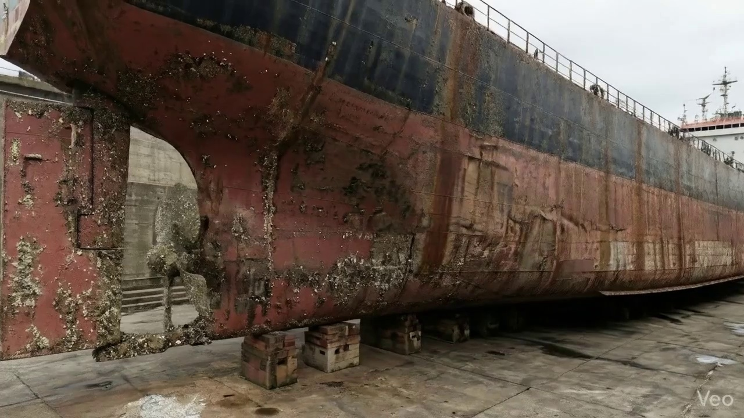

Repair Procedure
**Vessel Inspection Report: Explanation of Plate Insert Repair Process**
This report details the professional procedure for a localized plate insert repair, often necessitated by damage such as buckling, corrosion, or fatigue. The process outlines a methodical approach to ensure the structural integrity, watertightness, and aesthetic finish of the vessel are fully restored.
---
**1. Assessment Phase:**
* **Necessity:** This initial step is paramount for precisely defining the scope of damage and ensuring that the subsequent repair addresses all affected areas. A thorough assessment prevents partial repairs that could lead to premature failure or overlooked structural weaknesses. It also establishes baseline measurements for quality control.
* **Process:** Skilled inspectors meticulously examine the deformed region. This involves visually identifying and physically marking the buckled or damaged area. The assessment determines whether the deformation is confined to a localized section or extends across multiple structural frames, impacting a wider area. Out-of-flatness measurements (e.g., using straight edges, calipers, or laser alignment tools) are taken to quantify the extent of distortion and provide critical data for repair planning and post-repair verification.
* **Safety & Structural Considerations:** A comprehensive assessment is the foundation for a safe and structurally sound repair. Misjudging the extent of damage could lead to leaving compromised material in place, creating new stress concentrations, or weakening adjacent structures. It guides decisions on the repair method and required material properties.
**2. Preparation Phase:**
* **Necessity:** The preparation phase is critical to remove all compromised material and create a clean, sound base for the new plate. Any existing distortion, fatigue, or corrosion must be completely eliminated to ensure the new weld can achieve optimal fusion and strength. The specified margin of good plate ensures that welding occurs on structurally sound parent material, preventing weld defects propagating into fatigued metal.
* **Process:** Using a cutting torch, all distorted plate material, along with any buckled girders or stiffeners within the damaged zone, are carefully cut away. The cutting continues until sound, unaffected metal is reached, ensuring a minimum margin of good plate equal to or greater than ¾ of the original plate's thickness remains around the perimeter of the cut-out. Any adjacent bent framing that would impede the fit-up of the new plate or compromise the structural alignment is either straightened using mechanical means or heat, or entirely removed and replaced if severely damaged.
* **Required Items: Cutting Torch (rental)**
* **Usage:** The cutting torch is a specialized tool employing an oxy-fuel or plasma cutting process to rapidly and efficiently sever steel plate and structural members. It is indispensable for cleanly and precisely removing the damaged sections of the hull, girders, and stiffeners as part of the preparation phase. Its high heat output allows for quick removal of material, crucial for expediting the initial repair stages.
* **Safety & Structural Considerations:** This phase involves hot work, requiring strict adherence to fire safety protocols, including fire watches, combustible material removal, and appropriate personal protective equipment (PPE). Structural integrity is paramount; the removal of damaged components is carefully planned to avoid over-weakening the vessel temporarily. The "margin of good plate" is a crucial structural requirement to ensure strong, durable welds.
**3. Plate Replacement Phase:**
* **Necessity:** This phase restores the structural continuity, watertight/weathertight integrity, and original contour of the hull or deck. The new plate serves as the primary structural component, replacing the material removed during preparation.
* **Process:** A new steel plate is fabricated. This plate must be of the same or greater thickness and material specification as the original hull plating to maintain structural equivalence. It is meticulously shaped and dimensioned to precisely fit the cut-out prepared in the previous step. The fabricated plate is then positioned against the remaining hull plating, ensuring proper alignment and minimal gaps. It is secured into place using tack welds, which are temporary, small welds designed to hold the plate until the full welding process commences. The complete weld is then executed all around the perimeter of the new plate, ensuring excellent fusion with the parent material. Appropriate preheat temperatures are applied, particularly in colder environments or on thicker plates, to prevent thermal shock and reduce hydrogen-induced cracking. Full penetration welds are employed wherever structurally feasible to achieve maximum strength and continuity.
* **Safety & Structural Considerations:** Correct material selection and fit-up are critical for structural performance. Improper preheat or welding techniques can lead to significant residual stresses, cracking, or reduced weld strength. Full penetration welds are specified to ensure the repaired section is as strong as or stronger than the original structure. Weld quality directly impacts the long-term integrity of the repair.
**4. Alignment and Welding Phase:**
* **Necessity:** This phase is focused on achieving the final, robust structural connection and minimizing any adverse effects of the welding process, such as distortion. It ensures the repair integrates seamlessly with the existing structure.
* **Process:** Following tack welding, continuous weld passes are applied to fully join the new plate to the existing structure. E7018 electrodes are specified, which are low-hydrogen electrodes known for their excellent mechanical properties and suitability for critical structural welding, minimizing the risk of hydrogen embrittlement. Throughout the welding process, potential welding-induced distortion is actively managed using various techniques, such as strongbacks and clamps to restrain the plate, or by employing minimal heat input welding sequences to control thermal expansion and contraction. Upon completion of welding, the weld seams are carefully ground fair with the hull surface. In instances where the initial buckling was extensive or the surrounding structure is inherently weaker, additional strengthening measures, such as doublers (plates welded over a joint) or additional stiffeners, may be applied to redistribute stress and enhance overall structural resilience.
* **Safety & Structural Considerations:** Welding involves significant heat, UV radiation, and fumes, necessitating full PPE (welding helmet, gloves, fire-retardant clothing) and adequate ventilation. Distortion control is vital to prevent residual stresses that could lead to cracking or premature fatigue. E7018 electrodes are chosen for their structural reliability. Grinding welds fair improves fatigue life and hydrodynamic performance. The addition of doublers or stiffeners reflects a proactive approach to prevent future issues in areas of high stress.
**5. Finishing Phase:**
* **Necessity:** The finishing phase confirms the quality of the repair, restores the vessel's protection against corrosion, and ensures the repaired area is aesthetically and hydrodynamically consistent with the original design.
* **Process:** A thorough inspection of the completed repair is conducted. This includes visual inspection for surface defects, proper contour, and weld continuity. Non-Destructive Testing (NDT) methods, such as magnetic particle inspection (MPI) or ultrasonic testing (UT), are employed to detect any subsurface weld defects (e.g., cracks, porosity, lack of fusion) that are not visible externally. Once the repair is verified as structurally sound, the new steel surface is prepared (e.g., abrasive blasting) and treated with marine-grade primer coats, followed by appropriate finish coats to restore full corrosion protection. Finally, the repaired deck or hull surface is faired back to its original contour, ensuring smooth transitions and no impact on vessel performance or safety.
* **Safety & Structural Considerations:** NDT is a critical quality assurance step, providing objective evidence of the weld integrity and structural soundness. Failure to apply proper corrosion protection will lead to rapid degradation of the new plate. Maintaining the original contour is important for hydrodynamic efficiency and to prevent snagging or accumulation of debris.
---
This comprehensive repair process, when executed diligently by qualified personnel, ensures that any structural damage is remedied to the highest standards, restoring the vessel's safety, structural integrity, and operational capability.

Repair Cost Breakdown
Item | Quantity | Unit Cost | Total Cost | Currency
Cutting Torch (rental) | 0.12 | 10764.0 | 1345.5 | INR
Estimated Repair Cost: 69305.88 INR

3.5 PD_5

Defect Overview
Here is a professional explanation of the "DEFORMATION" defect for a vessel inspection report:
---
**DEFECT EXPLANATION: DEFORMATION (Severity: High)**
**1. What the defect means:**
Deformation, specifically observed as buckling or warping, refers to an out-of-plane distortion of the vessel's structural components. This means the affected plating or stiffeners have deviated from their original flat or straight design geometry, manifesting as waves, bulges, or bends. In this instance, significant deformation has been identified on the **hull plating** and also, to a lesser extent, on the **rudder area**. Such distortions typically arise from excessive localized forces, such as grounding impacts, heavy sea loads, or thermal stresses induced by welding processes.
**2. Why it is important:**
This defect is of high importance and is classified as severe because it directly compromises the fundamental structural integrity and designed strength of the vessel. Unlike minor surface imperfections, deformation indicates a failure of the material to maintain its designed shape and rigidity, significantly impacting its ability to carry intended loads. The presence of buckling or warping is a clear indicator that the affected structure has been subjected to stresses beyond its elastic limit or has a reduced capacity to resist normal operational loads, posing a direct threat to the vessel's seaworthiness.
**3. Risks if not repaired:**
Failure to address significant deformation presents substantial risks, including:
* **Compromised Seaworthiness:** The vessel's ability to withstand anticipated operational loads (e.g., severe weather, cargo stresses, docking forces) will be severely diminished, increasing the risk of further structural damage or failure.
* **Progressive Structural Failure:** Deformed areas become stress concentrators, increasing the likelihood of crack initiation and propagation in the affected plating and adjacent structures. This can lead to further buckling, tearing, or complete structural failure over time.
* **Loss of Watertight Integrity:** Severe deformation, particularly on the hull, can weaken watertight boundaries, potentially leading to water ingress into compartments, compromising stability and safety.
* **Reduced Manoeuvrability (Rudder Area):** Deformation on the rudder can impair its hydrodynamic efficiency, affecting steering response, increasing drag, and potentially leading to rudder failure under dynamic loads, resulting in a loss of control.
* **Classification and Operational Restrictions:** Classification societies typically mandate correction for significant deformation. Failure to repair can result in operational restrictions, detention by port state control, or withdrawal of essential certificates, severely impacting the vessel's ability to trade.
**4. Structural implications:**
Structurally, deformation directly reduces the vessel's hull girder strength and local scantling strength:
* **Hull Girder Strength:** Buckled hull plating effectively reduces the sectional modulus and moment of inertia of the hull girder, diminishing its overall resistance to global bending (hogging and sagging) and torsional forces. This makes the vessel less capable of withstanding the dynamic forces encountered at sea.
* **Local Scantling Strength:** The out-of-plane distortion of plating and/or stiffeners drastically reduces their ability to resist compressive and shear loads. A buckled plate is significantly weaker than a flat one, leading to premature yielding, further buckling, or tearing under normal operating conditions.
* **Load Redistribution and Stress Concentrations:** The defect alters the designed load path, concentrating stresses in unintended areas. This accelerates fatigue, increases the risk of brittle fracture, and can induce secondary stresses in surrounding, otherwise undamaged, structures.
* **Rudder Integrity:** Deformation on the rudder compromises its structural rigidity and aerodynamic profile, which is critical for steering and propulsion efficiency. It also significantly increases the risk of the rudder failing under operational loads, potentially leading to a catastrophic loss of control.
As per classification practice, significant buckling necessitates the renewal of the distorted metal by cutting out and replacing the affected sections to restore the original design strength and structural integrity. Localized set-in plating may be tolerated only if minor and deemed non-impairing by the attending surveyor.

Visual Evidence
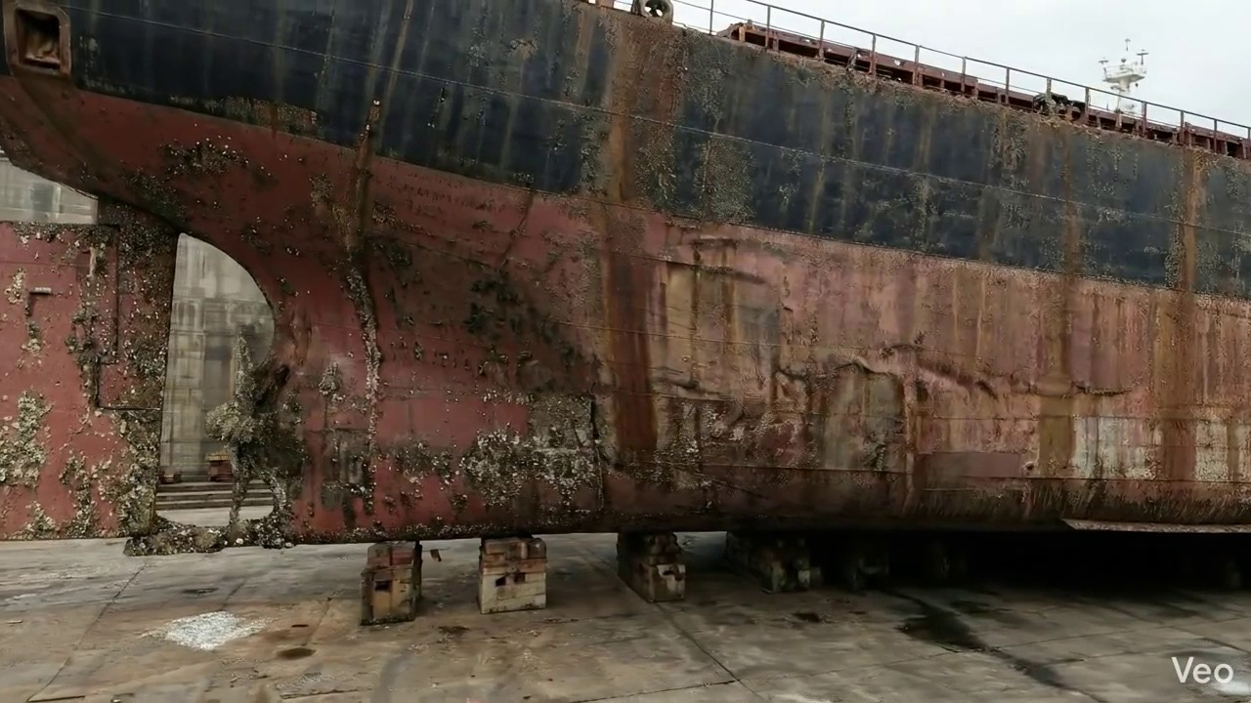

Repair Procedure
**Vessel Inspection Report: Repair Process Explanation – Shell Plating/Structural Member Renewal**
This report details a professional repair process for localized deformation or damage to a vessel's shell plating and associated internal structural members. The methodology aims to restore structural integrity, watertightness, and original hull contours.
---
**1. Assessment**
* **Necessity:** This initial phase is critical for accurately diagnosing the extent and nature of the damage. It provides the foundation for an effective repair plan, ensuring that all compromised material is identified and properly addressed. Without a thorough assessment, there is a risk of incomplete repair or overlooking underlying structural issues.
* **What Happens:** Skilled technicians meticulously inspect the deformed region. This involves visual examination to identify surface irregularities, cracks, or punctures, and systematic marking of the buckled or damaged area. Measurements of out-of-flatness (deviation from the original plane) are taken using appropriate gauges or straightedges. The assessment also determines if the damage is confined to a small area or extends across multiple frames, stiffeners, or bulkheads.
* **Why Required Items Are Used:** While no specific item is listed for this step, specialized measuring tools (e.g., straightedges, gauges, laser alignment tools) would be employed to quantify deformation, informing the scale of subsequent material removal and replacement.
* **Safety and Structural Considerations:**
* **Structural:** The primary structural consideration is to determine if the vessel's immediate stability or load-bearing capacity is compromised, potentially requiring temporary shoring. Identifying the affected structural members (frames, girders, stiffeners) is crucial for planning their eventual renewal or repair to maintain the vessel's design strength.
* **Safety:** Ensuring the area is clear of hazards and that lighting is adequate for precise inspection.
---
**2. Preparation**
* **Necessity:** This step ensures that all compromised or fatigued material is completely removed, providing a structurally sound base for the new plate and members. Leaving any distorted material could lead to premature failure of the repair due to latent stresses or cracks. The margin of sound plate ensures that welding occurs on uncompromised material.
* **What Happens:** Using thermal cutting equipment, all distorted plate, buckled girders, and stiffeners are carefully cut away. The cut extends into sound, undamaged metal, leaving a minimum margin equal to or greater than ¾ of the original plate thickness to ensure a robust welding surface. Any bent or damaged internal framing, if not to be renewed, is either straightened to its original profile or completely removed.
* **Why Required Items Are Used:**
* **Cutting Torch (rental):** This item is indispensable during the preparation phase. The cutting torch, typically an oxy-acetylene or plasma cutting system, provides the high heat required to rapidly and precisely sever steel plates and structural profiles. Its use allows for efficient removal of the damaged sections, enabling accurate cuts to create the aperture for the new plate. The quantity per square meter reflects the machine-days required for the cutting operation based on the repair area.
* **Safety and Structural Considerations:**
* **Structural:** Accurate cutting to sound metal is paramount. Incorrect cuts can weaken adjacent structures or make proper fit-up of the new plate challenging, compromising the final structural integrity. The specified margin ensures the weld zone is clear of existing stress risers.
* **Safety:** This is a "hot work" operation requiring strict adherence to safety protocols. This includes, but is not limited to, obtaining hot work permits, establishing fire watches, ensuring adequate ventilation to disperse fumes, using appropriate personal protective equipment (PPE) such as welding helmets, gloves, and flame-retardant clothing, and having fire suppression equipment readily available.
---
**3. Plate Replacement**
* **Necessity:** This is the core restorative measure, introducing new, structurally sound material to replace the section that was removed. Its purpose is to reinstate the hull's watertight integrity, structural strength, and original contour.
* **What Happens:** A new steel plate, matching or exceeding the original thickness and material specification (e.g., AH36, DH36), is precisely fabricated to the dimensions and curvature of the aperture created during preparation. This new plate is then carefully positioned against the remaining hull plating, ensuring a tight fit-up. It is then tack-welded at intervals to hold it securely in place before the full perimeter weld is applied. The complete welding process ensures proper fusion between the new and existing steel, with appropriate preheat applied as necessary (especially for thicker plates or certain steel grades) to prevent hydrogen cracking. Full penetration welds are prioritized where feasible to maximize joint strength.
* **Why Required Items Are Used:** While not explicitly listed here, welding machines (e.g., shielded metal arc welding - SMAW, gas metal arc welding - GMAW), welding consumables, and preheating equipment would be used. The quality of these items directly impacts the structural efficacy of the repair.
* **Safety and Structural Considerations:**
* **Structural:** The new plate's material properties and thickness must match or exceed the original to ensure the restored area meets the vessel's design strength. Proper fit-up is crucial to minimize weld gaps and ensure consistent weld quality. Full penetration welds are structurally superior, offering greater strength and fatigue resistance. Preheating, when required, is vital to prevent brittle fracture and hydrogen-induced cracking in the weld and heat-affected zone.
* **Safety:** Welders must utilize appropriate PPE (welding helmets, gloves, fire-resistant clothing), ensure adequate ventilation to prevent fume inhalation, and maintain a fire watch during continuous welding operations. Electrical safety precautions for welding equipment are also paramount.
---
**4. Alignment and Welding**
* **Necessity:** This phase focuses on achieving the final, robust welded connection, managing potential distortion, and enhancing structural resilience where necessary. It ensures the repair integrates seamlessly with the existing structure and performs reliably under operational stresses.
* **What Happens:** Continuous weld passes are applied, often utilizing E7018 electrodes, which are low-hydrogen electrodes known for good mechanical properties and reduced risk of hydrogen-induced cracking. Throughout the welding process, technicians monitor for distortion. If welding-induced distortion occurs, clamps, strong-backs, or specialized techniques like controlled sequence welding or minimal heat input are employed to mitigate it and maintain the structural alignment. Upon completion of welding, weld seams are ground fair and flush with the hull surface to reduce hydrodynamic resistance and stress concentrations. In situations where the initial buckling was extensive or the area is subject to high stresses, additional strengthening in the form of doubler plates or stiffeners may be strategically applied to enhance local structural integrity and stress distribution.
* **Why Required Items Are Used:**
* **E7018 Electrodes:** These are specified for their low hydrogen content, which is critical for welding medium to high-strength steels, particularly in structural applications where resistance to hydrogen embrittlement and cracking is paramount. They provide excellent weld metal properties, including strength, toughness, and ductility.
* Other items (not listed): Grinding tools are essential for fairing the welds. Clamps, strong-backs, and jigs are used for distortion control.
* **Safety and Structural Considerations:**
* **Structural:** The choice of E7018 electrodes is a key structural decision, enhancing the weld's integrity. Distortion control is vital; uncontrolled distortion can introduce new stresses, reduce fatigue life, and alter the vessel's hydrodynamics. Grinding welds fair removes potential stress concentrators and improves fatigue performance. The application of doublers or stiffeners is a direct structural enhancement, designed to reinforce areas of high stress or compensate for extensive original damage.
* **Safety:** Continuous safety practices for welding apply, including fire watch, ventilation, and PPE. Grinding operations require eye and hearing protection, and proper dust extraction.
---
**5. Finishing**
* **Necessity:** This final stage confirms the quality of the repair, protects the new steel from corrosion, and restores the vessel's aesthetic and hydrodynamic profile. It ensures the longevity and satisfactory performance of the repair.
* **What Happens:** The completed repair undergoes stringent inspection. This includes visual inspection for any surface defects, discontinuities, or improper profiling. Non-Destructive Testing (NDT) methods, such as ultrasonic testing (UT) or magnetic particle testing (MPT), are applied to detect internal flaws (e.g., lack of fusion, porosity, cracks) that are not visible externally. Once the repair passes inspection, the new steel surface is thoroughly cleaned and prepared before primer and finish coats are applied, matching the original coating system to restore corrosion protection. Finally, the repaired area on the deck or hull surface is faired back to its original contour, ensuring a smooth transition and minimizing resistance.
* **Why Required Items Are Used:** NDT equipment (UT/MPT machines), painting equipment (spray guns, rollers), and fairing tools would be used.
* **Safety and Structural Considerations:**
* **Structural:** NDT is crucial for verifying the internal quality of the welds, confirming the structural integrity of the repair, and ensuring it meets classification society standards. Any detected flaws must be rectified. Fairing the surface not only improves aesthetics but also reduces hydrodynamic drag and prevents localized stress concentrations that could lead to fatigue cracking.
* **Safety:** Paint application requires proper ventilation, respiratory protection (e.g., respirators with appropriate cartridges), and fire precautions if using volatile paints. NDT procedures require trained personnel following specific safety protocols.
---
This comprehensive repair process, when executed by qualified personnel and under appropriate supervision, ensures the restoration of the vessel's structural integrity and operational readiness in compliance with maritime regulations and best practices.

Repair Cost Breakdown
Item | Quantity | Unit Cost | Total Cost | Currency
Cutting Torch (rental) | 0.12 | 10764.0 | 1345.5 | INR
Estimated Repair Cost: 69305.88 INR

3.6 PD_6

Defect Overview
Generation failed.

Visual Evidence


Repair Procedure
Generation failed.

Repair Cost Breakdown
Item | Quantity | Unit Cost | Total Cost | Currency
Cutting Torch (rental) | 0.12 | 10764.0 | 1345.5 | INR
Estimated Repair Cost: 69305.88 INR

3.7 PD_7

Defect Overview
Generation failed.

Visual Evidence
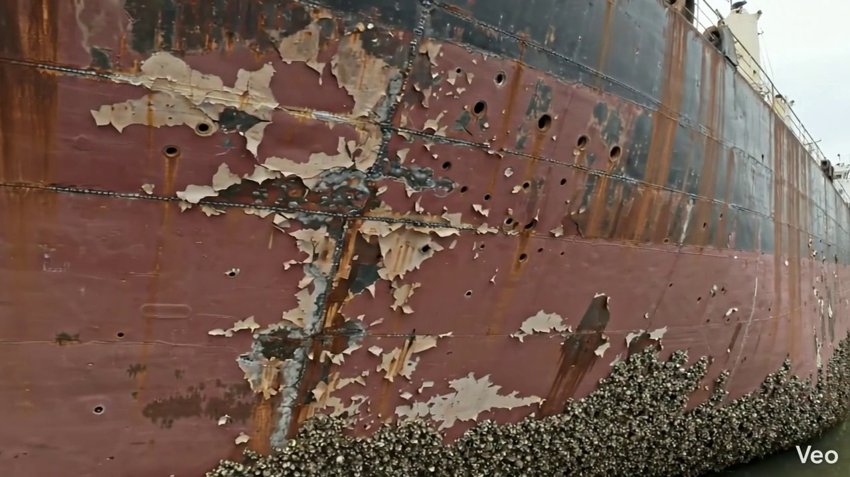

Repair Procedure
Generation failed.

Repair Cost Breakdown
Item | Quantity | Unit Cost | Total Cost | Currency
Cutting Torch (rental) | 0.12 | 10764.0 | 1345.5 | INR
Estimated Repair Cost: 69305.88 INR

3.8 PD_8

Defect Overview
Generation failed.

Visual Evidence
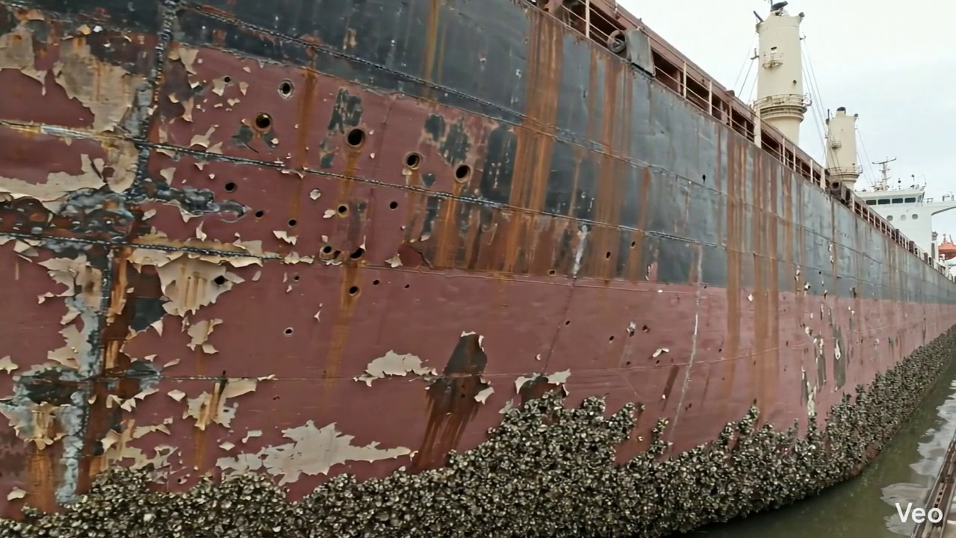

Repair Procedure
Generation failed.

Repair Cost Breakdown
Item | Quantity | Unit Cost | Total Cost | Currency
Cutting Torch (rental) | 0.08 | 10764.0 | 807.3 | INR
Estimated Repair Cost: 41583.53 INR

3.9 PD_9

Defect Overview
Generation failed.

Visual Evidence
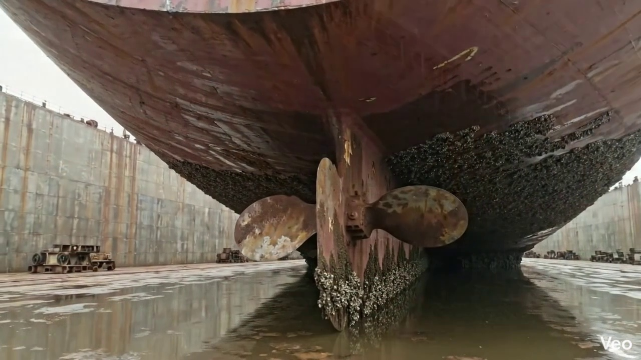

Repair Procedure
Generation failed.

Repair Cost Breakdown
Item | Quantity | Unit Cost | Total Cost | Currency
Cutting Torch (rental) | 0.05 | 10764.0 | 538.2 | INR
Estimated Repair Cost: 27722.35 INR

3.10 PD_10

Defect Overview
Generation failed.

Visual Evidence
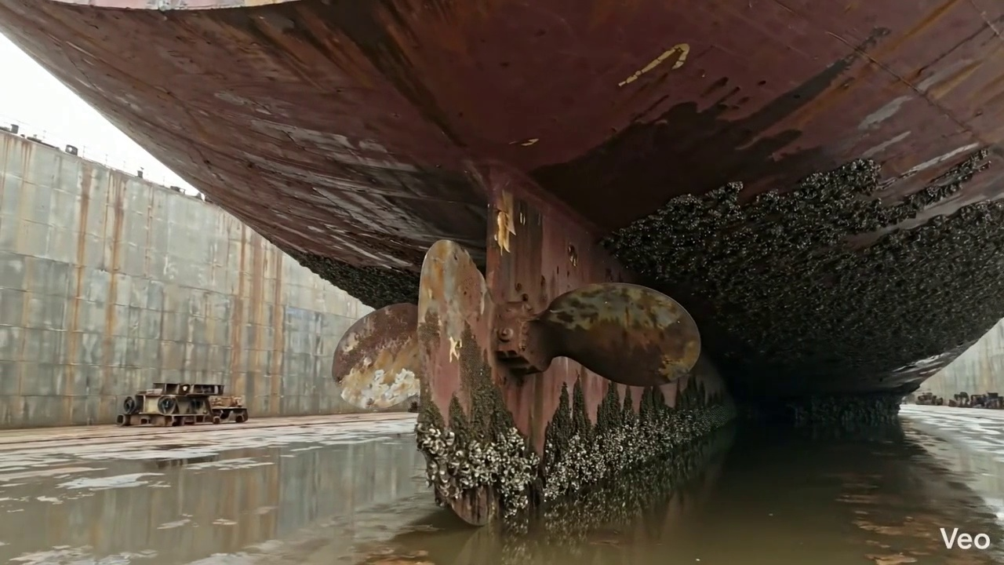

Repair Procedure
Generation failed.

Repair Cost Breakdown
Item | Quantity | Unit Cost | Total Cost | Currency
Cutting Torch (rental) | 0.05 | 10764.0 | 538.2 | INR
Estimated Repair Cost: 27722.35 INR

