Vessel Inspection Report

Table of Contents
1. Executive Summary
2. Vessel Repair Summary
3. Defect Analysis
3.1 PD_1
3.2 PD_2
3.3 PD_3
3.4 PD_4

1. Executive Summary
## Executive Summary: Maritime Vessel Inspection Report
This Executive Summary provides a high-level overview of the findings from the recent comprehensive maritime vessel inspection.
The inspection identified a total of **four (4) defects**. A cumulative estimated repair cost of **INR 277,223.52** has been calculated for the required remediation of these deficiencies.
Significantly, **all four identified defects were classified with a 'High' severity rating (100%)**. This classification indicates that the deficiencies pose immediate or significant risks to vessel safety, operational performance, regulatory compliance, or environmental protection, necessitating urgent attention.
Given the critical nature and high severity classification of all identified defects, **immediate attention and corrective actions are imperative**. A thorough review of the complete inspection report is strongly recommended to develop and execute an urgent rectification plan. Prompt resolution of these issues is essential to ensure continued vessel seaworthiness and safe operation.

2. Vessel Repair Summary
Metric | Value
Total Defects | 4
Total Estimated Cost | 277223.52 INR
Material Cost | 166334.11 INR
Labor Cost | 83167.06 INR
Equipment Cost | 27722.35 INR

3. Defect Analysis

3.1 PD_1

Defect Overview
Here is a professional explanation of the DEFORMATION defect for a vessel inspection report:
---
**Defect Name:** DEFORMATION
**Severity:** HIGH
**Explanation:**
**1. What the defect means:**
Deformation, specifically observed as buckling or warping, refers to an undesirable out-of-plane bending or distortion of the vessel's hull plating or structural stiffeners. This defect implies that the affected metal is no longer in its original, flat or designed planar configuration. In this instance, the deformation is predominantly noted in the general **HULL_AREA**, with significant presence in the **KEEL_AREA** and some observed in the **BOW_AREA**. Common causes for such deformation include severe external forces such as grounding impacts, excessive heavy sea loads impacting the hull, or internal stresses generated by uneven welding heat during construction or repair.
**2. Why it is important:**
This defect is categorized with a **HIGH** severity rating, indicating a critical impairment to the vessel's structural integrity. Even moderate levels of buckling or warping can severely compromise the designed strength of the hull girder – the primary load-bearing structure of the vessel. Its importance is further highlighted by classification society practice, which mandates that significant buckling must be corrected, typically through replacement, as it directly impacts the vessel's seaworthiness and safety standards. Localized, small set-in plating might sometimes be tolerated under specific conditions, but significant deformation requires immediate attention.
**3. Risks if not repaired:**
Failure to repair this high-severity deformation carries several significant risks:
* **Reduced Structural Integrity:** The deformed sections, particularly those affecting the hull girder and keel, lose their original load-carrying capacity, making the vessel inherently weaker than designed.
* **Progressive Damage:** Under continued operational loads (e.g., wave impacts, cargo stresses, maneuvering forces), the deformation is likely to propagate, worsen, or lead to fatigue cracks in the affected and adjacent structures.
* **Catastrophic Failure:** In extreme conditions, such as severe weather or accidental loading, the compromised structure could lead to localized or even global structural failure, potentially resulting in hull breaches, loss of watertight integrity, or capsizing.
* **Watertight Integrity Compromise:** Severe buckling can stress the plating to the point of fracturing, leading to water ingress into compartments, posing risks to stability and machinery.
* **Regulatory Non-Compliance:** Unrepaired significant deformation will lead to non-compliance with classification society rules and statutory regulations, potentially resulting in operational restrictions, detention, or withdrawal of the vessel's Certificate of Class.
**4. Structural Implications:**
The structural implications of this deformation are profound:
* **Loss of Hull Girder Strength:** The primary implication is a direct and significant reduction in both the local strength of the affected plating/stiffeners and the overall global strength of the hull girder. The deformed material cannot effectively resist compressive, tensile, or shear stresses.
* **Reduced Stiffness and Stability:** Buckling signifies a loss of structural stability. The deformed members no longer contribute effectively to the overall stiffness of the hull, making it more susceptible to further deformation and reducing its ultimate load-carrying capacity before collapse.
* **Stress Concentrations:** The out-of-plane bending alters the intended load paths, creating abnormal stress concentrations in the surrounding, potentially undamaged, structural members. This can induce secondary failures or accelerate fatigue in areas not directly deformed.
* **Compromised Load Distribution:** The ability of the hull structure to uniformly distribute operational and environmental loads is impaired, placing excessive strain on remaining intact sections.
* **Mandated Renewal:** As per classification practice, significant buckling often necessitates the removal of the distorted metal and its replacement with new, appropriately formed plating and/or stiffeners. This is essential to restore the design strength, stiffness, and stability required for safe operation.

Visual Evidence
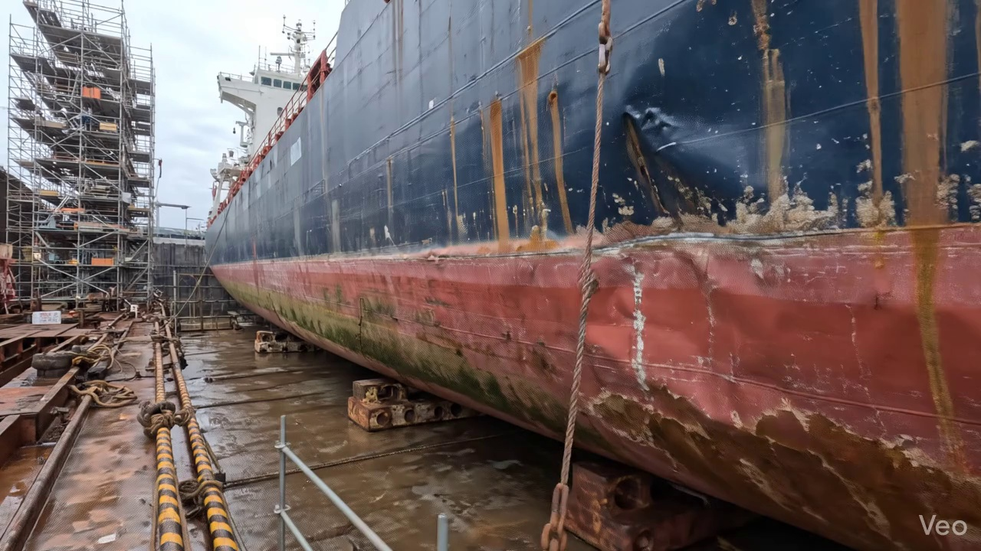

Repair Procedure
**Vessel Inspection Report - Deformed Plating Repair Process Explanation**
This section outlines the professional methodology employed for the repair of deformed plating, ensuring the restoration of the vessel's structural integrity, watertight envelope, and operational characteristics.
---
**Repair Process Breakdown:**
**1. Assessment**
* **Necessity:** This initial phase is critical for accurately diagnosing the extent and nature of the damage. Without a comprehensive assessment, repairs risk being superficial or failing to address underlying structural issues, potentially compromising the vessel's safety and longevity.
* **During Repair:** Skilled technicians meticulously inspect the deformed region. This involves:
* Visual inspection to identify visible buckling, cracks, or material fatigue.
* Marking the precise boundaries of the buckled area.
* Determining if the deformation is localized to a single plate or if it extends to adjacent plates, internal framing (girders, stiffeners), or spans multiple structural frames.
* Measuring any deviations from the original flat plane (out-of-flatness) using straight edges, calipers, or laser alignment tools to quantify the degree of distortion. This data informs the scope of material removal and replacement.
* **Safety & Structural Considerations:** A thorough assessment directly impacts structural integrity. Incorrectly diagnosing the damage extent can lead to insufficient repair, leaving weakened sections susceptible to future failure under operational loads.
**2. Preparation**
* **Necessity:** This step ensures that all compromised material is removed, providing a sound, stable foundation for the new steel plate. Welding new material to damaged, fatigued, or distorted base metal would result in a structurally weak and unreliable repair. The specified margin (≥¾ thickness) ensures sufficient sound parent metal for proper weld heat absorption and robust fusion.
* **During Repair:** Using appropriate cutting equipment, such as the specified cutting torch, technicians precisely cut away:
* All identified distorted or damaged plate sections.
* Any buckled, bent, or otherwise compromised internal girders or stiffeners associated with the deformed area.
* The cutting extends into sound, undamaged metal, leaving a clean margin to facilitate high-quality welding.
* Existing bent framing that is not being fully replaced will be straightened to its original alignment using heat and mechanical force, or completely removed if heavily damaged.
* **Safety & Structural Considerations:** Proper preparation is fundamental to the structural success of the repair. Inadequate removal of damaged material will lead to stress concentrations and premature failure of the new weld or adjacent structure. Safety during this phase involves hot work procedures, fire watch, and proper ventilation due to cutting operations.
**3. Plate Replacement**
* **Necessity:** This is the core structural restoration step. The objective is to replace the removed material with new, uncompromised steel, thereby restoring the vessel's original design strength, watertight integrity (for hull plating), and load-bearing capabilities.
* **During Repair:**
* A new steel plate is fabricated. This plate will either match the original thickness or be marginally thicker, as determined by the repair specification and classification society requirements, using steel of appropriate grade.
* The new plate is precisely shaped and cut to perfectly fit the aperture created by the removal of the damaged section.
* It is then carefully positioned against the remaining hull plating, ensuring correct alignment and fit-up.
* The plate is secured in place with tack welds to maintain its position and alignment prior to final welding.
* Complete welding is performed around the entire perimeter of the new plate. Emphasis is placed on achieving good fusion between the new plate and the existing structure.
* Appropriate preheat is applied, especially for thicker plates or high-tensile steels, to mitigate hydrogen-induced cracking and ensure metallurgical soundness of the weld.
* Where design and access permit, full penetration welds are utilized to maximize joint efficiency and strength, eliminating potential root defects.
* **Safety & Structural Considerations:** The material grade and thickness must comply with classification society rules. Inadequate fit-up, poor fusion, or insufficient preheat can introduce defects (e.g., lack of fusion, cracking) that severely compromise the structural integrity and watertightness of the repair. Welding operations require strict adherence to safety protocols (PPE, ventilation, fire prevention).
**4. Alignment and Welding**
* **Necessity:** This phase completes the welding process, ensuring a robust, continuous structural connection that can withstand operational stresses. Managing distortion is crucial for maintaining the vessel's intended shape, hydrodynamic efficiency, and preventing internal stresses that could lead to cracking. Fairing the weld seams prevents stress risers and maintains a smooth surface.
* **During Repair:**
* Continuing weld passes are systematically applied using specified electrodes, such as E7018. E7018 electrodes are low-hydrogen, offering excellent mechanical properties and ductility, making them suitable for critical structural applications.
* Throughout the welding process, the repair area is closely monitored for welding-induced distortion. Techniques to mitigate distortion include the use of strongbacks and clamps to restrain the material, or controlled, minimal heat input welding sequences.
* Upon completion of welding, the weld seams are ground fair and flush with the surrounding hull or deck plating. This eliminates any abrupt changes in contour, which could act as stress concentration points or impair hydrodynamic performance.
* In situations where the original buckling was extensive or the area is subjected to high stresses, additional strengthening components (e.g., doubler plates or supplementary stiffeners) may be designed and welded in place to enhance local structural resilience and distribute loads more effectively.
* **Safety & Structural Considerations:** Proper electrode selection (E7018 for structural steel) ensures optimal weld mechanical properties. Uncontrolled distortion can lead to residual stresses, potential fatigue cracking, and misalignment of adjacent structures. Grinding ensures a smooth transition, reducing drag and stress concentration. Any additional strengthening must be engineered and approved to prevent unforeseen structural implications.
**5. Finishing**
* **Necessity:** This final stage confirms the quality of the repair, protects the new steel from the marine environment, and restores the vessel to its original operational and aesthetic standard.
* **During Repair:**
* The repair area undergoes rigorous inspection. This includes visual inspection for surface defects, and non-destructive testing (NDT) methods such as ultrasonic testing (UT) for internal defects, magnetic particle testing (MT) for surface-breaking cracks, or radiographic testing (RT) for volumetric defects, as per classification society and repair specifications.
* The new steel surface is prepared (e.g., blast cleaning) and immediately protected with marine-grade primer coats, followed by appropriate finish coats (e.g., antifouling, topcoat) to restore comprehensive corrosion protection.
* The repaired deck or hull surface is faired back to its original design contour, ensuring optimal hydrodynamic performance and preventing excessive drag or turbulent flow.
* **Safety & Structural Considerations:** NDT provides objective evidence of weld integrity, assuring the structural soundness of the repair. Failure to apply proper corrosion protection will lead to accelerated degradation of the new steel, compromising the repair's longevity. Maintaining the original contour is crucial for the vessel's performance and fuel efficiency.
---
**Utilization of Required Items:**
* **Cutting Torch (rental):**
* **Why used:** The cutting torch is an indispensable tool specifically utilized during the "Preparation" phase of the repair process. Its high-temperature flame (oxy-fuel or plasma) allows for the efficient and precise cutting away of the distorted steel plate, buckled girders, and stiffeners. This is essential for removing all damaged material and creating a clean, accurately sized aperture for the new replacement plate. Its use ensures that subsequent welding operations are performed on sound, undamaged base metal. The rental aspect indicates it is a specialized piece of equipment brought in for specific repair durations rather than being a permanently owned asset.
---
This detailed explanation covers the necessity, procedural aspects, equipment usage, and critical safety and structural considerations for each step of the maritime plating repair process.

Repair Cost Breakdown
Item | Quantity | Unit Cost | Total Cost | Currency
Cutting Torch (rental) | 0.12 | 10764.0 | 1345.5 | INR
Estimated Repair Cost: 69305.88 INR

3.2 PD_2

Defect Overview
**Defect Name:** DEFORMATION
**Severity:** High
---
**Explanation of Defect: DEFORMATION (Buckling or Warping)**
During the recent inspection, significant deformation, characterized as buckling and warping, was identified in the vessel's structure, primarily within the **Keel Area** (61.26% overlap) with some involvement of the general **Hull Plating** (5.69% overlap). This defect is assessed as **HIGH severity**, necessitating urgent attention.
---
**1. What the defect means:**
Deformation, specifically observed as buckling or warping, refers to an out-of-plane bending or distortion of the vessel's hull plating and/or its supporting stiffeners. Unlike simple indentation, buckling involves a significant change in the plate's overall shape, causing it to deviate from its intended flat or curved profile. These distortions typically arise from various stressors, including direct impacts such as groundings, prolonged exposure to heavy or severe sea loads, or internal stresses induced during construction or repair, such as uneven welding heat.
**2. Why it is important:**
The presence of deformation is of critical importance because even moderate buckling can severely compromise the hull girder strength of the vessel. The hull girder is the primary structural component that enables the ship to resist longitudinal bending moments (hogging and sagging forces) and torsional stresses encountered during operation. Given its significant presence in the keel area, which is a fundamental longitudinal strength member, this deformation directly impacts the vessel's overall structural robustness. Classification societies mandate the correction of such significant defects to ensure continued compliance with structural integrity standards and to maintain the vessel's seaworthiness certificate.
**3. Risks if not repaired:**
Failure to address this deformation carries substantial and escalating risks:
* **Progressive Failure:** The distorted plating and stiffeners are subject to increased stress concentrations. Under normal operational loads, these areas are prone to fatigue cracking, which can propagate rapidly, or further exacerbation of the existing deformation.
* **Catastrophic Structural Failure:** In extreme weather conditions, during subsequent impacts, or under severe wave bending moments, the compromised structure could experience sudden, catastrophic failure. This could lead to breaches of watertight integrity, uncontrolled ingress of water, loss of buoyancy, and potential foundering or capsizing of the vessel.
* **Operational Limitations & Detentions:** An unrepaired high-severity defect would likely lead to severe operational limitations, potential detention by Port State Control authorities, and could result in the withdrawal or suspension of the vessel's class certification, rendering it unable to trade.
* **Increased Repair Costs:** Delaying repairs will likely lead to an expansion of the damaged area, making subsequent repairs more extensive, complex, and costly.
**4. Structural implications:**
Structurally, deformation directly impairs the vessel's ability to withstand designed loads. The out-of-plane distortion reduces the effective cross-sectional area and the moment of inertia of the affected plating and stiffeners. This reduction diminishes their load-bearing capacity, leading to:
* **Reduced Hull Girder Strength:** The primary implication is a significant reduction in the hull girder's ability to resist global bending and torsional forces, making the vessel inherently weaker and more susceptible to failure under dynamic loads.
* **Stress Concentrations:** Buckled areas act as stress concentrators, leading to localized areas of abnormally high stress that can initiate cracks even under normal operating conditions.
* **Loss of Structural Redundancy:** The localized failure or weakening of buckled members can overload adjacent structures, potentially initiating a cascading failure effect.
* **Impact on Primary Strength Members:** The extensive involvement of the keel area (61.26%) is particularly critical as the keel is a major primary longitudinal strength member. Its deformation directly compromises the backbone of the vessel, impacting its longitudinal strength and overall stiffness.
---
**Conclusion:**
Given the high severity of the deformation and its significant presence in the critical keel area, immediate and comprehensive repair is imperative. Classification practice typically requires the distorted metal to be cut out and replaced with new, correctly formed plating and stiffeners to restore the vessel's original structural integrity and ensure its continued seaworthiness and compliance with international maritime regulations.

Visual Evidence
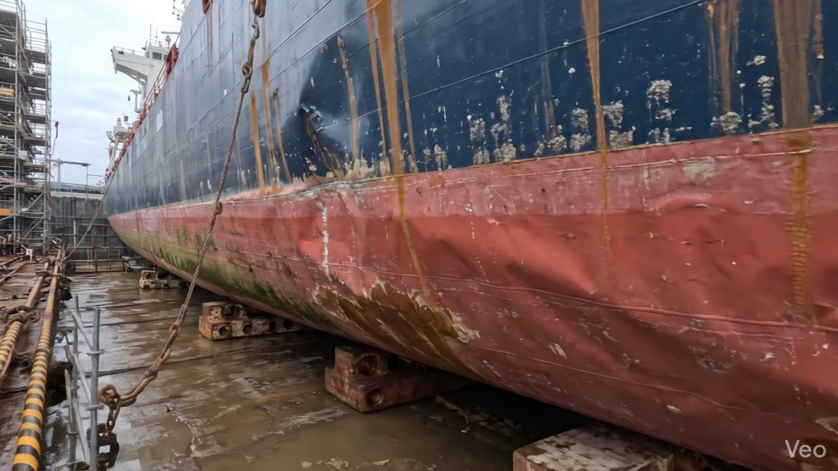

Repair Procedure
**Vessel Inspection Report: Explanation of Structural Steel Repair Process**
This report details the systematic process for structural steel repair, focusing on the rationale behind each step, the activities performed, the utilization of key equipment, and critical safety and structural considerations.
---
**1. Assessment**
* **Necessity:** The initial assessment is fundamental for precisely defining the scope and nature of the damage. This step ensures that all affected areas are identified, the extent of deformation is quantified, and an appropriate repair strategy can be formulated. Without a thorough assessment, there is a risk of either under-repairing critical damage or unnecessarily expanding the repair area.
* **Process:** During this phase, the deformed region undergoes detailed visual inspection. Buckled areas are marked to delineate the extent of damage. A critical evaluation determines whether the deformation is localized to a specific plate or if it extends to surrounding structural members such as frames, girders, or stiffeners. Out-of-flatness measurements are taken to quantify the degree of structural deviation.
* **Required Items Usage:** This step primarily involves visual inspection and measurement tools; specialized equipment like cutting torches are not typically utilized here.
* **Safety & Structural Considerations:**
* **Safety:** Personnel conducting the assessment must ensure the damaged area is stable and safe for entry. In cases of severe structural compromise, temporary shoring or support may be required to prevent further collapse or movement during inspection.
* **Structural:** Accurate assessment is paramount for structural integrity. It prevents overlooking hidden damage that could lead to future failure and avoids unnecessary removal of sound material, which can inadvertently weaken the surrounding structure.
---
**2. Preparation**
* **Necessity:** The preparation phase is crucial for creating a sound and clean foundation for the new steel. All compromised, distorted, or fatigued material must be removed to ensure that subsequent welding operations are performed on structurally sound metal, guaranteeing the integrity and longevity of the repair.
* **Process:** This step involves the controlled removal of all distorted plate material and any buckled girders or stiffeners. Cutting is executed to reach sound, undamaged metal, leaving a critical margin of good plate material (typically equal to or greater than ¾ of the original plate thickness) around the cut-out. Any bent framing adjacent to the repair area is either straightened or completely removed as deemed necessary by the repair plan.
* **Required Items Usage:**
* **Cutting Torch (rental):** The cutting torch is indispensable in this phase. It is utilized for the thermal cutting of the damaged steel plate, girders, and stiffeners. The precise and efficient removal of distorted material to sound metal is achieved through the high-temperature cutting capabilities of this equipment. Its rental status implies it's a specialized tool acquired for the specific duration and scope of the repair, contributing to operational efficiency and cost management.
* **Safety & Structural Considerations:**
* **Safety:** This is a "hot work" operation requiring strict adherence to safety protocols. A Hot Work Permit is mandatory, along with continuous fire watch personnel during and after cutting. Welders and cutters must wear appropriate Personal Protective Equipment (PPE), including welding helmets, flame-retardant clothing, and gloves. Adequate ventilation is critical, especially in enclosed spaces, to prevent the accumulation of hazardous fumes.
* **Structural:** Careful planning and execution of cuts are essential to avoid further weakening the surrounding structure. The specified margin of sound material ensures that the remaining plate has sufficient strength to support the new insert plate and transfer loads effectively.
---
**3. Plate Replacement**
* **Necessity:** This step restores the structural continuity and, where applicable, the watertight or weathertight integrity of the vessel by integrating new, uncompromised material into the prepared opening. It directly contributes to reinstating the vessel's design strength and load-carrying capacity.
* **Process:** A new steel plate, manufactured to the same or greater thickness specifications as the original, is precisely fabricated and shaped to match the dimensions of the cut-out. This new plate is then carefully positioned against the existing hull plating, ensuring proper alignment. It is initially secured by tack-welds, followed by complete welding around the entire perimeter. Critical attention is given to achieving good fusion between the new and existing materials. Appropriate preheat procedures are applied, particularly for thicker plates or specific steel grades, to mitigate thermal stress and prevent hydrogen-induced cracking. Full penetration welds are employed wherever feasible to maximize joint strength and structural continuity.
* **Required Items Usage:** The cutting torch is not typically used for the final fit-up and welding of the new plate, as this stage focuses on precision placement and joining.
* **Safety & Structural Considerations:**
* **Safety:** Standard welding safety protocols, including appropriate PPE, adequate ventilation, and fire watch, must be strictly observed. Proper lifting and positioning techniques for the new plate are crucial to prevent injuries.
* **Structural:** Precise fit-up is paramount for optimal weld quality. Any significant gaps or misalignments can compromise weld strength. The selection of welding parameters, including preheat and proper electrode usage, directly impacts the structural integrity of the completed joint, ensuring it meets classification society requirements.
---
**4. Alignment and Welding**
* **Necessity:** This phase is critical for fully integrating the new steel plate into the vessel's structure, ensuring the repair meets specified strength requirements, and that any welding-induced distortions are effectively controlled. Maintaining the original hull contour and preventing stress concentrations are key objectives.
* **Process:** Continuous weld passes are systematically applied using E7018 electrodes. These low-hydrogen electrodes are chosen for their excellent mechanical properties and resistance to cracking, making them ideal for high-integrity structural repairs. Throughout the welding process, rigorous control measures are implemented to mitigate welding-induced distortion; this includes the strategic use of clamps, careful sequencing of weld passes, and minimal heat input techniques. Upon completion of welding, the weld seams are meticulously ground fair with the surrounding hull surface. This action eliminates abrupt transitions, reducing stress concentrations and restoring hydrodynamic efficiency. In situations involving extensive original buckling, engineering assessment may dictate the application of additional strengthening elements, such as doubler plates or supplementary stiffeners, to reinforce the area and enhance its resistance to future stress.
* **Required Items Usage:** This step primarily involves welding equipment and grinding tools; the cutting torch is not directly used here.
* **Safety & Structural Considerations:**
* **Safety:** All general welding safety procedures remain in effect. Grinding operations necessitate the use of eye protection, respiratory masks, and hearing protection.
* **Structural:** The choice of E7018 electrodes is critical for achieving high-quality, ductile, and strong welds, integral to structural continuity. Effective distortion control is vital to prevent residual stresses, which can compromise fatigue life and potentially alter the vessel's hydrodynamics. Fairing the weld seams not only improves aesthetics but also reduces stress risers and minimizes hydrodynamic drag. The application of doublers or stiffeners is a considered engineering decision to provide localized reinforcement, ensuring the repaired section meets or exceeds the original structural capacity.
---
**5. Finishing**
* **Necessity:** The finishing stage serves to formally verify the quality and integrity of the completed repair, provide essential corrosion protection to the newly installed steel, and restore the aesthetic and functional contour of the vessel.
* **Process:** The repair undergoes a comprehensive inspection regime. This includes visual inspection to identify any surface defects such as undercut, porosity, or misalignment. Crucially, Non-Destructive Testing (NDT) methods (e.g., Magnetic Particle Testing, Ultrasonic Testing, Dye Penetrant Testing) are applied to detect any subsurface discontinuities or hidden flaws in the welds that are not apparent visually. Following successful inspection, the new steel surface is meticulously prepared and coated with appropriate primer coats to establish initial corrosion protection. Subsequently, finish coats are applied, matching the surrounding hull or deck, to provide long-term environmental protection and restore the vessel's aesthetic appearance. Finally, the repaired deck or hull surface is carefully faired back to its original design contour, ensuring optimal performance and structural harmony.
* **Required Items Usage:** This step involves NDT equipment, painting equipment, and potentially grinding tools; the cutting torch is not used here.
* **Safety & Structural Considerations:**
* **Safety:** If painting or inspection occurs in confined spaces, strict confined space entry protocols, including gas testing and continuous ventilation, must be followed. Personnel handling paints and coatings must use appropriate respiratory protection and PPE to guard against fumes and skin contact.
* **Structural:** NDT is a critical quality assurance measure, providing objective evidence that the structural integrity of the welds meets the required standards, thereby ensuring the long-term reliability of the repair. The application of a robust coating system is paramount for preventing corrosion of the new steel, which could otherwise undermine the repair's structural effectiveness over time in the harsh marine environment. Restoring the original contour is essential for maintaining the vessel's hydrodynamic performance, stability, and preventing localized stress concentrations.

Repair Cost Breakdown
Item | Quantity | Unit Cost | Total Cost | Currency
Cutting Torch (rental) | 0.12 | 10764.0 | 1345.5 | INR
Estimated Repair Cost: 69305.88 INR

3.3 PD_3

Defect Overview
**Defect Name:** DEFORMATION
**Severity:** High
---
**1. What the defect means:**
Deformation, specifically observed as buckling or warping, refers to an out-of-plane bending or distortion of the vessel's hull plating or structural stiffeners from their original intended geometry. Unlike a simple dent, deformation implies a significant and often permanent change to the load-bearing shape of the steel structure. In this instance, the deformation is specifically noted in the **KEEL_AREA**, indicating distortion within a critical longitudinal structural component of the vessel. Such distortion can result from various factors including direct impact (e.g., grounding), excessive external loads from heavy seas, or internal stresses induced by welding.
**2. Why it is important:**
This defect is critically important due to its direct and severe impact on the vessel's structural integrity. A 'High' severity rating indicates that the observed deformation significantly compromises the localized strength of the affected area and, by extension, potentially the overall hull girder. Even moderate buckles can severely impair the ability of the hull plating and stiffeners to carry their design loads, particularly compressive forces. This permanent alteration of the structure's geometry directly reduces its designed strength and stiffness, making it a priority for immediate attention and corrective action as per classification society practices.
**3. Risks if not repaired:**
Failure to address and repair significant deformation in the keel area carries several critical risks:
* **Progressive Structural Weakening:** The deformed section acts as a stress concentration point, making it highly susceptible to further damage, crack initiation, and propagation under normal operational loads, especially during heavy weather or subsequent impacts.
* **Reduced Hull Girder Strength:** The keel is a primary component of the hull girder. Deformation in this area severely impairs the vessel's overall longitudinal strength, which is vital for its ability to withstand global bending moments (hogging and sagging). This increases the risk of premature fatigue cracking throughout the hull.
* **Potential for Watertight Integrity Breach:** Depending on its location and extent, severe deformation can lead to cracking or separation of plating, compromising the watertight or weathertight integrity of adjacent tanks or compartments, potentially leading to ingress of water or loss of contents.
* **Increased Risk of Catastrophic Failure:** The weakened structure is at an elevated risk of sudden and unpredictable failure, which can have severe implications for vessel safety, crew, cargo, and potential environmental damage.
* **Regulatory Non-Compliance:** Unrepaired defects of this severity will inevitably lead to deficiencies cited by classification societies and flag state administrations, potentially affecting the vessel's statutory certificates, insurance coverage, and operational status.
**4. Structural implications:**
The structural implications of significant deformation in the keel area are profound:
* **Loss of Load-Bearing Capacity:** Out-of-plane bending significantly reduces the local section modulus and moment of inertia of the affected plating and stiffeners. This diminishes their ability to effectively resist compressive, tensile, and shear forces, causing them to yield or buckle prematurely compared to their design strength.
* **Compromised Global Hull Girder Strength:** As the keel area is a crucial element of the hull girder, deformation here directly impacts the vessel's overall longitudinal strength, stiffness, and ability to effectively distribute and handle global bending and torsional moments experienced during operations.
* **Stress Concentration:** The distorted geometry creates high-stress concentration points at the boundaries of the buckle and in adjacent structural members. This leads to accelerated fatigue crack initiation and propagation in these localized areas, even under normal operating conditions.
* **Alteration of Original Design Parameters:** The vessel's original structural design and calculations assume intact plating and stiffeners. Deformation fundamentally alters these parameters, causing the structure to behave differently and less predictably under load, potentially leading to unforeseen weaknesses.
* **Necessity for Renewal:** As per classification practice, significant buckling that severely impairs hull girder strength typically requires corrective action involving the cutting out and replacement of the distorted metal to restore the original structural integrity and design strength. Localized set-in plating, if small and not impacting structural strength, might sometimes be tolerated, but substantial buckling, especially with a 'High' severity, mandates renewal.

Visual Evidence
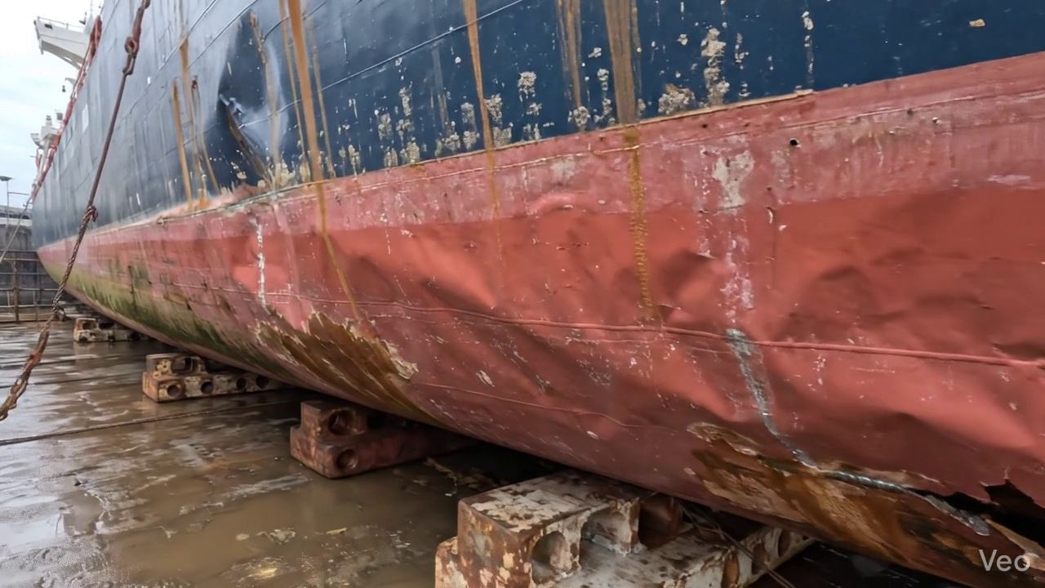

Repair Procedure
This explanation outlines the critical steps involved in a maritime steel repair process, detailing the necessity of each stage, the actions performed, the function of required tooling, and paramount safety and structural considerations.
---
### **Explanation of Maritime Steel Repair Process for Vessel Inspection Report**
This report details a standard repair process for localized deformation or damage to a vessel's steel plating and structural members. The methodology ensures restoration of structural integrity, watertightness, and hull fairness in compliance with classification society rules and industry best practices.
**1. Assessment Phase**
* **What happens:** Naval architects or qualified surveyors meticulously inspect the deformed region. This involves visually identifying the extent of buckling, marking the affected area, and determining if the damage is localized to a specific plate or if it impacts adjacent frames, girders, or bulkheads. Out-of-flatness measurements are taken using appropriate tools (e.g., straight edges, feeler gauges, laser alignment tools) to quantify the degree of deformation.
* **Why necessary:** This initial assessment is critical for defining the scope of the repair. It allows engineers to accurately determine the amount of material that requires replacement, evaluate the severity of structural compromise, and plan the most effective repair strategy. Precise measurements ensure that the repair area is adequately defined, preventing future propagation of damage or re-occurrence of similar issues.
**2. Preparation Phase**
* **What happens:** Following the assessment, all compromised material, including distorted plate sections and any buckled or bent internal girders or stiffeners, are carefully removed. The cutting is executed to sound metal, ensuring that no compromised material remains to propagate cracks or stresses. A margin of good plate, typically at least ¾ of the original plate thickness, is maintained around the cut-out to provide a robust base for welding. Any bent framing not requiring full replacement is straightened to restore its original structural profile.
* **Why necessary:** This phase is fundamental to achieving a durable repair. Removing all distorted material eliminates areas of concentrated stress and potential crack initiation sites. Cutting to sound metal ensures that the new weld will fuse with structurally sound material, guaranteeing weld integrity. The specified margin provides sufficient material for the weld joint preparation and reduces heat-affected zone issues in the parent material.
* **Why the 'Cutting Torch' is used:** The cutting torch is an indispensable tool for this phase. It provides an efficient and effective method for thermal cutting of steel plate and structural members. Its use enables precise removal of damaged sections while minimizing mechanical stress on the surrounding structure. The rental item listed indicates its periodic need for such operations, reflecting typical shipyard resource management.
**3. Plate Replacement Phase**
* **What happens:** A new steel plate, matching or exceeding the original thickness and material specification, is fabricated. This involves precise shaping and forming to perfectly fit the prepared cut-out in the hull or deck structure. The new plate is then carefully positioned against the remaining hull plating. It is initially secured with tack welds to maintain alignment and fit-up, followed by complete welding around its perimeter. Preheat is applied as necessary, depending on plate thickness and material type, to reduce thermal stress and prevent hydrogen cracking in the weld and heat-affected zone. Full penetration welds are utilized where structural continuity and strength are paramount.
* **Why necessary:** This step restores the primary structural integrity and watertight envelope of the vessel. Fabrication to precise dimensions ensures a good fit-up, which is crucial for weld quality and minimizes distortion. Tack welding provides temporary rigidity and accurate positioning before final welding. Full perimeter welding ensures watertightness and complete load transfer. Preheat is a critical quality control measure for thicker sections or high-strength steels, preventing brittle fracture and ensuring metallurgical soundness of the weld. Full penetration welds maximize joint strength and fatigue resistance.
**4. Alignment and Welding Phase**
* **What happens:** The main welding operation proceeds with continuing weld passes. The use of E7018 electrodes is specified, indicating a preference for low-hydrogen, high-strength weld metal suitable for structural applications. Throughout the welding process, close attention is paid to controlling distortion. Clamps, strongbacks, or strategic welding sequences (e.g., skip welding, back-step welding) are employed to minimize heat input and prevent buckling or warping of the surrounding structure. Once welding is complete, weld seams are ground fair with the hull surface to restore hydrodynamic smoothness and prepare for coating. In cases of extensive original buckling or areas subjected to high cyclic stresses, additional strengthening measures such as doublers (pads) or additional stiffeners may be incorporated to enhance localized structural resistance.
* **Why necessary:** This phase ensures the complete structural integration of the new plate. E7018 electrodes are specifically chosen for their excellent mechanical properties, good impact toughness, and low hydrogen content, which significantly reduces the risk of hydrogen-induced cracking in critical structural welds. Distortion control is vital to maintain the vessel's designed lines, minimize residual stresses, and avoid impacting adjacent structures or machinery. Grinding welds fair is essential for hydrodynamics, aesthetics, and ensuring proper adhesion of subsequent coating systems. The application of doublers or stiffeners signifies a proactive approach to prevent future damage in areas identified as potentially vulnerable, enhancing the vessel's long-term durability.
**5. Finishing Phase**
* **What happens:** The completed repair undergoes thorough inspection. This includes comprehensive visual examination for surface defects such as cracks, porosity, undercut, or incomplete fusion. Additionally, Non-Destructive Testing (NDT) methods, such as Ultrasonic Testing (UT) or Magnetic Particle Inspection (MPI), are performed to confirm internal weld soundness and detect any sub-surface imperfections. Upon satisfactory inspection, the new steel is prepared (e.g., abrasive blasting) and promptly coated with appropriate primer and finish coats to restore corrosion protection. Finally, the repaired deck or hull surface is faired back to its original contour, ensuring smooth transitions and proper drainage.
* **Why necessary:** The finishing phase is crucial for verifying the quality and longevity of the repair. Visual and NDT inspections provide objective evidence that the repair meets specified quality standards and is free from detrimental defects, ensuring the structural integrity of the vessel. The application of a marine-grade coating system is paramount to prevent premature corrosion of the new steel, which would rapidly compromise the repair's effectiveness. Fairing the surface restores the vessel's hydrodynamic efficiency, prevents localized turbulence, and ensures proper functionality of adjacent systems or equipment.
---
**Safety and Structural Considerations:**
* **Hot Work Safety:** The "Preparation" and "Alignment and Welding" phases involve extensive hot work (cutting and welding). Strict adherence to hot work permits, fire watch protocols, clear demarcation of work zones, provision of appropriate fire extinguishing equipment, and removal of combustible materials are mandatory. Proper ventilation is critical to mitigate exposure to welding fumes and gases.
* **Personal Protective Equipment (PPE):** All personnel involved must utilize appropriate PPE, including welding masks, gloves, flame-retardant clothing, safety glasses, and hearing protection.
* **Structural Stability:** During material removal in the "Preparation" phase, temporary shoring or bracing may be required to maintain the local structural stability of the vessel, preventing unintended deformation or collapse of adjacent structures. The sequence of cutting and replacement is carefully planned to minimize impact on overall hull girder strength.
* **Material Compatibility:** The replacement steel must be compatible with the existing hull material, typically verified by material certificates, to ensure consistent mechanical properties and weldability.
* **Weld Quality and Integrity:** The quality of welding is paramount. Operators must be certified welders, and welding procedures (WPS) must be qualified. Control of heat input, interpass temperature, and distortion is vital to prevent cracking, maintain metallurgical properties, and ensure the structural continuity and watertightness of the repair.
* **Non-Destructive Testing (NDT):** NDT methods are essential for verifying the internal soundness of critical welds, identifying any hidden defects that could compromise the long-term integrity of the repair.
* **Corrosion Protection:** The application of a robust marine coating system is not merely aesthetic but a critical component of the repair to prevent corrosion and extend the service life of the new steel.
* **Fairness and Hydrodynamics:** Ensuring the repaired surface is faired back to its original contour is important for maintaining the vessel's hydrodynamic performance, fuel efficiency, and aesthetic appearance.
This comprehensive approach ensures that the repair is not only effective in the short term but also contributes to the vessel's long-term structural integrity and operational safety.

Repair Cost Breakdown
Item | Quantity | Unit Cost | Total Cost | Currency
Cutting Torch (rental) | 0.12 | 10764.0 | 1345.5 | INR
Estimated Repair Cost: 69305.88 INR

3.4 PD_4

Defect Overview
**DEFECT REPORT: DEFORMATION**
**Severity:** High
**Location:** KEEL AREA (20.7% overlap)
---
**1. What the defect means:**
Deformation, as observed in the vessel's keel area, refers to an out-of-plane bending, often manifesting as buckling or warping, of the hull plating and/or its associated stiffeners. This indicates a physical distortion where the metal deviates from its intended flat or smoothly curved design profile. Such deformation in the keel is typically caused by significant external forces, such as grounding impacts, heavy sea loads imposing excessive stress, or internal stresses induced by uneven welding during construction or repair.
**2. Why it is important:**
This defect is classified as high severity due to its critical impact on the vessel's structural integrity. The keel is a primary longitudinal strength member, often referred to as the "backbone" of the hull. Deformation in this area directly compromises the local strength and stiffness of the affected plating and stiffeners. More significantly, even moderate buckling can severely impair the overall longitudinal hull girder strength, which is fundamental to the vessel's ability to withstand hogging and sagging stresses during operation. Classification societies universally mandate the correction of significant buckling due to these critical implications.
**3. Risks if not repaired:**
Failure to repair significant deformation in the keel area carries substantial risks:
* **Compromised Structural Integrity:** The weakened and distorted plating creates areas of high stress concentration, significantly increasing the risk of localized yielding, fatigue crack initiation, or even catastrophic structural failure, especially under dynamic loads from heavy seas or during cargo operations.
* **Potential for Water Ingress:** Progressive deformation, material thinning at the apex of buckles, or fatigue cracking could lead to the loss of watertight integrity in the hull envelope, potentially resulting in flooding of compartments.
* **Reduced Vessel Lifespan & Operational Limitations:** Operating the vessel with such a defect will lead to accelerated wear and tear, reducing its overall design lifespan. It may also necessitate speed restrictions, cargo limitations, or result in detention by port state control and potential withdrawal of classification, severely impacting operational capability and commercial viability.
* **Increased Repair Scope:** Delaying repairs can allow the deformation to worsen or induce damage in adjacent structures, leading to a much larger and more costly repair requirement in the future.
**4. Structural implications:**
Structurally, deformation in the keel area has profound and critical implications:
* **Loss of Sectional Modulus:** The out-of-plane bending effectively reduces the cross-sectional area and the moment of inertia of the affected plating and stiffeners. This directly diminishes their sectional modulus, thereby reducing their resistance to bending moments and shear forces.
* **Impairment of Hull Girder Strength:** As a primary component of the hull girder, deformation in the keel directly reduces the overall longitudinal strength and stiffness of the vessel. This makes the vessel less capable of resisting the global hogging and sagging stresses induced by waves and varying load distributions.
* **Stress Concentrations & Load Path Disruption:** The deformed areas become critical points where operational stresses concentrate. This disrupts the intended smooth transfer of loads through the structure, potentially forcing stresses into unintended and weaker load paths or accelerating material fatigue at these localized points.
* **Reduced Residual Strength:** The presence of deformation significantly reduces the vessel's reserve strength, making it more vulnerable to future impacts, extreme weather events, or unforeseen operational stresses.
* **Adverse Effect on Adjacent Structures:** The localized deformation can induce secondary stresses in adjacent, otherwise sound, structural members, potentially leading to their premature failure or exacerbating existing minor defects.
Given the high severity and critical location of this deformation in the keel area, immediate rectification through cutting out and replacing the distorted metal, as per classification society guidelines, is strongly recommended to restore the vessel's structural integrity and ensure continued safe operation.

Visual Evidence
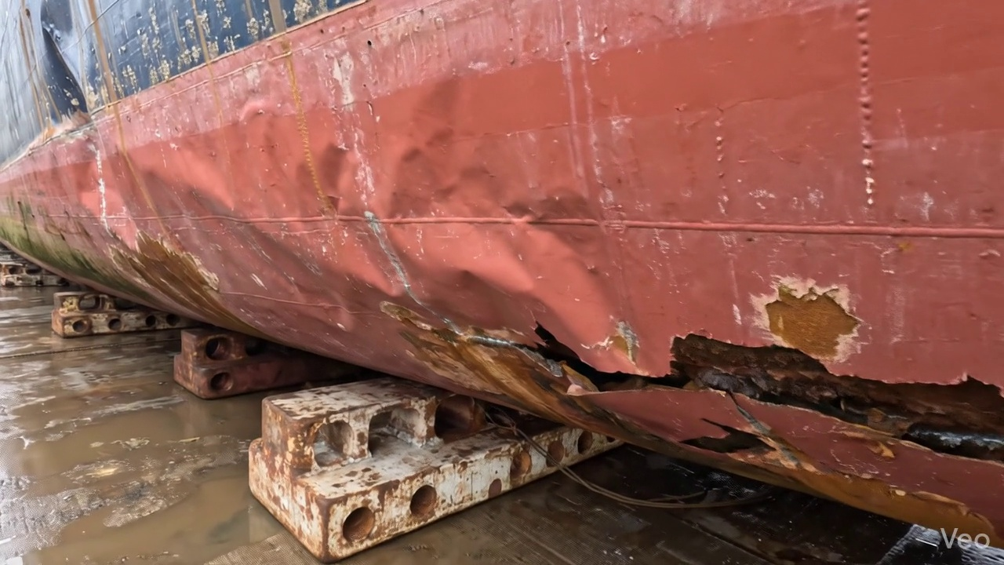

Repair Procedure
The following details a professional explanation of the specified maritime steel plate repair process, outlining each step's necessity, execution, specific equipment usage, and critical safety and structural considerations, as required for a vessel inspection report.
---
### **Maritime Steel Plate Repair Process Explanation**
This document details the standard procedure for repairing buckled or deformed steel plating on a vessel, ensuring the restoration of structural integrity and compliance with maritime standards.
#### **1. Assessment**
* **Necessity:** This initial phase is crucial for accurately characterizing the damage, determining its scope, and planning an effective and targeted repair. It prevents unnecessary material removal and ensures all compromised areas are identified.
* **What happens:** A thorough visual inspection is conducted on the deformed region. The buckled area is precisely marked, and an assessment is made to determine if the deformation is localized or extends across multiple structural frames. Out-of-flatness measurements are taken using appropriate gauges or straightedges to quantify the extent of the deformation. This data forms the basis for the repair strategy.
* **Required Items Usage:** No specific listed items are used directly in this phase; however, measurement tools (e.g., straightedges, calipers, measuring tapes) are essential.
* **Safety & Structural Considerations:** Proper assessment prevents under-scoping the repair, which could leave residual stresses or weakened areas, leading to future failure. It ensures that the repair design addresses the root cause and full extent of the damage.
#### **2. Preparation**
* **Necessity:** This step is vital for removing all compromised material, including fatigued, cracked, or severely deformed steel, to create a sound, clean base for the new plate. This prevents the propagation of existing defects into the new repair.
* **What happens:** All distorted plate material, along with any buckled girders or stiffeners associated with the damaged area, is cut away. This cutting extends to sound, undamaged metal, ensuring a margin of at least three-quarters (¾) of the plate thickness of good material remains. Any bent internal framing that cannot be straightened effectively is also removed to facilitate the fit-up of new components.
* **Required Items Usage:** The **Cutting Torch** is the primary tool used in this phase. It provides the necessary heat and precision to efficiently cut through thick steel plating and structural members, enabling the removal of damaged sections. The listed item, "Cutting Torch (rental)," directly supports this operation.
* **Safety & Structural Considerations:** Hot work permits are mandatory. A fire watch must be present. Personal Protective Equipment (PPE), including eye protection, gloves, and flame-retardant clothing, is essential. Adequate ventilation is required, especially in confined spaces, to dissipate fumes. Structurally, ensuring cuts are made to sound metal is critical; otherwise, new welds could be initiated on compromised material, leading to premature failure.
#### **3. Plate Replacement**
* **Necessity:** This step directly restores the structural integrity, watertightness, and original contour of the vessel's hull or deck.
* **What happens:** A new steel plate is fabricated. This new plate must be of the same or greater thickness and of a compatible material grade as the original, and meticulously shaped to precisely fit the cut-out section. Once fabricated, it is carefully positioned against the remaining hull plating. Tack-welds are then applied strategically to hold the plate securely in alignment, preventing movement during the primary welding process. Following tack-welding, complete welding is executed around the entire perimeter, prioritizing full penetration welds where possible to ensure maximum strength and fusion. Appropriate preheat is applied to the base metal, especially for thicker plates or high-tensile steels, to mitigate thermal stresses and prevent hydrogen-induced cracking.
* **Required Items Usage:** No specific listed items are directly attributed to this step, but welding equipment (power source, cables, torch, electrodes) and fabrication tools (benders, rollers, measuring tools) are fundamental.
* **Safety & Structural Considerations:** Correct material selection (thickness, grade) is paramount for maintaining structural equivalence. Proper preheat and interpass temperatures are critical to control residual stresses and prevent weld defects. Welders must be qualified, and welding procedures (WPS) must be followed rigorously.
#### **4. Alignment and Welding**
* **Necessity:** This phase ensures the structural continuity of the repair, minimizes residual stresses, prevents distortion, and achieves a fair, hydrodynamic surface.
* **What happens:** Continuing weld passes are applied to complete the full penetration weld, typically using low-hydrogen E7018 electrodes. These electrodes are chosen for their excellent mechanical properties and resistance to hydrogen-induced cracking. Throughout the welding process, continuous monitoring for heat-induced distortion is critical. Techniques such as strategic clamping, back-step welding, or controlled, minimal heat input welding are employed to maintain the original alignment and contour of the hull. Upon completion of welding, all weld seams are meticulously ground fair with the surrounding hull surface to eliminate stress concentrators, improve aesthetic appeal, and optimize hydrodynamic flow. In cases where the original buckling was extensive, additional strengthening elements, such as doubler plates or stiffeners, may be incorporated to further enhance the structural robustness and evenly distribute loads.
* **Required Items Usage:** While E7018 electrodes are specified, they are not listed under "Required Items." Consumables like grinding discs and welding gases are implicitly used.
* **Safety & Structural Considerations:** Proper ventilation is crucial to protect welders from fumes. Arc flash protection (helmets, clothing) is mandatory. The use of E7018 electrodes requires specific storage conditions (e.g., drying ovens) to maintain low hydrogen content. Structurally, full penetration and good fusion are essential. Grinding must remove high spots without excessively thinning the plate. The decision to add doublers or stiffeners must be made in consultation with naval architects or class society engineers to ensure proper load distribution and avoid creating new stress points.
#### **5. Finishing**
* **Necessity:** The final finishing phase confirms the quality and integrity of the repair, restores the vessel's protective coatings, and ensures the repaired area is aesthetically and hydrodynamically integrated.
* **What happens:** The completed repair undergoes a comprehensive inspection. This includes a thorough visual inspection for surface defects, followed by Non-Destructive Testing (NDT) methods, such as Ultrasonic Testing (UT) to check for internal defects and plate thickness, or Magnetic Particle Inspection (MPI) to detect surface and near-surface cracks. Once the repair passes NDT, the new steel surface is thoroughly cleaned to remove slag, spatter, and grinding dust. A marine-grade primer is then applied, followed by appropriate finish coats, to restore the vessel's corrosion protection system and match the surrounding paint scheme. Finally, the repaired deck or hull surface is faired back to its original contour, ensuring smooth transitions and no abrupt changes that could affect performance or accumulate debris.
* **Required Items Usage:** No specific listed items are directly attributed to this step, but NDT equipment, cleaning tools, painting equipment (sprayers, brushes), and fairing tools (grinders, sanders) are utilized.
* **Safety & Structural Considerations:** NDT personnel must be certified. Proper surface preparation is vital for coating adhesion and longevity. The choice of coatings must be compatible with existing systems and marine environment specifications. Inadequate coating application could lead to premature corrosion, compromising the repair. The final fairing must achieve the design lines without excessive material removal.
---

Repair Cost Breakdown
Item | Quantity | Unit Cost | Total Cost | Currency
Cutting Torch (rental) | 0.12 | 10764.0 | 1345.5 | INR
Estimated Repair Cost: 69305.88 INR

