Vessel Inspection Report

Table of Contents
1. Executive Summary
2. Vessel Repair Summary
3. Defect Analysis
3.1 PD_1

1. Executive Summary
Generation failed.

2. Vessel Repair Summary
Metric | Value
Total Defects | 1
Total Estimated Cost | 69305.88 INR
Material Cost | 41583.53 INR
Labor Cost | 20791.76 INR
Equipment Cost | 6930.59 INR

3. Defect Analysis

3.1 PD_1

Defect Overview
Generation failed.

Visual Evidence
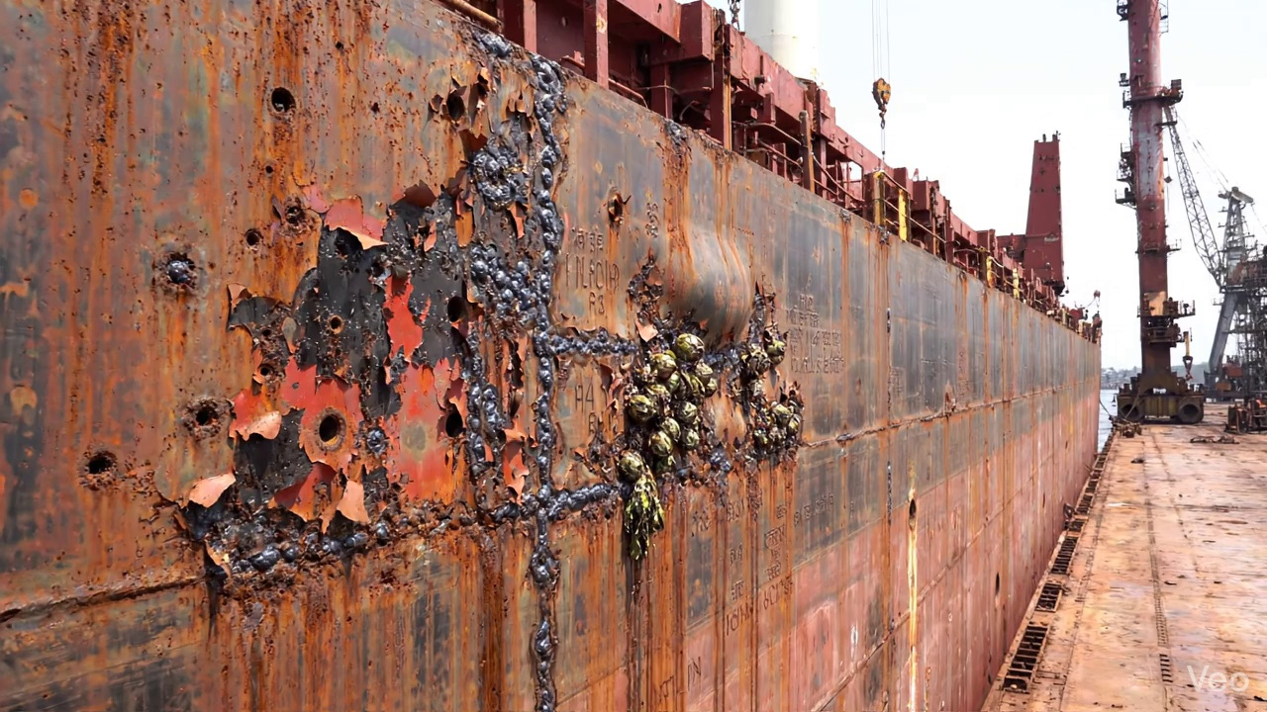

Repair Procedure
Generation failed.

Repair Cost Breakdown
Item | Quantity | Unit Cost | Total Cost | Currency
Cutting Torch (rental) | 0.12 | 10764.0 | 1345.5 | INR
Estimated Repair Cost: 69305.88 INR

