Vessel Inspection Report

Table of Contents
1. Executive Summary
2. Vessel Repair Summary
3. Defect Analysis
3.1 PD_1

1. Executive Summary
Generation failed.

2. Vessel Repair Summary
Metric | Value
Total Defects | 1
Total Estimated Cost | 27722.35 INR
Material Cost | 16633.41 INR
Labor Cost | 8316.7 INR
Equipment Cost | 2772.24 INR

3. Defect Analysis

3.1 PD_1

Defect Overview
Generation failed.

Visual Evidence
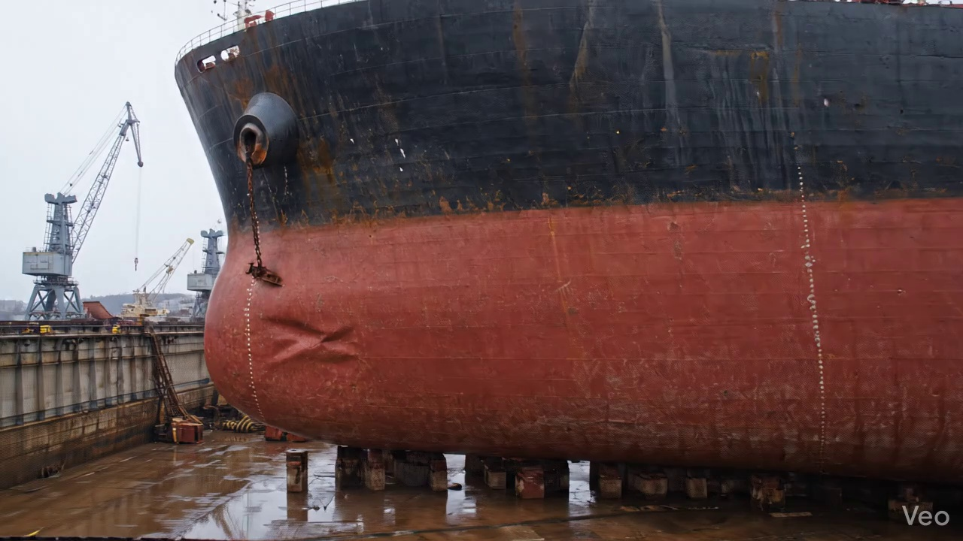

Repair Procedure
Generation failed.

Repair Cost Breakdown
Item | Quantity | Unit Cost | Total Cost | Currency
Cutting Torch (rental) | 0.05 | 10764.0 | 538.2 | INR
Estimated Repair Cost: 27722.35 INR

