Vessel Inspection Report

Table of Contents
1. Executive Summary
2. Vessel Repair Summary
3. Defect Analysis
3.1 PD_1
3.2 PD_2
3.3 PD_3
3.4 PD_4

1. Executive Summary
Generation failed.

2. Vessel Repair Summary
Metric | Value
Total Defects | 4
Total Estimated Cost | 221778.82 INR
Material Cost | 133067.29 INR
Labor Cost | 66533.65 INR
Equipment Cost | 22177.88 INR

3. Defect Analysis

3.1 PD_1

Defect Overview
Generation failed.

Visual Evidence
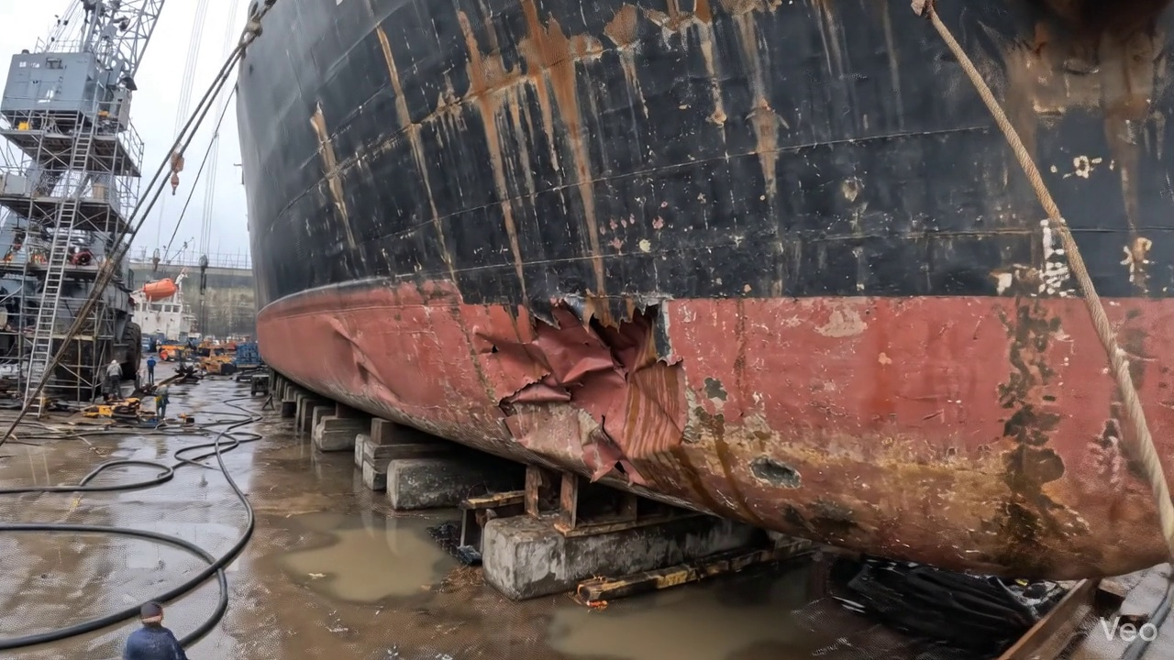

Repair Procedure
Generation failed.

Repair Cost Breakdown
Item | Quantity | Unit Cost | Total Cost | Currency
Cutting Torch (rental) | 0.08 | 10764.0 | 807.3 | INR
Estimated Repair Cost: 41583.53 INR

3.2 PD_2

Defect Overview
Generation failed.

Visual Evidence
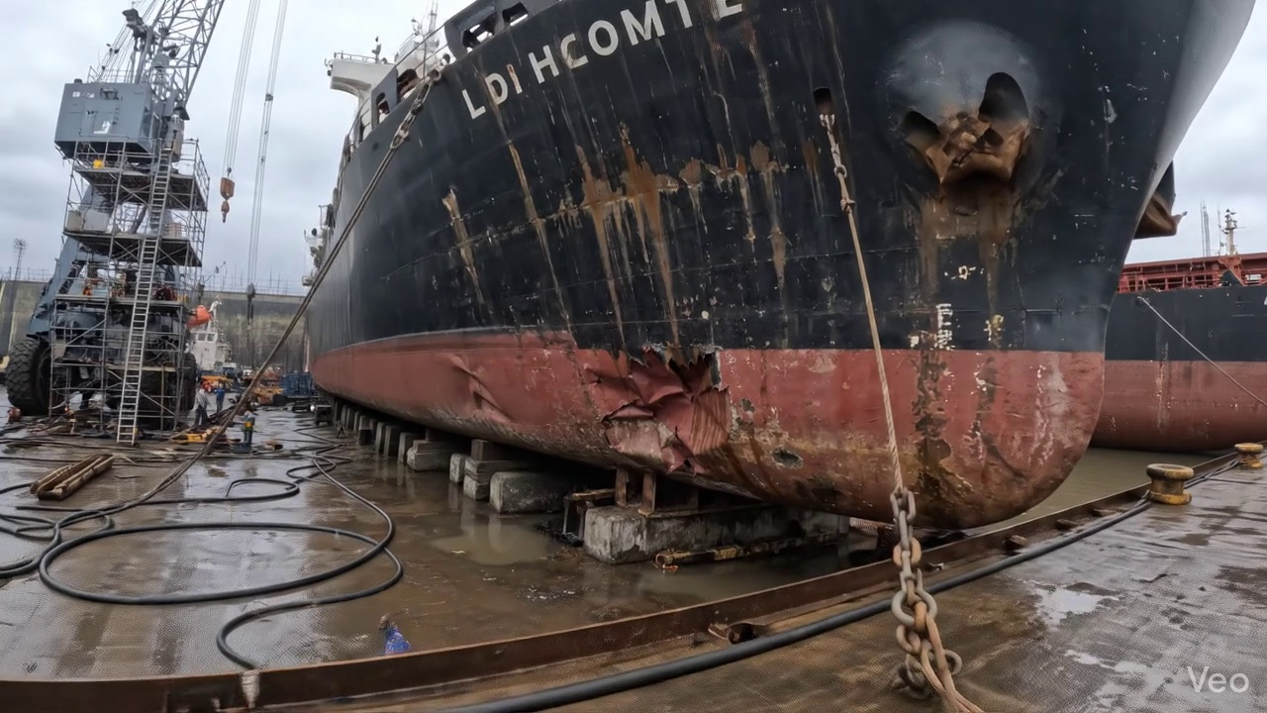

Repair Procedure
Generation failed.

Repair Cost Breakdown
Item | Quantity | Unit Cost | Total Cost | Currency
Cutting Torch (rental) | 0.08 | 10764.0 | 807.3 | INR
Estimated Repair Cost: 41583.53 INR

3.3 PD_3

Defect Overview
Generation failed.

Visual Evidence
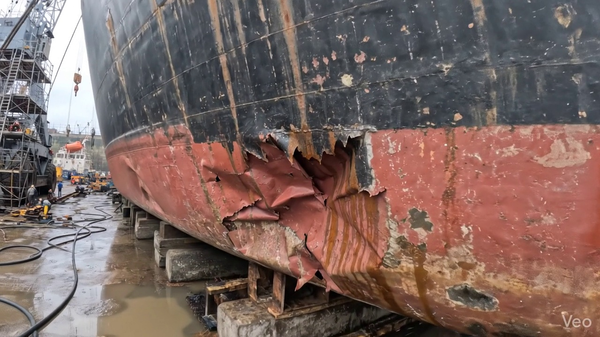

Repair Procedure
Generation failed.

Repair Cost Breakdown
Item | Quantity | Unit Cost | Total Cost | Currency
Cutting Torch (rental) | 0.12 | 10764.0 | 1345.5 | INR
Estimated Repair Cost: 69305.88 INR

3.4 PD_4

Defect Overview
Generation failed.

Visual Evidence
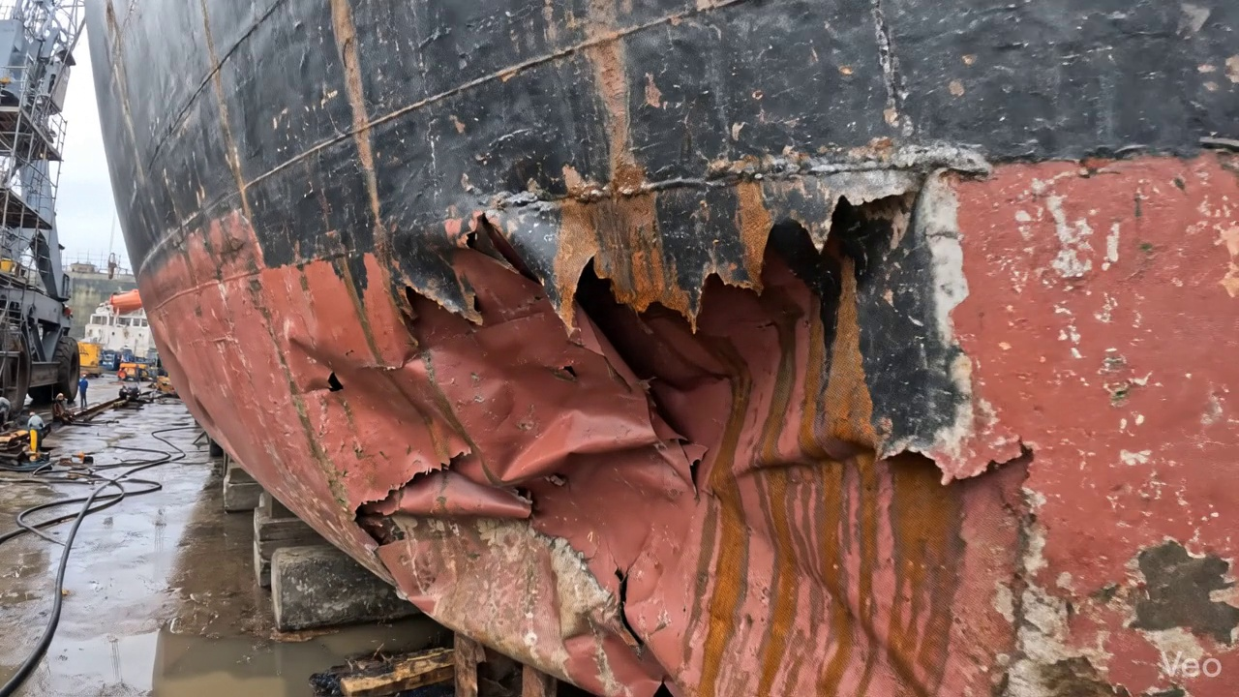

Repair Procedure
Generation failed.

Repair Cost Breakdown
Item | Quantity | Unit Cost | Total Cost | Currency
Cutting Torch (rental) | 0.12 | 10764.0 | 1345.5 | INR
Estimated Repair Cost: 69305.88 INR

