Vessel Inspection Report

Table of Contents
1. Executive Summary
2. Vessel Repair Summary
3. Defect Analysis
3.1 PD_1
3.2 PD_2
3.3 PD_3
3.4 PD_4

1. Executive Summary
Generation failed.

2. Vessel Repair Summary
Metric | Value
Total Defects | 4
Total Estimated Cost | 221778.82 INR
Material Cost | 133067.29 INR
Labor Cost | 66533.65 INR
Equipment Cost | 22177.88 INR

3. Defect Analysis

3.1 PD_1

Defect Overview
**Defect Explanation: DEFORMATION (Medium Severity)**
**1. What the defect means.**
Deformation, in this context, refers to an out-of-plane bending, often manifesting as buckling or warping, observed on the vessel's hull plating or its underlying stiffeners. This is a visible alteration from the intended flat or smoothly curved surface, indicating that the material has experienced stresses beyond its elastic limit, resulting in a permanent change in shape. The overlapping part identified as 'HULL_AREA' with a significant overlap ratio indicates that this deformation is present on a substantial section of the vessel's primary shell structure.
**2. Why it is important.**
This defect is important because even moderate levels of deformation, such as buckling or warping, severely impair the intrinsic strength of the affected hull plating and stiffeners. These components are fundamental to the vessel's overall hull girder strength, which is critical for resisting global forces like bending moments and shear stresses experienced during operations. A medium severity classification suggests that while not an immediate catastrophic failure, the deformation represents a significant localized weakening that compromises the structural integrity of the hull.
**3. Risks if not repaired.**
If not repaired, the identified deformation poses several risks:
* **Progressive Failure:** The weakened area is susceptible to further deformation or localized collapse under recurring or increased operational loads (e.g., heavy seas, cargo stresses), potentially leading to a cascading structural failure.
* **Fatigue Cracking:** Deformed areas introduce stress concentrations that can accelerate the initiation and propagation of fatigue cracks, particularly at the boundaries of the buckle or adjacent welded connections.
* **Compromised Watertight Integrity:** Severe buckling or warping in hull plating can compromise the watertight or weathertight integrity of compartments, leading to ingress of water which could affect stability or damage cargo/equipment.
* **Reduced Seaworthiness and Safety:** The cumulative effect of weakened structural components diminishes the vessel's overall seaworthiness, increasing the risk of structural failure and posing a significant safety hazard to the crew, cargo, and the vessel itself.
* **Non-Compliance:** Unrepaired significant deformations may lead to non-compliance with classification society rules and statutory regulations, potentially affecting the vessel's class status and ability to trade.
**4. Structural implications.**
The hull plating and stiffeners form the primary load-carrying structure of the vessel, acting as a monolithic beam (the hull girder) to resist hydrostatic pressure, wave-induced forces, and cargo loads. Deformation directly impacts the structural efficiency by:
* **Reduced Compressive and Shear Capacity:** Buckling significantly reduces the ability of plating and stiffeners to carry compressive and shear loads, as the material can no longer effectively distribute these stresses.
* **Increased Bending Stresses:** The out-of-plane bending effectively creates a shorter structural path and introduces localized bending moments, leading to higher stress levels in the deformed area than designed.
* **Alteration of Load Paths:** Deformation can alter the intended load paths, diverting stresses to adjacent, potentially undamaged, structures which may then become overstressed.
* **Diminished Ultimate Strength and Fatigue Life:** The overall ultimate strength of the hull girder is reduced, meaning it can withstand less total load before failure. Simultaneously, the fatigue life is diminished due to the localized stress concentrations.
Classification practice mandates that significant buckling must be corrected by cutting out and replacing the distorted metal to restore the original design strength and structural integrity. While small, localized set-in plating might sometimes be tolerated under specific conditions, significant deformations necessitate renewal to prevent the aforementioned risks and maintain the vessel's structural robustness.

Visual Evidence
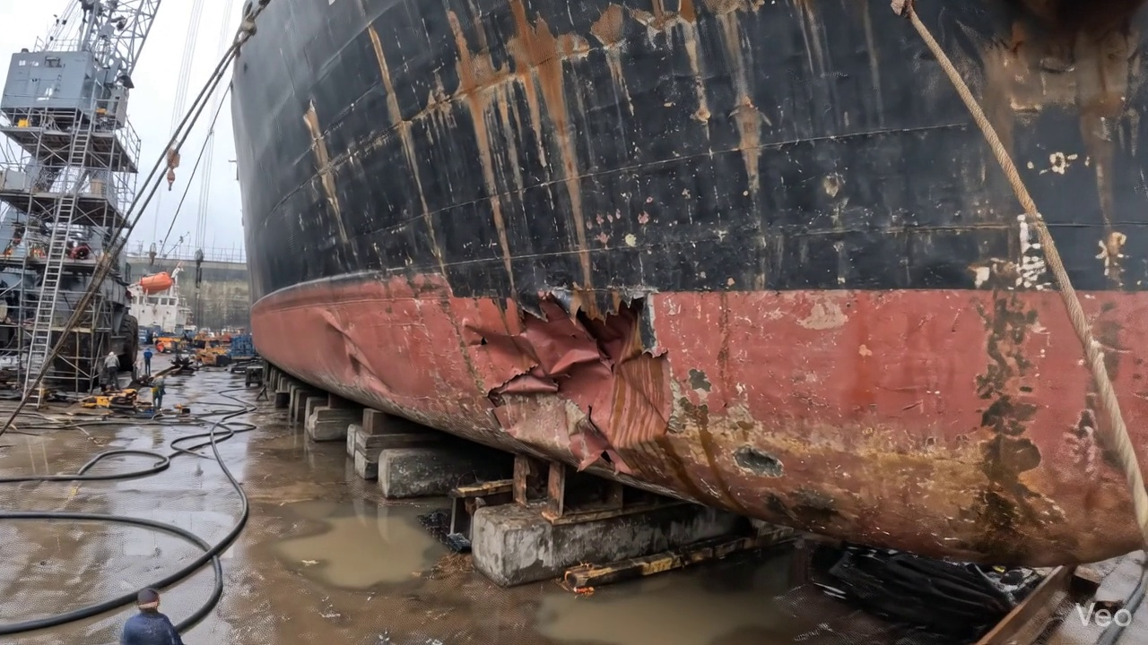

Repair Procedure
Generation failed.

Repair Cost Breakdown
Item | Quantity | Unit Cost | Total Cost | Currency
Cutting Torch (rental) | 0.08 | 10764.0 | 807.3 | INR
Estimated Repair Cost: 41583.53 INR

3.2 PD_2

Defect Overview
Generation failed.

Visual Evidence
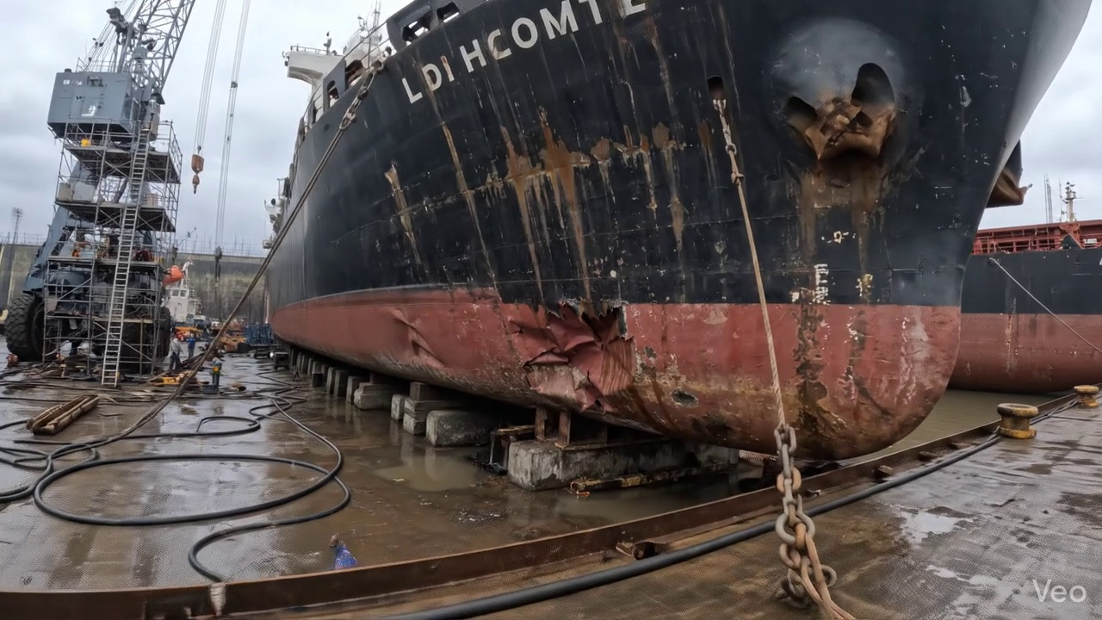

Repair Procedure
## Vessel Inspection Report: Explanation of Structural Steel Repair Process
**Repair Process Overview:**
The described repair procedure addresses localized or extensive deformation of a vessel's hull plating and associated internal framing. It is a robust method for restoring structural integrity and watertightness, adhering to recognized maritime repair practices.
### 1. Assessment
* **Why it's necessary:** This initial step is critical to thoroughly understand the extent and nature of the damage. Without a precise assessment, there is a risk of either under-repairing (leaving compromised material) or over-repairing (unnecessary removal of sound structure), both of which have implications for cost, time, and long-term structural integrity. It establishes the scope of work and informs the repair strategy.
* **What happens during the repair:** Skilled personnel visually inspect the deformed region. They use chalk or other marking tools to delineate the buckled area and determine if the damage is confined to a small spot (localized) or extends across multiple structural frames. Precision measurement tools are employed to quantify any out-of-flatness, which helps in fabricating the replacement plate to the correct contour.
### 2. Preparation
* **Why it's necessary:** This is a foundational step to ensure the new steel plate is welded to sound, undamaged parent metal. Cutting away all distorted plate and buckled framing eliminates potential stress concentrators, fatigue points, and weakened material that could compromise the integrity of the subsequent weld and the overall repair. The specified margin (≥¾ thickness) ensures the weld joint is placed on robust material, maximizing weld strength and preventing 'thin edge' burn-through during welding.
* **What happens during the repair:** Using specialized cutting equipment, all visibly deformed or structurally compromised steel plating, girders, and stiffeners are precisely removed. The cut extends beyond the visually damaged area to ensure only sound, original material remains at the edges of the cut-out. Any adjacent framing that is bent but not severely damaged may be straightened to its original alignment, or removed if the damage is beyond economical repair.
* **Why the required items are used:**
* **Cutting Torch (rental):** This item is essential for this step. A cutting torch, typically oxy-fuel or plasma, is used for the efficient and precise removal of the damaged steel components. Its high heat output allows for quick cutting through thick steel plates and structural members, preparing the opening for the new insert plate. The "rental" aspect indicates it's a piece of specialized equipment brought in for the duration of the cutting work.
### 3. Plate Replacement
* **Why it's necessary:** This step restores the physical barrier of the hull or deck, re-establishing watertight or weathertight integrity and the primary structural continuity of the vessel. The new plate must meet or exceed the original material specifications to ensure the repaired area is as strong, or stronger, than the original structure.
* **What happens during the repair:** A new steel plate is fabricated in a workshop, matching the grade and thickness of the original material (or thicker if specified for enhanced strength). This plate is meticulously shaped to precisely fit the opening created in the 'Preparation' phase. Once accurately aligned, the plate is temporarily secured with tack welds, which are small, intermittent welds designed to hold the plate in position without inducing significant stress or distortion. Subsequently, a continuous weld bead is applied around the entire perimeter, ensuring thorough fusion with the existing hull plating. Appropriate preheat is applied to the joint to prevent hydrogen cracking and ensure proper weld metallurgy, especially for thicker plates or high-strength steels. Full penetration welds are prioritized to maximize the joint's strength and continuity.
### 4. Alignment and Welding
* **Why it's necessary:** This phase is critical for achieving the full structural strength and service life of the repair. It focuses on depositing weld metal to achieve the required strength while meticulously controlling distortion and stress. Proper welding techniques and material selection prevent premature failure, fatigue, and maintain the hydrodynamic profile of the vessel. Additional strengthening is a critical measure for areas subjected to high stresses or where the original structure was found to be inadequate.
* **What happens during the repair:** Multiple weld passes are applied to completely fill the weld groove. **E7018 electrodes** are specifically chosen for their excellent mechanical properties, including high strength, good toughness, and low hydrogen characteristics, making them suitable for critical structural welds in shipbuilding. Welders carefully manage heat input and may use techniques like skip welding or back-step welding to minimize thermal distortion. Clamps or strongbacks are frequently employed to physically restrain the plate and prevent warping. After welding, the weld seams are ground smooth and fair with the surrounding hull surface to restore the original contour, reduce stress concentrations, and improve aesthetic and hydrodynamic performance. In instances where the original buckling was extensive, indicating high localized stresses, additional strengthening such as doubler plates or new stiffeners may be welded in place to distribute loads and enhance the long-term resilience of the repaired area.
### 5. Finishing
* **Why it's necessary:** This final phase ensures the quality and longevity of the repair. Inspection verifies the structural integrity of the welds, while protective coatings safeguard the new steel from corrosion in the harsh marine environment. Restoring the contour maintains the vessel's hydrodynamic efficiency and aesthetic appearance.
* **What happens during the repair:** A comprehensive inspection is performed. This includes visual inspection for surface defects, discontinuities, and proper weld profile. Non-Destructive Testing (NDT) methods, such as Ultrasonic Testing (UT) for internal defects or Magnetic Particle Inspection (MPI) for surface and near-surface cracks, are applied to confirm the soundness of the welds and the absence of hidden flaws. Once the repair passes inspection, the new steel surface is prepared (e.g., blast cleaning) and coated with a suitable marine primer, followed by subsequent finish coats, restoring the vessel's corrosion protection system. Finally, the repaired area is faired back to its original contour, ensuring smooth transitions and no adverse impact on fluid flow along the hull or on the deck's functionality.
---
### Safety and Structural Considerations:
**Safety Considerations:**
* **Hot Work Permits:** All cutting and welding activities necessitate strict adherence to hot work permit procedures, including designated hot work zones and spark containment.
* **Fire Watch:** A dedicated fire watch is required during and immediately after hot work to prevent fires, especially in proximity to combustible materials.
* **Personal Protective Equipment (PPE):** All personnel involved must wear appropriate PPE, including welding helmets, flame-retardant clothing, gloves, safety glasses, and respiratory protection (especially during grinding and painting).
* **Confined Space Entry:** If the repair area involves tanks or other enclosed spaces, strict confined space entry protocols, including gas testing and ventilation, must be followed.
* **Fume Extraction:** Adequate ventilation and fume extraction systems are crucial during welding and painting to protect workers from harmful fumes.
* **Lifting and Rigging:** Safe lifting and rigging practices are essential for handling steel plates and structural members.
**Structural Considerations:**
* **Material Specification:** The replacement steel must match or exceed the original material's grade, chemical composition, and mechanical properties to maintain structural equivalence.
* **Welding Procedure Specification (WPS) / Procedure Qualification Record (PQR):** All welding must be performed in accordance with approved WPSs and by qualified welders to ensure consistent weld quality and mechanical properties.
* **Preheat and Interpass Temperature Control:** Crucial for preventing hydrogen cracking, managing residual stresses, and achieving optimal weld microstructure, especially with thicker plates or high-strength steels.
* **Full Penetration Welds:** Prioritized to ensure complete fusion throughout the joint thickness, maximizing strength and structural continuity.
* **Distortion Control:** Techniques such as balanced welding, pre-cambering, sequence welding, and physical restraints (clamps/strongbacks) are vital to minimize warpage and maintain the vessel's original contours and alignment.
* **Non-Destructive Testing (NDT):** Essential for verifying the internal and surface integrity of welds, ensuring freedom from critical defects that could lead to structural failure.
* **Stress Distribution:** In cases of extensive buckling, the application of doublers or additional stiffeners is a sound engineering practice to redistribute stresses, enhance local strength, and prevent recurrence of damage.
* **Class Society Requirements:** All repairs must comply with the specific rules and regulations of the vessel's classification society, which dictate material standards, welding procedures, inspection criteria, and documentation.

Repair Cost Breakdown
Item | Quantity | Unit Cost | Total Cost | Currency
Cutting Torch (rental) | 0.08 | 10764.0 | 807.3 | INR
Estimated Repair Cost: 41583.53 INR

3.3 PD_3

Defect Overview
Generation failed.

Visual Evidence
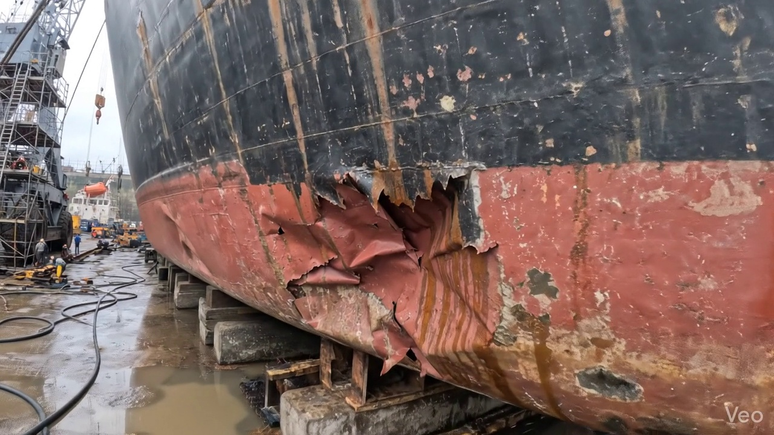

Repair Procedure
Generation failed.

Repair Cost Breakdown
Item | Quantity | Unit Cost | Total Cost | Currency
Cutting Torch (rental) | 0.12 | 10764.0 | 1345.5 | INR
Estimated Repair Cost: 69305.88 INR

3.4 PD_4

Defect Overview
Generation failed.

Visual Evidence
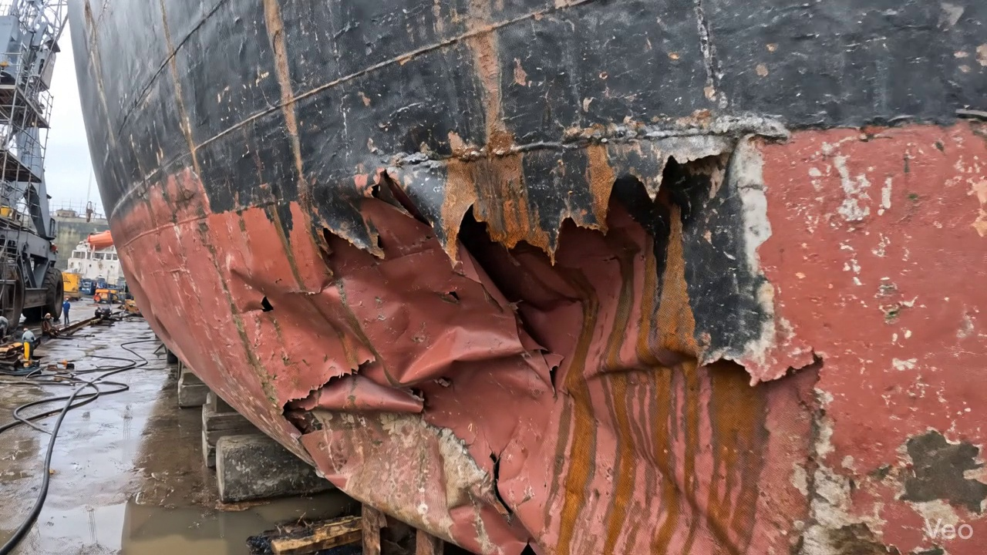

Repair Procedure
Generation failed.

Repair Cost Breakdown
Item | Quantity | Unit Cost | Total Cost | Currency
Cutting Torch (rental) | 0.12 | 10764.0 | 1345.5 | INR
Estimated Repair Cost: 69305.88 INR

