Vessel Inspection Report

Table of Contents
1. Executive Summary
2. Vessel Repair Summary
3. Defect Analysis
3.1 PD_1

1. Executive Summary
## Maritime Vessel Inspection Executive Summary
This executive summary presents the findings of the recent maritime vessel inspection.
The inspection identified a **single non-conformity**, which has been classified with a **high severity** rating. This critical finding demands immediate attention due to its potential impact on vessel operational integrity, safety, or regulatory compliance.
The estimated cost for the rectification of this high-severity defect is **INR 69,305.88**.
Prompt action for remediation is strongly recommended to ensure continued adherence to maritime standards and to mitigate potential operational risks.

2. Vessel Repair Summary
Metric | Value
Total Defects | 1
Total Estimated Cost | 69305.88 INR
Material Cost | 41583.53 INR
Labor Cost | 20791.76 INR
Equipment Cost | 6930.59 INR

3. Defect Analysis

3.1 PD_1

Defect Overview
**Defect Name:** Deformation (Buckling/Warping)
**Severity:** High
---
**1. What the Defect Means:**
Deformation, specifically observed as buckling or warping, refers to an unintended out-of-plane bending or distortion of a vessel's hull plating or structural stiffeners. This is a visible deviation from the original design profile of the affected component. Common causes include significant impact forces such as grounding incidents, excessive localized stresses from heavy sea loads, or thermal stresses induced by uneven welding practices during construction or repair. The provided data indicates this deformation significantly overlaps with a HULL_AREA, covering approximately 33% of that section, highlighting its substantial presence within a critical structural zone.
**2. Why it is Important:**
This defect is critically important due to its direct and immediate impact on the structural integrity of the vessel. Even seemingly moderate deformation can significantly compromise the primary hull girder strength. The hull girder acts as the main structural beam of the ship, resisting global bending and shearing forces. Any impairment to its components, such as localized buckling, reduces the overall strength and stiffness necessary to withstand operational loads, potentially leading to widespread structural weaknesses and instability.
**3. Risks if Not Repaired:**
Failure to adequately repair significant deformation carries substantial risks:
* **Progressive Structural Failure:** The weakened area is more susceptible to further distortion or cracking under normal operational stresses (e.g., wave impacts, cargo loads), potentially leading to a catastrophic failure of the affected structure.
* **Loss of Watertight/Weathertight Integrity:** In severe cases, particularly if cracks develop or plating is extensively warped, the deformation can breach the watertight or weathertight envelope of the hull, leading to water ingress into compartments, affecting stability, buoyancy, and potentially damaging cargo or machinery.
* **Reduced Seaworthiness and Safety:** The compromised hull girder strength reduces the vessel's ability to safely navigate heavy seas, posing a significant risk to the vessel, cargo, and crew. This directly impacts the vessel's fitness for service.
* **Non-Compliance and Detentions:** Classification societies strictly require the repair of significant deformation. Non-compliance will result in survey deficiencies, potential port state control detentions, and ultimately, loss of the vessel's class, making it unable to trade.
**4. Structural Implications:**
The structural implications of deformation are severe and multifaceted:
* **Reduced Load-Carrying Capacity:** Buckled plating or stiffeners lose their ability to effectively carry compressive, tensile, or shear loads. The out-of-plane distortion significantly reduces the component's effective cross-sectional area and moment of inertia, thus severely weakening the overall structure's resistance to applied forces.
* **Stress Concentrations:** The deformed areas can create localized stress concentrations at the edges of the buckle or warp, acting as initiation points for fatigue cracks, especially under dynamic loading cycles inherent in ship operations.
* **Global Hull Girder Weakening:** As noted, deformation directly impairs the hull girder's ability to act as a monolithic beam. This reduces the vessel's ultimate longitudinal strength, making it vulnerable to critical hogging, sagging, and torsional stresses that the entire vessel experiences.
* **Local Instability:** Buckling represents a form of structural instability where the material fails by deflecting laterally rather than by yielding. This significantly reduces the component's critical buckling stress, meaning it will fail at much lower loads than originally designed for.
* **Required Repair Methodology:** Classification practice mandates that significant buckling typically requires cutting out and replacing the distorted metal to restore the original structural integrity and design profile. Localized set-in plating is only tolerated if minimal and within stringent limits, but for significant buckles like this (high severity, affecting 33% of a hull area), renewal is the standard requirement.

Visual Evidence
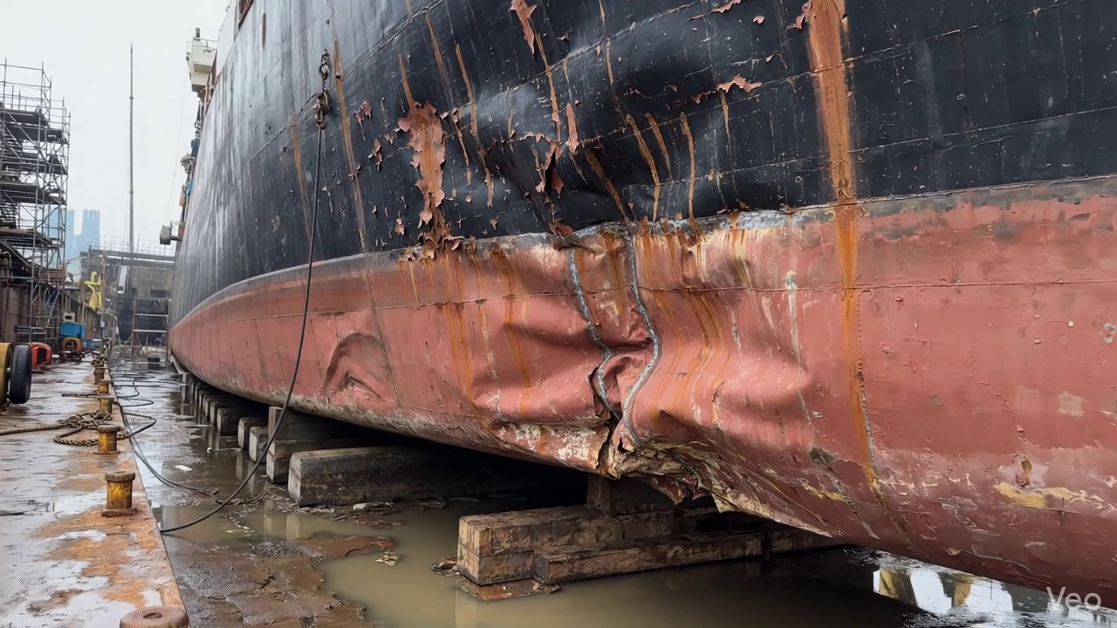

Repair Procedure
Generation failed.

Repair Cost Breakdown
Item | Quantity | Unit Cost | Total Cost | Currency
Cutting Torch (rental) | 0.12 | 10764.0 | 1345.5 | INR
Estimated Repair Cost: 69305.88 INR

