Vessel Inspection Report

Table of Contents
1. Executive Summary
2. Vessel Repair Summary
3. Defect Analysis
3.1 PD_1

1. Executive Summary
**Executive Summary: Maritime Vessel Condition Assessment**
A comprehensive inspection of the subject vessel was conducted to ascertain its current operational integrity and compliance.
**Key Findings:**
The inspection identified a single critical discrepancy within the vessel's systems. Notably, this finding is categorized as **High severity**, indicating a significant potential impact on operational safety, regulatory compliance, or vessel performance.
**Financial Implications:**
The projected financial impact for rectifying this high-severity deficiency is estimated at **69,305.88 INR**.
**Conclusion & Recommendation:**
Despite the low overall number of identified defects, the singular high-severity finding necessitates immediate and urgent attention. It is imperative that this critical item be addressed promptly to mitigate inherent risks and ensure the vessel's continued seaworthiness and full regulatory compliance.

2. Vessel Repair Summary
Metric | Value
Total Defects | 1
Total Estimated Cost | 69305.88 INR
Material Cost | 41583.53 INR
Labor Cost | 20791.76 INR
Equipment Cost | 6930.59 INR

3. Defect Analysis

3.1 PD_1

Defect Overview
Here is a professional explanation of the DEFORMATION defect for a vessel inspection report:
---
**Defect Name:** DEFORMATION
**Severity:** High
---
**1. What the defect means:**
Deformation, specifically observed as buckling or warping, refers to an out-of-plane bending or distortion of the vessel's hull plating or structural stiffeners. Unlike simple indentations or minor set-ins, deformation involves a significant change in the original planar form of the material, causing it to bulge outwards or inwards from its intended shape. This condition typically arises from significant external forces such as grounding impacts, heavy sea loads (e.g., slamming), or internal stresses like those induced by uneven welding procedures or thermal stress during construction or repair. While minor, localized set-in plating might occasionally be tolerated if insignificant, true deformation implies a structural compromise.
**2. Why it is important:**
This defect is deemed of **high severity** due to its direct and significant impact on the vessel's structural integrity, particularly the primary hull girder strength. Even seemingly moderate instances of buckling or warping severely impair the inherent strength, rigidity, and load-carrying capacity of the affected components. As this deformation is located within the critical HULL_AREA, it directly undermines the fundamental structural backbone of the vessel, which is designed to withstand complex static and dynamic loads encountered at sea. Its presence indicates a failure to maintain design margins for strength and stiffness.
**3. Risks if not repaired:**
Failure to address significant deformation poses several critical risks:
* **Progressive Structural Failure:** The deformed area acts as a stress concentration point, leading to accelerated fatigue cracking or further localized failure, especially under dynamic loading conditions (e.g., wave action, vessel movements).
* **Compromised Watertight Integrity:** Severe buckling can rupture watertight boundaries or weaken joints, leading to water ingress into compartments, potentially affecting buoyancy, stability, and damaging cargo or machinery.
* **Reduced Seaworthiness and Safety:** A significantly weakened hull is less capable of withstanding anticipated operational loads. Under extreme conditions, such as severe weather or an additional impact, the compromised structure could experience catastrophic failure, jeopardizing the vessel's seaworthiness, stability, and the safety of crew, cargo, and the marine environment.
* **Classification and Regulatory Non-Compliance:** Uncorrected significant deformation will result in non-compliance with classification society rules and flag state regulations, leading to potential operational restrictions, detention, or refusal of certification.
**4. Structural implications:**
The structural implications of significant deformation are profound:
* **Impairment of Hull Girder Strength:** The most critical implication is the severe impairment of the vessel's primary hull girder strength. The hull girder, which functions as a large beam, loses its ability to effectively withstand longitudinal bending moments (hogging and sagging) and torsional forces. Out-of-plane deformation significantly reduces the sectional modulus and moment of inertia of the affected area, directly diminishing the hull's overall resistance to these critical stresses.
* **Loss of Stiffness and Load-Bearing Capacity:** Buckled plating and stiffeners lose their original design stiffness and load-bearing capacity. This effectively means the material is no longer contributing to the overall structural strength as intended, and the loads are transferred unevenly to adjacent, potentially undamaged, structural members, which were not designed to carry such additional or redistributed stresses.
* **Stress Concentrations and Fatigue Life Reduction:** The distorted geometry creates highly localized stress concentrations around the buckles and their boundaries. These areas become hot spots for crack initiation and propagation under cyclic loading, leading to a significant reduction in the fatigue life of the affected components and, potentially, the entire hull structure.
* **Mandatory Renewal:** Given these severe implications, classification practice mandates the correction of significant buckling by cutting out and replacing the distorted metal with new material of appropriate specification. This ensures the restoration of the original structural integrity, design strength, and safety margins.

Visual Evidence
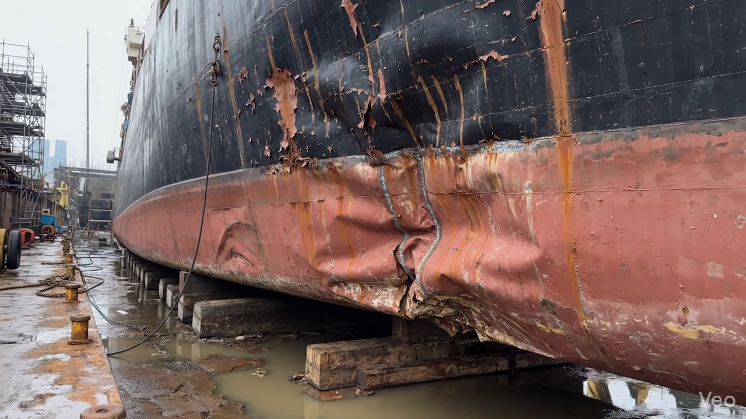

Repair Procedure
Generation failed.

Repair Cost Breakdown
Item | Quantity | Unit Cost | Total Cost | Currency
Cutting Torch (rental) | 0.12 | 10764.0 | 1345.5 | INR
Estimated Repair Cost: 69305.88 INR

