Vessel Inspection Report

Table of Contents
1. Executive Summary
2. Vessel Repair Summary
3. Defect Analysis
3.1 PD_1
3.2 PD_2
3.3 PD_3
3.4 PD_4

1. Executive Summary
## Maritime Vessel Inspection Executive Summary
This executive summary details the key findings from the recent maritime vessel inspection. The assessment aimed to evaluate the overall condition, operational integrity, and compliance of the vessel.
**Key Findings:**
* **Total Deficiencies Identified:** A total of **four (4)** deficiencies were identified during the inspection.
* **Estimated Remediation Cost:** The aggregate estimated cost for rectifying these deficiencies is **INR 221,778.82**.
* **Severity Distribution:**
* **Low Severity:** 0 deficiencies
* **Medium Severity:** 2 deficiencies
* **High Severity:** 2 deficiencies
The presence of two (2) high-severity deficiencies indicates immediate attention is required to address potential risks to vessel safety, operational performance, or regulatory compliance. The two (2) medium-severity items also warrant timely action to prevent escalation and maintain optimal vessel condition.
**Conclusion & Recommendation:**
The inspection findings necessitate prompt and decisive action, particularly concerning the high-severity items. A detailed rectification plan should be developed and executed without delay to ensure the vessel's continued seaworthiness, adherence to safety standards, and compliance with relevant maritime regulations. Further details and specific recommendations for each identified deficiency are provided in the comprehensive inspection report.

2. Vessel Repair Summary
Metric | Value
Total Defects | 4
Total Estimated Cost | 221778.82 INR
Material Cost | 133067.29 INR
Labor Cost | 66533.65 INR
Equipment Cost | 22177.88 INR

3. Defect Analysis

3.1 PD_1

Defect Overview
Generation failed after retries.

Visual Evidence
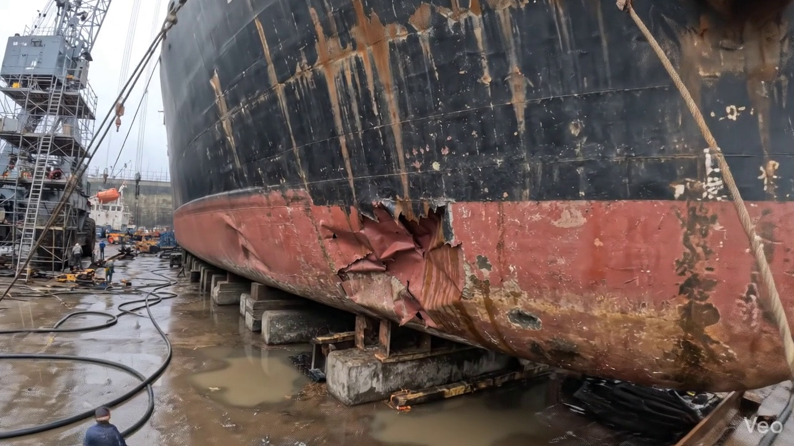

Repair Procedure
Generation failed after retries.

Repair Cost Breakdown
Item | Quantity | Unit Cost | Total Cost | Currency
Cutting Torch (rental) | 0.08 | 10764.0 | 807.3 | INR
Estimated Repair Cost: 41583.53 INR

3.2 PD_2

Defect Overview
Generation failed after retries.

Visual Evidence
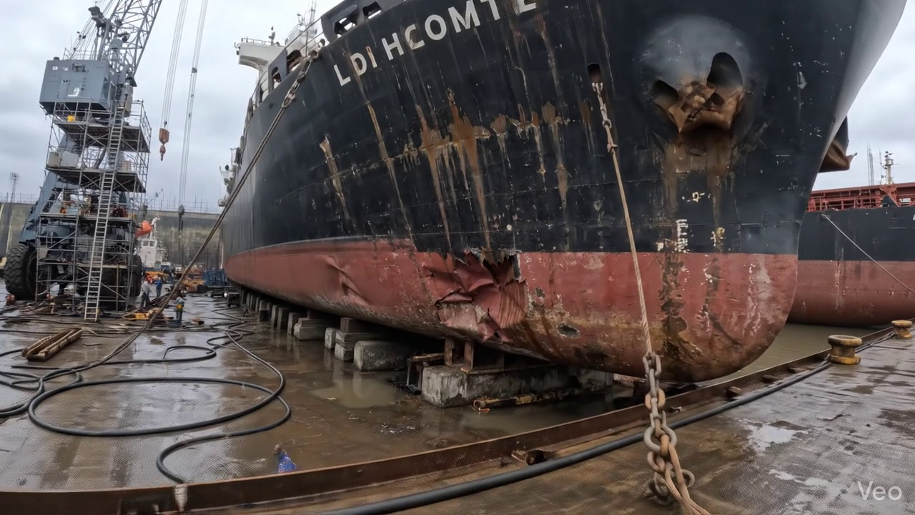

Repair Procedure
Generation failed after retries.

Repair Cost Breakdown
Item | Quantity | Unit Cost | Total Cost | Currency
Cutting Torch (rental) | 0.08 | 10764.0 | 807.3 | INR
Estimated Repair Cost: 41583.53 INR

3.3 PD_3

Defect Overview
Generation failed after retries.

Visual Evidence
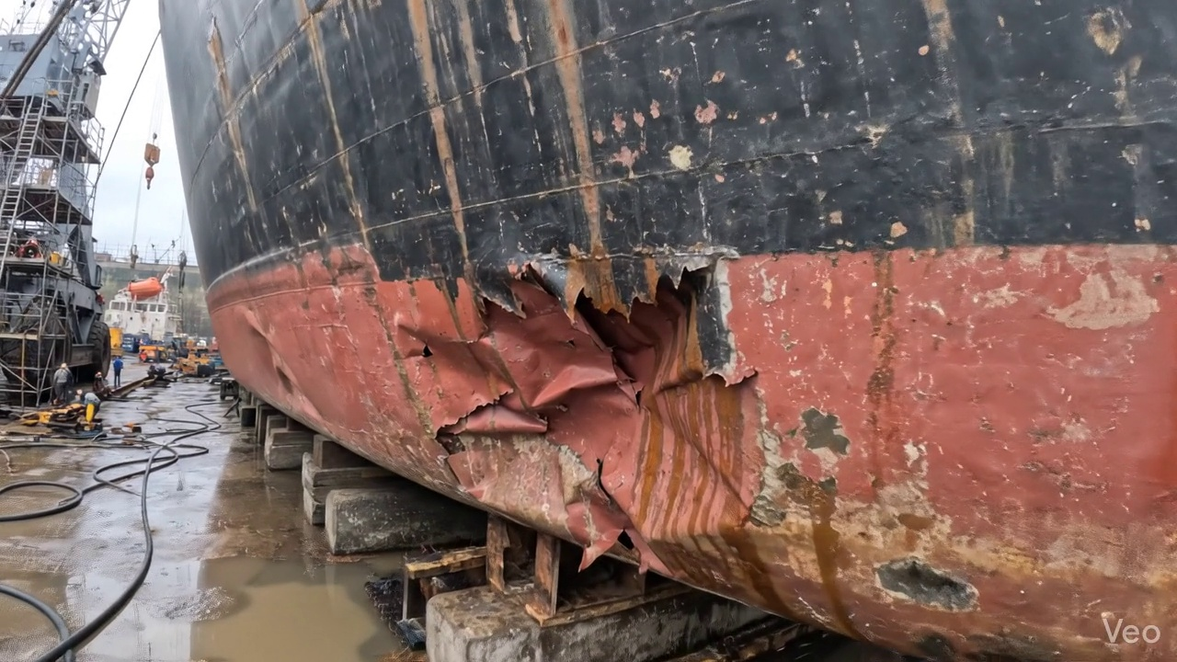

Repair Procedure
Generation failed after retries.

Repair Cost Breakdown
Item | Quantity | Unit Cost | Total Cost | Currency
Cutting Torch (rental) | 0.12 | 10764.0 | 1345.5 | INR
Estimated Repair Cost: 69305.88 INR

3.4 PD_4

Defect Overview
Generation failed after retries.

Visual Evidence
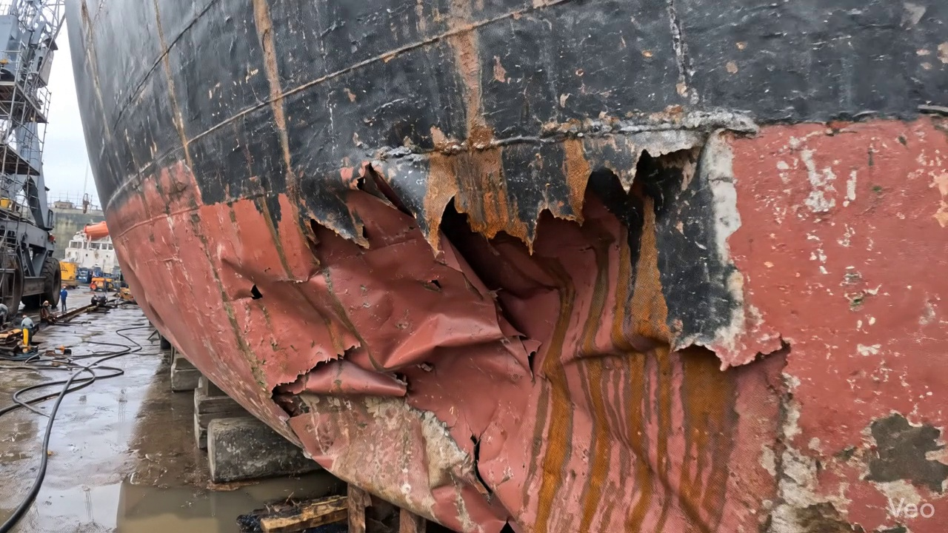

Repair Procedure
Generation failed after retries.

Repair Cost Breakdown
Item | Quantity | Unit Cost | Total Cost | Currency
Cutting Torch (rental) | 0.12 | 10764.0 | 1345.5 | INR
Estimated Repair Cost: 69305.88 INR

