Vessel Inspection Report

Table of Contents
1. Executive Summary
2. Vessel Repair Summary
3. Defect Analysis
3.1 PD_1
3.2 PD_2
3.3 PD_3
3.4 PD_4
3.5 PD_5
3.6 PD_6
3.7 PD_7
3.8 PD_8
3.9 PD_9
3.10 PD_10

1. Executive Summary
**Executive Summary: Maritime Vessel Condition Assessment**
This executive summary presents an overview of the findings from the recent comprehensive condition assessment conducted on a specified maritime vessel. The inspection aimed to evaluate the vessel's operational readiness, structural integrity, and compliance with prevailing maritime standards.
**Key Findings:**
A total of **10 defects** were identified during the inspection. These deficiencies are categorized by severity as follows:
* **Low-Severity:** 2
* **Medium-Severity:** 4
* **High-Severity:** 4
The presence of four high-severity defects underscores critical areas demanding prompt corrective action to mitigate operational risks, ensure crew safety, and maintain regulatory compliance. These high-severity issues typically relate to critical systems or structural components that could compromise the vessel's seaworthiness or operational integrity if left unaddressed.
**Financial Implications:**
The cumulative estimated cost for all identified repairs, encompassing parts, labor, and associated logistics, is **INR 499,002.34**. This financial outlay is essential to address the identified deficiencies and restore the vessel to optimal operating parameters, preventing potential escalation of issues and future larger expenditures.
**Conclusion:**
While the vessel remains operational, the significant proportion of high-severity defects and the associated repair costs necessitate immediate strategic planning and execution of corrective measures. A thorough review of the full inspection report is strongly recommended to prioritize actions, allocate resources effectively, and implement a robust remediation plan. Prompt resolution of these issues is paramount for maintaining the vessel's long-term asset value, ensuring uninterrupted service, and upholding the highest standards of maritime safety and operational efficiency.

2. Vessel Repair Summary
Metric | Value
Total Defects | 10
Total Estimated Cost | 499002.34 INR
Material Cost | 299401.4 INR
Labor Cost | 149700.7 INR
Equipment Cost | 49900.23 INR

3. Defect Analysis

3.1 PD_1

Defect Overview
**Defect Explanation: Deformation (Buckling/Warping) - Medium Severity**
**Observation:**
Deformation, specifically noted as buckling and warping, has been identified in the vessel's structure, categorized with a medium severity rating. This defect primarily affects the KEEL_AREA (with an approximate 11.5% overlap) and the PROPELLER_AREA (with an approximate 15.7% overlap).
---
**1. What the defect means:**
Deformation, in the context of a vessel's hull and structure, refers to an out-of-plane bending or distortion of the plating or structural stiffeners from their intended geometric form. This can manifest as:
* **Buckling:** A sudden loss of stability of a structural member under compressive stress, causing it to bend sharply out of its original plane.
* **Warping:** A more generalized, often gradual, distortion or twisting of a surface or structural component.
These distortions typically result from excessive localized loads such as grounding impacts, heavy dynamic sea loads, or significant internal stresses like those induced by uneven welding procedures or welding heat stress during construction or repair.
**2. Why it is important:**
The structural integrity of a vessel's hull plating and stiffeners is fundamental to its watertightness, longitudinal strength, and overall safety at sea. Even moderate levels of buckling or warping are critically important because they indicate that the material in the affected area has been stressed beyond its elastic limit or has lost its designed geometric stability. This significantly compromises the ability of that section to withstand operational forces and contribute effectively to the vessel's global strength. Classification societies universally require such defects to be addressed to maintain class, statutory certificates, and operational safety.
**3. Risks if not repaired:**
Failure to promptly address deformation carries several significant risks:
* **Progressive Loss of Strength:** The distorted areas are no longer able to carry their designed share of the structural loads, leading to overstressing of adjacent, intact structure. This can progressively weaken the entire hull girder.
* **Fatigue Cracking:** Buckled or warped plating and stiffeners create stress concentrations. Under dynamic loading from waves, vessel movements, or engine vibrations, these areas become highly susceptible to fatigue cracking, which can propagate and lead to through-plate fractures.
* **Localized Structural Failure:** In extreme weather or under further impact, the compromised areas could experience sudden, localized structural collapse or tearing, potentially leading to immediate loss of watertight integrity, flooding, or further catastrophic damage.
* **Operational Restrictions & Regulatory Non-Compliance:** Unrepaired deformation can lead to operational restrictions imposed by port state control, delays, detention, or even withdrawal of the vessel's class or insurance coverage.
* **Specific Risks to Overlapping Parts:**
* **KEEL_AREA:** Deformation here compromises the primary longitudinal strength member, increasing vulnerability to grounding damage and affecting the distribution of loads across the vessel's bottom.
* **PROPELLER_AREA:** Distortion near the propeller can affect stern tube alignment, increase propeller-induced vibrations, or lead to accelerated wear and damage to the propulsion system components, including the propeller and shaft bearings.
**4. Structural implications:**
Structurally, deformation fundamentally impairs the vessel's ability to act as a cohesive beam (hull girder).
* **Reduced Section Modulus & Moment of Inertia:** Out-of-plane bending significantly reduces the local section modulus and moment of inertia of the plating and stiffeners. This means the affected structural elements can no longer effectively resist compressive, tensile, or shear forces as designed.
* **Load Redistribution & Stress Concentration:** Applied loads (e.g., hogging, sagging, torsional forces) are no longer distributed evenly, causing stresses to concentrate around the distorted zones. This uneven distribution leads to premature yielding or buckling in these areas.
* **Diminished Buckling Resistance:** The deformed plating and stiffeners have a severely diminished resistance to further buckling. Once a panel or stiffener has buckled, its critical buckling stress is significantly reduced, making it more prone to further collapse under normal operating loads.
* **Impact on Hull Girder Strength:** Even moderate buckling can severely impair the overall hull girder strength, reducing the vessel's capacity to withstand global bending and torsional moments.
* **Specific Implications for Overlapping Parts:**
* **KEEL_AREA:** This area is crucial for longitudinal strength and resisting bottom impacts. Deformation here directly compromises the vessel's primary longitudinal girder, affecting its ability to resist hogging and sagging stresses and increasing vulnerability during groundings.
* **PROPELLER_AREA:** The structural integrity around the propeller is vital for supporting the stern tube, shafting, and bearings. Deformation can lead to misalignments, increased vibration, and potential fatigue damage to critical propulsion components, impacting efficiency and reliability.
**Recommendation:**
Given the medium severity and location of the deformation in critical structural areas (Keel and Propeller), it is strongly recommended that a thorough engineering assessment be conducted by a qualified surveyor and/or naval architect. Remedial action, typically involving the cutting out and replacement of the distorted plating and stiffeners, must be undertaken in accordance with classification society requirements to restore the vessel's structural integrity and ensure continued safe and compliant operation. Small, localized set-in plating might sometimes be tolerated if proven insignificant, but the noted significant buckles necessitate renewal.

Visual Evidence
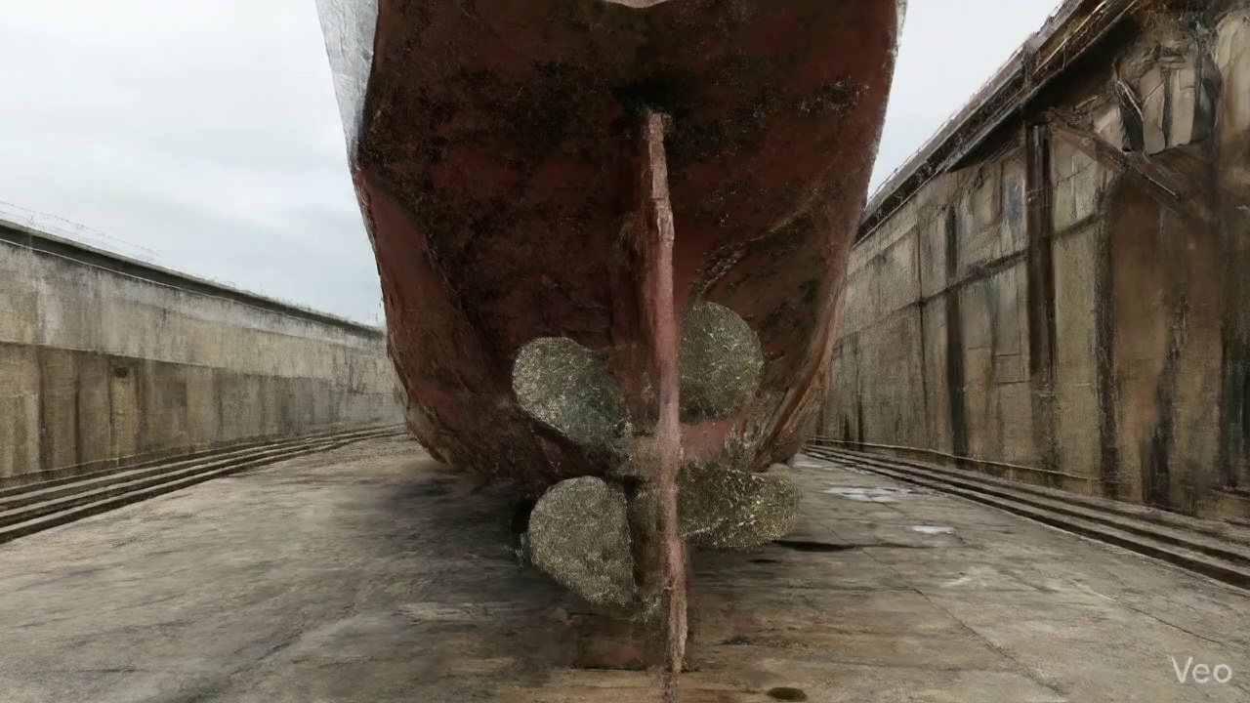

Repair Procedure
**VESSEL INSPECTION REPORT: STRUCTURAL HULL PLATE REPAIR PROCEDURE**
This section outlines the detailed procedure for a structural hull plate repair, encompassing assessment, execution, quality control, and finishing, along with critical safety and structural considerations.
---
**Repair Process Explanation:**
**1. Assessment**
* **Necessity:** This initial phase is paramount for accurately defining the scope, severity, and nature of the damage. It prevents under- or over-scoping the repair, ensuring that all compromised areas are identified and the appropriate repair methodology is selected. A precise understanding of the deformation pattern (localized vs. spanning frames) is critical for determining the extent of material removal required and potential implications for adjacent structures.
* **What Happens:** Skilled personnel conduct a thorough visual inspection of the deformed region. This involves precisely marking the buckled area and employing various measuring tools (e.g., straight edges, templates, laser scanners) to quantify any out-of-flatness and document the extent of the deformation. The inspection determines if the damage is confined to a single plate or if it impacts surrounding stiffeners, girders, or multiple structural bays.
* **Safety & Structural Considerations:** A comprehensive assessment is the foundation of a structurally sound repair. Misdiagnosis could lead to incomplete repairs, leaving residual stresses or weakened areas that could result in future structural failure. For safety, understanding the damage extent helps in planning safe access and work methods.
**2. Preparation**
* **Necessity:** This step is crucial for removing all material that has lost its structural integrity or has been plastically deformed beyond its acceptable limits. By cutting away distorted plate and buckled framing to sound metal, stress concentrators are eliminated, and a clean, stable foundation is provided for welding new material. The specified margin (≥¾ thickness) is critical to ensure that the heat-affected zone (HAZ) of the new weld does not overlap with previously fatigued or damaged material, promoting optimal weld quality and preventing crack propagation into existing structure.
* **What Happens:** All identified distorted plate, buckled girders, and stiffeners are precisely excised using thermal cutting equipment. The cuts are made to "sound metal," meaning material that shows no signs of deformation, cracking, or material degradation. Any bent framing not designated for complete removal is either carefully straightened using controlled heat and mechanical force or cold worked, or it is removed entirely to maintain structural alignment.
* **Why Cutting Torch is Used:** The cutting torch is indispensable in this phase for its efficiency and precision in severing steel sections. It enables rapid removal of damaged components and allows for the preparation of clean, beveled edges necessary for subsequent high-quality welding.
* **Safety & Structural Considerations:** This phase involves significant hot work, necessitating strict adherence to fire prevention protocols, including fire watches, proper ventilation, and the use of appropriate Personal Protective Equipment (PPE). Structurally, ensuring cuts are made to sound metal is paramount to prevent the propagation of existing damage and to establish a robust base for the new insert plate.
**3. Plate Replacement**
* **Necessity:** The primary purpose of plate replacement is to restore the original structural strength, watertight integrity, and hydrodynamic profile of the hull. It introduces new material designed to meet or exceed the original specifications, ensuring the vessel's structural continuity and resistance to external forces.
* **What Happens:** A new steel plate, typically of the same or greater thickness and material grade as the original, is fabricated. This involves precise marking, cutting, and forming (e.g., rolling, pressing) to match the exact dimensions and curvature of the excised section. The new plate is then carefully positioned against the remaining hull plating, ensuring proper fit-up and alignment. It is initially secured with tack-welds to maintain its position, followed by continuous, controlled welding passes around the entire periphery. Preheat is applied to the weld area, as required by the Welding Procedure Specification (WPS), to control the cooling rate of the weld metal and HAZ, thereby preventing hydrogen-induced cracking and minimizing residual stresses. Full penetration welds are utilized where possible to maximize joint strength and ensure optimal load transfer.
* **Safety & Structural Considerations:** Strict adherence to approved Welding Procedure Specifications (WPS) and the use of certified welders are critical to prevent weld defects such as lack of fusion, porosity, or cracking. Material traceability for the new plate is essential to confirm its compliance with class requirements. Proper preheat and interpass temperature control are vital for metallurgical integrity.
**4. Alignment and Welding**
* **Necessity:** This step completes the structural integration of the new plate, ensuring that it is fully bonded to the existing structure. Controlling welding-induced distortion is crucial to maintain the hull's intended shape, minimize residual stresses which could lead to fatigue cracking, and ensure adjacent machinery or structures remain unaffected. Grinding welds fair contributes to hydrodynamic efficiency and prevents localized stress points. The application of additional strengthening addresses areas of high stress concentration or ensures the repair exceeds the original design in identified vulnerable areas.
* **What Happens:** Continuing weld passes are applied systematically to fully integrate the new plate. The use of E7018 electrodes is specified due to their low-hydrogen characteristics, which minimize the risk of hydrogen embrittlement in high-strength steel structures. During welding, continuous monitoring for heat-induced distortion is performed. Clamps, strongbacks, or specialized welding sequences (e.g., skip welding, back-step welding) are employed to mitigate distortion. Upon completion of welding, all weld seams are meticulously ground fair with the hull surface to ensure a smooth contour. In cases where the original damage indicated inherent structural weakness or where stress analyses deem it necessary, additional strengthening elements like doublers or stiffeners are fitted and welded to further reinforce the repaired area.
* **Safety & Structural Considerations:** E7018 electrodes are critical for achieving high-quality welds with excellent mechanical properties while mitigating the risk of hydrogen-induced cracking. Distortion control is paramount to prevent misalignment of adjacent structures, maintain structural integrity, and minimize internal stresses. Grinding welds fair enhances the vessel's hydrodynamics and reduces potential points of corrosion initiation or fatigue. Additional strengthening, if applied, must be correctly engineered and integrated to prevent new stress concentrations.
**5. Finishing**
* **Necessity:** This final stage serves to formally verify the quality of the repair, protect the newly exposed steel from corrosion, and restore the vessel's exterior aesthetics and hydrodynamic efficiency to design specifications.
* **What Happens:** The completed weld repair undergoes stringent inspection. This typically involves Visual Testing (VT) to check for surface imperfections, augmented by Non-Destructive Testing (NDT) methods such as Magnetic Particle Testing (MPT) for surface-breaking defects or Ultrasonic Testing (UT) for subsurface discontinuities. Upon successful inspection and acceptance by the surveyor, the new steel surface is thoroughly cleaned and prepared (e.g., grit blasting) to achieve the required surface profile. This is followed by the application of marine-grade primer and subsequent finish coats (e.g., anti-corrosive, anti-fouling), restoring the vessel's original corrosion protection system. Finally, the entire repaired area is faired to blend seamlessly with the existing hull contour, ensuring smooth water flow and preventing increased drag.
* **Safety & Structural Considerations:** NDT provides objective assurance of weld integrity, identifying critical defects not visible to the naked eye. Effective coating is vital for preventing premature degradation of the repair due to environmental exposure, extending its service life, and maintaining the vessel's asset value. Fairing contributes directly to fuel efficiency and prevents localized hydrodynamic stresses. Personnel involved in coating application must follow safety data sheets (SDS) for hazardous materials and ensure adequate ventilation.
---
**General Safety and Structural Considerations for the Entire Repair Process:**
* **Classification Society and Regulatory Compliance:** All repair procedures, material selections, and testing must strictly adhere to the rules and regulations of the vessel's Classification Society, Flag State administration, and relevant international conventions (e.g., IMO).
* **Competent Personnel:** All welding, cutting, and inspection activities must be performed by certified and qualified personnel (e.g., welders certified to relevant standards, NDT technicians certified to EN ISO 9712 or ASNT SNT-TC-1A).
* **Material Traceability:** Full traceability and certification for all new steel materials (plate, electrodes) are essential to verify their compliance with design specifications and class requirements.
* **Hot Work Precautions:** Comprehensive hot work permits, fire watches, fire-fighting equipment, and proper ventilation must be in place throughout cutting and welding operations.
* **Confined Space Entry:** If the repair involves working in confined spaces, strict entry procedures, atmospheric monitoring, and standby rescue teams are mandatory.
* **Structural Stability:** During extensive plate removal, the vessel's structural integrity and stability must be continuously monitored and managed, potentially requiring temporary shoring or load redistribution.
* **Environmental Controls:** Measures to mitigate environmental impact (e.g., waste disposal, spill prevention) must be implemented, especially when working in dry docks or alongside.
* **Risk Assessment:** A comprehensive risk assessment should be conducted for the entire repair project, identifying potential hazards and implementing control measures for personnel safety and structural integrity.
This detailed explanation provides a professional overview of the maritime repair process, addressing its necessity, execution, and critical safety and structural implications for a vessel inspection report.

Repair Cost Breakdown
Item | Quantity | Unit Cost | Total Cost | Currency
Cutting Torch (rental) | 0.08 | 10764.0 | 807.3 | INR
Estimated Repair Cost: 41583.53 INR

3.2 PD_2

Defect Overview
Here is a professional explanation of the "DEFORMATION" defect for a vessel inspection report, based on the provided description:
---
**Defect Name:** DEFORMATION
**Severity:** Medium
**Explanation:**
**1. What the defect means:**
Deformation, specifically manifesting as buckling or warping, refers to an undesirable out-of-plane bending or distortion of a vessel's hull plating or its supporting stiffeners. This condition indicates that the metal has lost its original intended flat or contoured shape and has been subjected to stresses beyond its elastic limit. Common causes identified for such deformation include significant external forces like grounding impacts, exposure to heavy sea loads, or internal stresses generated during construction or repair, such as uneven welding heat stress.
**2. Why it is important:**
This defect is critically important because even moderate levels of buckling or warping can severely impair the overall hull girder strength. The hull girder is the primary longitudinal load-bearing structure of the vessel, akin to the backbone of the ship. Its integrity is fundamental to the vessel's ability to withstand global bending and shearing forces encountered during operation, thereby ensuring seaworthiness and structural stability.
**3. Risks if not repaired:**
If left unrepaired, deformation poses several significant risks. The primary risk is a progressive reduction in the vessel's structural integrity and load-carrying capacity. This makes the vessel more vulnerable to further damage under normal operating conditions, adverse weather, or future impacts. Diminished strength can lead to accelerated material fatigue, localized failures, the initiation and propagation of cracks, and potentially compromise watertight integrity. In severe cases, particularly if the deformation is extensive or in critical areas, there is an increased risk of catastrophic structural failure, endangering the vessel, crew, and cargo.
**4. Structural implications:**
Structurally, deformation directly compromises the local and global strength of the vessel. At a local level, the buckled or warped plating and stiffeners lose their designed stiffness and ability to effectively distribute loads, leading to stress concentrations in the affected and adjacent areas. Globally, this local weakening contributes to a reduction in the overall hull girder's ability to resist longitudinal bending and shear forces. Classification societies generally mandate correction of significant buckling by cutting out and replacing the distorted metal to restore the original design strength and ensure compliance with structural safety standards. While minor, localized "set-in" plating might occasionally be tolerated if assessed as structurally insignificant, any significant buckling requires renewal to prevent progressive structural deterioration and maintain the vessel's intended structural performance throughout its operational life.

Visual Evidence
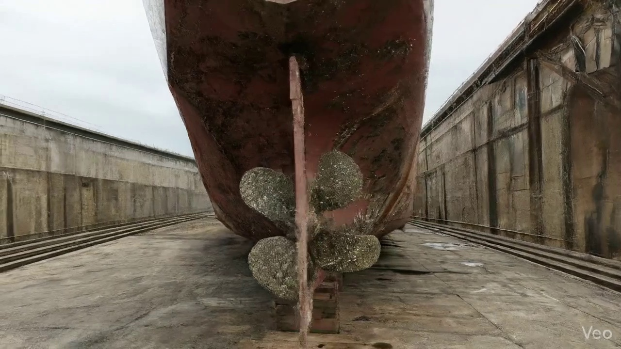

Repair Procedure
This document outlines the professional repair process undertaken to address a deformed region on a vessel, ensuring the restoration of structural integrity, watertightness, and aesthetic fairness.
---
### **Vessel Repair Process: Deformed Plate Section**
**1. Assessment**
* **Necessity:** This initial phase is crucial for comprehensively understanding the extent and nature of the damage. It allows for accurate planning of the repair, ensuring that only the compromised material is removed and that surrounding structures are not inadvertently affected or overlooked. It also forms the basis for determining the required materials, personnel, and equipment.
* **Process:** Skilled technicians conduct a thorough visual inspection of the deformed area. They precisely mark the boundaries of the buckled plate and evaluate if the damage is localized to a single panel or extends across multiple frames, indicating a potentially larger structural issue. Critical measurements, particularly out-of-flatness, are recorded to quantify the deformation and guide the subsequent fairing process.
* **Required Items Usage:** While no specific tools are listed here, this step implicitly utilizes standard measuring instruments (e.g., straightedges, calipers, measuring tapes, optical levels) to quantify deformation.
* **Safety & Structural Considerations:** Proper assessment prevents premature commencement of work, ensuring all damage is identified. Misjudgment could lead to insufficient repair, leaving latent defects that compromise the vessel's structural integrity or seaworthiness. Structural elements supporting the damaged area are carefully evaluated for secondary damage.
**2. Preparation**
* **Necessity:** The objective of this step is to meticulously remove all compromised material and prepare the surrounding healthy structure for the installation of the new plate. Cutting to "sound metal" with a defined margin ensures that no weakened or fatigued material remains, providing a robust base for welding and preventing the propagation of existing defects.
* **Process:** Using precision cutting tools, all distorted plate sections, along with any buckled girders or stiffeners, are carefully cut away. The cut extends into sound, undamaged metal, leaving a margin of good plate (typically $\ge$ ¾ of the original plate thickness) to facilitate a strong and reliable weld joint. If adjacent framing elements are bent but not severely damaged, they may be straightened in situ or removed for repair/replacement. The edges of the cut-out are then prepared (e.g., bevelled) to achieve optimal weld penetration.
* **Required Items Usage:** The **Cutting Torch (rental)** is indispensable for this stage. It provides the necessary heat and precision to efficiently and cleanly cut through steel plating and structural members, removing the damaged sections while maintaining control over the cut line to preserve the integrity of the surrounding "sound metal."
* **Safety & Structural Considerations:** **Safety:** Hot work permits are essential. Fire watches must be established in the vicinity, and proper ventilation ensured to mitigate the risks associated with sparks, molten metal, and fumes. **Structural:** Maintaining the specified margin and cutting to sound metal is paramount for achieving a high-quality, structurally sound weld. Inadequate preparation can lead to stress concentrations, poor fusion, and premature failure of the repair.
**3. Plate Replacement**
* **Necessity:** This step focuses on restoring the structural continuity, load-carrying capability, and integrity of the vessel's hull envelope (watertight/weathertight seal) by integrating new material.
* **Process:** A new steel plate, matching or exceeding the original thickness and grade, is precisely fabricated to the dimensions and contour of the cut-out. This involves accurate cutting, shaping, and edge preparation (e.g., bevelling) to ensure an optimal fit. The fabricated plate is then carefully positioned within the opening, aligned with the remaining hull plating, and secured using tack welds. Once alignment is verified, continuous welding commences, ensuring good fusion between the new and existing material. Full penetration welds are employed wherever practicable to maximize joint strength and structural integrity. Appropriate preheat, based on steel thickness and ambient temperature, is applied to prevent hydrogen-induced cracking and ensure proper metallurgical bonding.
* **Required Items Usage:** While not explicitly listed here, welding equipment, consumables, and measuring tools are utilized.
* **Safety & Structural Considerations:** **Safety:** Proper personal protective equipment (PPE) for welding is mandatory. Adequate ventilation is required to disperse welding fumes. **Structural:** The use of new steel of equivalent or greater thickness ensures the restored section meets or exceeds original design strength. Achieving full penetration welds is critical for transferring loads effectively across the joint. Proper fit-up and preheat are crucial for preventing residual stresses and weld defects that could compromise the long-term structural integrity.
**4. Alignment and Welding**
* **Necessity:** This phase is dedicated to completing the structural connection, achieving the full strength of the repair, and meticulously fairing the repaired area to the vessel's original contours. Controlling distortion is vital to prevent new structural imperfections.
* **Process:** Subsequent weld passes are applied to complete the joint, typically using low-hydrogen electrodes such as E7018. During welding, meticulous attention is paid to controlling heat input to minimize distortion. Techniques such as intermittent welding, balanced welding sequences, or the use of strongbacks and clamps are employed to maintain alignment and prevent buckling. After welding is complete, all weld seams are ground smooth and fair with the surrounding hull surface to restore hydrodynamic efficiency and aesthetic appeal. In instances where the original buckling was extensive, or if the area is subject to high localized stresses, additional strengthening measures such as doubler plates or stiffeners may be permanently affixed to enhance structural robustness and prevent recurrence.
* **Required Items Usage:** **E7018 electrodes** are specified due to their low-hydrogen properties, which reduce the risk of hydrogen embrittlement in structural steel welds, ensuring high tensile strength and toughness. Welding machines, grinding equipment, and various clamping devices are actively used.
* **Safety & Structural Considerations:** **Safety:** Welding safety procedures, including fire watch and ventilation, remain critical. Grinding operations require eye and respiratory protection. **Structural:** E7018 electrodes are a industry standard for critical structural applications. Controlling welding-induced distortion is paramount; uncontrolled distortion can lead to residual stresses, reduced fatigue life, and aesthetic concerns. The application of doublers or stiffeners signifies a proactive approach to prevent future issues in areas identified as high-stress points. Achieving a fair surface is important for preventing turbulence, cavitation, and associated performance degradation.
**5. Finishing**
* **Necessity:** This final stage confirms the quality and integrity of the repair, restores the vessel's protective coatings, and ensures the repaired area is aesthetically and hydrodynamically consistent with the original design.
* **Process:** A multi-faceted inspection regimen is implemented. This includes a thorough visual inspection for surface defects, followed by non-destructive testing (NDT) methods such as magnetic particle testing (MT) or ultrasonic testing (UT) to detect any subsurface discontinuities or cracks within the welds. Once the repair is verified as sound, the new steel surface is prepared (e.g., abrasive blasting) and treated with marine-grade primer and subsequent finish coats to restore corrosion protection and match the vessel's existing paint scheme. The deck or hull surface is meticulously faired back to its original contour, ensuring smooth transitions and optimal performance.
* **Required Items Usage:** NDT equipment, surface preparation tools (e.g., grinders, blasting equipment), and painting equipment (e.g., spray guns, brushes, rollers) are utilized.
* **Safety & Structural Considerations:** **Safety:** NDT procedures require trained personnel. Painting operations require proper ventilation and PPE due to fumes. **Structural:** The NDT inspection is a critical quality assurance step, providing objective evidence that the repair meets specified standards and is free from detrimental defects. Restoring the coating system is essential for long-term corrosion prevention, which directly impacts the structural lifespan of the repaired area. Fairing the surface maintains hydrodynamic efficiency and prevents localized stress concentrations due to abrupt changes in contour.
---
This comprehensive approach ensures that the repair of the deformed plate region is executed to the highest professional standards, restoring the vessel's structural integrity, safety, and operational performance.

Repair Cost Breakdown
Item | Quantity | Unit Cost | Total Cost | Currency
Cutting Torch (rental) | 0.08 | 10764.0 | 807.3 | INR
Estimated Repair Cost: 41583.53 INR

3.3 PD_3

Defect Overview
Here is a professional explanation of the defect "DEFORMATION" for a vessel inspection report:
---
**Defect Name:** DEFORMATION
**Severity:** Medium
**Explanation:**
1. **What the defect means:**
Deformation, specifically observed as buckling or warping, refers to an out-of-plane bending or distortion of the vessel's hull plating or structural stiffeners. This type of damage typically results from external forces such as grounding impacts, heavy sea loads experienced during adverse weather, or internal stresses like those induced by uneven welding heat. In this instance, deformation has been identified within the **RUDDER_AREA**.
2. **Why it is important:**
This defect is important because even moderate levels of buckling can severely impair the vessel's structural integrity, particularly its crucial hull girder strength. The hull girder is the primary load-bearing structure of the ship, and any compromise to its form significantly reduces its ability to withstand operational stresses. Furthermore, deformation in the critical **RUDDER_AREA** is of particular concern as it can directly affect the alignment and operational efficiency of the steering gear, rudder stock, and potentially interact with the propulsion system's supporting structure. Classification societies mandate the correction of significant buckles, underscoring their importance for maintaining a vessel's seaworthiness and class compliance.
3. **Risks if not repaired:**
If left unrepaired, deformation poses several significant risks:
* **Reduced Structural Integrity:** The primary risk is a further weakening of the hull girder, making the vessel more susceptible to progressive damage, especially during future heavy weather or operational incidents.
* **Propagation of Damage:** Unrepaired buckles can act as stress concentration points, leading to the initiation and propagation of fatigue cracks in the affected plating and adjacent structures.
* **Operational Limitations:** The vessel may face operational restrictions, such as reduced speed limits or cargo load limitations, imposed by class or port state control due to compromised structural strength.
* **Safety Hazard:** Severe or progressive deformation can compromise the vessel's watertight integrity or lead to catastrophic structural failure, posing a direct threat to the safety of the vessel, crew, and cargo.
* **Classification and Regulatory Non-Compliance:** Failure to rectify significant deformation will result in non-compliance with classification society rules, potentially leading to increased insurance premiums, loss of class status, or detention.
* **Impact on Rudder System:** Specifically within the **RUDDER_AREA**, unrepaired deformation can lead to misalignment of the rudder stock, increased wear on bearings, compromised sealing, and potentially impair the vessel's steering capability and propulsion efficiency.
4. **Structural implications:**
The structural implications of deformation are significant:
* **Impairment of Hull Girder Strength:** The most critical implication is the reduction in the hull girder's ability to resist longitudinal bending and torsional stresses. Buckling effectively reduces the effective section modulus of the hull, compromising its overall strength.
* **Localized Stress Concentrations:** The out-of-plane bending creates highly localized stress concentrations that can accelerate fatigue cracking in the deformed areas and adjacent structural members.
* **Loss of Stiffness and Rigidity:** Deformed plating and stiffeners lose their original stiffness and rigidity, allowing for greater deflection and potential for progressive damage under dynamic loads.
* **Reduced Fatigue Life:** The overall fatigue life of the affected structure and surrounding components is considerably reduced due to the altered stress distribution.
* **Impact on Rudder Area Integrity:** In the **RUDDER_AREA**, deformation can distort the supporting structure around the rudder trunk and stern frame. This can lead to misalignment of the rudder components, increased vibration, accelerated wear of crucial bearings and seals, and potential damage to the rudder stock or propeller shaft line, necessitating extensive and costly repairs. While minor set-in plating might sometimes be tolerated, significant buckles in this vital area must be renewed to restore structural integrity and ensure safe operation.

Visual Evidence
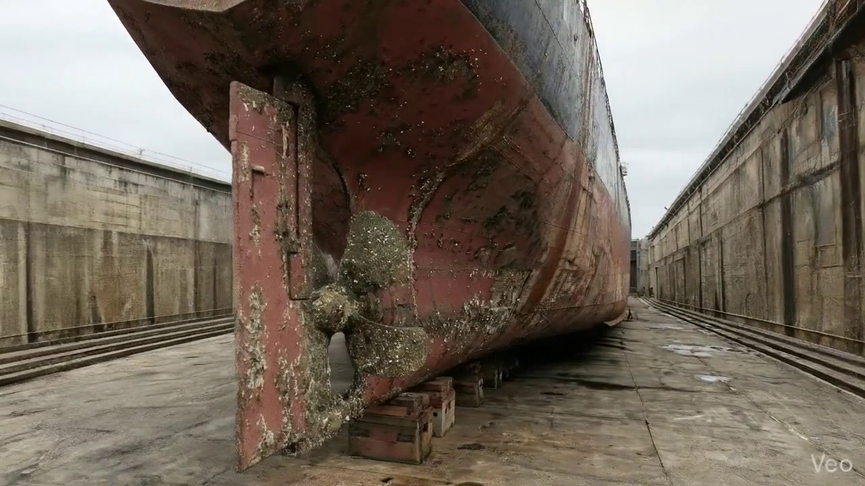

Repair Procedure
This report details the professional process for repairing deformed hull plating and associated structural members, ensuring the vessel's structural integrity and compliance with maritime standards.
---
### **Explanation of Maritime Repair Process**
**1. Assessment**
* **Why Necessary:** This crucial first step is to accurately quantify the extent and nature of the damage. It prevents underscoping or overscoping the repair, ensuring that all compromised material is identified and addressed, and that the repair plan directly addresses the structural compromise without impacting adjacent sound structures.
* **What Happens:** A thorough visual inspection is conducted to identify and mark the buckled or deformed region. This includes determining if the damage is localized to a small area or if it extends across multiple structural frames. Out-of-flatness measurements are taken to quantify the deformation, guiding the subsequent cutting and fairing processes.
* **Safety & Structural Considerations:** Proper assessment is fundamental to safety as it identifies potential weak points or stress concentrations that could lead to further structural failure if not fully addressed. It dictates the scope of hot work and the need for structural reinforcement.
**2. Preparation**
* **Why Necessary:** To create a sound, clean foundation for the new material, eliminating all weakened, fatigued, or fractured metal. This prevents crack propagation from the old material into the new weld and ensures optimal metallurgical bonding, which is critical for restoring structural integrity. The margin of sound plate ensures that welding occurs on uncompromised material.
* **What Happens:** All distorted plate, buckled girders, and stiffeners within the defined damaged area are precisely cut away. This removal extends to sound metal, leaving a minimum margin of good plate equivalent to or greater than ¾ of the plate thickness. Any remaining bent framing is either straightened or completely removed if heavily compromised.
* **Why the Required Item is Used:**
* **Cutting Torch (rental):** The **Cutting Torch** is an indispensable tool for this stage. Its high thermal energy allows for rapid and efficient severance of steel plating and structural members. Given the need to remove precise sections of deformed material quickly and effectively, the cutting torch minimizes downtime and labor. The stated quantity of 0.08 machine-days/sq.m reflects its essential role in preparing the repair area for new steel installation.
* **Safety & Structural Considerations:** This step is vital for structural integrity by ensuring the repair starts with sound base material. Safety considerations include ensuring proper ventilation, fire watch, and Personal Protective Equipment (PPE) during hot work, especially given the use of a cutting torch.
**3. Plate Replacement**
* **Why Necessary:** To reinstate the hull's structural integrity, watertightness, and load-bearing capacity to classification society standards. The new plate must match or exceed the original specifications to maintain the vessel's design strength and ensure seamless integration with the existing structure.
* **What Happens:** A new steel plate, fabricated to the exact dimensions and contour of the cut-out, is prepared. This plate will be of the same grade and specified as the same or greater thickness as the original material. It is then carefully positioned against the remaining hull plating, tack-welded to maintain alignment and fit, and subsequently fully welded all around. Emphasis is placed on achieving good fusion and applying appropriate preheat (to mitigate hydrogen-induced cracking, especially in thicker sections or high-strength steels). Full penetration welds are utilized where structural continuity and strength are paramount.
* **Safety & Structural Considerations:** Proper material selection (matching or exceeding original specifications) is paramount for structural integrity. The welding process, including adequate preheat and full penetration welds, ensures the new plate becomes an integral part of the hull, capable of withstanding operational stresses. Weld procedure specifications (WPS) must be followed to guarantee weld quality.
**4. Alignment and Welding**
* **Why Necessary:** To systematically build up the weld seam, ensuring full structural continuity, proper load transfer, and maintaining the hull's fair form. This multi-pass technique minimizes distortion and residual stress while maximizing weld strength. Grinding ensures a smooth transition, preventing stress risers.
* **What Happens:** Continuing weld passes are applied using E7018 low-hydrogen electrodes, known for their excellent mechanical properties and crack resistance, particularly in structural applications. Throughout the welding process, diligent monitoring for distortion is performed. If welding-induced distortion occurs, immediate corrective actions such as the use of clamps, strongbacks, or controlled, minimal heat input techniques are employed. Upon completion, weld seams are ground fair with the hull surface to achieve a smooth transition, which is important for hydrodynamic efficiency and preventing localized stress concentrations. In cases where the original buckling was extensive, additional strengthening through doublers or stiffeners may be strategically applied to distribute loads and enhance structural resilience.
* **Safety & Structural Considerations:** The use of E7018 electrodes is critical for producing high-integrity structural welds with good ductility and impact strength. Meticulous control of welding parameters and heat input is crucial to prevent excessive distortion, which can compromise the hull's geometric accuracy and introduce unwanted residual stresses. Grinding the welds fair is not just for aesthetics but essential to prevent stress concentrations that could initiate cracks. The addition of doublers or stiffeners significantly enhances the structural integrity in areas of historically high stress or extensive damage.
**5. Finishing**
* **Why Necessary:** To verify the quality of the completed repair, restore the vessel's protective coatings against corrosion, and ensure compliance with aesthetic and hydrodynamic requirements. This final stage confirms the repair's longevity and fitness for service.
* **What Happens:** The repair is rigorously inspected. This includes detailed Visual Testing (VT) to check for surface defects and contour, followed by Non-Destructive Testing (NDT) methods such as Magnetic Particle Inspection (MPI) or Ultrasonic Testing (UT) to detect any subsurface defects or cracks within the weldment. Once approved, the new steelwork receives marine-grade primer and subsequent finish coats to restore corrosion protection. Finally, the deck or hull surface is faired back to its original contour, ensuring proper drainage, safe walking surfaces, and optimal hydrodynamic performance.
* **Safety & Structural Considerations:** Comprehensive inspection (VT and NDT) is non-negotiable for assuring the structural soundness and longevity of the repair. Any detected defects must be rectified. The application of corrosion protection is vital to prevent premature degradation of the new steelwork and adjacent areas, thereby extending the service life of the repair and the vessel itself. Maintaining the original contour ensures proper functionality and safety for crew and cargo.
---
**Overall Safety & Structural Considerations for the Entire Process:**
* **Personnel Safety:** Strict adherence to hot work procedures, fire watches, proper ventilation, and the use of appropriate PPE (welding helmets, gloves, respirators, fall protection) are paramount. Confined space entry protocols must be followed if applicable.
* **Regulatory Compliance:** All repairs must conform to the vessel's classification society rules and relevant international maritime regulations. This includes approval of repair procedures (WPS, PQR) and oversight by a surveyor.
* **Material Traceability:** Ensuring that new steel plate matches specified grade and thickness, with full material certificates, is critical for structural integrity.
* **Stability and Load Management:** For extensive repairs, considerations for temporary structural support or ballasting may be necessary to maintain vessel stability during the repair process.
* **Environmental Protection:** Proper disposal of waste materials and containment of paint/blast residue are essential.

Repair Cost Breakdown
Item | Quantity | Unit Cost | Total Cost | Currency
Cutting Torch (rental) | 0.08 | 10764.0 | 807.3 | INR
Estimated Repair Cost: 41583.53 INR

3.4 PD_4

Defect Overview
Here is a professional explanation of the "DEFORMATION" defect for a vessel inspection report:
---
**DEFECT EXPLANATION:**
**Defect Name:** DEFORMATION
**Severity:** HIGH
**1. What the defect means:**
Deformation, specifically observed as buckling or warping, represents an out-of-plane distortion of a vessel's structural components such as hull plating, frames, or stiffeners. It means that the metal has deviated significantly from its original, intended flat or straight profile, manifesting as a bulge, ripple, or twist. This defect typically arises from external forces like grounding impacts, heavy sea loads exceeding design limits, or internal stresses such as uneven welding heat application during construction or repair. It is distinct from minor indentations or localized set-in plating, which may sometimes be tolerated if small and not impacting structural integrity.
**2. Why it is important:**
Deformation is a critical defect because it severely impairs the vessel's hull girder strength, which is the primary resistance of the ship's entire structure to bending moments (hogging and sagging) experienced at sea. Even moderate buckles can significantly reduce the load-carrying capacity of the affected members. It indicates a fundamental compromise of the vessel's structural integrity and its ability to withstand operational stresses. Classification societies and regulatory bodies mandate the correction of significant deformation due to its profound impact on vessel safety and seaworthiness.
**3. Risks if not repaired:**
Failure to repair significant deformation carries high risks, including:
* **Catastrophic Structural Failure:** The weakened hull structure is highly susceptible to collapse, progressive buckling, or even vessel break-up, particularly under dynamic loads, heavy weather, or subsequent impacts.
* **Loss of Watertight Integrity:** Severe deformation can lead to cracks or structural failures that compromise watertight compartments, resulting in water ingress, flooding, and severe stability issues, potentially leading to capsizing or sinking.
* **Accelerated Fatigue and Cracking:** Deformed areas create stress concentration points, accelerating material fatigue and initiating cracks that can propagate rapidly through the structure.
* **Operational Restrictions:** The vessel may face detention by Port State Control, have its class suspended, or be subject to severe trading or cargo loading restrictions, leading to significant commercial losses and operational downtime.
* **Safety Hazard:** Poses a direct and significant risk to the crew, cargo, and the marine environment.
**4. Structural implications:**
The structural implications of deformation are profound:
* **Compromised Hull Girder Strength:** Directly reduces the vessel's longitudinal strength, diminishing its ability to resist hogging and sagging moments. The affected plating and stiffeners lose their structural efficiency.
* **Reduced Section Modulus and Moment of Inertia:** The out-of-plane bending effectively reduces the structural properties of the affected cross-sections, meaning they can no longer bear the designed compressive or tensile loads effectively.
* **Load Redistribution:** Deformed plating loses its ability to carry in-plane loads, forcing these stresses to be redistributed to adjacent, potentially undamaged structures, which may then become overstressed and buckle themselves.
* **Instability of Stiffeners:** Buckled plating compromises the support it provides to stiffeners, and vice versa. Deformed stiffeners lose their ability to maintain the shape of the plating, leading to a synergistic weakening of the entire panel.
* **Stress Concentrations:** The sharp changes in geometry at the edges of buckles or warps create high-stress concentration points, which are prime locations for crack initiation and propagation, especially under cyclical loading.
* **Classification Mandate for Renewal:** The standard classification practice of correcting buckling by cutting out and replacing the distorted metal, rather than attempting to straighten it, underscores the irreversible structural damage and loss of material properties that deformation signifies.

Visual Evidence
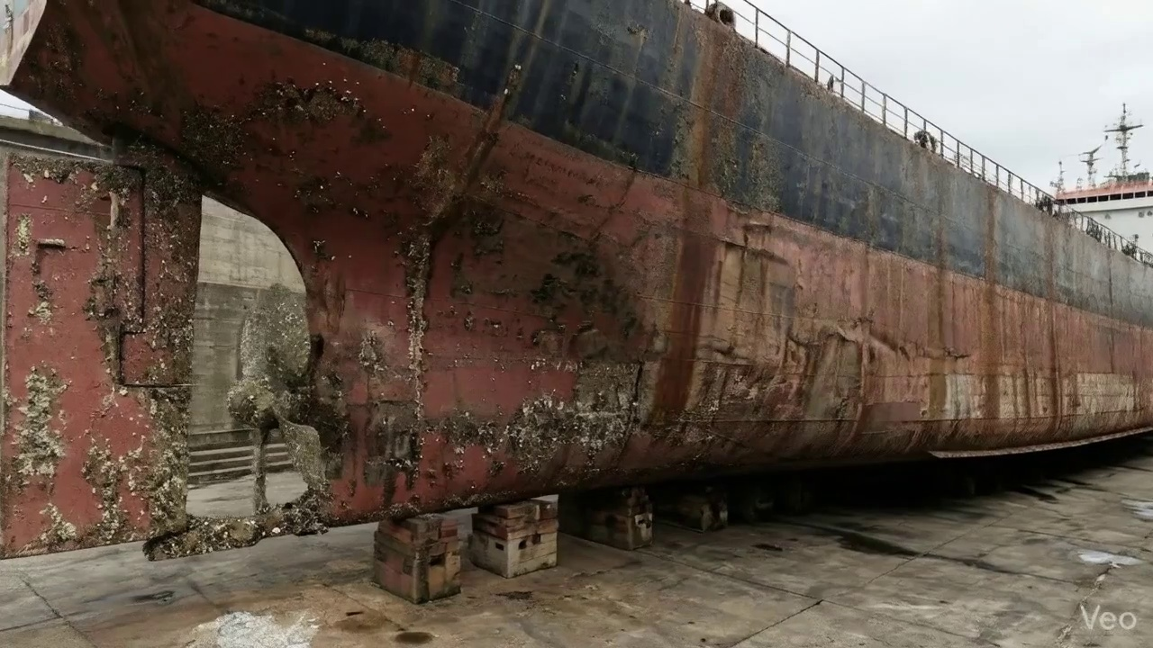

Repair Procedure
This report outlines the detailed process for localized maritime structural repairs, focusing on rectifying buckled or deformed hull plating, and addresses the necessity of each step, the activities performed, the utility of specified equipment, and overarching safety and structural considerations.
---
### **Explanation of Maritime Repair Process for Vessel Inspection Report**
This repair procedure is designed to systematically address and rectify localized structural deformations in a vessel's hull or deck plating, ensuring the restoration of structural integrity, watertightness, and compliance with classification society standards.
**1. Why Each Repair Step is Necessary & What Happens During the Repair:**
* **Assessment:**
* **Necessity:** This initial phase is critical for accurately diagnosing the extent and severity of damage. Without a precise understanding of the deformation's scope (localized vs. spanning frames) and magnitude (out-of-flatness measurements), an effective and complete repair strategy cannot be formulated. It prevents hidden damage from compromising the repair's longevity.
* **What Happens:** Skilled technicians meticulously inspect the affected area. This involves visual examination to identify buckling, denting, or distortion, followed by marking the precise boundaries of the deformed zone. Measurements are taken to quantify the out-of-flatness, indicating the degree of deviation from the original design contour. The assessment also determines if the deformation is confined to a single plate or if adjacent frames, girders, or stiffeners are also compromised.
* **Preparation:**
* **Necessity:** This step is paramount to remove all compromised material, ensuring that the new structural components are welded to sound, undamaged base metal. This prevents crack propagation from existing defects and provides a stable, strong foundation for the new plating. Leaving a margin of sound plate ensures sufficient material for a robust weld joint.
* **What Happens:** Using thermal cutting equipment (e.g., a cutting torch), all distorted plate material, along with any buckled or bent girders and stiffeners within the damaged zone, are precisely cut away. This removal extends beyond the visible deformation to ensure cutting into sound, uncompromised metal. A minimum margin of ¾ of the original plate thickness is maintained around the cut-out. Any bent framing that is not removed is carefully straightened to its original alignment.
* **Plate Replacement:**
* **Necessity:** This step directly restores the structural continuity, watertight integrity, and designed strength of the hull or deck. Precise fabrication and proper welding techniques are essential to integrate the new material seamlessly and reliably into the existing structure.
* **What Happens:** A new steel plate, fabricated to match or exceed the original material specifications and thickness, is precisely templated and shaped to fit the prepared cut-out. This new plate is then carefully positioned against the remaining sound hull plating, ensuring proper alignment and gap fit-up. It is then secured in place using tack welds. Subsequently, full-circumference welding is performed, encompassing multi-pass welding with appropriate preheat application (especially for thicker plates or high-tensile steels) to ensure good fusion, minimize residual stresses, and prevent hydrogen-induced cracking. Full penetration welds are prioritized wherever structurally feasible to maximize joint strength and integrity.
* **Alignment and Welding:**
* **Necessity:** This phase completes the structural integration, ensuring the weld joint achieves its full designed strength and the overall structure remains true to its original form. Controlling distortion is vital to prevent residual stresses, maintain the vessel's hydrodynamic profile, and ensure proper fitment of other components. Post-weld grinding and potential additional strengthening enhance the repair's longevity and safety.
* **What Happens:** Continuing weld passes are applied, typically using E7018 low-hydrogen electrodes known for their excellent mechanical properties and resistance to cracking, building up the weld to its full profile. Throughout this process, strict control measures are employed to mitigate welding-induced distortion, such as strategic clamping, back-stepping techniques, or controlled heat input. Upon completion of welding, the weld seams are carefully ground fair and smooth to match the adjacent hull plating, reducing stress concentrations and improving hydrodynamic flow. In situations where the initial buckling was extensive or the area is identified as a high-stress zone, additional strengthening components like doubler plates or strategically placed stiffeners may be added to enhance local structural resilience.
* **Finishing:**
* **Necessity:** This final stage is crucial for validating the quality of the repair, protecting the new steel from environmental degradation, and restoring the vessel's original operational characteristics. NDT ensures that critical welds are free from hidden defects.
* **What Happens:** A thorough inspection of the completed repair is conducted. This includes visual examination to check for surface defects, weld profile, and overall fairness, followed by Non-Destructive Testing (NDT) methods such as Magnetic Particle Inspection (MPI) or Ultrasonic Testing (UT) to verify the internal soundness of critical welds. Once the repair passes inspection, the new steel surface is meticulously cleaned and prepared (e.g., grit blasting) before applying appropriate marine-grade primer and finish coats to restore the vessel's full corrosion protection system. Finally, the repaired deck or hull surface is faired back to its original designed contour, ensuring no adverse impact on hydrodynamics or deck functionality.
**2. Why the Required Items are Used:**
* **Cutting Torch (rental):**
* **Quantity/Metrics:** 0.01 machine-days/sq.m, Required Quantity: 0.12 machine-days.
* **Purpose:** The cutting torch is an essential piece of equipment specifically utilized during the "Preparation" phase. Its primary function is the precise and efficient thermal cutting of the damaged and distorted steel plate, buckled girders, and stiffeners to expose sound, undamaged base metal. This tool is indispensable for creating the clean, defined cut-out necessary for fitting the new plate. The specified quantity (0.12 machine-days) indicates the estimated operational time required for cutting for the estimated repair area (e.g., 12 sq.m if 0.01 machine-day per sq.m is the rate), with the rental model optimizing cost for specialized equipment not constantly in use.
**3. Safety and Structural Considerations:**
* **Structural Integrity and Compliance:** The overarching safety and structural consideration is the full restoration of the vessel's original structural integrity and compliance with relevant classification society rules and statutory requirements. This encompasses material selection, weld quality, and the overall design of the repair.
* **Welding Procedure Qualification:** All welding procedures must be qualified in accordance with recognized standards (e.g., AWS, DNV-GL, Lloyd's Register) to ensure the weld joints possess the required mechanical properties, including strength, ductility, and fatigue resistance. Welders performing the repair must be certified to these qualified procedures.
* **Material Compatibility:** The new steel plate must be compatible with the existing hull material, typically matching or exceeding its grade and thickness, to prevent galvanic corrosion and ensure uniform stress distribution across the repaired area.
* **Distortion Control and Residual Stress:** Uncontrolled heat input during welding can induce significant residual stresses and distortion, leading to misalignment, stress concentrations, or premature fatigue cracking. Techniques like preheating, controlled welding sequences (e.g., skip welding, back-step welding), and post-weld peening or heat treatment (if applicable) are vital to manage these effects.
* **Non-Destructive Testing (NDT):** The mandatory application of NDT methods (MPI, UT) is a critical safety measure. It provides objective verification of the internal soundness of welds, detecting subsurface defects (e.g., lack of fusion, porosity, cracks) that are not visible externally but could severely compromise the structural integrity and lead to catastrophic failure under operational loads.
* **Corrosion Protection:** The final coating application is vital for preventing corrosion of the new steelwork. Corrosion can rapidly degrade the structural integrity of the repair, making its longevity dependent on effective paint system application and adhesion.
* **Hot Work Safety:** The use of cutting torches and welding equipment necessitates strict adherence to hot work permits, fire watch protocols, provision of appropriate Personal Protective Equipment (PPE) for all personnel, and adequate ventilation to prevent fires, explosions, and exposure to harmful fumes.
* **Environmental Protection:** Measures must be in place to prevent the release of welding fumes, grinding dust, and paint solvents into the marine environment, adhering to international and local environmental regulations.

Repair Cost Breakdown
Item | Quantity | Unit Cost | Total Cost | Currency
Cutting Torch (rental) | 0.12 | 10764.0 | 1345.5 | INR
Estimated Repair Cost: 69305.88 INR

3.5 PD_5

Defect Overview
**Defect Name:** DEFORMATION
**Severity:** High
**Explanation:**
This report details a high-severity defect identified as DEFORMATION, affecting both the vessel's hull plating and the rudder area.
---
**1. What the defect means:**
Deformation, specifically observed as buckling and/or warping, signifies an out-of-plane bending or distortion of the vessel's structural components. This includes the hull plating, where it impacts approximately 20.46% of the measured hull area, and extends to the rudder area, affecting about 16.98% of its surface. Unlike simple indentation, deformation involves a change in the original plane of the material, causing it to bulge inwards or outwards. Such damage typically results from external forces like grounding impacts, heavy sea loads, or internal stresses such as uneven welding heat.
**2. Why it is important:**
The presence of deformation is critical due to its direct impact on the fundamental integrity and performance of the vessel. For the hull, even seemingly moderate buckles are significant as they compromise the vessel's primary longitudinal strength, known as hull girder strength, which is essential for the vessel to resist global bending and shear forces. In the rudder area, deformation is particularly critical as it directly affects the vessel's steerability, control, and hydrodynamic efficiency, potentially leading to unpredictable handling characteristics and increased operational risks. Classification societies universally deem significant deformation as a defect requiring urgent attention due to its implications for structural safety.
**3. Risks if not repaired:**
Failure to rectify significant deformation poses severe risks to the vessel's continued safe operation:
* **Hull Integrity:** On the hull, unrepaired deformation can lead to progressive structural failure. This includes the initiation and propagation of cracks, potential for catastrophic collapse of the affected plating under dynamic loads (e.g., slamming in heavy seas), or localized fatigue failures at stress concentration points. This directly compromises the vessel's watertight integrity and overall structural strength.
* **Rudder System Failure:** Regarding the rudder, unrepaired deformation carries a high risk of impaired steering response, increased drag leading to reduced fuel efficiency, and, critically, the potential for rudder blade fracture or detachment. Such an event would result in a complete loss of steerage, presenting an immediate and extreme hazard to navigation and safety of life at sea, especially in congested waters, adverse weather, or during critical maneuvering operations.
* **Operational & Regulatory Impact:** These structural failures can lead to operational limitations, port state control detentions, costly emergency repairs, and significantly increased insurance premiums.
**4. Structural implications:**
Structurally, deformation represents a localized or widespread reduction in the load-bearing capacity of the affected components.
* **Hull Structure:** For hull plating and stiffeners, out-of-plane bending dramatically reduces the plate's ability to carry compressive and shear loads efficiently. This initiates high stress concentrations at the crests and troughs of the buckles, making the material highly susceptible to brittle fracture or fatigue cracking under cyclic loading. Critically, this compromises the overall hull girder's ability to resist global bending and torsional moments experienced during vessel operation, potentially leading to a cascading structural failure under extreme conditions.
* **Rudder Structure:** In the rudder, deformation alters the designed hydrodynamic profile, leading to turbulent flow, reduced lift, and increased drag. More alarmingly, it can introduce high stress points within the rudder structure, especially at the stock connection, potentially leading to fatigue or brittle fracture of the rudder blade or stock, which are critical elements for propulsion and maneuvering. The altered geometry also disrupts the flow around the propeller, potentially reducing propulsion efficiency.
Based on classification practice and the high severity, significant deformation typically necessitates correction by cutting out and replacing the distorted metal to restore the original structural integrity and design geometry. Local repairs or fairing are generally not sufficient to fully restore original strength and prevent recurrence.

Visual Evidence
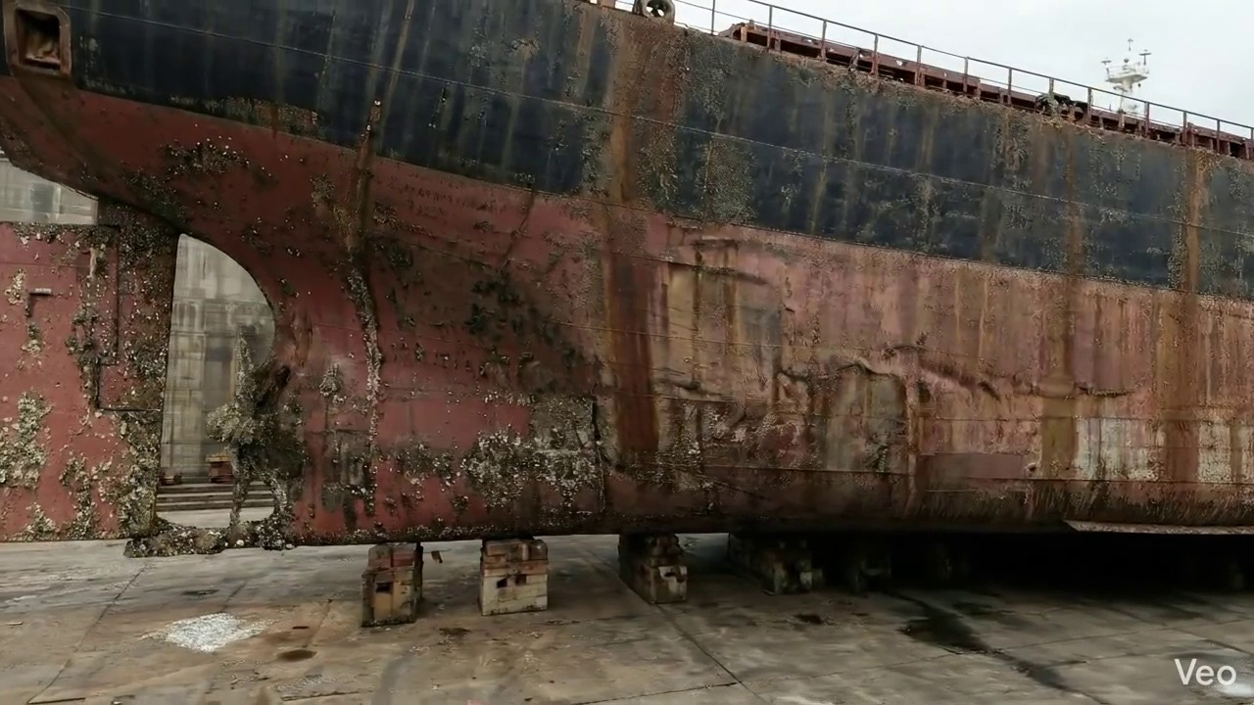

Repair Procedure
## Vessel Inspection Report: Explanation of Hull Plate and Framing Repair Process
**Date:** [Current Date]
**Vessel Name:** [Vessel Name, if applicable]
**Location of Repair:** [Specify, e.g., Starboard Midship Hull Plate]
**Repair Type:** Localized Hull Plate and Framing Renewal
This section details the professional explanation of the hull plate and framing repair process undertaken, outlining the necessity of each step, the actions performed, the utilization of specified equipment, and critical safety and structural considerations.
---
### Detailed Repair Process Explanation:
The repair process described is a standard methodology for addressing localized structural deformation or damage to a vessel's hull plating and internal framing. Its objective is to restore the vessel's structural integrity, watertightness, and original hydrodynamic profile.
#### 1. Assessment
* **Why necessary:** This initial step is critical for thoroughly understanding the nature, extent, and severity of the damage. An accurate assessment dictates the scope of the repair, material requirements, and the specific procedures to be followed. It ensures that all compromised material, visible or hidden, is identified, preventing incomplete repairs that could lead to premature failure or recurrence of issues.
* **What happens during the repair:** Skilled personnel meticulously inspect the deformed region. This involves visually identifying buckled areas, marking their boundaries, and carefully checking whether the deformation is isolated to a single plate or extends to adjacent plates, stiffeners, or main frames. Precision measurements of any 'out-of-flatness' are taken to quantify the deformation and determine the required cut-out dimensions.
#### 2. Preparation
* **Why necessary:** The preparation phase is fundamental to creating a sound foundation for the new steel. All material that has been compromised by deformation, fatigue, or impact damage must be removed. Welding new material onto distorted or fatigued steel would create stress concentrations, compromise weld integrity, and potentially lead to new cracking. Leaving a margin of sound, undeformed plate ensures that the subsequent welding process occurs on structurally robust material. Straightening or removing bent framing is essential to re-establish the internal structural support and ensure proper alignment for the new plate.
* **What happens during the repair:** Using cutting equipment, all identified distorted plate material, along with any buckled girders or stiffeners, are carefully cut away. The cutting proceeds until only sound, undeformed metal remains, ensuring a minimum margin of good plate equal to or greater than ¾ of the original plate thickness. Any internal framing (stiffeners, girders) found to be bent beyond acceptable limits are either precisely straightened using heat and mechanical force or completely removed for replacement.
#### 3. Plate Replacement
* **Why necessary:** This step directly restores the structural integrity, watertightness, and original design profile of the hull. Fabricating a new plate of the same or greater thickness ensures that the repaired section is either equivalent to or stronger than the original structure. Precise shaping and fitting are crucial to minimize weld gaps, which in turn reduces residual stress, welding distortion, and the potential for defects. Proper welding techniques, including preheat and achieving good fusion, are vital for creating a robust, structurally sound connection. Full penetration welds maximize joint strength and reliability.
* **What happens during the repair:** A new steel plate is fabricated according to the precise dimensions and contour required for the cut-out. This new plate, typically of the same material grade and thickness (or specified greater thickness for increased robustness), is then carefully positioned within the opening in the remaining hull plating. Once accurately aligned, the plate is secured with tack-welds to maintain its position. Subsequently, a complete perimeter weld is applied, ensuring thorough fusion with the existing hull and adhering to appropriate preheat procedures to prevent hydrogen-induced cracking and ensure weld quality. Where feasible and structurally required, full penetration welds are utilized.
#### 4. Alignment and Welding
* **Why necessary:** This phase ensures the final structural integrity and quality of the welded joint. The use of E7018 electrodes is standard for critical structural applications due to their high strength, ductility, and low hydrogen properties, which minimize the risk of brittle fracture. Managing welding-induced distortion is paramount to prevent the introduction of new stresses, warping of the hull, or misalignment, which could compromise the vessel's hydrodynamics and structural performance. Grinding the weld seams fair improves the aesthetic finish, restores the smooth hydrodynamic flow, and eliminates potential stress risers. In cases of extensive original buckling, the application of additional strengthening members (doublers or stiffeners) is a proactive measure to redistribute loads and reduce localized stress concentrations, enhancing the long-term durability of the repaired area.
* **What happens during the repair:** Successive weld passes are meticulously applied using E7018 low-hydrogen electrodes to build up the weld seam to the required profile and strength. Throughout the welding process, continuous monitoring for distortion is performed. If distortion begins to occur, corrective measures such as strategic clamping, back-stepping welding techniques, or controlled minimal heat input methods are employed to mitigate it. Upon completion of welding, all weld seams are ground smooth and fair with the surrounding hull surface. For repairs involving significant original damage, additional structural reinforcement in the form of doubler plates or supplementary stiffeners may be permanently affixed to enhance the load-bearing capacity and fatigue resistance of the repaired section.
#### 5. Finishing
* **Why necessary:** The finishing step serves as the final quality control and protection stage. Visual inspection and Non-Destructive Testing (NDT) are essential for verifying the integrity of the repair, including detection of any surface or subsurface defects that are not visible to the naked eye. The application of primer and finish coats is crucial for restoring the vessel's anti-corrosion protection, preventing rust and degradation of the new steel. Finally, ensuring the deck or hull surface is faired back to its original contour is important for maintaining the vessel's hydrodynamic efficiency and aesthetic appearance.
* **What happens during the repair:** A comprehensive inspection of the completed weld repair is conducted, including a visual examination for surface defects, and NDT methods such as Ultrasonic Testing (UT) or Magnetic Particle Inspection (MPI) to confirm subsurface integrity and detect any internal flaws. Following successful inspection, the new steel surfaces are prepared and immediately treated with appropriate marine-grade primer and subsequent finish coats to provide long-term corrosion protection. The repaired area is then faired and blended into the surrounding structure to restore the original smooth contour of the hull or deck.
---
### Explanation of Required Items:
#### Cutting Torch (rental)
* **Quantity per sq.m:** 0.01 machine-days/sq.m
* **Unit Cost:** INR 10764.0
* **Required Quantity:** 0.12 machine-days
* **Total Cost:** INR 1345.5
* **Why it is used:** The cutting torch is an essential piece of equipment for the "Preparation" phase of the repair process. It is used to efficiently and precisely cut away the damaged, distorted hull plate and any buckled internal structural members (girders, stiffeners) to reach sound metal. Its ability to rapidly sever steel sections makes it indispensable for creating the necessary cut-out for the new plate insertion. The "rental" designation indicates that this tool is either specialized equipment not owned outright by the repair facility for infrequent use or is rented to manage capital expenditure for short-duration project requirements.
---
### Safety and Structural Considerations:
1. **Hot Work Safety:** The use of cutting torches and welding equipment necessitates strict adherence to hot work procedures. This includes obtaining hot work permits, ensuring proper ventilation, establishing fire watches with appropriate extinguishing equipment, and removal of all flammable materials from the vicinity.
2. **Structural Integrity:** The entire repair process is geared towards restoring and often enhancing the vessel's structural integrity. Critical considerations include:
* **Material Selection:** Using steel of the same or greater thickness and compatible material grade ensures structural equivalence or improvement.
* **Weld Quality:** Proper preheat, interpass temperature control, appropriate electrode selection (E7018), and full penetration welds where specified are crucial for achieving strong, defect-free joints resistant to fatigue and brittle fracture.
* **Distortion Control:** Managing welding-induced distortion prevents the creation of new residual stresses or aesthetic deformities that could compromise long-term structural performance.
* **Load Path Continuity:** Ensuring that all internal framing (girders, stiffeners) are properly aligned, re-attached, or renewed ensures continuous load paths and effective stress distribution.
* **Reinforcement:** The consideration of additional strengthening (doublers, stiffeners) for extensive damage indicates a proactive approach to prevent future stress-related issues.
3. **Personnel Competency:** All cutting, welding, and inspection activities must be performed by certified and experienced personnel to ensure compliance with relevant standards and classification society rules.
4. **Corrosion Protection:** The application of primer and finish coats is not merely cosmetic; it is a critical structural consideration. It protects the newly exposed and welded steel from environmental degradation, ensuring the longevity of the repair.
5. **Classification Society and Regulatory Compliance:** All repair procedures, material choices, and inspection methodologies must conform to the requirements of the vessel's classification society and flag state regulations. This ensures the repair meets international safety and structural standards.
6. **Non-Destructive Testing (NDT):** NDT methods are a fundamental safety assurance measure, verifying the internal soundness of welds and the absence of critical defects that could lead to structural failure under operational loads.
This detailed explanation confirms the repair process is comprehensive, professionally executed, and considers all critical aspects for safe and effective restoration of the vessel's structural integrity.

Repair Cost Breakdown
Item | Quantity | Unit Cost | Total Cost | Currency
Cutting Torch (rental) | 0.12 | 10764.0 | 1345.5 | INR
Estimated Repair Cost: 69305.88 INR

3.6 PD_6

Defect Overview
**Defect Explanation: Deformation (Buckling/Warping) in Hull Plating**
**Severity:** High
---
1. **What the defect means:**
Deformation, specifically observed as buckling or warping, refers to an out-of-plane bending or distortion of the vessel's hull plating or supporting structural stiffeners. This means the affected metal is no longer flat or in its intended geometric plane but has become significantly bent inwards or outwards. This type of damage typically results from external forces such as grounding impacts, heavy sea loads, or internal stresses like those induced by uneven welding or heat during construction or repair processes.
2. **Why it is important:**
This defect is of high importance due to its direct and severe impact on the structural integrity of the vessel, particularly the critical hull girder which is the primary strength element. Even seemingly moderate buckles are capable of significantly compromising the vessel's primary strength members, reducing their load-carrying capacity and stability. Being located within the 'HULL_AREA', this defect directly affects the fundamental structural backbone designed to withstand bending, shear, and torsional forces encountered during operations.
3. **Risks if not repaired:**
If not adequately repaired, deformation poses several significant risks. The compromised hull girder strength increases susceptibility to further damage, including the potential for cracking, fatigue failures, or accelerated corrosion in the affected areas under routine operational loads or adverse weather conditions. In severe cases, or under extreme stress, this could lead to catastrophic structural failure, loss of watertight integrity, ingress of water, and ultimately endanger the vessel, its crew, and cargo. Furthermore, failure to address such defects will likely result in non-compliance with classification society rules and regulatory requirements, impacting the vessel's ability to trade or maintain its class.
4. **Structural implications:**
Structurally, deformation signifies a direct reduction in both the local and global stiffness and strength of the affected plating and stiffeners. The out-of-plane bending fundamentally reduces the plate's effective cross-sectional area and its ability to carry compressive and shear loads efficiently, potentially leading to premature buckling failure of the entire plate panel or adjacent structural members. For stiffeners, buckling reduces their effectiveness in supporting the plating and transferring loads to main frames and bulkheads. This directly compromises the vessel's longitudinal strength, which is vital for resisting hull girder bending moments. Classification societies mandate the correction of significant buckling, typically by cutting out and replacing the distorted metal, because it represents a fundamental weakening of the primary structure that cannot be reliably ignored or tolerated for safe operation.

Visual Evidence


Repair Procedure
**Vessel Inspection Report - Deformed Hull Plating Repair Process Explanation**
This document details the professional methodology employed for the repair of deformed hull plating, as outlined in the provided process steps. The explanation covers the necessity of each step, the actions performed, the rationale for specific equipment usage, and critical safety and structural considerations.
---
**1. Assessment Phase**
* **Necessity:** The assessment phase is paramount for accurately defining the extent and nature of the damage. A thorough understanding of the deformation, whether localized or spanning multiple structural frames, is crucial for developing an effective and structurally sound repair plan. Misjudging the damage scope can lead to incomplete repairs and residual structural weaknesses.
* **What Happens:** Skilled technicians meticulously inspect the affected region visually and often tactilely. The buckled area is precisely marked, and observations are made to determine if the deformation is confined to a small area or extends across adjacent frames and stiffeners. Out-of-flatness measurements are systematically taken using straight edges and precision instruments to quantify the degree of deformation and identify areas requiring material removal or straightening.
* **Required Items Usage:** The cutting torch is not utilized during this diagnostic phase.
* **Safety & Structural Considerations:** Structurally, this phase directly impacts the subsequent repair's efficacy; an inaccurate assessment could compromise the vessel's long-term integrity. Safety considerations are primarily general shipyard safety, such as ensuring stable access and clear pathways around the inspection area.
---
**2. Preparation Phase**
* **Necessity:** This phase is critical for removing all compromised material, ensuring that subsequent welding operations connect new, sound steel to existing, undamaged structure. This is fundamental for achieving full structural continuity and preventing premature failure of the repair.
* **What Happens:** All identified distorted plate sections, buckled girders, and stiffeners are precisely cut away. The cutting extends into sound, undamaged metal, leaving a specified margin (typically ≥¾ of the material thickness) to ensure a clean, stable base for welding. Any bent framing that cannot be straightened to classification society standards is also removed. This process prepares the aperture for the insertion of new structural components.
* **Required Items Usage:** The **Cutting Torch (rental)** is an indispensable tool during this preparation phase. It is utilized for the thermal cutting of steel plates, girders, and stiffeners to remove the distorted material. Its high temperature allows for efficient and precise removal of the damaged sections, preparing the work area for new plate insertion. The "quantity per sq.m" metric suggests it's rented based on expected usage, correlating directly with the area requiring cutting.
* **Safety & Structural Considerations:**
* **Safety:** Thermal cutting is a "hot work" operation requiring strict adherence to safety protocols, including a dedicated fire watch, proper ventilation to dissipate hazardous fumes, and the use of personal protective equipment (PPE) such such as welding shields, flame-retardant clothing, and gloves. Fire prevention measures, including clearing combustible materials from the vicinity, are paramount.
* **Structural:** It is imperative to cut to sound material, avoiding any heat-affected zones or fatigue-prone areas. The specified margin ensures that the new welds are made on material with original metallurgical properties, guaranteeing a robust repair.
---
**3. Plate Replacement Phase**
* **Necessity:** This phase is essential for physically restoring the original structural integrity, watertightness (if applicable), and design contour of the vessel. It introduces new material to replace what was removed, re-establishing the primary structural load path.
* **What Happens:** A new steel plate, fabricated to match or exceed the original material's grade and thickness, is precisely shaped to fit the prepared aperture. This new plate is then carefully maneuvered into position and secured to the remaining hull plating through tack-welding. Full penetration welds are prioritized wherever feasible to maximize the strength and integrity of the connection, along with appropriate preheat procedures if required by material thickness or ambient conditions, to prevent hydrogen-assisted cracking.
* **Required Items Usage:** While the cutting torch may be used for minor adjustments to the new plate or for preparing weld bevels, its primary role as a rental item is not central to the main plate replacement activity.
* **Safety & Structural Considerations:**
* **Safety:** Welding operations demand similar safety precautions as cutting, including arc flash protection, ventilation, and fire watch. Proper rigging and handling of the new plate are necessary to prevent injuries from falling objects.
* **Structural:** The selection of steel grade and thickness must comply with classification society rules and the vessel's original specifications. Accurate fit-up of the new plate minimizes residual stresses and ensures optimal weld quality. Proper tack-welding and preheating (when necessary) are critical for preventing weld defects and ensuring metallurgical soundness.
---
**4. Alignment and Welding Phase**
* **Necessity:** This phase completes the structural integration of the new plate, ensuring a robust, continuous connection that can withstand operational stresses and maintain the vessel's lines. It also addresses and mitigates any distortion induced by the welding process itself.
* **What Happens:** Continuous weld passes are systematically applied using E7018 electrodes, which are specified for their low hydrogen content, excellent mechanical properties, and ability to produce high-quality structural welds. Throughout this process, active measures such as using strong-backs, clamps, or specialized welding sequences (e.g., skip welding, back-step welding) are employed to control and minimize heat-induced distortion. Upon completion of welding, the weld seams are meticulously ground fair and flush with the surrounding hull plating to eliminate stress concentrations, improve hydrodynamic flow, and restore the original contour. In instances of extensive initial buckling or if residual stresses are deemed high, additional strengthening measures such as doublers or extra stiffeners may be incorporated to enhance the long-term structural integrity and resilience of the repaired area.
* **Required Items Usage:** The cutting torch is not directly used in this phase.
* **Safety & Structural Considerations:**
* **Safety:** Continued adherence to welding safety protocols is required. Grinding operations necessitate appropriate PPE, including eye protection, hearing protection, and respiratory protection against grinding dust.
* **Structural:** The use of E7018 electrodes is a standard for high-strength structural welding. Effective distortion control is paramount to prevent unwanted stress build-up and maintain the vessel's design profile. Grinding welds fair eliminates potential fatigue initiation points, while additional strengthening measures provide localized reinforcement, ensuring the repaired section performs adequately under service loads.
---
**5. Finishing Phase**
* **Necessity:** The finishing phase is crucial for verifying the quality and integrity of the completed repair, ensuring long-term corrosion protection, and restoring the vessel's aesthetic and functional contours.
* **What Happens:** The entire repaired area undergoes a comprehensive inspection regime. This includes thorough visual inspection for surface defects (e.g., cracks, undercut, porosity) and the application of Non-Destructive Testing (NDT) methods, such as Magnetic Particle Testing (MPT), Ultrasonic Testing (UT), or Radiographic Testing (RT), to detect any subsurface flaws or discontinuities in the welds. Once the repair passes all inspections, the new steel surface is thoroughly cleaned, prepared, and coated with appropriate primer and finish paint systems to restore anti-corrosion protection. Finally, the deck or hull surface is faired back to its original smooth contour, which is essential for maintaining hydrodynamic efficiency and preventing unwanted turbulence or localized stress risers.
* **Required Items Usage:** The cutting torch is not utilized in this concluding phase.
* **Safety & Structural Considerations:**
* **Safety:** NDT procedures, particularly RT, may involve radiation safety protocols. Painting operations require adequate ventilation and PPE to protect against hazardous fumes.
* **Structural:** NDT is the final verification step, confirming the repair meets classification society and owner-specified quality standards, ensuring full structural integrity. The application of a robust coating system is vital for preventing corrosion, which could otherwise compromise the integrity of the new steel over time. Restoring the contour is essential for the vessel's operational performance and longevity.
---

Repair Cost Breakdown
Item | Quantity | Unit Cost | Total Cost | Currency
Cutting Torch (rental) | 0.12 | 10764.0 | 1345.5 | INR
Estimated Repair Cost: 69305.88 INR

3.7 PD_7

Defect Overview
Here is a professional explanation of the maritime defect "DEFORMATION" for a vessel inspection report:
---
**Defect Name: DEFORMATION (Buckling / Warping)**
**Severity: High**
**Location: HULL_AREA (Approx. 14.3% overlap)**
**1. What the defect means:**
Deformation, in the context of vessel structures, refers to the observed out-of-plane bending, buckling, or warping of the hull plating or associated stiffening members within the identified HULL_AREA. This indicates that the metal has undergone permanent distortion from its original intended shape. Common manifestations include concave or convex bends in plating (buckling) or twisting and rippling (warping) of plates and profiles. This defect is a direct consequence of forces or stresses exceeding the material's elastic limit.
**2. Why it is important:**
This defect is of critical importance due to its direct and severe impact on the vessel's structural integrity. Classified as 'High' severity, deformation signifies that the affected material is no longer functioning as designed. Even moderate buckling can drastically reduce the load-bearing capacity of the hull girder and local structures, compromising the vessel's ability to withstand operational stresses from sea loads, cargo, and internal pressures. Classification societies universally consider significant deformation a serious defect requiring intervention, as it directly undermines the structural safety margins.
**3. Risks if not repaired:**
Failure to promptly and adequately repair significant deformation presents several grave risks:
* **Progressive Structural Failure:** The deformed area becomes a point of stress concentration, accelerating fatigue crack initiation and propagation in the surrounding plating, welds, and stiffeners. This can lead to a cascading failure of the local structure.
* **Loss of Watertight/Weathertight Integrity:** Severe deformation, particularly if accompanied by tearing or weld failures, can compromise the vessel's watertight or weathertight envelope, leading to ingress of water into tanks, compartments, or cargo holds, with potentially catastrophic consequences.
* **Reduced Hull Girder Strength:** The overall strength of the vessel's main structural girder is diminished, increasing the risk of structural collapse or rupture under dynamic loads such as heavy seas or uneven loading.
* **Regulatory Non-Compliance and Operational Restrictions:** Unrepaired high-severity deformation will lead to non-compliance with classification society rules and statutory requirements, resulting in detentions, operational limitations, withdrawal of class, and potential issues with insurance coverage.
* **Increased Vibrations and Fatigue:** A compromised structure can lead to increased localized and global vibrations, accelerating fatigue damage throughout the vessel's structure and machinery.
**4. Structural implications:**
The structural implications of deformation are profound and extend from local to global effects:
* **Compromised Hull Girder Strength:** Buckling of hull plating, especially in areas subject to significant bending moments (e.g., sheer strake, deck plating), drastically reduces the effective sectional area and moment of inertia of the hull girder. This directly weakens the vessel's primary longitudinal strength, its ability to resist hogging and sagging forces.
* **Loss of Local Strength and Stiffness:** The out-of-plane distortion renders the plating and stiffeners less effective in carrying their intended compressive, tensile, and shear loads. Stiffeners, which are designed to prevent plating from buckling, become ineffective or even contribute to the weakness when they themselves are deformed.
* **Altered Load Paths and Stress Redistribution:** Deformation causes an uneven distribution of stresses, with loads shunting away from the weakened area and concentrating on adjacent, potentially sound, structures. This can lead to overloading of otherwise healthy sections and accelerate their degradation.
* **Geometric Instability:** The deformed shape itself is less stable than the original flat or curved structure, making it more susceptible to further collapse or "snap-through" buckling under operational loads.
* **Reduced Fatigue Life:** The localized strain and stress concentrations inherent in deformed structures significantly reduce the fatigue life of the material and associated welds, predisposing the structure to premature cracking.
---
**Recommendation:** Given the 'High' severity and critical structural implications, immediate and thorough assessment by a qualified structural engineer is required. Repair, typically involving the cutting out and renewal of the distorted plating and stiffeners as per classification society approved procedures, is mandatory to restore the vessel's structural integrity and ensure safe operation. Small, localized set-in plating may be tolerated only after thorough evaluation and approval by the attending surveyor and classification society.

Visual Evidence
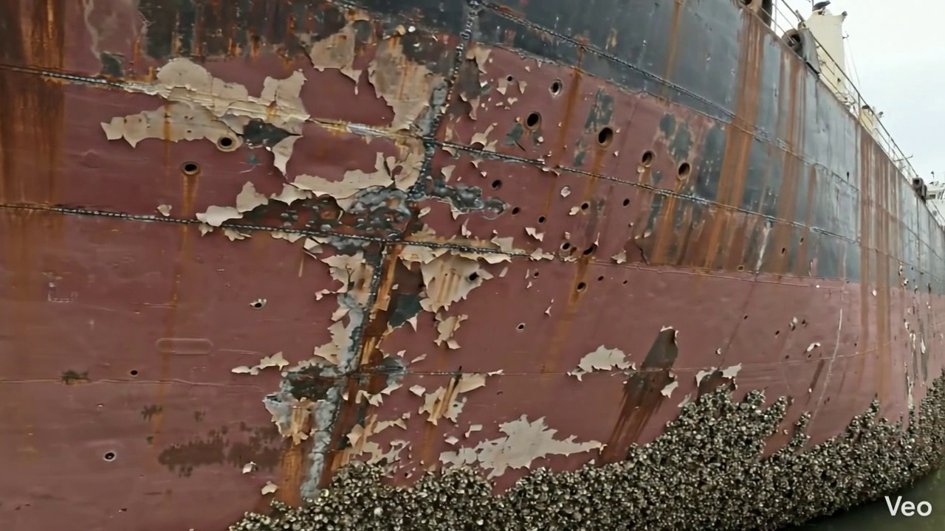

Repair Procedure
This document details the professional repair process for localized hull or structural deformation, ensuring the restoration of the vessel's integrity in compliance with maritime standards.
---
**Repair Process Explanation:**
**1. Assessment**
* **What happens:** A thorough visual and often tactile inspection is conducted on the compromised region. The specific extent of the deformation, including any buckling, cracking, or material thinning, is identified and marked. Technicians determine if the damage is confined to a small area or if it extends across multiple structural frames, potentially indicating a broader issue. Precise measurements of any out-of-flatness or deviation from the original design contour are recorded.
* **Why necessary:** This initial step is critical for accurately defining the scope of the repair. It ensures that the repair addresses the *entire* damaged area and helps in planning the subsequent stages, including material requirements and fabrication needs. Understanding the extent of the damage (localized vs. spanning frames) directly influences the complexity and potential structural implications of the repair, preventing the oversight of underlying or adjacent damage.
**2. Preparation**
* **What happens:** Using appropriate cutting tools, all identified distorted, buckled, or otherwise compromised steel plate, girders, and stiffeners are carefully cut away. The cutting is executed to reach structurally sound metal, ensuring that no fatigued, cracked, or excessively thinned material remains. A margin of good plate, typically specified as equal to or greater than three-quarters of the plate's thickness, is left around the cut-out to ensure a robust foundation for the new weldment and prevent heat-affected zone issues in weakened material. Any framing that is bent but not severely damaged may be straightened to its original alignment; otherwise, it is also removed.
* **Why necessary:** This step is fundamental to the structural integrity of the repair. Removing all compromised material ensures that the new steel will be welded to a sound substrate capable of bearing its design loads. The specified margin helps to create a stable, uncompromised boundary for welding, minimizing the risk of weld defects or premature failure in the heat-affected zone. Straightening or removing bent framing restores the primary structural support for the plating.
**3. Plate Replacement**
* **What happens:** A new steel plate, matching or exceeding the original material's thickness and grade, is fabricated in a workshop to precisely fit the dimensions and curvature of the prepared cut-out. This new plate is then carefully positioned against the remaining hull plating, ensuring proper alignment with the existing structure. It is then tack-welded into place at intervals to secure its position and maintain alignment before the full welding process begins. Complete welding is then performed around the entire perimeter of the new plate, focusing on achieving excellent fusion with the existing material and utilizing appropriate preheat procedures to manage thermal stresses. Full penetration welds are employed where design and access allow, to maximize weld strength.
* **Why necessary:** This stage directly restores the physical continuity and load-bearing capacity of the hull. Fabricating a new plate ensures dimensional accuracy and material integrity. Tack-welding is crucial for holding the plate in correct alignment, preventing distortion during final welding. Complete welding creates a watertight seal and transfers structural loads effectively, while proper preheat mitigates the risk of brittle fracture and helps achieve sound, ductile welds. Full penetration welds provide maximum strength and fatigue resistance.
**4. Alignment and Welding**
* **What happens:** Subsequent weld passes are meticulously applied using approved welding electrodes, typically E7018, which are known for their high strength, ductility, and low hydrogen properties suitable for marine applications. Throughout the welding process, continuous monitoring for heat-induced distortion is performed. If distortion begins to occur, corrective measures such as the use of strongbacks, clamps, or specialized welding sequences (e.g., skip welding, back-step welding) with minimal heat input are employed to maintain the hull's original contour and minimize residual stresses. Once welding is complete, all weld seams are ground fair and flush with the hull surface to ensure a smooth hydrodynamic profile and facilitate subsequent coating applications. In instances where the original buckling was extensive, indicating high localized stresses or a potential design weakness, additional strengthening elements such as doublers (additional plate layers) or stiffeners may be permanently attached to further enhance structural rigidity and distribute stresses more effectively.
* **Why necessary:** E7018 electrodes ensure the weld metal possesses superior mechanical properties, crucial for vessel structures. Controlling distortion is vital to maintain the vessel's hydrodynamic efficiency, preserve structural alignment, and prevent the introduction of adverse residual stresses that could lead to future fatigue or cracking. Grinding weld seams fair improves hydrodynamics, reduces drag, and provides a suitable surface for corrosion protection. The addition of doublers or stiffeners is a proactive measure to prevent recurrence of buckling in high-stress areas, enhancing the long-term structural integrity and resilience of the repaired section.
**5. Finishing**
* **What happens:** The completed repair is subjected to rigorous inspection, which includes visual examination for surface defects, proper weld profile, and dimensional accuracy. Non-Destructive Testing (NDT) methods, such as Magnetic Particle Inspection (MPI), Ultrasonic Testing (UT), or Dye Penetrant Inspection (DPI), are applied to ensure internal weld integrity and freedom from hidden defects. Once the repair passes inspection, the new steel surface is thoroughly cleaned and prepared for coating. It then receives several layers of marine-grade primer and finish coats to restore the vessel's corrosion protection system. Finally, the deck or hull surface is faired back to its original contour, ensuring aesthetic consistency and optimal performance.
* **Why necessary:** This final phase verifies the quality and effectiveness of the entire repair. Visual and NDT inspections provide objective evidence that the welds meet required standards and that the structural integrity has been fully restored. Applying primer and finish coats is essential for long-term corrosion prevention in the harsh marine environment, protecting the new steel from degradation. Fairing the surface ensures the vessel maintains its intended hydrodynamic characteristics and contributes to a professional, well-maintained appearance.
---
**Explanation of Required Items:**
* **Cutting Torch (rental):**
* **Why it is used:** The cutting torch is an essential piece of equipment for the "Preparation" phase of the repair. It utilizes a high-temperature flame (oxy-fuel or plasma) to quickly and efficiently cut through steel plate and structural members. Its primary function is to precisely remove the damaged and distorted sections of the hull, girders, and stiffeners, allowing for the installation of new, sound material. The use of a cutting torch significantly reduces the time and effort required for material removal compared to mechanical methods, making it a critical tool for expediting the repair process. Renting the torch (as opposed to purchasing) is often a cost-effective solution for intermittent or specialized repair projects, ensuring access to high-quality equipment without the capital expenditure of ownership.
---
**Safety and Structural Considerations:**
**Safety Considerations:**
1. **Hot Work Permits:** Strict adherence to hot work permit procedures is paramount, given the use of cutting torches and welding equipment, to prevent fire and explosion.
2. **Fire Watch:** A dedicated fire watch personnel must be present during all cutting and welding operations to monitor for sparks and potential ignition sources.
3. **Ventilation:** Adequate ventilation is crucial, especially in confined spaces, to remove welding fumes, gases, and airborne contaminants, protecting worker health.
4. **Personal Protective Equipment (PPE):** Welders and all personnel in the vicinity must wear appropriate PPE, including welding helmets, flame-retardant clothing, gloves, safety glasses, and respirators.
5. **Confined Space Entry:** If the repair involves working inside tanks or other confined spaces, strict confined space entry protocols, including gas testing, ventilation, and stand-by personnel, must be followed.
6. **Material Handling:** Safe lifting and handling practices must be employed when positioning new steel plates and structural members to prevent injuries.
**Structural Considerations:**
1. **Material Compatibility:** The new steel plate and welding consumables (e.g., E7018 electrodes) must be fully compatible with the existing hull material to ensure metallurgical integrity and prevent galvanic corrosion.
2. **Design Loads and Class Requirements:** The repair must restore the vessel's structural strength to meet or exceed original design specifications and comply with the rules and regulations of the relevant Classification Society.
3. **Thermal Distortion and Residual Stress:** Careful control of heat input during welding is crucial to minimize thermal distortion and the introduction of harmful residual stresses, which could lead to premature cracking or buckling.
4. **Weld Quality:** All welds must be of high quality, free from defects such as cracks, porosity, undercut, and lack of fusion, as verified by visual inspection and NDT.
5. **Stress Concentration:** The design and execution of the repair must avoid creating new stress concentration points, which could become fatigue initiation sites. The addition of doublers or stiffeners in high-stress areas helps mitigate this risk.
6. **Fatigue Life:** The repair should not adversely affect the overall fatigue life of the vessel's structure. Smooth transitions and fairing are important for this.
7. **Watertight Integrity:** For hull repairs, the final welded connection must ensure complete watertight integrity, preventing ingress of water into compartments.
---

Repair Cost Breakdown
Item | Quantity | Unit Cost | Total Cost | Currency
Cutting Torch (rental) | 0.12 | 10764.0 | 1345.5 | INR
Estimated Repair Cost: 69305.88 INR

3.8 PD_8

Defect Overview
**Defect Explanation: DEFORMATION**
**Defect Name:** DEFORMATION
**Severity:** Medium
**Location:** HULL_AREA (approximately 5.59% overlap with the defect)
---
**1. What the defect means:**
Deformation, specifically identified as buckling or warping, refers to an undesirable out-of-plane bending, distortion, or 'set-in' of the vessel's hull plating or structural stiffeners. Unlike simple indentation, buckling indicates a loss of stability where the plating or stiffener bends under compressive loads, while warping signifies a twist or general non-planar distortion. This particular defect is noted within the HULL_AREA of the vessel. Such defects commonly arise from various factors including localized impact forces (e.g., grounding incidents), excessive heavy sea loads imposing dynamic stresses, or thermal stresses induced by uneven welding processes.
**2. Why it is important:**
This defect is of significant importance because even moderate levels of deformation, particularly buckling, can severely compromise the hull girder strength of the vessel. The hull girder functions as the primary structural beam, responsible for resisting global bending moments and shear forces acting on the ship. Any reduction in its integrity directly impacts the vessel's overall structural resilience, its ability to withstand operational loads, and its fundamental seaworthiness. The presence of deformation indicates that the affected structure is no longer performing optimally, having exceeded its elastic limit or local stability thresholds.
**3. Risks if not repaired:**
Failure to address this medium-severity deformation carries several critical risks:
* **Progressive Structural Failure:** Deformed plating and stiffeners can redistribute stresses to adjacent intact structures, potentially leading to stress concentrations, accelerated fatigue cracking, and a cascading, progressive failure of surrounding structural members.
* **Reduced Load-Carrying Capacity:** The affected area's ability to safely withstand operational loads (such as hydrostatic pressure, cargo weights, and dynamic wave forces) is significantly diminished. This increases the likelihood of localized yielding, brittle fracture, or structural collapse under normal or adverse sea conditions.
* **Loss of Watertight/Weathertight Integrity:** Severe deformation can compromise the integrity of seams, connections, or penetrations within the hull, potentially leading to breaches in watertight or weathertight boundaries. This poses a risk of compartment flooding, loss of buoyancy, and compromised vessel stability.
* **Classification and Regulatory Non-Compliance:** Uncorrected significant deformation is generally considered a serious structural deficiency by classification societies and regulatory bodies. This can lead to class conditions, operational restrictions, detention, or refusal of class renewal, directly impacting the vessel's ability to trade.
**4. Structural implications:**
Structurally, deformation implies a fundamental impairment of the stiffness, stability, and ultimate strength of the affected components and, by extension, the entire hull girder.
* **Loss of Section Modulus and Moment of Inertia:** Buckled plating effectively ceases to contribute fully to the overall section modulus and moment of inertia of the hull girder. These properties are critical measures of a structure's resistance to bending and torsional forces. Their reduction directly weakens the hull's ability to maintain its form under stress.
* **Local Instability and Premature Failure:** Buckling indicates local instability under compressive loads. Structural elements designed to carry significant axial compression will fail prematurely by buckling, well below the material's ultimate tensile or compressive strength, due to the geometric imperfection introduced by the deformation.
* **Accelerated Fatigue Life Reduction:** The altered stress patterns and stress raisers around deformed areas can significantly accelerate the initiation and propagation of fatigue cracks, thereby reducing the predicted service life of the affected structure and increasing the need for future unscheduled repairs.
* **Compromised Global Structural Integrity:** The localized weakening contributes to a reduced overall safety margin for the vessel. Under severe environmental conditions, the deformed area could act as a 'weak link,' initiating a catastrophic structural failure of the entire vessel.
Given the medium severity and the critical nature of the HULL_AREA, the classification practice for significant buckles typically involves cutting out and replacing the distorted metal with new, correctly formed plating and/or stiffeners to restore the original structural integrity and comply with classification rules. Therefore, appropriate repair action is recommended to rectify this deformation.

Visual Evidence
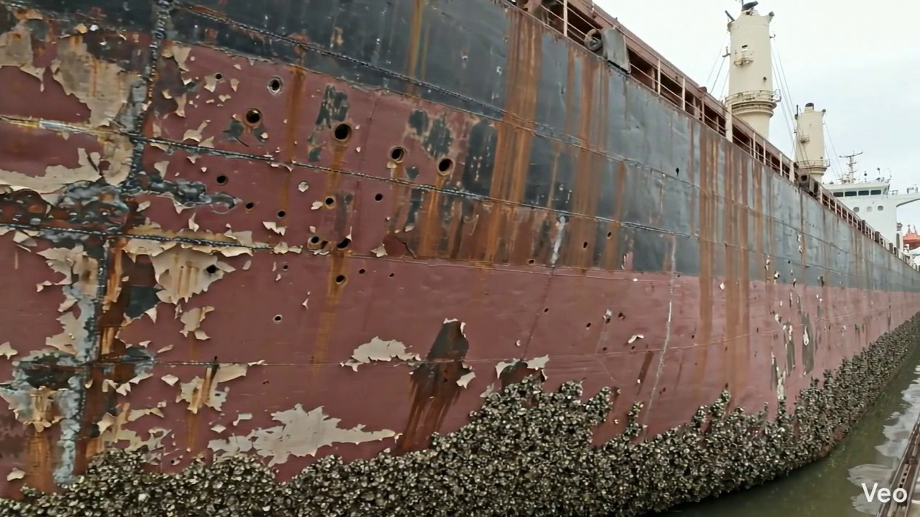

Repair Procedure
## Vessel Inspection Report: Maritime Steel Plate Repair Methodology
This report details the comprehensive repair process for localized deformation in a vessel's hull or deck plating, focusing on restoring structural integrity, watertightness, and original contour.
---
### **1. Repair Process Explanation**
#### **1.1. Assessment**
* **What happens:** The repair process commences with a thorough visual inspection of the deformed area. Technicians mark the precise boundaries of the buckled region and conduct detailed measurements of out-of-flatness using specialized tools. This step also involves determining if the deformation is localized to a single plate or if it extends to adjacent structural members such as frames, girders, or stiffeners.
* **Why necessary:** This initial assessment is critical for defining the exact scope of the repair. It ensures that all compromised material is identified and removed, preventing the propagation of existing damage or the creation of new stress points. Accurate measurement of deformation guides the subsequent cutting and fabrication, ensuring proper fit-up and minimizing potential for residual stress.
#### **1.2. Preparation**
* **What happens:** Following assessment, all identified distorted plate material, along with any buckled or damaged internal girders or stiffeners, is carefully cut away. This cutting extends to "sound metal," meaning structurally unaffected material, leaving a margin of good plate that is typically at least three-quarters of the original plate thickness. Any internal framing that is bent but not completely severed is either straightened or removed, as dictated by its condition and the repair plan.
* **Why necessary:** This step is paramount to eliminating all compromised material, which could otherwise act as stress concentrators or points of failure in the repaired structure. Cutting to sound metal provides a robust base for the new weld, ensuring proper fusion and load transfer. The specified margin ensures that the new weld lands on adequately thick, undamaged material, preventing "burn-through" or insufficient weld strength.
#### **1.3. Plate Replacement**
* **What happens:** A new steel plate, matching or exceeding the original material specifications (grade, thickness), is precisely fabricated to the dimensions and contour of the cutout. This new plate is then carefully positioned against the remaining sound hull plating and secured temporarily using tack welds. Once aligned correctly, full perimeter welding commences.
* **Why necessary:** This step directly restores the physical integrity of the hull or deck. Using a new plate of equivalent or greater strength ensures the repaired section meets design load requirements. Accurate fabrication and fit-up are crucial for minimizing gaps, which facilitates robust welding and reduces the risk of defects. Tack welding maintains alignment, preventing distortion during subsequent welding passes. Full penetration welds are prioritized to ensure maximum joint efficiency and structural continuity.
#### **1.4. Alignment and Welding**
* **What happens:** Continuous weld passes are applied to permanently join the new plate to the existing structure. E7018 electrodes are specified for this process. Throughout welding, diligent monitoring for distortion is maintained. If distortion occurs, technicians employ corrective measures such as strategic clamping, back-stepping techniques, or minimal heat input strategies. Upon completion of welding, all weld seams are meticulously ground fair with the surrounding hull plating to restore the original contour. In cases of extensive initial buckling or anticipated high stress, additional strengthening elements like doubler plates or stiffeners may be incorporated.
* **Why necessary:** This is the core structural integrity phase. E7018 electrodes are low-hydrogen, which is critical for structural steel applications as they significantly reduce the risk of hydrogen-induced cracking, especially important in cold conditions or with thicker sections. Proper preheat (as typically implied for E7018 on structural steel) helps control cooling rates, reducing hardness and residual stresses in the Heat Affected Zone (HAZ). Controlling weld-induced distortion is vital to maintain the vessel's hydrodynamic efficiency, avoid unfairness, and prevent the introduction of new residual stresses. Grinding welds fair contributes to both hydrodynamic performance and reduces stress concentrations at the weld toe. Additional strengthening is a prophylactic measure to enhance the long-term fatigue life and strength of the repair in areas subject to higher localized stresses.
#### **1.5. Finishing**
* **What happens:** The completed repair undergoes rigorous inspection. This includes a thorough visual examination for surface defects (e.g., undercut, porosity, cracks) and non-destructive testing (NDT) methods (such as Magnetic Particle Inspection (MPI) or Ultrasonic Testing (UT)) to verify the internal integrity of the welds. Following successful inspection, the new steel is prepared and coated with appropriate primer and finish coats to reinstate corrosion protection. Finally, the deck or hull surface is faired back to its original contour, ensuring smooth transitions.
* **Why necessary:** The finishing stage ensures the quality and longevity of the repair. Visual and NDT inspections provide objective verification that the welds meet required standards, preventing hidden defects that could compromise structural integrity. Applying a complete coating system is essential to protect the new steel from the harsh marine environment, preventing premature corrosion and ensuring the vessel's service life. Fairing the surface is critical for maintaining the vessel's hydrodynamic performance, preventing unnecessary drag, and ensuring compliance with classification society requirements for hull smoothness.
---
### **2. Required Items Explanation**
* **Cutting Torch (rental):**
* **Why used:** The cutting torch is an essential tool for the "Preparation" phase of the repair process. It provides an efficient and effective method for thermally cutting away the distorted steel plate and any associated internal structural members (girders, stiffeners). For thick steel sections common in vessel construction, thermal cutting (oxy-fuel or plasma) is significantly faster and more practical than mechanical cutting methods.
* **Explanation:** The itemized cost reflects the rental of this specialized equipment. Its use is critical for achieving clean, precise cuts necessary to remove damaged material down to sound metal, creating the opening for the new plate. The "machine-days/sq.m" metric suggests its utilization is proportional to the area of plate removed, making it a direct operational cost for the repair project.
---
### **3. Safety and Structural Considerations**
#### **3.1. Safety Considerations**
* **Hot Work Permits:** All cutting and welding activities constitute hot work and require appropriate permits, fire watches, and designated safety zones to prevent ignition of combustible materials.
* **Personal Protective Equipment (PPE):** Welders and supporting personnel must wear full PPE, including welding helmets, flame-retardant clothing, gloves, safety glasses, and hearing protection.
* **Ventilation:** Adequate ventilation is crucial to remove welding fumes, especially in confined spaces, to protect workers from respiratory hazards.
* **Fire Prevention:** Fire extinguishers, hoses, and trained fire watch personnel must be readily available throughout the hot work operation.
* **Fall Protection:** When working on deck or hull exteriors, appropriate fall protection measures (e.g., scaffolding, safety harnesses, guardrails) must be in place.
* **Confined Space Entry:** If the repair requires entry into tanks or voids, strict confined space entry protocols, including gas testing, ventilation, and stand-by personnel, must be followed.
#### **3.2. Structural Considerations**
* **Material Compatibility:** The replacement plate must be of the same or equivalent steel grade and mechanical properties as the original to ensure structural continuity and uniform load transfer.
* **Weld Quality and Integrity:** All welds must achieve full penetration where specified, with proper fusion, minimal porosity, and freedom from cracks or other defects. NDT is critical for verifying internal weld quality.
* **Load Path Continuity:** The repair must restore the continuity of all primary and secondary structural members to ensure loads are effectively transferred through the repaired section without creating new stress concentrations.
* **Fatigue Resistance:** In areas subject to cyclic loading (e.g., hull plating), the repair design and welding procedures must consider fatigue resistance to prevent premature cracking. Grinding welds fair reduces stress risers that can initiate fatigue cracks.
* **Distortion Control:** Proper welding sequence, clamping, and heat input control are essential to minimize residual stresses and distortion, which can affect the vessel's overall fairing, stability, and structural integrity.
* **Classification Society Approval:** For major structural repairs, design and procedure approvals from the relevant Classification Society are mandatory to ensure compliance with international maritime standards and continued certification.
* **Watertight/Weathertight Integrity:** For hull or deck repairs, the finished repair must guarantee complete watertightness (below the waterline) or weathertightness (above the waterline) to prevent ingress of water.

Repair Cost Breakdown
Item | Quantity | Unit Cost | Total Cost | Currency
Cutting Torch (rental) | 0.08 | 10764.0 | 807.3 | INR
Estimated Repair Cost: 41583.53 INR

3.9 PD_9

Defect Overview
Generation failed.

Visual Evidence
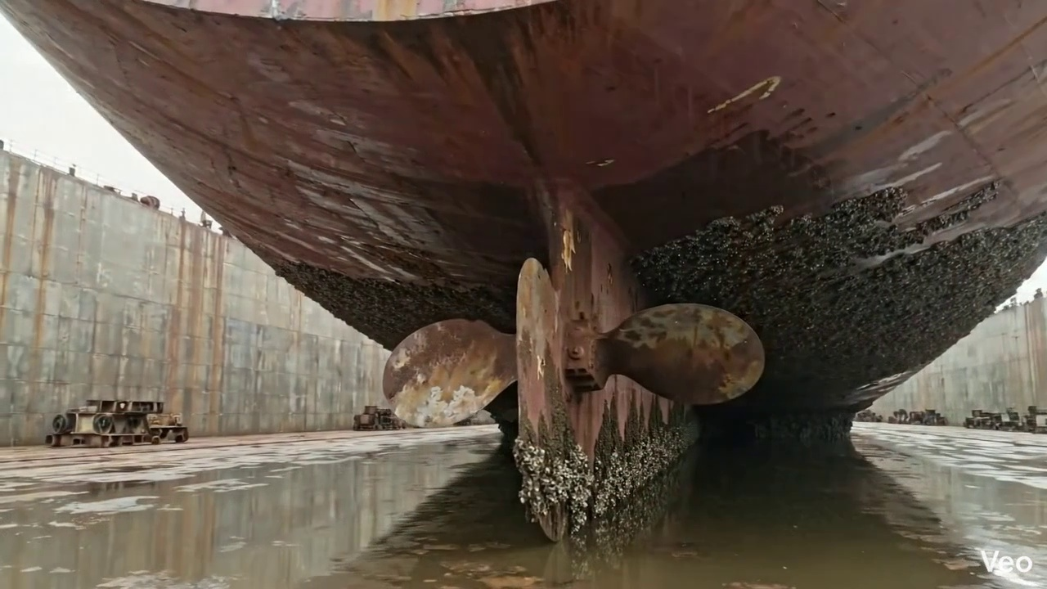

Repair Procedure
Generation failed.

Repair Cost Breakdown
Item | Quantity | Unit Cost | Total Cost | Currency
Cutting Torch (rental) | 0.05 | 10764.0 | 538.2 | INR
Estimated Repair Cost: 27722.35 INR

3.10 PD_10

Defect Overview
Generation failed.

Visual Evidence
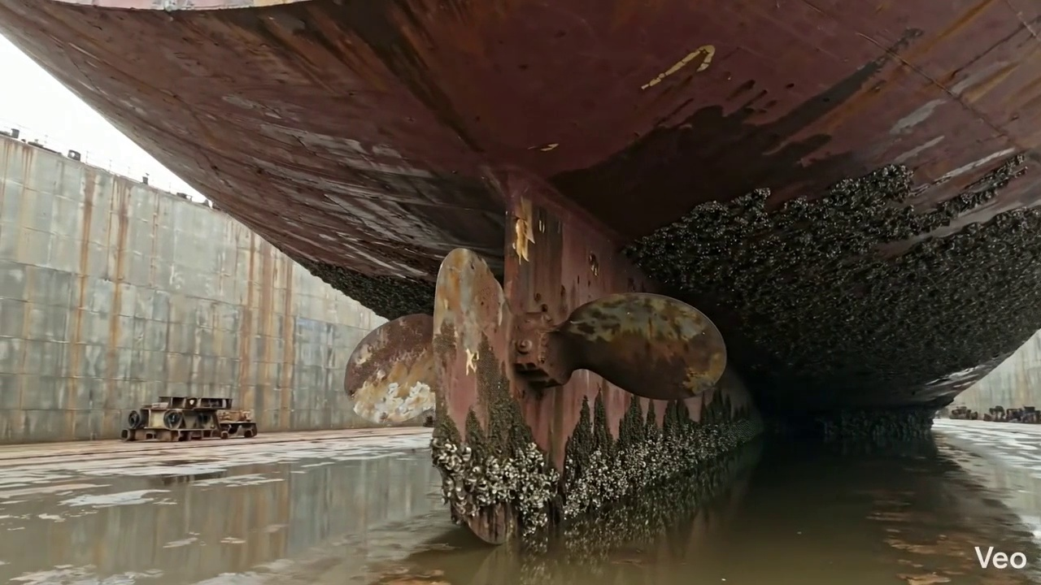

Repair Procedure
Generation failed.

Repair Cost Breakdown
Item | Quantity | Unit Cost | Total Cost | Currency
Cutting Torch (rental) | 0.05 | 10764.0 | 538.2 | INR
Estimated Repair Cost: 27722.35 INR

