Vessel Inspection Report

Table of Contents
1. Executive Summary
2. Vessel Repair Summary
3. Defect Analysis
3.1 PD_1

1. Executive Summary
**Executive Summary: Maritime Vessel Inspection**
A recent comprehensive inspection of the maritime vessel was concluded, identifying a singular critical defect.
**Key Findings:**
* **Total Defects Identified:** 1
* **Severity Distribution:** The sole defect identified is categorized as **high severity**.
* **Estimated Rectification Cost:** The projected cost for the necessary repairs to address this critical non-conformity is **INR 69,305.88**.
**Assessment:**
The presence of a single, high-severity defect warrants immediate attention. While the overall number of deficiencies is low, the critical nature of this particular finding indicates a significant potential impact on operational integrity, safety standards, or regulatory compliance.
**Recommendation:**
Prompt and decisive action is imperative for the immediate rectification of this high-severity defect. This is crucial to ensure the vessel's continued seaworthiness, safeguard personnel, maintain operational efficiency, and uphold all applicable maritime regulations. Further details regarding the specific defect and recommended corrective actions are outlined in the full inspection report.

2. Vessel Repair Summary
Metric | Value
Total Defects | 1
Total Estimated Cost | 69305.88 INR
Material Cost | 41583.53 INR
Labor Cost | 20791.76 INR
Equipment Cost | 6930.59 INR

3. Defect Analysis

3.1 PD_1

Defect Overview
**Defect Name:** DEFORMATION
**Severity:** HIGH
---
### Professional Explanation of Defect: DEFORMATION
The identified defect, classified as **Deformation**, is assessed with a **High severity** rating. This condition significantly impacts the structural integrity of the vessel and requires urgent attention. The significant overlap with the HULL_AREA (approximately 28%) indicates a widespread or substantial area of structural alteration.
**1. What the defect means:**
Deformation refers to an undesirable change in the original form or shape of the vessel's structural components, specifically characterized by out-of-plane bending, buckling, or warping of hull plating and/or stiffeners. This means that the flat surfaces of the hull or the supporting structural members are no longer planar but are distorted inwards or outwards. This condition typically arises from external forces such as grounding impacts, heavy sea loads exceeding design parameters, or internal stresses like thermal distortion induced by welding operations.
**2. Why it is important:**
This defect is critically important due to its direct adverse impact on the vessel's primary structural integrity. Even seemingly moderate buckles or warping can significantly compromise the designed strength characteristics of the hull girder. The presence of deformation indicates that the material has yielded or permanently deflected, meaning it has lost its original load-bearing capacity and stiffness in the affected area. Classification societies and maritime regulations mandate corrective action for significant deformation due to these inherent weaknesses.
**3. Risks if not repaired:**
Failure to promptly repair significant deformation carries substantial risks to the vessel's safety, operational viability, and seaworthiness:
* **Compromised Watertight Integrity:** Buckled or warped plating is highly susceptible to fatigue cracking, especially at the edges of the deformed area or where stiffeners meet the plating. Such cracks can breach the hull, leading to water ingress into compartments, potential flooding, and loss of buoyancy or stability.
* **Progressive Structural Failure:** Localized weakening due to deformation can lead to increased stress concentrations in adjacent sound material. Under dynamic operational loads (e.g., waves, cargo shifts), these stress risers can propagate, causing more extensive damage, further buckling, or even catastrophic hull failure, particularly in severe weather conditions.
* **Reduced Vessel Seaworthiness:** The vessel's ability to safely withstand expected operational loads and sea states will be severely diminished, increasing the risk of structural failure and loss of the vessel.
* **Classification and Regulatory Non-Compliance:** Unrepaired significant deformation will invariably result in a lack of class compliance, leading to potential detentions by port state control, operational restrictions, and invalidation of insurance coverage.
**4. Structural implications:**
Structurally, deformation directly impairs the primary strength of the vessel, specifically the hull girder. The hull girder functions as a large beam designed to resist global bending moments (hogging and sagging) and shear forces experienced during operation. Out-of-plane deformation reduces the effective section modulus and moment of inertia of the affected members (plating and stiffeners). This has several critical implications:
* **Reduced Bending and Shear Strength:** The hull's overall ability to resist the primary global stresses it encounters at sea is diminished, making it more vulnerable to structural failure under design loads.
* **Increased Stress Concentrations:** The altered geometry due to buckling redistributes stress unevenly, concentrating forces in specific areas. These "hot spots" are prime locations for crack initiation and propagation.
* **Loss of Stiffness and Stability:** The overall rigidity of the hull is reduced. This can lead to excessive vibrations, dynamic responses that deviate from design parameters, and potentially exacerbate other structural issues.
* **Reduced Residual Strength:** The vessel's inherent capacity to absorb further impact or stress without immediate catastrophic failure is significantly lowered, creating a dangerous 'point of no return' if further stresses are applied.
---

Visual Evidence
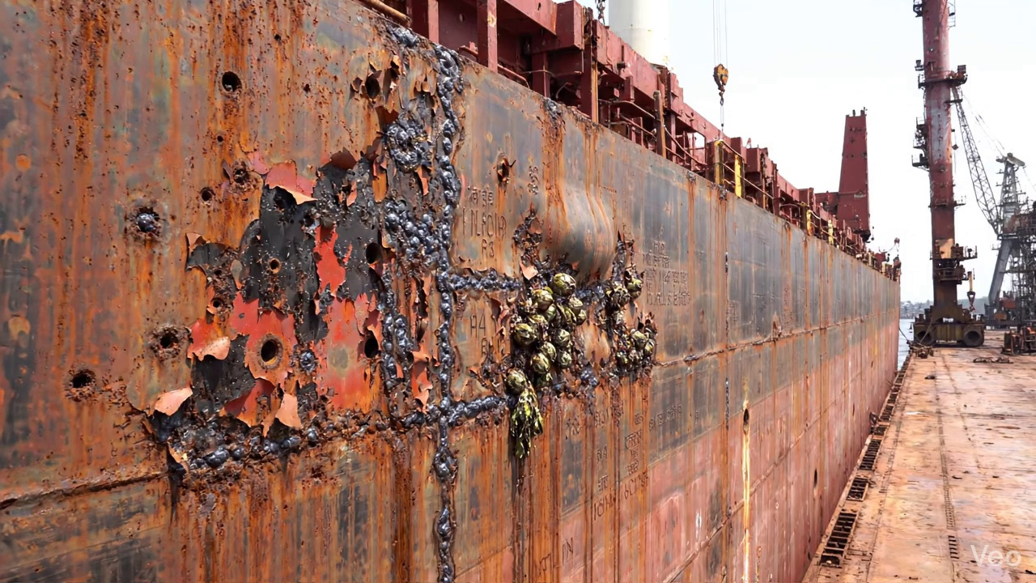

Repair Procedure
Generation failed.

Repair Cost Breakdown
Item | Quantity | Unit Cost | Total Cost | Currency
Cutting Torch (rental) | 0.12 | 10764.0 | 1345.5 | INR
Estimated Repair Cost: 69305.88 INR

