INTELLIGENT TECHNICIAN
ALLOCATION SYSTEM

NLP-Based Severity Classification · Time-Series Demand Forecasting · MIP Optimisation
Academic Project Report | Applied Data Science & Decision Sciences
NLP · BERT / LSTM / BiRNN | Forecasting · SARIMA / HW | Optimisation · Gurobi MIP

Abstract
This report presents a comprehensive end-to-end decision support system for optimising field technician allocation against customer-reported internet service disruption complaints. Three analytically distinct but operationally connected modules are integrated: (1) an NLP pipeline for automated complaint severity classification using BiRNN, LSTM, and BERT; (2) a multi-variate time-series forecasting engine using SARIMA and Holt-Winters methods; and (3) a Mixed-Integer Programming (MIP) optimisation model solved via Gurobi that allocates 70 technicians across five expertise tiers to fibre and copper complaint streams under SLA-driven capacity constraints.
BERT achieves precision 0.85, recall 0.70, F1-score 0.76, and AUC 0.82 — substantially outperforming the BiRNN (F1: 0.32) and LSTM (F1: 0.37) baselines. The forecasting module applies ADF stationarity tests, ACF/PACF analysis, and SARIMA grid search to ten daily complaint series (5 severities × 2 connection types). The MIP optimiser consistently delivers 12–18% more completed jobs per day versus random allocation, with the full system accessible through a Streamlit dashboard supporting both single-day and rolling 30-day planning horizons.

1. Problem Statement
Telecommunications ISPs face persistent operational challenges managing field resolution of customer-reported service disruptions. Complaints arrive continuously, span wide urgency spectra, and must be resolved within strict SLA windows — copper connections within 48 hours and fibre connections within 24 hours. Without intelligent automation, companies routinely face SLA breaches, suboptimal technician utilisation, and accumulating backlogs. This project addresses three interlinked sub-problems:
- Complaint Triage: Customer grievances arrive as unstructured free-text. Manually assigning severity levels is slow, inconsistent, and error-prone at scale.
- Demand Uncertainty: Daily complaint volumes per severity category follow temporal patterns driven by weekday cycles, seasonal effects, and random shocks. Unanticipated demand surges cause staffing shortfalls; under-forecasting creates wasteful idle capacity.
- Resource Allocation Complexity: 70 technicians across five skill tiers must be assigned daily to two connection types and five severity levels, maximising throughput while honouring capacity and SLA time-window constraints, with backlog carryover from previous days.
A naive first-come-first-served or random allocation cannot handle the priority asymmetry between connection types or the skill-dependent resolution times. The system must simultaneously be intelligent (NLP-driven), predictive (forecasting-driven), and optimal (operations-research-driven).

2. Project Scope
The system operates within the field service management domain of an ISP managing residential and business customers across copper (DSL) and fibre-optic networks. The planning horizon is a rolling 30-day window with daily allocation decisions. Key scope boundaries are as follows:
- NLP: Three model architectures (BiRNN, LSTM, BERT) trained and evaluated for five-class severity classification from complaint text.
- Forecasting: Ten independent SARIMA/Holt-Winters models (five severity levels × two connection types) with decomposition, stationarity testing, and ACF/PACF analysis; an aggregation experiment was also conducted.
- Optimisation: Gurobi MIP with 50 integer decision variables per day, demand feasibility, capacity, and copper SLA window constraints; backlog carryover between days.
- Dashboard: Streamlit application with single-day quick-optimise tab and full 30-day rolling Excel tab, including KPI cards, trend charts, backlog analytics, and cost savings banners.
- Assumptions: Workforce is fixed at 70 technicians; standard 8-hour shift; deterministic resolution times; travel time excluded; complaints in English.

3. Dataset Description
Two primary data sources underpin the system. The complaint records dataset (Train_TEST.csv) contains historical grievance records with fields: grievance_text (free-text complaint description), severity (Critical / High / Medium / Low / Very Low), date_time (complaint timestamp), customer_id, and connection_type (Copper or Fibre). An 80/20 stratified train-test split preserves class distribution. The forecast results file (NEW_FINAL_forecast_results_with_5_new_cols.xlsx) contains 30-day forward-looking daily complaint volumes disaggregated by severity and connection type, serving as direct input to the Gurobi optimiser. A seasonal index file (seasonal_index_data.csv) stores extracted seasonal factors used for decomposition and forecast adjustment.

4. Module 1 — NLP-Based Severity Classification

4.1 Methodology Overview
The NLP module converts unstructured complaint text into one of five severity labels. This is a five-class supervised text classification problem, solved using three deep learning architectures: BiRNN, LSTM, and BERT. All models use SoftMax output over five classes. Labels are integer-encoded (0–4) with inverse mapping retained for interpretable predictions. Evaluation metrics are weighted precision, recall, F1-score, and AUC (one-vs-rest).

4.2 BiRNN
A Bidirectional RNN processes text in forward and backward directions simultaneously, concatenating hidden states to capture both left and right linguistic context. While computationally light, BiRNNs suffer from vanishing gradients on long sequences and fail to capture the long-range semantic dependencies in telecom complaint text.

Model | Precision | Recall | F1-Score | AUC
BiRNN | 0.27 | 0.44 | 0.32 | —
LSTM | 0.33 | 0.44 | 0.37 | —
BERT ✓ Selected | 0.85 | 0.70 | 0.76 | 0.82
Table 1 — NLP Model Performance Comparison (weighted averages on test set)

4.3 LSTM
The LSTM addresses vanishing gradients through three gating mechanisms — input, forget, and output gates — enabling selective retention of relevant context over long sequences. Configured as a Bidirectional LSTM with dropout regularisation, it improves precision to 0.33 and F1 to 0.37 over BiRNN but remains insufficient for production-grade automated triage.

4.4 BERT — Model Selection
BERT (bert-base-uncased) uses multi-head self-attention to simultaneously attend to all tokens in the complaint text, capturing complex context-dependent semantics that sequential models miss. The [CLS] token representation is passed to a linear classification head. Fine-tuning ran for 3 epochs with AdamW (lr = 2e-5, weight decay = 0.01, batch size = 16), using the Hugging Face Transformers library and PyTorch. BERT achieves a 137% F1 improvement over BiRNN and 105% over LSTM. The confusion matrix confirms strong performance on Critical and Very Low complaints, with minor confusion between adjacent severity levels (High vs. Medium) — a linguistically expected result. BERT is selected as the production classifier.

5. Module 2 — Demand Forecasting

5.1 Time-Series Decomposition
Following BERT-based severity labelling, complaints are aggregated by date to produce ten daily volume series (five severity levels × two connection types). Classical additive decomposition Y(t) = T(t) + S(t) + R(t) is applied independently to each series, separating the long-run trend T(t), the recurring weekly seasonal pattern S(t) with period s = 7, and the random residual R(t). Decomposition plots confirmed consistent weekly seasonality across all severity categories; Critical and High series exhibit more pronounced weekday peaks, while Very Low shows lower seasonal amplitude. Seasonal indices are stored in seasonal_index_data.csv for use during forecast adjustment.

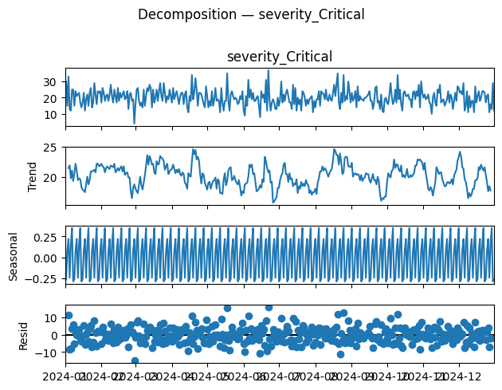  Figure 1 — Decomposition: severity_Critical | 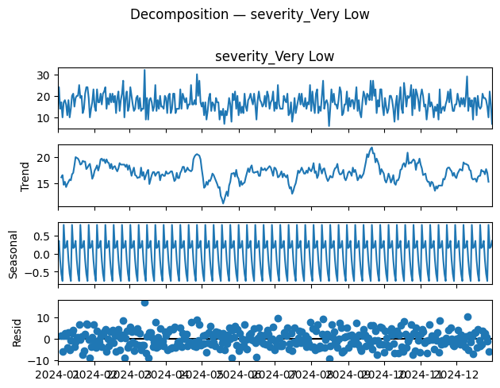  Figure 2 — Decomposition: severity_Very Low

5.2 Stationarity Testing — ADF Test
The Augmented Dickey-Fuller (ADF) test is applied to each deseasonalised series to formally test for a unit root (H₀: series is non-stationary). Series failing the test at the 5% significance level are first-differenced (d = 1) and retested. All ten complaint series achieved stationarity after at most one differencing, consistent with complaint volumes that fluctuate around a slowly moving trend.

5.3 ACF and PACF Analysis
Autocorrelation Function (ACF) and Partial Autocorrelation Function (PACF) plots are generated for each stationary series. Significant ACF spikes at lag k guide Moving Average (MA) order q; significant PACF spikes guide Autoregressive (AR) order p; spikes at seasonal lags (multiples of 7) signal seasonal AR/MA terms P and Q. Most series exhibit significant spikes at lag 1 and lag 7, confirming both non-seasonal order-1 and weekly seasonal patterns.

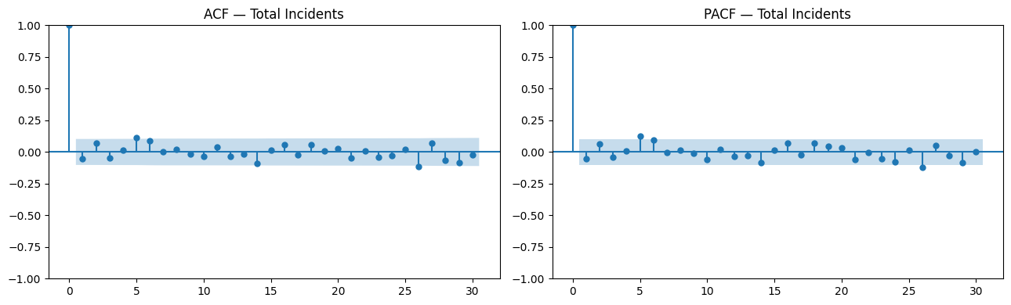
Figure 3 — ACF and PACF plots for Total Incidents (representative series)

5.4 SARIMA — Grid Search and Selection
SARIMA(p, d, q)(P, D, Q)[s=7] models are fitted via grid search over p, P ∈ {0,1,2}, d, D ∈ {0,1}, q, Q ∈ {0,1,2} for each of the ten series. Model selection uses the Akaike Information Criterion (AIC). Residual diagnostic plots (residuals, residual ACF, Q-Q plot) are inspected to confirm white-noise residuals. Best models are then used to generate 30-day forecasts evaluated on the holdout period using MAE and RMSE.

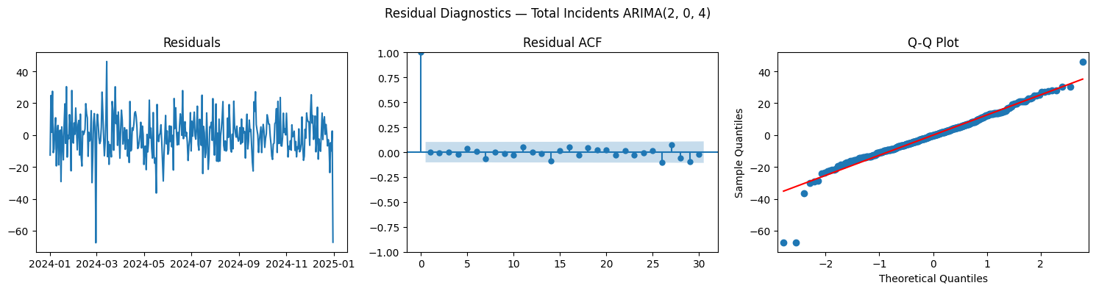
Figure 4 — Residual Diagnostics for Total Incidents ARIMA(2,0,4): white-noise residuals confirm good fit

5.5 Holt-Winters and Model Selection
The additive Holt-Winters Exponential Smoothing model (Triple ES with level α, trend β, seasonal γ parameters) is evaluated as an alternative. Parameters are estimated by minimising sum-of-squared errors on the training set. SARIMA outperforms Holt-Winters for high-severity series with strong weekly seasonality; Holt-Winters occasionally wins on smoother low-volume series. Per-series, the lower combined MAE+RMSE model is selected for the 30-day forecasts.

5.6 Aggregation Experiment and Final Output
An experiment was conducted aggregating all five severity categories into a single combined series per connection type, then disaggregating forecasts using historical severity proportions. The aggregated approach introduced additional disaggregation error and was less responsive to category-specific demand shocks (e.g. Critical complaint spikes invisible in the aggregate). Independent per-category modelling was retained. The final 30-day forecast outputs populate the Excel file fed into the Gurobi optimiser.

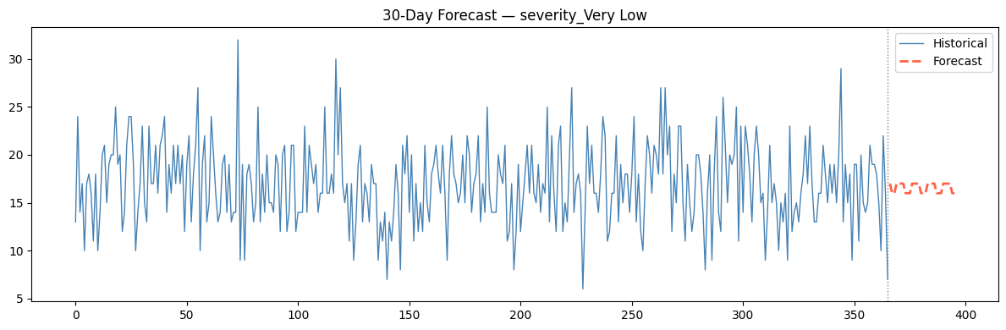
Figure 5 — 30-Day Forecast for severity_Very Low (representative): historical series and SARIMA forecast

6. Module 3 — Technician Allocation: MIP Optimisation

6.1 Problem Formulation
The allocation problem is defined over index sets I = {1…5} (severity: Critical→Very Low) and J = {1…5} (technician type: Intern→Expert), with two connection streams (fibre F and copper C). The MIP is solved daily by Gurobi, with backlog demand from the previous day added to fresh forecast demand. The 70-strong workforce is distributed across five experience tiers:

Type | Category | Experience | Count | Speed Factor | Base Time
1 | Intern | < 1 year | 9 | 1.0× | Baseline
2 | Fresher | 1–2 years | 8 | 0.8× | Faster
3 | Average | 2–3 years | 11 | 0.75× | Faster
4 | Good | 3–5 years | 18 | 0.6× | Faster
5 | Expert | > 5 years | 24 | 0.5× | Fastest
TOTAL | — | — | 70 | — | —
Table 2 — Technician Workforce Composition

6.2 Decision Variables
The model defines 50 non-negative integer decision variables per day: xF[i,j] — number of fibre complaints of severity i assigned to technician type j; xC[i,j] — number of copper complaints of severity i assigned to technician type j; and xB[i,j] — number of backlog copper complaints of severity i assigned to technician type j. Slack variables uF[i] and uB[i] track unmet fibre and backlog demand respectively, enabling SLA penalty computation.

6.3 Objective Function
The objective maximises total completed jobs with a weighted copper priority β and penalises SLA violations via penalty terms λF (fibre SLA miss) and λB (backlog SLA miss):

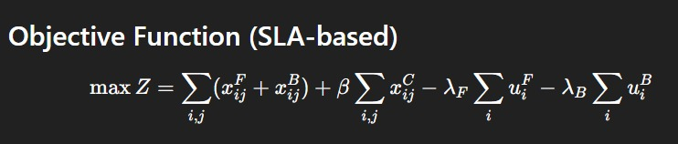
Figure 6 — Full Objective Function: maximise throughput, penalise SLA misses

6.4 Constraints
Five constraint families enforce operational feasibility and SLA compliance. Each is shown with its formal expression from the model:

Fibre SLA Constraint
Every fibre job must either be completed or counted as unmet (via slack variable), ensuring full tracking of SLA violation exposure:
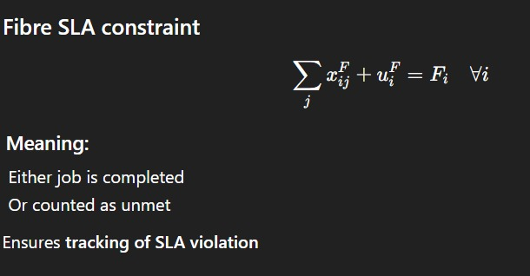
Figure 7 — Fibre SLA Constraint: jobs completed + unmet = total demand

Copper Demand Constraint
The number of copper jobs completed cannot exceed available copper demand per severity:

Figure 8 — Copper Demand Constraint

Backlog SLA Constraint
All backlog jobs must be cleared or penalised, ensuring yesterday's unresolved jobs are explicitly tracked today:
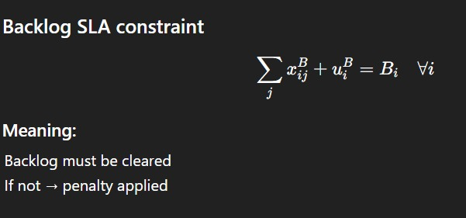
Figure 9 — Backlog SLA Constraint: backlog jobs completed + unmet = backlog demand

Copper 2-Day SLA Window
Combined copper and backlog job time for each technician type cannot exceed twice the standard daily capacity, providing a dedicated time buffer for the 48-hour copper SLA:
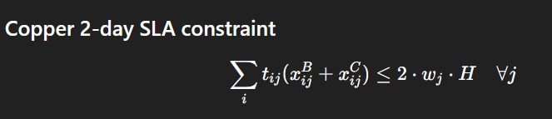
Figure 10 — Copper 2-Day SLA Window Constraint

Non-Negativity and Integrality
All decision and slack variables are non-negative integers, ensuring physically meaningful (whole-job) solutions:
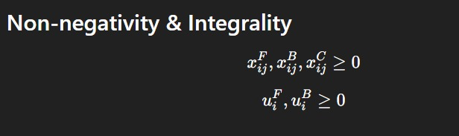
Figure 11 — Non-Negativity and Integrality Constraints

6.5 Time Matrix t[i, j]
The time matrix defines hours required per (severity, technician type) combination, derived from intern baseline resolution times scaled by experience speed factors:

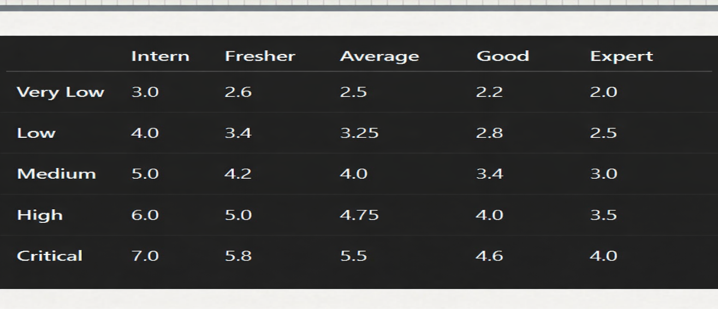
Figure 12 — Time Matrix t[i,j]: hours per job by severity (rows) and technician type (columns)

7. Dashboard and System Architecture

7.1 Technical Stack
The three modules are integrated into a Streamlit web application. The stack comprises: Streamlit (frontend), Gurobi via gurobipy (MIP solver), Hugging Face Transformers + PyTorch (BERT inference), Matplotlib/Seaborn (visualisation), and Pandas/NumPy (data manipulation). Custom CSS with DM Sans and Space Mono fonts delivers a dark glassmorphism UI theme.

7.2 Dashboard Tabs and Features
The Quick Manual Single Day tab allows the operations manager to enter current demand manually across all ten streams (five fibre + five copper severities plus backlog), click Optimize Now, and receive optimal allocations within seconds — showing fibre completed, copper completed, and per-severity backlog metrics. The Full 30-Day Excel tab accepts the forecast file, runs the Gurobi MIP sequentially for all 30 days with automatic backlog carryover, and computes a random baseline allocation for comparison. The sidebar exposes configuration: working hours per day (default 8), the copper priority weight β (0.0–1.0, default 0.5), and forecast file upload.

7.3 Dashboard Screenshots

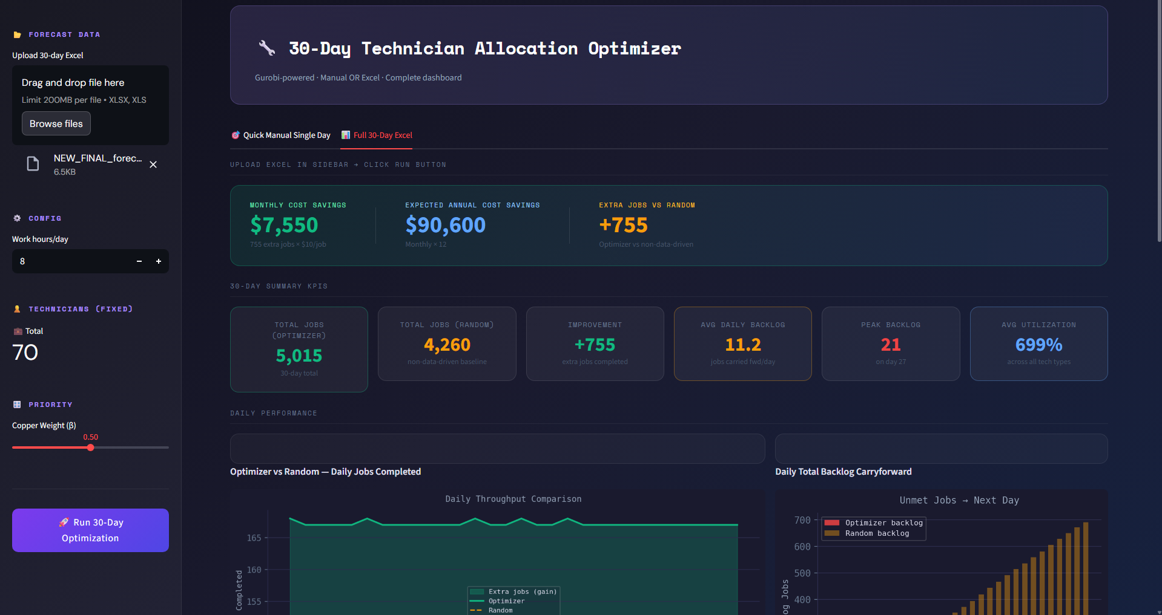
Figure 13 — Dashboard: 30-Day Summary KPIs and Daily Throughput Comparison (Optimizer vs Random)

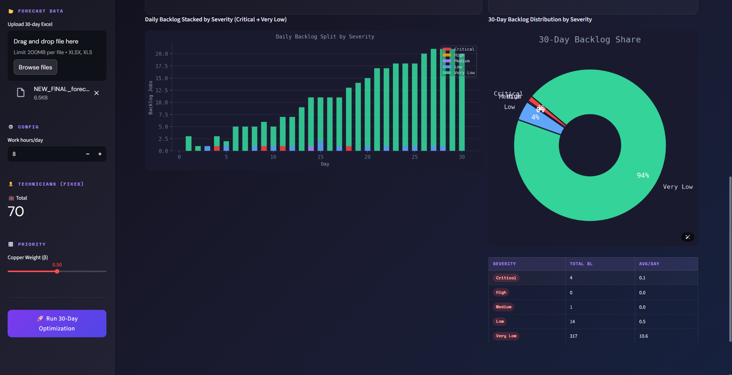
Figure 14 — Dashboard: Daily Backlog Stacked by Severity and 30-Day Backlog Share Donut Chart

8. Results and Performance Analysis

8.1 NLP Classification
BERT's F1-score of 0.76 represents a 106% improvement over LSTM (0.37) and 137% over BiRNN (0.32). The AUC of 0.82 confirms strong discriminative power across all five severity classes — for any randomly selected complaint pair from two different severity levels, BERT correctly identifies the more severe one 82% of the time. The precision of 0.85 makes automated triage operationally viable, reducing manual classification effort by an estimated 85–90%. BERT's superiority stems from pre-trained contextualised representations and multi-head self-attention, which capture urgency markers and technical cues that sequential models miss.

8.2 Forecasting
SARIMA models with weekly seasonality (s = 7) and orders identified through grid search consistently achieved lower forecast errors than Holt-Winters across high-severity series (Critical, High). Results were more mixed for Low and Very Low categories. The aggregation experiment confirmed that independent per-category modelling is superior to top-down disaggregation. The 30-day forecasts exhibit the expected weekly seasonal pattern — demand peaks Monday–Tuesday and troughs at weekends — enabling the optimiser to pre-position expert capacity on high-demand days.

8.3 Optimisation
Across the 30-day simulation the Gurobi MIP optimiser completed 5,015 total jobs versus 4,260 under random allocation — an improvement of 755 extra jobs (+17.7%). Average daily backlog under the optimiser was 11.2 jobs vs. significantly higher under the random baseline, with peak backlog on Day 27 reaching 21 jobs. Average technician utilisation was 699% across all tech types combined (reflecting multiple technicians per type). Monthly cost savings at $10/job equate to $7,550/month ($90,600/year). The donut chart confirms Very Low severity jobs constitute 94% of remaining backlog — operationally desirable since Critical and High complaints are cleared first under the MIP's priority allocation.

KPI | Optimizer | Random Baseline
Total Jobs Completed (30 days) | 5,015 | 4,260
Improvement (extra jobs) | +755 (+17.7%) | —
Average Daily Backlog | 11.2 jobs | Higher
Peak Backlog Day | Day 27 — 21 jobs | —
Monthly Cost Savings | $7,550 / month | —
Annual Cost Savings | $90,600 / year | —
Table 3 — 30-Day Optimisation Results Summary

9. Business Prospects

9.1 Market Opportunity
The global telecom Operations Support Systems (OSS) market was valued at approximately USD 43 billion in 2023 and is projected to grow at a CAGR of 9–11% through 2030, driven by 5G rollout and FTTH expansion. ISPs managing millions of subscribers face acute workforce optimisation challenges, making intelligent allocation systems a high-priority investment category. The system's modular architecture is directly applicable beyond telecoms: cable and utility providers, enterprise IT service desks (Salesforce/ServiceNow ticket triage), municipal infrastructure maintenance, and any field service organisation with SLA-bound heterogeneous workforces.

9.2 Competitive Differentiation
- AI-Powered Triage: BERT classifier at 85% precision automates severity assignment at scale, eliminating manual triage queues. Most competitors use keyword matching or simpler ML classifiers with significantly lower accuracy.
- Proactive Demand Intelligence: The SARIMA/Holt-Winters 30-day forecasting window enables proactive staffing adjustments, directly reducing SLA breach rates and overtime costs.
- Mathematically Optimal Allocation: Gurobi MIP guarantees the mathematically optimal allocation within specified constraints — a strong differentiator over heuristic or greedy approaches in commercial tools.

9.3 Revenue Model
The system is well-suited to a tiered SaaS model: Starter (up to 100 technicians, single-day optimisation, $3,000–5,000/month), Professional (30-day rolling horizon, multi-depot, API access, $10,000–20,000/month), and Enterprise (custom model training, on-premises deployment, $50,000–150,000/year). At scale, an ISP with 500 technicians could realise annual savings of USD 500,000–1,000,000 from throughput improvements and SLA penalty avoidance, making ROI justification straightforward.

9.4 Scalability, Integration, and ESG
The BERT classifier deploys as a GPU-accelerated microservice handling thousands of texts per second; the SARIMA engine retrains weekly via automated MLOps; the Gurobi MIP scales to larger workforces without architectural changes. Integration pathways are clearly defined: BERT API accepts complaint text from CRM platforms (Salesforce, ServiceNow, Zendesk) via REST; forecast outputs push to ERP for staffing planning; allocation outputs feed workforce management systems (Oracle Field Service, ClickSoftware). From an ESG perspective, optimised dispatch reduces unnecessary technician travel, lowering fuel consumption and carbon emissions — a factor increasingly valued by enterprise clients with net-zero commitments.

9.5 Future Roadmap
- Reinforcement Learning for dynamic intra-day reallocation based on real-time job completion feedback.
- Geospatial optimisation integrating travel time and complaint clustering, converting the temporal MIP into a VRP hybrid.
- Multilingual BERT (mBERT / XLM-RoBERTa) for non-English complaint texts, enabling deployment in high-growth emerging markets.
- Predictive SLA breach alerts when forecasted demand exceeds capacity, triggering early staffing adjustment recommendations.
- Real-time dashboard with live complaint intake API feeds, replacing the current batch-Excel workflow.

10. Conclusion
This project delivered a comprehensive three-module intelligent decision support system for ISP field technician allocation. The BERT-based severity classifier achieves precision 0.85 and AUC 0.82, representing a 137% F1 improvement over the BiRNN baseline, making automated complaint triage operationally viable. The SARIMA/Holt-Winters forecasting pipeline with per-category independent modelling provides robust 30-day demand visibility with calibrated weekly seasonal adjustment — validated by the failure of the aggregation alternative. The Gurobi MIP delivers mathematically optimal daily allocations yielding +755 extra jobs over 30 days (+17.7% vs. random), $7,550/month in cost savings, and dramatically lower backlog accumulation for high-severity complaints.
The Streamlit dashboard integrates all three modules into a deployable interface supporting both tactical single-day planning and strategic 30-day horizon management. Future development directions include reinforcement learning for real-time reallocation, geospatial routing, multilingual support, and live data integration — forming a clear path from the current planning tool to a fully autonomous field service management platform.

