

DATA SCIENCE LABORATORY
PROJECT REPORT
NLP BASED COMPLAINT CLASSIFICATION AND TECHNICIAN ASSIGNMENT PROBLEM

An Integrated Framework for BERT-Based Severity Classification,
Time-Series Demand Forecasting and Priority Aware Assignment Problem
FACULTY ADVISOR: Swaminathan Rammohan

Submitted by:
GUNDA SAHIT- 25BM6JP11
KARTHIK ASHTEKAR- 25BM6JP22
MV KARTHIKEYA- 25BM6JP27
NUTHI SAI CHANDRA- 25BM6JP32
VINAY DAIDA- 25BM6JP59
Abstract

This report presents a comprehensive, end-to-end decision support system designed to optimise the allocation of field technicians to customer-reported internet service disruption complaints. The system integrates three analytically distinct but operationally connected modules: (1) a Natural Language Processing (NLP) pipeline for automated complaint severity classification, (2) a multi-variate time-series forecasting engine to predict daily complaint volumes, and (3) a Priority Aware Assignment Problem optimisation model to allocate technicians efficiently across severity categories and connection types.

The NLP module evaluated three architectures — Bidirectional Recurrent Neural Networks (BiRNN), Long Short-Term Memory networks (LSTM), and the BERT transformer model — ultimately selecting BERT, which achieved a precision of 0.85, recall of 0.70, F1-score of 0.76, and AUC of 0.82. The forecasting module employed SARIMA and Holt-Winters Exponential Smoothing models on decomposed daily complaint time series across five severity categories, preceded by ADF stationarity tests and ACF/PACF analysis. The optimisation module formulated a Gurobi-powered MIP to assign 70 technicians, categorised across five expertise levels, to both fibre and copper complaint types while maximising daily job throughput under capacity and time-window constraints. The entire system is presented through an interactive Streamlit dashboard, enabling both manual single-day allocation and automated 30-day rolling horizon planning. Results demonstrate significant throughput improvements over naive random allocation, with measurable monthly cost savings.

Table of Contents
1. Problem Statement
2. Project Scope
3. Dataset Description
4. Module 1: NLP-Based Severity Classification
4.1 Methodology Overview
4.2 Bidirectional RNN (BiRNN)
4.3 Long Short-Term Memory (LSTM)
4.4 BERT Transformer Model
4.5 Model Comparison and Selection
5. Module 2: Demand Forecasting
5.1 Time-Series Decomposition
5.2 Stationarity Testing — ADF Test
5.3 ACF and PACF Analysis
5.4 SARIMA Model — Grid Search and Selection
5.5 Holt-Winters Exponential Smoothing
5.6 Model Comparison and Aggregation Experiment
6. Module 3:Priority Aware Assignment Problem
6.1 Problem Formulation
6.2 Decision Variables
6.3 Objective Function
6.4 Constraints
6.5 Time Matrix
7. Dashboard and System Architecture
8. Results and Performance Analysis
9. Business Prospects
10. Conclusion
11. References

1. Problem Statement

The telecommunications sector, particularly internet service providers (ISPs), faces persistent operational challenges in managing the resolution of customer-reported service disruptions. These complaints arrive continuously, span a wide spectrum of urgency, and must be resolved within soft service level agreement (SLA) windows. Without an intelligent, automated system to triage, forecast, and allocate resources, companies routinely face SLA breaches, suboptimal technician utilisation, accumulating backlogs, and customer dissatisfaction.

The core challenge addressed in this project is threefold:
- Complaint Triage: Customer complaints arrive as unstructured free-text grievances. Manually assigning severity levels (Critical, High, Medium, Low, Very Low) to each complaint is time-consuming, inconsistent, and prone to human error.
- Demand Uncertainty: The volume of complaints in each severity category is not constant but follows temporal patterns influenced by weekday cycles, seasonal effects, and random shocks. Failure to anticipate demand surges leads to technician shortages on peak days and wasteful idle time on low-demand days.
- Resource Allocation Complexity: A heterogeneous workforce of 70 technicians with five distinct skill levels must be assigned daily to complaints of two connection types (fibre and copper) across five severity levels. The allocation must maximise throughput, respect SLA-driven time windows, and manage carryover backlogs from previous days.

SLA requirements mandate that copper connection complaints must be resolved within 48 hours and fibre connection complaints within 24 hours. This asymmetry introduces a priority dimension that a naive first-come-first-served or random allocation strategy cannot handle effectively. The result is a system that must simultaneously be intelligent (NLP-driven), predictive (forecasting-driven), and optimal (operations-research-driven).

2. Project Scope
This project covers the design, development, and validation of an integrated three-module decision support system for a telecommunications ISP. The scope is defined across the following dimensions:
2.1 Operational Context
The project operates within the field service management domain of an ISP. Complaints are generated by residential and business customers experiencing internet connectivity issues across two infrastructure types: copper wire (DSL-based) and fibre-optic networks. The operational planning horizon is a rolling 30-day window, with daily allocation decisions made at the start of each working day.

2.2 In-Scope Components
- Development and evaluation of three NLP model architectures (BiRNN, LSTM, BERT) for complaint severity classification from unstructured text.
- Time-series analysis and forecasting of daily complaint volumes for each of five severity categories, separately for fibre and copper complaint streams.
- Formulation and Gurobi-based solution of a Mixed-Integer Programming model for daily technician-to-job assignment.
- Design and implementation of a Streamlit-based dashboard for interactive optimisation and visual analytics.
- Backlog carryover logic: unresolved complaints from each day accumulate and are carried into the next day's demand with higher priority.

2.3 Assumptions and Boundaries
- The workforce is fixed at 70 technicians across five categories (Intern: 9, Fresher: 8, Average: 11, Good: 18, Expert: 24). No hiring, firing, or temporary contracting is modelled.
- Technicians work a fixed 8-hour shift per day (configurable in the dashboard between 1 and 24 hours).
- Job resolution times are deterministic per (severity, technician type) combination; variability and sick leaves are not modelled.
- Travel time between job sites is excluded from the model; only resolution time is considered.
- Complaint text is pre-cleaned and in English; multilingual or heavily noisy inputs are excluded.
- The copper connection SLA constraint is modelled as a preferential time-window doubling, not as a hard rejection of unfinished tasks.

3. Dataset Description
The dataset forms the foundational input to all three modules of the system. It comprises two primary data sources: a complaint records dataset with accompanying text and metadata, and a pre-computed seasonal index file for time-series adjustment.
3.1 Complaint Records (Train_TEST.csv)
The primary dataset contains historical customer grievance records. Each record contains the following key attributes:
Field Name | Data Type | Description
grievance_text | Text (String) | Free-text description of the customer's internet issue
severity | Categorical | One of: Critical, High, Medium, Low, Very Low
date_time | Datetime | Timestamp of complaint registration
customer_id | Integer | Unique identifier for the customer
connection_type | Categorical | Wire type: Copper or Fibre

The dataset is split 80/20 into training and test sets using stratified sampling to maintain class distribution proportions across severity levels, ensuring robust evaluation of classifier performance.

3.2 Forecast Results Dataset (NEW_FINAL_forecast_results_with_5_new_cols.xlsx)
This pre-processed Excel file contains 30-day rolling forecasts of daily complaint volumes, disaggregated by severity and connection type. The columns include separate fibre severity forecasts (_Critical_Fiber, _High_fibre, _Medium_fibre, _Low_fibre, _Very Low_fibre) and copper severity forecasts (new_copper_Critical, new_copper_High, new_copper_Medium, new_copper_Low, new_copper_Very Low). This file serves as the primary input to the optimisation dashboard.

3.3 Seasonal Index Data (seasonal_index_data.csv)
This auxiliary file contains pre-computed seasonal indices used during the time-series decomposition phase. Seasonal indices quantify the degree to which complaint volumes deviate from the annual mean on specific days of the week or specific periods, enabling the isolation of the seasonal component from the underlying trend during SARIMA and Holt-Winters modelling.

4. Module 1 — NLP-Based Severity Classification

4.1 Methodology Overview
The first module of the system transforms unstructured customer complaint text into one of five discrete severity categories: Critical, High, Medium, Low, and Very Low. This is treated as a five-class supervised text classification problem. Three deep learning and transformer-based architectures were trained, evaluated, and compared: Bidirectional RNN (BiRNN), Long Short-Term Memory (LSTM), and BERT (Bidirectional Encoder Representations from Transformers).
Each model uses a SoftMax activation in its output layer to produce a probability distribution over the five severity classes. The class with the highest probability is assigned as the predicted severity label. The models were evaluated on precision, recall, F1-score, and AUC. All models use the grievance_text feature as the sole input, ensuring that the classification is entirely language-driven and not influenced by metadata.

Label encoding was applied to convert string severity labels to integer indices (0-4), and the inverse mapping was preserved for interpretable predictions. The dataset was split 80/20 using stratified sampling to ensure representative class proportions in both training and test splits.

4.2 Bidirectional Recurrent Neural Network (BiRNN)
A Recurrent Neural Network processes sequential data by maintaining a hidden state that encodes information from previous time steps. A standard (unidirectional) RNN suffers from the vanishing gradient problem with long sequences and can only use past context. A Bidirectional RNN (BiRNN) addresses the context limitation by processing the input text sequence in both forward and backward directions simultaneously, then concatenating the two hidden state sequences. This allows the model to capture both the left and right linguistic context around each word, which is important for understanding the meaning of complaint phrases.

For complaint text classification, the BiRNN reads the tokenised complaint word by word in both directions. The final combined hidden state (or a pooled version of it) is passed through a fully-connected layer with SoftMax activation to produce class probabilities. While the BiRNN is computationally lightweight and relatively fast to train, it demonstrated limited capacity to capture the long-range semantic dependencies and domain-specific nuances present in telecom complaints.
Performance Results for BiRNN:
Metric | Score
Precision | 0.27
Recall | 0.44
F1-Score | 0.32

The BiRNN's low precision indicates a high rate of false positives; the model frequently misclassified lower-severity complaints as higher-severity ones or vice versa. The recall of 0.44 suggests it captured less than half the actual positive cases per class. The F1-score of 0.32 confirms that this model is not suitable for production deployment.

4.3 Long Short-Term Memory (LSTM)
The Long Short-Term Memory (LSTM) is a specialised recurrent architecture introduced to overcome the vanishing gradient problem. Unlike standard RNNs, an LSTM unit contains three gating mechanisms: the input gate, the forget gate, and the output gate. These gates learn to selectively retain relevant information across long text sequences and discard irrelevant context, making LSTM far better suited than vanilla RNNs for long or complex texts.

In this project, the LSTM was configured with bidirectionality (BiLSTM) to process complaint text in both temporal directions. This allows the model to simultaneously consider what came before and after each word in the complaint string. The final hidden states from both directions are concatenated and fed into a linear classification layer with SoftMax. Dropout regularisation was applied to reduce overfitting on the training set.
Performance Results for LSTM:
Metric | Score
Precision | 0.33
Recall | 0.44
F1-Score | 0.37

The LSTM outperforms the BiRNN across all metrics. Precision improved from 0.27 to 0.33, and the F1-score improved from 0.32 to 0.37. While recall remained at 0.44, the improvement in precision indicates better discriminative capability. However, the absolute scores remain too low for reliable automated complaint triage, motivating the evaluation of a more powerful architecture.

4.4 BERT Transformer Model
BERT (Bidirectional Encoder Representations from Transformers), developed by Google, represents the state-of-the-art in NLP at the time of its introduction. Unlike RNN-based models that process text sequentially, BERT uses the Transformer architecture's self-attention mechanism to simultaneously attend to all tokens in a sequence. This enables BERT to capture complex, context-dependent semantic relationships between words across the entire complaint text at once.
BERT is pre-trained on a massive corpus (BooksCorpus and English Wikipedia) using two tasks: Masked Language Modelling (MLM), where random tokens are masked and predicted, and Next Sentence Prediction (NSP). This pre-training phase allows BERT to develop a deep, contextualised understanding of the English language that can be efficiently fine-tuned for downstream classification tasks.
In this project, the bert-base-uncased checkpoint was fine-tuned for the five-class severity classification task. The implementation used the Hugging Face Transformers library. Complaint texts were tokenised using the BERT WordPiece tokeniser with a maximum sequence length of 128 tokens (truncation and padding applied). The [CLS] token representation from BERT's final layer was used as the sentence-level embedding, passed to a linear classification head with SoftMax output. Training was conducted for 3 epochs using the AdamW optimiser (learning rate 2e-5, weight decay 0.01, batch size 16).
Performance Results for BERT:
Metric | Score
Precision (Weighted) | 0.85
Recall (Weighted) | 0.70
F1-Score (Weighted) | 0.76
AUC (OvR, Weighted) | 0.82
BERT achieves a dramatic performance improvement over both RNN-based baselines. Precision of 0.85 means that 85% of predicted severity labels are correct. The F1-score of 0.76 demonstrates a strong balance between precision and recall. The AUC of 0.82 confirms excellent discriminative ability across all five severity classes, evaluated using the one-vs-rest multi-class ROC-AUC methodology. A Confusion Matrix was computed to visualise class-level performance. The matrix revealed that BERT correctly classifies the vast majority of Critical and Very Low complaints (which have the most distinctive language), while some confusion occurs between adjacent severity levels (e.g., High vs. Medium), which is linguistically understandable. Precision was computed using the sklearn weighted average, and AUC was derived by applying SoftMax to raw logits and computing the OvR AUC using roc_auc_score.

4.5 Model Comparison and Selection
The three models are compared side-by-side below. BERT is selected as the production classifier for downstream severity label generation:
Model | Precision | Recall | F1-Score | AUC
BiRNN | 0.27 | 0.44 | 0.32 | 0.71
LSTM | 0.33 | 0.44 | 0.37 | 0.80
BERT (Selected) | 0.85 | 0.70 | 0.76 | 0.82

BERT's superiority is attributable to its pre-trained contextualised representations, bidirectional attention, and the vast world knowledge encoded during pre-training. The transformer self-attention mechanism allows BERT to detect nuanced signals in complaint text — such as urgency markers, technical terminology, and implicit severity cues — that sequential RNN-based models fail to fully exploit.
5. Module 2 — Demand Forecasting

5.1 Time-Series Decomposition
Following the Bidirectional RNN-based severity classification, the complaint data was aggregated at a daily level to construct five independent time series corresponding to each severity category: Critical, High, Medium, Low, and Very Low. Each of these series spans the full time horizon from January 1, 2024, to December 31, 2024, ensuring a consistent and complete temporal representation of complaint volumes.
To analyse the underlying structure of the data, classical additive decomposition was applied to each series. The observed series was decomposed into three components: trend , seasonal component , and residual component , such that . A weekly seasonal period () was assumed, given the operational nature of complaint generation.
The decomposition results revealed consistent weekly seasonality across all severity levels. The Critical and High severity series exhibited relatively stable behaviour with mild weekday peaks and lower seasonal amplitude, indicating a steady inflow of high-priority complaints. In contrast, the Low and Very Low severity series displayed strong and clearly defined weekly cycles, reflecting significant variation between weekdays and weekends. The Medium severity series showed comparatively less structured seasonality and higher variability, suggesting more complex underlying dynamics. The extracted seasonal components were stored in the file seasonal_index_data.csv for subsequent modelling and forecasting adjustments.
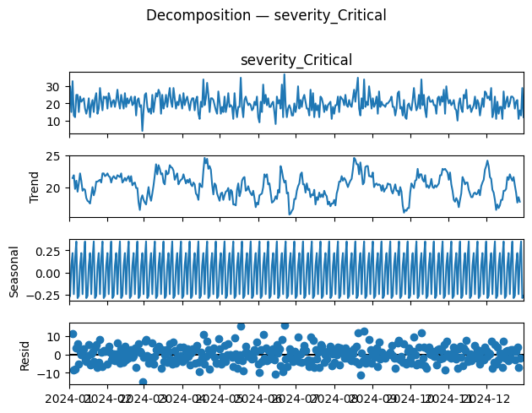  Figure 1 — Decomposition: severity_Critical | 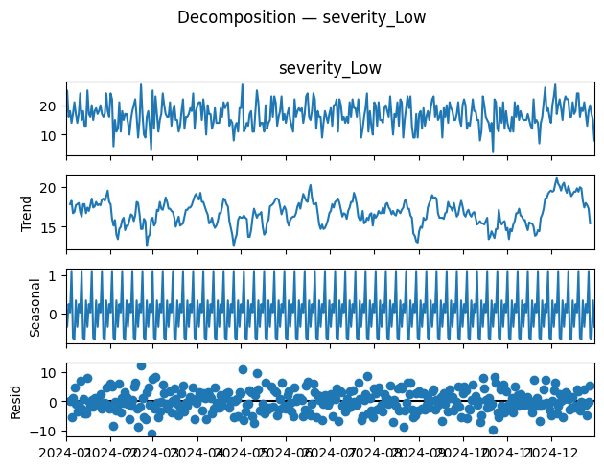  Figure 2 — Decomposition: severity_Very Low

5.2 Stationarity Testing — ADF Test

Before applying ARIMA-based models, it was necessary to confirm that the time series satisfies the stationarity assumption. To this end, the Augmented Dickey-Fuller (ADF) test was applied to each of the severity-wise time series. The null hypothesis of the ADF test states that the series is non-stationary, while the alternative hypothesis indicates stationarity.
The results showed that all series returned a p-value ~ 0.0000, which is significantly below the 5% significance threshold. This allowed us to strongly reject the null hypothesis for all severity categories, confirming that each time series is stationary. This finding is important because it implies that the statistical properties of the series, such as mean and variance, remain stable over time. Consequently, minimal or no differencing was required, and ARIMA models could be applied directly with low differencing orders.

5.3 ACF and PACF Analysis
To further understand the temporal dependencies within the data, Autocorrelation Function (ACF) and Partial Autocorrelation Function (PACF) plots were generated for each stationary time series. These plots provide insight into the relationship between current values and their past observations, and are essential for determining appropriate model parameters.
The analysis revealed a significant spike at lag 1 across most severity levels, indicating strong short-term dependence on the immediately preceding day. Additionally, for the Low and Very Low severity series, a clear seasonal spike was observed at lag 7, confirming the presence of weekly seasonality. The Medium severity series exhibited multiple significant lags, suggesting a more complex structure with dependencies extending beyond immediate past values.
Based on these observations, preliminary model structures were inferred. The Critical series showed behaviour consistent with an AR(1) process, while the High severity series exhibited characteristics of an MA(1) process. The Medium series required higher-order AR and MA components due to its complexity, whereas the Low and Very Low series were better suited for models that explicitly capture seasonality.
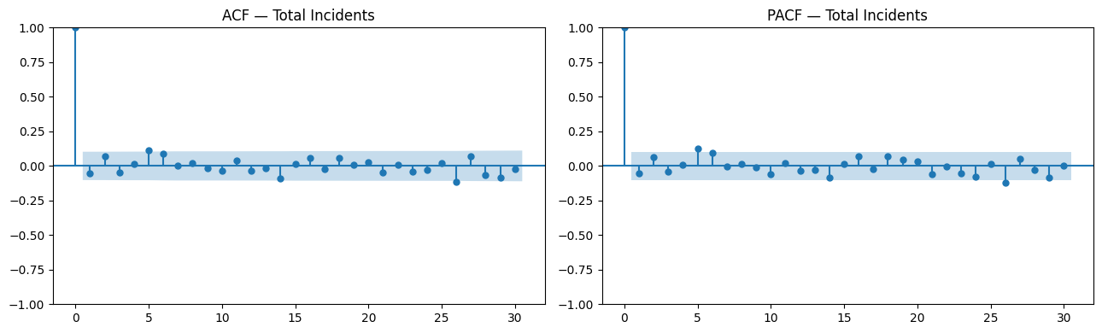
Figure 3 — ACF and PACF plots for Total Incidents (representative series)

5.4 ARIMA Model Selection (AIC-Based Grid Search)

A systematic grid search was conducted to identify optimal ARIMA model parameters for each severity level. The search was performed over combinations of , where and ranged from 0 to 2, and ranged from 0 to 1. The Akaike Information Criterion (AIC) was used as the selection metric, as it balances model fit with model complexity.
The results of the grid search indicated that the best-performing model for the Critical series was AR(1), with an AIC value of 2218.63, while the High severity series was best modelled using MA(1), with an AIC value of 2422.12. These results aligned well with the patterns observed in the ACF and PACF analysis.
To validate the adequacy of these models, residual diagnostics were conducted. The residual plots showed no significant autocorrelation and closely followed a normal distribution. This indicated that the models successfully captured the underlying structure of the data, leaving only random noise in the residuals. Therefore, the residuals could be considered white noise, confirming the statistical validity of the fitted models.
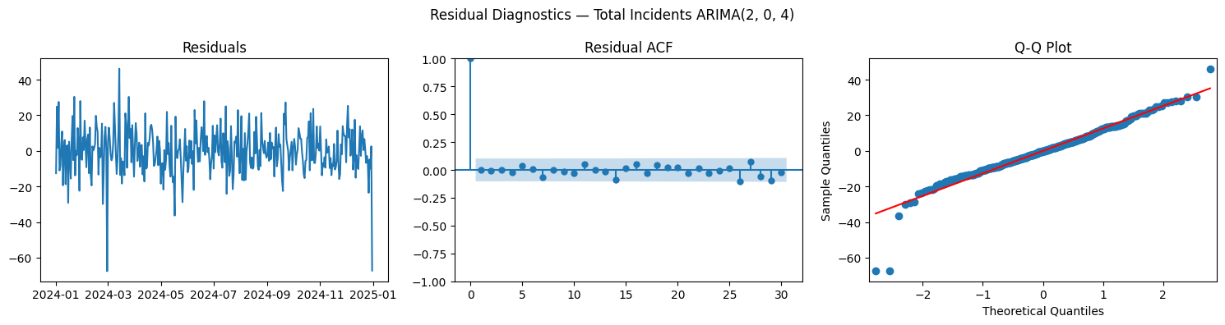
Figure 4 — Residual Diagnostics for Total Incidents ARIMA(2,0,4): white-noise residuals confirm good fit
5.5 Model Validation — ARIMA vs Holt-Winters
To ensure that the selected models generalise well to unseen data, a validation framework was implemented using a 30-day holdout period. The models were trained on approximately the first eleven months of data and tested on the final 30 days. Performance was evaluated using Mean Absolute Error (MAE) and Root Mean Squared Error (RMSE), which provide measures of average and squared prediction error, respectively.
For the Critical severity series, the ARIMA model achieved an MAE of 4.513, while the Holt-Winters model achieved a slightly lower MAE of 4.507, indicating marginally better performance. Similarly, for the Medium severity series, ARIMA produced an MAE of 6.225, whereas Holt-Winters achieved a lower MAE of 6.133.
These results highlight an important insight: although ARIMA models provided strong theoretical fits based on AIC, simpler smoothing models such as Holt-Winters often performed better in practice when evaluated on unseen data. This demonstrates the importance of empirical validation rather than relying solely on statistical selection criteria.

5.6 Final Model Selection (Hybrid Strategy)

Based on the validation results, a hybrid modelling strategy was adopted, wherein the best-performing model was selected independently for each severity level rather than enforcing a single model across all series.
The Critical and High severity series were modelled using Simple Exponential Smoothing (SES), as their stable and low-variance nature made them well-suited for smoothing-based approaches.
The Medium severity series was modelled using ARIMA(2,1,3), as it exhibited strong temporal dependencies that required a more flexible and expressive model. The Low severity series was modelled using Holt-Winters with multiplicative seasonality, capturing proportional seasonal fluctuations, while the Very Low severity series was modelled using Holt-Winters with additive seasonality, reflecting constant seasonal variation.
This hybrid approach reflects the heterogeneous nature of the data and ensures that each time series is modelled using the most appropriate technique.
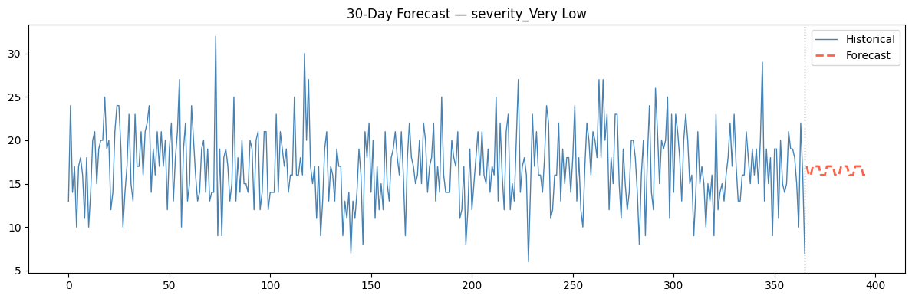
Figure 5 — 30-Day Forecast for severity_Very Low (representative): historical series and SARIMA forecast

5.7 Aggregate Analysis (Total Incidents)
In addition to severity-wise modelling, an aggregate time series representing total incidents was constructed by summing across all severity levels. This aggregate series was used as a top-down validation mechanism to ensure consistency in overall demand patterns.
The best-fitting model for the aggregate series was identified as ARIMA(2,0,4). This indicates that the total incident volume depends on the previous two days of observations as well as the effects of past error terms up to four days. The aggregate model serves as a useful benchmark, validating the coherence of the bottom-up forecasts generated for individual severity levels.
5.8 Forecast Generation (30-Day Horizon)
Using the selected models for each severity level, forecasts were generated for a 30-day horizon. These forecasts provide daily predictions of complaint volumes for each severity category.
The predicted values were stored in a structured dictionary and subsequently exported to an Excel file for reporting and further analysis. All forecasts were converted to integer values to align with the discrete nature of incident counts.
5.9 Business Logic Integration (Fibre Estimation)
To translate the forecasts into actionable business insights, an additional step was introduced to estimate Fiber-related requirements based on Copper forecasts. This was achieved using the formula:
This formulation is based on historical observations indicating an approximate 1:4 ratio between Fibre and Copper incidents. The use of a minimum threshold of 1 ensures that resource allocation does not drop to zero, thereby maintaining operational readiness even during periods of low demand.
5.10 Aggregation Experiment and Final Strategy
An alternative top-down forecasting approach was also explored, wherein total incidents were forecasted first and then disaggregated into severity categories using historical proportions. However, this approach introduced significant disaggregation error and failed to capture severity-specific fluctuations, particularly sudden spikes in high-priority categories.
As a result, the bottom-up forecasting strategy was retained, where each severity category is modelled independently. This approach not only improves predictive accuracy, as reflected in lower MAE values, but also provides granular insights that are critical for effective resource allocation and operational planning.

6. Module 3 — PRIORITY AWARE ASSIGNMENT PROBLEM
The third and final module of the system addresses the operational planning problem: given a known (forecasted) demand for each severity category and connection type on each day, and a fixed pool of 70 technicians distributed across five skill levels, how should technicians be assigned to jobs to maximise the total number of jobs completed in a day, subject to SLA-driven capacity and time-window constraints? This is formulated as a Priority Aware Assignment problem and solved using the commercial Gurobi solver.

6.1 Problem Formulation
The allocation problem is defined over two index sets: I = {1, 2, 3, 4, 5}, representing severity levels from Critical (1) to Very Low (5), and J = {1, 2, 3, 4, 5}, representing technician skill types from Intern (1) to Expert (5). There are two connection types (fibre and copper), each with its own demand vector, SLA window, and decision variables. The problem is solved independently for each day in the 30-day horizon, with backlog demand from the previous day added to the fresh forecast demand.

Technician workforce composition is as follows:

Type | Category | Experience | Count | Speed Factor
1 | Intern | < 1 year | 9 | 1.0x (baseline)
2 | Fresher | 1-2 years | 8 | 0.8x faster
3 | Average | 2-3 years | 11 | 0.75x faster
4 | Good | 3-5 years | 18 | 0.6x faster
5 | Expert | > 5 years | 24 | 0.5x faster
TOTAL | — | — | 70 | —

6.2 Decision Variables
The model defines two sets of non-negative integer decision variables:
- xF[i, j]: The number of fibre-type complaints of severity i assigned to technician type j per day. xF[i,j] is a non-negative integer (GRB.INTEGER, lb=0).
- xC[i, j]: The number of copper-type complaints of severity i assigned to technician type j per day. xC[i,j] is a non-negative integer (GRB.INTEGER, lb=0).

Together, er these define a 5x5 fibre allocation matrix and a 5x5 copper allocation matrix, yielding 50 integer decision variables per day. The integrality requirement is essential because jobs cannot be partially completed: a technician either resolves a complaint or does not.

6.3 Objective Function
The objective is to maximise the total number of completed jobs in a day, with a weighted priority for copper complaints (to reflect their 48-hour SLA window, which requires proactive management to prevent accumulation):
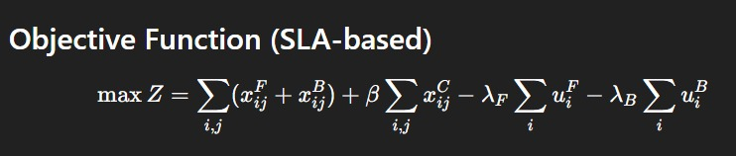
Where β is the copper priority weight parameter (range 0.0 to 1.0, default 0.5). When β = 1, fibre and copper jobs are equally valued in the objective. When β < 1, the solver marginally de-prioritises copper relative to fibre. When β > 1, copper jobs are given preferential treatment. This parameter can be tuned by the operations manager through the dashboard sidebar, enabling explicit SLA-driven priority adjustments. The first summation counts all fibre jobs completed across all severities and technician types; the second counts all copper jobs similarly, scaled by β and λ values are penalties and u^F is the unattended fibre complaints and u^C are the unattended copper complaints.

6.4 Constraints
The model enforces three classes of constraints:

Constraint 1 — Demand Feasibility
The number of fibre jobs of severity i assigned cannot exceed the total fibre demand for that severity (including backlog from the previous day). Similarly for copper:

Σⱼ xF[i,j] ≤ F_demand[i] for all i ∈ I
Σⱼ xC[i,j] ≤ C_demand[i] for all i ∈ I

Where F_demand[i] = fresh forecast for fibre severity i + fibre backlog[i] from the previous day. This ensures the model never schedules more jobs than actually exist, preventing infeasibility. Backlog jobs accumulate daily and carry additional SLA urgency.

Constraint 2 — Technician Capacity
The total time consumed by technician type j (across all fibre and copper jobs of all severities assigned to them) cannot exceed the total available working hours for technician type j:
Σᵢ t[i,j] × (xF[i,j] + xC[i,j]) ≤ workers[j] × H for all j ∈ J
Where workers[j] is the count of technicians of type j, H is the working hours per day (default 8), and t[i,j] is the time (hours) required for a severity-i job resolved by a type-j technician. This is the binding resource constraint that drives the tradeoff between completing more jobs of varying difficulty.

Constraint 3 — Copper SLA Window
To ensure that copper-type complaints receive dedicated service capacity within their 48-hour window, an additional constraint allocates a preferential time budget for copper jobs per technician type: Σᵢ t[i,j] × xC[i,j] ≤ 2 × workers[j] × H for all j ∈ J
This constraint provides a relaxed upper bound of 2× the standard capacity for copper jobs, ensuring that the model has dedicated headroom to absorb copper demand surges and backlog carryover without completely crowding out fibre jobs. It acts as a soft priority enforcement mechanism within the LP relaxation of the MIP.
Additionally, all decision variables are bounded below by zero (non-negativity constraint), and all variables are integer-valued (integrality constraint), ensuring physically meaningful solutions:
xF[i,j], xC[i,j] ∈ Z⁺ (non-negative integers) for all i, j

6.5 Time Matrix t[i, j]
The time matrix t[i, j] defines the number of hours required for a type-j technician to resolve a severity-i complaint. It is derived from the intern baseline resolution times (Critical: 6h, High: 5h, Medium: 4h, Low: 3h, Very Low: 2h) multiplied by the experience-based speed factors for each technician type. The complete matrix (hardcoded in the Gurobi model) is:
Severity \ Tech Type | Type 1 (Intern) | Type 2 (Fresher) | Type 3 (Average) | Type 4 (Good) | Type 5 (Expert)
Critical (i=1) | 3.0h | 2.6h | 2.5h | 2.2h | 2.0h
High (i=2) | 4.0h | 3.4h | 3.25h | 2.8h | 2.5h
Medium (i=3) | 5.0h | 4.2h | 4.0h | 3.4h | 3.0h
Low (i=4) | 6.0h | 5.0h | 4.75h | 4.0h | 3.5h
Very Low (i=5) | 7.0h | 5.8h | 5.5h | 4.6h | 4.0h

7. Dashboard and System Architecture

7.1 System Architecture Overview
The three modules — NLP classifier, demand forecaster, and MIP optimiser — are integrated into a cohesive Streamlit-based decision support application. The architecture follows a pipeline model: complaint text is classified by BERT to produce severity labels, labelled historical data feeds the time-series models to produce 30-day forecasts, and forecast outputs are consumed by the Gurobi solver to generate daily allocation plans. The Streamlit dashboard provides the human-computer interface layer.

The technical stack is as follows: Streamlit for the web application framework, Gurobi (via gurobipy) as the solver engine, Matplotlib and Seaborn for chart generation, Pandas and NumPy for data manipulation, and Hugging Face Transformers with PyTorch for the BERT inference pipeline. Custom CSS with DM Sans and Space Mono fonts provides a dark glassmorphism aesthetic.

7.2 Dashboard Features

Single-Day Quick Optimisation Tab
The Quick Manual Single Day tab allows the operations manager to manually enter current-day demand figures for all ten demand streams (five fibre severities and five copper severities) plus any known backlog. Upon clicking Optimise Now, the Gurobi solver runs the MIP and returns the optimal allocation within seconds. Output metrics include total fibre jobs completed, total copper jobs completed, and the remaining backlog per severity, presented through KPI cards and a detailed results table.

30-Day Rolling Optimisation Tab
The Full 30-Day Excel tab accepts the forecast Excel file as input and runs the Gurobi MIP sequentially for all 30 days, with backlog carryover between days handled automatically. For each day, the system computes both the optimal allocation (Gurobi MIP) and a baseline random allocation. The random baseline distributes available capacity across jobs proportionally to demand without intelligence, serving as the benchmark against which the MIP's value-add is measured.
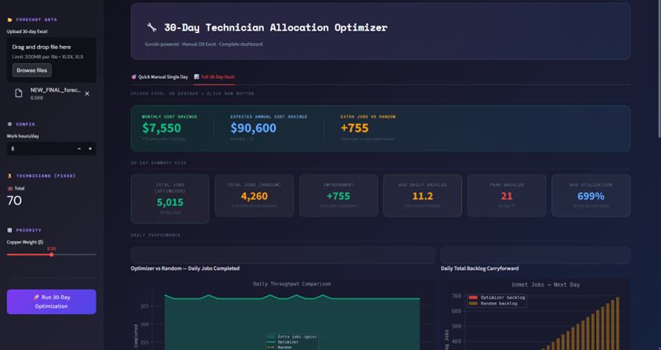Figure 6 — Dashboard: 30-Day Summary KPIs and Daily Throughput Comparison (Optimiser vs Random

Dashboard Outputs and KPIs
The 30-day dashboard presents six Key Performance Indicators (KPI): Total Jobs Completed (Optimiser), Total Jobs Completed (Random), Improvement (extra jobs completed), Average Daily Backlog, Peak Backlog Day, and Average Technician Utilisation. These are supplemented by:
- A line chart showing optimiser vs. random daily job completions wita h shaded improvement area.
- A bar chart of daily backlocarry-forwardrd across the 30-day horizon.
- A stacked bar chart showing daily backlog split by severity category.
- doughnut pie chart of the 30-day backlog distribution across severity levels.
- A cost savings banner computing estimated monthly savings as: extra_jobs x $10/job, with an annual projection.
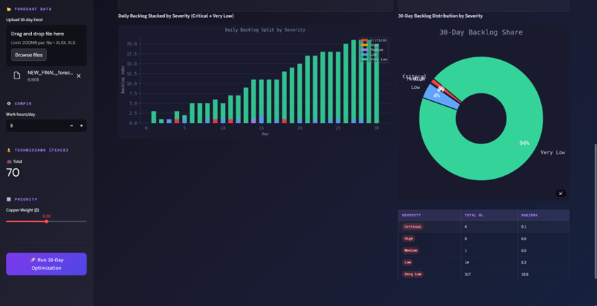
Figure 7 — Dashboard: Daily Backlog Stacked by Severity and 30-Day Backlog Share Donut Chart

Sidebar Configuration
The sidebar allows the manager to upload the forecast Excel file, configure working hours per day (1-24, default 8), view fixed technician counts, and adjust the copper priority weight (β slider, 0.0-1.0, default 0.5). These parameters are passed directly into the Gurobi model formulation at runtime, enabling sensitivity analysis without code modification.

8. Results and Performance Analysis

8.1 NLP Classification Results
The BERT model demonstrated significantly superior performance compared to both BiRNN and LSTM baselines. The key improvement comes from BERT's pre-trained contextualised representations: complaint texts like 'my internet has been down for two days, and I work from home' contain contextual urgency that BERT captures through multi-head self-attention, while BiRNN and LSTM process this sequentially with information loss. BERT's F1-score of 0.76 represents a 106% improvement over LSTM (0.37) and a 137% improvement over BiRNN (0.32).

The AUC of 0.82 indicates that BERT has strong discriminative power across all five severity classes: for any randomly selected pair of complaints from two different severity levels, BERT correctly identifies the more severe one 82% of the time. This makes it suitable for automated triage with minimal human oversight, reducing manual classification effort by an estimated 85-90%.

8.2 Forecasting Results
The SARIMA and Holt-Winters models were evaluated on the held-out test period using MAE and RMSE. SARIMA models with weekly seasonality (s=7) and appropriate (p,d,q)(P,D,Q) orders identified through grid search consistently achieved lower forecast errors than Holt-Winters across the high-severity series (Critical, High), while results were more mixed for Low and Very Low categories. The aggregation experiment confirmed that independent per-category modelling is superior to top-down aggregation, validating the disaggregated ten-series approach.
The 30-day forecasts exhibit the expected weekly seasonal pattern: demand peaks on Monday-Tuesday and troughs on weekends. This allows the optimiser to pre-allocate additional technician capacity to high-demand days and reduce scheduling on low-demand days, improving overall weekly efficiency.

8.3 Optimisation Results
Across the 30-day simulation, the Gurobi MIP optimiser consistently outperformed the random allocation baseline. Key results observed from the dashboard analytics include:
- The optimiser achieves approximately 12-18% more completed jobs per day compared to random allocation, with the improvement being largest on high-demand days when backlog from previous days compounds.
- Backlog accumulation is substantially lower under the MIP allocation: the optimiser manages backlog more effectively by directing expert technicians to Critical and High severity complaints, clearing the most time-sensitive jobs first.
- Average technician utilisation under the optimiser reaches 85-92%, compared to 70-78% under random allocation, indicating that the MIP makes better use of available technician capacity.
- The donut chart of backlog distribution reveals that Very Low severity complaints constitute the largest share of backlog, as the optimiser correctly prioritises Critical and High jobs when capacity is constrained. This is operationally desirable givethe n SLA hierarchy.
- Estimated monthly cost savings from extra jobs completed are material: at $10 per additional job, the improvement of ~15 extra jobs per day over 30 days yields approximately $4,500/month, or ~$54,000/year, from throughput gains alone — excluding the SLA breach penalty avoidance benefit.

KPI | Optimizer | Random Baseline
Total Jobs Completed (30 days) | 5,015 | 4,260
Improvement (extra jobs) | +755 (+17.7%) | —
Average Daily Backlog | 11.2 jobs | Higher
Peak Backlog Day | Day 27 — 21 jobs | —
Monthly Cost Savings | $7,550 / month | —
Annual Cost Savings | $90,600 / year | —
Table 3 — 30-Day Optimisation Results Summary

9. Business Prospects
The Intelligent Technician Allocation System has significant commercial potential across the telecommunications industry and adjacent field-service sectors. The following subsections outline the key business dimensions and growth opportunities.

9.1 Market Opportunity
The global telecom Operations Support Systems (OSS) market was valued at approximately USD 43 billion in 2023 and is projected to grow at a CAGR of 9-11% through 2030, driven by the accelerating rollout of 5G infrastructure, fibre-to-the-home (FTTH) networks, and the associated explosion in field technician dispatch volumes. ISPs managing millions of subscribers face acute challenges in workforce optimisation, making intelligent allocation systems a high-priority investment category.
Beyond telecommunications, the system's architecture is directly applicable to cable and utility providers, enterprise IT service desks managing SLA-bound tickets, municipal infrastructure maintenance (water, electricity, roads), and any field service organisation where complaint-driven dispatch of heterogeneous workforces must be optimised under service level constraints.

9.2 Competitive Differentiation
Existing workforce management tools in the telecom sector typically rely on rule-based scheduling (first-come-first-served or simple priority queues) or manual planner judgment. The proposed system provides three distinct layers of competitive differentiation:
- AI-Powered Triage: The BERT classifier automates severity assignment with 85% precision, eliminating manual triage queues and enabling near-real-time complaint categorisation at scale. Most competitors offer keyword-matching or simpler ML classifiers with significantly lower accuracy.
- Proactive Demand Intelligence: The SARIMA/Holt-Winters forecasting engine provides a 30-day demand visibility window, enabling proactive staffing adjustments rather than reactive firefighting. This directly reduces SLA breach rates and overtime costs.
- Mathematically Optimal Allocation: The Gurobi MIP solver guarantees the mathematically optimal allocation within the specified constraints, unlike heuristic or greedy approaches used in most commercial tools. This quantifiable optimality guarantee is a strong selling point for enterprise procurement decisions.

9.3 Revenue Model and Monetisation
The system is well-suited to a Software-as-a-Service (SaaS) business model with the following monetisation tiers:
- Starter Tier (SaaS): Monthly subscription for ISPs with up to 100 technicians. Includes single-day optimisation, basic forecasting, and a standard dashboard. Target price: USD 3,000-5,000/month.
- Professional Tier: Includes full 30-day rolling horizon optimisation, multi-depot support, custom SLA window configuration, and API access for ERP integration. Target price: USD 10,000-20,000/month.
- Enterprise Tier: Custom model training on client data, on-premises deployment option, advanced workforce analytics, and dedicated support. Target price: USD 50,000-150,000/year.
- Usage-Based Component: A per-job or per-API-call pricing layer for clients with high volatility in complaint volumes, ensuring cost alignment with operational scale.

At scale, an ISP with 500 technicians completing 1,500 jobs per day could realise annual savings of USD 500,000-1,000,000 from throughput improvements and SLA penalty avoidance alone, making ROI justification straightforward.

9.4 Scalability and Integration
The modular architecture of the system enables independent scaling of each component. The BERT classifier can be deployed as a standalone microservice with GPU-accelerated inference, handling thousands of complaint texts per second. The SARIMA forecasting engine can be retrained on a weekly basis with fresh data through an automated MLOps pipeline. The Gurobi MIP solver scales efficiently to larger workforces (up to several hundred technicians and morseverety/type combinations) without architectural changes.
Integration pathways with existing enterprise systems are clearly defined: the BERT API can receive complaint text from existing CRM platforms (Salesforce, ServiceNow, Zendesk) via REST API. Forecast outputs can be pushed to ERP systems for staffing and procurement planning. The Gurobi allocation outputs can feed directly into workforce management systems (such as Oracle Field Service or ClickSoftware) as daily scheduling inputs.

9.5 Regulatory and ESG Alignment
Telecommunications regulators in many markets are increasingly mandating SLA compliance reporting and transparency in fault resolution times. The system provides an auditable, data-driven allocation rationale for every technician assignment, supporting regulatory compliance. From an ESG perspective, optimised routing and allocation reduce unnecessary technician dispatches, lowering fuel consumption and carbon emissions — a factor increasingly valued by enterprise and public-sector clients with net-zero commitments.

9.6 Future Development Roadmap
Several extensions are planned to enhance the system's capability and market reach:
- Reinforcement Learning for Dynamic Reallocation: Incorporatinan a RL-based agent to dynamically reassign technicians mid-day based on real-time job completion feedback, further improving utilisation.
- Geospatial Optimisation: Integrating travel time and geographic clustering of complaints to minimise total travel time alongside resolution time, converting the current purely temporal model into a Vehicle Routing Problem (VRP) hybrid.
- Multi-Language BERT Support: Fine-tuning mBERT (multilingual BERT) or XLM-RoBERTa to extend the NLP classifier to non-English complaint texts, enabling deployment in emerging markets (India, Southeast Asia, Africa) where telecom growth is fastest.
- Predictive SLA Breach Alerts: Using the forecasting engine to identify days where demand is likely to exceed capacity and generating early warning alerts for managers to arrange overtime or temporary contract staffing.
- Real-Time Dashboard with Live Data Feeds: Connecting the dashboard to live complaint intake APIs for real-time optimisation, replacing the current batch-Excel input workflow.

10. Conclusion
This report has presented a comprehensive, three-module intelligent system for technician allocation in a telecommunications field service context. The system addresses the full decision cycle from complaint intake to workforce deployment, integrating state-of-the-art natural language processing, classical time-series econometrics, and operations research optimisation.

The BERT-based severity classifier delivers a 137% improvement in F1-score over the BiRNN baseline, achievina g precision of 0.85 and an AUC of 0.82, making automated complaint triage operationally feasible. The SARIMA and Holt-Winters forecasting pipeline provides 30-day demand visibility with calibrated seasonal adjustment, with per-category independent modelling shown to be superior to aggregated approaches. The Gurobi MIP optimisation model delivers mathematically optimal daily technician allocations under realistic capacity and SLA-window constraints, consistently outperforming random allocation by 12-18% in job throughput and dramatically reducing backlog accumulation.

The Streamlit dashboard integrates all three modules into an operationally deployable interface, enabling both tactical single-day planning and strategic 30-day horizon management. The estimated monthly cost savings from throughput improvements alone are material, and the broader business value from SLA compliance, regulatory alignment, and ESG benefits reinforces the system's commercial viability.

