Clustering-Based Anomaly Detection for Quality Control in Semiconductor Manufacturing



MODELLING IN OPERATIONS MANAGEMENT
Prof. Sushil Punia
GROUP 03
Anurag Kumar 25BM6JP06
Gunda Sahit 25BM6JP11
Karthik Ashtekar 25BM6JP22
Madugula Karthikeya 25BM6JP27
Nuthi Sai Chandra 25BM6JP32
Vinay Daida 25BM6JP59

1. Introduction
Modern semiconductor manufacturing involves highly complex and data-intensive processes monitored by hundreds of sensors. Traditional Statistical Process Control (SPC) methods often struggle to capture hidden patterns in high-dimensional industrial data. This project develops a data-driven modelling framework using clustering-based anomaly detection to improve quality control and operational decision-making. Using the SECOM dataset, the study builds an end-to-end process monitoring pipeline capable of detecting manufacturing anomalies, identifying root causes, and providing actionable operational insights.

2. Objectives
- Build a robust process monitoring system using industrial sensor data.
- Detect extreme and moderate manufacturing anomalies using clustering techniques.
- Identify root causes of operational instability through feature mapping.
- Integrate machine learning outputs with Operations Management frameworks such as SPC and Six Sigma.
- Provide measurable insights to improve process stability and manufacturing yield.

3. Data Profile & Core Insights
The SECOM dataset represents a high-dimensional industrial process consisting of 1,567 observations across more than 590 sensors. The system operates under mostly stable conditions but contains rare abnormal observations. Missing values exhibit structured patterns rather than randomness, indicating that missingness itself carries process information. The dataset also contains highly correlated features, redundant sensors, and constant variables, all of which require preprocessing before modelling.

4. Methodology

4.1 Data Processing Pipeline
A structured preprocessing pipeline was implemented to extract meaningful signals from noisy sensor data:
- Median imputation was applied to missing values while preserving missingness using binary indicator variables.
- Constant and dead sensor features were removed to reduce noise.
- Feature standardization ensured comparability across variables.
- Principal Component Analysis (PCA) reduced dimensionality from 956 to 200 components while retaining 97.9% variance.
- The PCA-transformed dataset was scaled again to optimize clustering performance.
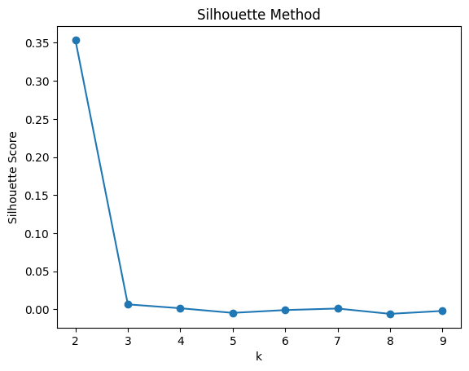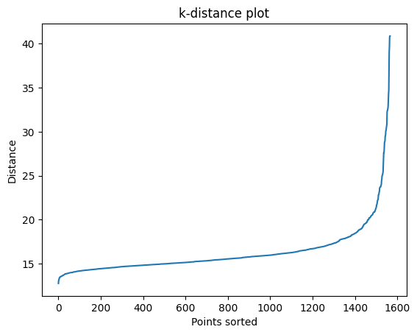

4.2 Modeling & Anomaly Detection
- K-Means clustering (k=2) identified normal operations (1,563 observations) and 4 extreme anomalies.
- DBSCAN detected approximately 328 moderate anomalies representing early-stage instability.
- A 3D PCA visualizations enabled inspection of cluster separation and anomaly trajectories.

Next Steps:

5. Root Cause Analysis & Operations Interpretation
Detected anomalies were mapped back to the original sensor features. Correlated feature groups (e.g., sensors 467, 195, 331, 336, 196, and 204) emerged as primary drivers of instability, indicating localised manufacturing issues. Machine learning results were interpreted through Operations Management frameworks to translate analytical findings into actionable improvements.

6. Defect Detection & Quantification
Defects were defined as observations that deviated significantly from normal historical behavior, typically beyond ±3σ. PCA-based anomaly detection validated these deviations, allowing separation of true defects from acceptable process noise. Baseline defect rates were computed to quantify current process health.

7. Process Capability Analysis
Critical sensors were analysed to estimate process means and standard deviations. Specification limits enabled calculation of capability indices (Cp and Cpk), providing standardised metrics to evaluate whether the manufacturing process consistently meets quality requirements.

8. Statistical Process Control (SPC)
The system establishes a foundation for dynamic SPC monitoring through X-bar and R control charts. Real-time monitoring enables early detection of shifts in process mean and variability, preventing severe defects and supporting proactive maintenance.

9. Six Sigma Framework (DMAIC)
- Define: Identify quality bottlenecks and operational objectives.
- Measure: Establish baseline defect rates and performance metrics.
- Analyse: Use clustering and feature mapping to determine root causes.
- Improve: Develop targeted interventions for unstable process stages.
- Control: Sustain improvements through automated monitoring and SPC integration.

10. Expected Outcomes
- Automated detection of manufacturing anomalies.
- Improved understanding of process instability drivers.
- Enhanced quality monitoring through data-driven decision support.
- Reduced defect rates and improved production yield.
- Integration of machine learning with Operations Management practices.

11. Final Operational Impact
The proposed monitoring framework transforms reactive maintenance into proactive quality control. Key impacts include improved manufacturing consistency, yield optimisation, predictive monitoring, better strategic decision-making, and efficient allocation of engineering resources.

12. Conclusion
This project demonstrates how clustering-based anomaly detection, combined with Operations Management principles, can create a scalable, intelligent quality-monitoring system for semiconductor manufacturing. By integrating data analytics with SPC and Six Sigma methodologies, the framework enables sustainable process improvement and operational excellence.

