**Data Analyst Assignment**

**Overview**

You have been given eye blink data of persons identified by their unique user id. The data is stored in JSON file and contains the start and end timestamps of a blink “T1” and ‘’T2’’ respectively. Please note the difference of timestamps will be in milliseconds.

Json file name: 4267907207_29042024_1_32_11_1714375510865.json

Here:

“4267907207”: user id

“29042024”: date in DDMMYYYY format i.e. DAY : 29 , Month: 04 , Year:2024

rest you can ignore.

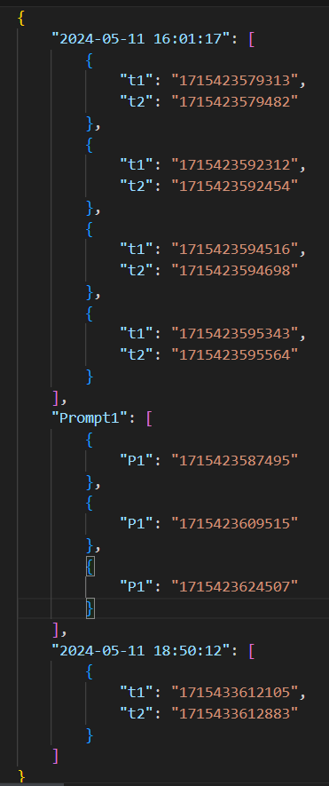

Figure 1

Figure 1 is a snapshot of a Json file. You can see the start timestamp “t1’ and end timestamp “t2”.

Ignore the timestamps stored under the field name “Prompt1”.

Refer the following link for conversion of timestamps into date and time:

[Epoch Converter - Unix Timestamp Converter](https://www.epochconverter.com/)

**Tasks**

1. Extract the blink data from Json files
2. Segregate the blink into intervals, all blinks with inter blink duration <25 secs belong to the same interval vice versa for different interval (Interblink duration is difference of start timestamp of a blink with the end timestamp of the previous blinks ).
3. Blink rate for each interval
4. Visualise the above data and bring about blink patterns and insights with the aim to understand the blinking behaviour of a person.

Enrich you submission with graphs and other means of visualisation wherever applicable. The submission will be in the form of a jupyter notebook.