**Name-Karthik Deepak**

**Class-3D**

**USN-1BM19CS200**

**WEEK 1:**

#include<stdio.h>

int main()

{

int i, a,b,c;

int sum,diff,mul,mod;

float divi;

while(1)

{

printf("CHOOSE THE OPERATION YOU WISH TO DO : \n");

printf("1. Add\n");

printf("2. Subtract\n");

printf("3. Multiply\n");

printf("4. Divide\n");

printf("5. Modulus\n");

printf("6. Greater than\n");

printf("7. Lesser than\n");

printf("8. Not equal to\n");

printf("9. Equal to\n");

printf("10.Increment by 5\n");

scanf("%d",&i);

printf("Enter two numbers to perform the selected operation:\n");

scanf("%d%d",&a,&b);

sum=a+b;

diff=a-b;

mul=a*b;

divi=(a*1.0)/b;

mod=a%b;

switch(i)

{

case 1:printf("Sum=%d \n", sum);

break;

case 2:printf("Difference= %d \n" , diff);

break;

case 3:printf("Multiplication= %d \n", mul);

break;

case 4:printf("Division= %f \n", divi);

break;

case 5:printf("Modulus= %d \n", mod);

break;

case 6: if(a>b)

{

printf("%d > %d \n",a,b);

}

else

{

printf("%d > %d \n",b,a);

}

break;

case 7: if(a<b)

{

printf("%d < %d \n",a,b);

}

else

{

printf("%d < %d \n",b,a);

}

break;

case 8:if(a!=b)

{

printf("%d != %d \n",a,b);

}

else

{

printf("%d = %d \n",b,a);

}

break;

case 9: if(a==b)

{

printf("%d = %d \n",a,b);

}

else

{

printf("%d != %d \n",a,b);

}

break;

case 10:

printf("Incremented Value is \n",a,a+5);

printf("Incremented Value is \n",b,b+5);

break;

default:printf("WRONG CHOICE! \n");

}

printf("Press 1 to calculate more, or Press any other key to exit\n\n");

scanf("%d",&c);

if(c!=1)

{

break;

}

}

}

**OUTPUT:**

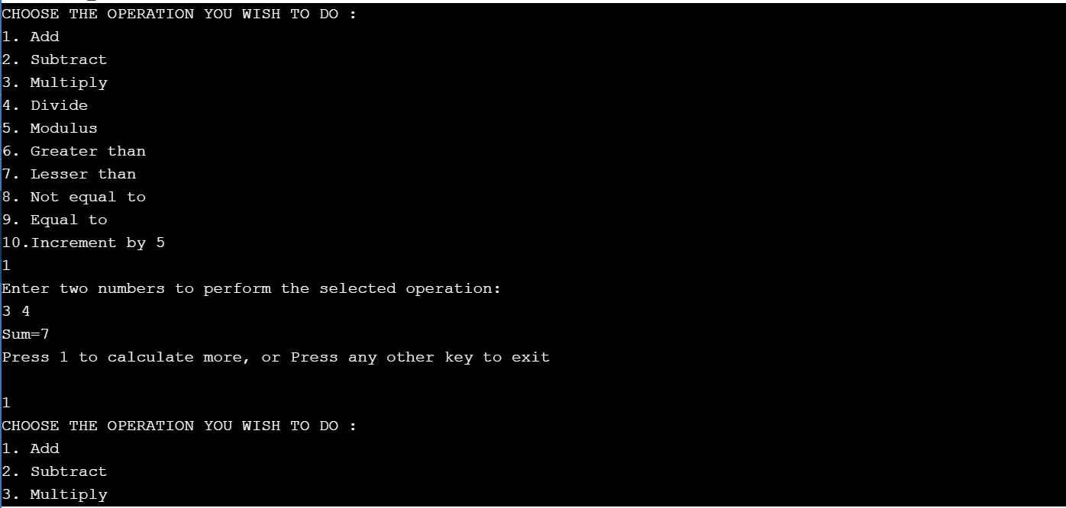

**PROGRAM 2:**

#include <stdio.h>

int sumaver(int a,int b)

{

int sum;

sum=a+b;

printf("Sum= %d \n",sum);

return sum/2;

}

void printeven(int a,int b)

{

int small,big;

if(a>b)

{

small=b;

big=a;

}

else

{

small=a;

big=b;

}

printf("Even numbers between two numbers are:\n");

int i;

for(i=small+1;i<big;i++)

{

if(i%2==0)

printf("%d \n",i);

}

}

int main()

{

int a,b,c,avg,n1,n2;

printf("Enter three numbers:\n");

scanf("%d%d%d",&a,&b,&c);

if(c<a && c<b)

{

n1=a;

n2=b;

}

else if(b<a && b<c)

{

n1=a;

n2=c;

}

else

{

n1=b;

n2=c;

}

avg=sumaver(n1,n2);

printf("Average of two numbers is : %d \n",avg);

printeven(n1,n2);

}

**OUTPUT:**

