# Gangadhara, Karthik  
# 1001-677-851  
# 2019-09-01  
# Assignment-00-02

Have you taken and passed the CSE-5301 Data Analysis and Modeling Techniques course? (Yes/ NO)

NO (I am doing it parallelly this semester)

If yes, specify the university, department, year, and the semester that you took CSE 5301:

University: ____________________

Department: ____________________

Year: ____________________

Semester: ____________________

I, Karthik Gangadhara have fully read and understood the syllabus".

# Syllabus

# CSE 5368 Neural Networks Fall 2019

|  |  |
| --- | --- |
| Instructor: | Farhad Kamangar |
| Office Location: | ERB 524 |
| Office Telephone Number: | 817-272-3617 |
| Email Address: | kamangar@uta.edu |
| Faculty Profile: | <https://www.uta.edu/profiles/farhad-kamangar> |
| Office Hours: | * Tuesdays  & Thursdays 5:00-6:45 PM * Other times by appointment. |
| Section Information: | CSE-5368-001 |
| Time and Place of Class: | TuTh 7:00-8:20 PM; GACB 103 |
| Course Website: | <http://ranger.uta.edu/~kamangar/Courses/CSE_5368_FA19> |

## Description of Course Content:

5368. NEURAL NETWORKS (3-0) Theoretical principles of neurocomputing. Learning algorithms, information capacity, and mapping properties of feedforward and recurrent networks. Different neural network models will be implemented and their practical applications discussed. Prerequisite: CSE 5301 and calculus II, knowledge of a high level programming language, or consent of instructor.

## Student Learning Outcomes:

This course focuses both on the theoretical and practical aspects of neural networks. Major neural networks paradigms and concepts such as Perceptrons, Hebbian learning, performance surfaces, optimization, multi-layer networks, backpropagation, self-organizing maps, stochastic networks, Adaptive Resonance Theory, and Hopfield networks will be integrated into this course. After completing this course, students will be able to:

* Understand the concepts, and representation of the common neural network models and the most essential deep learning models and algorithms.
* Understand the mathematical foundations of deep learning and the concepts of the performance surfaces and different methods for optimizations.
* Reason about the performance of neural networks and implement neural network models for particular applications.
* Learn to implement neural networks (from scratch)
* Learn to use popular neural network libraries such as Tensorflow and Keras.
* Equip students with the skills to read papers and implement their own ideas to real world problems to do research.

## Requirements:

Please be advised that this course is intended for graduate students in computer science and engineering. It is assumed that all students are comfortable with math (calculus, linear algebra, vectors, and matrices) and are proficient in high level programming languages, particularly Python.

Prerequisite: CSE 5301 and calculus II, working knowledge of a high level programming language, or consent of instructor.

## Textbook:

Neural Network Design (2nd Edition),Martin T. Hagan, Howard B. Demuth, Mark H. Beale, Orlando De Jesus, ISBN-10: 0-9717321-1-6, ISBN-13: 978-0-9717321-1-7

## Supplemental Books (Recommended):

* Deep Learning Step by Step with Python: A Very Gentle Introduction to Deep Neural Networks for Practical Data Science, [N D Lewis](https://www.amazon.com/s/ref=dp_byline_sr_book_1?ie=UTF8&text=N+D+Lewis&search-alias=books&field-author=N+D+Lewis&sort=relevancerank), 2016, ISBN-10: 1535410264, ISBN-13: 978-1535410267
* Make Your Own Neural Network, [Tariq Rashid](https://www.amazon.com/s/ref=dp_byline_sr_book_1?ie=UTF8&text=Tariq+Rashid&search-alias=books&field-author=Tariq+Rashid&sort=relevancerank), 2016, ISBN-10: 1530826608, ISBN-13: 978-1530826605
* Artificial Intelligence for Humans, Volume 3: Deep Learning and Neural Networks, [Jeff Heaton](https://www.amazon.com/Jeff-Heaton/e/B001IZRB9E/ref=dp_byline_cont_book_1), 2015, ISBN-10: 1505714346, ISBN-13: 978-1505714340

## Course Schedule and Important Dates

* First day of class: Aug. 22, 2019
* Census day: Sept. 6, 2019
* Midterm Exam Thursday, Oct. 24, 2019
* Last day to drop classes: Nov. 1, 2019
* Thanksgiving Holidays: Nov. 28 & 29, 2019
* Last day of classes: Dec. 4, 2019
* Final Exam Tuesday, Dec 10, 2019 (8:15-10:45 PM)

## Descriptions of major assignments and examinations:

There will be programming assignments, one midterm exams, one final exam, and in-class quizzes.

## Exams and Quizzes:

* Midterm and final exams will include theoretical and programming questions.
* Exams and quizzes will be comprehensive and shall include information from the textbook as well as information from class lectures.
* Quizzes consist of occasional, unannounced, written questions and they will be based on the assigned advance readings and class lectures.  A quiz may be given at any time during any class period. There will be no make-up quizzes. Quizzes will be given only to those students who are present when the quizzes are passed out.
* The lowest quiz score will be dropped (The midterms and final exam are absolutely required).
* The quiz policy may be adjusted in the case of documented disability.
* There will be no makeup exams or quizzes. If, and only if, you have an approved medical or university excuse for being absent from a test or a quiz, the next scheduled exam shall count twice.

## Assignments

* All assignments will be assigned well in advance of the due date. All assignments are due at 11:59 PM on the specified date. There is a 24 hour grace period after the due date. The purpose of the grace period is to compensate for the unforeseen events such as network or server problems. No assignment will be accepted after the grace period.
* Assignments must be submitted electronically using Canvas.
* The programming language for this class will be Python. The examples and demos in the lectures will also use the Python language. However, you may use any other programming language that you choose for submitting your assignments.
* For certain assignments there will be a signup sheet for each student to reserve a time slot to personally demonstrate the assignment to the teaching assistant.
* Each assignment must be self-contained (unless it is explicitly stated otherwise), i.e. it must include all the required components to run. The teaching assistant will only use the submitted files. No additional or supplemental files may be used at the run time. In other words, your assignments must run as submitted.
* Programs that do not run will receive no credit (No partial credits).
* Programs that implement some, but not all, of the requirements may receive partial credit. However, these programs must still run without errors.
* It is each student's responsibility to completely test their program PRIOR to submission and make sure that it executes without error(s) as submitted.
* The instructor and the teaching assistant(s) are available outside the class to offer help and clarify the concepts.

## Grading Policy:

Grades will be calculated based on the following percentages:

|  |  |
| --- | --- |
| Quizzes | 25% |
| Assignments | 25% |
| Midterm Exam | 25% |
| Final | 25% |

 Letter grades are assigned as follows:

|  |  |
| --- | --- |
| 87%–100% | A |
| 75%–87% | B |
| 65%–75% | C |
| 55%–65% | D |
| 0%–55% | F |

* There will be **no curves** and the letter grades will be absolutely based on the table shown above. Multiple studies have shown that grading on a curve discourages studying. The problem with grading curves is that they are not applied until the end of a semester. This uncertainty may lead to high stress levels and leaves students with no idea where they stand in a course or what it will take to get a certain grade.
* All the grades and assignment will be posted on Canvas and students are expected to keep track of their performance throughout the semester and seek guidance from the instructor if their performance drops below satisfactory levels.

## General Policies:

* **Your opinion matters.** All constructive suggestions will be seriously considered. However, your suggestions should be applicable to all students in the class and not to a particular group or individual. **Please do not ask for any exception.**
* **Be there.** Multiple research studies suggest that the use of electronic devices in class can lead to a distracting learning environment. **You learn better when you are mentally present.** Cell phones, laptops, I-Pads, Kindles, and other electronic devices must be turned off during class (unless explicitly specified otherwise for particular in-class exercises).
* All announcements will be communicated via email. You are responsible for checking your email.
* Do not be late in attending the class. Your late arrival will disturb the continuity of the subject and may break other student's concentration. **DO NOT enter the classroom if you are late.**
* Non-programmable calculators, or smart devices, are allowed during the exams.
* Part of the objective of this course, and any other course, is to prepare students for professional life in real world. In real world there is no excuse for not knowing the rules and responsibilities. You are responsible for understanding the rules and carry out your responsibilities. In real world if you do not get the job done, nobody will care about the reasons or excuses.
* You are responsible for all material presented during classes from which you were absent.
* This class is heavy on math and programming. Please be prepared.

## Frequently Asked Questions (FAQ):

**Question:** I REALLY need a grade of X because of GPA, … . What can I do?

**Answer:** Invent a time machine. Go back to the start of the semester and make sure that your semester average exceeds the threshold for grade X. There is no other option.

**Question:** I made a mistake and submitted a wrong file as my assignment. What can I do?

**Answer:** All assignments are graded as submitted. Once the submission deadline is passed no changes or modification can be made to the submitted files. Please note that you may submit your assignments as many times as you want before the deadline, however, it is your responsibility to verify your submission and make sure it is correct.

## Attendance:

At The University of Texas at Arlington, taking attendance is not required but attendance is a critical indicator in student success. Each faculty member is free to develop his or her own methods of evaluating students’ academic performance, which includes establishing course-specific policies on attendance. As the instructor of this section, I will not take attendance. However, while UT Arlington does not require instructors to take attendance in their courses, the U.S. Department of Education requires that the University have a mechanism in place to mark when Federal Student Aid recipients “begin attendance in a course.” UT Arlington instructors will report when students begin attendance in a course as part of the final grading process. Specifically, when assigning a student a grade of F, faculty report the last date a student attended their class based on evidence such as a test, participation in a class project or presentation, or an engagement online via Canvas. This date is reported to the Department of Education for federal financial aid recipients.

## Make-up Exam Policy:

There are no make-up exams. If and only if you have a University excuse for being absent from a test, the next scheduled exam shall count twice.

## Incomplete Grade Policy:

No incomplete shall be given in this course, except if you miss the final with a university approved letter.

No special make-up work will be accepted after the end of the semester. In the event of a documented major medical problem, with a university approved letter, a grade of Incomplete will be given pending the submission of complete work. However, make-up work “to improve one’s grade” will not be accepted.

## Grade Grievances:

Any appeal of a grade in this course must follow the procedures and deadlines for grade-related grievances as published in the current University Catalog:

<http://catalog.uta.edu/academicregulations/grades/#undergraduatetext>

<http://catalog.uta.edu/academicregulations/grades/#graduatetext>

<http://www.uta.edu/deanofstudents/student-complaints/index.php>.

## Drop Policy:

Students may drop or swap (adding and dropping a class concurrently) classes through self-service in MyMav from the beginning of the registration period through the late registration period. After the late registration period, students must see their academic advisor to drop a class or withdraw. Undeclared students must see an advisor in the University Advising Center. Drops can continue through a point two-thirds of the way through the term or session. It is the student's responsibility to officially withdraw if they do not plan to attend after registering. **Students will not be automatically dropped for non-attendance**. Repayment of certain types of financial aid administered through the University may be required as the result of dropping classes or withdrawing. For more information, contact the Office of Financial Aid and Scholarships (<http://wweb.uta.edu/aao/fao/>).

## Disability Accommodations:

UTArlington is on record as being committed to both the spirit and letter of all federal equal opportunity legislation, including *The Americans with Disabilities Act (ADA), The Americans with Disabilities Amendments Act (ADAAA),* and *Section 504 of the Rehabilitation Act.* All instructors at UT Arlington are required by law to provide “reasonable accommodations” to students with disabilities, so as not to discriminate on the basis of disability. Students are responsible for providing the instructor with official notification in the form of **a letter certified** by the Office for Students with Disabilities (OSD).Only those students who have officially documented a need for an accommodation will have their request honored. Students experiencing a range of conditions (Physical, Learning, Chronic Health, Mental Health, and Sensory) that may cause diminished academic performance or other barriers to learning may seek services and/or accommodations by contacting: **The Office for Students with Disabilities, (OSD)** [www.uta.edu/disability](http://www.uta.edu/disability) or calling 817-272-3364. Information regarding diagnostic criteria and policies for obtaining disability-based academic accommodations can be found at [www.uta.edu/disability](http://www.uta.edu/disability). Counseling and Psychological Services, (CAPS) or calling 817-272-3671 is also available to all students to help increase their understanding of personal issues, address mental and behavioral health problems and make positive changes in their lives.

**Counseling and Psychological Services (CAPS):**

[www.uta.edu/caps/](http://www.uta.edu/caps/) or calling 817-272-3671 is also available to all students to help increase their understanding of personal issues, address mental and behavioral health problems and make positive changes in their lives.

## Non-Discrimination Policy:

The University of Texas at Arlington does not discriminate on the basis of race, color, national origin, religion, age, gender, sexual orientation, disabilities, genetic information, and/or veteran status in its educational programs or activities it operates. For more information, visit [uta.edu/eos](http://www.uta.edu/hr/eos/index.php).

## Title IX Policy:

The University of Texas at Arlington (“University”) is committed to maintaining a learning and working environment that is free from discrimination based on sex in accordance with Title IX of the Higher Education Amendments of 1972 (Title IX), which prohibits discrimination on the basis of sex in educational programs or activities; Title VII of the Civil Rights Act of 1964 (Title VII), which prohibits sex discrimination in employment; and the Campus Sexual Violence Elimination Act (SaVE Act). Sexual misconduct is a form of sex discrimination and will not be tolerated.*For information regarding Title IX, visit* or contact Ms. Jean Hood, Vice President and Title IX Coordinator at (817) 272-7091 or jmhood@uta.edu.

## Academic Integrity:

All students enrolled in this course are expected to adhere to the UT Arlington Honor Code:

I pledge, on my honor, to uphold UT Arlington’s tradition of academic integrity, a tradition that values hard work and honest effort in the pursuit of academic excellence.

I promise that I will submit only work that I personally create or contribute to group collaborations, and I will appropriately reference any work from other sources. I will follow the highest standards of integrity and uphold the spirit of the Honor Code.

UT Arlington faculty members may employ the Honor Code in their courses by having students acknowledge the honor code as part of an examination or requiring students to incorporate the honor code into any work submitted. Per UT System *Regents’ Rule* 50101, §2.2, suspected violations of university’s standards for academic integrity (including the Honor Code) will be referred to the Office of Student Conduct. Violators will be disciplined in accordance with University policy, which may result in the student’s suspension or expulsion from the University. Additional information is available at <https://www.uta.edu/conduct/>.

All students are expected to pursue their academic careers with honesty and integrity. “Scholastic dishonesty includes, but is not limited to, cheating, plagiarism, collusion, the submission for credit of any work or materials that are attributable in whole or in part to another person, taking an examination for another person, any act designed to give unfair advantage to a student or the attempt to commit such acts” (Regents’ Rules and Regulations, Part One, Chapter VI, Section 3, Subsection 3.2, Subdivision 3.22.). Students found guilty of dishonesty in their academic pursuits are subject to penalties that may include suspension from the university. **Any student found guilty of academic dishonesty will receive a -100% for that work (test, assignments, project, etc.) as well as having the course grade lowered one full letter grade - in addition to any other penalties assessed (suspension, expulsion, probation).** These and other applying UTA rules, will be strictly enforced. Any case of academic dishonesty will be treated in accordance with the UTA Handbook of Operating Procedures or the Judicial Affairs. If you do not understand this policy, it is your responsibility to obtain clarification or any additional information you may require. Students are not allowed to:

* Collaborate with others on the code they write
* Copy any part of someone else's program, even if they have permission and/or have modified the code
* Share or give their code, or even a subset of the code to, another student
* Review another student’s solution (including from past semesters)
* All work turned in for grading must be the student's own work.

## Electronic Communication:

UT Arlington has adopted MavMail as its official means to communicate with students about important deadlines and events, as well as to transact university-related business regarding financial aid, tuition, grades, graduation, etc. All students are assigned a MavMail account and are responsible for checking the inbox regularly. There is no additional charge to students for using this account, which remains active even after graduation. Information about activating and using MavMail is available at <http://www.uta.edu/oit/cs/email/mavmail.php>.

## Campus Carry:

Effective August 1, 2016, the Campus Carry law (Senate Bill 11) allows those licensed individuals to carry a concealed handgun in buildings on public university campuses, except in locations the University establishes as prohibited. Under the new law, openly carrying handguns is not allowed on college campuses. For more information, visit <http://www.uta.edu/news/info/campus-carry/>

## Student Feedback Survey:

At the end of each term, students enrolled in face-to-face and online classes categorized as “lecture,” “seminar,” or “laboratory” are directed to complete an online Student Feedback Survey (SFS). Instructions on how to access the SFS for this course will be sent directly to each student through MavMail approximately 10 days before the end of the term. Each student’s feedback via the SFS database is aggregated with that of other students enrolled in the course. Students’ anonymity will be protected to the extent that the law allows. UT Arlington’s effort to solicit, gather, tabulate, and publish student feedback is required by state law and aggregate results are posted online. Data from SFS is also used for faculty and program evaluations. For more information, visit <http://www.uta.edu/sfs>.

## Final Review Week:

For semester-long courses**,** a period of five class days prior to the first day of final examinations in the long sessions shall be designated as Final Review Week. The purpose of this week is to allow students sufficient time to prepare for final examinations. During this week, there shall be no scheduled activities such as required field trips or performances; and no instructor shall assign any themes, research problems or exercises of similar scope that have a completion date during or following this week *unless specified in the class syllabus*. During Final Review Week, an instructor shall not give any examinations constituting 10% or more of the final grade, except makeup tests and laboratory examinations. In addition, no instructor shall give any portion of the final examination during Final Review Week. During this week, classes are held as scheduled. In addition, instructors are not required to limit content to topics that have been previously covered; they may introduce new concepts as appropriate.

## Emergency Exit Procedures:

Should we experience an emergency event that requires us to vacate the building, students should exit the room and move toward the nearest exit. When exiting the building during an emergency, one should never take an elevator but should use the stairwells. Faculty members and instructional staff will assist students in selecting the safest route for evacuation and will make arrangements to assist individuals with disabilities.

## Student Support Services:

UT Arlington provides a variety of resources and programs designed to help students develop academic skills, deal with personal situations, and better understand concepts and information related to their courses. Resources include [tutoring](http://www.uta.edu/universitycollege/current/academic-support/learning-center/tutoring/index.php), [major-based learning centers](http://www.uta.edu/universitycollege/resources/college-based-clinics-labs.php), developmental education, [advising and mentoring](http://www.uta.edu/universitycollege/resources/advising.php), personal counseling, and [federally funded programs](http://www.uta.edu/universitycollege/current/academic-support/mcnair/index.php). For individualized referrals, students may visit the reception desk at University College (Ransom Hall), call the Maverick Resource Hotline at 817-272-6107, send a message to [resources@uta.edu](mailto:resources@uta.edu), or view the information at <http://www.uta.edu/universitycollege/resources/index.php>.

## The IDEAS Center:

**(**2nd Floor of Central Library) offers **free** tutoring to all students with a focus on transfer students, sophomores, veterans and others undergoing a transition to UT Arlington. To schedule an appointment with a peer tutor or mentor email [IDEAS@uta.edu](mailto:IDEAS@uta.edu) or call (817) 272-6593.

* Emergency Phone Numbers:

In case of an on-campus emergency, call the UT Arlington Police Department at 817-272-3003 (non-campus phone), 2-3003 (campus phone). You may also dial 911.

## Course Overview

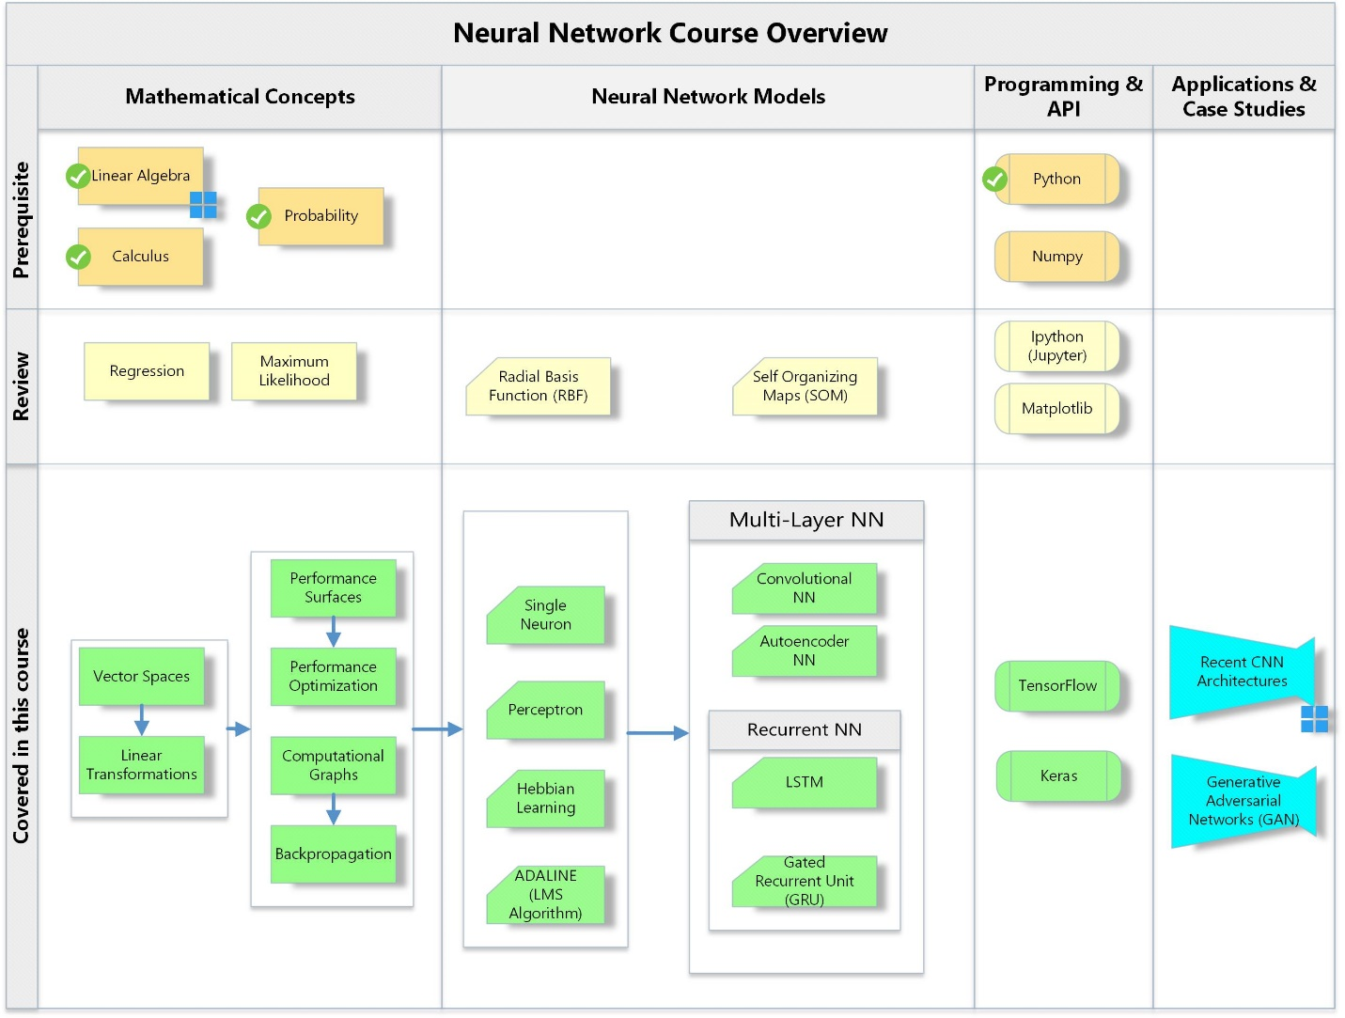

## Course Topics:

|  |  |
| --- | --- |
| Introduction  * Introduction to Python, Numpy, Matplotlib * Definitions * Historical background * Theoretical background * Matrix operations * Relationship to biological networks * Anatomy of a single neuron | Week 1 |
| Neuron Model and Network Architectures  * Artificial Neural Networks * Single neuron and single layer of neurons. * Inside an artificial neuron * Transfer functions * Multiple neurons * Topology of neural network architectures * Recurrent neural networks | Week 2 |
| Regression (Linear & Logistic)Perceptrons  * Definition * Learning rules * Convergence * Applications | Week 3 |
| Computational GraphsVector Spaces and Linear Transformations  * Vectors * Linear transformations * Matrix operations * Eigenvalues and Eigenvectors * Orthogonalization and diagnolization | Week 4 |
| Introduction to TensorFlow and KerasHebbian Learning  * Linear associator * The Hebb rule * Variations of Hebbian learning | Week 5 |
| Performance Surface and Optimization  * Tyler series * Directional Derivatives * Performance / cost functions * Quadratic functions (Eigensystem, Hessian) * MSE, Softmax, … * Steepest descent * Conjugate gradient | Week 6 |
| Widrow-Hoff Learning  * ADALINE * LMS Algorithm * Adaptive filtering | Week 7 |
| Multi-Layer Networks  * Backpropagation * Convolutional Neural Networks * Recurrent Neural Networks * Self-Organizing map * Raidal Basis Functions (RBF) | Week 8-11 |
| Applications of neural networks  * Pattern recognition & computer vision * Practical Considerations * Generative Adversarial Networks (GAN) * LSTM * GRU * AlexNet, GoogleNet, and ResNet * Visualization * Time series forecasting | Week 12-15 |

As the instructor for this course, I reserve the right to adjust this schedule in any way that serves the educational needs of the students enrolled in this course. –Farhad Kamangar.