

Part Number | 0250-46767
Revision | 06
Title | Global Comparable Raw Materials Cross Reference Standard
ECO Releasing this Rev. | 3172665
Original Document Author | Vince Kirchhoff/ Mohanraj Sundarrajan

APPLIED MATERIALS CONFIDENTIAL: This document and the information contained in it are confidential, and cannot be copied or disclosed in whole or in part without the expressed written consent of Applied Materials Inc. |   3050 Bowers Ave.,  Santa Clara, CA 95054

Applied Materials Document Template 0250-75116 Rev. 08

objective
The growth of Applied Materials and its changing business model has driven manufacturing to a global supply base in regions outside of the United States (US). Engineering requirements, referencing U.S. Industry standards for raw materials, (metals), are not always available in other manufacturing regions. This document provides quick identification for functionally comparable, design-acceptable materials (metals) referenced under both U.S. and International Standards, for Sizes and Composition.

scope
This document provides alternate and engineering comparable metals within an engineering allowance framework for Applied Materials use cases. It includes bar (square, flat, round, hexagonal), sheet, plate, structural and mechanical tube (square, round, rectangular) and structural profile shapes (H-beam, I-beam, angle, channel, and tee). This document provides quick solutions for alternatives on composition a quick cross-reference for controlling agency, national standards and imperial -vs- metric sizes. It serves as both an NPI design tool and for reference in revision change on Legacy products. It now includes SAP number cross-references for Applied Materials Display division

responsibility
It is the responsibility of Documentation and Data Control (D&DC) to maintain this document under the approval of divisional Design Engineering Authority (DEA).

requirements
4.1. Prerequisites
Knowledge of materials properties and how a selected material is likely to impact a design is a prerequisite for proper material selection. Material strength, ductility, weldability, and manufacturability are just a few factors that must be considered.
4.2. Critical Parameters
Full identification of material designation must be used to describe requirements. Use of the terms “CRS” or “HRS” without citing supporting standards incompletely describes materials critical parameters and is unacceptable.

4.3. Personnel
N/A
4.4. Safety
N/A
4.5. Drawing Update Process

DFX Engineering will lead the future revisions of this document.

This document will be reviewed every 12 to 18 months.

All updates will be performed with the Applied Materials ECO process, including a broadcast message to notify all Design Engineers throughout the company.

references

Acronyms/Definitions

AA- The Aluminum Association (USA) identifies uniform global standards for aluminum alloys identification, characteristics, and chemistry

AISI- American Iron and Steel Institute

Alloy Steel- Any of a variety of steels containing by mass percent .30 for chromium, .30 for cobalt, .40 for copper, .40 for lead, 1.65 for manganese, .08 for molybdenum, .30 for nickel

ASM- American Society for Metals

ASME- American Society of Mechanical Engineers

ASTM- American Society for Testing of Materials (baseline material standards for comparative alternative material standards selections)

Bar- metal non-structural shapes; rounds, squares, hexagons, flats (rectangular cross-sections)

BOM- Bill of Material

BS- British Standard. Material standards (EN…) aligned with most European national standards, commonly available in Malaysia

CRS (Cold Rolled Steel) - Low Carbon steel with a maximum carbon content of 10%. HRS processed by rolling at below recrystallization temperature. Results are closer thickness tolerance, smoother surface finish than hot rolled and oiled.

DEA- Design Engineering Authority

DIN- German Institute for Standardization. A material standard commonly used in Europe.

ECO-Engineering Change Order Document used for changes to all Applied Materials documents in the Teamcenter Lifecycle Manager.

EG-Electro Galvanized Sheet Steel (may use either HRS or CRS stock)

FAI-First Article Inspection

GA- “Manufacturers Standard Gage for Sheet Metal” for legacy commercial identification reference only. Currently not used by ASTM for carbon steel, stainless steel, or aluminum sheet. This standard uses only decimal values (inch or mm) for thickness identification of any sheet stock.

GB/T- National Standards of People’s Republic of China for materials

Global sourcing region. A global region considered to be a lower cost source than the US region.

GMOX - Global Materials Operations Supplier Site

HRS (Hot Rolled Steel) - Low Carbon steel with a maximum carbon content of 10%. Processed by rolling at above recrystallization temperature. Results are improved ductility; as rolled, mill scale surface is a rougher surface finish than CRS; P&O (pickled to remove mill scale & oiled) has a better surface finish similar to CRS.

HRP&O or HRPO – Hot Rolled, Pickled and Oiled (P&O) finish is used on HRS to remove rolling mill scale for a smoother & uniform surface; oiled to prevent corrosion. Available on HRS material stock ≤ 0.50” (12.5 mm) thick.

Imperial Units- Unit of measure in inches.

IS- Bureau of India Standards (BIS) for materials

ISO- International Standards Organization.

JIS- Japanese Industrial Standards for materials

KS- Korean National Standards for materials

Legacy Product- Products or components with Production released status in the Teamcenter Product Life Cycle Manager.

MEA-Manufacturing Engineering Authority.

National Standard- selected non-ASTM materials standards internationally recognized as a sourcing country’s national materials standards. These non-ASTM standards are comparable relative to base ASTM material standards.

NPI Product (New Product Introduction)- Products not released in the Teamcenter Product Life Cycle Manager. NPI or New Design is all first-time designs in the prototype or project in Phase 1 to 3 in PLC, or products outside of PLC in a redesign program, to add functionality or improve performance.

Oiled- A thin film of oil is applied to the surface of the material to prevent corrosion and aid in separation of sheets in large bundles.

Pickling – Chemical or electromechanical removal of surface oxides on metals. Process is applicable to both carbon and stainless steels.

PLC – Product Life Cycle

PO-Purchase Order.

SAE – The Society of Automotive Engineers

SAP Number- Material identification in SAP database assigned to types or classes of materials used by Applied Materials Display organization

SI –International System of Units (metric)

Sheet Metal – Any of a variety of metal alloys created by forming the metal between rollers to reduce thickness. Material is available in sheet or coil form. Per ASTM standards, HRS thickness range .0067-.2391 inch or 0.15-6.0 mm; CRS max commercial thickness is .142 inch or 3.6 mm. The material may be provided in either Metric or Imperial thickness units.

SNF – Supplier Notification Form used to communicate a change by a supplier to a new manufacturing location or sub-tier supplier.

SPS – Supplier Problem Sheet- Used by suppliers to communicate problems with production.

Stainless Steel – Steel with minimum of 11% chromium and a maximum carbon content less than 2%.

Standard – Voluntary consensus, related technical information, having internationally recognized quality and applicability that contribute to the reliability of materials, and facilitate national, regional, and international commerce.

Tube- metal hollow shapes defined by outer dimensions and material wall thickness; cross-sections are rounds, squares, rectangles.

UNS Number- Unified Numbering System for Metals and Alloys.

Werkstoff Number- DIN Material Numbers (contains a decimal point after the first numeric digit.

Reference Documents

Applied Materials Standard Drawing Notes Doc. 0250-01536

ASTM A6/A6M, Standard Specification for General Requirements for Rolled Structural Steel Bars, Plates, Shapes, and Sheet Piling

ASTM A29/A29M, Standard Specification for Steel Bars, Carbon and Alloy, Hot –Wrought, General Requirements for

ASTM A36/A36M, Standard Specification for Carbon Structural Steel

ASTM A108/A108M, Standard Specification for Steel Bar, Carbon and Alloy, Cold Finished

ASTM A167, Standard Specification for Stainless and Heat-Resisting Chromium-Nickel Steel Plate, Sheet, and Strip (Inactive, see ASTM A240)

ASTM A 240/A240M, Standard Specification for Chromium, Chromium –Nickel, Stainless Steel Plate, Sheet, and Strip for Pressure Vessels and for General Applications (combined content from inactive ASTM A167)

ASTM A 276/A276M, Standard Specification for Stainless Steel Bars and Shapes

ASTM A283/A283M, Standard Specification for Low and Medium Tensile Strength Carbon Steel Plates

ASTM A311/A311M, Standard Specification for Cold-Drawn, Stress-Relieved Carbon Steel Bars Subject to Mechanical Property Requirements

ASTM A400, Standard Practice for Steel Bars, Selection Guide, Composition, and Mechanical Properties

ASTM A480/A480M, Standard Specification for General Requirements for Flat-Rolled Stainless and Heat Resisting Steel Plate, Sheet, and Strip

ASTM A484/A484M, Standard Specification for General Requirements for Stainless Steel Bars, Billets, and Forgings

ASTM A500/A500M, Standard Specification for Cold Formed Welded and Seamless Carbon Steel Structural Tubing in Rounds and Shapes

ASTM A511/A511M, Standard Specification for Seamless Stainless Steel Mechanical Tubing and Hollow Bar

ASTM A513/A513M, Standard Specification for Electric-Resistance-Welded Carbon and Alloy Steel Mechanical Tubing

ASTM A514/A514M, Standard Specification for High Yield Strength, Quenched and tempered Alloy Steel Plate, Suitable for Welding

ASTM A554, Standard Specification for Welded Stainless Steel Mechanical Tubing

ASTM A568/A568M, Standard Specification for Steel, Sheet, Carbon, Structural, and High Strength, Low Alloy, Hot Rolled, Cold Rolled, General requirements for

ASTM A572/A572M, Standard Specification for High Strength Low Alloy Columbium-Vanadium Structural Steel

ASTM A633/A633M, Standard Specification for Normalized High Strength Low-Alloy Structural Steel Plates

ASTM A635/A635M, Standard Specification for Steel, Sheet, Strip, Heavy Thickness Coils, Hot-Rolled, Alloy, Carbon, Structural, High-Strength Low-Alloy, and High-Strength Low-Alloy with Improved Formability, General Requirements for

ASTM A653/A653M, Standard Specification for Steel Sheet, Zinc-Coated (Galvanized) or Zinc-Iron Alloy-Coated (Galvannealed) by the Hot-Dip Process

ASTM A656/A656M, Standard Specification for Hot-Rolled Structural Steel, High-Strength Low-Alloy Plate with Improved Formability

ASTM A786/A786M, Standard Specification for Hot-Rolled Carbon, Low-Alloy, High-Strength Low-Alloy, and Alloy Steel Floor Plates

ASTM A790/A790M, Standard Specification for Seamless and Welded Ferritic/Austenitic Stainless Steel Pipe

ASTM A793, Standard Specification for Rolled Floor Plate, Stainless Steel

ASTM A879/A879M, Standard Specification for Steel Sheet, Zinc Coated by the Electrolytic Process for Applications Requiring Designation of the Coating mass on Each Surface (Supersedes ASTM A591)

ASTM A959, Standard Guide for Specifying Harmonized Standard Grade Compositions for Wrought Stainless Steels

ASTM A992/A992M, Standard Specification for Structural Steel Shapes

ASTM A1008/A1008M, Standard Specification for Steel, Sheet, Cold -Rolled, Carbon, Structural, High-Strength Low-Alloy, High-Strength Low-Alloy with Improved Formability, Solution Hardened, and Bake Hardenable (Supersedes ASTM A366/A366M)

ASTM A1011/A1011M, Standard Specification for Steel, Sheet and Strip, Hot-Rolled, Carbon, Structural, High-Strength Low-Alloy with Improved Formability, and Ultra-High Strength (Supersedes ASTM A569)

ASTM A1016/A1016M, Standard Specification for General Requirements for Ferritic Alloy Steel, Austenitic Alloy Steel, and Stainless Steel Tubes

ASTM A1018/A1018M, Standard Specification for Steel, Sheet and Strip, Heavy-Thickness Coils, Hot-Rolled, Carbon, Commercial, Drawing, Structural, High-Strength Low-Alloy, High-Strength Low-Alloy with Improved Formability, and Ultra-High Strength

ASTM B209/B209M, Standard Specification for Aluminum and Aluminum- Alloy Sheet and Plate

ASTM B210/B210M, Standard Specification for Aluminum and Aluminum-Alloy Drawn Seamless Tubes

ASTM B211/B211M, Standard Specification for Aluminum and Aluminum-Alloy Rolled or Cold Finished Bar, Rod, and Wire

ASTM B221-B221M, Standard Specification for Aluminum and Aluminum-Alloy Extruded Bars, Rods, Wire, Profiles and Tubes

ASTM B632/B632M, Standard Specification for Aluminum-Alloy Rolled Tread Plate

ASTM B308/B308M, Standard Specification for Aluminum-Alloy 6061-T6 Standard Structural Profiles

ANSI H35.1/H35.1M, American National Standard Alloy and Temper Designation Systems for Aluminum

ANSI H35.2/H35.2M, American National Standard, Dimensional Tolerances for Aluminum Mill Products

A Comprehensive Review of Chinese Material Standards for AMAT Applications: Dr. Frank Chen, 2007

ASTM DS67D, Handbook of Comparative World Steel Standards, Fifth Edition, John E. Bringas, 2016, ISBN-EB: 978-0-08031-7078-0

ASTM E527, Standard Practice for Numbering Metals and Alloys in the Unified Numbering System (UNS)

methods

Procedure
This document applies to all existing and future products for Applied Materials that are fabricated from materials covered in this standard. Materials Selection Matrix (MSM) (see Appendix tables section 7.0) may be used to make a material or alternate material selection(s). Legacy or NPI categories, described in sections 6.1.1 to 6.1.2, are business cases that will drive the use of this document. The process is different for each category. The details of each method are as follows:

    - Legacy Product: 3 cases

      - Change of Region: A Purchase Order (PO) is issued to a regional supplier from Global materials or a global supplier moving the legacy part from an existing approved location (usually US based) to another global region, where the materials specified on the drawing are not readily available.
The new supplier or supplier location must request an alternate material with an SPS. The SPS must be submitted in GMOX and routed to the appropriate approver. When specifying a Material from the MSM, all Manufacturing Engineers, Design Engineers, and SPS approvers, should list the ASTM specification on the drawing. The Engineer shall also validate that any material from that material group may be substituted without notification to Applied Materials. The First Article Inspection shall include the Material Certs for the substituted material. The resulting ECO for this SPS is a document change only ECO.

      - Change in Material Standard: The referenced Industry Standard has been made obsolete or superseded by another Industry Standard.
        - The requestor is informed that the specified material is no longer available and has been obsoleted or superseded. The supplier shall submit an SPS requesting an update to the drawing for an alternate material. Provided the supplier has knowledge of the MSM, they may also provide that information in the SPS request, stating that the material selection is from the matrix listed in this document. With no recommendation from the supplier the SPS approver is to return the SPS for further clarification and include the MSM from this document for the supplier to select an available material for the applicable global supply region. Once the supplier has completed the SPS with an appropriate material selection, based on the region, the approver must validate the selection and approve the SPS. The results of the approved SPS are the alternate material will be used to fabricate the part. If the ECO reviewer discovers that the listed material is no longer available and has been obsoleted or superseded, the reviewer shall log an issue with the ECO and request an update to the material specified on the drawing. Provided the reviewer has knowledge of the MSM, they may also provide that information in the issue, stating that the material selection is from the matrix listed in this document. At this point the engineer for the product (DEA or MEA) will validate the selection from the matrix (or with no recommendation provide an appropriate selection to the ECO). When specifying a Material from the MSM, all Manufacturing Engineers, Design Engineers, and SPS approvers, should list the ASTM specification on the drawing. The Engineer shall also validate that any material from that material group may be substituted without notification to Applied Materials. The First Article Inspection shall include the Material Certs for the substituted material. The resulting ECO for this SPS is a document change only ECO.

      - Generic Material Call-out: The material call out on the original drawing is a generic term (such as CRS) and a more specific material call out is required to order the material from the materials supplier. This is not allowed and is representative of an incomplete drawing.
        - Procurement of raw material requires the specification of material with reference to an industry standard. The MSM in this document should be used to select the material that meets the requirements of the drawing and is most economical for the supplier. An SPS is submitted, and the reviewer validates conformance to the MSM. An SPS without an industry standard specification will be returned for further clarification. When specifying a Material from the MSM, all Manufacturing Engineers, Design Engineers, and SPS approvers, should list the ASTM specification on the drawing. The Engineer shall also validate that any material from that material group may be substituted without notification to Applied Materials. The First Article Inspection shall include the Material Certs for the substituted material. The reviewer should provide guidance to the supplier, so the supplier can conform to the MSM. The resulting ECO for this SPS is a document change only ECO.

    - NPI or New Design products:

      - Materials selection process: All new metal products shall have a recognized global standard material specified in the title block, drawing BOM, or in a drawing note unless specifically required by the design engineer (see Exceptions). And the drawing notes shall also include the note format described below.
        - Use of the MSM- When specifying a Material from the MSM, all Design Engineers should list the ASTM specification on the drawing. The Engineer shall also validate that any material from that material group may be substituted without notification to Applied Materials. The First Article Inspection shall include the Material Certs for the substituted material.

    - Proper Drawing Note:
      - For all cases above, use the following Standard Drawing Note.
“ALTERNATE MATERIALS ALLOWED PER 0250-46767.”
      - This note is available in the Standard Notes Document, 0250-01536.
      - Identify selected material’s requirements clearly on or in the drawing BOM by fully referencing its industry standard, grade or class, and shape found in this document.
      - Stating only CRS, HRS, CRES or SST are NOT acceptable
      - If sheet or plate is used to form a “shape” like an angle, in the drawing or the BOM, it should state “sheet or plate” not “angle”. The term “angle” would only be used on a raw material of a rolled-structural shape.

Exceptions

Other required specialized design attributes such as a materials magnetic property, high yield strengths, heat treat ability, conductivity, temper conditions, etc. or other needed functional properties that are not the norm in fabrication should be reasons for not invoking this document and constitute an “exception” in its use.

The Design Engineer may choose to limit the use of global substitutions. The Design Engineer may choose to limit an individual component’s raw material to a global region, or to a specific globally recognized material standard. He should consider that this may cause higher pricing and increased lead times if the part is sourced in any global sourcing region.

APPENDIX TABLES

Description of table use

For legacy or NPI parts the DEA should select the desired functional material, (size & grade or type). Use the ASTM designation and place it on the drawing in a separate general note. Once delineated on the drawing by notation, the general user, (supplier or other) may select and supply (unless otherwise specified), an alternate comparable material.

In the BOM or in the default material block of the drawing the DEA should add “SEE NOTES”. A separate note should be added to the general notes as shown in section 6.1.3.

If a table is marked as “Restricted Use”, the prohibited use conditions are defined in the “Restricted Use Declaration” accompanying the table.

This document and the tables and information herein will be updated at each subsequent revision.

For part validation requirements, the supplier must refer to Applied Materials First Article Inspection Requirements, 2-60.1.

Appendix and Table Listing
This document contains 9 material groups.
Group 1: Low-Medium Carbon Steel Sheet & Plate [Table 3]
Group 2: Low-Medium Carbon Steel Bar (Rounds, Squares, Hexagons, Flats) [Table 3.1]
Group 2: Steel Structural Shapes (Angle, Channel, H-beam, I-beam, Tee) [Table 3.3]
Group 3: Low-Medium Carbon Steel Tube (Rounds, Squares, Rectangles) [Table 3.2]
Group 4: Stainless Steel Sheet, Strip & Plate [Table 4]
Group 5: Stainless Steel Bar (Rounds, Squares, Hexagons, Flats) [Table 4.1]
Group 5: Stainless Structural Shapes (Angle, Channel, H-beam, I-beam, Tee) [Table 4.3]
Group 6: Stainless Steel Tube (Rounds, Squares, Rectangles) [Table 4.2]
Group 7: Aluminum Sheet, Strip & Plate [Table 5]
Group 8: Aluminum Bar (Rounds, Squares, Hexagons, Flats) [Table 5.1]
Group 8: Aluminum Structural Shapes (Angle, Channel, Beam, Tee) [Table 5.3]
Group 9: Aluminum Tube- Seamless, D & E (Rounds, Squares, Rectangles) [Table 5.2]
Appendices A and B provide Quick Pick User information containing Cross Reference Materials that can be freely substituted. Most of the time this is all the users will need.
Appendices C, D and E provide greater detailed data on material composition. Can be used if closer scrutiny and materials composition match is desired or to determine which entries may be excluded by exception.
All tables listed under the Appendices are hyperlinked to the corresponding table images at the end of the document. For high-resolution display of these table’s contents use the separate Excel file if these lower resolution images do not provide sufficient resolution to clearly display all relevant content for any materials listed in this document.

Appendix A – Quick Pick Thickness Tables (Imperial to Metric)
Carbon and Stainless Steels and Aluminum.

TABLE 1 – Quick Pick SHEET Thickness Cross Reference
Carbon and Stainless Steels and Aluminum.

TABLE 2 – Quick Pick PLATE Thickness Cross Reference

Appendix B – Quick Pick for Global Material Substitutions
Carbon Steel Sheet, Plate, Bar, Tube.

TABLE 3 – Carbon Sheet & Plate (Group 1 Material)

TABLE 3.1 – Carbon Bar (Group 2 Material)

TABLE 3.2 – Carbon Tube (Group 3 Material)

TABLE 3.3 – Carbon Structural Shapes (Group 2 Material)
Stainless Steel Sheet, Plate, Bar, Tube.

TABLE 4 – Stainless Steel Sheet & Plate (Group 4 Material)
        - TABLE 4.1 – Stainless Steel Bar (Group 5 Material)
        - TABLE 4.2 – Stainless Steel Tube (Group 6 Material)
        - TABLE 4.3 – Stainless Steel Structural Shapes (Group 5 Material)
Aluminum Sheet, Plate, Bar, Tube – Restricted Use.

TABLE 5 – Aluminum Sheet Metal & Plate (Group 7 Material)

TABLE 5.1 – Aluminum Bar (Group 8 Material)

TABLE 5.2 – Aluminum Tube (Group 9 Material)

TABLE 5.3 – Aluminum Structural Shapes (Group 8 Material)

Appendix C – Sheet Thickness Tolerance Tables
Table for reference only.

TABLE 6 – Quick tolerance reference chart CRS-HRS Carbon Sheet.
Table for reference only.

TABLE 7 – Quick tolerance reference chart Stainless Sheet.
Table for reference only.

TABLE 8 - Quick tolerance reference chart Aluminum Sheet.

Appendix D – Plate Thickness (Imperial & Metric) Tolerance Tables
Table for reference only.

TABLE 9 – Hot Rolled Carbon Steel Plate.
Table for reference only.

TABLE 10 – Stainless Steel Plate.
Table for reference only.

TABLE 11 – Aluminum Plate.

Appendix E – Detailed Global Chemical & Mechanical Comparison Tables
Table for reference only.

TABLE 12 – Carbon Steel Sheet & Plate (Group 1 Material) Chemical & Mechanical Properties.

Table for reference only.

TABLE 12.1 – Carbon Steel Bar and Shapes (Group 2 Material) Chemical & Mechanical Properties.

Table for reference only.

TABLE 12.2 – Carbon Steel Tube (Group 3 Material) Chemical & Mechanical Properties.
Table for reference only.

TABLE 13 - Stainless Steel Sheet & Plate (Group 4 Material) Chemical and Mechanical Properties.

Table for reference only.

TABLE 13.1 - Stainless Steel Bar and Shapes (Group 5 Material) Chemical & Mechanical Properties.

Table for reference only.

TABLE 13.2 - Stainless Steel Tube (Group 6 Material) Chemical & Mechanical Properties.
Table for reference only.

TABLE 14 – Aluminum Sheet & Plate (Group 7 Material) Chemical & Mechanical Properties.

Table for reference only.

TABLE 14.1 – Aluminum Bar and Shapes (Group 8 Material) Chemical & Mechanical Properties.
Table for reference only.

TABLE 14.2 – Aluminum Tube (Group 9 Material) Chemical and Mechanical Properties.
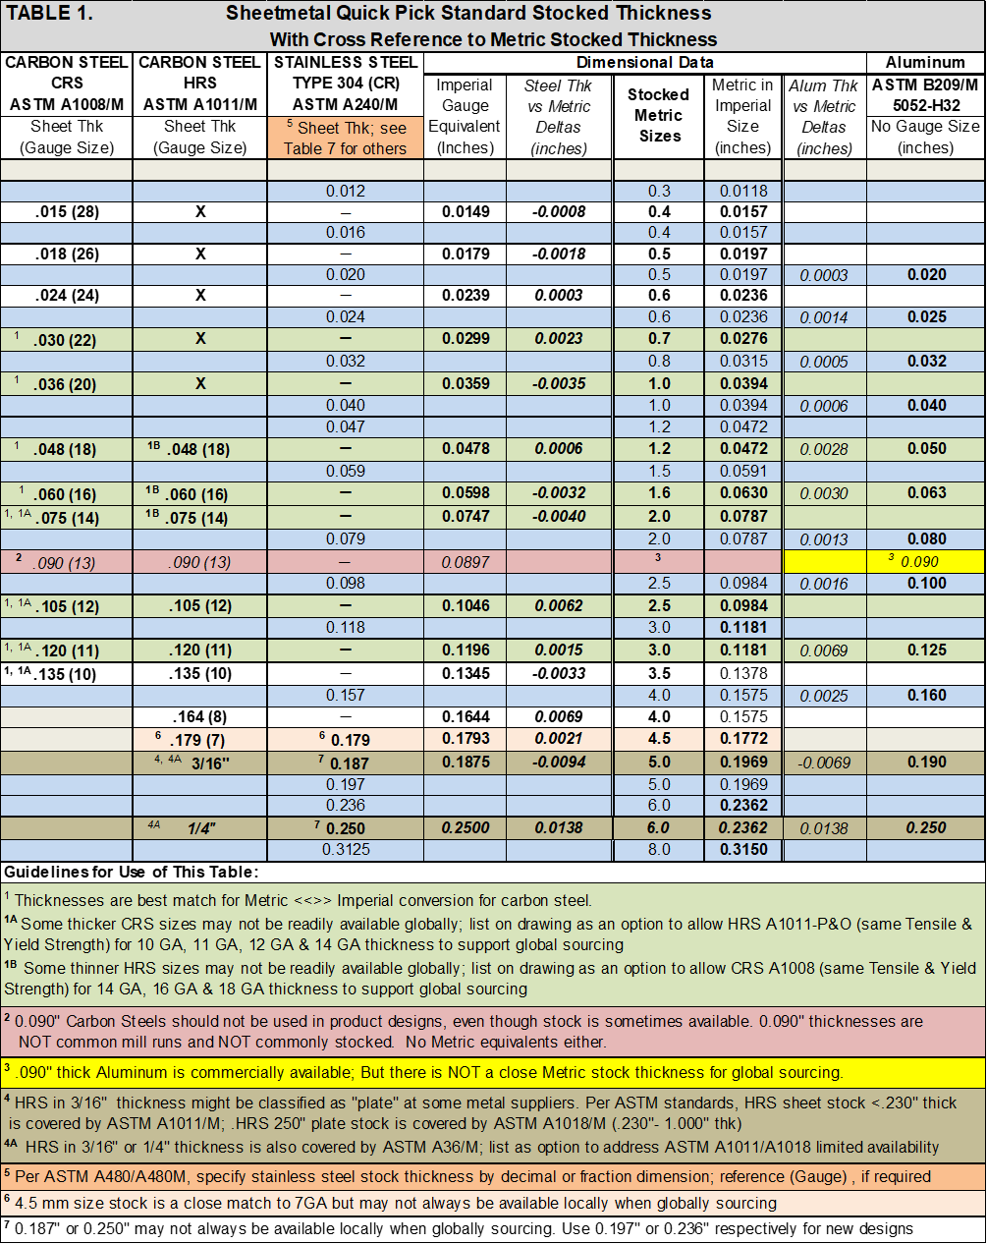
Back to appendix- A

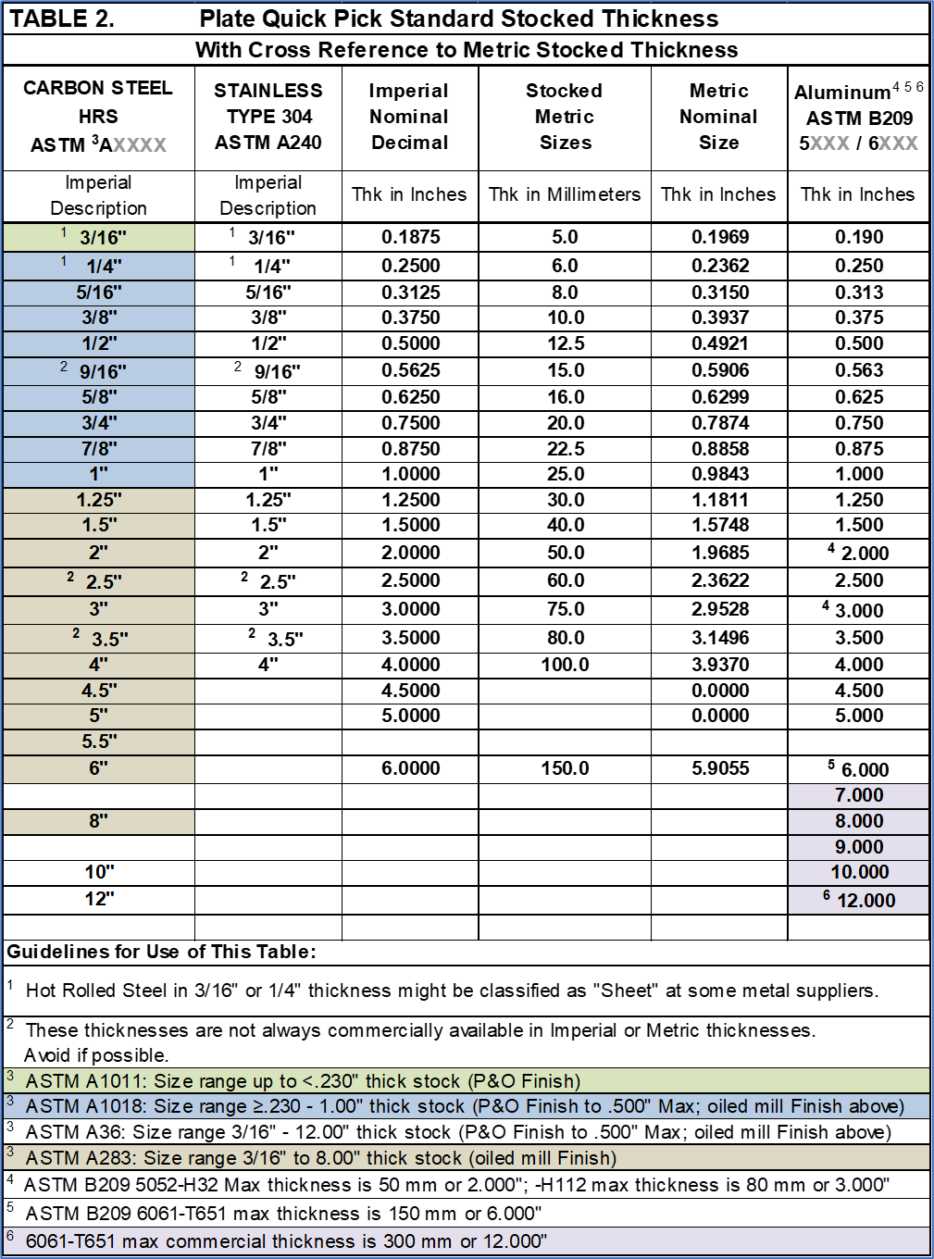

Back to Appendix A

Back to Appendix-B

Back to appendix-b
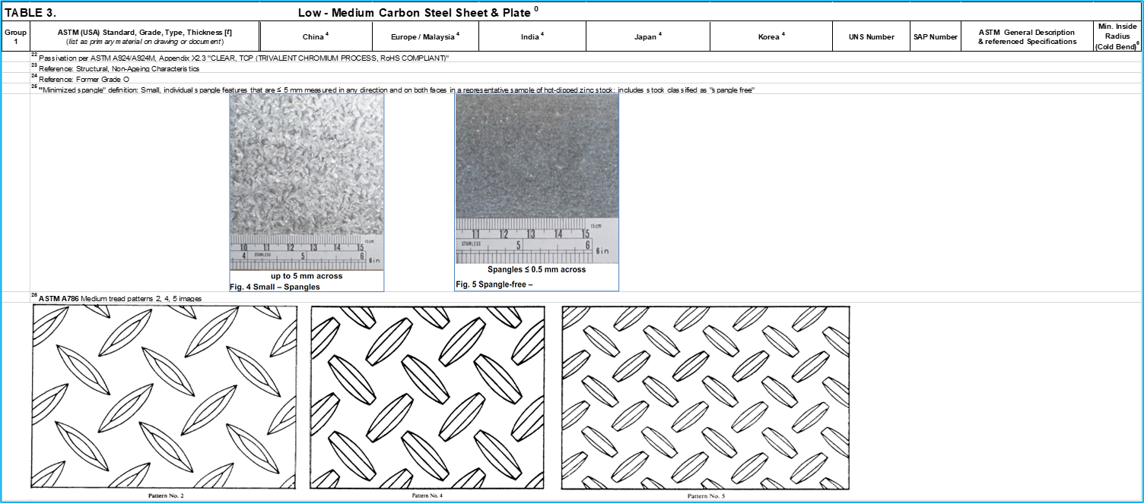
Back to appendix-b

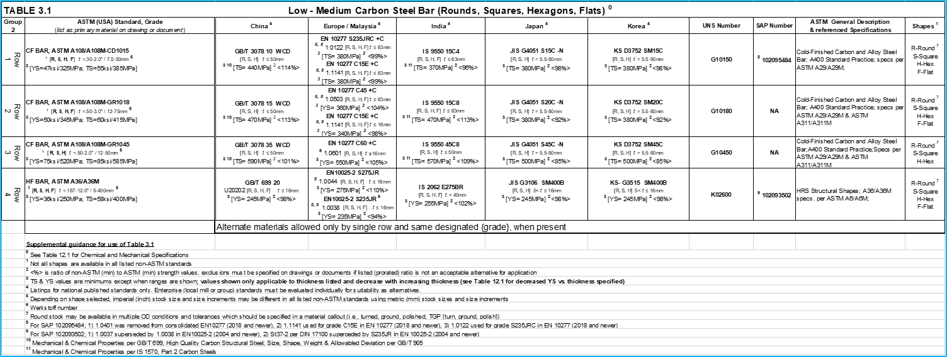
Back to appendix-b

Back to appendix-b

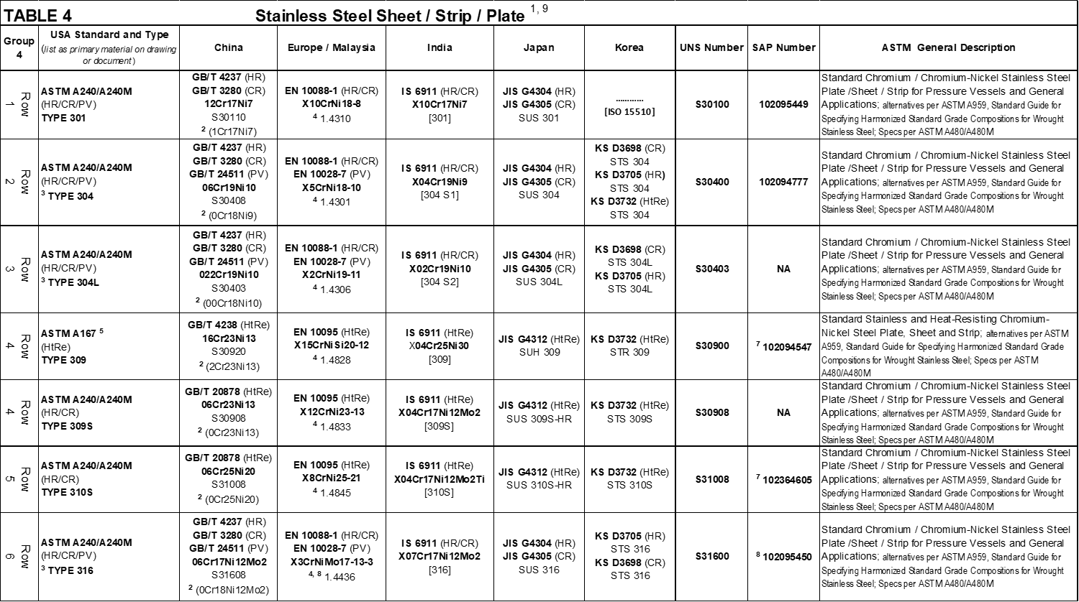
Back to appendix-b
Back to appendix-b

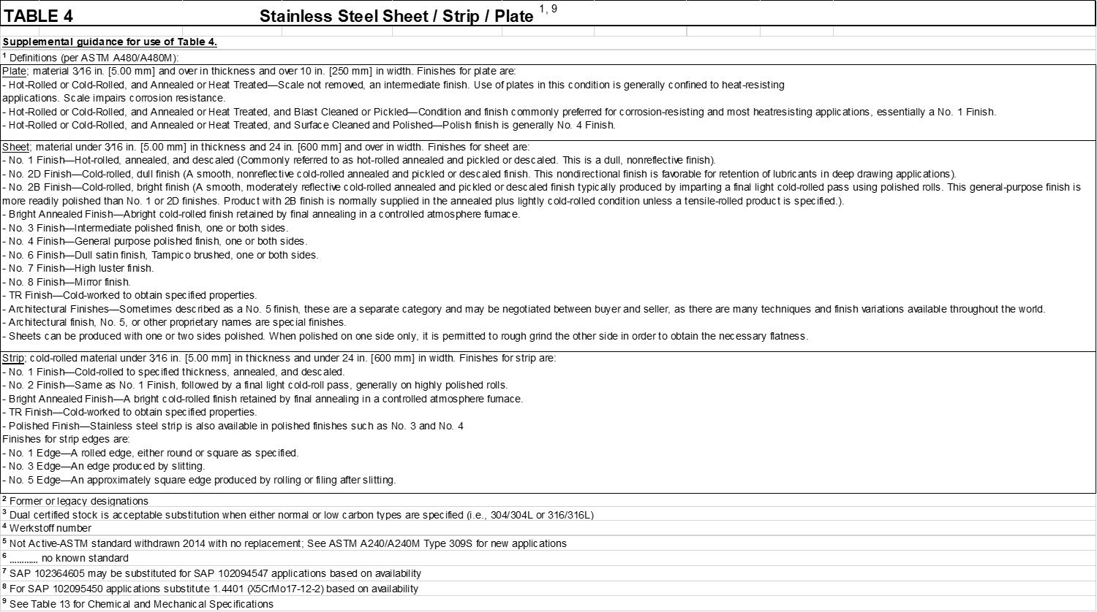
BACK TO APPENDIX-B

BACK TO APPENDIX-B
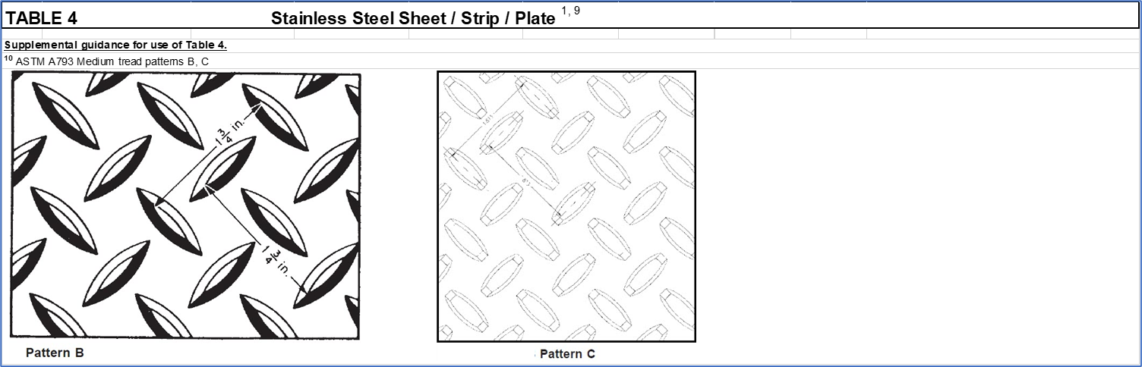

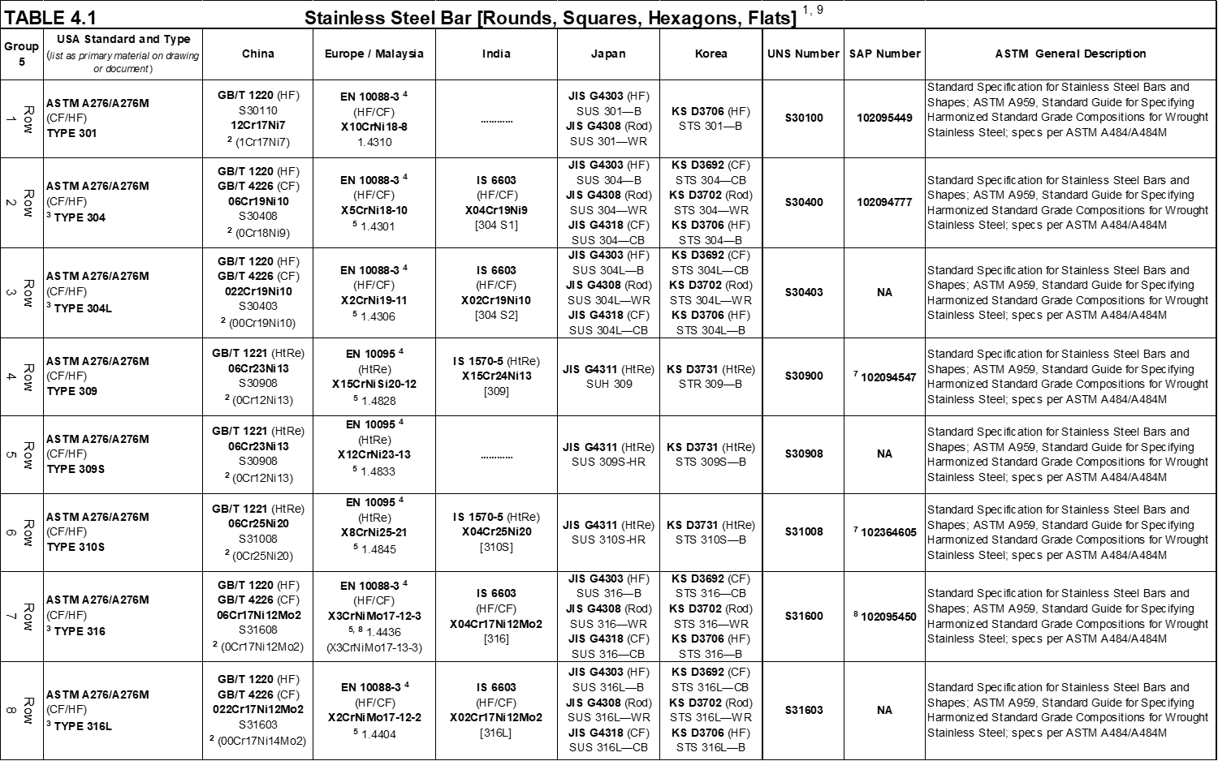
BACK TO APPENDIX-B

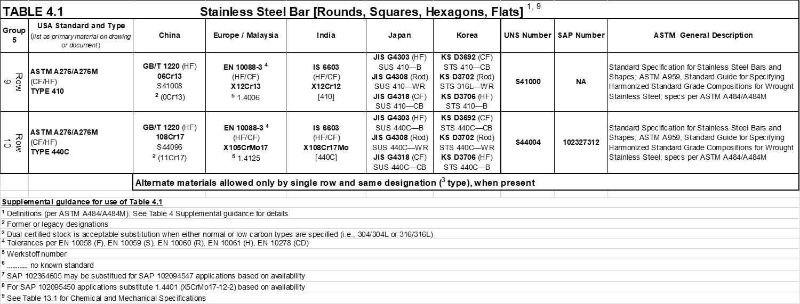
BACK TO APPENDIX-B

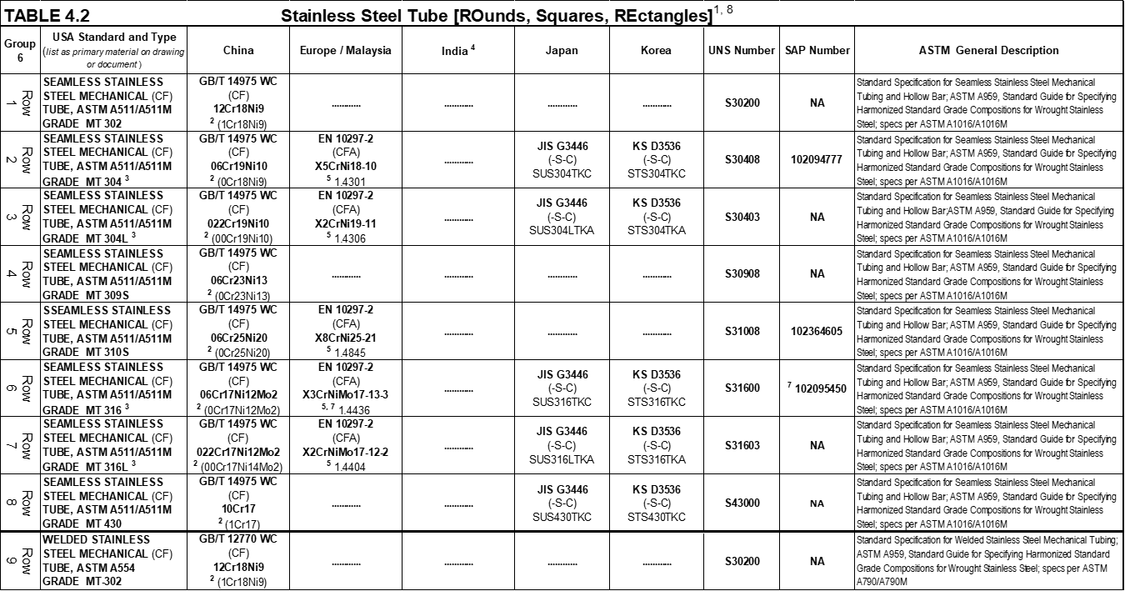
BACK TO APPENDIX-B

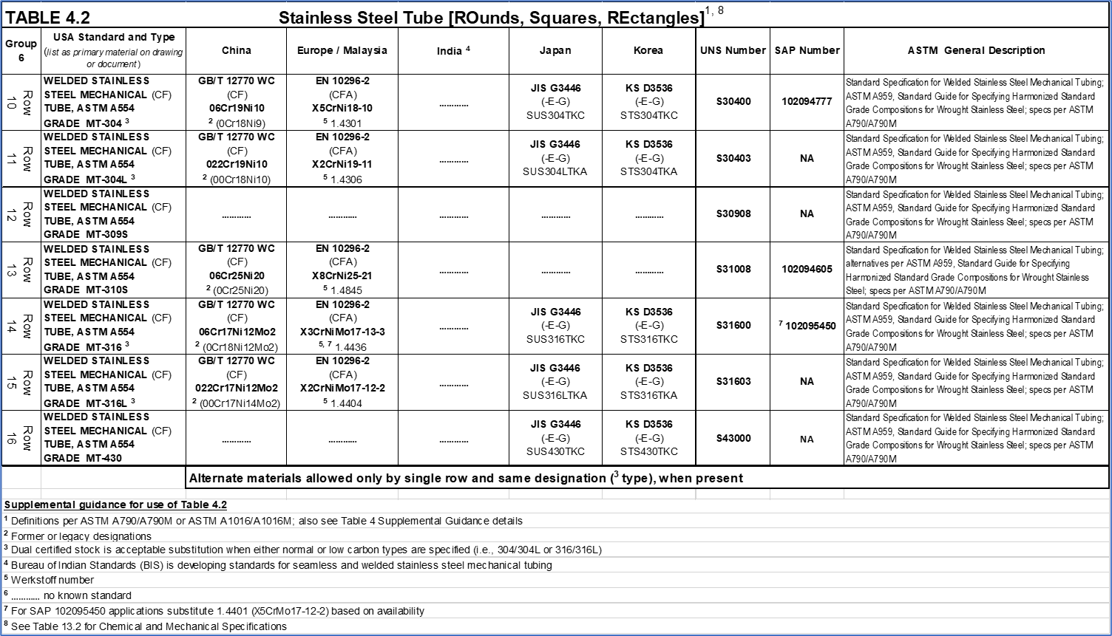
BACK TO APPENDIX-B

BACK TO APPENDIX-B

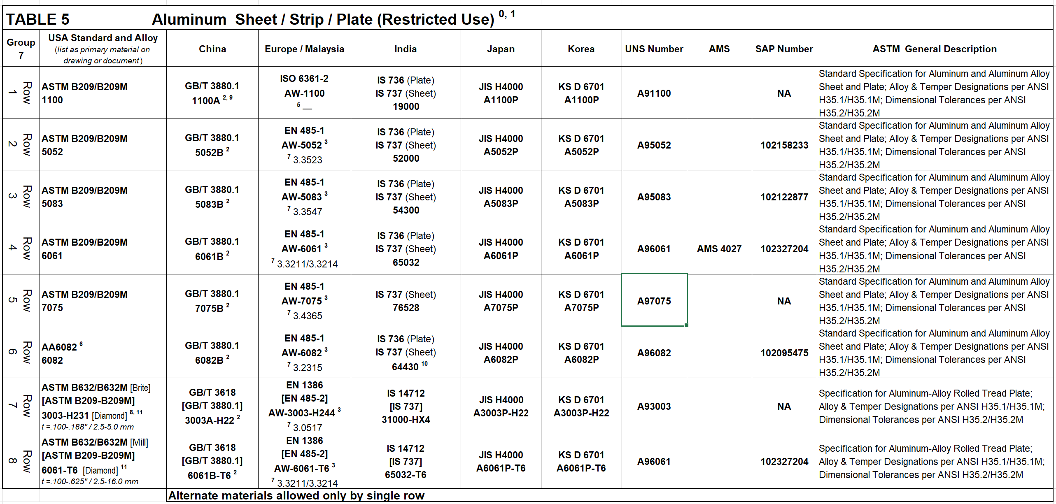Back to appendix-b

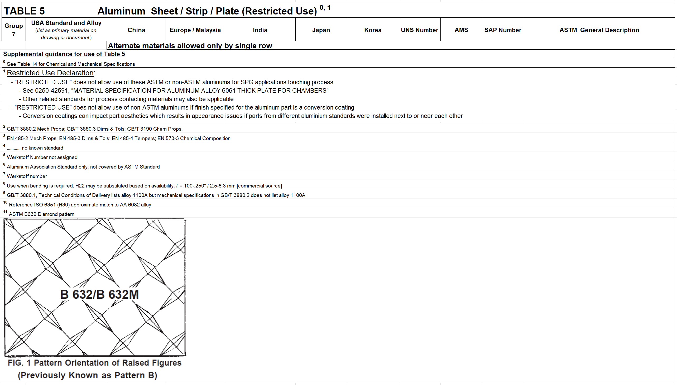Back to appendix-b

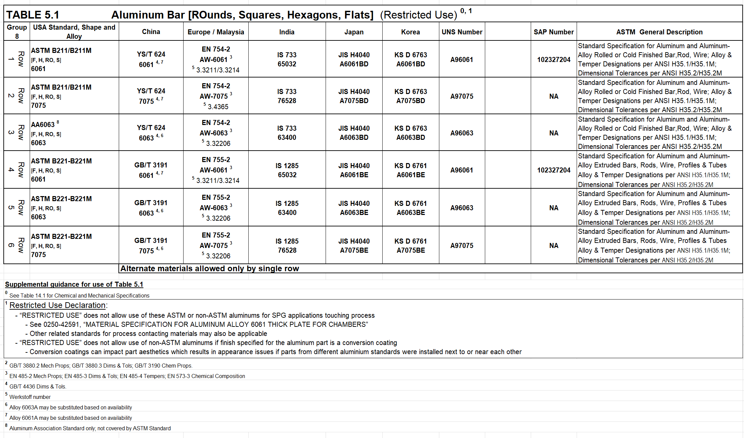Back to appendix-b

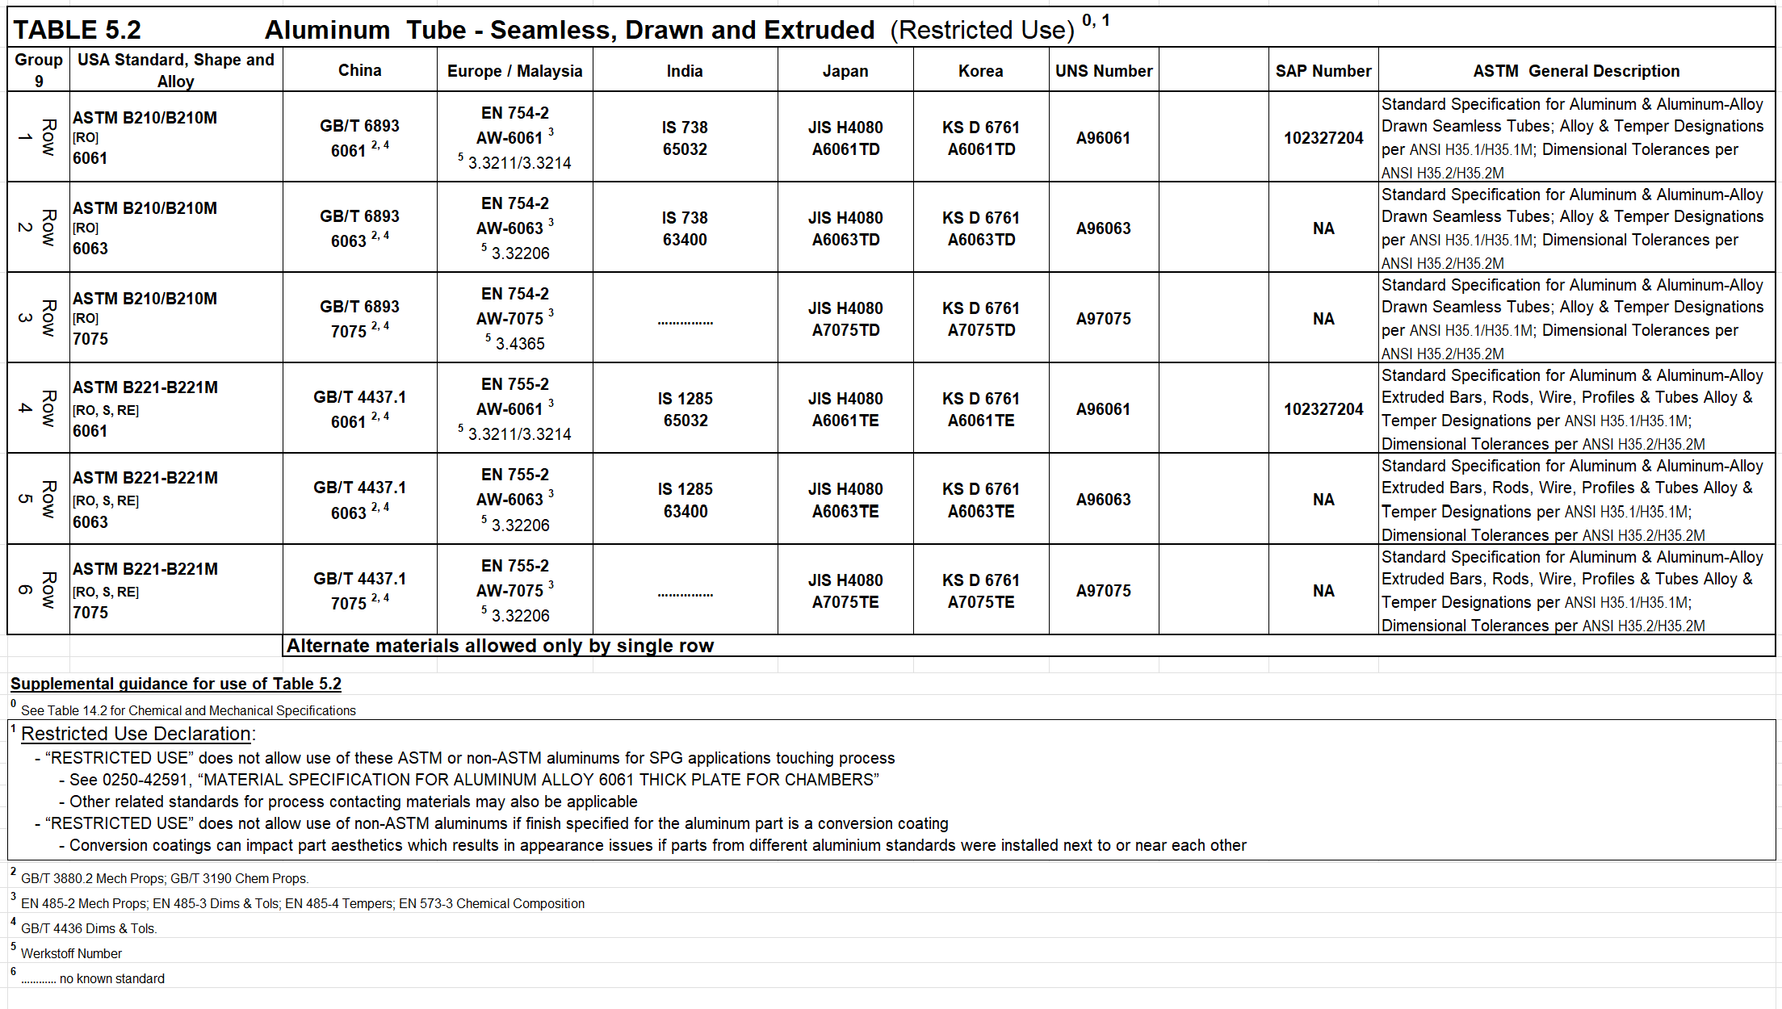Back to appendix-b

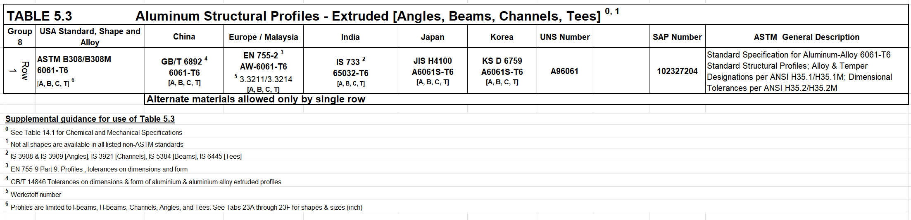Back to appendix-b

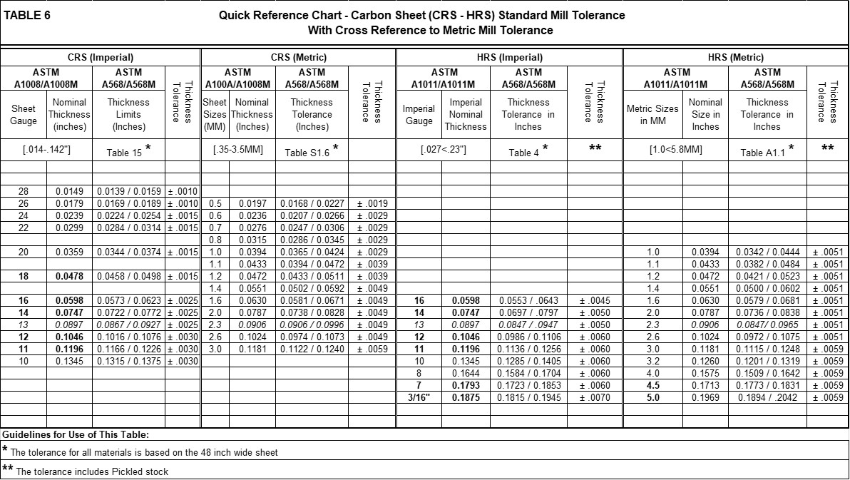
back to appendix-c

back to appendix-c

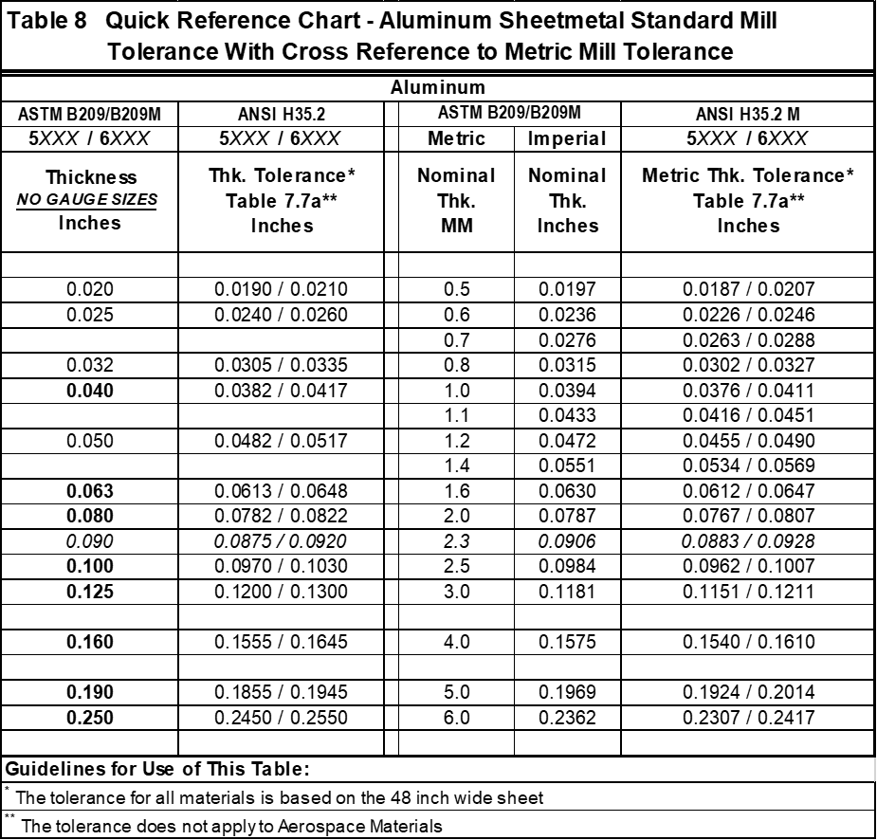
back to appendix-c

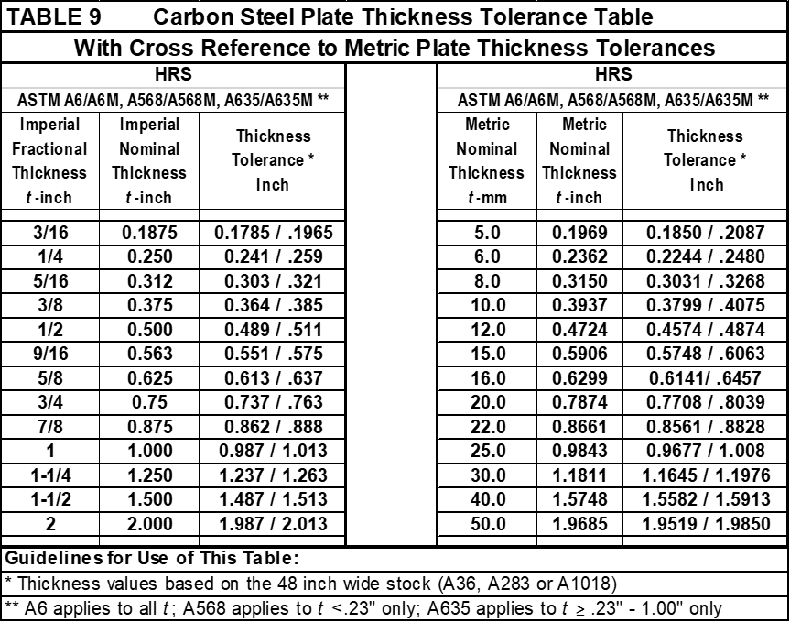
bACK TO APPENDIX- d

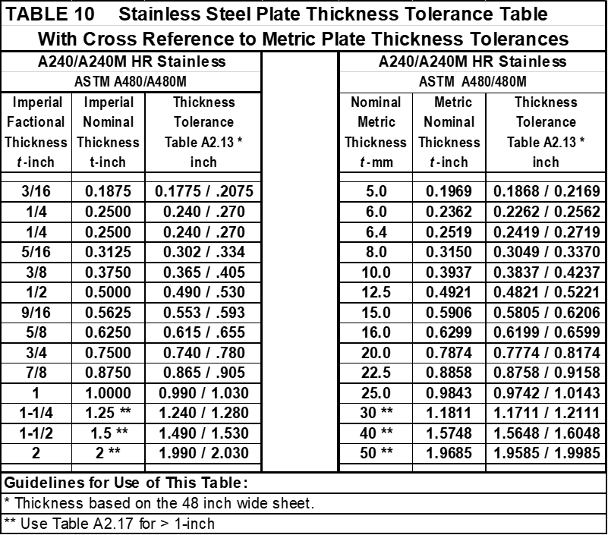
Back to appendix- d

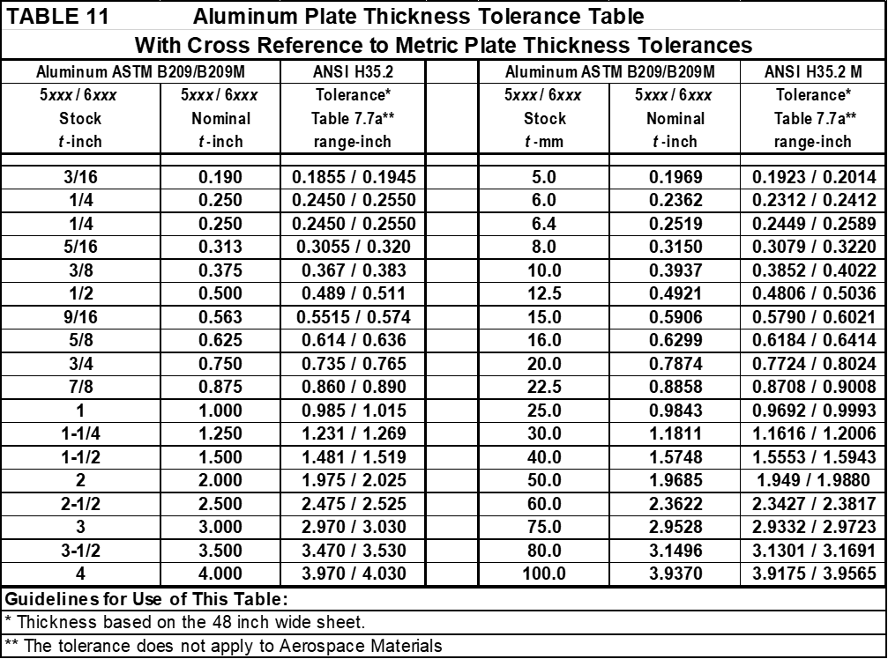
Back to appendix- d

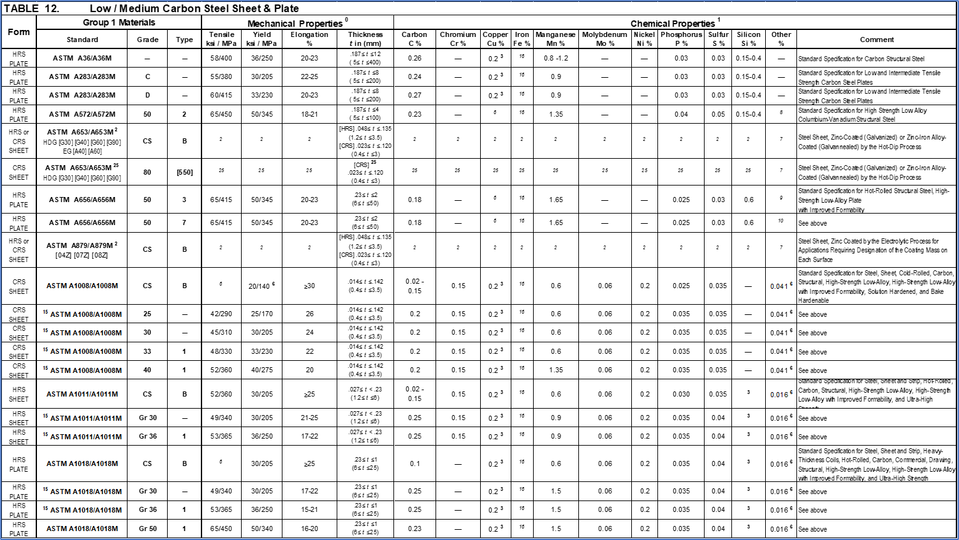
Back to appendix- E

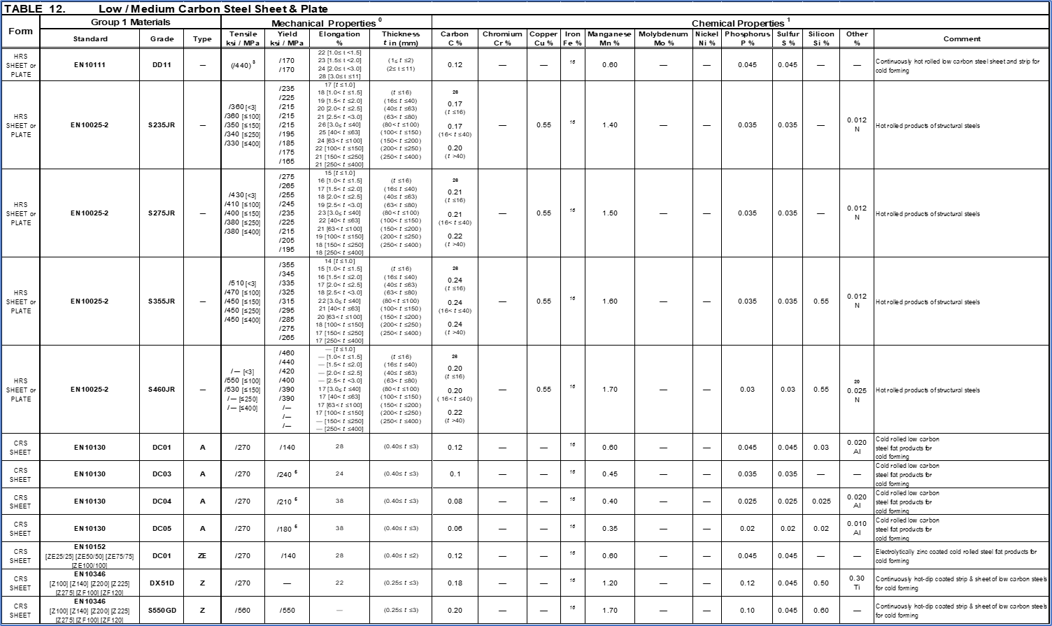
Back to appendix- E

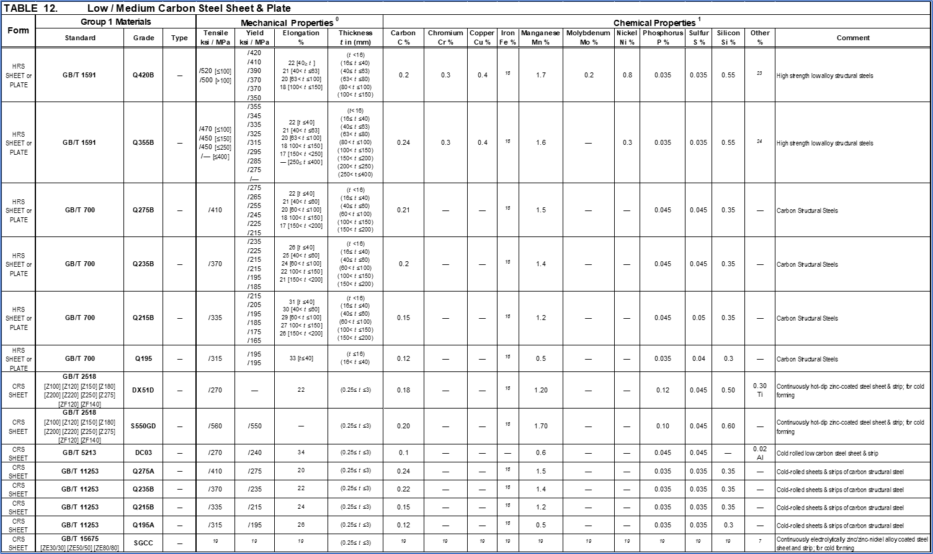
Back to appendix- E

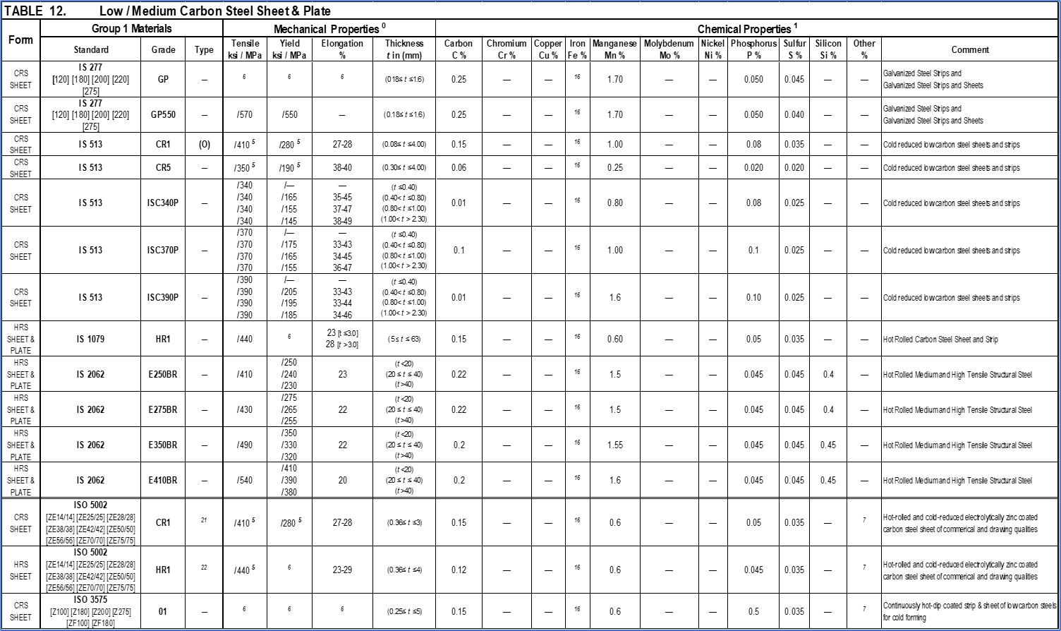
Back to appendix- E
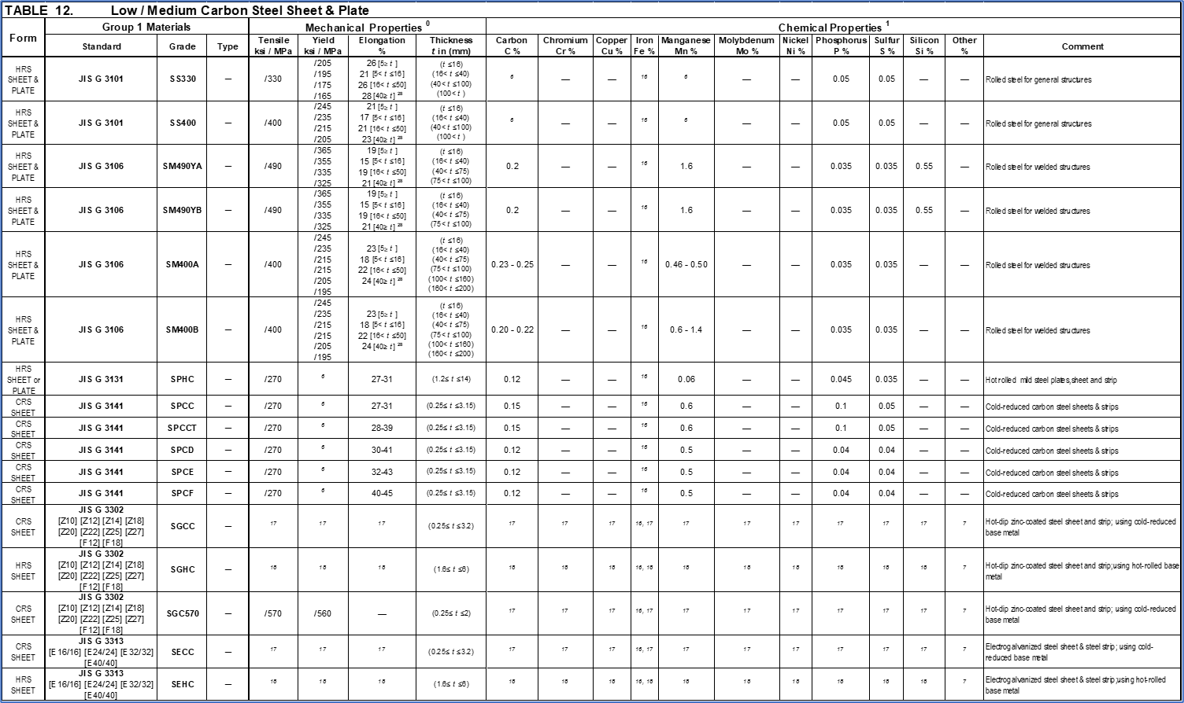
Back to appendix- E
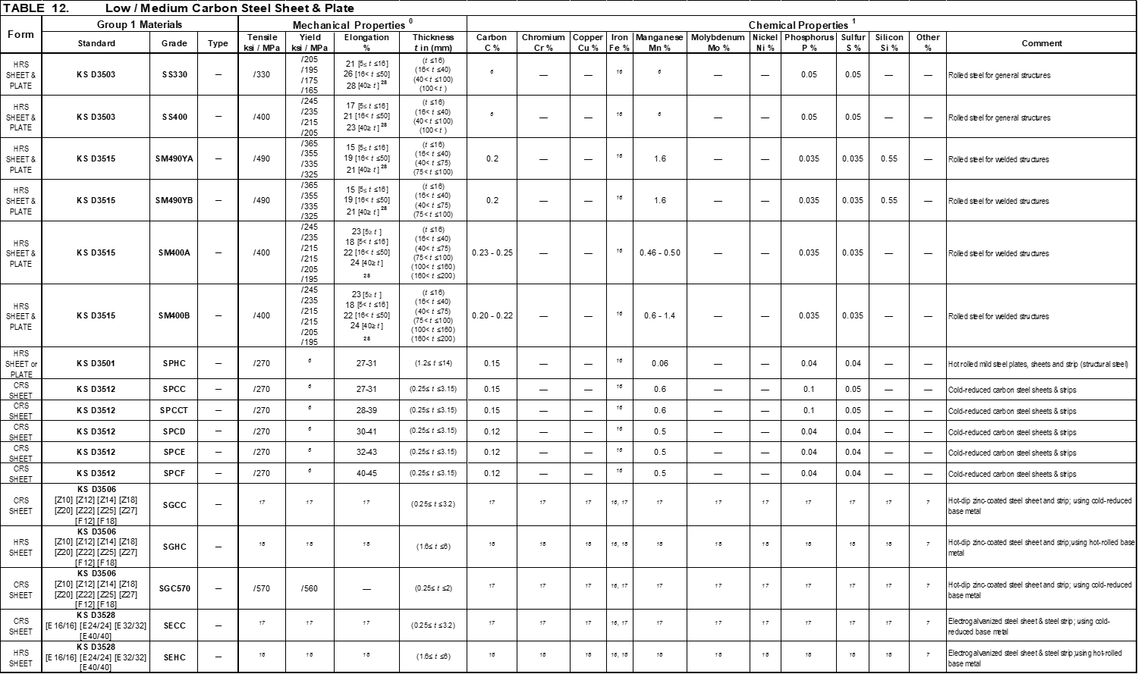
Back to appendix- E
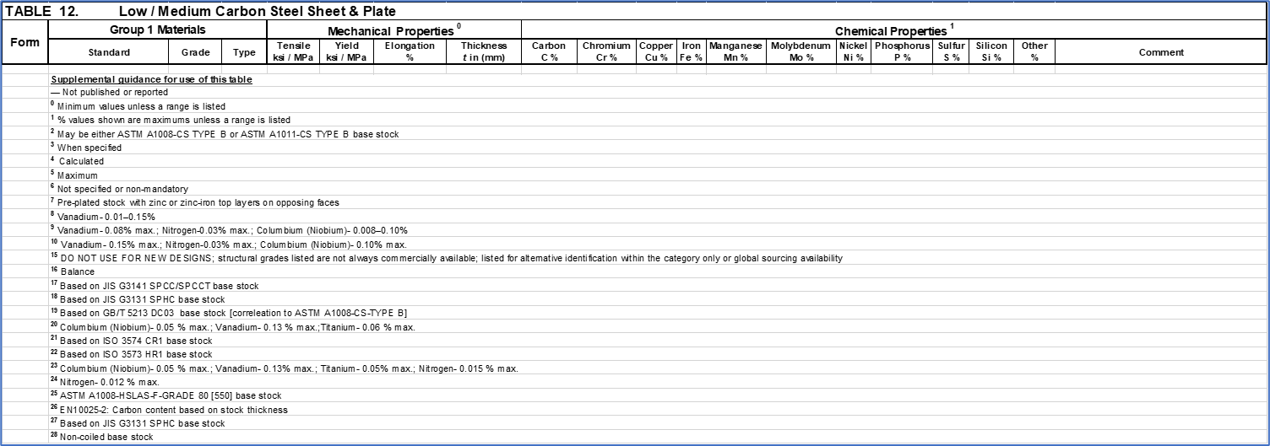
Back to appendix- E
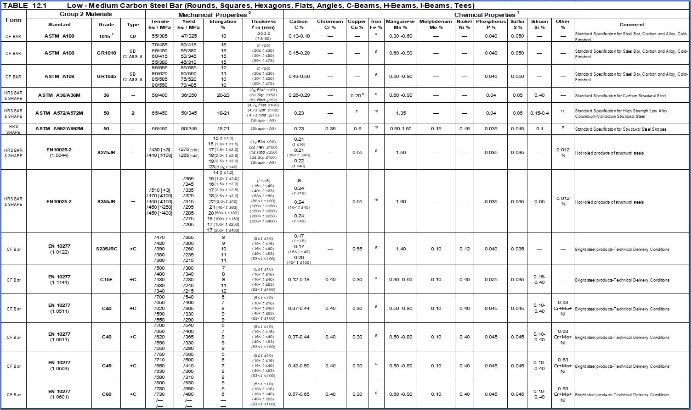
Back to appendix- E
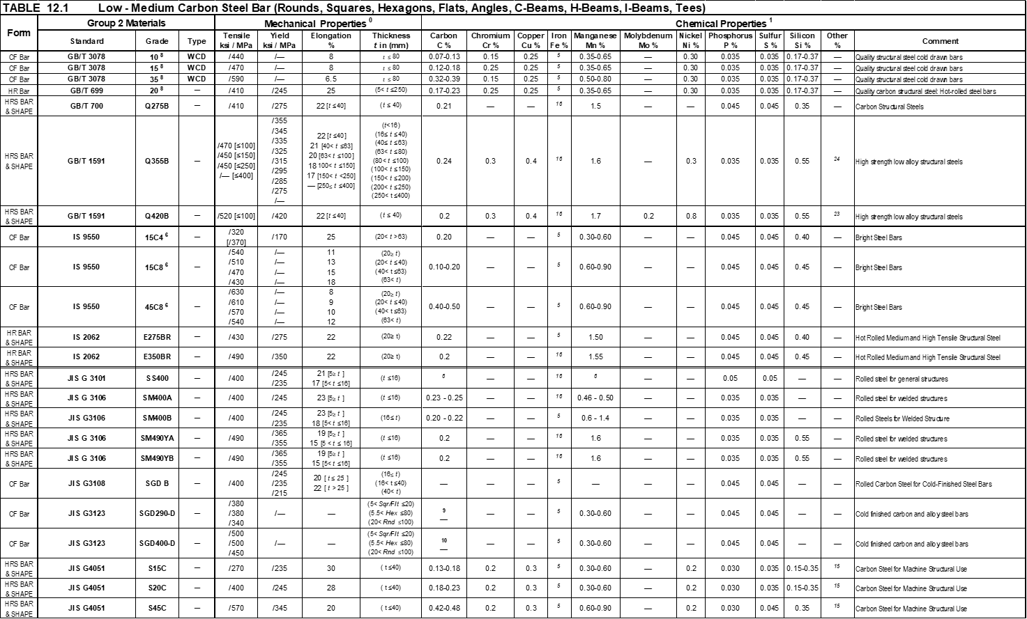
Back to appendix- E
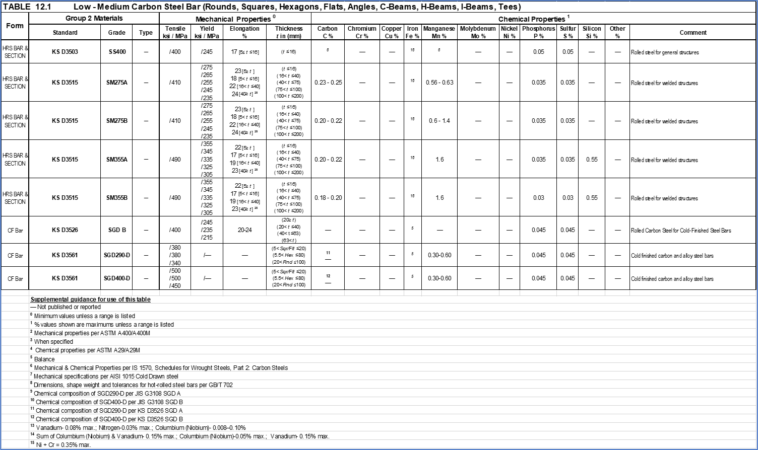
Back to appendix- E
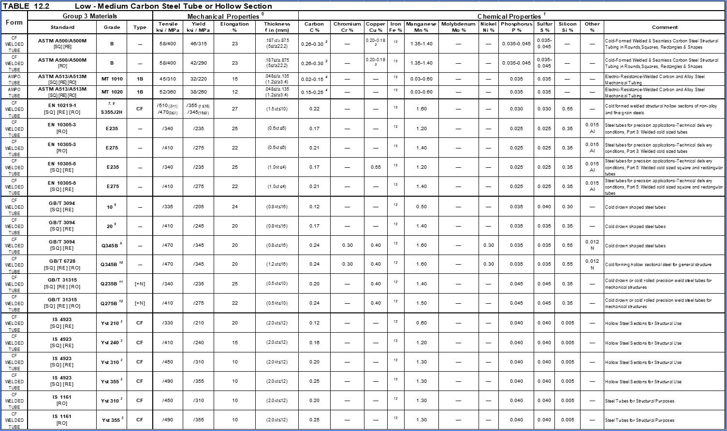
Back to appendix- E
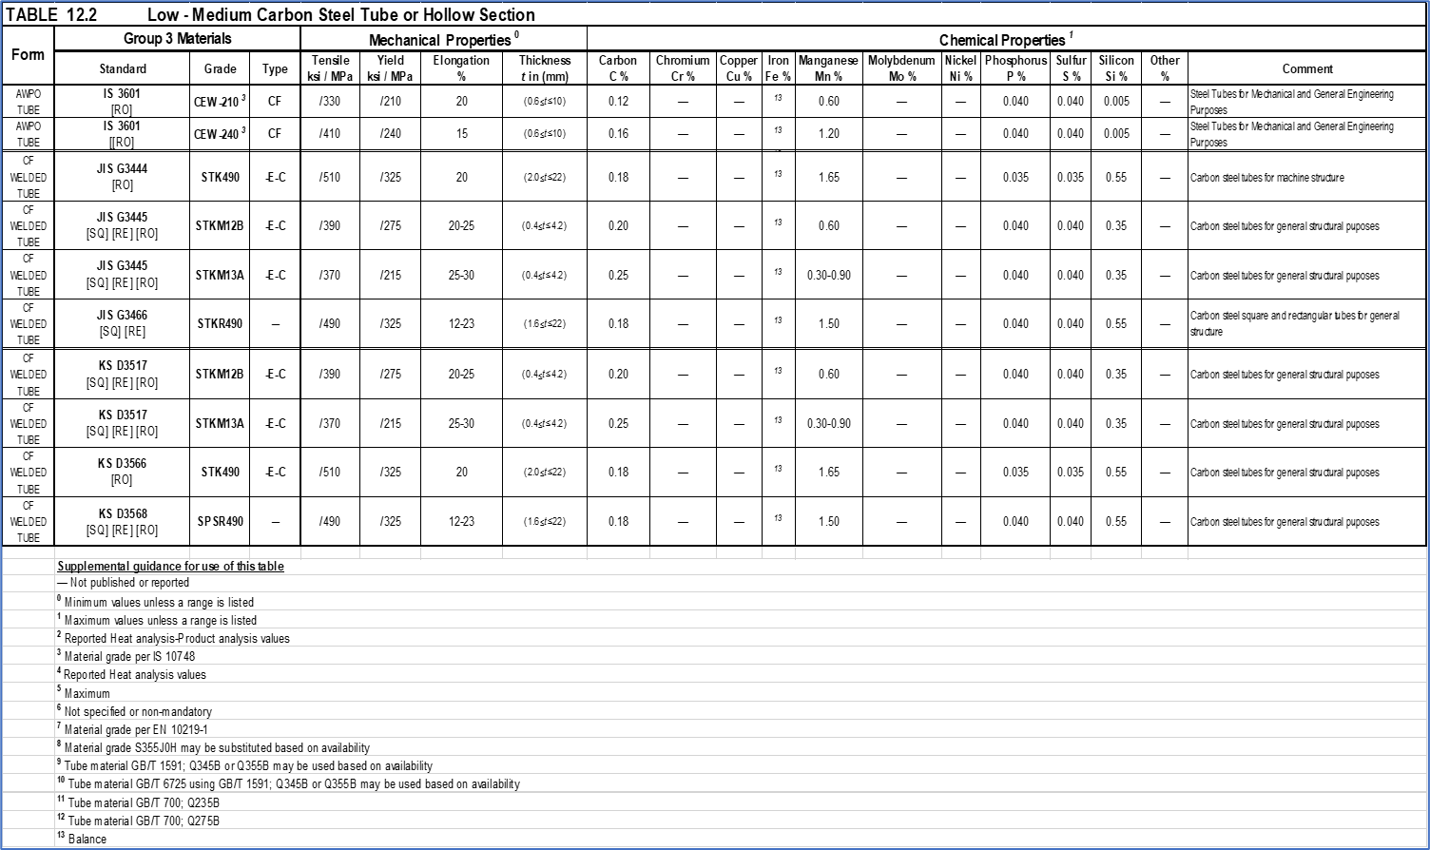
Back to appendix- E
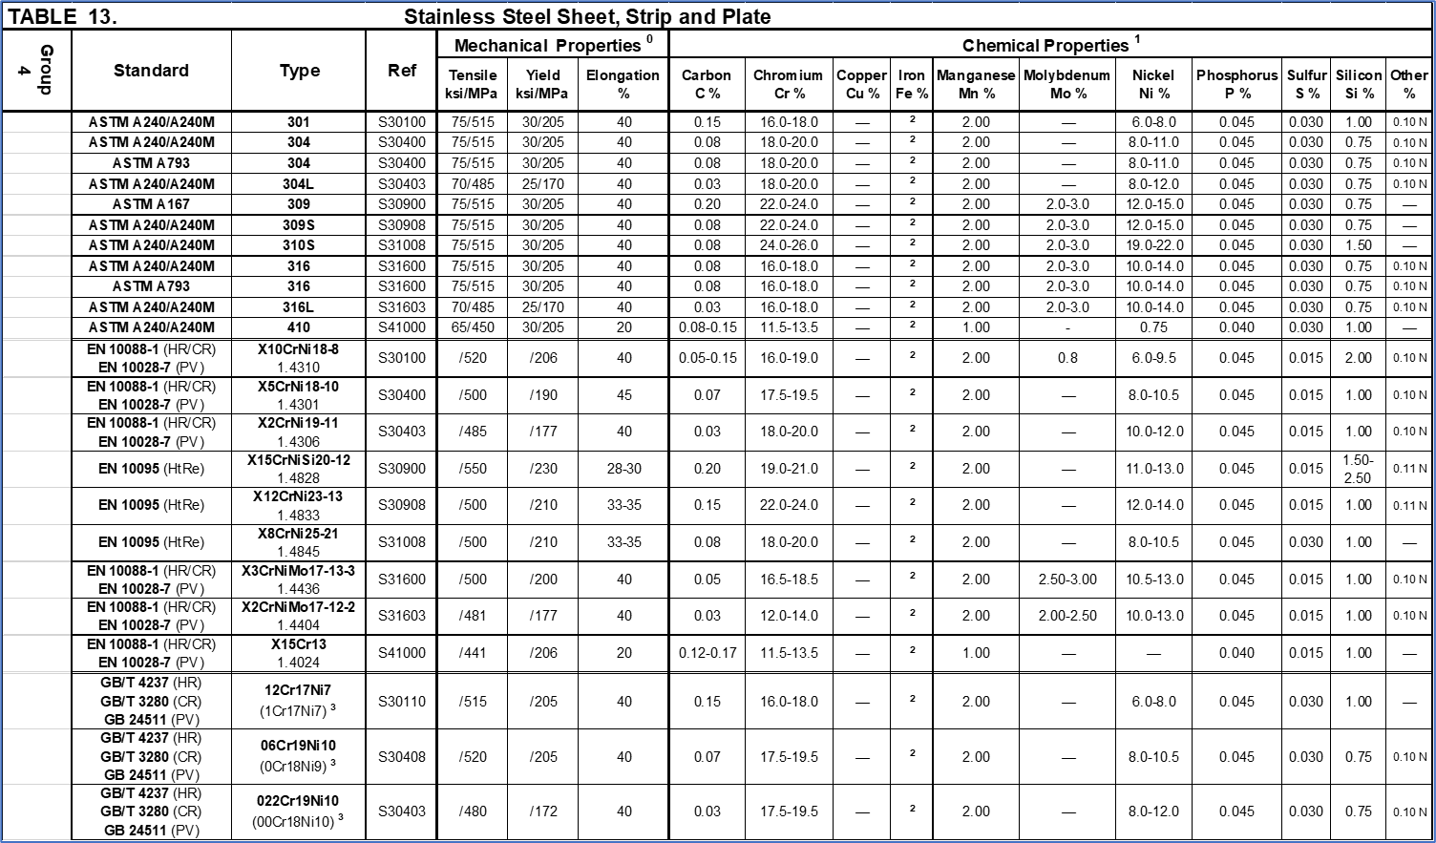
Back to appendix- E
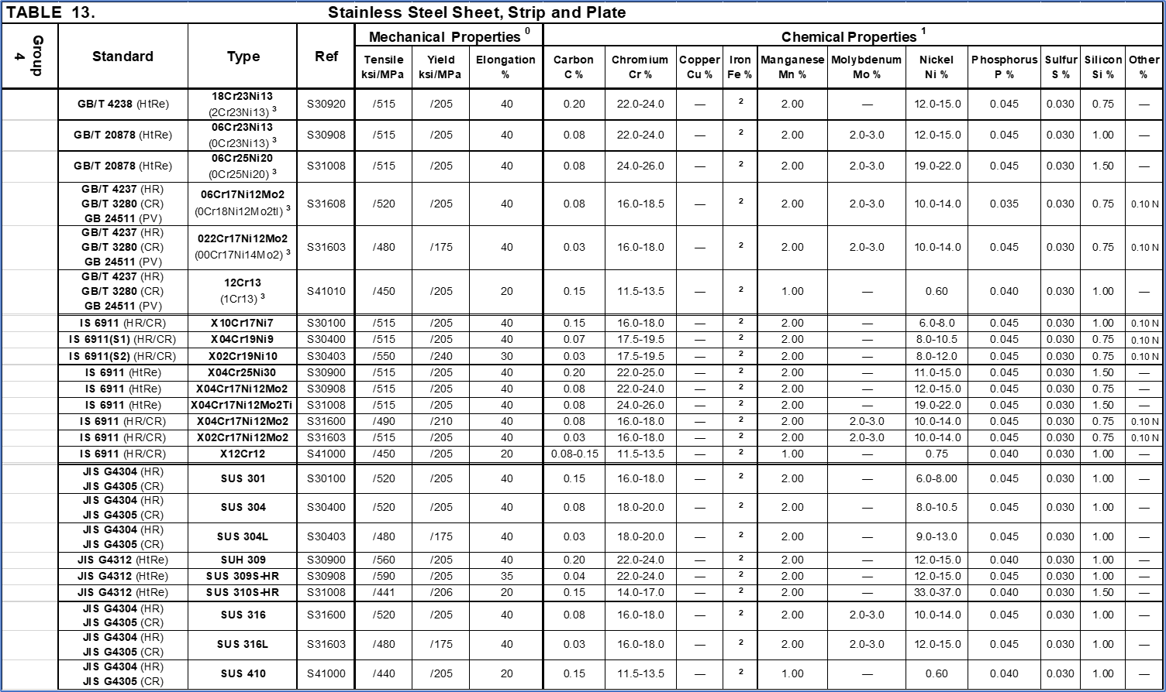
Back to appendix- E
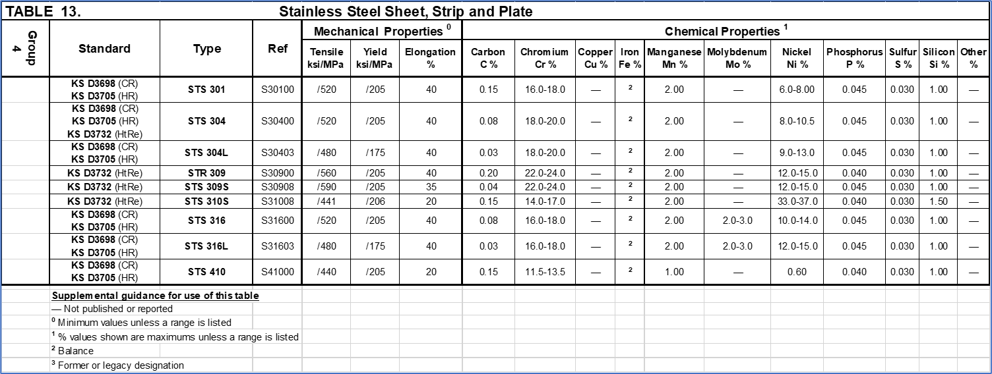
Back to appendix- E

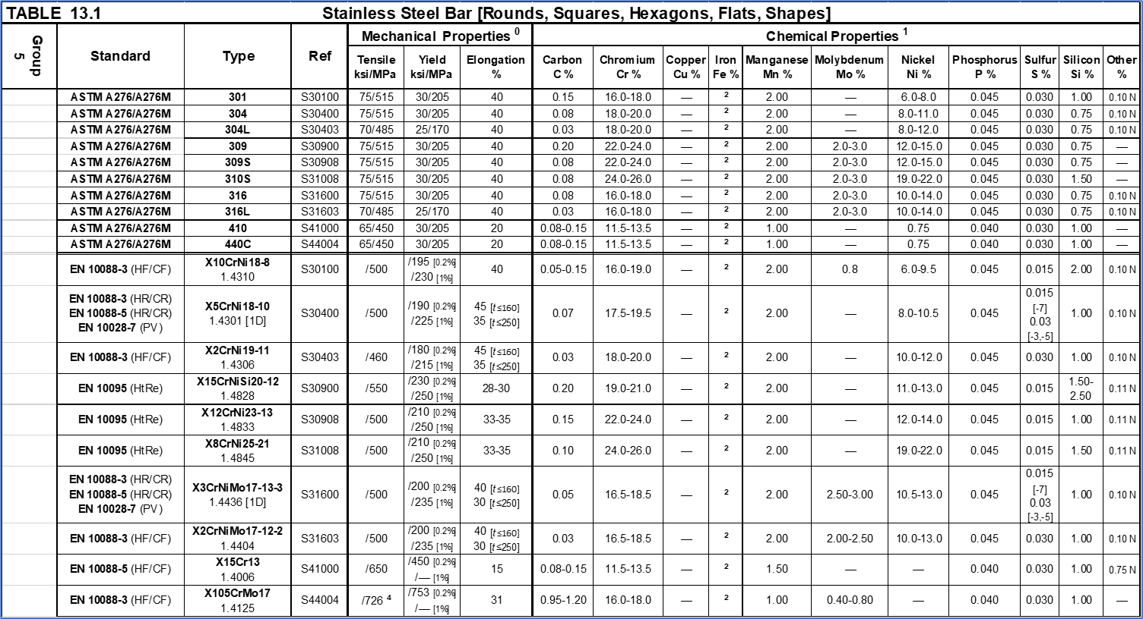
Back to appendix- E

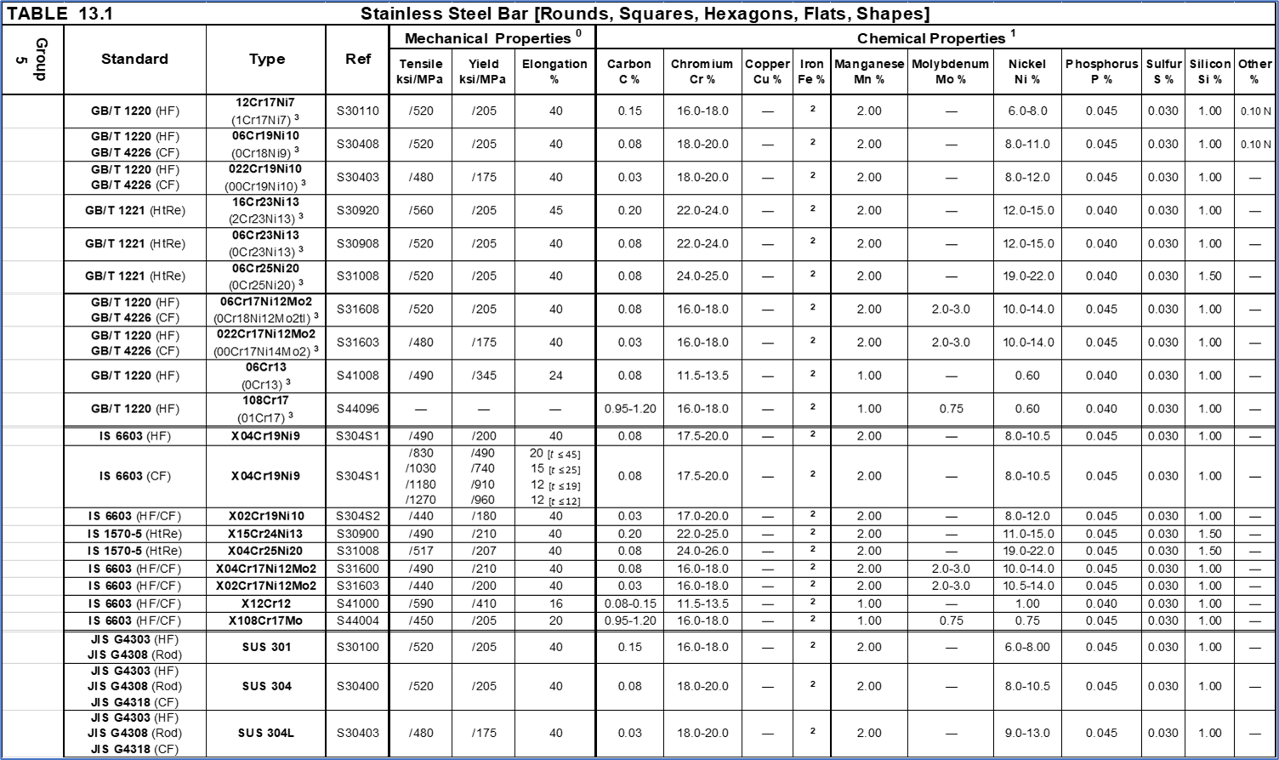
Back to appendix- E

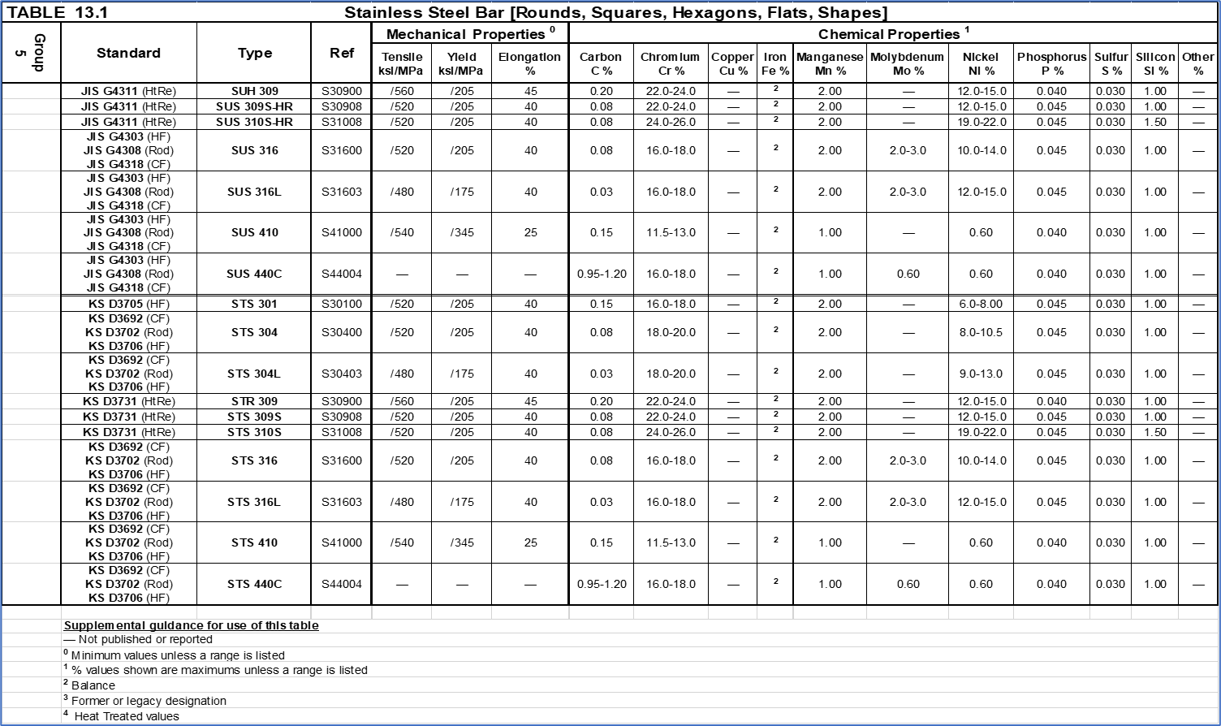
Back to appendix- E

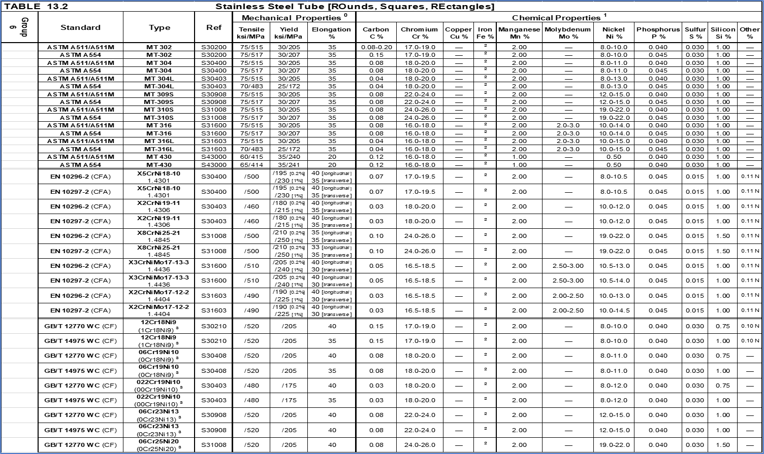
Back to appendix- E

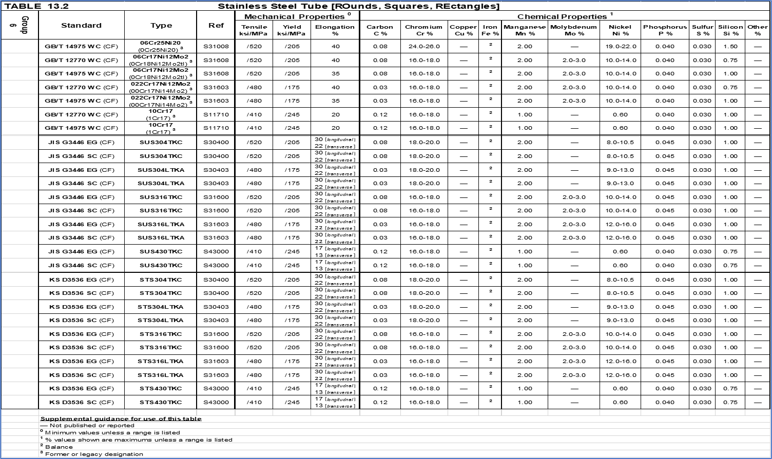
Back to appendix- E

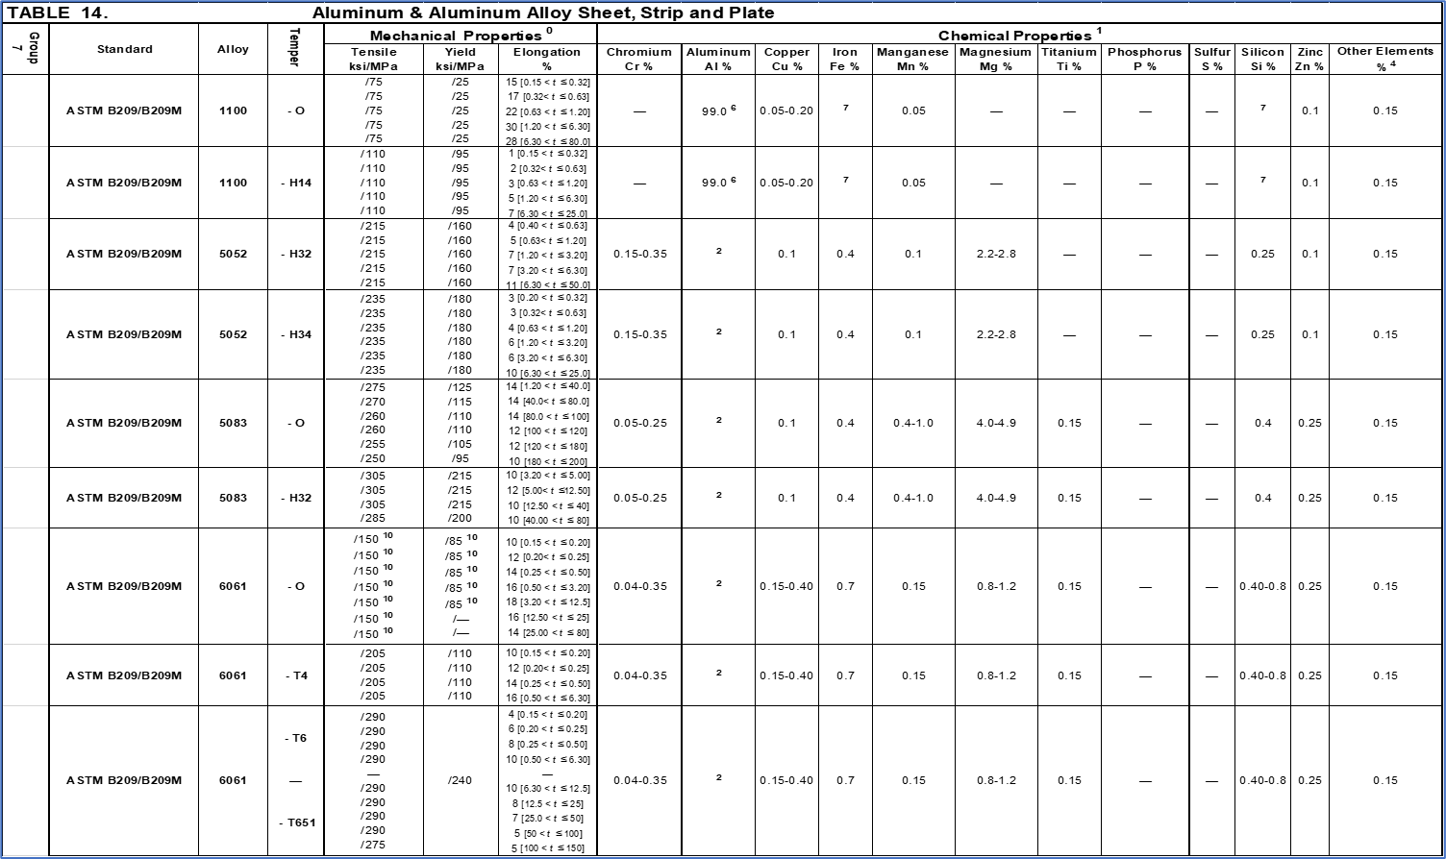
Back to appendix- E
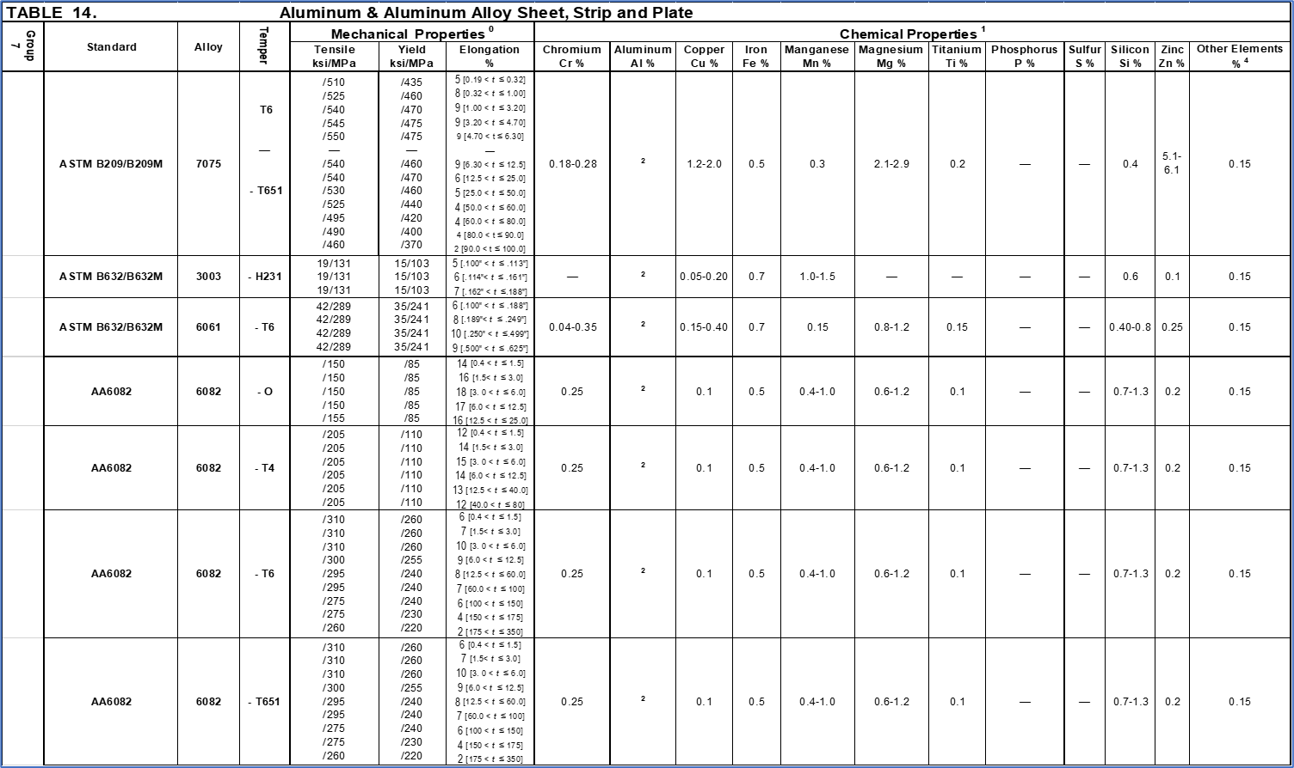
Back to appendix- E
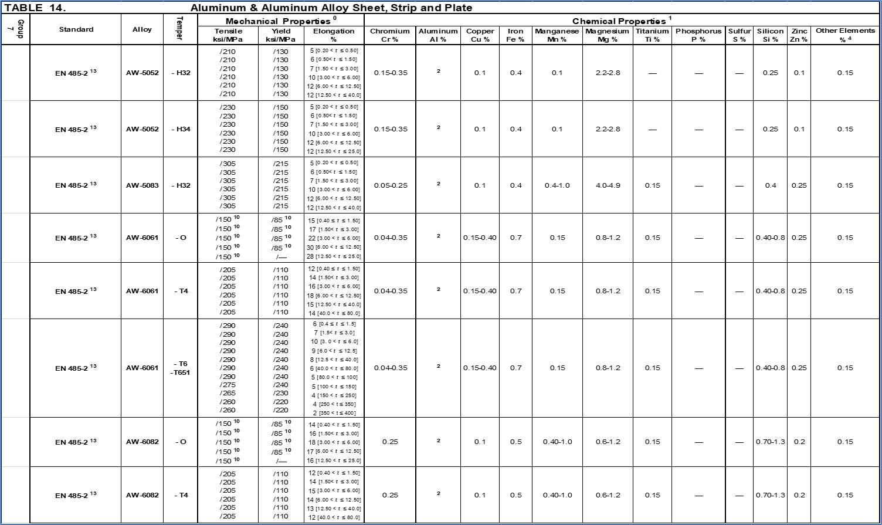
Back to appendix- E
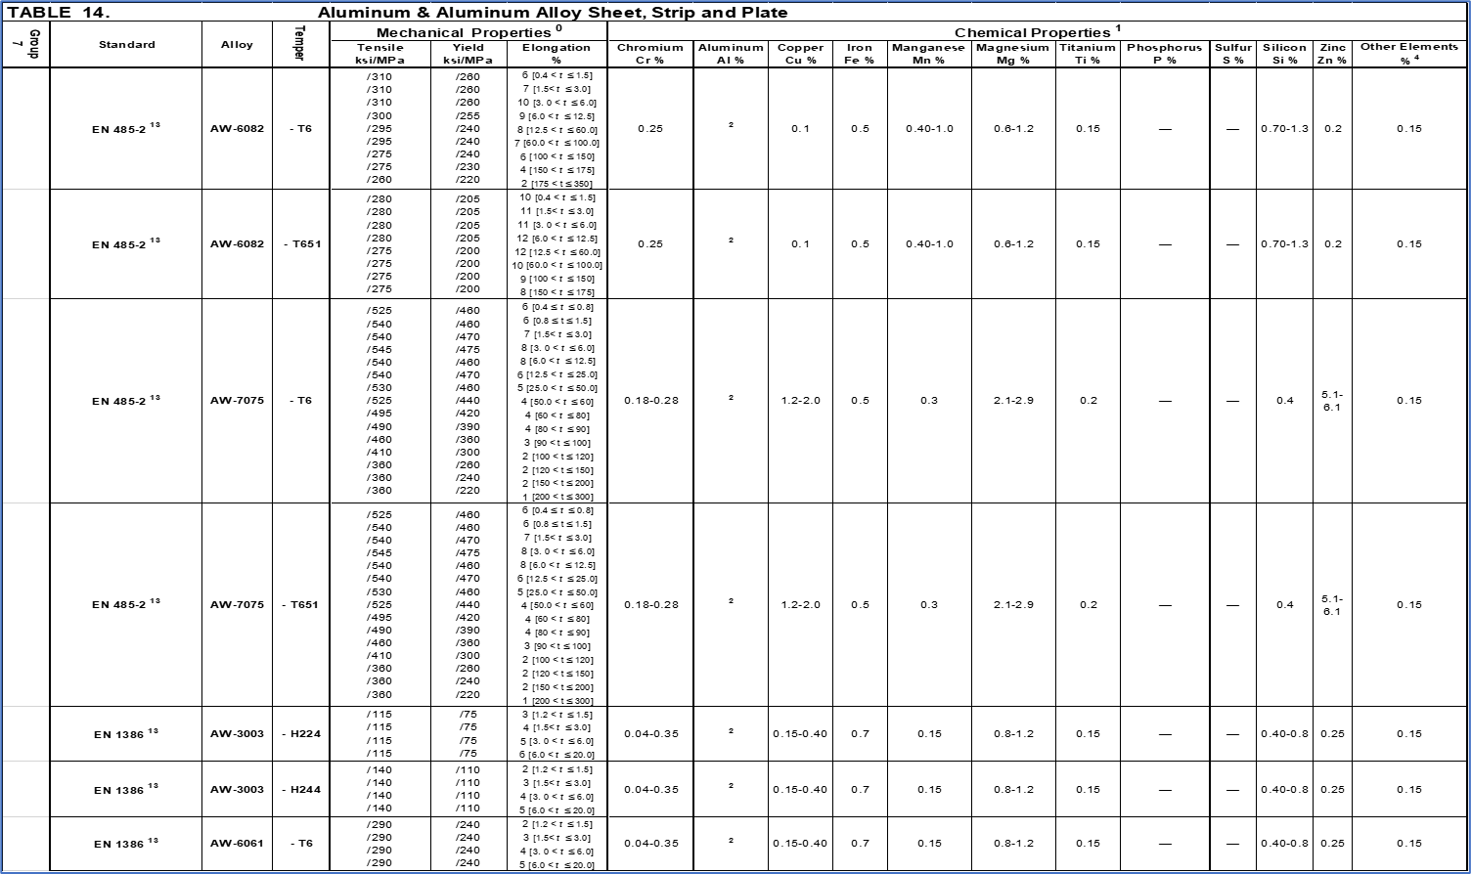
Back to appendix- E
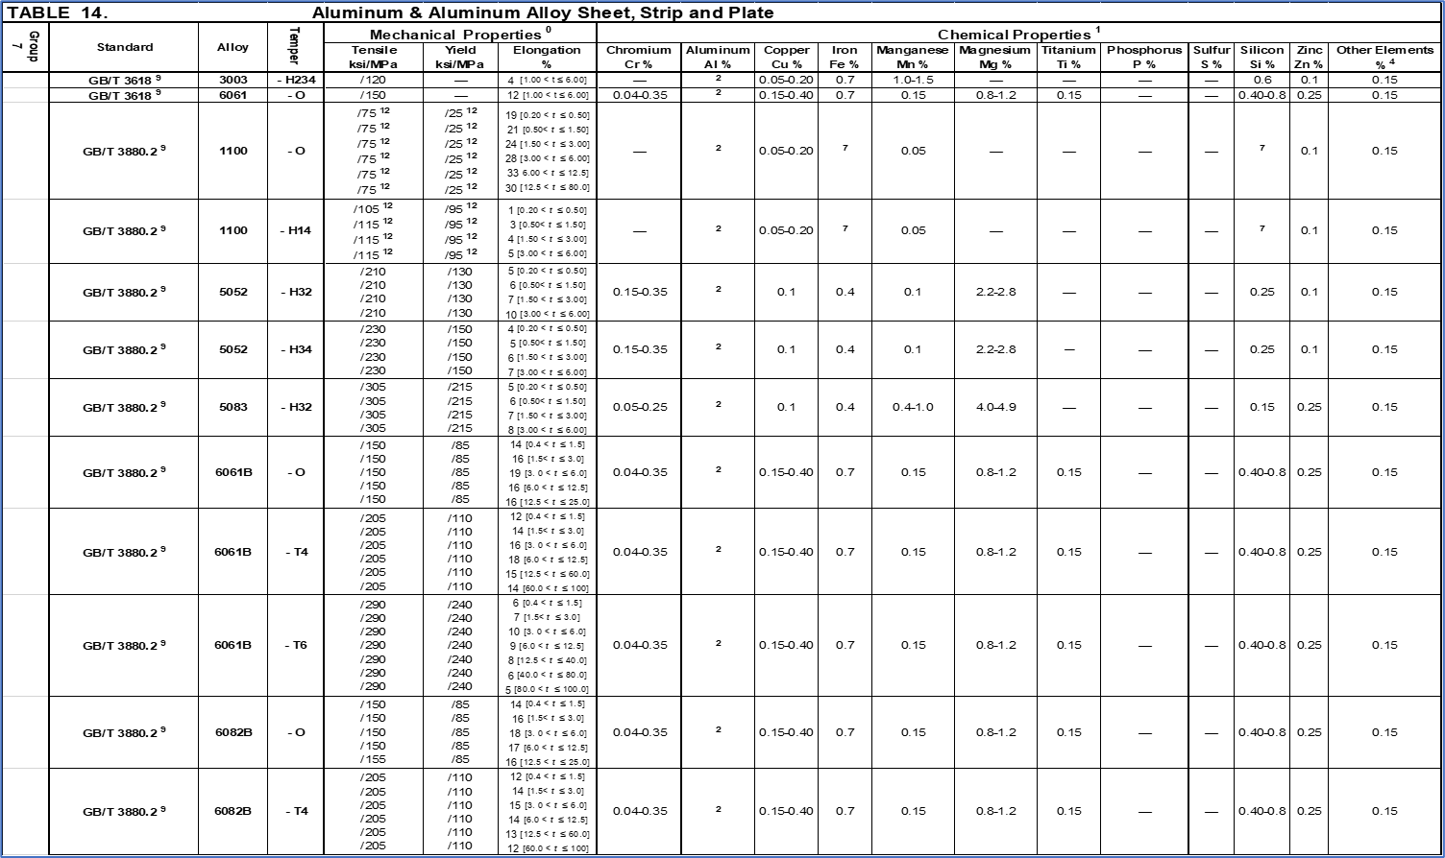
Back to appendix- E
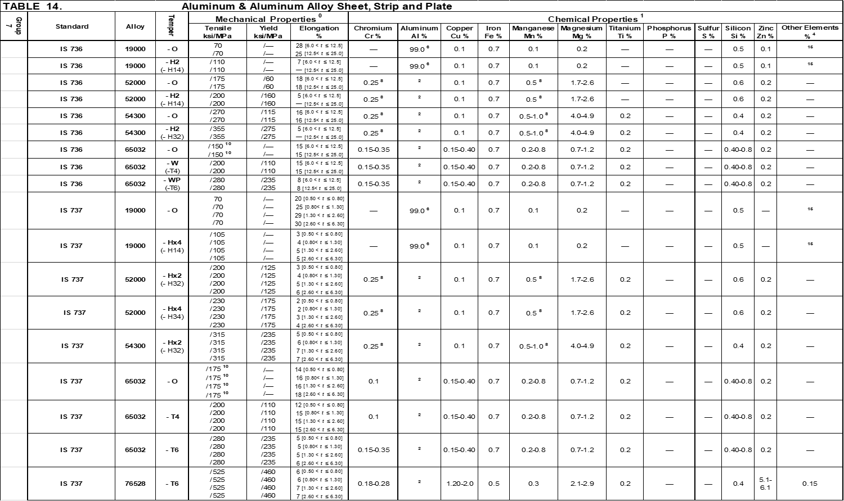
Back to appendix- E
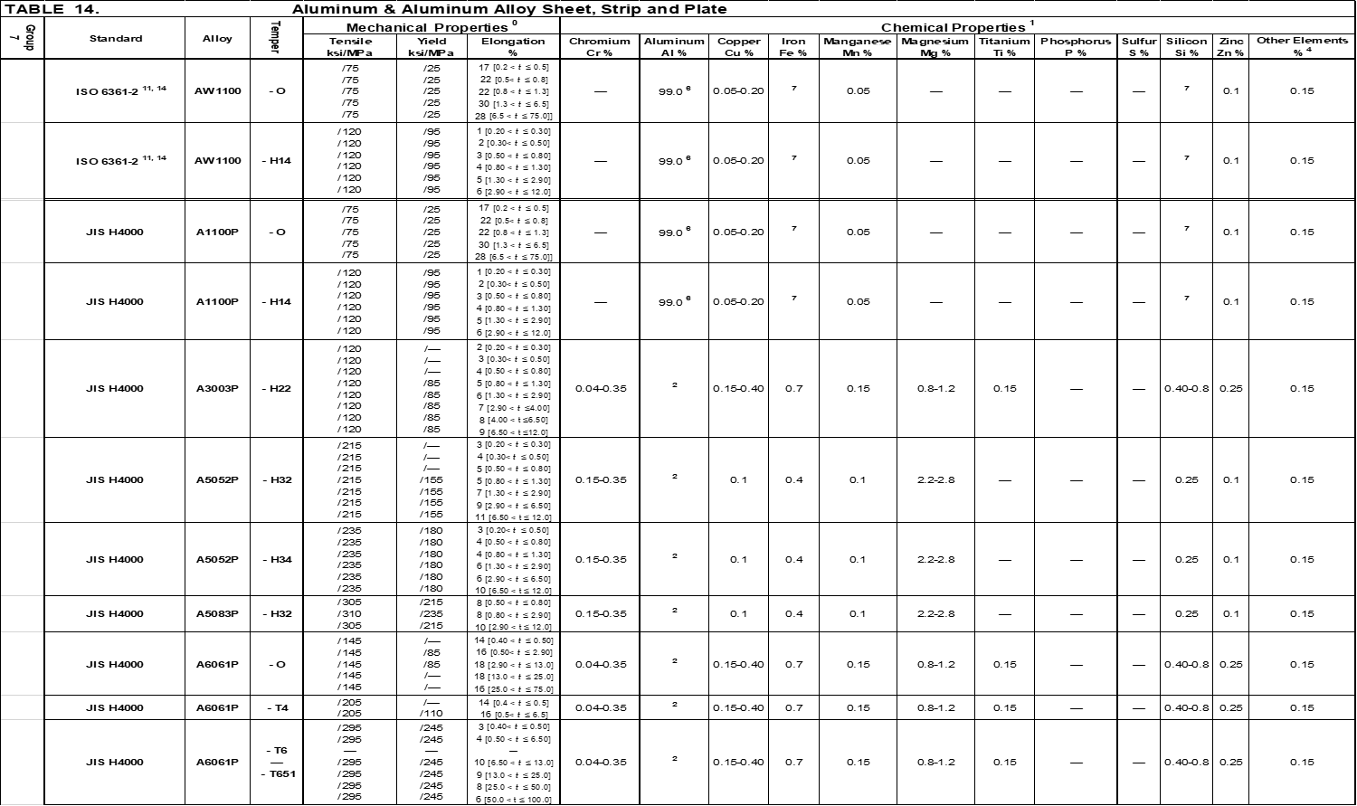
Back to appendix- E
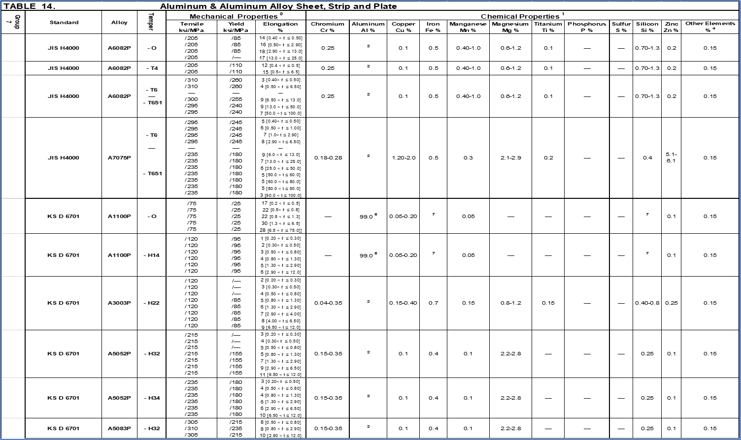
Back to appendix- E
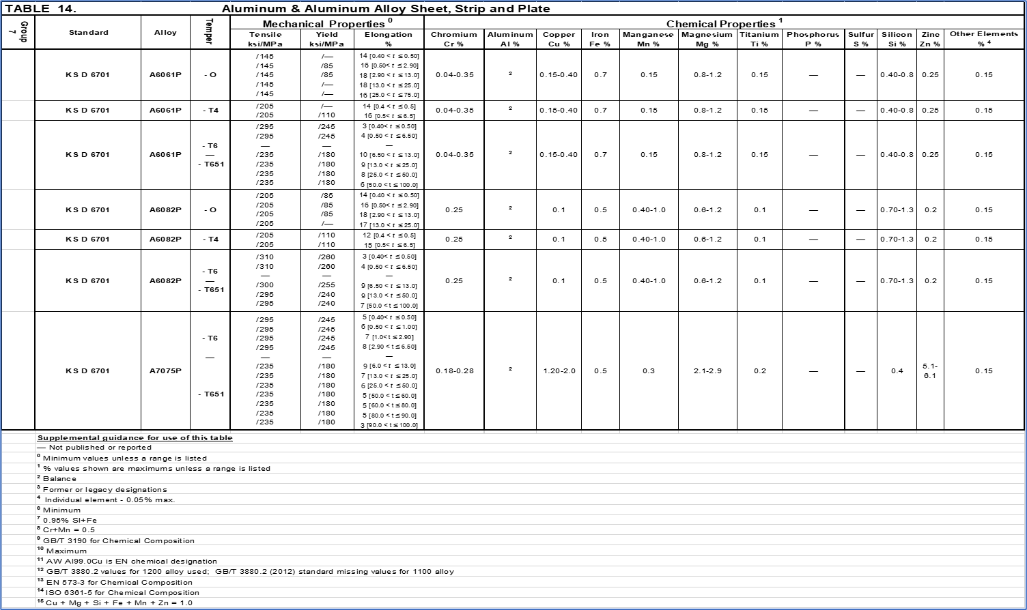
Back to appendix- E
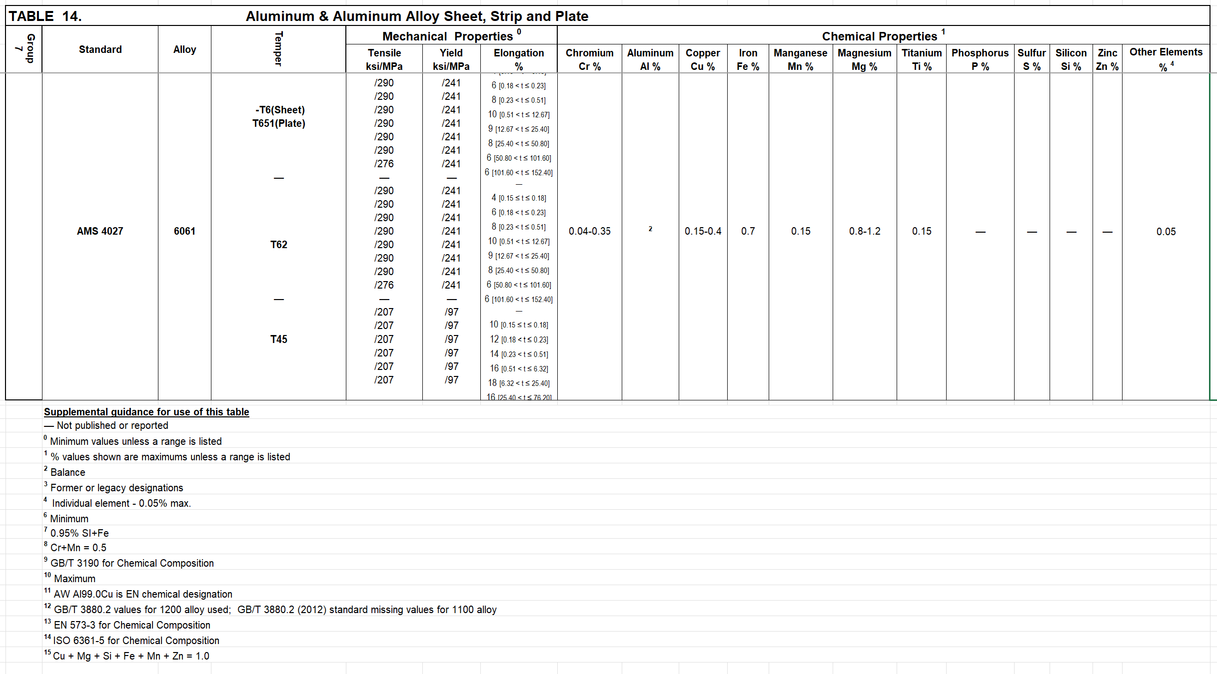
Back to appendix- E

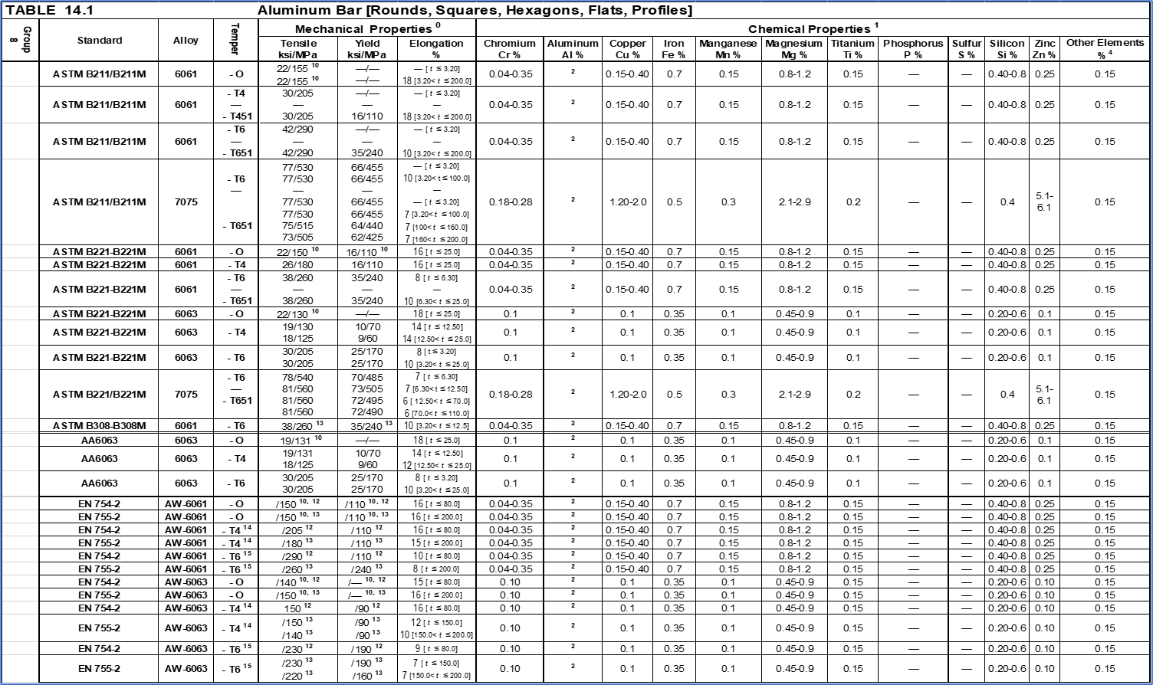
Back to appendix- E
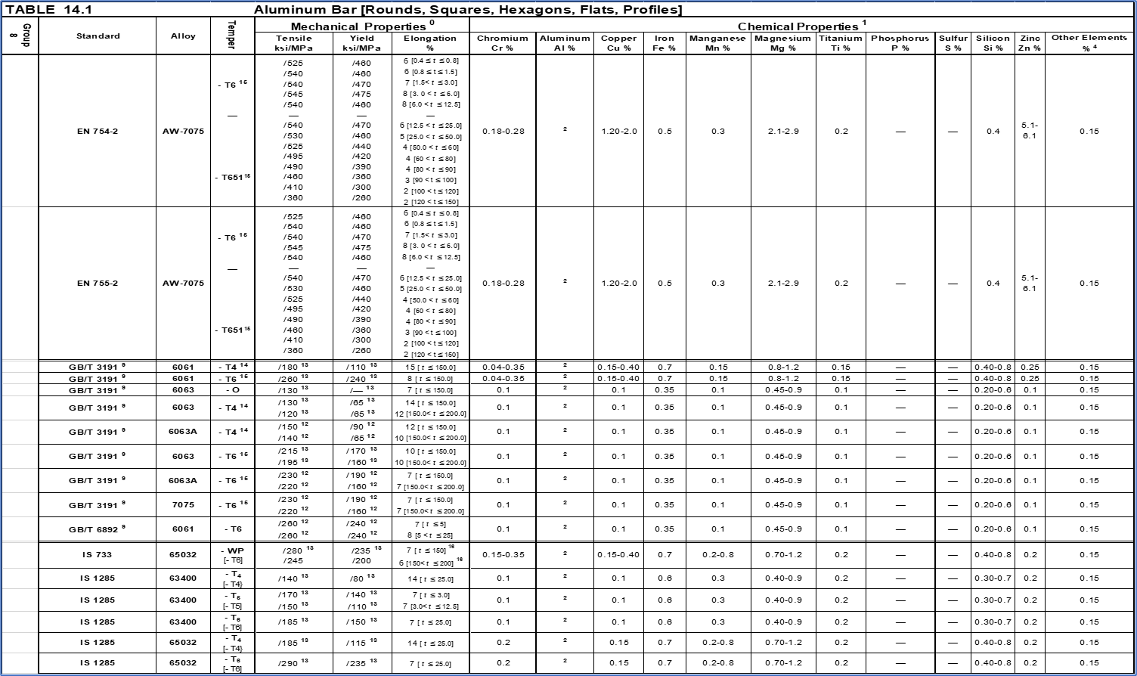
Back to appendix- E
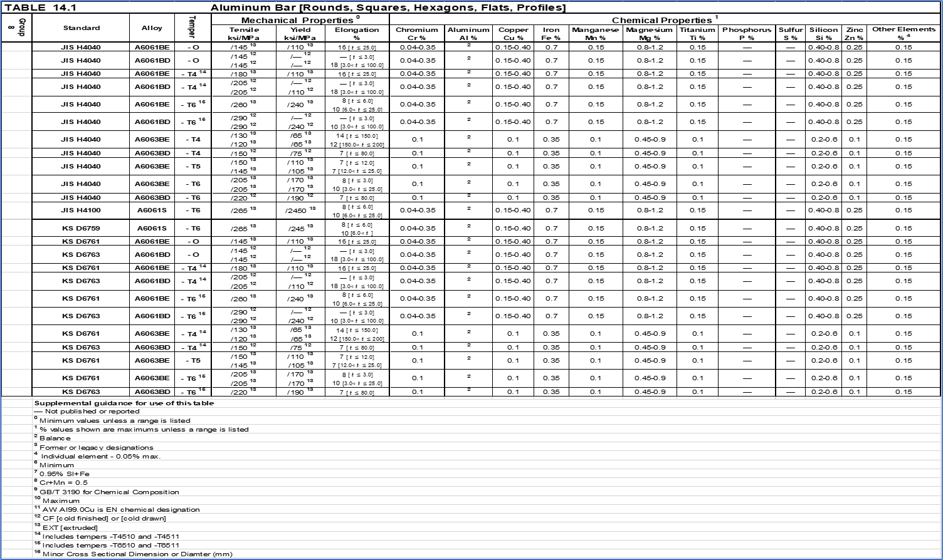
Back to appendix- E
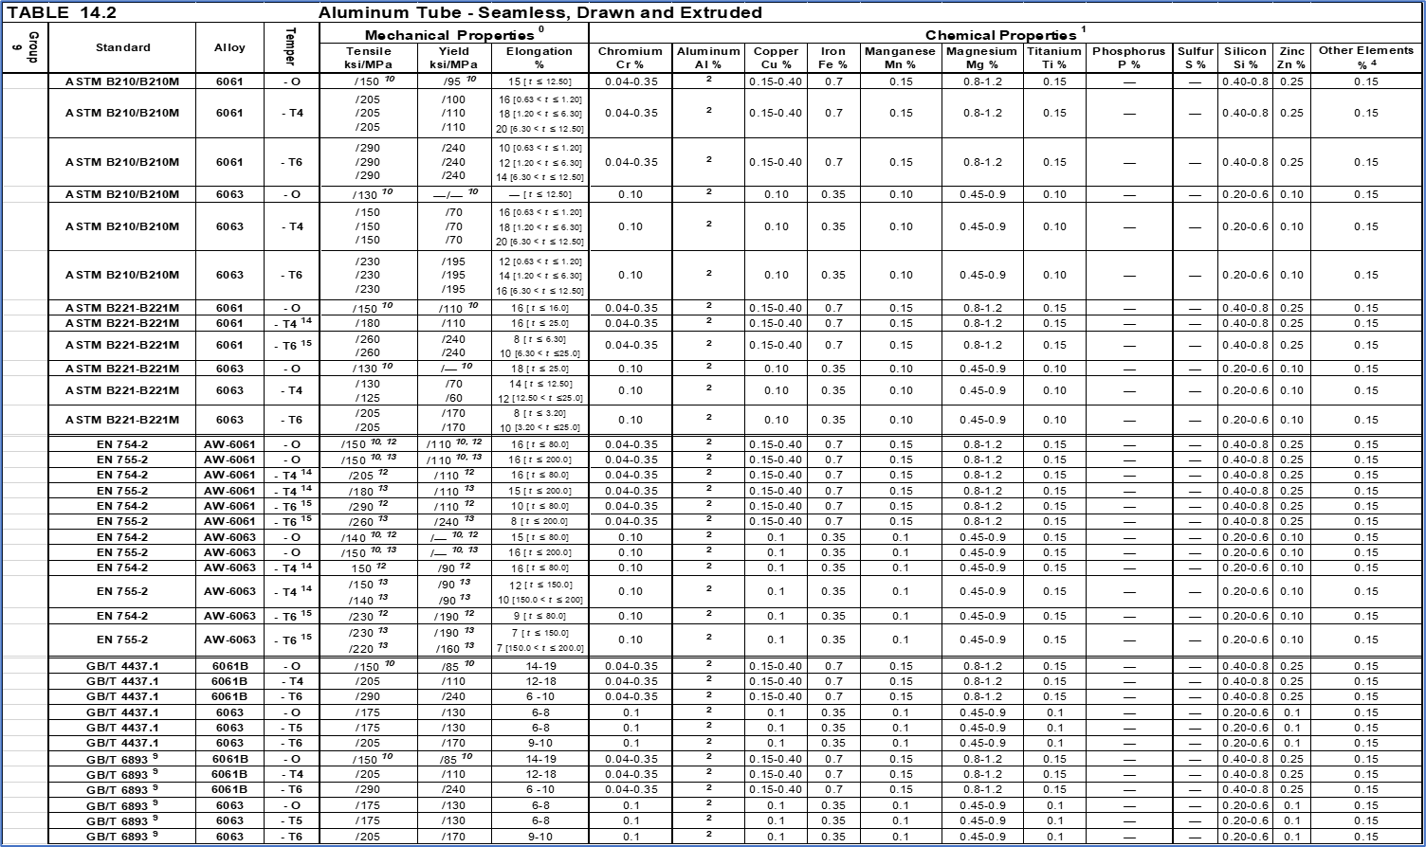
Back to appendix- E
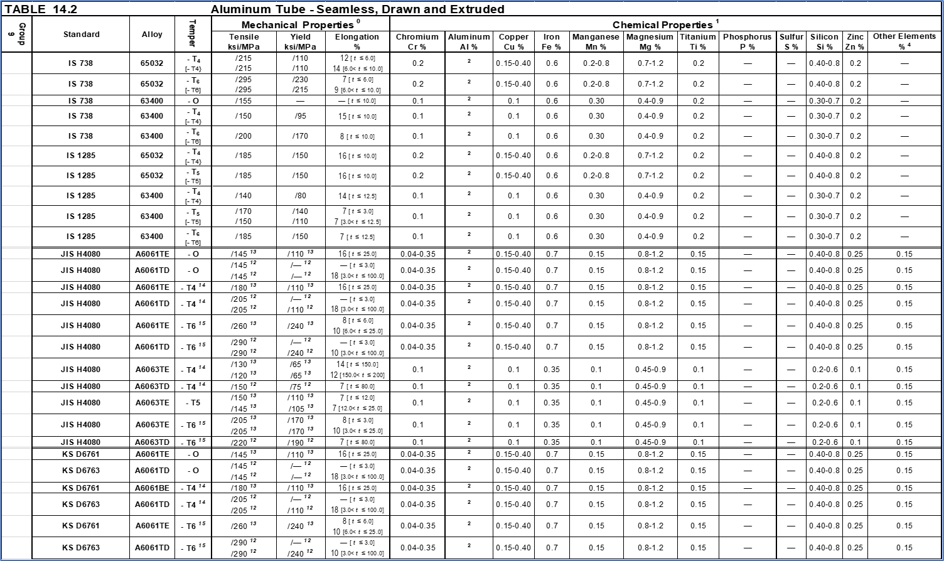
Back to appendix- E

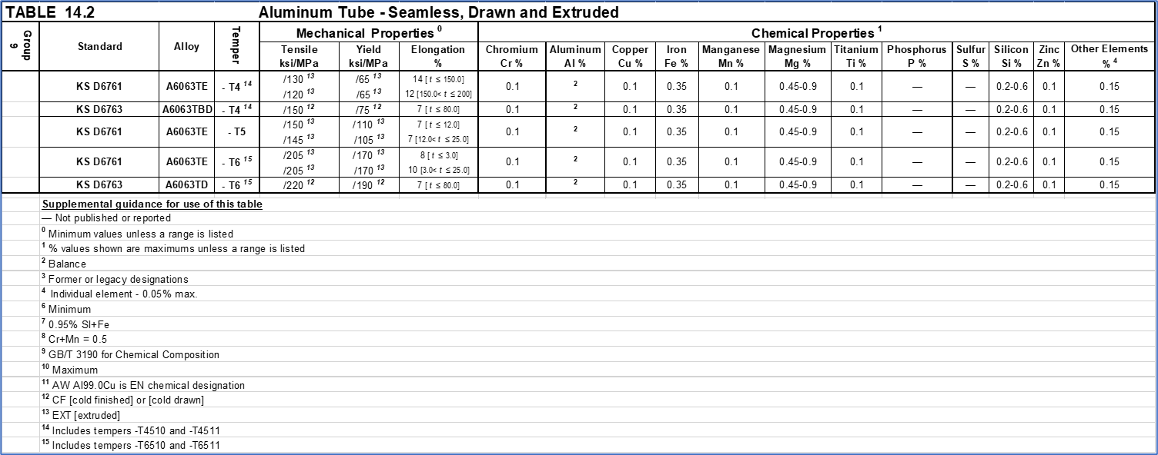
Back to appendix- E

Attachments
0250-46767.xlsx file is attached in Teamcenter as separate data set. This file contains all the live tables for images shown previously which need to be revised along with this procedure.

This Excel file also contains additional data not shown in this document.
- Tab 15: Zinc pre-plated stock coating thickness reference data for all listed standards
- Tab 16: ASTM A6/A6M Carbon Steel Structural Shape, Size and Tolerance Tables – Angles, Beams, Channels
- Tab 17A: GB/T 706 Carbon Steel Structural Shape, Size and Tolerance Tables – Angles, Beams, Channels
- Tab 17B: GB/T 11263 Carbon Steel Structural Shape, Size and Tolerance Tables – Beams, Tees
- Tab 18: EN 10034/10056/10635 Carbon Steel Structural Shape, Size and Tolerance Tables – Angles, Beams, Channels
- Tab 19A: IS 808 Carbon Steel Structural Shape, Size and Tolerance Tables – Angles, Beams, Channels
- Tab 19B: IS 12778 Carbon Steel Structural Shape, Size and Tolerance Tables – Beams, Parallel Flange
- Tab 20: JIS G 3192 Carbon Steel Structural Shape, Size and Tolerance Tables – Angles, Channels, Beams, Tees
- Tab 21A: EN 10056 Stainless Steel Structural Shape, Size and Tolerance Tables – Angles, Equal Leg
- Tab 21B: EN 10088 Stainless Steel Structural Shape, Size and Tolerance Tables – Angles, Equal Leg, Cold Drawn
- Tab 21C: EN 10056 Stainless Steel Structural Shape, Size and Tolerance Tables – Angles, Unequal Leg
- Tab 21D: EN 10034 Stainless Steel Structural Shape, Size and Tolerance Tables – Beams, HE
- Tab 21E: EN 10034 Stainless Steel Structural Shape, Size and Tolerance Tables – Beams, IPE
- Tab 21F: EN 10024 Stainless Steel Structural Shape, Size and Tolerance Tables – Beams, IPN
- Tab 21G: EN 10034 Stainless Steel Structural Shape, Size and Tolerance Tables – Beams, UB
- Tab 21H: EN 10034 Stainless Steel Structural Shape, Size and Tolerance Tables – Channels, UPA
- Tab 21I: EN 10279 Stainless Steel Structural Shape, Size and Tolerance Tables – Channels, UPE
- Tab 21J: EN 10279 Stainless Steel Structural Shape, Size and Tolerance Tables – Channels, UPN
- Tab 21K: EN 10088 Stainless Steel Structural Shape, Size and Tolerance Tables – Tees, Equal Flange. T
- Tab 21L: EN 10088 Stainless Steel Structural Shape, Size and Tolerance Tables – Tees, Un-equal Flange, TB
- Tab 22A: ASTM A276/A276M Stainless Steel Structural Shape, Size and Tolerance Tables – Angles, 304 (HR & Laser Fused)
- Tab 22B: ASTM A276/A276M Stainless Steel Structural Shape, Size and Tolerance Tables – Angles, 316 (HR & Laser Fused)
- Tab 22C: ASTM A276/A276M Stainless Steel Structural Shape, Size and Tolerance Tables – Beams, Standard & Wide Flange, 304 (HR & Laser Fused)
- Tab 22D: ASTM A276/A276M Stainless Steel Structural Shape, Size and Tolerance Tables – Beams, Standard & Wide Flange, 316 (HR & Laser Fused)
- Tab 22E: ASTM A276/A276M Stainless Steel Structural Shape, Size and Tolerance Tables – Channels, 304 (HR, tapered flanges & Laser Fused, non-tapered flanges)
- Tab 22F: ASTM A276/A276M Stainless Steel Structural Shape, Size and Tolerance Tables – Channels, 316 (HR, tapered flanges & Laser Fused, non-tapered flanges)
- Tab 22G: ASTM A276/A276M Stainless Steel Structural Shape, Size and Tolerance Tables – Tees, 304 (HR, tapered flanges & Laser Fused, non-tapered flanges)
- Tab 23A: ASTM B221_B221M Extruded Aluminum Structural Shape, Size and Tolerance – Angles, 6061-T6 (square corners)
- Tab 23B: ASTM B308/B308M Extruded Aluminum Structural Shape, Size and Tolerance – Beams, American Standard, 6061-T6
- Tab 23C: ASTM B308/B308M Extruded Aluminum Structural Shape, Size and Tolerance – Beams, American Association, 6061-T6
- Tab 23D: ASTM B308/B308M Extruded Aluminum Structural Shape, Size and Tolerance – Channels, American Standard, 6061-T6
- Tab 23E: ASTM B308/B308M Extruded Aluminum Structural Shape, Size and Tolerance – Channels, American Association, 6061-T6
- Tab 23F: ASTM B308/B308M Extruded Aluminum Structural Shape, Size and Tolerance – Tees, American Standard, 6061-T6

THIS PAGE IS INTENTIONALLY LEFT BLANK.

