Explainable Deep Learning Framework for Heart Disease Diagnosis
Karthik H D
School of Computer Applications
Dayananda Sagar University
Bengaluru, India
sca25msd038@dsu.edu.in

Abstract—A diagnostic model is easier to trust when it can show which parts of an image led to its decision. This paper describes a deep learning framework for heart disease diagnosis that pairs an ImageNet-pretrained EfficientNet-B0 classifier with a Grad-CAM explanation module. We use the public CAD Cardiac MRI Dataset: 63,425 cardiac magnetic resonance (CMR) slices from 30 patients, 16 without and 14 with coronary artery disease. The classifier is trained in two stages, 25 epochs with a frozen backbone and then 15 epochs with the last 40 backbone layers unfrozen at a lower learning rate. Our first evaluation split the data at image level and gave, on 9,512 held-out images, an accuracy of 97.53% (95% CI 97.20–97.82%), a sensitivity of 96.49%, a specificity of 98.24% and a ROC-AUC of 0.9978. That split placed every patient in both the training and the test data, and an audit showed that the test images had also been used for validation. We therefore repeated the experiment with patient-level five-fold cross-validation and one random seed per fold. Across the five runs the model reached an accuracy of [[NEW05_ACC]]% and a ROC-AUC of [[NEW05_AUC]] (mean ± SD). With the decision threshold tuned on validation patients for a target sensitivity of [[TARGET_SENS]]%, test sensitivity was [[NEWT_SENS]]% and specificity [[NEWT_SPEC]]%. Grad-CAM maps for correct and incorrect predictions in both classes [[AUTHOR: finish in a few words, e.g. “concentrate mainly on the myocardium and blood pool”]]. We regard the patient-level figures, not the image-level ones, as the estimate of performance on new patients.
Index Terms—Heart disease, explainable AI, Grad-CAM, medical image classification, transfer learning, EfficientNet, data leakage

I. Introduction
Cardiovascular disease remains the largest single cause of death worldwide: the World Health Organization estimates 19.8 million deaths in 2022, about 32% of all deaths [1]. Imaging is central to its diagnosis, and reading images is time-consuming specialist work. This has made cardiac imaging an active target for deep learning [2]–[4], and a review of clinical AI expects such tools to take over part of the routine reading load [5].
Training a deep network from scratch needs far more labelled images than most clinical projects can collect. Transfer learning addresses this by starting from a network trained on a large natural-image collection such as ImageNet [6] and adapting it to the medical task [7], [8]. EfficientNet-B0 [9] is a reasonable backbone for such a project: it has about four million parameters in our configuration and trains in a few hours on a single cloud GPU.
Accuracy alone is not enough in a clinical setting. A clinician needs to see what the network is looking at, and a developer needs a way to catch a model that has learnt a shortcut, such as a scanner marking, instead of the disease [10]–[12]. Class-activation methods such as Grad-CAM [13] address this by highlighting the image regions that raise a class score. A second, less visible problem is the evaluation itself: if training and test images are related, a model can score well without learning anything that transfers to new patients [14].
This paper presents a binary Normal/Sick classifier built on EfficientNet-B0 and trained in two stages, together with a Grad-CAM module that explains its predictions. Our contributions are: (i) a two-stage transfer-learning pipeline for a 63,425-image cardiac MRI dataset; (ii) a Grad-CAM module attached to the final convolutional layer, with heat maps for correct and incorrect predictions of both classes; (iii) a full account of training behaviour and held-out performance, with exact error counts, extended diagnostic measures and confidence intervals; (iv) an analysis of two data-splitting problems, including a reproduction that measures validation–test overlap; and (v) a re-evaluation with patient-level cross-validation, five random seeds and a decision threshold tuned for a target sensitivity.
Section II reviews related work, Section III describes the method, Section IV the experimental setup, Section V the results and Section VI discusses them. Sections VII and VIII give the limitations and conclusions.

II. Related Work

A. Deep Learning for Cardiac Diagnosis
Litjens et al. surveyed several hundred deep learning studies in medical image analysis and found convolutional networks dominant across modalities and organs [2]. For the heart, the ACDC challenge compared deep learning methods for cardiac MRI segmentation and disease classification on a shared public benchmark [3]. Madani et al. trained a convolutional network to recognise standard echocardiographic views [4], a routine first step in automated echo analysis. Topol's review of clinical AI places such results in context and stresses that most had not yet been tested prospectively in clinical practice [5].

B. Transfer Learning and Efficient Architectures
Transfer learning from ImageNet has been the default starting point in many of these studies. Kermany et al. adapted a pretrained network to retinal OCT and paediatric chest radiographs [7], and Esteva et al. fine-tuned one on skin-lesion photographs and matched dermatologists on the tasks they tested [8]. Raghu et al., however, reported that for large medical datasets ImageNet pretraining improves final accuracy only modestly, although it can speed up convergence [15]. EfficientNet scales network depth, width and input resolution together, which gives strong accuracy for a given parameter budget [9].

C. Explainability and Evaluation Pitfalls
Grad-CAM weights the final feature maps with the gradient of the class score and so needs no change to the network architecture [13]. Evaluation is a recurring concern in this literature. Zech et al. found that a pneumonia detector performed noticeably worse on radiographs from hospitals it had not been trained on [10]. Roberts et al. reviewed machine-learning models for COVID-19 imaging and found methodological flaws and biases that left none of the reviewed models ready for clinical use [11]. DeGrave et al. used saliency maps and generative models to show that COVID-19 radiograph classifiers relied on shortcuts such as text markers and image borders rather than lung pathology [12]. Kapoor and Narayanan documented data leakage across many scientific fields and gave a taxonomy of its forms, including a lack of clean separation between training and test data [14]. These findings motivate the attention we give to data splitting in Sections V-D and VI-A.

III. Method

A. Dataset and Data Split
We used the CAD Cardiac MRI Dataset, released on Kaggle by Sharifrazi [17] and described by Khozeimeh et al. [16]. The images were acquired prospectively between September 2018 and September 2019 in the CMR department of Omid Hospital, Tehran, on a 1.5 T Siemens Magnetom Aera scanner, with approval from the hospital’s ethics committee and written informed consent from every participant [16]. The protocol covers cine steady-state free precession, perfusion, T2-weighted and late gadolinium enhancement sequences, in long-axis (two-, three- and four-chamber) and short-axis views [16]. The imaging modality is therefore cardiac magnetic resonance (CMR), and each file in the release is a single 2-D slice stored as a JPEG image.
The release has two class folders. Normal holds images of people without coronary artery disease (CAD), and Sick holds images of patients with CAD. Each class folder is divided into numbered sub-directories, 16 under Normal and 14 under Sick. According to the dataset creator, as reported in [18], each sub-directory holds the images of one patient, and the folders nested inside it hold that patient’s individual image series. The 63,425 images therefore come from 30 patients: 37,564 Normal images from 16 people and 25,861 Sick images from 14. The source article describes a larger collection of 63,648 images [16], so the public release is a subset. The Kaggle page gives the licence as “Unknown”. We used the data only for non-commercial academic research, credit the creator and the source article, and do not redistribute the images beyond the example slices in Fig. 5. All images were read as three-channel colour images and resized to 224×224 pixels.
For the first evaluation, the Keras function image_dataset_from_directory was called twice with a 30% validation split and a fixed seed of 42, giving a training subset of 44,398 images and a held-out subset of 19,027 images. The held-out subset, batched in groups of eight, was then halved: the first 1,189 batches (9,512 images) formed the test set and the remaining batches (9,515 images) the validation set (Table I). The test set is 59.6% Normal and 40.4% Sick. The original notebook did not print the class counts of the other two subsets; we recovered them by repeating the same calls on the same files.
Because this split puts images of every patient into all three subsets, we also evaluated the model with patient-level, stratified five-fold cross-validation. The 30 patients were shuffled once (seed 42) and dealt into five folds of six patients; four folds hold three Normal and three Sick patients and the fifth holds four Normal and two Sick. In each run one fold is the test set, two Normal and two Sick patients drawn from the other folds form the validation set, and the remaining 20 patients are used for training. No patient appears in more than one subset of a run, every patient is tested exactly once across the five runs, and the validation and test sets are fixed file lists. Each test fold is scored once, after training and threshold selection are finished. Table I gives the sizes of both splits.
Table I
Data Split
Subset | Images | Normal | Sick
Image-level split (original)
Training | 44,398 | [[O_TR_N]] | [[O_TR_S]]
Validationª | 9,515 | [[O_VA_N]] | [[O_VA_S]]
Test | 9,512 | 5,666 | 3,846
Patient-level cross-validation (mean per run)^{b}
Training (20 pts) | [[C_TR]] | [[C_TR_N]] | [[C_TR_S]]
Validation (4 pts) | [[C_VA]] | [[C_VA_N]] | [[C_VA_S]]
Test (6 pts) | [[C_TE]] | [[C_TE_N]] | [[C_TE_S]]
All data (30 pts) | 63,425 | 37,564 | 25,861
ªHeld-out pool minus the final test pass; validation membership changed between epochs (Section V-D). ^{b}Image counts are means over the five runs; patient counts are exact. pts: patients.

B. Preprocessing and Augmentation
During training, each batch passes through a random horizontal flip, a random rotation of up to 0.05 of a full turn (18°), a random zoom of up to 10% and a random contrast change of up to 10%. These layers are active only in training mode, so validation and test images are seen unaltered. Images are then passed to the Keras EfficientNet preprocessing function. Horizontal flipping deserves a comment: in CMR slices left and right carry anatomical meaning, so this augmentation is not ideal. We kept it so that the patient-level runs use exactly the configuration of the original run.
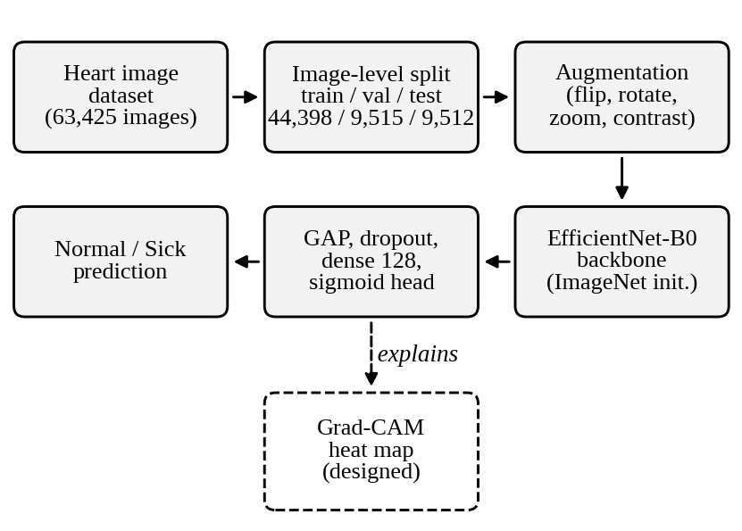
Fig. 1. Proposed framework: data split, augmentation, EfficientNet-B0 backbone with classification head, two-stage training, test evaluation and the Grad-CAM module (dashed), which runs after training and does not change the predictions.

C. Network and Two-Stage Training
The backbone is EfficientNet-B0 without its classification top, initialised with ImageNet weights [6] and called in inference mode, so its batch-normalisation statistics are never updated. The 7×7×1280 feature map is reduced by global average pooling and passed to a small head: dropout of 0.3, a 128-unit dense layer with ReLU activation, dropout of 0.2 and a single sigmoid output giving the probability of the Sick class. The full model has 4,213,668 parameters, of which 164,097 belong to the head.
Both stages minimise the binary cross-entropy
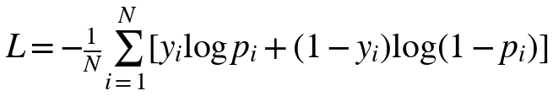 (1)
where N is the number of images in a batch, y_{i} ∈ {0, 1} is the label of image i (1 = Sick) and p_{i} is the predicted probability of the Sick class. Optimisation used the Adam optimiser. In stage 1 the backbone was frozen and only the head was trained (164,097 parameters) for up to 25 epochs at a learning rate of 10⁻³. In stage 2 the last 40 of the 237 backbone layers, from the squeeze-and-excitation part of block 6c onward, were unfrozen. These layers hold 2,050,704 parameters, so 2,214,801 parameters were trainable. This stage ran for up to 15 epochs at a learning rate of 10⁻⁵. Both stages used early stopping on validation AUC (patience 6, best weights restored), a learning-rate reduction by a factor of 0.3 when the validation loss stalled for 3 epochs, and a checkpoint of the best validation-AUC model. Table II lists the configuration.
Table II
Model and Training Configuration
Item | Setting
Input | 224×224 RGB, batch size 8
Backbone | EfficientNet-B0, ImageNet weights, no top
Head | GAP → dropout 0.3 → dense 128 (ReLU) → dropout 0.2 → dense 1 (sigmoid)
Parameters | 4,213,668 total
Stage 1 | Backbone frozen; Adam, lr 10⁻³; ≤25 epochs; 164,097 trainable
Stage 2 | Last 40 layers unfrozen; Adam, lr 10⁻⁵; ≤15 epochs; 2,214,801 trainable
Callbacks | Early stopping on val. AUC (patience 6); LR ×0.3 on val. loss plateau (patience 3); checkpoint
Decision | Sick if predicted probability ≥ 0.5
GAP: global average pooling.

D. Grad-CAM Explanation Module
The module applies Grad-CAM [13] to the last convolutional block of the backbone (the 7×7×1280 top_activation output in Keras). Let A^{k} be the k-th feature map of this layer and y^{c} the pre-sigmoid score of class c. Each map receives a weight equal to the spatially averaged gradient of the score,
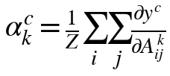 (2)
where Z = 49 is the number of spatial positions. The explanation map is the rectified, weighted sum of the feature maps,
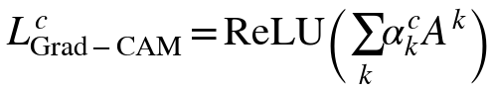 (3)
which is upsampled to 224×224 pixels and overlaid on the input image. For the Sick class the map shows the regions that pushed the prediction toward disease; for Normal the sign of the score is reversed. The module runs after training and does not change the model's weights or predictions.
We chose Grad-CAM for practical reasons. Plain class activation mapping requires the pooled features to feed a linear output layer directly, whereas our head has a hidden 128-unit layer between them. Perturbation-based methods need hundreds to thousands of forward passes per image, whereas Grad-CAM needs one forward and one backward pass. Its 7×7 resolution is coarse, so it shows which part of an image mattered but not fine boundaries. The module is intended for two uses: letting a reader see the evidence behind an individual prediction, and checking, over many test images, whether the network relies on cardiac structures or on artefacts such as borders, text or acquisition markings. Here we apply it to test images from the patient-level runs (Section V-E), and each image is explained by the model of the run in which its patient was held out.

E. Evaluation Metrics
The test set was scored once, with a threshold of 0.5 and Sick as the positive class. We report accuracy, sensitivity, specificity, precision, F1, balanced accuracy and ROC-AUC. Because accuracy and F1 can hide poor performance on one class, we add the Matthews correlation coefficient (MCC), Cohen’s κ, Youden’s index J, the positive and negative likelihood ratios (LR+, LR−) and the diagnostic odds ratio (DOR). Confidence intervals for proportions are 95% Wilson intervals computed from the confusion-matrix counts. Intervals for the likelihood ratios and the odds ratio use the log method, and those for F1, J, MCC and κ come from 20,000 multinomial bootstrap resamples of the four counts. For the image-level run, ROC-AUC was taken from the training notebook and all other measures from the confusion matrix, since individual predicted probabilities were not stored.
The patient-level runs store every predicted probability, so ROC-AUC and all other measures are computed directly from them. Each measure is reported as the mean ± sample standard deviation over the five runs. Besides the default threshold of 0.5, we chose a threshold for each run on its validation patients: the highest value at which validation sensitivity was at least [[TARGET_SENS]]%. That threshold was then applied unchanged to the run’s test fold.

IV. Experimental Setup
The model was implemented in TensorFlow/Keras and trained on Google Colab with a GPU runtime. The batch size was 8, giving 5,550 steps per epoch, and the TensorFlow and NumPy seeds were set to 42. According to the training log, stage-1 epochs took 233–278 s and stage-2 epochs 298–353 s, about 1.7 h and 1.3 h in total; the longer stage-2 epochs reflect the extra backward pass through the unfrozen blocks.
The patient-level runs used the same model, schedule, callbacks and batch size. The five runs used the seeds 42, 7, 123, 2024 and 31, set for Python, NumPy and TensorFlow together, so that weight initialisation, augmentation and shuffling differ between runs. Images were loaded from the saved file lists with the same decoding and bilinear resizing as the Keras directory loader. A run took [[RUN_HOURS]] h on average.
To measure how the validation and test subsets interact, we reproduced the notebook's data calls on a synthetic dataset of 600 labelled dummy images in two classes, each split into three sub-directories, with a unique identifier encoded in the pixel values. The same arguments were used (30% validation split, seed 42, batch size 8), giving 180 held-out images in 23 batches, of which the first 11 formed the test half. We iterated the validation half 40 times, once per simulated epoch, followed by one pass over the test half, and recorded the image identifiers seen in each pass. The reproduction ran on TensorFlow 2.21; the exact overlap can differ between versions, but the mechanism does not.

V. Results

A. Training Behaviour
Fig. 2 traces training. Stage 1 improved steadily: validation accuracy rose from 0.9119 after the first epoch to 0.9721 after epoch 25, and validation AUC from 0.9723 to 0.9967. Early stopping did not trigger, and the learning-rate reduction never fired in either stage. Training accuracy stayed below validation accuracy for the whole run; augmentation and dropout, which act only during training, are a plausible reason, as is the relatedness of training and held-out images discussed in Section VI.
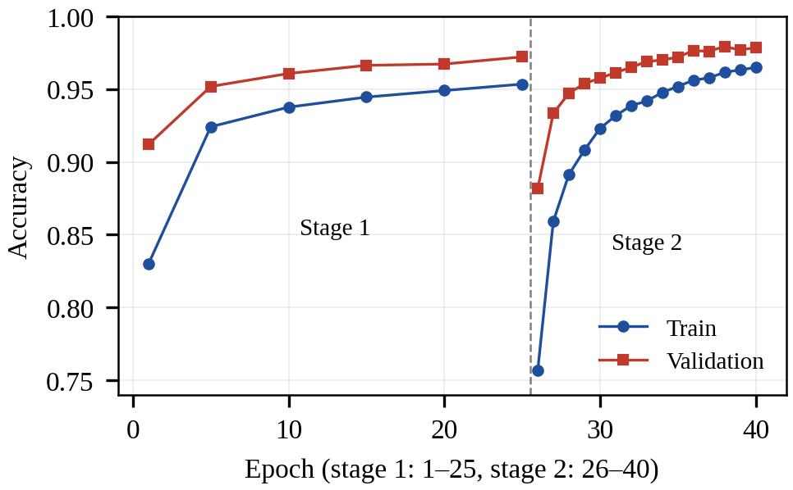
Fig. 2. Training and validation accuracy over the 25 epochs of stage 1 and the 15 epochs of stage 2 (stage-1 values are shown every fifth epoch).
The start of stage 2 was unexpected. In its first epoch training accuracy fell to 0.7567 and validation accuracy to 0.8816, even though the learning rate had been lowered a hundredfold. Validation precision fell to 0.8169 while recall stayed at 0.9097, so for a short time the model flagged too many Normal images as Sick. Performance recovered within about five epochs and then passed the stage-1 level. The best validation AUC, 0.9982, was reached at epochs 13 and 15 of stage 2, with a final validation accuracy of 0.9785 and validation loss of 0.0499. The notebook does not allow the cause of the initial drop to be isolated; a short learning-rate warm-up is a reasonable remedy for future runs.

B. Test Performance
On the 9,512 test images the model classified 9,277 correctly, an accuracy of 97.53% (95% CI 97.20–97.82%). The confusion matrix (Fig. 3) shows 5,566 true negatives, 3,711 true positives, 100 false positives and 135 false negatives. Table III lists the main and extended measures. Per-class F1 was 97.93% for Normal and 96.93% for Sick (macro-F1 97.43%), and the ROC curve area was 0.9978. The MCC of 0.9487, Cohen's κ of 0.9486 and Youden's J of 0.9472 agree closely, as expected when the classes are only moderately imbalanced. Likelihood ratios above 10 and below 0.1 are conventionally regarded as strong evidence; here LR+ is 54.7 and LR− is 0.0357.
The patient-level runs tell a different story from the image-level one, and Table III puts them side by side. At the default threshold of 0.5, accuracy was [[NEW05_ACC]]%, sensitivity [[NEW05_SENS]]%, specificity [[NEW05_SPEC]]% and ROC-AUC [[NEW05_AUC]] (mean ± SD over five runs), against 97.53%, 96.49%, 98.24% and 0.9978 for the image-level split, a drop of [[DELTA_ACC]] percentage points in accuracy. The spread between runs is wide because each test fold holds only six patients. Fig. 3(b) pools the out-of-fold predictions for all 63,425 images: [[CM_TN]] true negatives, [[CM_TP]] true positives, [[CM_FP]] false positives and [[CM_FN]] false negatives, an overall accuracy of [[CM_ACC]]%.
Table III
Test Performance: Image-Level Split vs. Patient-Level Cross-Validation
Measure | Image-level | Patient-level, t = 0.5 | Patient-level, tuned t
Accuracy (%) | 97.53 | [[NEW05_ACC]] | [[NEWT_ACC]]
Sensitivity (%) | 96.49 | [[NEW05_SENS]] | [[NEWT_SENS]]
Specificity (%) | 98.24 | [[NEW05_SPEC]] | [[NEWT_SPEC]]
PPV, Sick (%) | 97.38 | [[NEW05_PPV]] | [[NEWT_PPV]]
NPV (%) | 97.63 | [[NEW05_NPV]] | [[NEWT_NPV]]
F1, Sick (%) | 96.93 | [[NEW05_F1]] | [[NEWT_F1]]
Balanced accuracy (%) | 97.36 | [[NEW05_BACC]] | [[NEWT_BACC]]
MCC | 0.9487 | [[NEW05_MCC]] | [[NEWT_MCC]]
Cohen’s κ | 0.9486 | [[NEW05_KAPPA]] | [[NEWT_KAPPA]]
Youden’s J | 0.9472 | [[NEW05_J]] | [[NEWT_J]]
LR+ | 54.7 | [[NEW05_LRP]] | [[NEWT_LRP]]
LR− | 0.0357 | [[NEW05_LRN]] | [[NEWT_LRN]]
DOR | 1,530 | [[NEW05_DOR]] | [[NEWT_DOR]]
ROC-AUC | 0.9978 | [[NEW05_AUC]] | [[NEWT_AUC]]
Threshold | 0.5 | 0.5 | [[THR]]
Image-level: one run, 9,512 images; 95% Wilson CIs are 97.20–97.82% (accuracy), 95.86–97.03% (sensitivity) and 97.86–98.55% (specificity), assuming independent images (Section VI). Patient-level: mean ± SD over five runs; t tuned on validation patients for [[TARGET_SENS]]% sensitivity.
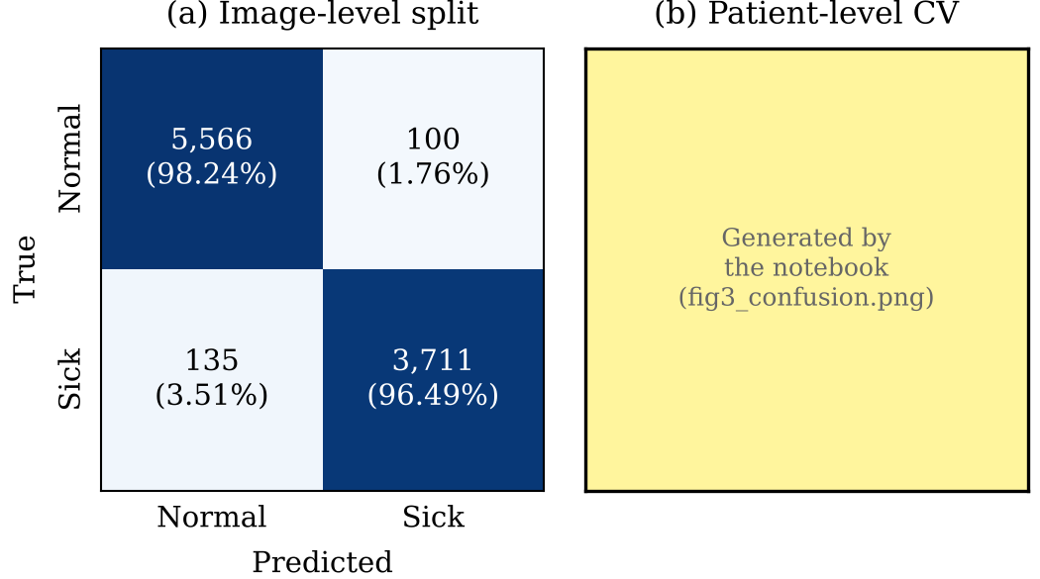
Fig. 3. Confusion matrices at threshold 0.5: (a) the image-level test set (9,512 images); (b) pooled out-of-fold predictions of the five patient-level runs (63,425 images). Percentages are row-wise.
The two error types are not balanced. The miss rate on Sick images (3.51%) is about twice the false-alarm rate on Normal images (1.76%), and the two Wilson intervals do not overlap. The model predicted Sick for 40.1% of test images, close to the true share of 40.4%, so the imbalance is not caused by a general bias toward one class.
In the patient-level runs the miss rate on Sick images was [[CM_MISS]]% and the false-alarm rate on Normal images [[CM_FA]]% (pooled, threshold 0.5). Tuning the threshold targets the miss rate directly. For each run we chose the highest threshold that kept validation sensitivity at or above [[TARGET_SENS]]%, which gave thresholds of [[THR]]. On the test patients this produced a sensitivity of [[NEWT_SENS]]% and a specificity of [[NEWT_SPEC]]%, compared with [[NEW05_SENS]]% and [[NEW05_SPEC]]% at 0.5 (Table III, last column). Since each validation set holds only four patients, the target does not carry over to the test fold exactly: [[NT_MET]] of the [[N_SEEDS]] runs reached it on test data.
Fig. 4 shows the ROC curve of the original image-level evaluation. It climbs almost vertically at the left edge and reaches a true-positive rate close to 1.0 by a false-positive rate of about 0.05, in line with the AUC of 0.998. Given the overlap described in Section V-D, this curve shows how easy the test images were for a model that had already seen the same patients rather than how well the model generalises.
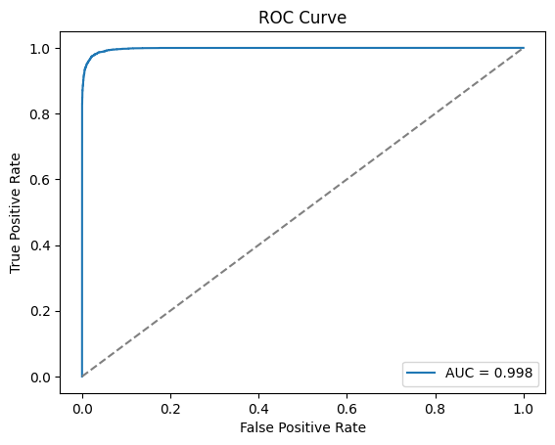
Fig. 4. ROC curve of the original image-level evaluation on 9,512 test images (AUC = 0.998), as produced by the training notebook.

C. Effect of Prevalence
The data are about 40% Sick, far above the prevalence in most screening settings. Table IV holds the patient-level sensitivity and specificity at the tuned threshold ([[NEWT_SENS]]% and [[NEWT_SPEC]]%, means over five runs) fixed and shows how the predictive values change with prevalence. At 10% prevalence the PPV is [[T4_10_PPV]]%, and at 1% it is [[T4_1_PPV]]%, so in a population where one person in a hundred is Sick about [[T4_1_FA_OF_10]] of every ten positive predictions would be false alarms. The NPV at 1% prevalence is [[T4_1_NPV]]%. For comparison, the image-level figures gave a PPV of 35.6% at 1% prevalence. These are calculations, not new measurements, and they assume that sensitivity and specificity do not change with the population.
Table IV
Predictive Values and Errors per 10,000 Images
Prev. (%) | PPV (%) | NPV (%) | Missed | False alarms
1 | [[T4_1_PPV]] | [[T4_1_NPV]] | [[T4_1_MISS]] | [[T4_1_FA]]
5 | [[T4_5_PPV]] | [[T4_5_NPV]] | [[T4_5_MISS]] | [[T4_5_FA]]
10 | [[T4_10_PPV]] | [[T4_10_NPV]] | [[T4_10_MISS]] | [[T4_10_FA]]
20 | [[T4_20_PPV]] | [[T4_20_NPV]] | [[T4_20_MISS]] | [[T4_20_FA]]
[[T4_D_PREV]] (data) | [[T4_D_PPV]] | [[T4_D_NPV]] | [[T4_D_MISS]] | [[T4_D_FA]]
Computed from the patient-level sensitivity and specificity at the tuned threshold (mean of five runs); not measured.

D. Validation–Test Overlap
Because the held-out pool is reshuffled on every pass, the take and skip operations that form the two halves select different images each time. In any single simulated epoch, 23–37 of the 88 images in the final test pass were in that epoch's validation half. The overlap accumulates: after nine epochs all 88 final test images had been used for validation at least once, and by the end of 40 epochs the validation half had covered all 180 held-out images. Repeated passes over the test half also returned different images: 20 passes covered 147 of the 180 images. In the real run, the same mechanism means that essentially every test image took part in validation during training.

E. Grad-CAM Explanations
Fig. 5 shows Grad-CAM maps for eight test images from the patient-level runs: two true positives, two true negatives, two false negatives and two false positives at threshold 0.5. Within each outcome the images were drawn at random, from different patients, and each map was computed with the model of the run in which that patient was held out, so no model explains an image it was trained on. Each map explains the predicted class: for a Sick prediction it marks the regions that raised the Sick score, and for a Normal prediction those that lowered it.
[[AUTHOR: Write 2–3 sentences after looking at Fig. 5. (1) In the correct predictions, where do the maps concentrate: myocardium, blood pool, chest wall, background? (2) Do the errors look different, e.g. maps on image borders, dark areas or text? (3) Does any map suggest a shortcut?]] These are eight examples. They show what the model attended to in these cases, not that its reasoning is sound in general; Section VI-B lists the checks that are still needed.
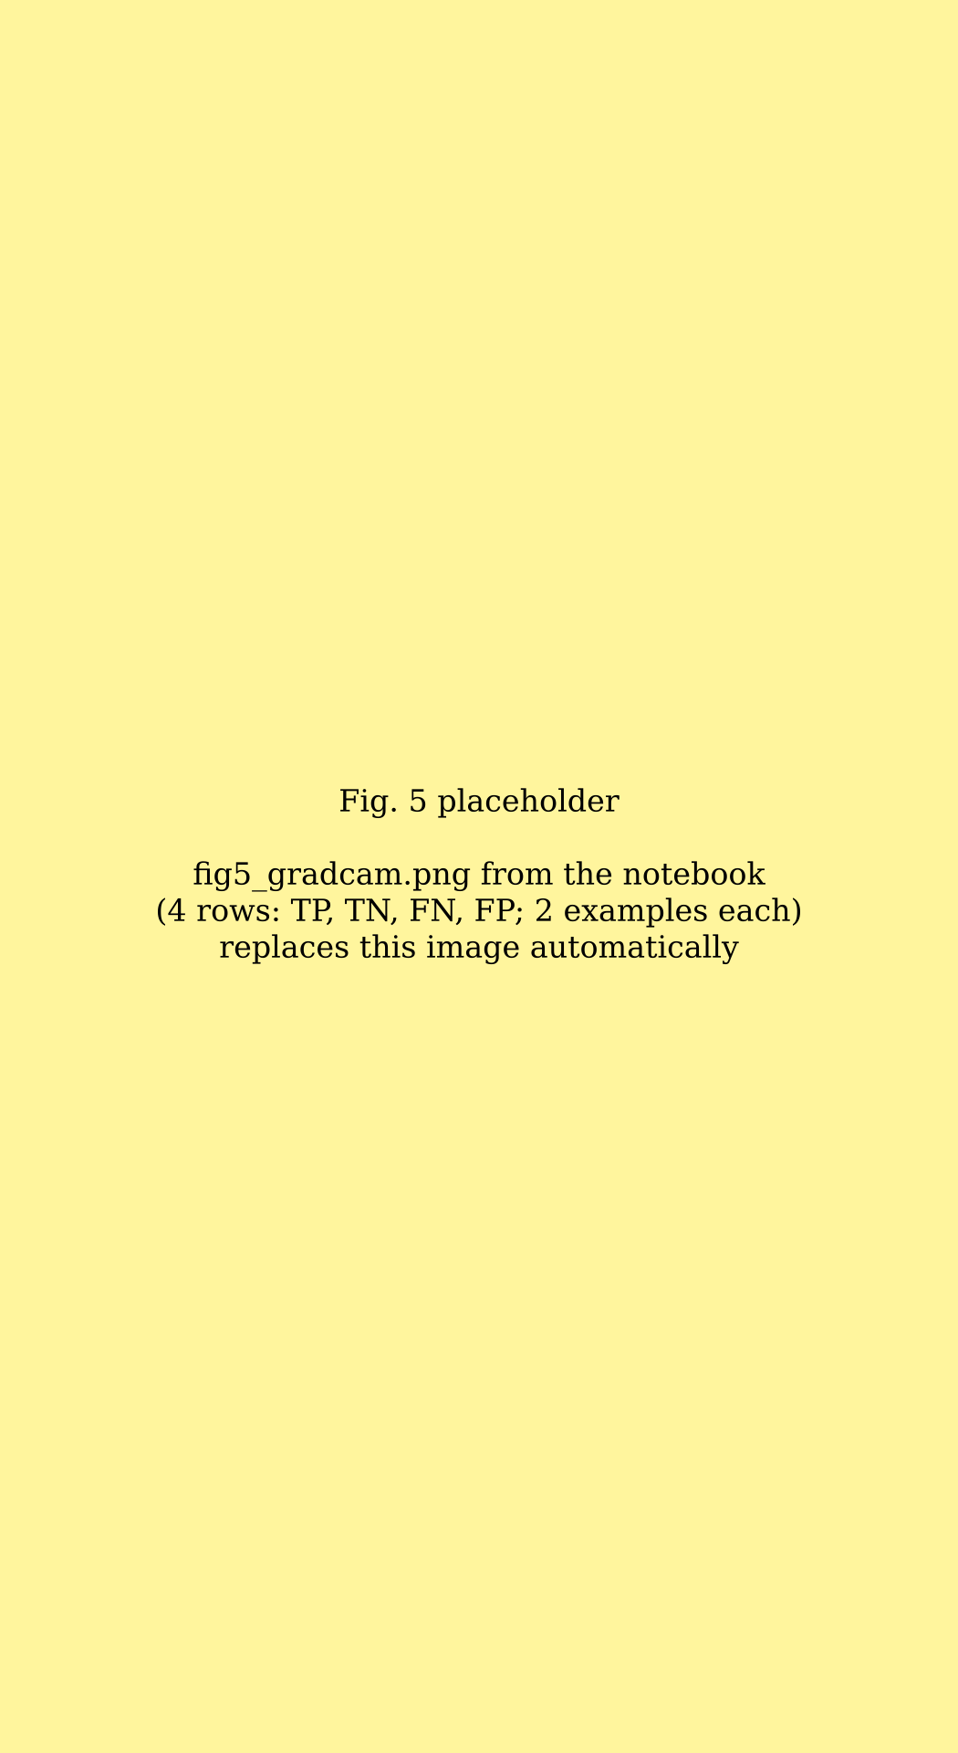
Fig. 5. Grad-CAM maps for randomly drawn test images from the patient-level runs. Rows: true positive, true negative, false negative, false positive (Sick is the positive class). Each panel gives the true and predicted class and the predicted probability of Sick (p). Warmer colours mark regions that contributed more to the predicted class.

VI. Discussion

A. Reliability of the Reported Scores
The image-level numbers in Section V are high, and much of the value of this study lies in understanding why they overstate performance on new patients. Two properties of the split matter.
Image-level split. The 30% hold-out was drawn from individual image files, not from the 30 sub-directories, so every sub-directory contributes images to the training, validation and test subsets. Each sub-directory holds one patient, so the test set contains close relatives of training images: other slices and frames of the same heart, taken with the same scanner settings. A network can then score well partly by recognising the patient rather than the disease, the kind of shortcut found in practice by DeGrave et al. [12] and consistent with the pitfalls identified in [10] and [11]. That validation accuracy stayed above training accuracy throughout stage 1 fits this picture. The patient-level results in Section V-B measure how much it mattered.
Validation–test overlap. As Section V-D shows, the validation and test halves are not fixed sets. The validation set drove early stopping and checkpointing, so test images influenced which weights were kept, although they were never used to update the weights directly. This is a form of leakage between model selection and evaluation [14]. Its effect is probably smaller than that of the image-level split, because selection chose among only 40 checkpoints, but it cannot be ruled out. The confidence intervals in Table III assume independent images, which neither issue guarantees, so they understate the true uncertainty.
The architecture itself is not the concern. The scores are in line with what fine-tuned ImageNet models typically achieve [15]; what the current evaluation cannot show is how much of that performance transfers to new patients. Direct comparison with the cardiac studies in Section II is not meaningful, because they use other modalities, tasks and datasets.

B. Role of the Explanation Module
The explanation module is relevant to exactly this question. If Grad-CAM maps on test images concentrate on image borders, labels or other features that identify a source folder rather than on cardiac tissue, that would support the concern that the scores reflect source recognition, as saliency analysis revealed in the COVID-19 case [12]. Maps that fall on anatomically plausible regions would be reassuring but would not settle the matter: saliency maps can look plausible without being reliable, and a map shows where the evidence is, not what it is. We therefore plan to test the maps against a randomised-weights baseline, to compare Grad-CAM with other attribution methods, and to have a cardiologist rate a sample of maps for correct and incorrect predictions. The heat maps are an aid for checking and communicating the model, not a guarantee that its reasoning is sound.

C. Clinical Considerations
Three points matter if a model like this were ever used in practice. First, at a threshold of 0.5 the image-level model missed about twice as many Sick images as it wrongly flagged, whereas in screening a missed case is usually the more costly error; Section V-B shows the effect of choosing the threshold on validation patients for a target sensitivity. Second, Section V-C shows that at realistic prevalences many positive predictions would be false alarms, so the output is better suited to triage than to diagnosis. Third, the model classifies single images while a diagnosis is made per patient; combining image-level outputs into a patient-level decision is a separate step that has not been studied here.

D. Corrected Evaluation Protocol
The patient-level runs in this paper follow most of the protocol we would recommend. The file list is split once and saved, with whole patients assigned to a single subset; the validation and test sets are fixed file lists; each test fold is used once, after all choices have been made; the threshold is chosen on validation data for a target sensitivity; and training is repeated with five seeds. Two steps remain: an independent site or scanner as external test data, and a review of the Grad-CAM maps by a cardiologist.

VII. Limitations and Ethical Considerations
The original split was made at image level, so images of the same patient appear in training and test data, and its validation and test subsets overlap between epochs. The patient-level cross-validation removes both problems, but the cohort is small: 30 patients, so each test fold holds six of them and the estimates vary noticeably between runs. Patient-level confidence intervals would need many more patients to be informative. There is no external test set. The model classifies single slices, and aggregating them into a patient-level decision has not been studied. Predicted probabilities of the original run were not saved, so other thresholds cannot be evaluated for it. The prevalence analysis assumes that sensitivity and specificity carry over to other populations. Finally, the Grad-CAM maps are shown for eight examples and have not yet been checked against a randomised-weights baseline or reviewed by a cardiologist.
The dataset was collected with ethics approval and written informed consent [16] and contains no patient-identifiable information. Its Kaggle licence is listed as “Unknown”, so we used it only for non-commercial research (Section III-A). The model is a research prototype and is not intended for clinical use. Both notebooks fix their random seeds, record the full training logs and save the trained models, the patient splits and the predicted probabilities, and every number in this paper can be traced to those outputs or to calculations on them; seeds alone do not make GPU training fully deterministic, so a re-run may give slightly different numbers.

VIII. Conclusion and Future Work
We described an explainable framework for heart disease diagnosis built around an ImageNet-pretrained EfficientNet-B0 and applied it to the CAD Cardiac MRI Dataset. Under the original image-level split the classifier reached 97.53% accuracy, 96.49% sensitivity, 98.24% specificity and a ROC-AUC of 0.9978 on 9,512 held-out images. Because the same 30 patients appeared in the training and the test data, and the test images had also served for validation, we treat these figures as an upper bound. With patient-level five-fold cross-validation, where every test patient was unseen during training and model selection, accuracy was [[NEW05_ACC]]% and ROC-AUC [[NEW05_AUC]] (mean ± SD over five runs). Tuning the threshold on validation patients for a target sensitivity of [[TARGET_SENS]]% gave a test sensitivity of [[NEWT_SENS]]% at a specificity of [[NEWT_SPEC]]%. The difference between the two evaluations, [[DELTA_ACC]] percentage points of accuracy, shows how much the image-level split flattered the model. The Grad-CAM maps [[AUTHOR: one sentence on what they showed, matching Section V-E]].
The main remaining limitation is the size of the cohort. Thirty patients are too few for a stable estimate, and the spread across folds reflects that. The next steps are an external test set from another site or scanner, a patient-level decision that combines the predictions for all slices of a patient, a randomised-weights check of the Grad-CAM maps and a review of the maps by a cardiologist.

References
[1] World Health Organization, “Cardiovascular diseases (CVDs),” Fact sheet, Jul. 31, 2025. [Online]. Available: https://www.who.int/news-room/fact-sheets/detail/cardiovascular-diseases-(cvds). Accessed: Sep. 28, 2026.
[2] G. Litjens et al., “A survey on deep learning in medical image analysis,” Med. Image Anal., vol. 42, pp. 60–88, Dec. 2017, doi: 10.1016/j.media.2017.07.005.
[3] O. Bernard et al., “Deep learning techniques for automatic MRI cardiac multi-structures segmentation and diagnosis: Is the problem solved?” IEEE Trans. Med. Imag., vol. 37, no. 11, pp. 2514–2525, Nov. 2018, doi: 10.1109/TMI.2018.2837502.
[4] A. Madani, R. Arnaout, M. Mofrad, and R. Arnaout, “Fast and accurate view classification of echocardiograms using deep learning,” npj Digit. Med., vol. 1, Art. no. 6, 2018, doi: 10.1038/s41746-017-0013-1.
[5] E. J. Topol, “High-performance medicine: The convergence of human and artificial intelligence,” Nat. Med., vol. 25, no. 1, pp. 44–56, Jan. 2019, doi: 10.1038/s41591-018-0300-7.
[6] J. Deng, W. Dong, R. Socher, L.-J. Li, K. Li, and L. Fei-Fei, “ImageNet: A large-scale hierarchical image database,” in Proc. IEEE Conf. Comput. Vis. Pattern Recognit. (CVPR), 2009, pp. 248–255, doi: 10.1109/CVPR.2009.5206848.
[7] D. S. Kermany et al., “Identifying medical diagnoses and treatable diseases by image-based deep learning,” Cell, vol. 172, no. 5, pp. 1122–1131, Feb. 2018, doi: 10.1016/j.cell.2018.02.010.
[8] A. Esteva et al., “Dermatologist-level classification of skin cancer with deep neural networks,” Nature, vol. 542, no. 7639, pp. 115–118, Feb. 2017, doi: 10.1038/nature21056.
[9] M. Tan and Q. V. Le, “EfficientNet: Rethinking model scaling for convolutional neural networks,” in Proc. 36th Int. Conf. Mach. Learn. (ICML), PMLR vol. 97, 2019, pp. 6105–6114.
[10] J. R. Zech et al., “Variable generalization performance of a deep learning model to detect pneumonia in chest radiographs: A cross-sectional study,” PLOS Med., vol. 15, no. 11, Art. no. e1002683, Nov. 2018, doi: 10.1371/journal.pmed.1002683.
[11] M. Roberts et al., “Common pitfalls and recommendations for using machine learning to detect and prognosticate for COVID-19 using chest radiographs and CT scans,” Nat. Mach. Intell., vol. 3, pp. 199–217, Mar. 2021, doi: 10.1038/s42256-021-00307-0.
[12] A. J. DeGrave, J. D. Janizek, and S.-I. Lee, “AI for radiographic COVID-19 detection selects shortcuts over signal,” Nat. Mach. Intell., vol. 3, no. 7, pp. 610–619, Jul. 2021, doi: 10.1038/s42256-021-00338-7.
[13] R. R. Selvaraju et al., “Grad-CAM: Visual explanations from deep networks via gradient-based localization,” in Proc. IEEE Int. Conf. Comput. Vis. (ICCV), 2017, pp. 618–626, doi: 10.1109/ICCV.2017.74.
[14] S. Kapoor and A. Narayanan, “Leakage and the reproducibility crisis in machine-learning-based science,” Patterns, vol. 4, no. 9, Art. no. 100804, Sep. 2023, doi: 10.1016/j.patter.2023.100804.
[15] M. Raghu, C. Zhang, J. Kleinberg, and S. Bengio, “Transfusion: Understanding transfer learning for medical imaging,” in Adv. Neural Inf. Process. Syst. (NeurIPS), vol. 32, 2019.
[16] F. Khozeimeh et al., “RF-CNN-F: Random forest with convolutional neural network features for coronary artery disease diagnosis based on cardiac magnetic resonance,” Sci. Rep., vol. 12, Art. no. 11178, Jul. 2022, doi: 10.1038/s41598-022-15374-5.
[17] D. Sharifrazi, “CAD Cardiac MRI Dataset,” Kaggle, version 2, 2021. [Online]. Available: https://www.kaggle.com/datasets/danialsharifrazi/cad-cardiac-mri-dataset. Accessed: Nov. 13, 2026.
[18] D. V. Marghidan, “Patient-level coronary artery disease classification from cardiac MRI using out-of-fold heart segmentation and same-slice region controls,” Research Square preprint, Oct. 2026, doi: 10.21203/rs.3.rs-11277802/v1.

