1.Create a secret in AWS Secrets Manager and use it in an application by referencing its ARN.

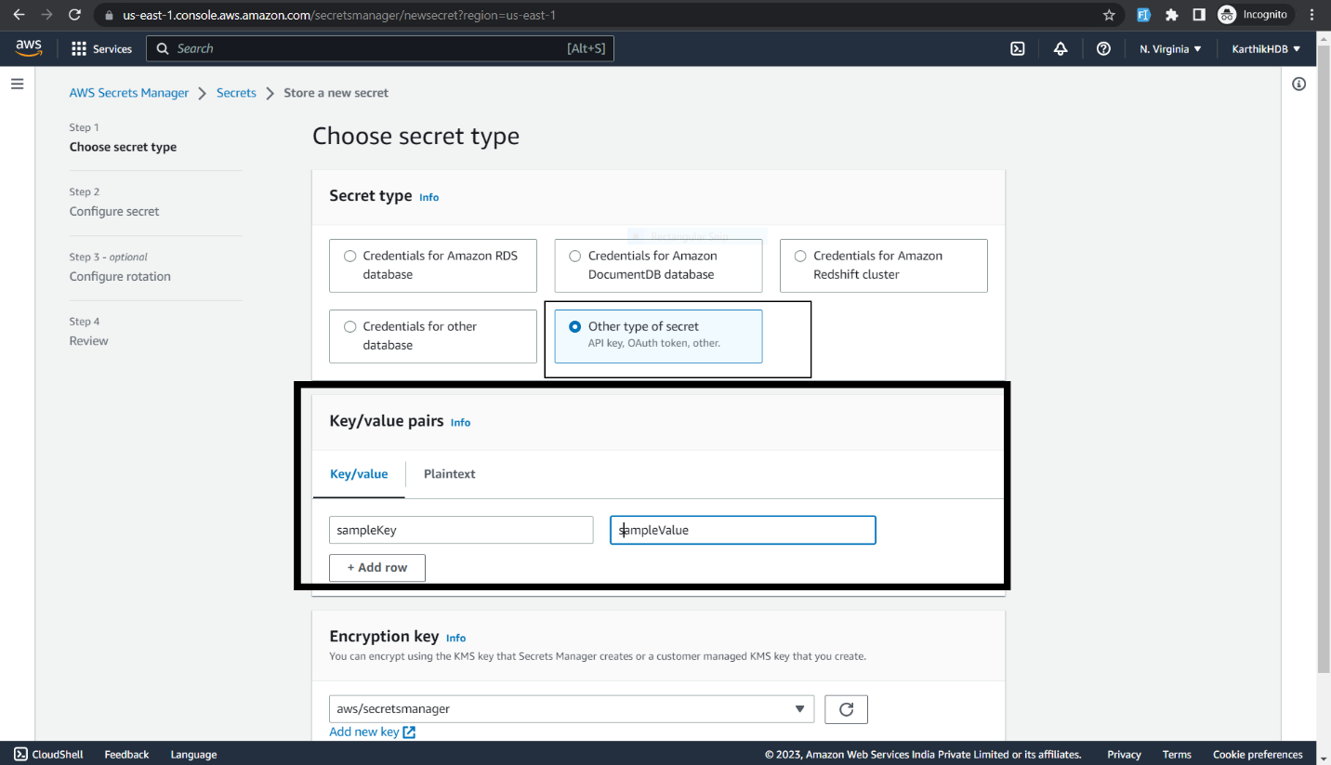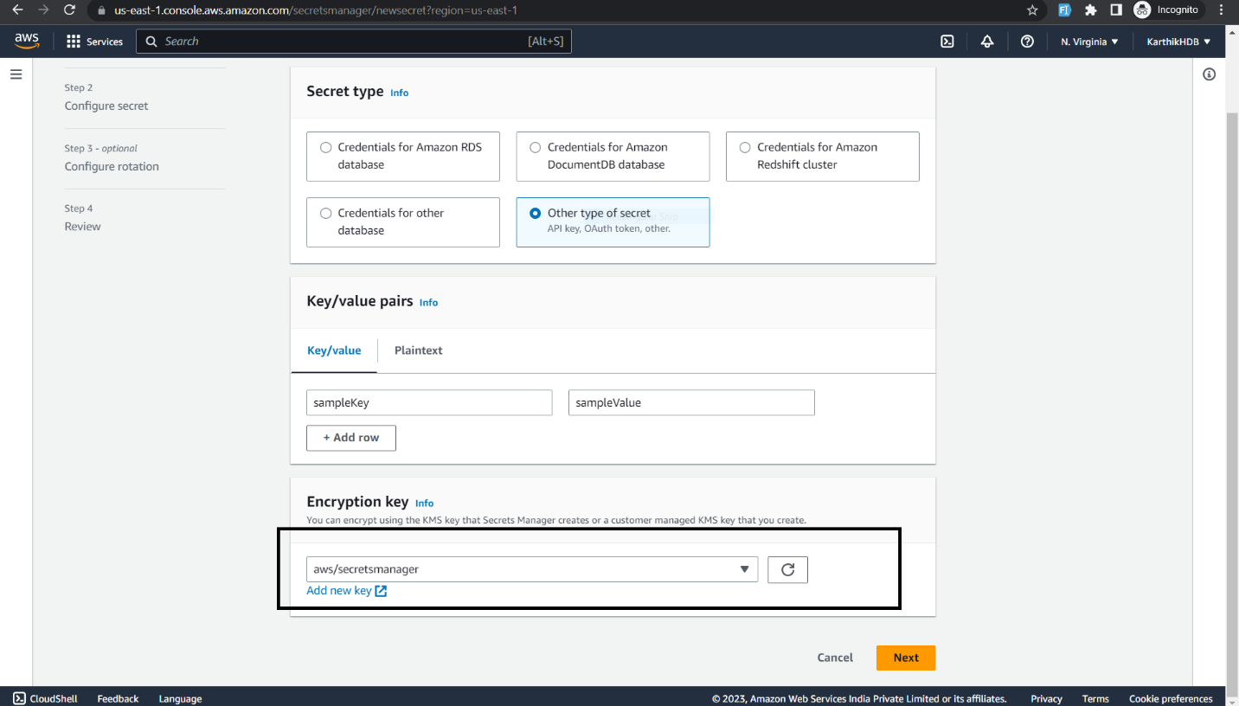

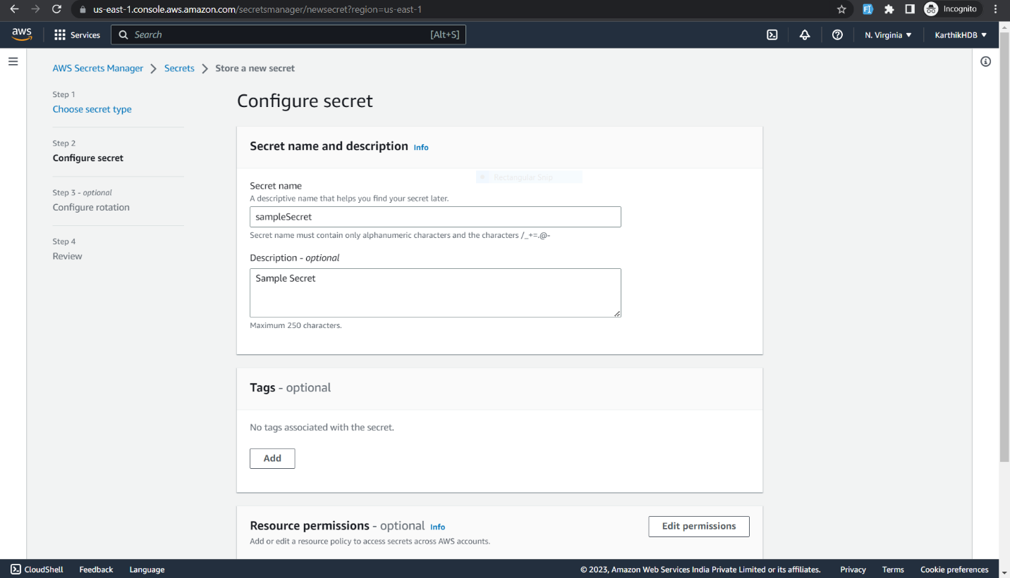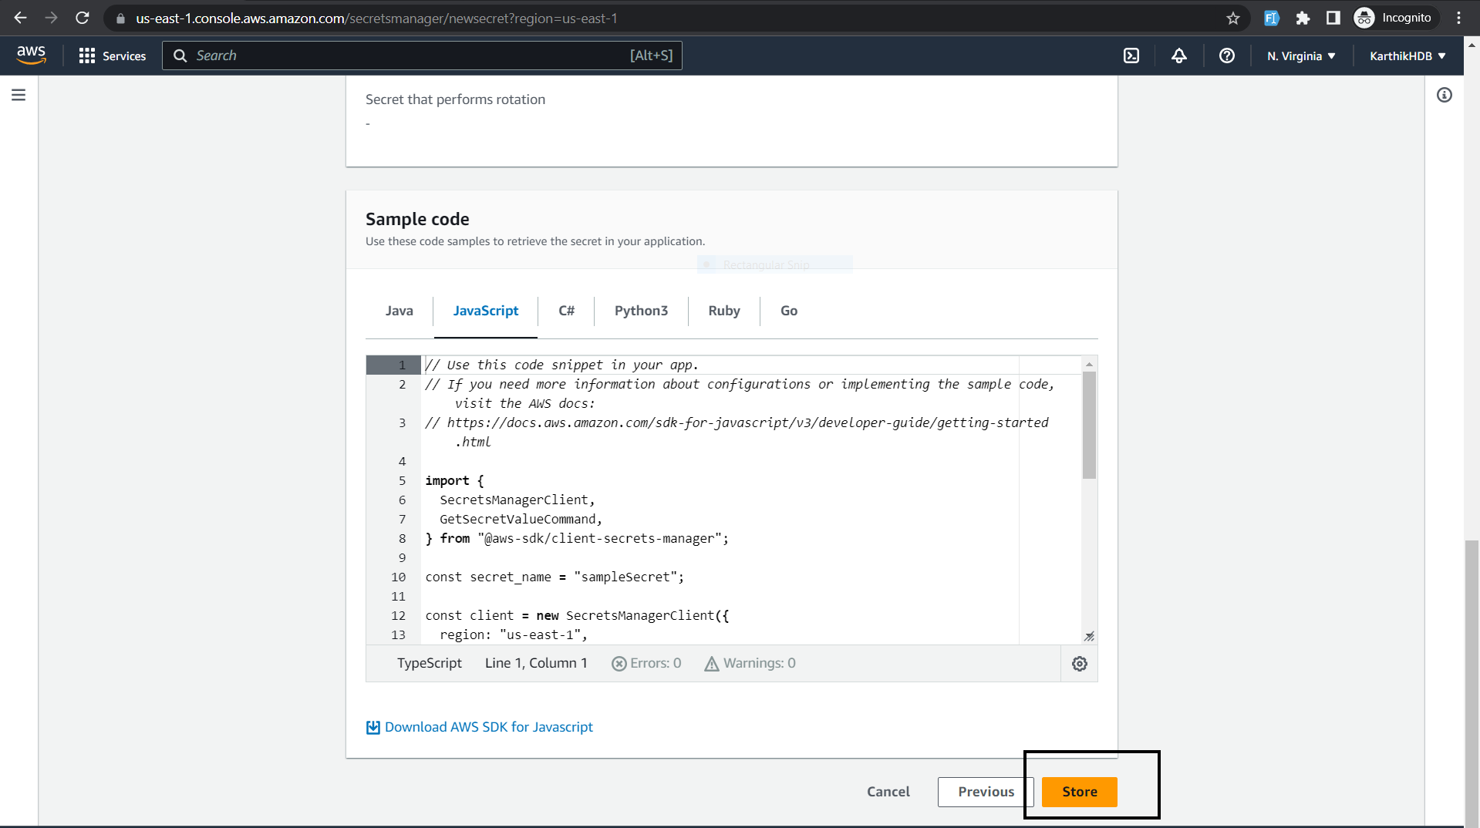

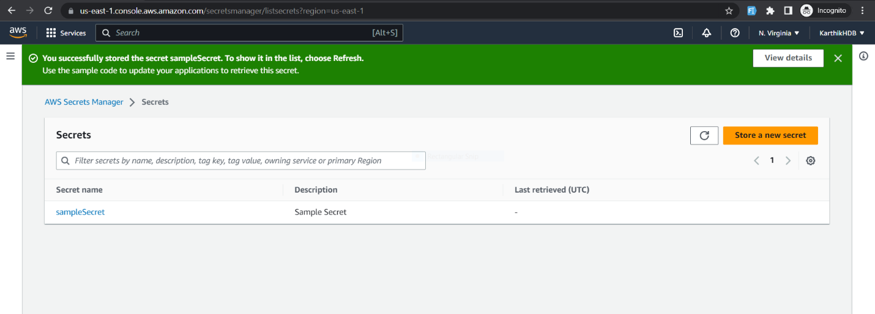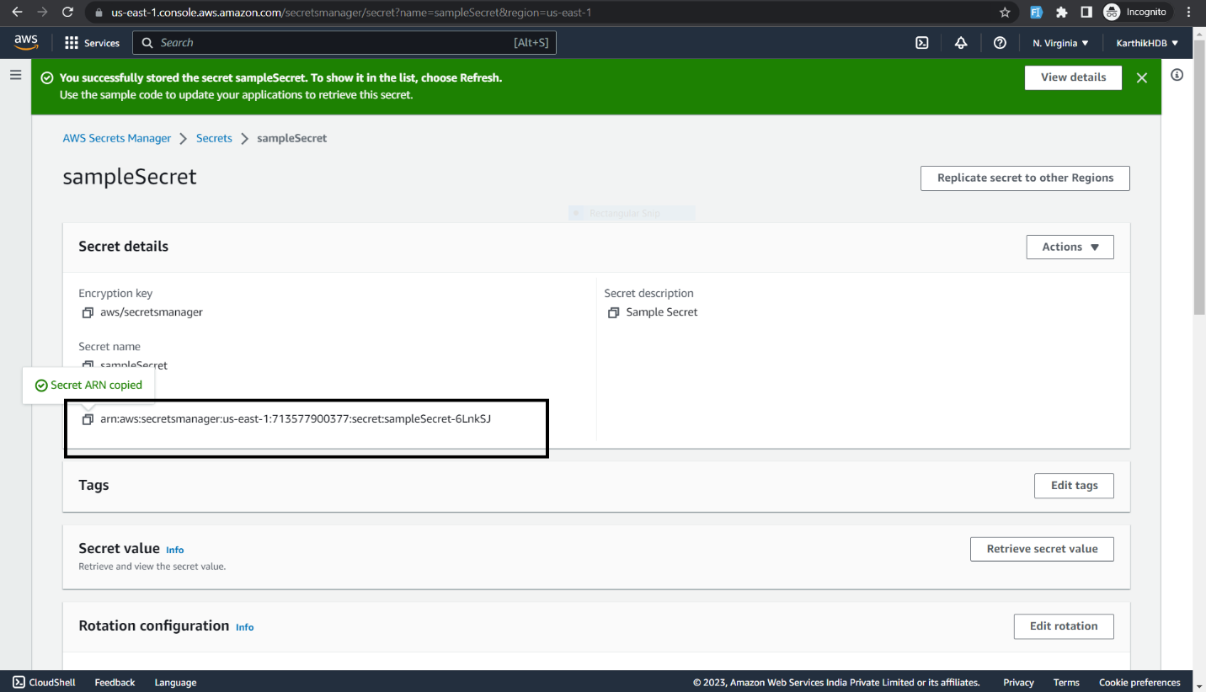

2.Rotate a secret in AWS Secrets Manager and update the application to use the new version of the secret

3.Use AWS CLI to retrieve a parameter from the Parameter Store and display its value.

4. Use AWS CLI to create a secret in AWS Secrets Manager and update its value.

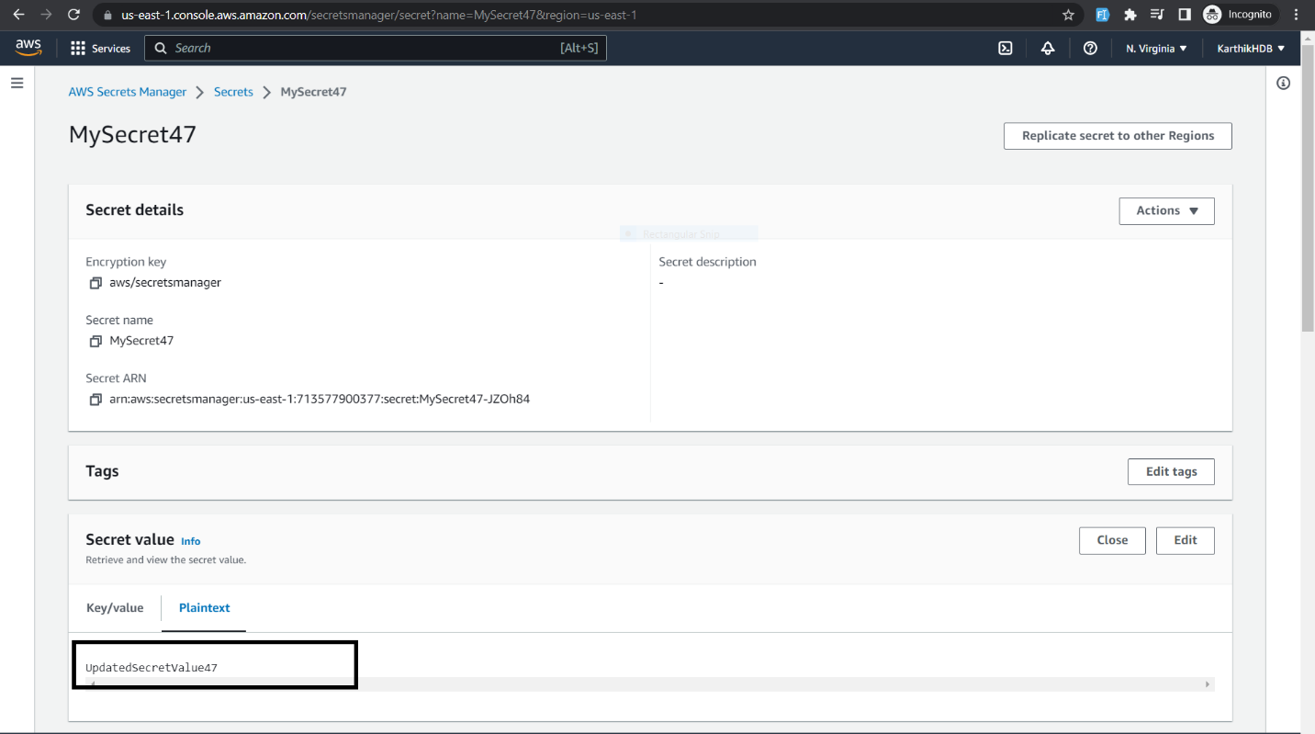

5th Question is on the repo as retrieveParam.js