**Assignment 2**

**CSP-554 Big Data Technologies**

**By**,

Karthik Channarayapatna Mahesh

A20383027

**10 .** (1 point) Execute the following hdfs command and take a screen snapshot of the names of the files or directories that are listed (also indicating which is a file and which a directory):

hadoop fs –ls /

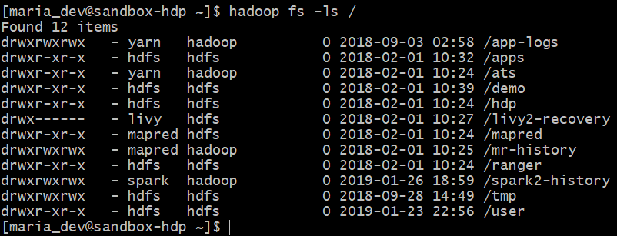

All 12 items found are directories. There are no files.

**11.** (1 point) Execute a command (you needed to figure out which one) to list the files and directories under the hdfs directory listed below:

/user

Write down the command you executed and also take a screen snapshot of names of the files or directories that are listed.

**Command** : Hadoop fs -ls /user

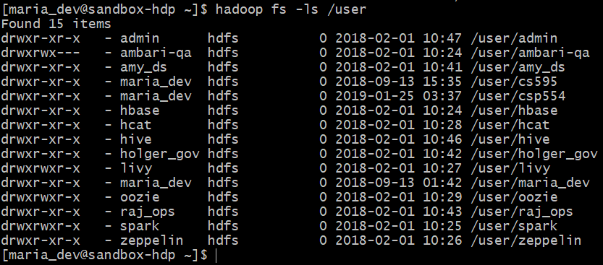

**12.** (2 points) Execute a command to create the following directory:

/user/csp554/<yournamenospaces>

Note: I created the hdfs directory “/user/csp554” for you already.

Record the command you executed and include it in your assignment submission.

**Command : Hadoop fs -mkdir /user/csp554/KarthikMahesh**

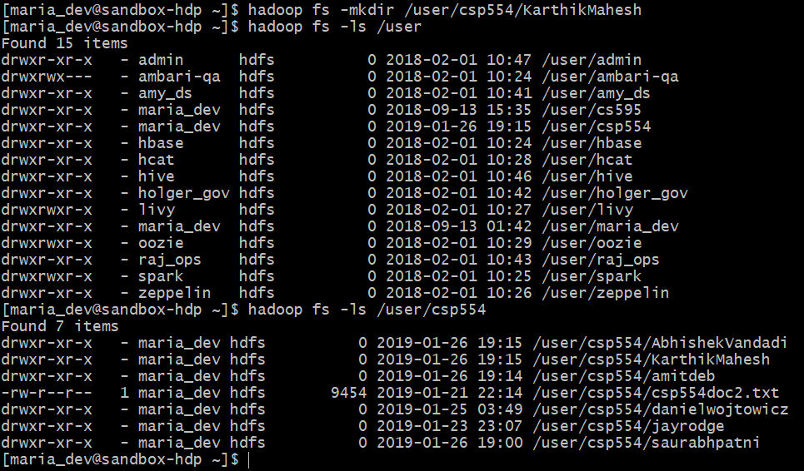

**13.** (2 points) Execute a command that copies a given local file (that I already created for you) to the given hdfs directory :

Local file: /home/maria_dev/csp554doc.txt

HDFS directory: /user/csp554/<yournamenospaces>

Record the command you executed and include it in your assignment submission.

**Command: Hadoop fs -copyFromLocal /home/maria_dev/csp554doc.txt /user/csp554/KarthikMahesh**



**14**. (2 points) Copy the given file from one hdfs directory to another hdfs directory and write down the command

Source hdfs file: /user/csp554/csp554doc2.txt

Note, I created this file for you already

Destination HDFS directory: /user/csp554/<yournamenospaces>

Record the command you executed and include it in your assignment submission.

**Command : Hadoop fs -cp /user/csp554/csp554doc2.txt /user/csp554/KarthikMahesh**

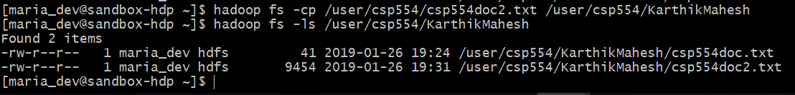

**15.** (2 points) This is to get you familiar with the approach to copy files from your MAC or PC to a local account on the Linux machine running the Hadoop Sandbox.

* Create a plain text file on your local machine (PC or MAC). Name it firstname_lastname.txt. The file should hold just one line and that line should hold your first and last name.
* Open a new terminal or bash window
* Copy the local file firstname_lastname.txt to the maria_dev account as follows:
  + scp –P 2222 ./firstname_lastname.txt maria_dev@localhost:/home/maria_dev
  + When prompted for a password, enter
    - maria_dev
  + Note that the “ssh” command used a small p (-p) to specify the port, the scp command uses a capital P (-P) to do so.
* Now, from your hadoop maria_dev account, execute a command that copies the firstname_lastname.txt file to the given hdfs directory :

Local file: /home/maria_dev/firstname_lastname.txt

HDFS directory: /user/csp554/<yournamenospaces>

Record the command you executed and take a screenshot of all files in the directory “/user/csp554/<yournamenospaces>”

**Command : scp -P 2222 ./Karthik_Mahesh.txt maria_dev@localhost:/home/maria_dev**

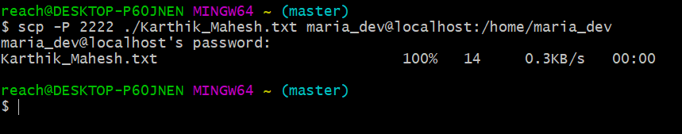

**Command : Hadoop fs -moveFromLocal /home/maria_dev/Karthik_Mahesh.txt /user/csp554/KarthikMahesh**

