Dayglow Architecture and Technology
Karthik Murugan | October 10 2026 | Version 2
Dayglow combines a coastal planning interface, a local language model agent and a deterministic scheduler. These diagrams show the implemented system and where each technology fits.
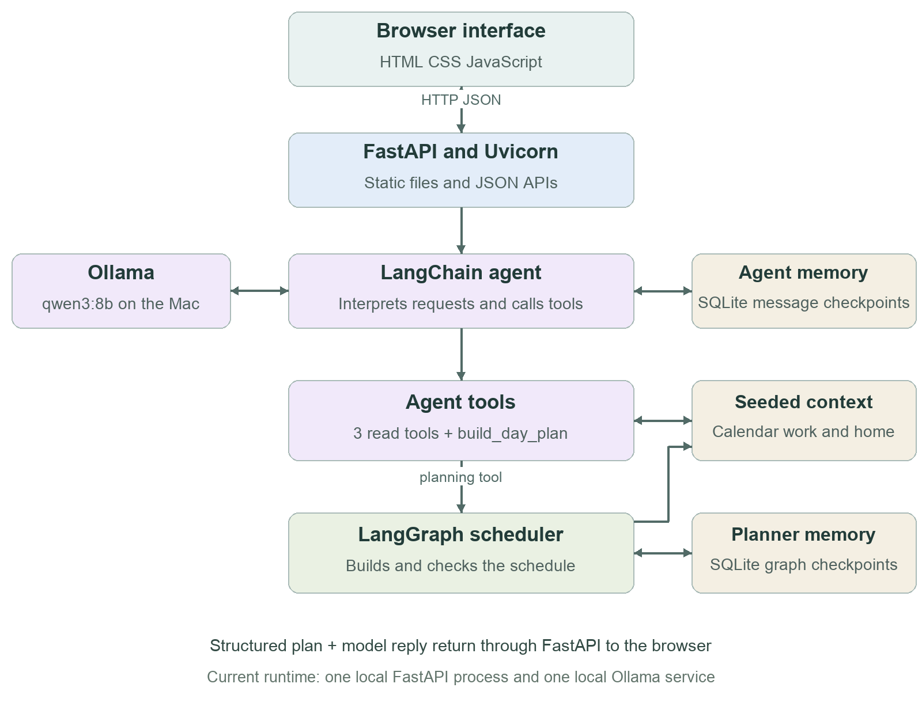

The key design decision
The model selects tools and explains results. LangGraph decides the actual task times and checks them. The calendar is rendered from structured scheduling output, rather than reconstructed from model text.
Current choices: one FastAPI origin, SQLite checkpoints and local Ollama. React, Next.js, Vercel, Docker and external calendar connectors are not used.

Technology stack
Versions below were checked in the current local Python environment. uv.lock records the project dependency resolution.
Layer | Technology | Purpose
Interface | HTML CSS JavaScript | Responsive coastal UI, navigation, calendar and one shared Copilot panel. No frontend framework or build step.
Backend language | Python 3.11 or newer | API, agent tools and scheduling logic; the project declares this minimum.
API framework | FastAPI 0.142.4 | HTTP endpoints, validation with Pydantic, and static frontend hosting.
Application server | Uvicorn 0.54.0 | Runs the FastAPI application on localhost:8000.
Agent framework | LangChain 1.4.4 | create_agent supplies the model and tool invocation loop.
Graph orchestration | LangGraph 1.2.14 | Explicit scheduler nodes, state transitions and checkpointed runs.
Model adapter | langchain-ollama 1.1.0 | ChatOllama connects the agent to the local Ollama service.
Language model | Ollama with qwen3:8b | Local inference; temperature 0 and 8192-token context configured in code.
Memory | SQLite with checkpoint adapter 3.1.1 | Separate databases for agent messages and scheduler state.
Verification | pytest and Playwright with Chrome | 24 backend tests plus browser workflow checks.
Project tools | uv Git and GitHub | Dependency management, locked versions and source control.

Where the code lives
dist/index.html and styles.css define the interface. dist/app.js manages UI state; api.js handles HTTP. backend/main.py exposes APIs; agent_service.py defines the agent; planner.py builds the scheduler graph; repository.py supplies current seeded data.

Agent and scheduler workflows
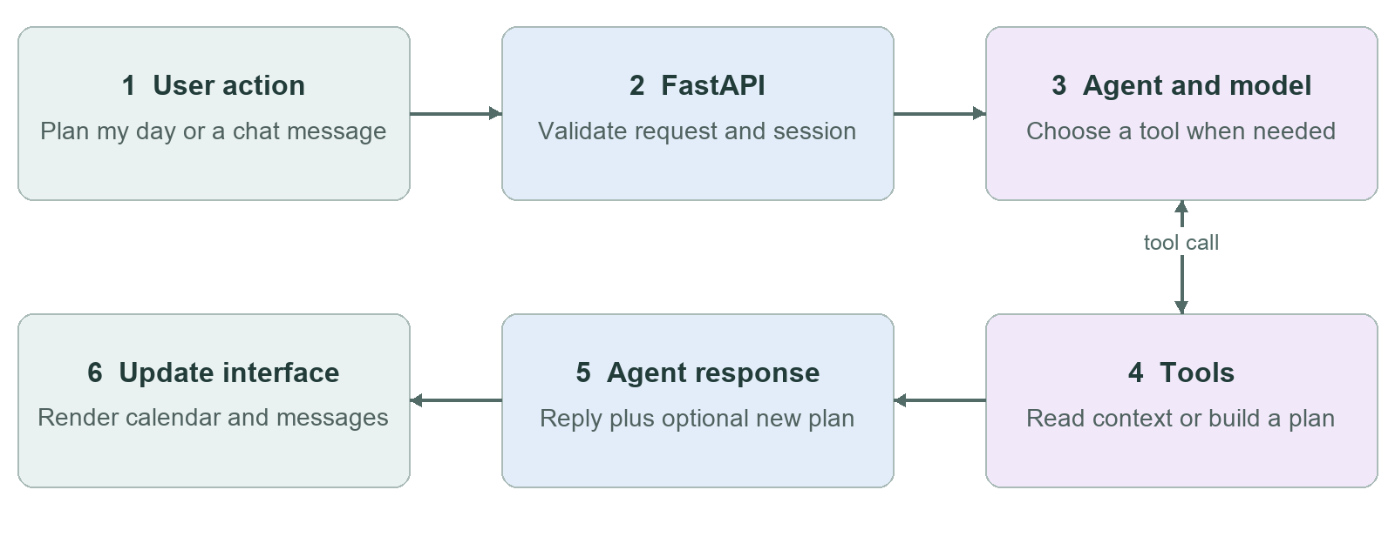

Four tools available to the agent
get_calendar reads commitments. get_work_tasks and get_home_tasks read incomplete tasks. build_day_plan invokes the scheduler. Plan my day requires that last tool to run; a chat reply may use history without producing a new plan.

Inside the planning tool
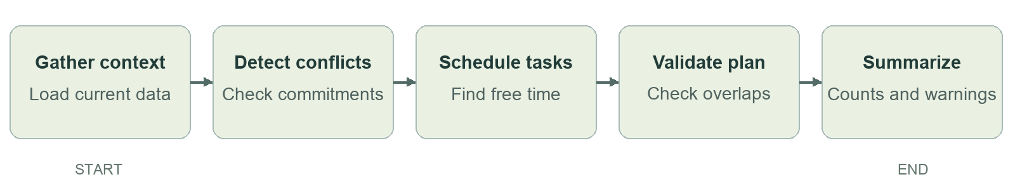
Tasks are sorted by deadline, priority and ID, then placed in the first uninterrupted free slot. Existing commitments remain fixed. Overlapping calendar events are reported; tasks that cannot fit are deferred. The default planning window is 09:00 to 18:00.

API entry points
POST /api/agent/plan runs the model-driven planning path. POST /api/chat runs conversation through the same agent. POST /api/plan runs only the deterministic scheduler. GET /api/calendar, /api/work and /api/home supply context. GET /api/plan/{thread_id} retrieves stored scheduler state.
The agent returns reply plus plan. plan is null unless a planning tool ran during that request. When present, it includes scheduled blocks, original calendar, conflicts, deferred tasks and planning activity.

Memory and deployment architecture
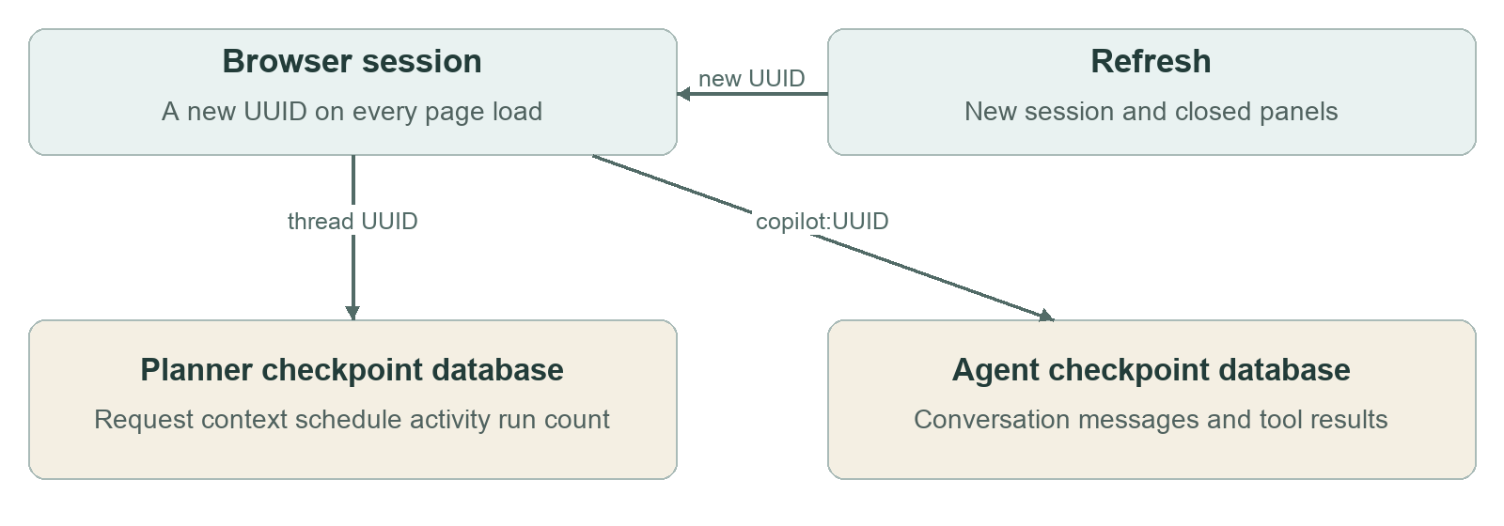

Two different types of state
Browser state holds the visible panels, completed selections and current conversation. Refresh starts a new session on Today with the calendar and Copilot closed. The server retains old graph and message checkpoints; the UI does not automatically restore them.
Planner data is stored in backend/data/checkpoints.sqlite. Agent messages are stored in backend/data/api-agent-checkpoints.sqlite. Separate process-local locks protect agent and scheduler operations. This is a single-process design; all agent requests share one lock.

Current system and future cloud deployment
Concern | Current implementation | Future deployment
Hosting | FastAPI and Ollama on the Mac | Hosted Python API and private model service
Storage | Local SQLite checkpoints | Managed database and durable user task storage
Identity | Session UUID and fixed profile | Authentication and per-user authorization
Data sources | Seeded calendar and task lists | Calendar and task connectors
Concurrency | Single-process locks | Background jobs and multi-instance coordination

Operational boundaries
The app does not write external calendar events, optimize globally or apply personal preferences to time slots. Refresh does not cancel work already running on the server. Browser timeouts are 30 seconds for context and five minutes for model requests. Cloud deployment is a future extension, not a currently deployed service.
Source baseline: LifeOSAgent commit ab0dbad. The current code has passed 24 backend tests and the final browser regression suite. Repository: https://github.com/KarthikMurugan/LifeOSAgent

