Code Review Agent Technical Design
  - Implemented system design | Version 1.1 | 28 October 2026
The agent reviews GitHub pull requests using three parallel specialists, validates their findings, and publishes a commit-bound summary review. The implementation prioritizes a small, understandable learning deployment: FastAPI intake, one background worker, a persistent SQLite queue, and Nebius Kimi K2.7 Code.
This document explains the implemented design, its operational behavior, the integration evidence, and the work needed before broader production use. Its audience is the engineer operating or extending the reviewer.

Scope and behavior
- Analyze bugs and consequential anti-patterns, security vulnerabilities, and missing regression tests.
- Support Python, JavaScript including JSX and module variants, and Java through static model analysis.
- Review committed changes through either a local CLI or GitHub App pull request events.
- Publish one summary review per revision with severity, confidence, reviewer outcomes, and limitations.
The hosted workflow does not approve PRs, request changes, push commits, create branches, publish inline suggestions, execute tests, or measure coverage. Internal finding records still contain suggested fixes and tests, but the GitHub summary omits those fields.

Key design decisions
Decision | Reason
Fixed parallel review | Each specialist has a clear responsibility; execution and failures are predictable.
Same model for all roles | Specialization comes from prompts. Initial behavior is easier to understand without model-routing differences.
Asynchronous webhook handling | HTTP intake persists work and returns without waiting for model inference.
Comment only GitHub App | Contents read and pull requests write are sufficient; source changes remain under developer control.
SQLite on one host | Two application containers and one shared volume are enough for the current learning workload.

Architecture and module interfaces
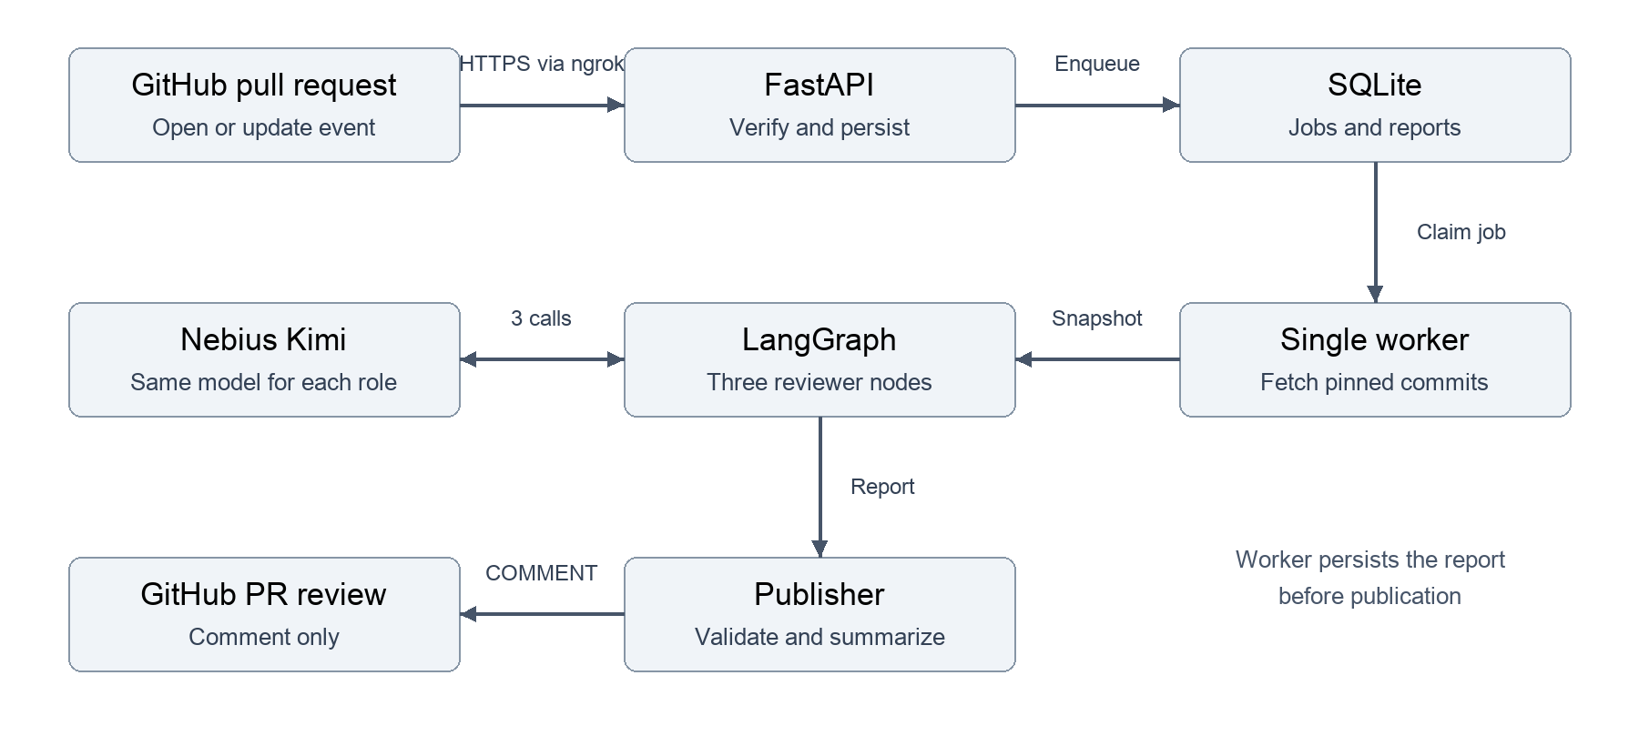
The API and worker share a named SQLite volume. The worker owns fetching, model calls, validation, and publication. The webhook API has neither the Nebius key nor the GitHub App private key in the supplied Compose configuration.
Module | Interface and implementation responsibility
server.py | create_app: signed intake, payload validation, health, authenticated job status.
jobs.py | JobStore: enqueue, claim, save report, finish, and fail through SQLite transactions.
github.py | App authentication, PR revision checks, bare Git fetch, publication reconciliation.
snapshot.py and languages.py | capture: immutable commit context, file selection, test discovery, and budgets.
reviewers.py and workflow.py | Reviewer.review and review_repository: provider adapter, parallel nodes, aggregate report.
models.py and reporting.py | Shared Pydantic contracts and readable local report rendering.

The review interface is review_repository(snapshot, reviewer) -> Report. The CLI and hosted worker supply its dependencies. ModelReviewer and DemoReviewer are interchangeable adapters; the demo returns scripted outputs without inference.

Container architecture
Two application containers share one persistent Docker volume. GitHub reaches the API through ngrok running on the Mac. GitHub and Nebius remain external to Docker Desktop.
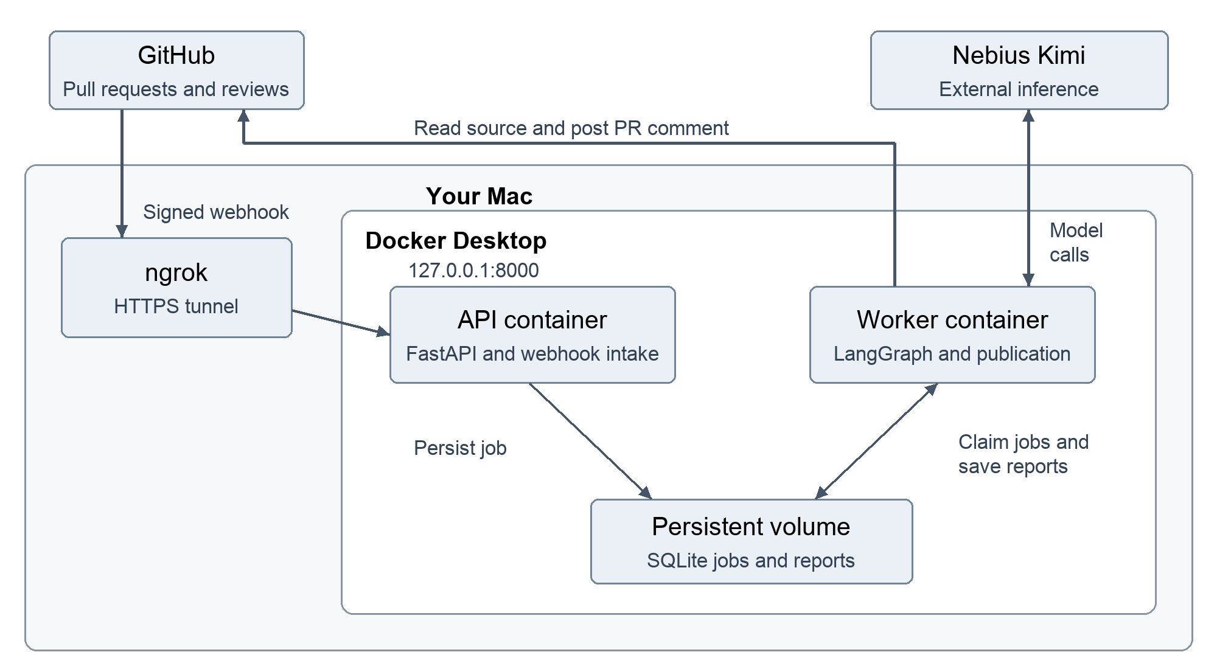
Part | Responsibility | Credentials
API container | Verify signatures, queue jobs, serve health and job status. | Webhook secret and status token
Worker container | Fetch pinned code, run reviewers, and post the summary. | Nebius key and GitHub App private key
Shared volume | Preserve queued work and reports across container restarts. | Stores private review data
ngrok on the Mac | Forward public HTTPS to the loopback API port. | Separate ngrok authentication

The three specialists run concurrently inside the worker process; they are not separate containers. SQLite is a database file on the shared volume, not a database container.
Only the API publishes a host port, bound to 127.0.0.1:8000. The worker needs no inbound port and makes outbound requests to GitHub and Nebius. Its report is saved before publication so publication retries can reuse the analysis.

Pull request lifecycle
The App subscribes to pull_request events. Supported actions are opened, synchronize, reopened, and ready_for_review. Draft or closed PRs are ignored. Signed ping events return successfully without creating a review job.
1. FastAPI reads the raw request body, enforces the payload limit, verifies its HMAC signature, and validates the delivery ID and review identifiers.
2. JobStore records the delivery and review identity transactionally. The HTTP response is 202 with a job ID; a duplicate event returns the existing ID.
3. The single worker claims a queued job. It signs a GitHub App JWT and obtains an installation token restricted to the target repository and required permissions.
4. The worker fetches current PR metadata. A closed or draft PR, changed base/head SHA, or mismatched base repository ID makes the job superseded.
5. Git fetches the expected base commit and the base repository PR head ref into a temporary bare repository. The fetched head must equal the queued head SHA.
6. The worker finds the merge-base and captures the source snapshot. Three reviewer nodes then run concurrently against the same bounded context.
7. The orchestrator validates excerpts and locations, removes exact duplicates within a role, sorts accepted findings, and records limitations. The worker saves the report before publication.
8. The publisher reconciles existing bot reviews, checks the current PR revision again, and posts a COMMENT review tied to the reviewed head SHA. It saves the review ID and completes the job.

Revision correctness
The queued base SHA is the PR base branch revision. The analysis base SHA is its merge-base with the PR head, so the report represents branch changes since divergence. A shallow fetch contains 100 commits; absent common history causes an explicit failure rather than a guessed comparison.
A push can race the final publication check. The review remains bound to its original commit and shows the reviewed SHA. Base-branch movement alone does not schedule a new job; another supported PR event is required.

Review context and finding validation
Specialist | Review focus
Bugs | Triggering inputs, incorrect behavior, resource handling, concurrency, and consequential anti-patterns.
Security | Attacker-controlled input, reachable execution paths, defenses, and plausible impact.
Tests | Missing behavioral scenarios and expected assertions, informed by visible test and framework context.

Each specialist makes one independent structured model call. These are fixed review nodes, not autonomous code-search agents. Function calling carries the structured answer; no repository tool or generated function is executed. LangGraph joins all three outcomes, and an append reducer prevents parallel results from overwriting each other.

Context selection
The snapshot includes changed supported head files and their diffs, followed by unchanged build manifests and convention-matched tests. It reads Git blobs rather than working-tree edits. Unchanged application callers and imported dependencies are not retrieved.
Sources include .py, .js, .jsx, .mjs, .cjs, and .java. Configuration includes JSON, TOML, YAML, INI, CFG, XML, Gradle, and properties files, including named Gradle Kotlin build files. TypeScript, HTML, CSS, compiled classes, and JARs are unsupported. Deleted files, binary data, symlinks, and excluded oversized content become explicit limitations.

Finding contract
A Finding contains title, path, start/end line, severity, confidence, explanation, trigger, an exact code excerpt, suggested_fix, and suggested_test. ReviewOutput contains up to ten findings plus limitations. AgentResult records the role, completion/failure outcome, output, and sanitized error type.
Pydantic checks structural validity. The orchestrator checks that the path belongs to a supplied changed file, the line range exists, and the evidence is a nonempty substring of that range. It does not establish root cause, exploitability, or whether the cited lines belong to a changed hunk. It does not independently confirm severity or semantic duplicates.
Severity | Interpretation
Critical | Catastrophic plausible impact
High | Major failure under realistic conditions
Medium | Material failure with narrower scope or preconditions
Low | Limited practical impact

Confidence is separately high, medium, or low. Sort order is severity, confidence, path, line, and role. A completed report is not a safety guarantee.

HTTP interface and security
Method and route | Authentication | Result
GET / | None | API identification and endpoint paths
GET /healthz | None | Database/process liveness, not provider readiness
POST /webhooks/github | GitHub HMAC signature | 202 queued, duplicate, ignored, or ping response
GET /jobs/{job_id} | Bearer status token | Execution status, attempts, error type, review ID, timestamps

Webhook signatures use HMAC SHA-256 over raw bytes and a constant-time comparison against X-Hub-Signature-256. The webhook secret must contain at least 32 characters. Invalid signatures return 401; malformed supported payloads return 400; bodies larger than 1 MB return 413. Unsupported events return an ignored response.

GitHub identity and permissions
The App requests Contents read and Pull requests write. A signed JWT authenticates token issuance; installation tokens are restricted to the repository ID from the signed event. The PR metadata is checked before fetching and publishing. Fixed github.com and api.github.com destinations are used rather than webhook-supplied clone URLs.

Repository and model trust
Repository text is untrusted data. Review instructions prohibit obeying embedded instructions; no model-accessible repository tools are enabled. Git fetching performs no checkout, hook execution, submodule initialization, LFS processing, build, or test execution. Prompt injection and incorrect model reasoning remain possible and are not solved by excerpt validation.
The worker sends selected source and test/configuration context to Nebius. App installation and operating policy must authorize that processing. Findings and raw model outputs are stored in SQLite; the database is private source-derived data and is not encrypted by the application.

Credential separation
The API receives only the webhook secret and status token. The worker receives the Nebius key and App identity, with its private key mounted as a runtime secret. Git credentials use a temporary askpass helper and an environment value rather than a URL or persistent Git credential configuration. Credentials and raw provider error bodies are not intentionally logged.
The Docker build context allowlist excludes .env files, PEM files, reports, and scratch data. Job status excludes source payloads and full reports. Key permissions, secret rotation, host access controls, and retention remain operator responsibilities.

Persistence and failure recovery
SQLite stores two tables. jobs holds id, normalized payload, status, attempts, lease_until, serialized report, review_id, error, and created/updated timestamps. deliveries maps each GitHub delivery ID to a job. Both intake and claiming use immediate transactions to arbitrate access.

Identity and duplicate handling
The job ID is a SHA-256 hash of installation ID, repository ID, PR number, base SHA, head SHA, and REVIEW_VERSION. The current version is comments-v1. Model ID, prompt contents, and configuration hashes are not automatically included; changes to review behavior require explicit version management to obtain a new identity.
queued -> running -> completed
|
+-> superseded
+-> queued for retry -> running
+-> failed after the attempt limit
Execution status and analysis completeness are different. completed means publication finished. A published Report may still be partial because a specialist failed, an excerpt was rejected, context was skipped, or any specialist returned limitations. Routine limitation text can therefore make an otherwise successful run partial.
Condition | Implemented behavior
Worker crashes | A running job becomes eligible again after its 15 minute lease expires. There is no lease heartbeat.
Transient processing error | Up to three claims; the worker pauses ten seconds after an exception. Only the exception type is retained.
Publication fails after saving | Retry reuses serialized analysis rather than rerunning reviewers.
Publish succeeds but acknowledgment is lost | Search bot-authored reviews for the stable job marker and head SHA before attempting another POST.
All reviewers fail | Persist and publish an explicitly partial report; a failure is not interpreted as zero defects.
No supported changed files | Create a partial report without making model requests.

Delivery is at least once. A crash before report persistence can repeat paid inference, and review reconciliation does not guarantee exactly-once publication under every race or consistency condition. Review-history reconciliation stops after ten pages of 100 entries. Report and delivery retention are manual.

Deployment and operating configuration
The local deployment uses Docker Desktop on macOS, two application containers, and a shared named volume. ngrok forwards a public HTTPS endpoint to the API on host loopback port 8000. The tunnel and Mac must remain available for webhook delivery.
The image uses Python 3.12 slim, Git, and pinned server Python dependencies. Both processes run as UID 10001 with read-only root filesystems and dropped capabilities. The API has a 32 MB writable /tmp; the worker has 512 MB. Root filesystems are hardened, but CPU/memory limits and a stronger execution sandbox are not configured. The Python base image and operating-system packages are not fully reproducibly pinned.
Variable | Where used | Purpose
GITHUB_WEBHOOK_SECRET | API | Raw request signature verification
REVIEW_API_TOKEN | API | Authenticated status requests
GITHUB_APP_ID | Worker | App JWT issuer
GITHUB_PRIVATE_KEY_FILE | Worker secret mount | Host PEM path in Compose; runtime path is /run/secrets/github-app.pem
NEBIUS_API_KEY | Worker | Model authentication
REVIEW_MODEL | Worker | Default nebius:moonshotai/Kimi-K2.7-Code
NEBIUS_BASE_URL | Worker | Default https://api.tokenfactory.nebius.com/v1
REVIEW_DB_PATH | Both | Shared /data/reviews.sqlite3 inside Compose

Starting and observing the application
docker compose up --build -d
docker compose ps
docker compose logs --tail=50 api worker
curl --fail http://localhost:8000/healthz
Before the App ID and private key are ready, compose.api.yaml starts only intake and health. Queued jobs remain available when the full stack is started with the same Compose project and volume. docker compose down preserves data; adding -v deletes the volume.
The private key must be readable by UID 10001. Compose file-backed secrets can retain host permissions. A healthy API checks only SQLite access; verify worker activity and GitHub delivery responses separately. Logs report job IDs and error classes, not detailed model validation diagnostics.

Limits verification and operating risks
Control | Current value
Specialists and model requests | 3 independent requests per analyzed revision
Per file size | 24,000 bytes
Shared source and diff budget | 100,000 characters before prompt and line-number overhead
Nebius generation budget | 8,192 output tokens per specialist
Specialist deadline | 180 seconds in worker and CLI; direct library default is 90 seconds
Provider retries | 0 automatic request retries
Queue execution | 1 active job; specialists inside it run concurrently
Publication | Up to 10 findings; summary capped at 50,000 characters

Input budgets count characters rather than provider tokens, so a request can still exceed a model limit. Provider output budgets may include reasoning tokens. Generation uses temperature 1.0 and top_p 0.95. The adapter is single turn and does not preserve nonstandard reasoning history.

Verification evidence
The implementation suite passes 19 checks. Coverage includes Git snapshot integrity, Python/JavaScript/Java context, parallel joining, timeout isolation, invalid-excerpt rejection, mocked Nebius requests, signed intake, duplicate events, status authentication, queue recovery, stale revisions, COMMENT-only publication, and report reuse after a publication failure. These are implementation checks, not review-quality evals.
An end-to-end run against CICD_SupportAgent PR 1 received a real webhook, completed all three reviewers, and posted a review as adk-code-reviewer[bot]. Analysis was partial: one test-related candidate failed evidence validation and no findings were accepted. This verifies transport and publication, not accuracy or recall.
Verification PR and posted bot review

Current risks and limitations
Excerpt matching can reject useful findings or accept weak snippets without proving the claim. Severity is model-assigned; exact deduplication leaves overlapping cross-role findings. Convention-based discovery can miss custom test layouts, and unchanged dependency context is absent. Shallow history, malformed structured output, provider failures, tunnel downtime, and expired leases can interrupt work. There are no calibrated quality metrics, rate-limit-aware retries, tenant quotas, automatic retention, or distributed-worker guarantees.

Decisions and next improvements

Why the current design fits the learning goal
A fixed graph makes reviewer responsibilities, shared input, parallel execution, and failure propagation visible. A deterministic orchestrator is easy to inspect. A separate worker keeps the webhook path fast, while SQLite supplies durable state without a broker. The GitHub App scopes repository access and keeps publication distinct from code modification.
The same implementation can be exercised offline through DemoReviewer, locally through the CLI, and end to end through webhooks. This provides useful seams for learning and debugging without requiring a distributed deployment or repository execution.

Proposed improvements not yet implemented
Priority | Change | Reason
1 | Improve finding diagnostics and completeness status | Preserve safe field-level validation details; separate failures, exclusions, and informational caveats.
2 | Bounded retrieval and stronger evidence checks | Inspect related callers and defenses; verify claimed novelty and improve diff-location accuracy.
3 | Review identity and operational controls | Include model/prompt/configuration hashes; add retention, spend controls, rate-limit backoff, and observability.
4 | Measure reviewer quality when resumed | Compare a general reviewer and specialist graph on labeled historical changes and clean controls. Evals were deferred for the current build.
5 | Scale only when required | Move to PostgreSQL and a distributed queue with lease ownership/heartbeats before adding concurrent workers.

Inline comments, generated patches, automated fixes, test execution, check-run gating, and merges are outside the current scope. They should be separate design decisions rather than implicit extensions of comment publication.

Implementation and protocol references
Implementation authority: Python modules in src/review_agent, Dockerfile, compose.yaml, compose.api.yaml, and tests/. The module map is on page 2. Operational instructions are in DEPLOYMENT.md and README.md.
LangGraph workflow patterns
GitHub webhook signature validation
GitHub App installation tokens
GitHub pull request review interface
Nebius Kimi K2.7 Code integration guide

