Playwright Integration Using GitHub Copilot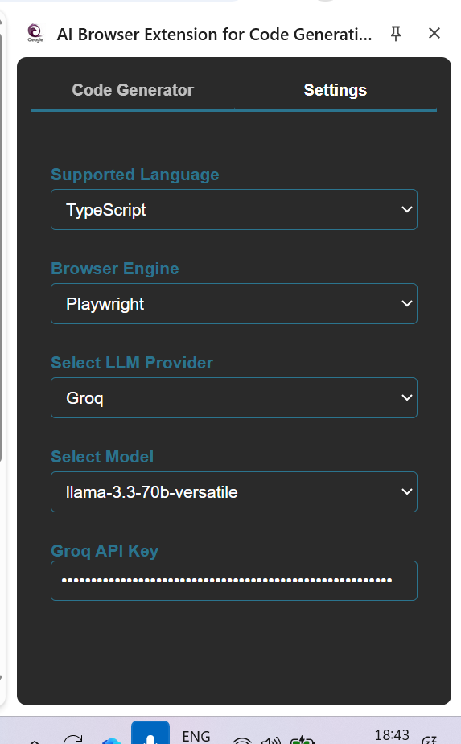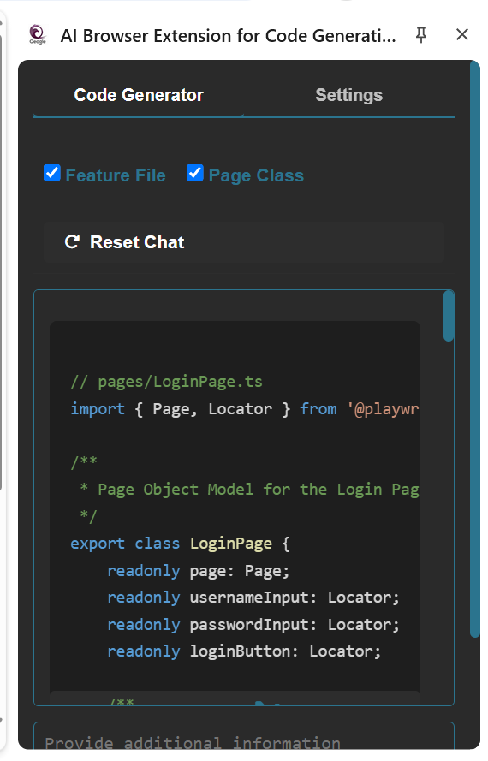

OUTPUT:
// pages/LoginPage.ts
import { Page, Locator } from '@playwright/test';

/**
* Page Object Model for the Login Page.
*/
export class LoginPage {
readonly page: Page;
readonly usernameInput: Locator;
readonly passwordInput: Locator;
readonly loginButton: Locator;

/**
* Initializes the LoginPage object.
* @param page The Playwright page object.
*/
constructor(page: Page) {
this.page = page;
this.usernameInput = page.locator('input[id="username"]');
this.passwordInput = page.locator('input[id="password"]');
this.loginButton = page.locator('input:has-text("Login")');
}

/**
* Navigates to the login page.
*/
async goto(): Promise<void> {
await this.page.goto('https://leaftaps.com/opentaps/control/login');
}

/**
* Enters the username.
* @param username The username to enter.
*/
async enterUsername(username: string): Promise<void> {
await this.usernameInput.fill(username);
}

/**
* Enters the password.
* @param password The password to enter.
*/
async enterPassword(password: string): Promise<void> {
await this.passwordInput.fill(password);
}

/**
* Clicks the login button.
*/
async clickLogin(): Promise<void> {
await this.loginButton.click();
}
}

// tests/login.spec.ts
import { test, expect, Page } from '@playwright/test';
import { LoginPage } from '../pages/LoginPage';

/**
* Test specification for the login functionality.
*/
test.describe('Login to Application', () => {
let page: Page;
let loginPage: LoginPage;

/**
* Sets up the test environment before each test.
*/
test.beforeEach(async ({ page: testPage }) => {
page = testPage;
loginPage = new LoginPage(page);
await loginPage.goto();
});

/**
* Tests a successful login with valid credentials.
*/
test('Successful login with valid credentials', async () => {
await loginPage.enterUsername('demosalesmanager');
await loginPage.enterPassword('crmsfa');
await loginPage.clickLogin();

await expect(page).toHaveURL('**/dashboard');
});

/**
* Tests an unsuccessful login with invalid credentials.
*/
test('Unsuccessful login with invalid credentials', async () => {
await loginPage.enterUsername('invaliduser');
await loginPage.enterPassword('invalidpassword');
await loginPage.clickLogin();

await expect(page).toHaveURL('**/login');
});

/**
* Tests a login with a valid username and an empty password.
*/
test('Login with valid username and empty password', async () => {
await loginPage.enterUsername('demosalesmanager');
await loginPage.enterPassword('');
await loginPage.clickLogin();

await expect(page).toHaveURL('**/login');
});

/**
* Tests a login with an empty username and a valid password.
*/
test('Login with empty username and valid password', async () => {
await loginPage.enterUsername('');
await loginPage.enterPassword('crmsfa');
await loginPage.clickLogin();

await expect(page).toHaveURL('**/login');
});
});

