User Story to Tests
Frontend- Host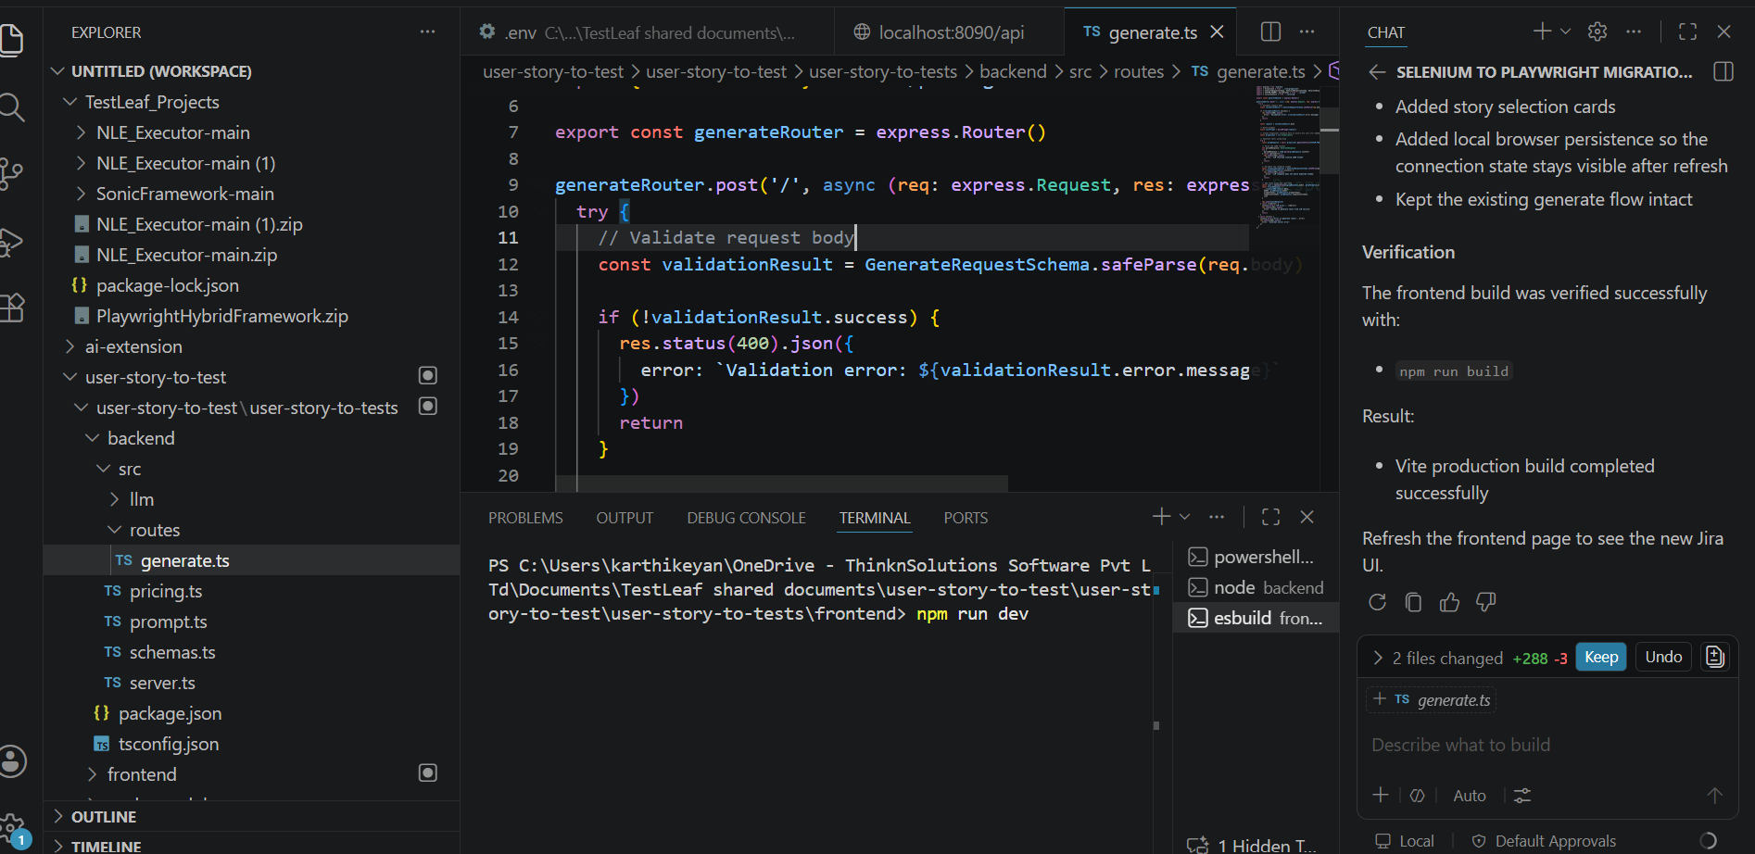

Backend- Host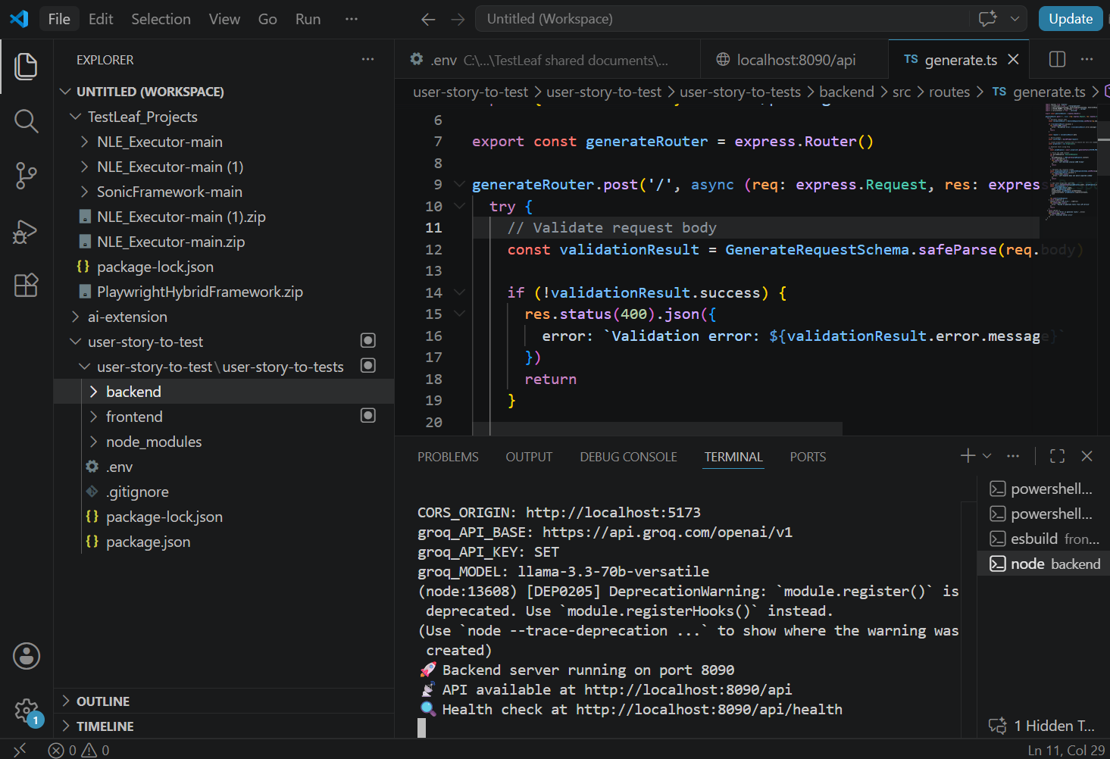
Backend-Output
Environment variables loaded:
PORT: 8090
CORS_ORIGIN: http://localhost:5173
groq_API_BASE: https://api.groq.com/openai/v1
groq_API_KEY: SET
groq_MODEL: llama-3.3-70b-versatile
(node:13608) [DEP0205] DeprecationWarning: `module.register()` is deprecated. Use `module.registerHooks()` instead.
(Use `node --trace-deprecation ...` to show where the warning was created)
🚀 Backend server running on port 8090
📡 API available at http://localhost:8090/api
🔍 Health check at http://localhost:8090/api/health
Groq API key configured successfully
Using model: llama-3.3-70b-versatile
API endpoint: https://api.groq.com/openai/v1/chat/completions
🚀 Making Groq API call:
📍 Endpoint: https://api.groq.com/openai/v1/chat/completions
🤖 Model: llama-3.3-70b-versatile
🔑 API Key: gsk_1o7osV...IYxp
📝 Request body: {
"model": "llama-3.3-70b-versatile",
"messages": [
{
"role": "system",
"content": "You are a senior QA engineer with expertise in creating comprehensive test cases from user stories. Your task is to analyze user stories and generate detailed test cases.\n\nCRITICAL: You must return ONLY valid JSON matching this exact schema:\n\n{\n \"cases\": [\n {\n \"id\": \"TC-001\",\n \"title\": \"string\",\n \"steps\": [\"string\", \"...\"],\n \"testData\": \"string (optional)\",\n \"expectedResult\": \"string\",\n \"category\": \"string (e.g., Positive|Negative|Edge|Authorization|Non-Functional)\"\n }\n ],\n \"model\": \"string (optional)\",\n \"promptTokens\": 0,\n \"completionTokens\": 0\n}\n\nGuidelines:\n- Generate test case IDs like TC-001, TC-002, etc.\n- Write concise, imperative steps (e.g., \"Click login button\", \"Enter valid email\")\n- Include Positive, Negative, and Edge test cases where relevant\n- Categories: Positive, Negative, Edge, Authorization, Non-Functional\n- Steps should be actionable and specific\n- Expected results should be clear and measurable\n- STRICTLY limit the number of test cases generated to 30 EXACTLY for all input combined\n\n\nReturn ONLY the JSON object, no additional text or formatting."
},
{
"role": "user",
"content": "Generate comprehensive test cases for the following user story:\n\nStory Title: Ahc Reports Reports Ahc\n\nAcceptance Criteria:\nGiven reports exist in the system, when a user views or generates a report, then the report should display accurate and up-to-date information.\n\nDescription:\nAs a user, I want to ahc reports reports ahc so that the related functionality works as expected.\n\nGenerate test cases covering positive scenarios, negative scenarios, edge cases, and any authorization or non-functional requirements as applicable. Return only the JSON response."
}
],
"max_completion_tokens": 4096,
"temperature": 0.2
}
📊 Response status: 200
📋 Response headers: {
'alt-svc': 'h3=":443"; ma=86400',
'cache-control': 'private, max-age=0, no-store, no-cache, must-revalidate',
'cf-cache-status': 'DYNAMIC',
'cf-ray': 'a12502aa3a2b3cac-BOM',
'content-encoding': 'br',
'content-type': 'application/json',
date: 'Sat, 27 Jun 2026 14:06:11 GMT',
server: 'cloudflare',
'set-cookie': '__cf_bm=TM1YDodjj5hrnzqnq9nzC9VStWzpcdlACnjUAvfIWi0-1782569166.4402425-1.0.1.1-Q.uqF8YSs8SesMUnoPJPtyq1EWKFa9nE7buSJTI_ARF2Ylr_oJrNV_GH2.68AbuH7uHBFh62zgvDjGS8tvioeGHOIKt_VPQlKWDISkMLuGrE8oSZH8nm4JKw3hB614yF; HttpOnly; SameSite=None; Secure; Path=/; Domain=groq.com; Expires=Sat, 27 Jun 2026 14:36:11 GMT',
'strict-transport-security': 'max-age=15552000',
vary: 'Origin',
via: '1.1 google',
'x-groq-region': 'bom',
'x-ratelimit-limit-requests': '1000',
'x-ratelimit-limit-tokens': '12000',
'x-ratelimit-remaining-requests': '999',
'x-ratelimit-remaining-tokens': '7500',
'x-ratelimit-reset-requests': '1m26.4s',
'x-ratelimit-reset-tokens': '22.5s',
'x-request-id': 'req_01kw4pdskkedr8hcgqk8ws6kk1'
}
✅ Success response: {
"id": "chatcmpl-d8dda4d1-1652-40e2-be3f-c1cb1fd4741d",
"object": "chat.completion",
"created": 1782569171,
"model": "llama-3.3-70b-versatile",
"choices": [
{
"index": 0,
"message": {
"role": "assistant",
"content": "```\n{\n \"cases\": [\n {\n \"id\": \"TC-001\",\n \"title\": \"View Existing Report\",\n \"steps\": [\n \"Login to the system\",\n \"Navigate to the reports section\",\n \"Select an existing report\"\n ],\n \"expectedResult\": \"The report displays accurate and up-to-date information\",\n \"category\": \"Positive\"\n },\n {\n \"id\": \"TC-002\",\n \"title\": \"Generate New Report\",\n \"steps\": [\n \"Login to the system\",\n \"Navigate to the reports section\",\n \"Click the generate report button\",\n \"Select the required report parameters\"\n ],\n \"expectedResult\": \"The newly generated report displays accurate and up-to-date information\",\n \"category\": \"Positive\"\n },\n {\n \"id\": \"TC-003\",\n \"title\": \"Report Data Validation\",\n \"steps\": [\n \"Login to the system\",\n \"Navigate to the reports section\",\n \"Select an existing report\",\n \"Verify the report data against the actual data in the system\"\n ],\n \"expectedResult\": \"The report data matches the actual data in the system\",\n \"category\": \"Positive\"\n },\n {\n \"id\": \"TC-004\",\n \"title\": \"Non-Existent Report\",\n \"steps\": [\n \"Login to the system\",\n \"Navigate to the reports section\",\n \"Attempt to select a non-existent report\"\n ],\n \"expectedResult\": \"An error message is displayed indicating the report does not exist\",\n \"category\": \"Negative\"\n },\n {\n \"id\": \"TC-005\",\n \"title\": \"Invalid Report Parameters\",\n \"steps\": [\n \"Login to the system\",\n \"Navigate to the reports section\",\n \"Click the generate report button\",\n \"Enter invalid report parameters\"\n ],\n \"expectedResult\": \"An error message is displayed indicating the invalid parameters\",\n \"category\": \"Negative\"\n },\n {\n \"id\": \"TC-006\",\n \"title\": \"Report Generation Timeout\",\n \"steps\": [\n \"Login to the system\",\n \"Navigate to the reports section\",\n \"Click the generate report button\",\n \"Wait for an extended period of time\"\n ],\n \"expectedResult\": \"A timeout error message is displayed or the report generation is cancelled\",\n \"category\": \"Edge\"\n },\n {\n \"id\": \"TC-007\",\n \"title\": \"Large Report Data\",\n \"steps\": [\n \"Login to the system\",\n \"Navigate to the reports section\",\n \"Select a report with a large amount of data\"\n ],\n \"expectedResult\": \"The report is generated and displayed correctly without any performance issues\",\n \"category\": \"Edge\"\n },\n {\n \"id\": \"TC-008\",\n \"title\": \"Unauthorized Access\",\n \"steps\": [\n \"Login to the system with an unauthorized user account\",\n \"Navigate to the reports section\"\n ],\n \"expectedResult\": \"Access to the reports section is denied\",\n \"category\": \"Authorization\"\n },\n {\n \"id\": \"TC-009\",\n \"title\": \"Report Performance\",\n \"steps\": [\n \"Login to the system\",\n \"Navigate to the reports section\",\n \"Generate multiple reports in quick succession\"\n ],\n \"expectedResult\": \"The system does not experience any significant performance degradation\",\n \"category\": \"Non-Functional\"\n },\n {\n \"id\": \"TC-010\",\n \"title\": \"Report Security\",\n \"steps\": [\n \"Login to the system\",\n \"Navigate to the reports section\",\n \"Attempt to access a report with sensitive information\"\n ],\n \"expectedResult\": \"The report is displayed with the sensitive information redacted or encrypted\",\n \"category\": \"Non-Functional\"\n },\n {\n \"id\": \"TC-011\",\n \"title\": \"Report Usability\",\n \"steps\": [\n \"Login to the system\",\n \"Navigate to the reports section\",\n \"Generate a report with a complex layout\"\n ],\n \"expectedResult\": \"The report is displayed in a clear and readable format\",\n \"category\": \"Non-Functional\"\n },\n {\n \"id\": \"TC-012\",\n \"title\": \"Report Accessibility\",\n \"steps\": [\n \"Login to the system using a screen reader\",\n \"Navigate to the reports section\",\n \"Generate a report\"\n ],\n \"expectedResult\": \"The report is accessible and readable using the screen reader\",\n \"category\": \"Non-Functional\"\n },\n {\n \"id\": \"TC-013\",\n \"title\": \"Report Localization\",\n \"steps\": [\n \"Login to the system with a non-default language setting\",\n \"Navigate to the reports section\",\n \"Generate a report\"\n ],\n \"expectedResult\": \"The report is displayed in the selected language\",\n \"category\": \"Non-Functional\"\n },\n {\n \"id\": \"TC-014\",\n \"title\": \"Report Data Export\",\n \"steps\": [\n \"Login to the system\",\n \"Navigate to the reports section\",\n \"Generate a report\",\n \"Export the report data to a file\"\n ],\n \"expectedResult\": \"The report data is exported correctly to the file\",\n \"category\": \"Positive\"\n },\n {\n \"id\": \"TC-015\",\n \"title\": \"Report Data Import\",\n \"steps\": [\n \"Login to the system\",\n \"Navigate to the reports section\",\n \"Import report data from a file\"\n ],\n \"expectedResult\": \"The report data is imported correctly into the system\",\n \"category\": \"Positive\"\n },\n {\n \"id\": \"TC-016\",\n \"title\": \"Report Scheduling\",\n \"steps\": [\n \"Login to the system\",\n \"Navigate to the reports section\",\n \"Schedule a report to be generated at a later time\"\n ],\n \"expectedResult\": \"The report is generated at the scheduled time\",\n \"category\": \"Positive\"\n },\n {\n \"id\": \"TC-017\",\n \"title\": \"Report Subscription\",\n \"steps\": [\n \"Login to the system\",\n \"Navigate to the reports section\",\n \"Subscribe to a report\"\n ],\n \"expectedResult\": \"The report is sent to the subscribed user at the scheduled time\",\n \"category\": \"Positive\"\n },\n {\n \"id\": \"TC-018\",\n \"title\": \"Report Unsubscription\",\n \"steps\": [\n \"Login to the system\",\n \"Navigate to the reports section\",\n \"Unsubscribe from a report\"\n ],\n \"expectedResult\": \"The report is no longer sent to the unsubscribed user\",\n \"category\": \"Positive\"\n },\n {\n \"id\": \"TC-019\",\n \"title\": \"Report Archiving\",\n \"steps\": [\n \"Login to the system\",\n \"Navigate to the reports section\",\n \"Archive a report\"\n ],\n \"expectedResult\": \"The report is archived and no longer accessible\",\n \"category\": \"Positive\"\n },\n {\n \"id\": \"TC-020\",\n \"title\": \"Report Restoration\",\n \"steps\": [\n \"Login to the system\",\n \"Navigate to the reports section\",\n \"Restore an archived report\"\n ],\n \"expectedResult\": \"The report is restored and accessible again\",\n \"category\": \"Positive\"\n },\n {\n \"id\": \"TC-021\",\n \"title\": \"Report Deletion\",\n \"steps\": [\n \"Login to the system\",\n \"Navigate to the reports section\",\n \"Delete a report\"\n ],\n \"expectedResult\": \"The report is deleted and no longer accessible\",\n \"category\": \"Positive\"\n },\n {\n \"id\": \"TC-022\",\n \"title\": \"Report Audit Log\",\n \"steps\": [\n \"Login to the system\",\n \"Navigate to the reports section\",\n \"Generate a report\",\n \"View the audit log for the report\"\n ],\n \"expectedResult\": \"The audit log shows the report generation and any subsequent actions\",\n \"category\": \"Non-Functional\"\n },\n {\n \"id\": \"TC-023\",\n \"title\": \"Report Versioning\",\n \"steps\": [\n \"Login to the system\",\n \"Navigate to the reports section\",\n \"Generate a report\",\n \"Modify the report parameters and generate a new version\"\n ],\n \"expectedResult\": \"The new version of the report is generated and accessible\",\n \"category\": \"Positive\"\n },\n {\n \"id\": \"TC-024\",\n \"title\": \"Report Comparison\",\n \"steps\": [\n \"Login to the system\",\n \"Navigate to the reports section\",\n \"Generate two reports with different parameters\",\n \"Compare the two reports\"\n ],\n \"expectedResult\": \"The reports are compared and the differences are highlighted\",\n \"category\": \"Positive\"\n },\n {\n \"id\": \"TC-025\",\n \"title\": \"Report Filtering\",\n \"steps\": [\n \"Login to the system\",\n \"Navigate to the reports section\",\n \"Generate a report\",\n \"Apply filters to the report\"\n ],\n \"expectedResult\": \"The report is filtered according to the applied filters\",\n \"category\": \"Positive\"\n },\n {\n \"id\": \"TC-026\",\n \"title\": \"Report Sorting\",\n \"steps\": [\n \"Login to the system\",\n \"Navigate to the reports section\",\n \"Generate a report\",\n \"Sort the report by a specific column\"\n ],\n \"expectedResult\": \"The report is sorted according to the selected column\",\n \"category\": \"Positive\"\n },\n {\n \"id\": \"TC-027\",\n \"title\": \"Report Grouping\",\n \"steps\": [\n \"Login to the system\",\n \"Navigate to the reports section\",\n \"Generate a report\",\n \"Group the report by a specific column\"\n ],\n \"expectedResult\": \"The report is grouped according to the selected column\",\n \"category\": \"Positive\"\n },\n {\n \"id\": \"TC-028\",\n \"title\": \"Report Drill-Down\",\n \"steps\": [\n \"Login to the system\",\n \"Navigate to the reports section\",\n \"Generate a report\",\n \"Drill-down into a specific section of the report\"\n ],\n \"expectedResult\": \"The report is drilled-down into the selected section\",\n \"category\": \"Positive\"\n },\n {\n \"id\": \"TC-029\",\n \"title\": \"Report Error Handling\",\n \"steps\": [\n \"Login to the system\",\n \"Navigate to the reports section\",\n \"Generate a report with invalid parameters\"\n ],\n \"expectedResult\": \"An error message is displayed indicating the invalid parameters\",\n \"category\": \"Negative\"\n },\n {\n \"id\": \"TC-030\",\n \"title\": \"Report Performance Under Load\",\n \"steps\": [\n \"Login to the system with multiple users\",\n \"Navigate to the reports section\",\n \"Generate multiple reports simultaneously\"\n ],\n \"expectedResult\": \"The system does not experience any significant performance degradation\",\n \"category\": \"Non-Functional\"\n }\n ],\n \"model\": \"comprehensive_test_cases\",\n \"promptTokens\": 0,\n \"completionTokens\": 0\n}\n```"
},
"logprobs": null,
"finish_reason": "stop"
}
],
"usage": {
"queue_time": 0.048425387,
"prompt_tokens": 404,
"prompt_time": 0.022853518,
"completion_tokens": 2434,
"completion_time": 4.636286466,
"total_tokens": 2838,
"total_time": 4.659139984
},
"usage_breakdown": null,
"system_fingerprint": "fp_dae98b5ecb",
"x_groq": {
"id": "req_01kw4pdskkedr8hcgqk8ws6kk1",
"seed": 1635400199
},
"service_tier": "on_demand"
}

Frontend-Execution Output-

Jira integration-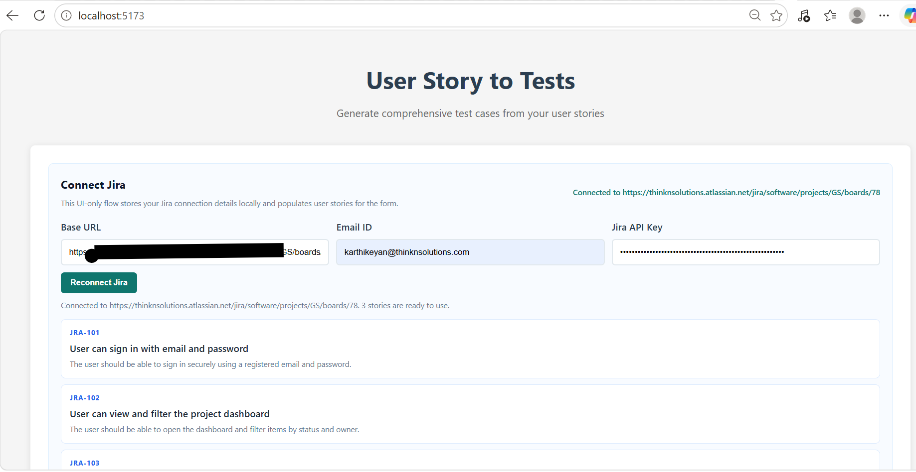
User Story, Description Acceptance Criteria-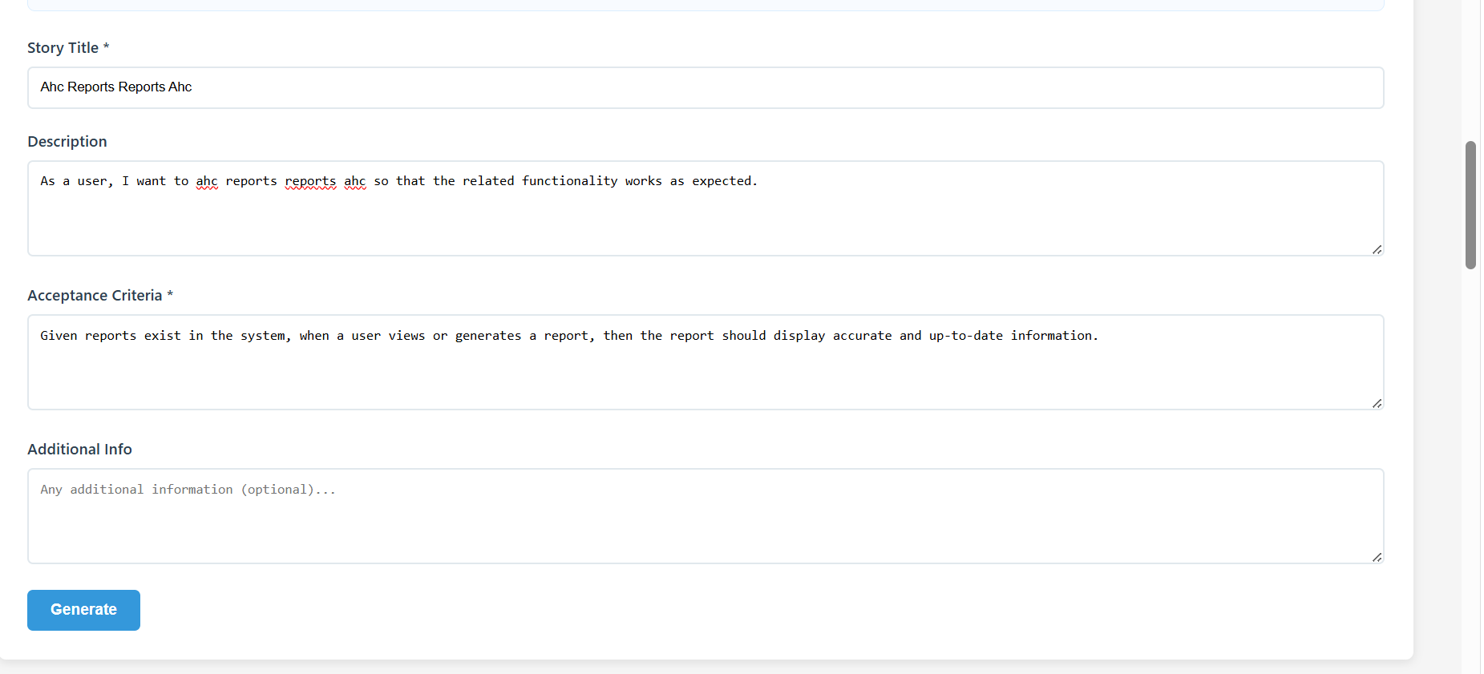

Frontend-Out-put Testcases-