Image Used:
Postman Output:
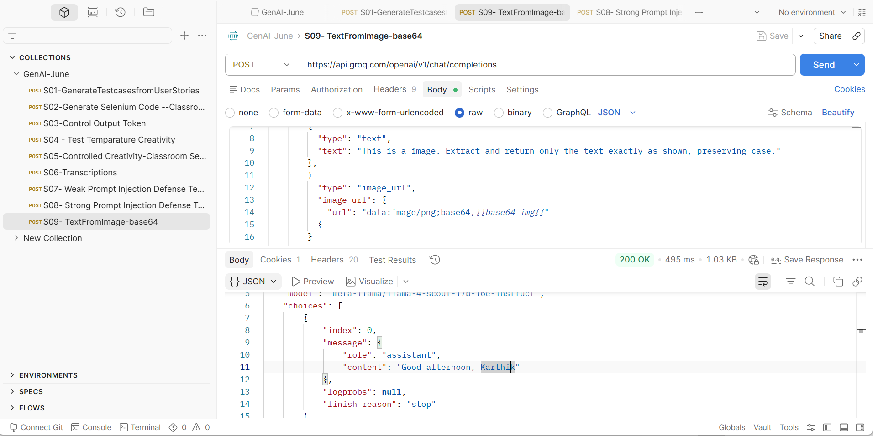
Complete Response:
{
"id": "chatcmpl-e4eff4cc-9777-42b1-8ffc-23418bcb3752",
"object": "chat.completion",
"created": 1781771213,
"model": "meta-llama/llama-4-scout-17b-16e-instruct",
"choices": [
{
"index": 0,
"message": {
"role": "assistant",
"content": "Good afternoon, Karthik"
},
"logprobs": null,
"finish_reason": "stop"
}
],
"usage": {
"queue_time": 0.403072726,
"prompt_tokens": 757,
"prompt_time": 0.032653624,
"completion_tokens": 7,
"completion_time": 0.015799496,
"total_tokens": 764,
"total_time": 0.04845312
},
"usage_breakdown": null,
"system_fingerprint": "fp_79da0e0073",
"x_groq": {
"id": "req_01kvcxe625fef944nmhcfwbdr0",
"seed": 577425632
},
"service_tier": "on_demand"
}

