Name: Rahul V S | Reg. No: 3122235001104
Exp. No: 9 | Date: 01-10-2026

Implementation of Mini Compiler using Lex and Yacc
Aim:
To implement a mini compiler using Lex and Yacc that takes a Java source program as input and carries it through lexical analysis, syntax analysis, intermediate code generation, code optimization and code generation, producing 8086-style assembly code.
Tools Used:
- Lex (Flex) - To recognize keywords, identifiers, constants, operators and special characters as tokens, and to report lexical errors.
- Yacc (Bison) - To define the grammar, validate the syntax, check declarations and generate three address code using syntax directed translation rules.
- C Programming Language - To implement the symbol table, the code optimizer and the code generator.
- C Compiler (GCC/CC) - To compile the generated C code.
- Linux Terminal (Ubuntu on WSL) - To execute the Lex, Yacc and gcc commands.
- Java Input File (input.java) - Source program given as input to the compiler.
Code:
scanner.l
%{
#include <stdio.h>
#include <stdlib.h>
#include <string.h>
#include <limits.h>
#include "y.tab.h"

/* Phase 1 : every token is listed together with its class */
static void show(const char *kind)
{
printf("%s - %s\n", yytext, kind);
}

static void lexError(const char *msg)
{
printf("Lexical error at line %d: %s\n", yylineno, msg);
exit(1);
}
%}

%option noyywrap nounput noinput yylineno
%x COMMENT

DIGIT [0-9]
LETTER [a-zA-Z_]

%%

"//".* { /* single line comment */ }
"/*" { BEGIN(COMMENT); }
<COMMENT>"*/" { BEGIN(INITIAL); }
<COMMENT>\n { }
<COMMENT>. { }
<COMMENT><<EOF>> { lexError("unterminated comment"); }

"class" { show("keyword"); return CLASS; }
"public" { show("keyword"); return PUBLIC; }
"static" { show("keyword"); return STATIC; }
"void" { show("keyword"); return VOID; }
"int" { show("keyword"); return INT; }
"if" { show("keyword"); return IF; }
"else" { show("keyword"); return ELSE; }
"while" { show("keyword"); return WHILE; }
"String" { show("predefined class"); return STRINGKW; }
"main" { show("identifier"); return MAIN; }
"System.out.println" { show("function call"); return PRINTLN; }

{LETTER}({LETTER}|{DIGIT})* { show("identifier");
yylval.str = strdup(yytext); return ID; }

{DIGIT}+ { if (strlen(yytext) > 10 || atoll(yytext) > INT_MAX)
lexError("integer constant too large");
show("integer constant");
yylval.str = strdup(yytext); return NUM; }

\"[^"\n]*\" { show("string constant");
yylval.str = strdup(yytext); return STR; }
\"[^"\n]* { lexError("unterminated string"); }

"<="|">="|"=="|"!="|"<"|">" { show("relational operator");
yylval.str = strdup(yytext); return RELOP; }
"**"|"^" { show("arithmetic operator (power)"); return POW; }
"=" { show("assignment operator"); return '='; }
[+\-*/%] { show("arithmetic operator"); return yytext[0]; }
[(){}\[\];,] { show("special character"); return yytext[0]; }

[ \t\r\n]+ { /* skip white space */ }
. { char m[40];
sprintf(m, "unknown character '%s'", yytext);
lexError(m); }

%%

parser.y
%{
#include <stdio.h>
#include <stdlib.h>
#include <string.h>
#include <ctype.h>
#include "compiler.h"

int yylex(void);
void yyerror(const char *s);
extern int yylineno;
extern char *yytext;
extern FILE *yyin;

static int phase2Started = 0;

static void startPhase2(void)
{
if (!phase2Started) printf("\n----- PHASE 2: SYNTAX ANALYSIS -----\n");
phase2Started = 1;
}

/* ---------------------------------------------------------------- symbol table */

#define MAXSYM 200

typedef struct {
char name[NAMELEN];
char type[12];
int bytes, addr;
char value[NAMELEN]; /* initial value if it is a constant, else "-" */
int depth; /* block in which the variable is declared */
int hidden; /* the block has ended: no longer visible */
int assigned; /* a value has been given to the variable */
} Sym;

static Sym sym[MAXSYM];
static int nsym = 0, nextAddr = 1000, depth = 0;

static int findSym(const char *name)
{
int k;
for (k = nsym - 1; k >= 0; k--)
if (!sym[k].hidden && !strcmp(sym[k].name, name)) return k;
return -1;
}

static void semError(const char *msg, const char *name)
{
startPhase2();
printf("Semantic error at line %d: %s '%s'\n", yylineno, msg, name);
exit(1);
}

static void addSym(const char *name, const char *value, int assigned)
{
if (findSym(name) >= 0) semError("variable already declared:", name);
if (isTemp(name)) semError("name is reserved for temporaries:", name);
if (nsym >= MAXSYM) semError("too many variables:", name);
strcpy(sym[nsym].name, name);
strcpy(sym[nsym].type, "int");
sym[nsym].bytes = 4;
sym[nsym].addr = nextAddr;
nextAddr += 4;
strcpy(sym[nsym].value, value);
sym[nsym].depth = depth;
sym[nsym].hidden = 0;
sym[nsym].assigned = assigned;
nsym++;
}

static void endBlock(void)
{
int k;
for (k = 0; k < nsym; k++)
if (sym[k].depth == depth) sym[k].hidden = 1;
depth--;
}

static void checkDeclared(const char *name)
{
if (findSym(name) < 0) semError("undeclared variable", name);
}

static void checkUse(const char *name)
{
int k = findSym(name);
if (k < 0) semError("undeclared variable", name);
if (!sym[k].assigned) semError("variable might not have been initialized:", name);
}

static void markAssigned(const char *name)
{
sym[findSym(name)].assigned = 1;
}

/* --------------------------------------------------------- code generation helpers */

static char *binary(const char *op, const char *a, const char *b)
{
char *t = newTemp();
emit(op, a, b, t);
return t;
}

static const char *negate(const char *rel) /* jump when the condition is false */
{
if (!strcmp(rel, "<")) return ">=";
if (!strcmp(rel, ">")) return "<=";
if (!strcmp(rel, "<=")) return ">";
if (!strcmp(rel, ">=")) return "<";
if (!strcmp(rel, "==")) return "!=";
return "==";
}
%}

%union { char *str; }

%token <str> ID NUM STR RELOP
%token CLASS PUBLIC STATIC VOID MAIN INT IF ELSE WHILE STRINGKW PRINTLN POW
%type <str> expr cond

%left '+' '-'
%left '*' '/' '%'
%right UMINUS
%right POW

%nonassoc LOWER_THAN_ELSE
%nonassoc ELSE

%%

program
: CLASS ID '{' PUBLIC STATIC VOID MAIN '(' STRINGKW args ')' block '}'
;

args
: '[' ']' ID
| ID '[' ']'
;

block
: '{' { depth++; }
stmts '}' { endBlock(); }
;

stmts
: stmts stmt
| /* empty */
;

stmt
: decl ';'
| assign
| ifstmt
| whilestmt
| print
| block
;

/* Declaration statement : int a, b = 5; */
decl
: INT declist
;

declist
: declitem
| declist ',' declitem
;

declitem
: ID { addSym($1, "-", 0); }
| ID '=' expr { addSym($1, isNum($3) ? $3 : "-", 1);
emit("=", $3, "", $1); }
;

/* Assignment statement : a = b + 1; */
assign
: ID '=' expr ';' { checkDeclared($1);
emit("=", $3, "", $1);
markAssigned($1); }
;

/* Conditional statement : if (c) s | if (c) s else s */
ifstmt
: IF '(' cond ')' stmt %prec LOWER_THAN_ELSE
{ emit("label", "", "", $3); }
| IF '(' cond ')' stmt ELSE { char *end = newLabel();
emit("goto", "", "", end);
emit("label", "", "", $3);
$<str>$ = end; }
stmt { emit("label", "", "", $<str>7); }
;

/* Looping statement : while (c) s */
whilestmt
: WHILE { char *top = newLabel();
emit("label", "", "", top);
$<str>$ = top; }
'(' cond ')' stmt { emit("goto", "", "", $<str>2);
emit("label", "", "", $4); }
;

print
: PRINTLN '(' STR ')' ';' { emit("print", $3, "", ""); }
| PRINTLN '(' expr ')' ';' { emit("print", $3, "", ""); }
;

/* the generated jump leaves the statement when the condition is FALSE */
cond
: expr RELOP expr { char *out = newLabel();
emit(negate($2), $1, $3, out);
$$ = out; }
;

expr
: expr '+' expr { $$ = binary("+", $1, $3); }
| expr '-' expr { $$ = binary("-", $1, $3); }
| expr '*' expr { $$ = binary("*", $1, $3); }
| expr '/' expr { $$ = binary("/", $1, $3); }
| expr '%' expr { $$ = binary("%", $1, $3); }
| expr POW expr { $$ = binary("^", $1, $3); }
| '-' expr %prec UMINUS { char *t = newTemp();
emit("neg", $2, "", t);
$$ = t; }
| '(' expr ')' { $$ = $2; }
| NUM { $$ = $1; }
| ID { checkUse($1); $$ = $1; }
;

%%

void yyerror(const char *s)
{
startPhase2();
printf("Syntactically incorrect: %s near '%s' at line %d\n", s, yytext, yylineno);
exit(1);
}

int main(int argc, char *argv[])
{
const char *path = (argc > 1) ? argv[1] : "input.java";
FILE *asmFile;
int k, before;

yyin = fopen(path, "r");
if (!yyin) {
printf("Cannot open %s\n", path);
return 1;
}

printf("----- PHASE 1: LEXICAL ANALYSIS -----\n");
yyparse();
startPhase2();
printf("Syntactically correct\n");

printf("\n----- SYMBOL TABLE -----\n");
printf("%-12s %-8s %-8s %-10s %-10s\n", "Name", "Type", "Bytes", "Address", "Value");
for (k = 0; k < nsym; k++)
printf("%-12s %-8s %-8d %-10d %-10s\n",
sym[k].name, sym[k].type, sym[k].bytes, sym[k].addr, sym[k].value);

printf("\n----- PHASE 3: INTERMEDIATE CODE (TAC) -----\n");
printTAC();
before = liveCount();

printf("\n----- PHASE 4: OPTIMIZED CODE -----\n");
optimize();
printTAC();
printf("\n");
printOptimizationReport();
printf("Instructions: %d -> %d\n", before, liveCount());

printf("\n----- PHASE 5: TARGET CODE (8086 style) -----\n");
asmFile = fopen("output.asm", "w");
if (!asmFile) {
printf("Cannot create output.asm\n");
return 1;
}
generate(asmFile);
fclose(asmFile);
printf("\nAssembly code written to output.asm\n");
return 0;
}

compiler.h
/*
* Mini compiler - shared declarations
*
* Intermediate code is kept as a table of quadruples (op, arg1, arg2, result):
*
* + - * / % ^ result = arg1 op arg2
* neg result = -arg1
* = result = arg1
* < <= > >= == != if arg1 op arg2 goto result
* goto goto result
* label result :
* print print arg1
*/
#ifndef COMPILER_H
#define COMPILER_H

#include <stdio.h>

#define MAXQ 1000 /* maximum number of quadruples */
#define NAMELEN 128 /* maximum length of a name or string */

typedef struct {
char op[8];
char a1[NAMELEN], a2[NAMELEN], res[NAMELEN];
int del; /* 1 = removed by the optimizer */
} Quad;

extern Quad q[MAXQ];
extern int nq;

/* quad.c */
void emit(const char *op, const char *a1, const char *a2, const char *res);
char *newTemp(void);
char *newLabel(void);
int isTemp(const char *s); /* t1, t2, ... */
int isNum(const char *s); /* integer constant */
int isStr(const char *s); /* "string constant" */
int isVar(const char *s); /* name of a source variable */
int isBin(const char *op); /* + - * / % ^ */
int isRel(const char *op); /* < <= > >= == != */
int defines(const Quad *x); /* quad assigns a value to x->res */
void printTAC(void);
int liveCount(void);

/* optimizer.c */
void optimize(void);
void printOptimizationReport(void);

/* codegen.c */
void generate(FILE *asmFile);

#endif

quad.c
/* Quadruple table : storage, temporaries, labels and printing */
#include <stdio.h>
#include <stdlib.h>
#include <string.h>
#include <ctype.h>
#include "compiler.h"

Quad q[MAXQ];
int nq = 0;

static int tcount = 0, lcount = 0;

void emit(const char *op, const char *a1, const char *a2, const char *res)
{
if (nq >= MAXQ) {
printf("Error: program is too long\n");
exit(1);
}
strcpy(q[nq].op, op);
strcpy(q[nq].a1, a1);
strcpy(q[nq].a2, a2);
strcpy(q[nq].res, res);
q[nq].del = 0;
nq++;
}

char *newTemp(void)
{
char buf[16];
sprintf(buf, "t%d", ++tcount);
return strdup(buf);
}

char *newLabel(void)
{
char buf[16];
sprintf(buf, "L%d", ++lcount);
return strdup(buf);
}

int isTemp(const char *s)
{
int k;
if (s[0] != 't' || !s[1]) return 0;
for (k = 1; s[k]; k++)
if (!isdigit((unsigned char)s[k])) return 0;
return 1;
}

int isNum(const char *s)
{
if (*s == '-') s++;
if (!*s) return 0;
while (*s)
if (!isdigit((unsigned char)*s++)) return 0;
return 1;
}

int isStr(const char *s)
{
return s[0] == '"';
}

int isVar(const char *s)
{
return (isalpha((unsigned char)s[0]) || s[0] == '_') && !isTemp(s);
}

int isBin(const char *op)
{
return op[0] && !op[1] && strchr("+-*/%^", op[0]);
}

int isRel(const char *op)
{
return !strcmp(op, "<") || !strcmp(op, ">") || !strcmp(op, "<=") ||
!strcmp(op, ">=") || !strcmp(op, "==") || !strcmp(op, "!=");
}

int defines(const Quad *x)
{
return isBin(x->op) || !strcmp(x->op, "neg") || !strcmp(x->op, "=");
}

int liveCount(void)
{
int k, n = 0;
for (k = 0; k < nq; k++)
if (!q[k].del) n++;
return n;
}

void printTAC(void)
{
int k;
for (k = 0; k < nq; k++) {
const Quad *x = &q[k];
if (x->del) continue;
if (!strcmp(x->op, "label"))
printf("%s:\n", x->res);
else if (!strcmp(x->op, "goto"))
printf(" goto %s\n", x->res);
else if (isRel(x->op))
printf(" if %s %s %s goto %s\n", x->a1, x->op, x->a2, x->res);
else if (!strcmp(x->op, "print"))
printf(" print %s\n", x->a1);
else if (!strcmp(x->op, "="))
printf(" %s = %s\n", x->res, x->a1);
else if (!strcmp(x->op, "neg"))
printf(" %s = -%s\n", x->res, x->a1);
else
printf(" %s = %s %s %s\n", x->res, x->a1, x->op, x->a2);
}
}

optimizer.c
/*
* Code optimizer for the quadruple table
*
* 1. Constant propagation and constant folding (data flow analysis, works across loops)
* 2. Algebraic identities x+0 x*1 x*0 x-x x^1 x^0 ...
* 3. Strength reduction x^2 -> x*x x*2 -> x+x
* 4. Merging of temporaries t = a+b ; x = t -> x = a+b
* 5. Common sub-expression elimination (inside a basic block)
* 6. Copy propagation t2 = t1
* 7. Dead code elimination unused temporaries, jumps to the next statement,
* unreferenced labels, unreachable code
*
* The passes are repeated until nothing changes, because one pass often creates a
* chance for another one. Variables of the source program are treated as live at the
* end of the program, so only temporaries and unreachable code are ever deleted.
* All arithmetic uses 32 bit int semantics, like Java.
*/
#include <stdio.h>
#include <stdlib.h>
#include <string.h>
#include <stdint.h>
#include "compiler.h"

#define MAXV 400 /* variables and temporaries */

enum { S_PROP, S_FOLD, S_ALG, S_STR, S_CSE, S_COPY, S_MERGE, S_DEAD, S_UNREACH, S_COUNT };

static const char *title[S_COUNT] = {
"Constant propagation", "Constant folding", "Algebraic identities",
"Strength reduction", "Common sub-expression elimination", "Copy propagation",
"Merging of temporaries", "Dead code elimination", "Unreachable code elimination"
};
static int count[S_COUNT];

typedef int32_t i32;

/* ------------------------------------------------------------------ arithmetic */

static i32 wrap(long long v)
{
return (i32)(uint32_t)v;
}

static i32 power(i32 base, i32 e) /* e <= 0 gives 1 */
{
uint32_t r = 1, x = (uint32_t)base;
uint32_t n = e > 0 ? (uint32_t)e : 0;
while (n) {
if (n & 1) r *= x;
x *= x;
n >>= 1;
}
return (i32)r;
}

static int evaluate(const char *op, i32 a, i32 b, i32 *r)
{
switch (op[0]) {
case '+': *r = wrap((long long)a + b); return 1;
case '-': *r = wrap((long long)a - b); return 1;
case '*': *r = wrap((long long)a * b); return 1;
case '/': if (b == 0 || (a == INT32_MIN && b == -1)) return 0;
*r = a / b; return 1;
case '%': if (b == 0 || (a == INT32_MIN && b == -1)) return 0;
*r = a % b; return 1;
case '^': *r = power(a, b); return 1;
}
return 0;
}

static void setCopy(Quad *x, const char *v)
{
char tmp[NAMELEN];
strcpy(tmp, v); /* v may point inside x */
strcpy(x->op, "=");
strcpy(x->a1, tmp);
x->a2[0] = '\0';
}

static int hasA1(const Quad *x)
{
return defines(x) || isRel(x->op) || !strcmp(x->op, "print");
}

static int hasA2(const Quad *x)
{
return isBin(x->op) || isRel(x->op);
}

static int nextLive(int i)
{
for (i++; i < nq; i++)
if (!q[i].del) return i;
return -1;
}

static int labelIndex(const char *name)
{
int k;
for (k = 0; k < nq; k++)
if (!q[k].del && !strcmp(q[k].op, "label") && !strcmp(q[k].res, name)) return k;
return -1;
}

/* ------------------------------------------- 1. constant propagation and folding */

typedef struct { int k; i32 v; } Val; /* k: 1 = constant v, 2 = not a constant */

static char vname[MAXV][NAMELEN];
static int nv = 0;
static Val in[MAXQ][MAXV]; /* value of every variable before quad i */
static char reached[MAXQ];
static int succ[MAXQ][2];

static int varIndex(const char *n)
{
int k;
for (k = 0; k < nv; k++)
if (!strcmp(vname[k], n)) return k;
if (nv >= MAXV) {
printf("Error: too many variables\n");
exit(1);
}
strcpy(vname[nv], n);
return nv++;
}

static Val getVal(const Val *st, const char *s)
{
Val r = { 2, 0 };
if (isNum(s)) { r.k = 1; r.v = wrap(atoll(s)); }
else if (isVar(s) || isTemp(s)) r = st[varIndex(s)];
return r;
}

static void transfer(Val *st, const Quad *x)
{
Val r = { 2, 0 }, a, b;
i32 v;
if (!defines(x)) return;
a = getVal(st, x->a1);
if (!strcmp(x->op, "=")) {
if (a.k == 1) r = a;
} else if (!strcmp(x->op, "neg")) {
if (a.k == 1) { r.k = 1; r.v = wrap(-(long long)a.v); }
} else {
b = getVal(st, x->a2);
if (a.k == 1 && b.k == 1 && evaluate(x->op, a.v, b.v, &v)) { r.k = 1; r.v = v; }
}
st[varIndex(x->res)] = r;
}

static int meet(Val *dst, const Val *src) /* returns 1 if dst changed */
{
int v, changed = 0;
for (v = 0; v < nv; v++) {
if (dst[v].k == 2) continue;
if (src[v].k == 2 || dst[v].v != src[v].v) { dst[v].k = 2; changed = 1; }
}
return changed;
}

static void substitute(const Val *st, char *name, int *changes)
{
char num[32];
Val r;
if (!isVar(name) && !isTemp(name)) return;
r = st[varIndex(name)];
if (r.k != 1) return;
sprintf(num, "%d", (int)r.v);
strcpy(name, num);
count[S_PROP]++;
(*changes)++;
}

static int constantPropagation(void)
{
Val out[MAXV];
int i, v, s, first, changed, changes = 0;

for (i = 0; i < nq; i++) { /* make a slot for every name */
if (q[i].del) continue;
if (defines(&q[i])) varIndex(q[i].res);
if (hasA1(&q[i]) && (isVar(q[i].a1) || isTemp(q[i].a1))) varIndex(q[i].a1);
if (hasA2(&q[i]) && (isVar(q[i].a2) || isTemp(q[i].a2))) varIndex(q[i].a2);
}

/* control flow graph */
for (i = 0; i < nq; i++) {
reached[i] = 0;
succ[i][0] = succ[i][1] = -1;
if (q[i].del) continue;
if (!strcmp(q[i].op, "goto")) {
succ[i][0] = labelIndex(q[i].res);
} else if (isRel(q[i].op)) {
succ[i][0] = nextLive(i);
succ[i][1] = labelIndex(q[i].res);
} else {
succ[i][0] = nextLive(i);
}
}

first = nextLive(-1);
if (first < 0) return 0;
reached[first] = 1;
for (v = 0; v < nv; v++) { in[first][v].k = 2; in[first][v].v = 0; }

do { /* iterate until nothing changes */
changed = 0;
for (i = 0; i < nq; i++) {
if (q[i].del || !reached[i]) continue;
memcpy(out, in[i], sizeof(Val) * nv);
transfer(out, &q[i]);
for (s = 0; s < 2; s++) {
int t = succ[i][s];
if (t < 0) continue;
if (!reached[t]) {
reached[t] = 1;
memcpy(in[t], out, sizeof(Val) * nv);
changed = 1;
} else if (meet(in[t], out)) {
changed = 1;
}
}
}
} while (changed);

for (i = 0; i < nq; i++) { /* rewrite the code */
Quad *x = &q[i];
if (x->del) continue;
if (!reached[i]) { x->del = 1; count[S_UNREACH]++; changes++; continue; }

if (hasA1(x)) substitute(in[i], x->a1, &changes);
if (hasA2(x)) substitute(in[i], x->a2, &changes);

if (isBin(x->op) && isNum(x->a1) && isNum(x->a2)) {
i32 r;
if (evaluate(x->op, wrap(atoll(x->a1)), wrap(atoll(x->a2)), &r)) {
char num[32];
sprintf(num, "%d", (int)r);
setCopy(x, num);
count[S_FOLD]++; changes++;
}
} else if (!strcmp(x->op, "neg") && isNum(x->a1)) {
char num[32];
sprintf(num, "%d", (int)wrap(-atoll(x->a1)));
setCopy(x, num);
count[S_FOLD]++; changes++;
} else if (isRel(x->op) && isNum(x->a1) && isNum(x->a2)) {
i32 a = wrap(atoll(x->a1)), b = wrap(atoll(x->a2));
int t = !strcmp(x->op, "<") ? a < b : !strcmp(x->op, ">") ? a > b :
!strcmp(x->op, "<=") ? a <= b : !strcmp(x->op, ">=") ? a >= b :
!strcmp(x->op, "==") ? a == b : a != b;
if (t) { strcpy(x->op, "goto"); x->a1[0] = x->a2[0] = '\0'; }
else x->del = 1;
count[S_FOLD]++; changes++;
}
}
return changes;
}

/* ----------------------------------------------------- 2. algebraic identities */

static int algebraicIdentities(void)
{
int i, changes = 0;
for (i = 0; i < nq; i++) {
Quad *x = &q[i];
char o;
int done = 1;
if (x->del || !isBin(x->op)) continue;
o = x->op[0];
if (o == '+') {
if (!strcmp(x->a2, "0")) setCopy(x, x->a1);
else if (!strcmp(x->a1, "0")) setCopy(x, x->a2);
else done = 0;
} else if (o == '-') {
if (!strcmp(x->a2, "0")) setCopy(x, x->a1);
else if (!strcmp(x->a1, x->a2)) setCopy(x, "0");
else done = 0;
} else if (o == '*') {
if (!strcmp(x->a1, "0") || !strcmp(x->a2, "0")) setCopy(x, "0");
else if (!strcmp(x->a2, "1")) setCopy(x, x->a1);
else if (!strcmp(x->a1, "1")) setCopy(x, x->a2);
else done = 0;
} else if (o == '/') {
if (!strcmp(x->a2, "1")) setCopy(x, x->a1);
else done = 0;
} else if (o == '%') {
if (!strcmp(x->a2, "1")) setCopy(x, "0");
else done = 0;
} else if (o == '^') {
if (!strcmp(x->a2, "1")) setCopy(x, x->a1);
else if (!strcmp(x->a2, "0")) setCopy(x, "1");
else done = 0;
}
if (done) { count[S_ALG]++; changes++; }
}
return changes;
}

/* ------------------------------------------------------ 3. strength reduction */

static int strengthReduction(void)
{
int i, changes = 0;
for (i = 0; i < nq; i++) {
Quad *x = &q[i];
if (x->del || !isBin(x->op)) continue;
if (x->op[0] == '^' && !strcmp(x->a2, "2") && !isNum(x->a1)) {
strcpy(x->op, "*"); /* x ^ 2 -> x * x */
strcpy(x->a2, x->a1);
} else if (x->op[0] == '*' && !strcmp(x->a2, "2") && !isNum(x->a1)) {
strcpy(x->op, "+"); /* x * 2 -> x + x */
strcpy(x->a2, x->a1);
} else if (x->op[0] == '*' && !strcmp(x->a1, "2") && !isNum(x->a2)) {
strcpy(x->op, "+"); /* 2 * x -> x + x */
strcpy(x->a1, x->a2);
} else continue;
count[S_STR]++; changes++;
}
return changes;
}

/* ----------------------------------------------------- uses of a name */

static int uses(const char *n)
{
int i, c = 0;
for (i = 0; i < nq; i++) {
if (q[i].del) continue;
if (hasA1(&q[i]) && !strcmp(q[i].a1, n)) c++;
if (hasA2(&q[i]) && !strcmp(q[i].a2, n)) c++;
}
return c;
}

/* ------------------------------------------------ 4. merging of temporaries */

static int mergeTemps(void)
{
int i, j, changes = 0;
for (i = 0; i < nq; i++) {
Quad *x = &q[i];
if (x->del || !defines(x) || !isTemp(x->res)) continue;
j = nextLive(i);
if (j < 0) continue;
if (!strcmp(q[j].op, "=") && !strcmp(q[j].a1, x->res) && uses(x->res) == 1) {
strcpy(x->res, q[j].res); /* t = a op b ; x = t */
q[j].del = 1;
count[S_MERGE]++; changes++;
}
}
return changes;
}

/* -------------------------------- 5. common sub-expression elimination */

typedef struct { char op[8], a1[NAMELEN], a2[NAMELEN], holder[NAMELEN]; } Avail;
static Avail av[MAXQ];
static int nav;

static void kill(const char *n) /* n is assigned: forget what depends on it */
{
int k;
for (k = 0; k < nav; ) {
if (!strcmp(av[k].a1, n) || !strcmp(av[k].a2, n) || !strcmp(av[k].holder, n))
av[k] = av[--nav];
else
k++;
}
}

static int commonSubexpressions(void)
{
int i, k, changes = 0;
nav = 0;
for (i = 0; i < nq; i++) {
Quad *x = &q[i];
char op[8], a1[NAMELEN], a2[NAMELEN];
int found = -1;
if (x->del) continue;
if (!strcmp(x->op, "label")) { nav = 0; continue; } /* new basic block */
if (!defines(x)) continue;
strcpy(op, x->op); strcpy(a1, x->a1); strcpy(a2, x->a2);

if (isBin(op)) {
int comm = (op[0] == '+' || op[0] == '*');
for (k = 0; k < nav && found < 0; k++) {
if (strcmp(av[k].op, op)) continue;
if ((!strcmp(av[k].a1, a1) && !strcmp(av[k].a2, a2)) ||
(comm && !strcmp(av[k].a1, a2) && !strcmp(av[k].a2, a1)))
found = k;
}
}
if (found >= 0) {
char holder[NAMELEN];
strcpy(holder, av[found].holder);
setCopy(x, holder);
count[S_CSE]++; changes++;
}
kill(x->res);
if (found < 0 && isBin(op) && strcmp(a1, x->res) && strcmp(a2, x->res)) {
strcpy(av[nav].op, op); strcpy(av[nav].a1, a1);
strcpy(av[nav].a2, a2); strcpy(av[nav].holder, x->res);
nav++;
}
}
return changes;
}

/* ----------------------------------------------------- 6. copy propagation */

static int copyPropagation(void)
{
int i, j, changes = 0;
for (i = 0; i < nq; i++) {
Quad *x = &q[i];
if (x->del || strcmp(x->op, "=") || !isTemp(x->res) || !isTemp(x->a1)) continue;
for (j = 0; j < nq; j++) { /* temporaries are assigned only once */
if (q[j].del) continue;
if (hasA1(&q[j]) && !strcmp(q[j].a1, x->res)) strcpy(q[j].a1, x->a1);
if (hasA2(&q[j]) && !strcmp(q[j].a2, x->res)) strcpy(q[j].a2, x->a1);
}
x->del = 1;
count[S_COPY]++; changes++;
}
return changes;
}

/* ------------------------------------------------- 7. dead code elimination */

static int labelReferenced(const char *name)
{
int j;
for (j = 0; j < nq; j++)
if (!q[j].del && (!strcmp(q[j].op, "goto") || isRel(q[j].op)) &&
!strcmp(q[j].res, name)) return 1;
return 0;
}

static int deadCode(void)
{
int i, changes = 0, changed = 1;
while (changed) {
changed = 0;
for (i = 0; i < nq; i++) {
Quad *x = &q[i];
int n;
if (x->del) continue;
n = nextLive(i);
if (defines(x) && isTemp(x->res) && uses(x->res) == 0)
x->del = 1; /* result never used */
else if (!strcmp(x->op, "=") && !strcmp(x->a1, x->res))
x->del = 1; /* x = x */
else if ((!strcmp(x->op, "goto") || isRel(x->op)) && n >= 0 &&
!strcmp(q[n].op, "label") && !strcmp(q[n].res, x->res))
x->del = 1; /* jump to next quad */
else if (!strcmp(x->op, "label") && !labelReferenced(x->res))
x->del = 1; /* nobody jumps here */
else
continue;
count[S_DEAD]++; changes++; changed = 1;
}
}
return changes;
}

/* ------------------------------------------------------------------- driver */

void optimize(void)
{
int round, c;
for (round = 0; round < 20; round++) {
c = constantPropagation();
c += algebraicIdentities();
c += strengthReduction();
c += mergeTemps();
c += commonSubexpressions();
c += copyPropagation();
c += deadCode();
if (!c) break;
}
}

void printOptimizationReport(void)
{
int k, any = 0;
printf("Optimizations applied\n");
for (k = 0; k < S_COUNT; k++)
if (count[k]) { printf(" %-36s : %d\n", title[k], count[k]); any = 1; }
if (!any) printf(" none\n");
}

codegen.c
/*
* Code generator : optimized quadruples -> 8086 style assembly code
*
* Registers : every variable of the source program owns a register (R0, R1, ...).
* Temporaries share the registers that follow: a temporary gets a free
* register when it is defined and gives it back after its last use, and a
* result may reuse the register of an operand that dies in the same quad.
* Constants : a constant operand is first moved to a scratch register (MOV R, #n).
* Power : x ^ n is expanded into repeated MUL (small constant n) or into a loop.
* Output : the assembly code is printed and also written to output.asm
*/
#include <stdio.h>
#include <stdlib.h>
#include <string.h>
#include <stdarg.h>
#include "compiler.h"

#define MAXR 600

static FILE *out;

static char vname[MAXR][NAMELEN]; /* source variables -> R0 .. R(nvar-1) */
static int nvar = 0;

typedef struct { char name[NAMELEN]; int reg; int last; } Temp;
static Temp tmp[MAXQ]; /* temporaries: register and last use */
static int ntmp = 0;

static char busy[MAXR]; /* register in use (temporaries only) */
static int maxReg = -1;
static int scratch[8], nscratch = 0;
static int powLabels = 0;

/* ---------------------------------------------------------------------- output */

static void ins(const char *fmt, ...)
{
char buf[200];
va_list ap;
va_start(ap, fmt);
vsnprintf(buf, sizeof buf, fmt, ap);
va_end(ap);
if (buf[strlen(buf) - 1] == ':') {
printf("%s\n", buf);
fprintf(out, "%s\n", buf);
} else {
printf(" %s\n", buf);
fprintf(out, " %s\n", buf);
}
}

/* -------------------------------------------------------------------- registers */

static int varReg(const char *n)
{
int k;
for (k = 0; k < nvar; k++)
if (!strcmp(vname[k], n)) return k;
return -1;
}

static void addVar(const char *n)
{
if (isVar(n) && varReg(n) < 0) strcpy(vname[nvar++], n);
}

static Temp *findTemp(const char *n)
{
int k;
for (k = 0; k < ntmp; k++)
if (!strcmp(tmp[k].name, n)) return &tmp[k];
strcpy(tmp[ntmp].name, n);
tmp[ntmp].reg = -1;
tmp[ntmp].last = -1;
return &tmp[ntmp++];
}

static int regOf(const char *n)
{
return isTemp(n) ? findTemp(n)->reg : varReg(n);
}

static int allocReg(void)
{
int r;
for (r = nvar; r < MAXR; r++)
if (!busy[r]) {
busy[r] = 1;
if (r > maxReg) maxReg = r;
return r;
}
printf("Error: out of registers\n");
exit(1);
}

static int newScratch(void)
{
int r = allocReg();
scratch[nscratch++] = r;
return r;
}

static void loadTo(int r, const char *a)
{
if (isNum(a)) ins("MOV R%d, #%s", r, a);
else if (regOf(a) != r) ins("MOV R%d, R%d", r, regOf(a));
}

static int operandReg(const char *a) /* register that holds operand a */
{
int r;
if (!isNum(a)) return regOf(a);
r = newScratch();
ins("MOV R%d, #%s", r, a);
return r;
}

/* Register for the result of quad i. A temporary that dies in this quad lends its
register to the result. */
static int destReg(int i, const Quad *x)
{
Temp *t;
const char *ops[2];
int k;
if (!isTemp(x->res)) return varReg(x->res);
t = findTemp(x->res);
ops[0] = x->a1; ops[1] = x->a2;
for (k = 0; k < 2; k++)
if (isTemp(ops[k]) && findTemp(ops[k])->last == i) {
t->reg = findTemp(ops[k])->reg;
return t->reg;
}
t->reg = allocReg();
return t->reg;
}

static void finish(int i, const Quad *x, int d)
{
const char *ops[2];
int k;
ops[0] = x->a1; ops[1] = x->a2;
for (k = 0; k < 2; k++)
if (isTemp(ops[k]) && findTemp(ops[k])->last == i && findTemp(ops[k])->reg != d)
busy[findTemp(ops[k])->reg] = 0;
if (isTemp(x->res) && findTemp(x->res)->last < 0) busy[d] = 0; /* never used */
for (k = 0; k < nscratch; k++) busy[scratch[k]] = 0;
nscratch = 0;
}

/* ------------------------------------------------------------------ instructions */

static const char *mnemonic(char op)
{
switch (op) {
case '+': return "ADD";
case '-': return "SUB";
case '*': return "MUL";
case '/': return "DIV";
default : return "MOD";
}
}

static const char *jumpFor(const char *rel)
{
if (!strcmp(rel, "<")) return "JL";
if (!strcmp(rel, ">")) return "JG";
if (!strcmp(rel, "<=")) return "JLE";
if (!strcmp(rel, ">=")) return "JGE";
if (!strcmp(rel, "==")) return "JE";
return "JNE";
}

/* d = a1 ^ a2 */
static void genPower(int d, const Quad *x)
{
int base = newScratch(), acc = newScratch();
int e = isNum(x->a2) ? atoi(x->a2) : -1;

if (isNum(x->a2) && e >= 2 && e <= 16) { /* repeated multiplication */
int k;
loadTo(base, x->a1);
ins("MOV R%d, R%d", acc, base);
for (k = 1; k < e; k++) ins("MUL R%d, R%d", acc, base);
} else if (isNum(x->a2) && e <= 1) { /* x ^ 1 or x ^ 0 */
if (e == 1) loadTo(acc, x->a1);
else ins("MOV R%d, #1", acc);
} else { /* loop */
int cnt = newScratch(), zero = newScratch(), one = newScratch();
int n = ++powLabels;
loadTo(base, x->a1);
loadTo(cnt, x->a2);
ins("MOV R%d, #1", acc);
ins("MOV R%d, #0", zero);
ins("MOV R%d, #1", one);
ins("P%d:", n);
ins("CMP R%d, R%d", cnt, zero);
ins("JLE P%d_end", n);
ins("MUL R%d, R%d", acc, base);
ins("SUB R%d, R%d", cnt, one);
ins("JMP P%d", n);
ins("P%d_end:", n);
}
ins("MOV R%d, R%d", d, acc);
}

static void genBinary(int d, const Quad *x)
{
const char *m = mnemonic(x->op[0]);
int r1 = isNum(x->a1) ? -1 : regOf(x->a1);
int r2 = isNum(x->a2) ? -1 : regOf(x->a2);
int commutative = (x->op[0] == '+' || x->op[0] == '*');

if (r2 == d && r1 != d) { /* the result register holds operand 2 */
if (commutative) {
ins("%s R%d, R%d", m, d, operandReg(x->a1));
} else {
int s = newScratch();
loadTo(s, x->a1);
ins("%s R%d, R%d", m, s, d);
ins("MOV R%d, R%d", d, s);
}
} else {
loadTo(d, x->a1);
ins("%s R%d, R%d", m, d, operandReg(x->a2));
}
}

void generate(FILE *asmFile)
{
int i, k;
out = asmFile;

/* registers of the variables (in order of first appearance) and last use of temporaries */
for (i = 0; i < nq; i++) {
const Quad *x = &q[i];
if (x->del) continue;
if (defines(x)) addVar(x->res);
if (defines(x) || isRel(x->op) || !strcmp(x->op, "print")) addVar(x->a1);
if (isBin(x->op) || isRel(x->op)) addVar(x->a2);
if (isTemp(x->a1)) findTemp(x->a1)->last = i;
if ((isBin(x->op) || isRel(x->op)) && isTemp(x->a2)) findTemp(x->a2)->last = i;
}

for (i = 0; i < nq; i++) {
const Quad *x = &q[i];
int d = -1;
if (x->del) continue;

if (!strcmp(x->op, "label")) {
ins("%s:", x->res);
} else if (!strcmp(x->op, "goto")) {
ins("JMP %s", x->res);
} else if (isRel(x->op)) {
int r1 = operandReg(x->a1), r2 = operandReg(x->a2);
ins("CMP R%d, R%d", r1, r2);
ins("%s %s", jumpFor(x->op), x->res);
} else if (!strcmp(x->op, "print")) {
if (isStr(x->a1)) ins("OUT %s", x->a1);
else if (isNum(x->a1)) ins("OUT #%s", x->a1);
else ins("OUT R%d", regOf(x->a1));
} else if (!strcmp(x->op, "=")) {
d = destReg(i, x);
loadTo(d, x->a1);
} else if (!strcmp(x->op, "neg")) {
d = destReg(i, x);
loadTo(d, x->a1);
ins("NEG R%d", d);
} else if (x->op[0] == '^') {
d = destReg(i, x);
genPower(d, x);
} else {
d = destReg(i, x);
genBinary(d, x);
}
finish(i, x, d);
}

printf("\nRegister Allocation\n");
for (k = 0; k < nvar; k++) printf(" %-10s -> R%d\n", vname[k], k);
if (maxReg >= nvar) printf(" temporaries -> R%d .. R%d\n", nvar, maxReg);
else printf(" temporaries -> none needed\n");
}

Input (input.java)
class Main {
public static void main(String[] args) {
int a = 10;
int b = 20;
int c = 2 * 3 + a * 1;
int d = b ** 2;
int sum = 0, i = 1;
while (i <= 5) {
sum = sum + i * 2;
i = i + 1;
}
int x1 = sum + i;
int x2 = sum + i;
int e = sum * 2;
if (a < b) {
System.out.println("b is greater");
} else {
System.out.println("a is greater");
}
System.out.println(c + d);
}
}

Additional input (input2.java)
class Test {
public static void main(String[] args) {
int n = 6, f = 1, k = 2;
int p = k ** n;
int q = n % 4 + (n - n);
while (n > 1) {
f = f * n;
n = n - 1;
}
int r = f / 3 + f * 2;
int s = f / 3 + f * 2;
int t = -f + p * 0 + q;
// a loop with a branch inside
int j = 0;
while (j < 4) {
if (j % 2 == 0)
System.out.println(j * j);
else
System.out.println(f - j);
j = j + 1;
}
System.out.println(r + s);
System.out.println(t);
System.out.println(p);
}
}

input2.java contains a loop whose values are not known at compile time, an if-else inside the loop, a remainder, a division and a repeated expression.
Commands Used
lex scanner.l
yacc -d parser.y
cc lex.yy.c y.tab.c quad.c optimizer.c codegen.c -lfl -o minicompiler
./minicompiler input.java

Output:
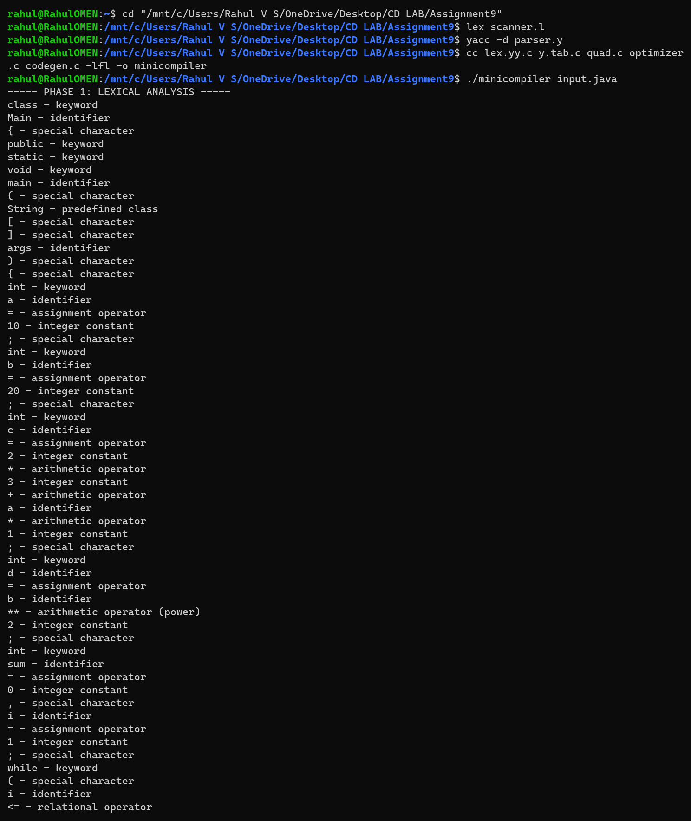
Output of the mini compiler for input.java (part 1 of 5)
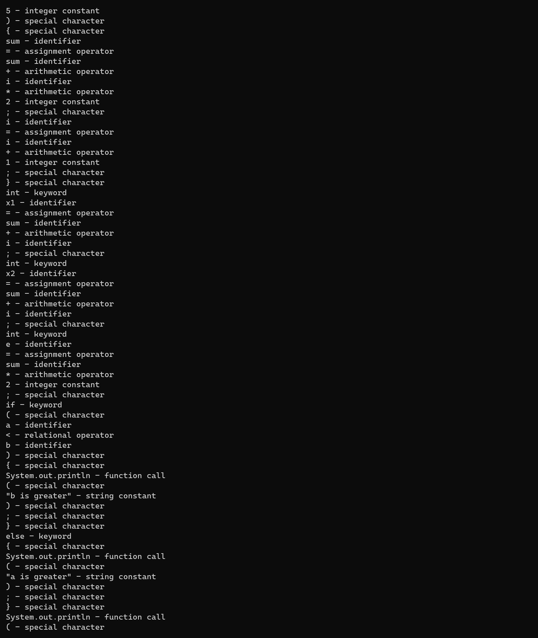
Output of the mini compiler for input.java (part 2 of 5)
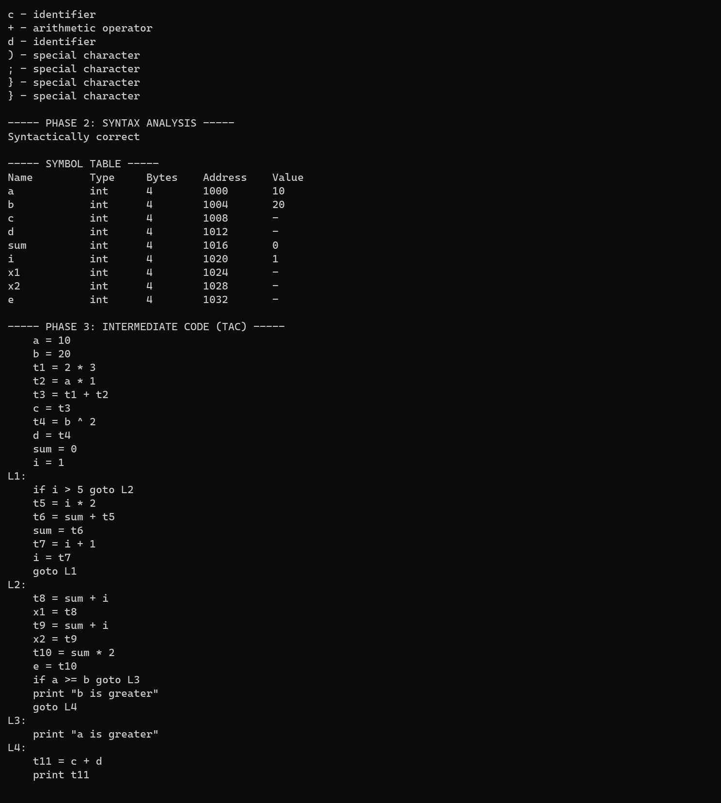
Output of the mini compiler for input.java (part 3 of 5)
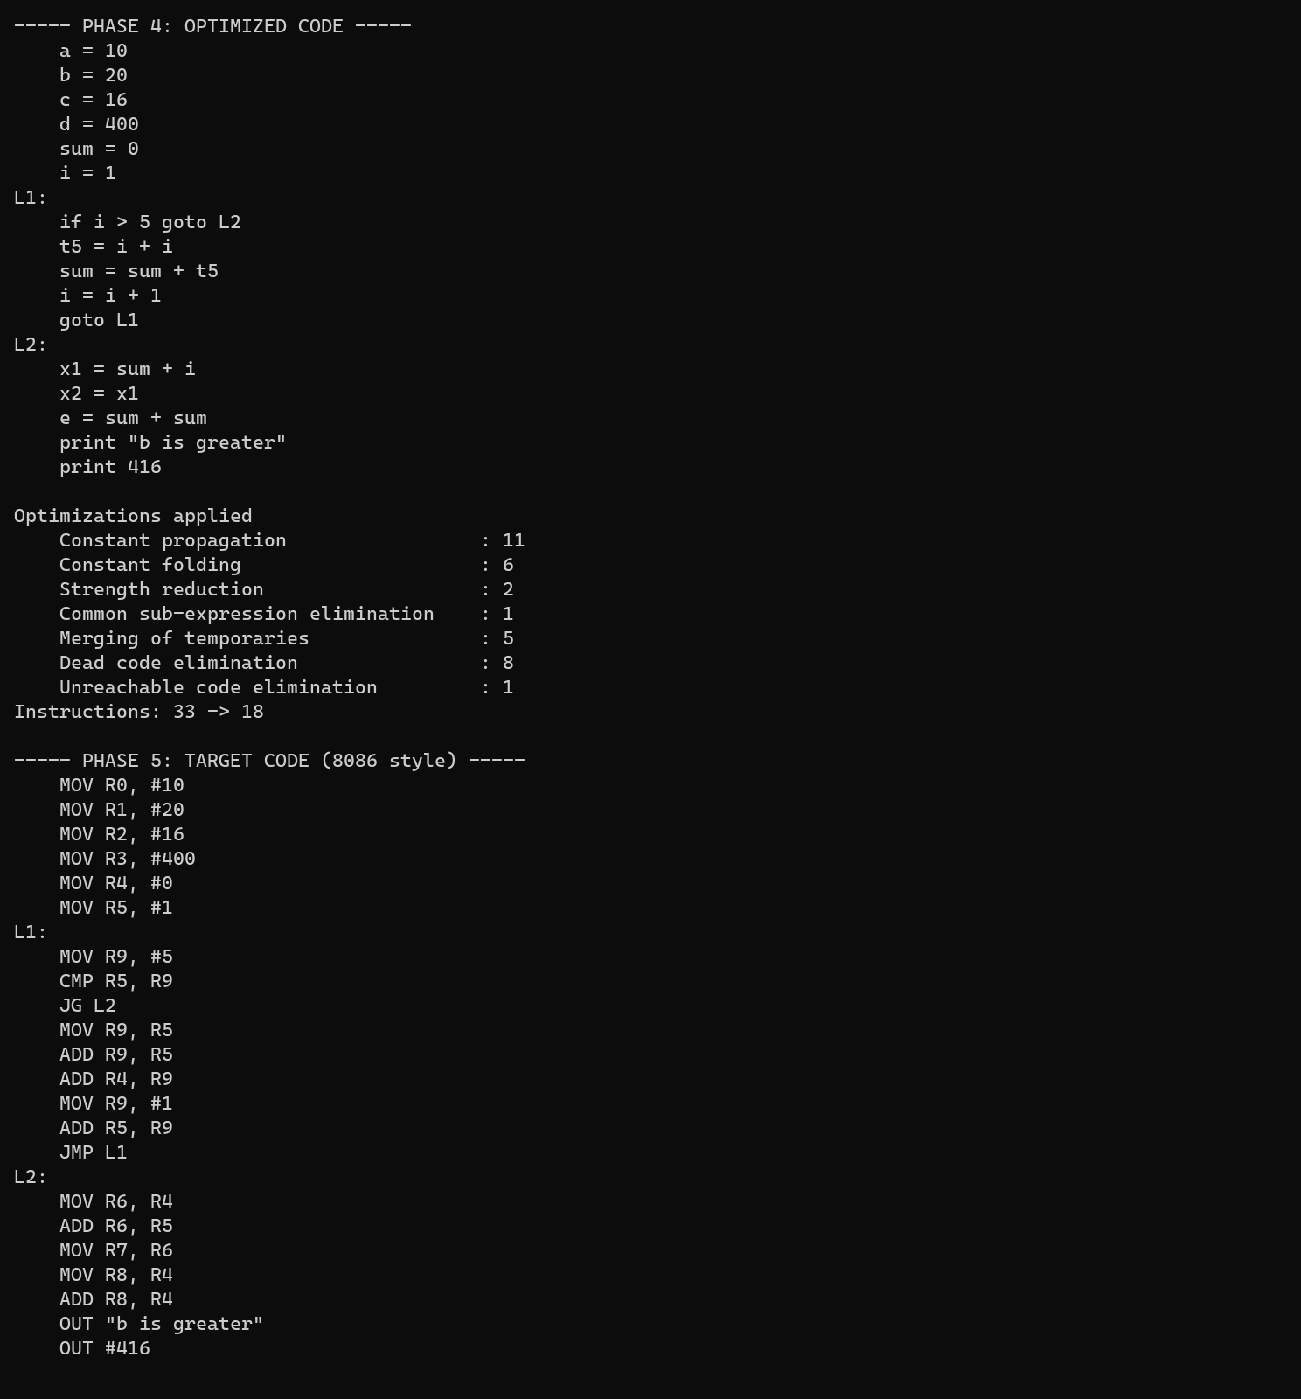
Output of the mini compiler for input.java (part 4 of 5)
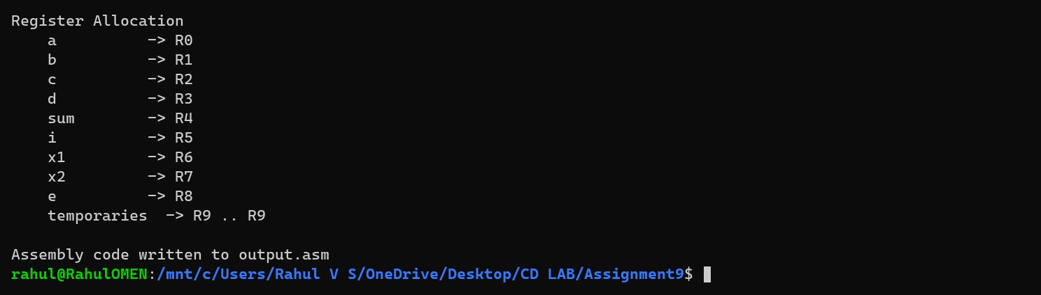
Output of the mini compiler for input.java (part 5 of 5)
Phase 1 lists every token with its class. Phase 2 reports Syntactically correct and the symbol table (type, size, address and initial value). Phase 3 is the three address code and Phase 4 the optimized code. Phase 5 is the 8086-style assembly code, which is also written to output.asm.
In the optimized code c = 2*3 + a*1 has been folded to 16 and d = b ** 2 to 400. As a < b is known to be true, the else part disappears and c + d is printed as the constant 416. Inside the loop i*2 became i+i, and the second sum + i is replaced by x2 = x1 (common sub-expression). The instructions went down from 33 to 18.
The compiler accepts a class with main, int declarations, assignments, if / else, while, System.out.println, the operators + - * / % and the power operator ** (or ^), and the relational operators < <= > >= == !=. Declarations are block scoped.
Additional Test Cases:
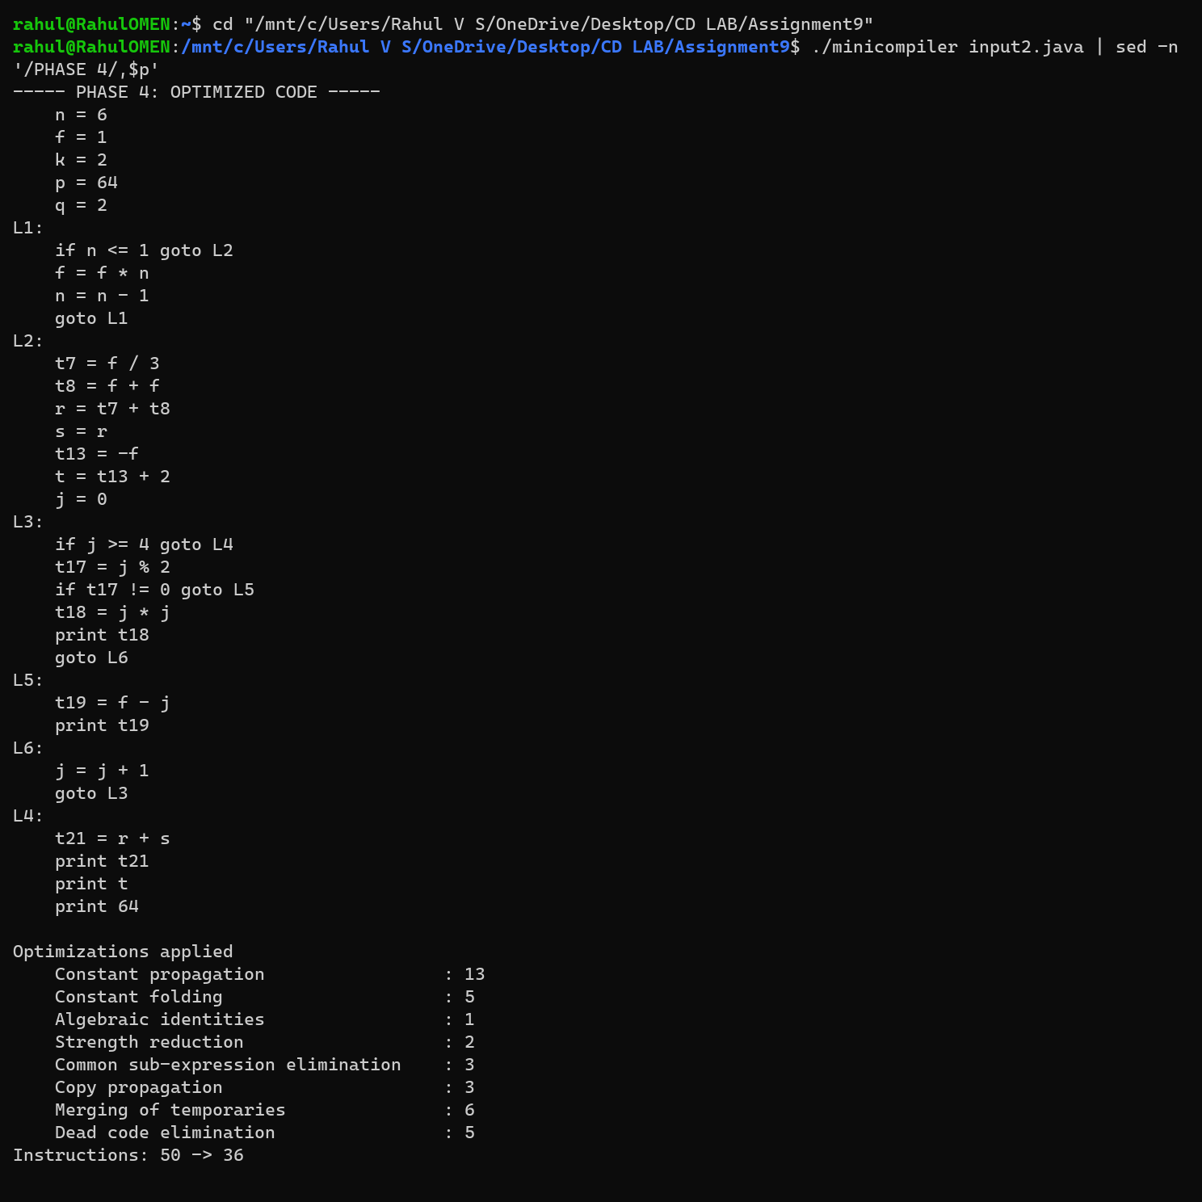
Additional test case: input2.java (optimized code and target code) (part 1 of 3)
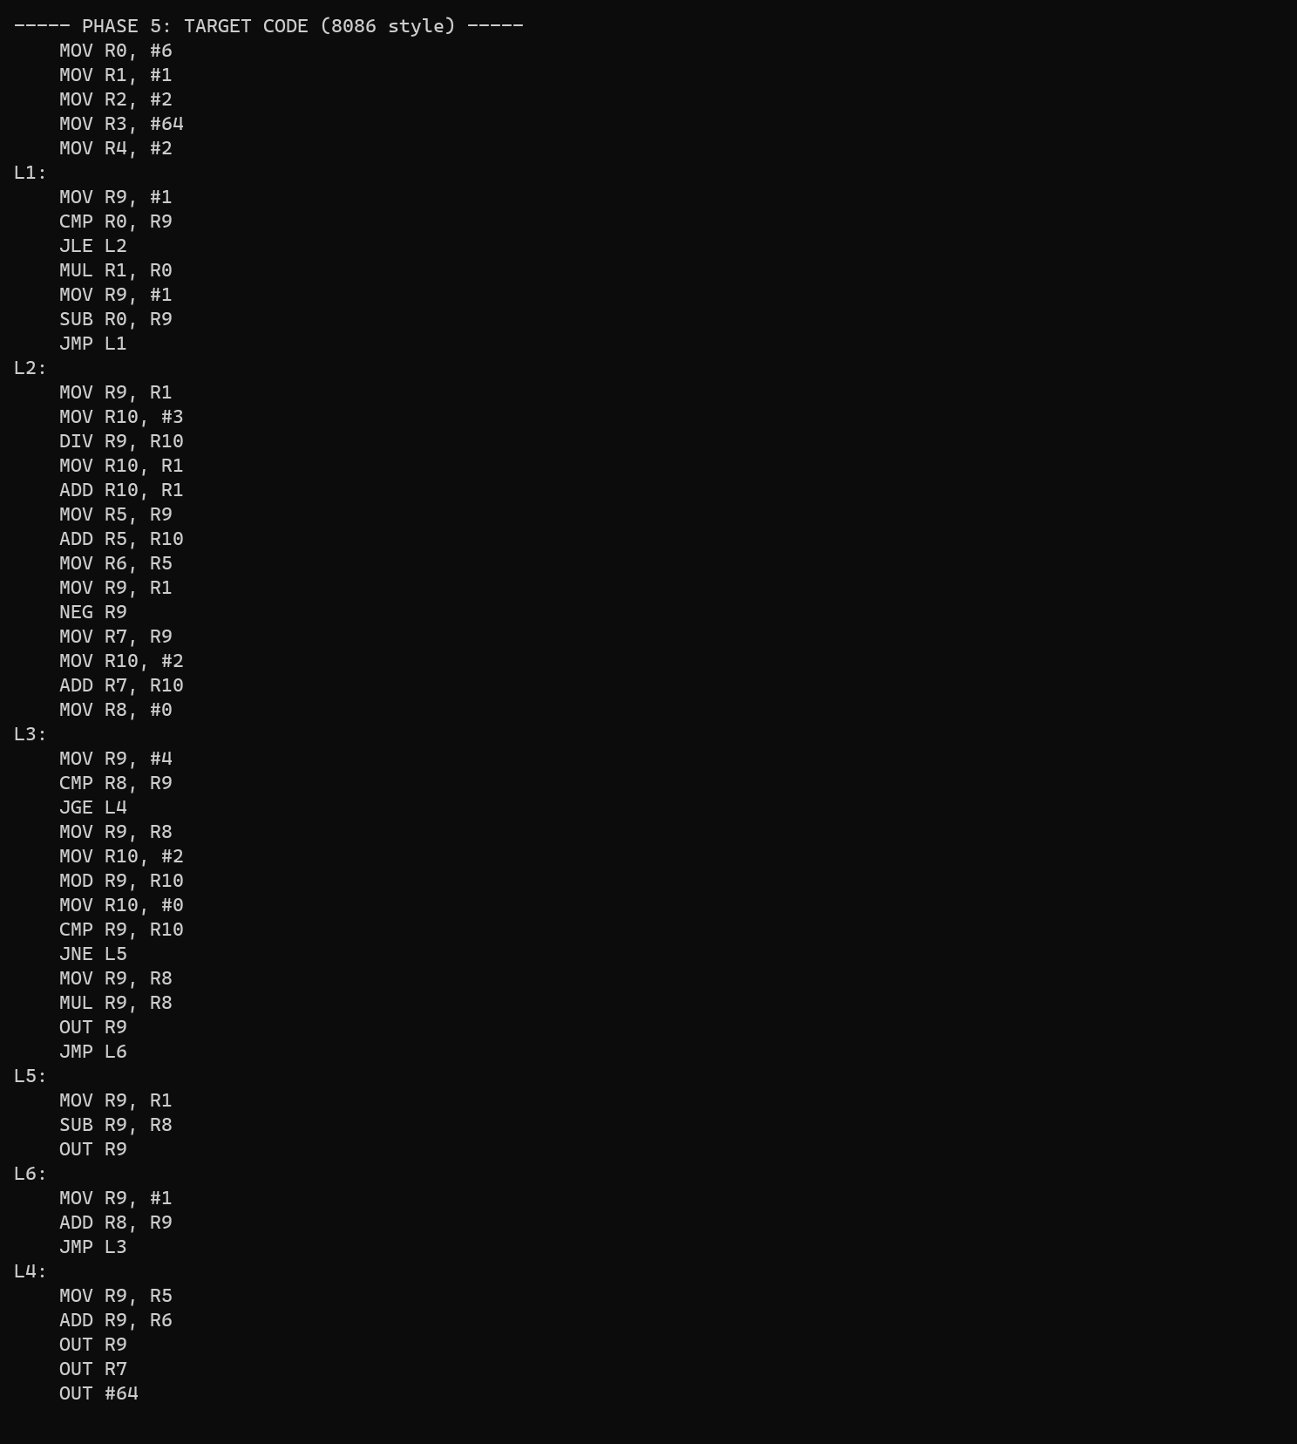
Additional test case: input2.java (optimized code and target code) (part 2 of 3)
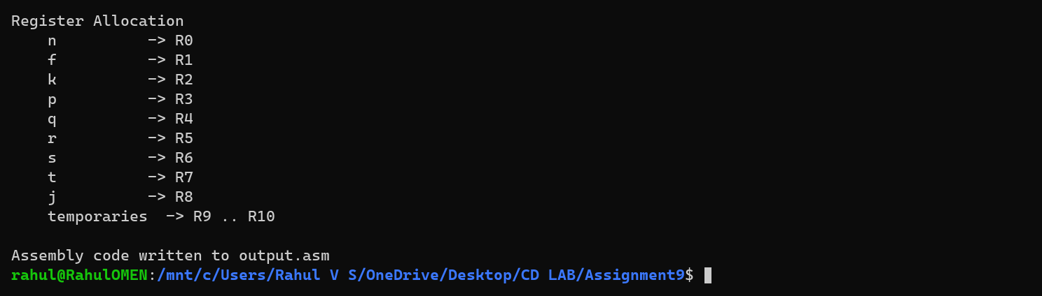
Additional test case: input2.java (optimized code and target code) (part 3 of 3)
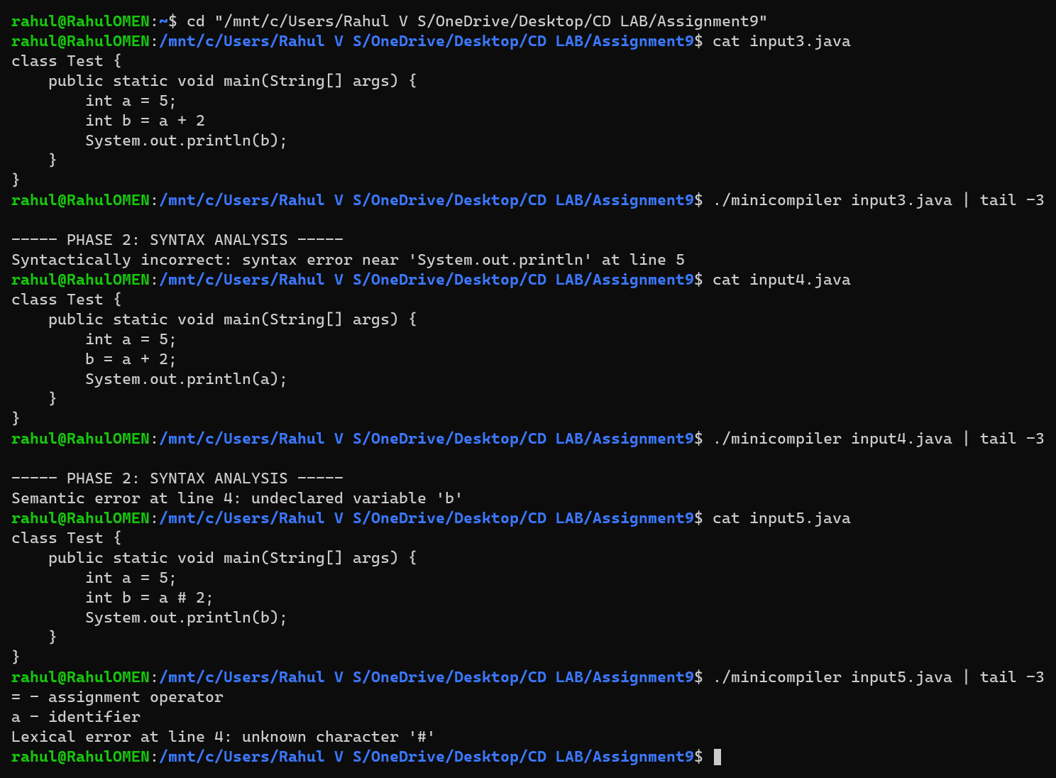
Error handling: syntax error, semantic error and lexical error
For input2.java the loop variables are not constants, so the loop is kept, but 2 ** 6 = 64, the remainder and the repeated expression f/3 + f*2 (computed once, then copied) are optimized. A missing semicolon is reported as a syntax error, an undeclared variable as a semantic error and the character # as a lexical error.
Learning Outcomes:
- Understood how the phases of a compiler (lexical analysis, syntax analysis, intermediate code generation, optimization and code generation) are combined into a single working compiler.
- Learnt to use Lex to recognize Java tokens and to pass them to the Yacc parser, reporting lexical errors such as unknown characters and unterminated strings.
- Learnt to write Yacc grammar rules with precedence and associativity for expressions, and for declaration, assignment, conditional and looping statements, and to build a symbol table with block scope and semantic checks.
- Learnt to generate three address code with temporaries and labels using syntax directed translation.
- Learnt to apply constant propagation and folding (using data flow analysis so that loops are handled correctly), algebraic identities, strength reduction, common sub-expression elimination and dead code elimination on three address code.
- Learnt to generate 8086-style assembly code with register allocation, comparison and jump instructions, and to compile and run Lex and Yacc programs together with C code.

